

Faculty of Health and Social Care
Module Code: LCHS7006

Module Title: Quality Assurance and Service Improvements

Component 2: Service Improvement Report
Root Cause Analysis and Recommendations for Sustainable Quality Improvement Following the Mid Staffordshire NHS Foundation Trust Scandal (2005–2009)

Student Name: Muhammed Atif Sajid Banglawala
Student ID: 2514910
Lecturer: Dr Fahad Khan
Word Count: 3,000
Date of Submission: 29 July 2026

Table of Contents
1. Introduction 3
2. Root Cause Analysis of Quality Assurance Failures 4
2.1 Donabedian Model Application 4
2.2 Fishbone Diagram Analysis 5
2.3 Strategic Analysis – SWOT 6
2.4 Kotter’s Eight-Step Change Model 8
2.5 The Plan-Do-Study-Act (PDSA) Cycle 9
3. Recommendations 10
4. Conclusion 11
References 13

1. Introduction
Patient safety is a constant challenge to quality in the National Health Service (NHS) because of the need to prioritise its care over targets and financial issues. The Mid Staffordshire NHS Foundation Trust scandal which took place at Stafford Hospital between January 2005 and March 2009 represents a paradigm example of systemic quality assurance failure (Francis, 2010 & Francis, 2013a). The higher hospital standardised mortality ratios and the horrific standards of basic care, combined with a care culture of patients being left unwashed, unfed, dehydrated and in soiled bedding, were the focus of an independent inquiry in 2010 and a subsequent public inquiry led by Sir Robert Francis QC (Francis, 2013b). Receptionists would be required to filter patients coming in to the emergency department, pain relief would not always be provided and colleagues raising concerns would be disregarded or deliberately sidelined. While quantification of excess deaths is challenged, the qualitative evidence of suffering and degradation and avoidable damage was undeniable (Francis, 2013b).
Later studies have demonstrated that board prioritisation of Foundation Trust status, financial balance and performance targets, combined with chronic understaffing and inadequate complaints procedures and a climate of fear, systematically prevented clinical quality issues from being addressed for several years (Francis, 2013a; Entwistle and Doering, 2024). All the above are multiple organisational failures that correspond to Reason's Swiss cheese model of accident causation, where successive layers of defences are partially or completely compromised, allowing hazards to slip through to harm (Reason, 2016). There was lack of action at every level of leadership, based on the clear indicators, where they were known, to take significant action.
With the introduction of the Duty of Candour, Freedom to Speak Up Guardians, fundamental standards and the Patient Safety Incident Response Framework (PSIRF) (NHS England, 2022), there is still considerable variation detected in cultural change and organisational learning more than a decade later (Martin, Stanford and Dixon-Woods, 2023; Hughes, 2023). Psychological safety, safe staffing and the implementation of inquiry recommendations in enduring improvements remain challenges for many trusts (Rafferty and Leary, 2023; Tasker, Jones and Brake, 2023). There have been more recent investigations of maternity care and mental health that have revealed the old problems of lack of interest and agency by staff alongside reduced reporting and ‘defensiveness' by organisations (The Independent, 2026; BBC News, 2026a; BBC News, 2026b; The Times, 2026). Sir Robert Francis' own interview by the Nuffield Trust highlights continuing implementation bridges (Nuffield Trust, 2023).
This service improvement report will critically examine the factors that cause a failure in the quality management of Mid Staffordshire by employing the Donabedian model, Fishbone analysis and SWOT analysis. Then it offers a systematic implementation plan that is based on the Plan-Do-Study-Act (PDSA) cycle and Kotter's eight steps of change. The goal is to establish recommendations grounded in evidence to improve organisational learning process reliability and the culture necessary for true learning and prevention of recurrence (Berwick, 2013; Kotter, 2012).

2. Root Cause Analysis of Quality Assurance Failures

2.1 Donabedian Model Application
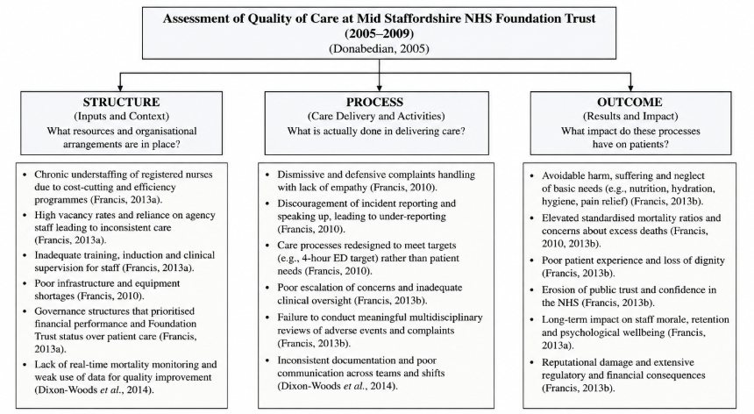
Figure 1: Donabedian Model Applied to Quality of Care at Mid Staffordshire NHS Foundation Trust (2005–2009)
(Source: Adapted from Donabedian 2005)
In Donabedian's model, the three concepts of structure, process and outcome are interrelated to evaluate the quality of healthcare (Donabedian, 2005). At Mid Staffordshire a succession of cost-cutting initiatives had resulted in regular understaffing of RNs, equipment deficiencies, the absence of adequate induction and training, and a deconstructed governance framework that ensured that financial accountability different to clinical accountability (Francis, 2013a; Entwistle and Doering, 2024). The lack of effective real-time mortality monitoring combined with the lack of independent challenge further undermined the structural basis for safety, and board-level structures focused on gaining Foundation Trust status and targets over care provided to patients (Francis, 2010, Dixon-Woods et al., 2014).
These structural deficiencies were exacerbated by process failures. Complaints handling was often dismissive or defensive; there was a discouragement of incident reporting at both formal and informal levels; clinical pathways were redesigned which focused on emergency department throughput, rather than whole person care (Francis, 2010; Francis 2013b). Escalation was not consistent and the extent of multidisciplinary discussion or identifying common cross-cutting safety issues was lukewarm. Leadership accountability systems lacked the effectiveness to challenge poor performance or to ensure timely action to address problems when they were identified through mortality alerts and concerns raised by patients or their families (Tingle, 2023; Francis, 2013a).
The consequences of these structural and process failures led to increased death rates, high levels of pressure injuries, falls, infections in hospital and most tragic of all, the loss of dignity and humanity of those receiving care (Francis, 2013b). The trust, and the NHS as a whole, lost a lot of credibility with the public and were subjected to continued rigorous criticism from outside the Trust. The Donabedian analysis shows that tracking outcomes is not enough to make improvements and there must be a focus on the enabling mechanisms that deliver positive outcomes as well as on consistent and reliable processes (Donabedian, 2005; Dixon-Woods et al., 2014). Critically applying the model also shows that simply using outcome indicators like crude mortality rates is insufficient if process and structure measures are not also included, because otherwise organisations can be supposedly compliant despite the poor functioning of the underlying systems during care (Martin et al., 2023; Hughes, 2023; Care Quality Commission 2023).

2.2 Fishbone Diagram Analysis
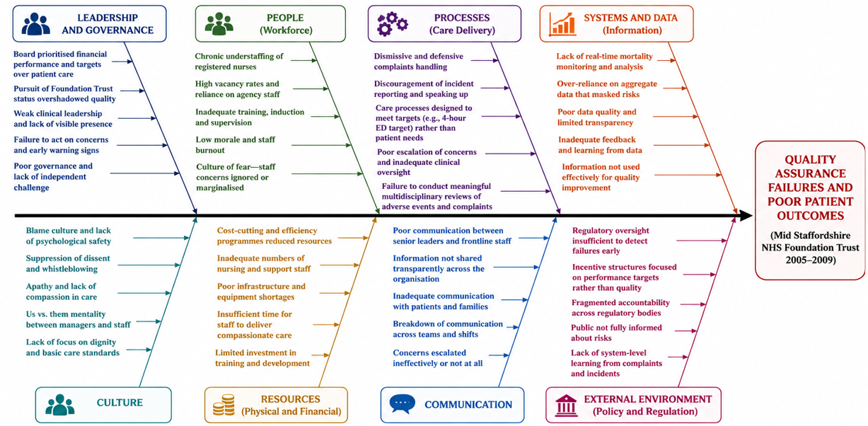
Figure 2: Fishbone (Ishikawa) Diagram of Root Causes of Quality Assurance Failures at Mid Staffordshire NHS Foundation Trust (2005–2009)
(Source: Self-Developed)
The Fishbone (Ishikawa) diagram is a useful structured approach to exploring the multifactorial (many causes) causes of the Mid Staffordshire failures. When used with the available evidence, the tool reveals six principal causes. In the People domain, there were significant shortages of registered nurses (RNs) and a dilution of skill mix with increased reliance on non-registered staff, excessive workload, and widespread low morale – which made it impossible to consistently and safely deliver basic care (Rafferty and Leary, 2023). Human-factors literature also emphasizes that professional silos and the threat to psychological safety can represent barriers to open discussion of adverse events and near misses (Tasker et al., 2023).
Process-related factors ranged from target-driven management systems that encouraged performance-game reporting, to a lack of standardisation in the protocol used to respond to an alert or a complaint (Francis, 2010). Technology and materials barriers included lack of equipment resources and a lack of information systems that could facilitate real-time identification of risks and effective risk communication. Environmental constraints, such as high bed occupancy, competing operational priorities, reduced the time available for thorough care and review (The Guardian, 2024; Department of Health and Social Care, 2024).
Lastly, Management factors were most notable, such as a Board which had a more intense focus on financial and regulatory production quality rather than clinical production quality, a higher prevalence of which would be indicative of amoral management and normalisation of deviance. The processes that create learning were weak; the executive was slow to respond to known problems and board-level accountability for quality and safety metrics were insufficient, enabling systemic weaknesses to persist (Francis, 2013a; Berwick, 2013). The Fishbone analysis reiterates that changing behaviours on any single domain will not sustain the outcome and that a multi domain approach is needed (Reason, 2016; Vincent, 2010). These six domains work together to produce classic scenarios in which latent organisational issues can combine with active front-line errors to bring hazards to the patients. Thus, tackling only the most evident active failures, represented by individual knowledge gaps, is unlikely to equate to long-term safety improvements without associated improvements in management systems, staffing and cultural structures (Martin et al., 2023; Hughes, 2023; University of Birmingham, 2023).

2.3 Strategic Analysis – SWOT
A SWOT analysis of the Mid Staffordshire context and its contemporary legacy highlights both residual challenges and strategic opportunities.
Strengths | Weaknesses
- Francis Inquiry strengthened accountability and transparency  - Duty of Candour and Freedom to Speak Up introduced  - Fundamental Standards and PSIRF support systems-based learning  - Increased national focus on patient safety and governance | - Toxic organisational culture and bullying  - Weak clinical leadership and board oversight  - Chronic understaffing and resource constraints  - Poor complaints handling and limited organisational learning
Opportunities | Threats
- Full implementation of PSIRF across NHS organisations  - Real-time digital safety dashboards and data analytics  - Stronger multidisciplinary learning culture  - Leadership development and workforce investment | - Continuing workforce shortages  - Financial pressures and competing organisational priorities  - Resistance to organisational change  - Risk of target-driven culture undermining patient-centred care
Strengths included the eventual external scrutiny that led to the Accountability Framework, the presence of individual clinicians who raised concerns, and the creation of the Duty of Candour, the Freedom to Speak Up and the Fundamental Standards (Francis, 2013a; Berwick, 2013; Care Quality Commission, 2023). The progressive movement towards systems-based inquiry with the introduction of PSIRF, is a significant advance (NHS England, 2022).
Weaknesses were the dominant features of the internal environment at the time of the scandal, and include the toxic culture of bullying and fear, poor clinical leadership, ineffective complaints systems, board isolation from the frontline, and persistent staff shortages (Francis, 2013a; Dixon-Woods et al., 2014; Rafferty and Leary, 2023). Safety is still seen by many organisations as a reporting requirement rather than an opportunity for work to continuously improve (Tasker et al., 2023; Tingle, 2023).
The further implementation of PSIRF, the emerging real time digital safety dashboards, and the development of bona fide multidisciplinary learning cultures create advantages (East London NHS Foundation Trust, 2026; Care Quality Commission, 2023; The King’s Fund, 2024). The Darzi investigation focuses on the improvement of service culture and staffing (Department of Health and Social Care, 2024).
Threats include shortages in the workforce, strain on finances, resistance to change, inconsistent methods across NHS Trusts, and the possibility that a focus on goals may return under different performance structures (The Guardian, 2024; The Times, 2026; University of Birmingham, 2023; Nuffield Trust, 2023). The SWOT analysis suggests that the combination of technical standardization along with intentional cultural and leadership changes is necessary for improving NHS Trusts in a sustainable way (Kotter, 2012; Berwick, 2013). The opportunity that PSIRF brings cannot be achieved without developing organizational capabilities and investing in psychological safety. If these changes do not take place, the PSIRF will only become a tool for regulatory compliance and will not improve learning (Hughes, 2023; Tasker et al., 2023).

2.4 Kotter’s Eight-Step Change Model
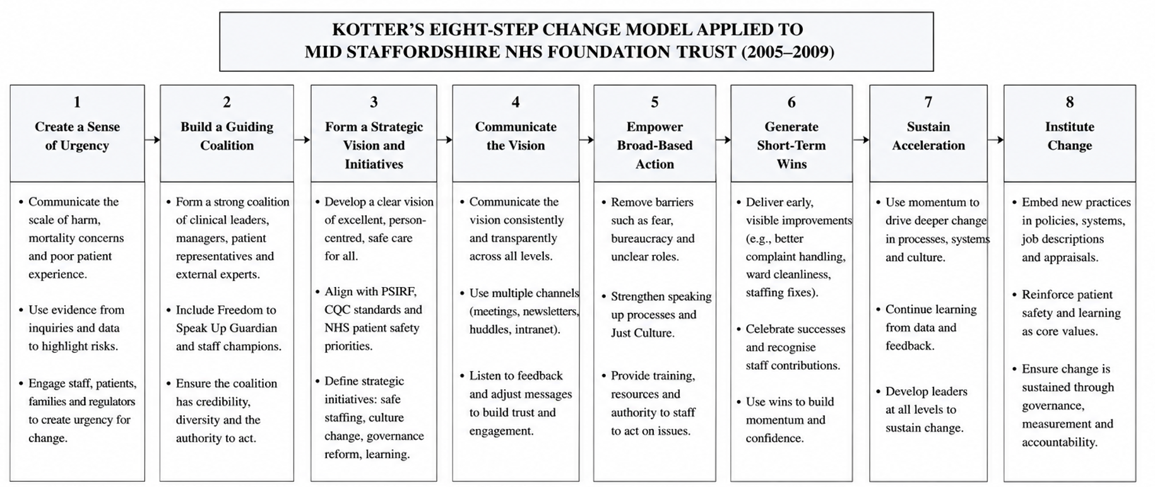
Figure 3: Kotter’s Eight-Step Change Model for Organisational Change at Mid Staffordshire NHS Foundation Trust (2005–2009)
Achieving sustainable change in organizations requires addressing both the technical and human elements in relation to interventions (Kotter, 2012). Kotter’s eight-step model can be employed for large-scale transformation and addresses the governance and cultural failings at Mid Staffordshire NHS Foundation Trust.
Step one is establishing the urgency to change. This can be accomplished by providing the public with data on the local context about preventable patient harm and hearing the stories of patients and their families, as well as staff and family members who had their concerns go uninvestigated (Francis, 2013b; Nuffield Trust, 2023; BBC News, 2026b). This step also requires forming a guiding coalition which, in this case, is a safety improvement team with executive sponsorship and team members from cross-disciplines, as well as a clinical safety improvement team and family and patient safety team members (Berwick, 2013; Hughes, 2023).

Staff safety is also improved by providing integrated safety management information systems and staffing as well as dedicated safety review staffing and the removal of safety concerns expressed by staff. Safety concerns of staff who have been emboldened by the removal of safety concerns are honored (Rafferty and Leary, 2023; Tasker et al., 2023). The 8-step model may also be employed to demonstrate the feasibility and value of organizational change by establishing incremental goals (Kotter, 2012).
The integration of safety and staffing metrics into board performance frameworks, annual benchmarking, appraisal processes and succession planning will help secure ‘Consolidating gains and anchoring new approaches’ into the organisational culture (Care Quality Commission, 2023; East London NHS Foundation Trust, 2026). Empirical evaluations ten years after the Francis Report confirm that of the organisations that combine improvement methods with focused, visible leadership, the majority will achieve sustained cultural changes. Initiatives that are neglected will achieve minimal, short-term compliance and will not change ‘day-to-day’ practices (Martin et al., 2023; Hughes, 2023; University of Birmingham, 2023).

2.5 The Plan-Do-Study-Act (PDSA) Cycle
Kotter’s model examines the strategic and cultural aspects of change. In contrast, the Plan-Do-Study-Act (PDSA) cycle offers an approach for the practical application of changes and iterative refinements. The PDSA model is particularly useful for the iterative process of system improvements related to safe staffing, safety huddles, complaint pathways, rounding, and learning and feedback tools.
During the Plan phase, baseline data are gathered, and an intervention or care bundle is developed and designed to be integrated into the existing care systems. The Do phase consists of fully developed, supported, and trained, care system changes for use in service or ward care piloted in an unmanaged state. During the Study phase, the developed change is assessed through the analysis of metrics pertinent to the compliance, harm, and reporting, as well as through the feedback of staff and families. PDSA aims to improve the outcome of a change, and the Act phase captures learning by optimizing the successful aspects of the change and improvement from the previous phases, while fully removing all unsuccessful aspects (East London NHS Foundation Trust, 2026).
The purpose of the PDSA model is to enable the iterative change process and support the continual improvement of a system or service. When integrated with Kotter’s model, PDSA offers a combination of process engineering and improvement (Kotter, 2012; Berwick, 2013; Tasker et al., 2023). Together, the two models provide a coherent strategy for translating the enduring lessons of Mid Staffordshire and the requirements of contemporary frameworks such as PSIRF into reliable local practice that reduces preventable harm and strengthens organisational learning.

3. Recommendations
Based on the root-cause and strategic analysis above, there are evidence-based recommendations to enhance the quality assurance arrangements and position services to improve in the short run when existing frameworks are used. All recommendations are connected to the analysis results and include an action plan to implement them with the help of the PDSA cycle.
Recommendation 1: Make safe staffing a fundamental structural requirement. Evidence-based ratios of nurses to patients based on professional recommendations and the specifics of acuity should be embraced by boards and tracked in real time and shared publicly, alongside financial and performance indicators (Rafferty and Leary, 2023). Bed closures or mutual aid or other safeguarding devices should be set off by automatic escalation procedures where ratios fall short of agreed limits instead of allowing it to operate under proven unsafe conditions. The intervention should be implemented in PDSA fashion: Plan (Months 1 to 3) - set up baseline audit of current ratios and develop the protocols and design escalation procedures; Do (Months 4 to 6) - pilot ratios on high-risk wards, comprehensive staff training; Study (Months 7 to 9) - measure compliance, missed-care events, falls, pressure ulcers and staff feedback; Act (Months 10 to 12) - revise the protocols and scale the organisation-wide with monthly audit and feedback loops.
Recommendation 2: Systematically develop psychological safety and a just culture. Freedom to speak up Guardians must be properly resourced, organisationally independent and in possession of easy access to avenue by which any concern should be lodged with the Board and, where it is necessary, outside regulators without the person raising the concern facing any career penalty (Tasker et al., 2023). All managers and clinical leaders should have the mandatory training in just-culture principles, the clear separation of human errors and at-risk and reckless behaviour. Training content, delivery mechanisms and escalation routes can be tested and developed in small steps using PDSA cycles and improvements measured by validated safety-culture surveys to be undertaken at least once a year and by triangulating the results with incident-reporting rates, staff retention rates and number of concerns raised.
Recommendation 3: Redesign governance to achieve quality and safety as equal to finance and operation performance. Board agendas must ensure a reserved time on quality reports which would not only have a set of quantitative measures but also patient and family stories which bring to life the lived experience of care (Francis, 2013a; Berwick, 2013). There ought to be a number of non-executive directors who have recent clinical backgrounds to make informed and strong challenge. The well-managed sphere of the Care Quality Commission provides a convenient external system of evaluating the efficacy of such arrangements (Care Quality Commission, 2023). A safety improvement team comprising of multiple disciplines that is blatantly executive-sponsored, conducting monthly, quarterly reporting to the board, rapid-cycle improvement of outcome and process metrics.
Recommendation 4: Establish system enhancement capacity on all levels with the help of PDSA, Lean thinking and systems-driven inquiry under PSIRF (NHS England, 2022). Local improvement teams should be supported by a central quality-improvement faculty that provides coaching, data analytics support and rapid-cycle evaluation expertise (Lachman, Batalden and Vanhaecht, 2024). Priority projects should target the fundamental standards of care that failed so catastrophically at Mid Staffordshire: nutrition, hydration, personal hygiene, pain management, dignity and communication with patients and families. The measures of success levels must comprise of process measures as well as outcome measures and the progress must be publicly reported within quality accounts.
Recommendation 5: Enhance system-level learning by enhancing transparent sharing of research findings in PSIRF, regular learning reviews to explicitly map progress against those Francis recommendations that remain applicable to the local setting, and external peer review (East London NHS Foundation Trust, 2026; University of Birmingham, 2023; Nuffield Trust, 2023). Boards must publicize quantitative as well as qualitative learning themes. Open external reporting also enhances external responsibility and minimises chances of isolation and complacency among organisations.
The recommendations collectively fill the structural, process- and cultural gaps as revealed in the Donabedian, Fishbone and SWOT analyses. Its introduction as a series of iterative PDSA cycles facilitated by the Kotter model of change is a feasible path to dependable risk identification, fair care and valuable learning in organisations, as long as it is sustained at the executive level, has sufficient resources and dual measures of process and outcome indicators (Kotter, 2012; Berwick, 2013; Martin et al., 2023).

4. Conclusion
The scandal of the Mid Staffordshire NHS Foundation Trust unveiled several failures in governance, the accountability of the leadership, staffing and the organisational culture that has lead to avoidable harm and the ongoing neglect of vulnerable patients (Francis, 2010; Francis, 2013a; Entwistle and Doering, 2024). Neither the independent nor public inquiries could find that patient safety was systematically sacrificed to the goals of pursuits and the status of Foundation Trust and that an atmosphere of fear cowed those who tried to speak out.
These failures were shown to be complex in terms of the interaction of structural, process and cultural weak points by the application of the Donabedian model, Fishbone analysis and SWOT framework. Ongoing understaffing, target-oriented procedures, a feeble board control, lack of equipment and the normalisation of deviance all occurred in an environment where hazards were allowed to develop unchecked. This system design failure is repetitive with the Swiss Cheese Model of accidents causation (Reason, 2016).
Lasting enhancement involves a concomitant consideration of technical process stability and the cultural and managerial environment that facilitates the real organisational learning. This is critical to safe staffing, psychological safety, balanced governance, capability to engage in continuous improvements, and transparent system-level learning. Such technical transformations can only be entrenched when they have a clear strategic vision, a leading coalition of clinicians and leaders, elimination of organisational barriers and constant attention to process fidelity and outcome effects (Kotter, 2012; Berwick, 2013).
Iterative Plan-Do-Study-Act test and an organised model of organisational change offers a consistent methodology of operationalising the lessons of Mid Staffordshire to be long-lasting into dependable local practice. Through the basics of care, concentrating on personnel competency, instituting accountability at cellular levels and impact measurement through clear benchmarking, healthcare organisations can diminish the mass of harm that is preventable, mitigating the old-fashioned issues of equity and dignity, and reinvesting trust in the ability of the NHS to learn. The suggestions provided in this report are a feasible and evidence based route to that valued direction.

References
Berwick, D. (2013) A promise to learn – a commitment to act: Improving the Safety of Patients in England. London: Department of Health.
BBC News (2026a) Lampard Inquiry: Manager says trust wanted 4,000 reports 'gone'. Available at: https://www.bbc.co.uk/news/articles/c6212klngkko (Accessed: 26 July 2026).
BBC News (2026b) Ex-NHS nurse tells Lampard Inquiry staff apathy 'astonishing'. Available at: https://www.bbc.co.uk/news/articles/cx2vjv3qj3jo (Accessed: 26 July 2026).
Care Quality Commission (2023) The state of health care and adult social care in England 2022/23. Available at: https://www.cqc.org.uk (Accessed: 26 July 2026).
Department of Health and Social Care (2024) Independent Investigation of the National Health Service in England (accessible version). Available at: https://www.gov.uk/government/publications/independent-investigation-of-the-nhs-in-england/independent-investigation-of-the-national-health-service-in-england-accessible-version (Accessed: 26 July 2026).
Dixon-Woods, M., Baker, R., Charles, K., Dawson, J., Jerzembek, G., Martin, G., McCarthy, I., McKee, L., Minion, J., Ozieranski, P. and Willars, J. (2014) ‘Culture and behaviour in the English National Health Service: overview of lessons from a large multimethod study’, BMJ Quality & Safety, 23(2), pp. 106–115.
Donabedian, A. (2005) An introduction to quality assurance in health care. Oxford: Oxford University Press.
East London NHS Foundation Trust (2026) Key areas of learning from the Francis Report. Available at: https://qi.elft.nhs.uk/wp-content/uploads/2026/02/key-learning-from-the-francis-report.pdf (Accessed: 26 July 2026).
Entwistle, T. and Doering, H. (2024) ‘Amoral management and the normalisation of deviance: The case of Stafford hospital’, Journal of Business Ethics, 190(3), pp. 723–738. Available at: https://doi.org/10.1007/s10551-023-05445-6
Francis, R. (2010) Independent Inquiry into care provided by Mid Staffordshire NHS Foundation Trust January 2005 – March 2009. London: The Stationery Office.
Francis, R. (2013a) Report of the Mid Staffordshire NHS Foundation Trust Public Inquiry. London: The Stationery Office.
Francis, R. (2013b) Report of the Mid Staffordshire NHS Foundation Trust Public Inquiry: Executive Summary. London: The Stationery Office.
Hughes, H. (2023) ‘Public inquiries, patient safety and the implementation gap’, Future Healthcare Journal, 10(1), pp. 7–9.
Kotter, J.P. (2012) Leading change. Boston: Harvard Business Review Press.
Lachman, P., Batalden, P. and Vanhaecht, K. (eds.) (2024) Handbook of Quality Improvement in Healthcare. Oxford: Oxford University Press.
Martin, G., Stanford, S. and Dixon-Woods, M. (2023) ‘A decade after Francis: is the NHS safer and more open?’, BMJ, 380, p. p513. Available at: https://doi.org/10.1136/bmj.p513
NHS England (2022) Patient Safety Incident Response Framework. Available at: https://www.england.nhs.uk/patient-safety/incident-response-framework/ (Accessed: 26 July 2026).
Nuffield Trust (2023) 10 years on: An interview with Sir Robert Francis. Available at: https://www.nuffieldtrust.org.uk/news-item/yearsyears10-years-on-an-interview-with-sir-robert-francis (Accessed: 26 July 2026).
Rafferty, A.M. and Leary, A. (2023) ‘Nursing notes on a scandal’, Future Healthcare Journal, 10(1), pp. 3–6.
Reason, J. (2016) Managing the risks of organizational accidents. London: Routledge.
Tasker, A., Jones, J. and Brake, S. (2023) ‘How effectively has a Just Culture been adopted? A qualitative study to analyse the attitudes and behaviours of clinicians and managers to clinical incident management within an NHS Hospital Trust and identify enablers and barriers to achieving a Just Culture’, BMJ Open Quality, 12(1), e002049. Available at: https://doi.org/10.1136/bmjoq-2022-002049
The Guardian (2024) England’s run-down hospitals are ‘outright dangerous’, say NHS chiefs. Available at: https://www.theguardian.com/uk-news/2024/dec/30/england-rundown-hospitals-are-outright-dangerous-say-nhs-chiefs (Accessed: 26 July 2026).
The Independent (2026) Nottingham NHS maternity scandal: Key findings from damning Ockenden report. Available at: https://www.independent.co.uk/news/health/nottingham-nhs-maternity-inquiry-donna-ockenden-b3001965.html (Accessed: 26 July 2026).
The King’s Fund (2024) The 10 Year Health Plan: Our Recommendations. Available at: https://www.kingsfund.org.uk/insight-and-analysis/long-reads/10-year-health-plan-recommendations (Accessed: 26 July 2026).
The Times (2026) NHS trust faces ‘unprecedented’ corporate manslaughter inquiry. Available at: https://www.thetimes.com/uk/crime/article/nottingham-nhs-trust-corporate-manslaughter-inquiry-valdo-calocane-k02nfzv39 (Accessed: 26 July 2026).
Tingle, J. (2023) ‘Patient safety in the NHS: after Francis’, British Journal of Nursing, 32(8), pp. 394–395.
University of Birmingham (2023) Ten years after the Francis Inquiry Report: will we ever learn? Available at: https://www.birmingham.ac.uk/news/2023/ten-years-after-the-francis-inquiry-report-will-we-ever-learn (Accessed: 26 July 2026).
World Health Organization (2021) Global patient safety action plan 2021–2030. Geneva: WHO.
Vincent, C. (2010) Patient Safety. 2nd edn. Chichester: Wiley-Blackwell.
Langley, G.J., Moen, R.D., Nolan, K.M., Nolan, T.W., Norman, C.L. and Provost, L.P. (2009) The Improvement Guide: A Practical Approach to Enhancing Organizational Performance. 2nd edn. San Francisco: Jossey-Bass.

