Human Resource Management at Apple Inc.: Upholding Employee Well-being

March 2023

MODULE NAME：Human Resource Management (BMMB7007)
NAME：Zilong Han
STUDENT NUMBER：2203389

Executive Summary
Apple Inc. is a multinational technology company in America that has specialized its productivity towards advanced products and services such as smartphones and personalized computers. Through its workforce, both employees and the senior managers, the whole team has accelerated the work culture through employee engagement and performance. However, the company has faced backlash on the way it has placed the area of employee well-being and its negative effects. A report has been formulated through extensive primary and secondary research to provide an in-depth on the importance of employee well-being.

Apple Company has performed well it is operations but there has been different cases and reports by employees who suffer from emotional stress and burnout at work. Different employees reported to have taken a leave after experiencing burnout that affected their mental health while others faced a mental breakdown due to working for long hours and handling many clients under 2 minutes. Employee well-being has been connected to better performance at workplace, better productivity of the organization and attraction of effective shareholders and investors to the company.
Through the human resource management, Apple Company can succeed in the area of employee well-being through various recommendations:
- Introduce stability among workers’ schedule to reduce stress at work and increase the state of employees’ mental health.
- Introduction and adoption of Whole Person Approach by focusing on not only the physical health of employees but also their financial, emotional and social health.
- Giving workers more control over their activities. By training workers on their roles before starting to work, employees are set to perform better on their own without pressure that might result to burnout and stress

Table of Contents
1. Introduction 1
2. Organization Review 1
3. Employee Well-being 2
3.1 Employee Wellbeing at Apple Inc. 2
3.2 Improvement of Employee Well-being at Apple Company 3
3.3 Benefits of Employee Well-being towards an Organization 4
3.3.1 Benefits towards the Organization 4
3.3.2 Benefits towards the Employees 5
3.3.3 Benefits towards Organizational Stakeholders 5
4. Recommendations 6
4.1 Stability among Workers’ Schedule 6
4.2 Whole-Person Approach 7
4.3 Giving Employees Control over their Tasks 8
5. Conclusion 8
References 9

1. Introduction
Employee well-being is one of the prioritized areas in companies that determine the success and productivity of the firm at large. The human resource management, particularly, is responsible in ensuring the wellness of employees is achieved and in return, accelerate the better performance of workers. Narrowing down to the tech-companies, such organizations nurture talents through innovation and invention and by focusing on employee well-being, the companies are set for success. The essay below discuses on the employee well-being strategy in Apple Company, its drawback and recommendations the company can adopt to increase performance and engagement of employees at large.

2. Organization Review
As an American multinational technology company founded in 1976, Apple Inc. is among the renowned and biggest technology company around the world (Laricchia, 2023). Headquartered in California, Apple Inc. has ventured into different innovation and inventions of tablet computers, smartphones and even personal computers (Tien, Dat & Chi, 2019). Known for its famous applications such as Apple Store, the company has upheld its position and significant performance. The number of employees has increased up to 164,000 as from the year 2022 and through its widespread stores in different countries, the company is ought to increase its activities (Laricchia, 2023).

The Human Resource is among the significant departments in a company that focuses on the key factors of the firms such as employee recruitment, hiring, well-being and performance. Apple Inc. has also put the HR managers who work as a team to ensure the employees not only complete tasks on time but also offer the workers the effective environment for them to be creative and innovative (Joseph, 2020). The company has centralized its HR within the company and also ensured that every offices around the world has HR department to promote better employee engagement, well-being and development.

3. Employee Well-being

3.1 Employee Wellbeing at Apple Inc.
Employee wellbeing is one of the prioritized areas of a company that determines its success and productivity overall. Good health and wellbeing of workers has been connected to a better organizational performance and better employee engagement with the seniors and the whole human resource management (Doz, 2020). Different companies introduce interval breaks during work, recreational activities during the weekend for workers and other activities that release tension at workplaces. According to the WorkWell model, the framework encourages the workplaces to enhance and maintain an effective and sustainable workplace wellbeing programme that suits its employees. The model mainly emphasizes on the physical, social and mental health of the workers around the workplaces (The Prince’s Responsible Business Network, 2019). By companies embedding such model, the organizational culture of it is boosted and employees feel valued and appreciated. A 2019 survey done by the Mental Health America analyzed that 70% out of 17,000 employees are searching for other jobs while 50% have checked out due to reasons such as working overtime and a poor culture that does not involve employee teamwork and engagement (Robinson, 2020). The issue of burnout has been escalating as employees prefer companies that are more into work-life balance culture. Such culture makes employees less stressed and can be more engaged at work and lead to more productivity.

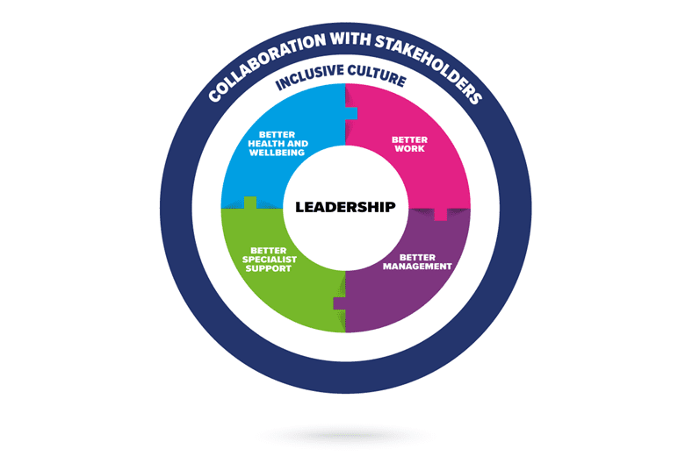
Figure 1: The Workwell Model (The Prince’s Responsible Business Network, 2019)

Other than the Workwell model, the Braden and Build Theory appreciates the importance of wellbeing among people. According to the theory, the function of positive emotions broadens the thought-action of a person and can lead to developing personal resources (Keeman et al., 2017). The thought-action relates to the set of activities that follow the thoughts. For instance, positive actions lead to a person expressing joy and can lead to sharing out the emotion to others or applying it at workplaces (Chang eta al., 2019). When the well-being of employees are taken care of, the workers result to being happy and contended with it and leads to performing better. Developing a sense of value can make the employees work much better and engage with their managers for guidance.

3.2 Improvement of Employee Well-being at Apple Company
The issue of burnout is one of the issues that employees have raised concerning their well-being at workplaces leading to mental breakdown among employees (Lan et al., 2020). According to the social exchange theory, burnout is experienced when the worker perceives the lack of equity between the contributions made, results obtained and efforts in their work (Meng et al., 2019). As a result, employees, supervisors and other colleagues end up developing emotional exhaustion that can be chronic (Edu, Laguia & Moriano, 2022). Narrowing down the employee-wellbeing at Apple Company, the organization has performed at its bets to ensure the employees are considered too. However, the well-being of workers has been criticized due to burn out of workers. Apple Inc. is known for its secretive corporate culture where employees are mandated to be in lock step with the management but is facing an issue of employee unrest. The employee unrest faced by the company came as a result of employee verbal abuse, discrimination at workplaces and burnout. The issue of burnout has been related to the mental illnesses among employees at Apple who either quitted or took a leave. For example, in 2021, one of the Apple employee decided to take a leave to cope with the stress developed due to responding to customers in under two minutes. By sitting at a computer for up to 10 hours daily, the employee concluded that the activity led to metal toll (Schiffer, 2021).

The employee-wellbeing at Apple needs improvement to reduce the number of employed quitting due to discrimination and intimidation around workplaces. A group of Apple employees worked in organizing a fight against racism, sexism and inequity that affected their well-being at work. By launching the #AppleToo campaign, the movement aimed at mobilizing workers to push the company respond much better to claims of employees facing challenges at work (Anguiano, 2021). In one of the statement made by an employee, the company was stated to evading public scrutiny which resulted to employees’ demands not being heard leading to quitting their jobs. On another hand, the apple company was reported to discriminate the people of color at workplaces. According to reports made by employees, there were different scenarios where leaders would not allow specific employees of color interview for roles they were deserving of. As a result, the well-being of such employees led to mental breakdown as they were considered to not belong to such roles and company.

3.3 Benefits of Employee Well-being towards an Organization

3.3.1 Benefits towards the Organization
One of the benefits of improving employee well-being towards the organization is an increased productivity. According to human relations theory, the increased employee-wellbeing is connected to higher morale of workers and in return, increased productivity in the firm (Ozkeser, 2019: Pattnaik & Jena, 2020). The morale of employees is an important factor that directs the employee into engaging with their seniors and colleagues and determine the success of the firms. Relating to the emotions theory, the positive emotions employed by workers leads to better attitude towards work and the environment at workplace. By creating an environment where employees are valued and respected, the rate of productivity increases and there is reduced employee turnover.

Not only does the employee well-being leads to increased productivity but also attracts new and high-value talents and skills (Sanchez et al., 2019). Other than increased salaries, prospective workers are attracted to companies that offer other benefits impacting them directly. Different researches have shown that employees include wellness initiatives on the list of benefits they expect form their aspiring companies. For example, wellness screenings, health and wellness competitions and on-site clinics are some of the initiatives employees look for before accepting jobs. When organizations introduce such initiatives to their work culture, the rate of employees applying for positions at the workplace will be increased and the firm will the priority of attracting and employing the best skilled workers.

3.3.2 Benefits towards the Employees
Among the employees, employee well-being reduces the level of stress among workers leading to better performance at work. Companies and firms that incorporate wellness programs towards their employees have reported a decrease on employee stress at workplaces. The JCD theory of stress explains that individuals who experience low control and high demands are more likely to have work-related stress which can lead to poor mental and physical stress (Pezaro, 2018). Stress at work is unavoidable as employees face pressure due to working on deadlines and other tasks. However, companies are encouraged to ensure the stress level among workers is reduced to improve the performance of workers. Stress is a significant issue that has affected employees due to increased burnout and excessive tasks given out under shorter deadlines (Diamantidis & Chatzoglou, 2019). By employee a better employee well-being initiatives, workers will be assured of their health and lead to increased productivity.

The issue of improved attendance is as a result of a better employee well-being experience among workers in a company. The workforce of a company is determined with the rate at which employees attend to their tasks on a daily basis and the rate at which they come to work. The health of teams and individuals is based on the way employees are treated at workplaces. By elevating the health of team members, the issue stress among members reduce as their well-being is taken care of. When employees’ health is appreciated by the company, there is a sense of respect and value towards them and in return increase their attendance rate at workplace.

3.3.3 Benefits towards Organizational Stakeholders
A company prioritizing employee well-being attracts strong and effective shareholders and investors who work towards the success of the company. Shareholders and investors play an important role in ensuring the workflow of a firm is a success through financial support and training towards employees. Shareholders are attracted to companies that value their employees and their overall health. By engaging workers in a well-organized culture that is mindful of their physical, mental and social health, workers in turn focus on increasing productivity which puts the company and its brand in a positive state. By doing so, effective investors are encouraged to assist and nurture such companies to success. According to the State of the Global Workplace 2021 report, 57% of workers were reported to suffer from high stress at the workplaces (Schooley, 2023). When investors and shareholders evaluate the level of stress at workplaces, it sets a significant factor that determines their association with the company. Companies are encouraged to create a better work culture that attracts the investors through the better performance and engagement of employees.

Better employee well-being among employees has benefited the shareholders by experiencing an increased shareholder return. Companies and organizations with better performance have been escorted with a strong employee wellbeing initiative that attracts the highly-skilled employees. Through a better employee well-being culture, companies have been reported to outperform stock market by 3% each year. Other firms that showcase best practice upon employees’ health have highlighted a higher shareholder return of 61% (What Works Wellbeing, 2017). Shareholders are individuals who play a significant role upon a company by offering support throughout its provision of goods and services. When companies report huge shareholder returns because of a better employee workforce, more shareholders and investors are attracted to be associated with such company. In return, firms receive monetary assistance and such initiative leads to better performance (Sjafjell & Taylor, 2019). Employees on the other hand are valued and respected which in turn increases their attendance to work and engagement.

4. Recommendations

4.1 Stability among Workers’ Schedule
One of the most effective recommendation to increasing employee well-being is the introduction of stability among workers’ schedule. Distinctive companies providing goods and services have employed the idea of ‘just in time’ scheduling to aim at matching the fluctuating demand with that of labor. In contrast, the unpredictable schedules results to frontline workers having a hard time in managing their own personal and social life leading to emotional distress and poor sleep routine. A research done at Gap showed that a better stability of schedule impacts the employees and the companies positively. More so, the increased scheduled stability led to a 7% increase in the participating stores’ median and 5% increase in workers’ productivity (Kelly et al., 2021). In terms of Apple Company, the firm can introduce such initiative to replace that of working for long hours which results to burnout and stress.

4.2 Whole-Person Approach
Stability of employees’ schedule will work effectively when Apple Company adopts the whole-person approach framework towards their workers (Oddo et al., 2021). Employee well-being is not only the physical health of workers but also their financial, mental and social status. By incorporating the framework to their wellness campaigns, Apple Company will not only aim at nurturing the physical state of its employees but also the state at which the workers are in their social, mental and financial manner. By focusing on every part that makes a person, the framework ensures a person can relate with the world and at the individual level. As for the Apple Company, it is important for it to not only rely on the physical appearance of employees but also their emotional status. The human resource management can introduce monthly or weekly programs that allow the employees to interact with their seniors and provide feedback of their state at work. Such initiative will ensure workers are treated well and incase of burnout, they are allowed to reschedule their work.

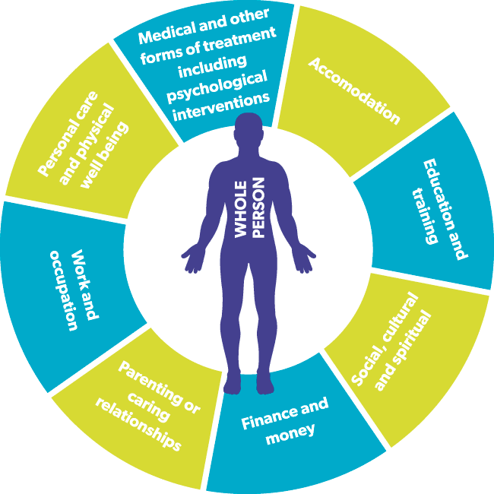
The Whole Person Approach: Investors in People, 2023

4.3 Giving Employees Control over their Tasks
Furthermore, Apple Company can give the workers more control over their activities in order to increase their well-being at workplace. As the research states, employees having less discretion of how they need to do their own work results to poor mental well-being as more work and reduced job control leads to workers being stressed out (Kelly et al., 2021). By offering a weekly training towards employees on how they should carry out their tasks and roles and resolve any customer complains leads to a better employee well-being and increased performance.

Conclusion
The employee well-being is an important factor that determines the success and productivity of a company through their engagement and performance. As one of the biggest technology company around the world, Apple Inc. has created a safe and effective workplace culture for employees to showcase their skills in the innovation sector. It has not only strived to increase the employee well-being but also employee engagement and participation. However, the issue of stress, burnout and discrimination have resulted to the company losing more employees and portraying a negative public image towards prospective workers and its customers. The health of workers has been occasionally reported to deteriorate leading to an increased employee turnover. Apple is mandated to understand the importance of a healthy employee wellbeing culture that not only benefits the workers but also the company itself and other stakeholders such as investors, shareholders and customers. By creating a better employee well-being culture through different initiatives such as a whole person approach, introducing stability among workers’ schedule and providing employees with control over their tasks, Apple Inc. will set a higher pace of performance and productivity.

References
Anguiano, D., 2021: #AppleToo: employees organize and allege harassment and discrimination. https://www.theguardian.com/technology/2021/sep/03/appletoo-apple-employees-organize-allege-harassment-discrimination (Accessed March 24th, 2023).
Chang, E.C., Chang, O.D., Li, M., Xi, Z., Liu, Y., Zhang, X., Wang, X., Li, Z., Zhang, M., Zhang, X. and Chen, X., 2019. Positive emotions, hope, and life satisfaction in Chinese adults: A test of the broaden-and-build model in accounting for subjective well-being in Chinese college students. The Journal of Positive Psychology, 14(6), pp.829-835.
Diamantidis, A.D. and Chatzoglou, P., 2019. Factors affecting employee performance: an empirical approach. International Journal of Productivity and Performance Management, 68(1), pp.171-193.
Doz, Y., 2020. Fostering strategic agility: How individual executives and human resource practices contribute. Human Resource Management Review, 30(1), p.100693.
Edú-Valsania, S., Laguía, A. and Moriano, J.A., 2022. Burnout: A review of theory and measurement. International journal of environmental research and public health, 19(3), p.1780.
Investors in People, 2023: The Whole Person Approach. https://www.mentalhealthwales.net/the-whole-person-approach/ (Accessed March 21th, 2023).
Joseph, D., 2020: Google, Apple or Samsung all have the same ‘formula of success’ in human resource management. https://themakingofamillionaire.com/google-apple-or-samsung-all-have-the-same-formula-of-success-in-human-resource-management-826939bfee8a (Accessed March 24th, 2023).
Keeman, A., Näswall, K., Malinen, S. and Kuntz, J., 2017. Employee wellbeing: Evaluating a wellbeing intervention in two settings. Frontiers in psychology, 8, p.505.
Kelly, E., Berkman, L., Kubzansky, L., & Lovejoy, M., 2021: 7 strategies to improve your employees’ health and well-being. https://hbr.org/2021/10/7-strategies-to-improve-your-employees-health-and-well-being (Accessed March 25th, 2023).
Lan, Y.L., Huang, W.T., Kao, C.L. and Wang, H.J., 2020. The relationship between organizational climate, job stress, workplace burnout, and retention of pharmacists. Journal of Occupational Health, 62(1), p.e12079.
Laricchia, F., 2023: Number of employees of Apple 2005-2022. https://www.statista.com/statistics/273439/number-of-employees-of-apple-since-2005/ (Accessed March 22th, 2023).
Meng, H., Luo, Y., Huang, L., Wen, J., Ma, J. and Xi, J., 2019. On the relationships of resilience with organizational commitment and burnout: a social exchange perspective. The International Journal of Human Resource Management, 30(15), pp.2231-2250.
Oddo, V.M., Zhuang, C.C., Andrea, S.B., Eisenberg-Guyot, J., Peckham, T., Jacoby, D. and Hajat, A., 2021. Changes in precarious employment in the United States: A longitudinal analysis. Scandinavian Journal of Work, Environment & Health, 47(3), p.171.
Ozkeser, B., 2019. Impact of training on employee motivation in human resources management. Procedia Computer Science, 158, pp.802-810.
Pattnaik, L. and Jena, L.K., 2020. Mindfulness, remote engagement and employee morale: Conceptual analysis to address the “new normal”. International Journal of Organizational Analysis, 29(4), pp.873-890.
Pezaro, S., 2018. Theories of work-related stress. Accessed on December, 18, p.2019.
Robinson, B., 2020: 3 New Blockbusters reports show job burnout escalating: What you need to know. https://www.forbes.com/sites/bryanrobinson/2020/03/05/3-new-blockbuster-reports-show-job-burnout-escalating-what-you-need-to-know/?sh=34b568001faa (Accessed March 24th, 2023).
Sánchez-Hernández, M.I., González-López, Ó.R., Buenadicha-Mateos, M. and Tato-Jiménez, J.L., 2019. Work-life balance in great companies and pending issues for engaging new generations at work. International journal of environmental research and public health, 16(24), p.5122.
Schooley, S., 2023: Employees reveal how stress affect their jobs. https://www.businessnewsdaily.com/2267-workplace-stress-health-epidemic-perventable-employee-assistance-programs.html (Accessed March 26th, 2023).
Schiffer, Z., 2021: USA: Apple frontline workers report mental health strain from pressure to meet targets and performance monitoring. https://www.business-humanrights.org/en/latest-news/usa-apple-frontline-workers-report-breakdown-between-corporate-values-and-working-conditions-amid-mental-health-strain-from-pressure-to-meet-targets-performance/ (Accessed March 22th, 2023).
Sjåfjell, B. and Taylor, M.B., 2019. Clash of norms: Shareholder primacy vs. sustainable corporate purpose. International and Comparative Corporate Law Journal, 13(3), pp.40-66.
The Prince’s Responsible Business Network, 2019: The Workwell Model. https://www.bitc.org.uk/the-wellbeing-workwell-model/ (Accessed March 24th, 2023).
Tien, N.H., Dat, N. and Chi, D.T.P., 2019. Product policy in international marketing comparative analysis between Samsung and Apple. Int. J. Res. Mark. Manag. Sales, 1, pp.129-133.
What Works Wellbeing, 2017: Why invest in employee wellbeing? https://whatworkswellbeing.org/resources/why-invest-in-employee-wellbeing/ (Accessed March 24th, 2023).

