Practice exercises for revision

1. Calculation

Write a C program to convert temperature from Celsius to Fahrenheit.

The formula is: Fahrenheit = Celsius * 1.8 + 32

Sample output:

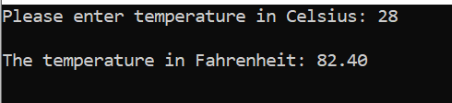

Solution:

#define _CRT_SECURE_NO_WARNINGS
#include <stdio.h>

void main()
{
float celsius, fahrenheit;
printf("Please enter temperature in Celsius: ");
scanf("%f", &celsius);

fahrenheit = celsius * 1.8 + 32;
printf("\nThe temperature in Fahrenheit: %.2f\n\n", fahrenheit);
}

2. If statements

2a. Write a program to enter two numbers into variables. Tell the user which is the largest number. (for the purposes of this program, assume that the numbers entered are different (not equal))

Sample output:

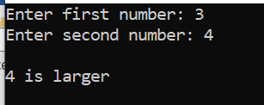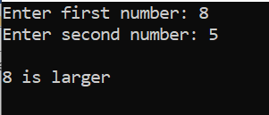

Solution:

#define _CRT_SECURE_NO_WARNINGS
#include <stdio.h>

void main()
{
int no1, no2;

printf("Enter first number: ");
scanf("%d", &no1);
printf("Enter second number: ");
scanf("%d", &no2);

if (no1 > no2)
{
printf("\n%d is larger\n\n", no1);
}
else
{
printf("\n%d is larger\n\n", no2);
}

}

2b. Write a program to enter three numbers into variables. Tell the user which the largest number is.
(again, for the purposes of this program, assume that the numbers entered are different (not equal))

Sample output:

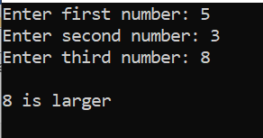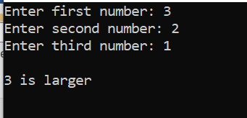

Solution:

#define _CRT_SECURE_NO_WARNINGS
#include <stdio.h>

void main()
{
int no1, no2, no3;

printf("Enter first number: ");
scanf("%d", &no1);
printf("Enter second number: ");
scanf("%d", &no2);
printf("Enter third number: ");
scanf("%d", &no3);

if (no1 > no2 && no1 > no3)
{
printf("\n%d is larger\n\n", no1);
}
else if (no2 > no1 && no2 > no3)
{
printf("\n%d is larger\n\n", no2);
}
else
{
printf("\n%d is larger\n\n", no3);
}
}

3. Using arrays/for loops

Write a program, with an array with the following values hard-coded into it (as shown below)

#define _CRT_SECURE_NO_WARNINGS
#include <stdio.h>

void main()
{
int myArray[6] = { 10, 20, 30, 40, 50, 60 };
}

Using for loop do the following:

3a. Print out the array values in order:
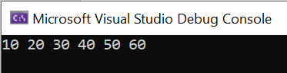

Solution:
#define _CRT_SECURE_NO_WARNINGS
#include <stdio.h>

void main()
{
int myArray[6] = { 10, 20, 30, 40, 50, 60 };

for (int i = 0; i < 6; i++)
{
printf("%d ", myArray[i]);
}

printf("\n\n");
}

3b. Print out the array in reverse order:
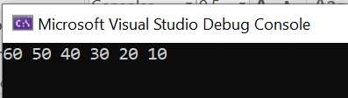

Solution:
#define _CRT_SECURE_NO_WARNINGS
#include <stdio.h>

void main()
{
int myArray[6] = { 10, 20, 30, 40, 50, 60 };

for (int i = 5; i >= 0; i--)
{
printf("%d ", myArray[i]);
}

printf("\n\n");
}

3c. Print out the array in order, but only every other item:
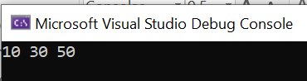

Solution:
#define _CRT_SECURE_NO_WARNINGS
#include <stdio.h>

void main()
{
int myArray[6] = { 10, 20, 30, 40, 50, 60 };

for (int i = 0; i <6; i=i+2)
{
printf("%d ", myArray[i]);
}

printf("\n\n");
}

3d. Print out the last 3 items in the array:
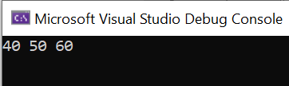

Solution:
#define _CRT_SECURE_NO_WARNINGS
#include <stdio.h>

void main()
{
int myArray[6] = { 10, 20, 30, 40, 50, 60 };

for (int i = 3; i < 6; i++)
{
printf("%d ", myArray[i]);
}

printf("\n\n");
}

3e. Print out the fourth element of the array only (40) – no loop required for this one!
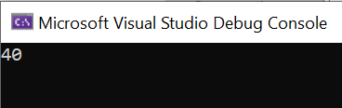

Solution:
#define _CRT_SECURE_NO_WARNINGS
#include <stdio.h>

void main()
{
int myArray[6] = { 10, 20, 30, 40, 50, 60 };

printf("%d ", myArray[3]);

printf("\n\n");
}

4. Using functions – passing arguments

4a) Write code in main() to enter a first initial (one letter only) and an age:

Sample output:
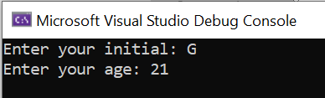

Solution:

#define _CRT_SECURE_NO_WARNINGS
#include <stdio.h>

void main()
{
char initial;
int age;

printf("Enter your initial: ");
scanf(" %c", &initial);
printf("Enter your age: ");
scanf("%d", &age);
}

4b) Pass the initial and the age entered as arguments to a function called printdetails()
Print the initial and age within the function.

Sample output:
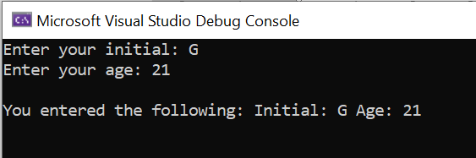

Solution:

source.cpp
#define _CRT_SECURE_NO_WARNINGS
#include <stdio.h>
#include "MyFunctions.h"

void main()
{
char initial;
int age;

printf("Enter your initial: ");
scanf(" %c", &initial);
printf("Enter your age: ");
scanf("%d", &age);

printdetails(initial, age);
}

MyFunctions.h
#pragma once

void printdetails(char theinit, int theage)
{
printf("\nYou entered the following: Initial: %c Age: %d\n\n", theinit, theage);
}

4c) Enter a second name and age from main, and pass them to your existing function printdetails()

Sample output:

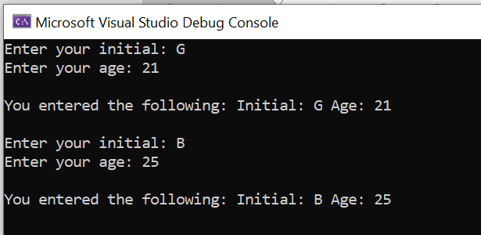

Solution:

source.cpp

#define _CRT_SECURE_NO_WARNINGS
#include <stdio.h>
#include "MyFunctions.h"

void main()
{
char initial;
int age;

printf("Enter your initial: ");
scanf(" %c", &initial);
printf("Enter your age: ");
scanf("%d", &age);

printdetails(initial, age);

printf("Enter your initial: ");
scanf(" %c", &initial);
printf("Enter your age: ");
scanf("%d", &age);

printdetails(initial, age);
}

MyFunctions.h (no change)
#pragma once

void printdetails(char theinit, int theage)
{
printf("\nYou entered the following: Initial: %c Age: %d\n\n", theinit, theage);
}

5. Functions with returns

5a Write a function called generaterandom() to generate a random number between 1 and 10.

Solution:

MyFunctions.h
#pragma once

int generaterandom()
{
int randomNo;
int low = 1, high = 10;
randomNo = rand() % (high - low + 1) + low;
return randomNo;
}

5b Call your function, and return the random number generated by the function back to your main program. Print it on the screen.

Sample output:
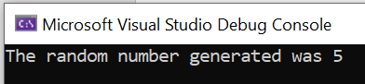

Solution:
source.cpp
#define _CRT_SECURE_NO_WARNINGS
#include <stdio.h>
#include <stdlib.h>
#include <time.h>
#include "MyFunctions.h"

void main()
{
int theRandom1;
srand(time(NULL));

theRandom1 = generaterandom();

printf("The random number generated was %d \n", theRandom1);
}

MyFunctions.h
#pragma once

int generaterandom()
{
int randomNo;
int low = 1, high = 10;
randomNo = rand() % (high - low + 1) + low;
return randomNo;
}
5c Call your function twice more (three times in total) and print out the random numbers returned to main.

Sample output:

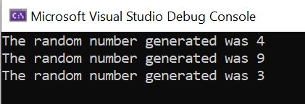

Solution:

source.cpp
#define _CRT_SECURE_NO_WARNINGS
#include <stdio.h>
#include <stdlib.h>
#include <time.h>
#include "MyFunctions.h"

void main()
{
int theRandom1, theRandom2, theRandom3;
srand(time(NULL));

theRandom1 = generaterandom();
theRandom2 = generaterandom();
theRandom3 = generaterandom();

printf("The random number generated was %d \n", theRandom1);
printf("The random number generated was %d \n", theRandom2);
printf("The random number generated was %d \n\n", theRandom3);

}

MyFunctions.h (no change)
#pragma once

int generaterandom()
{
int randomNo;
int low = 1, high = 10;
randomNo = rand() % (high - low + 1) + low;
return randomNo;
}

6. While loop

I have just made a nice hot cup of tea. However, I don't want to burn my mouth on the liquid (optimum temperature is between 57°C and 65°C.) Write a program that tells me when my tea is OK to drink.

Sample output:

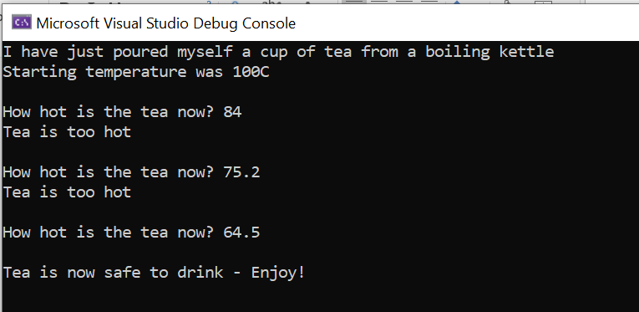

Solution:

#define _CRT_SECURE_NO_WARNINGS
#include <stdio.h>

void main()
{
float theTemp;
printf("I have just poured myself a cup of tea from a boiling kettle\n");
printf("Starting temperature was 100C\n\n");

printf("How hot is the tea now? ");
scanf("%f", &theTemp);

while (theTemp > 65)
{
printf("Tea is too hot\n\n");
printf("How hot is the tea now? ");
scanf("%f", &theTemp);
}

printf("\nTea is now safe to drink - Enjoy!\n\n");
}

