
Computer Architecture and Operating Systems
Module Code: ACCA4022

- Report Title: Operating Systems Assignment
- Student Name: Lucian Ilie
- Student ID: 2126669
- Lecturer Name: James Williams

I confirm that I have not used any AI tools in the research and creation of this
assignment. I confirm that I have not presented any AI generated materials as my own work. I confirm I have copies of my drafts, notes, and other resources I used, which I may be asked to provide in evidence.

Table of Contents
Introduction 4
Key Functions of General Operating Systems 4
Use of Windows OS CLI Commands 9
Use of Linux OS CLI Commands 16
Use of Windows OS Scripts 24
Use of Linux OS Scripts 25
Conclusion 27
Reference 29
Appendices 31
Appendix 1- OS tutorial activity 31
Appendix 2. Lecture Activities 32
Appendix 3- certified course 35

List of Figures
Figure 1: Tasklist 11
Figure 2: dir command 11
Figure 3: Change Directory 12
Figure 4: Ping 12
Figure 5: Trace 13
Figure 6: Net User 13
Figure 7: Task Scheduling 13
Figure 8: Disk Management 14
Figure 9: System info 15
Figure 10: Environment Variables 16
Figure 11: File Permissions & Security 16
Figure 12: System Monitoring 17
Figure 13: Process Management 18
Figure 14: Process Management Output 19
Figure 15: ls command 19
Figure 16: Change Directory 20
Figure 17: New Directory 20
Figure 18: Ping 20
Figure 19: Ifconfig 21
Figure 20: User Management 21
Figure 21: Sorting Command 22
Figure 22: Sorting Output 22
Figure 23: Disk Usage Monitoring 22
Figure 24: File Content Viewing 23
Figure 25: System Info 23
Figure 26: File Permission 23
Figure 27: Help and Documentation 24
Figure 28: Windows Script 26
Figure 29: Linux Script 27
Figure 30: Runn Script 27

Introduction
An Operating System (OS) is necessary software that controls the hardware resources and offers a platform on which one can execute applications [1]. It acts as a mediator between the users and the computer hardware and is used in the management of processes, allocation of memory and file systems. Windows, Linux, and macOS with their own features and user interfaces are the most common types of OS. This report will discuss what some of the most important functions of general-purpose operating systems are, delve into what some of the most commonly used CLI commands in Windows and Linux are, and demonstrate how scripting languages such as Batch and Bash get used to accomplish automation and system management tasks.

Key Functions of General Operating Systems
Operating Systems (OS) are important in enabling efficient operations of a computer. The OS controls the interface between the hardware and the software, creating an environment within which the applications can be run in a seamless environment. The main functions of an OS are as follows:
- Process Management: Processes are handled by the OS, and they include the execution and scheduling of processes. It makes sure that processes are given time on the CPU and can multitask by alternating between processes. Monitoring active processes and their resource usage (CPU, memory usage, etc.) are monitored with such tools as Windows Task Manager and the Linux top command. Task Manager in Windows offers real-time performance of the system, the processes underway, and the consumption of resources. The Processes tab can be used to view and manage running applications, whereas the Performance tab can be used to monitor CPU, memory, disk and network usage. Example: Windows Task Manager where CPU and memory use of the running processes are shown. (Ctrl+Shift+Esc).
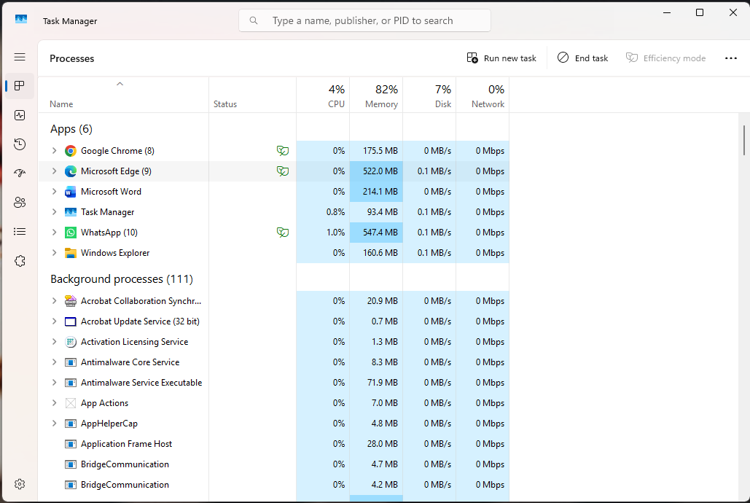

- Memory Management: This feature makes sure that every running process gets adequate memory. The OS has to track the memory allocation, ensure that the processes do not interfere with each other and deal with the virtual memory when the physical RAM runs out [2]. It operates memory hierarchies, such as RAM and caches, to facilitate an efficient utilization of system resources. To open memory management, the following bash needs to be done ctrl+shift+esc and select performance, than memory.
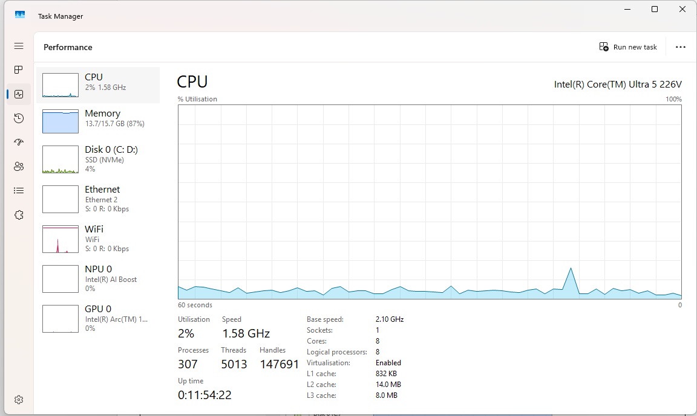
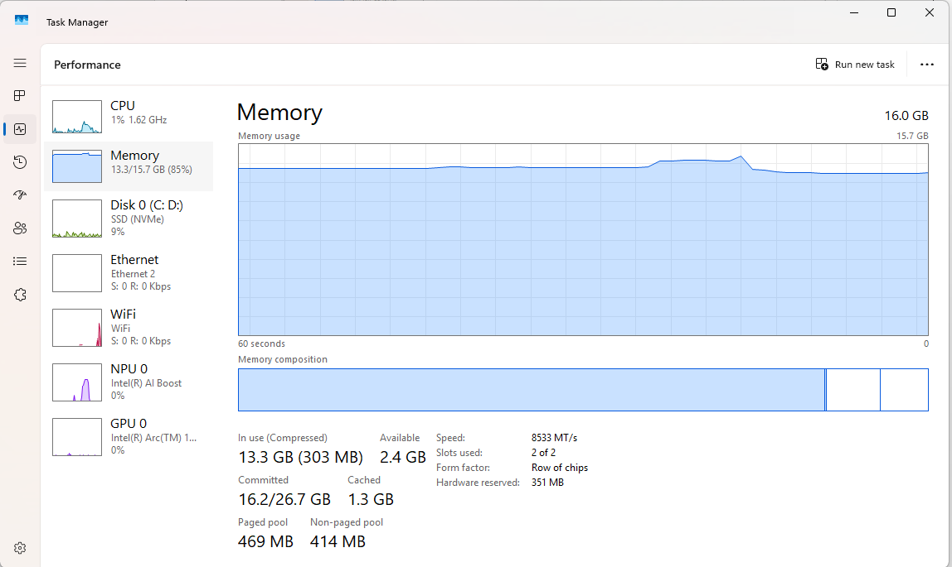
- File System Management: The OS is in charge of files and directories, where users and applications store, retrieve, and organize data. It supports the format of file systems such as NTFS (Windows), HFS+ (macOS), and EXT4 (Linux). It also offers file security and access control tools, to which only authorized users can be allowed to read, write, or execute files.
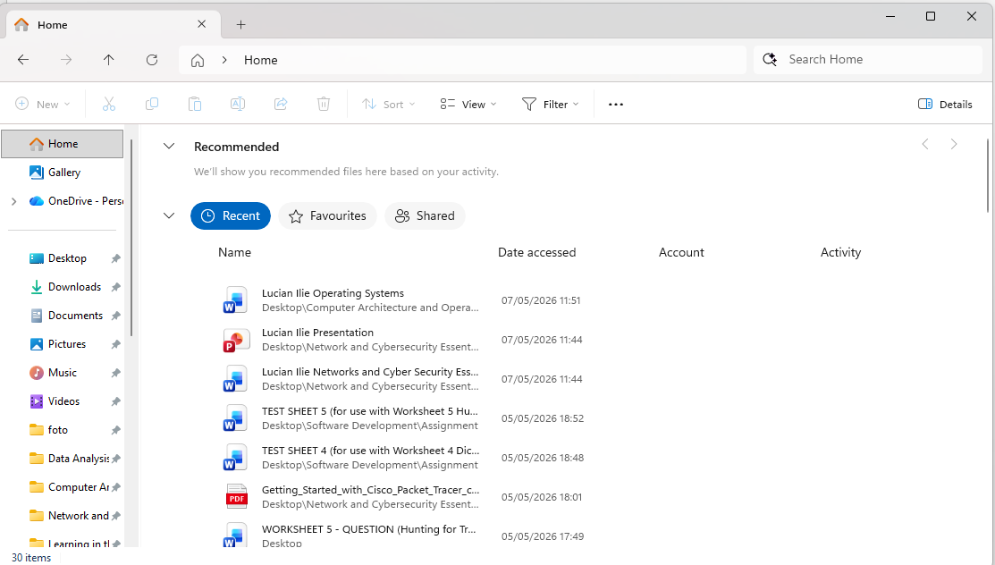

- Hardware Management: The OS manages and coordinates access to hardware such as hard drives, printers, and displays. It also supplies device drivers which enable software applications to communicate with hardware, hiding the complexity of hardware operations. The OS is also used to guarantee the effective use of system resources which include the CPU, RAM, and input/output devices. To access hardware management on Windows, one needs to open the Windows run box and type devmgmt.msc.

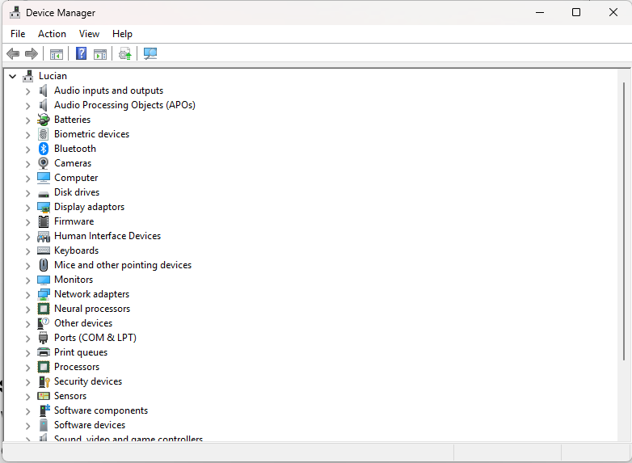
Key OS Types
- Windows: Windows is one of the most popular operating systems and is characterized by its intuitive interface and huge compatibility with a wide range of software. It is frequently employed both at home and in business. Windows is the diverse system with an abundance of the hardware and software applications, which has made it choice of many users.
- macOS: macOS, which is a product of Apple, is typified by the smooth design, reliability and security. It is developed to run on Apple hardware, and is generally used in creative industries, such as graphic design, video editing, and the music production. macOS is developed on UNIX, which offers a powerful and the safe framework.
- Linux: Linux is an open-source operating system with its features being defined by its flexibility, security and the customization capabilities. It is typically used in server environments but is also a popular tool among the developers and the enthusiasts. Ubuntu, Fedora and Debian are the popular Linux distributions (distros) with special features and user interfaces.
All these operating systems have their advantages, and in that regard, can be imposed on various users. Each of the OS plays a central role in the digital ecosystem: everyday computing (Windows), creativity (macOS), and server management and development (Linux).

Use of Windows OS CLI Commands
Windows Command Line is an easy and natural route to communicate with the operating system. Text-based commands also enable users and system administrators to command, automate and troubleshoot operations through text-based commands [4]. The CLI is also helpful when it comes to automating repetitive tasks, accessing advanced settings within a system, and in performing network diagnostics. It is an important tool of both users and IT professionals who want to have a more granular level of control of the system.
Batch/PowerShell Commands
Process Management:
Tasklist command shows the list of all the currently running processes on the system with the information about their memory usage and the process IDs. This command is helpful in controlling and ending the unwanted processes.
Tasklist
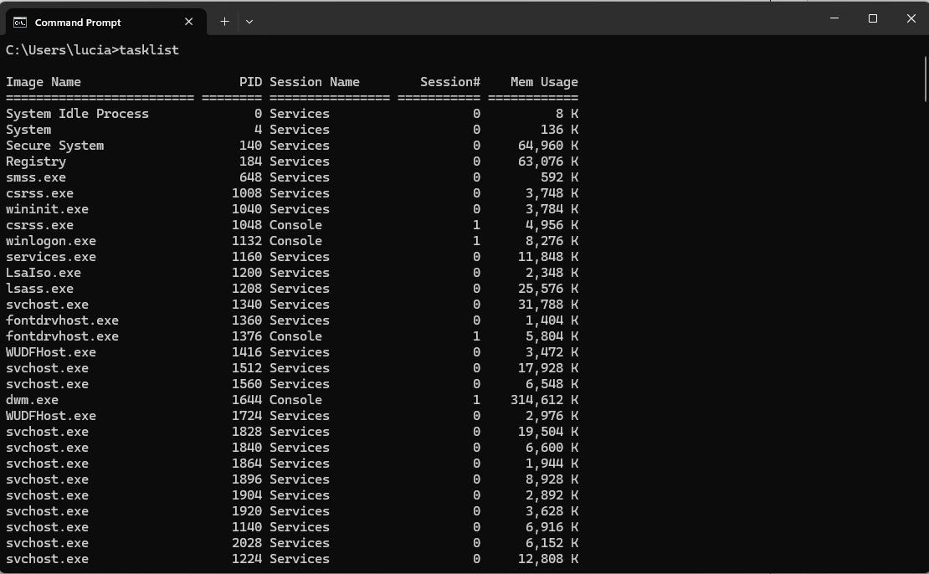
Figure 1: Tasklist
File & Directory Management:
The dir command displays the items in a given directory, whereas the cd command is used to switch the current directory [5]. These are commands that are used to navigate and control files and folders in the system.
dir C:\Users
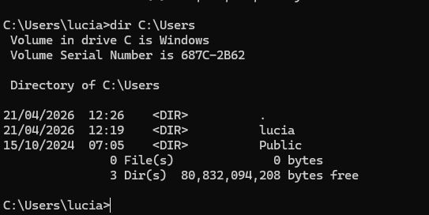
Figure 2: dir command

cd C:\Windows
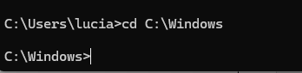
Figure 3: Change Directory

Network Testing/Monitoring:
The ping command is used to check the connectivity between a computer and a remote server by sending packets and time taken to respond. tracert is used to trace the route packets follow to a destination.
ping google.com
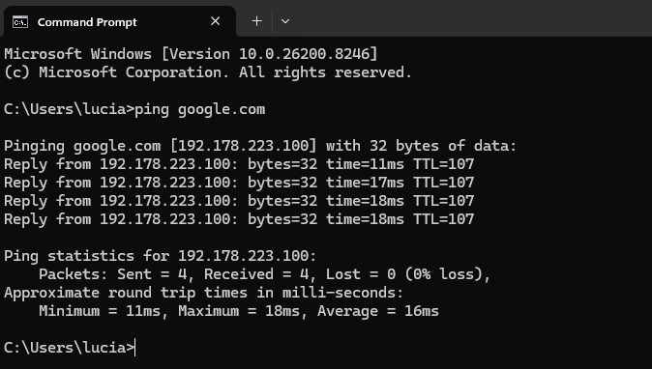
Figure 4: Ping

tracert google.com
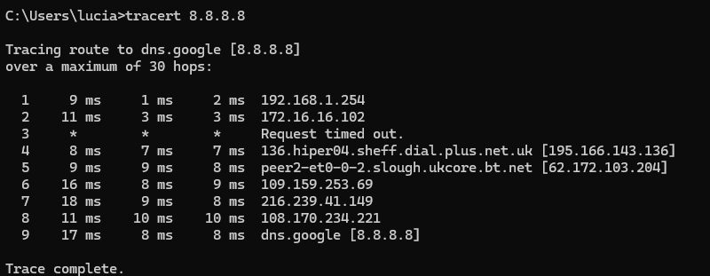
Figure 5: Trace

User Management:
Net user command is meant to view and manage user accounts on the system. Indicatively, you can add, update or remove users.
net user
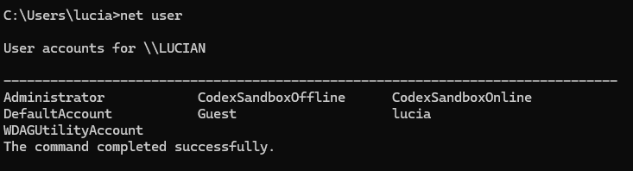
Figure 6: Net User

Task Scheduling:
To construct and handle schedule of the tasks command schtasks is used by the user [6]. And it can also be used to mechanize the routine practice line system maintenance and backups.
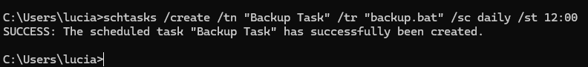
Figure 7: Task Scheduling

Disk Management:

chkdsk is a command that verifies the integrity of a disk and corrects errors in the file system. It reads the drive to determine bad sectors and logical problems. The /f option is exploited to automatically correct the identified errors.
chkdsk D: /f
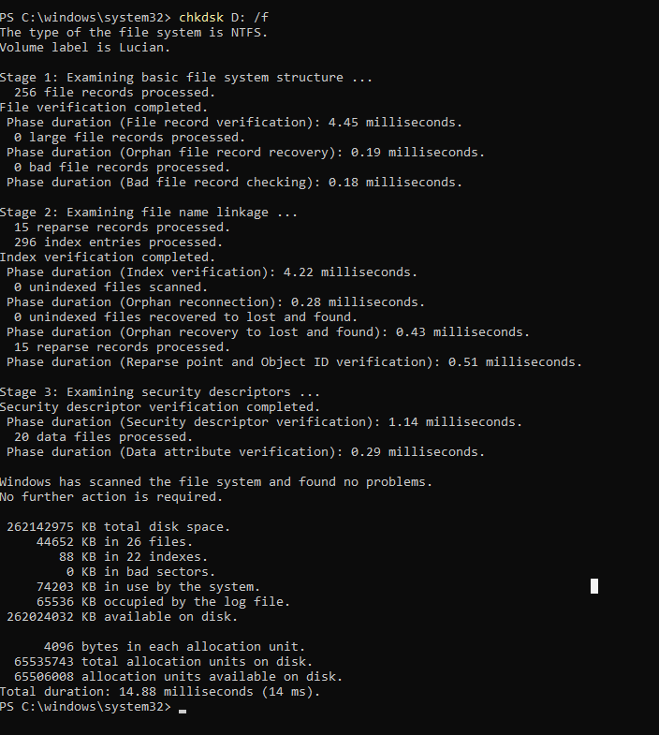
Figure 8: Disk Management

System Information:
The systeminfo command is a command that details the system configuration i.e. the OS version, the installed memory, processor details and the system uptime. It can be used in diagnostics and reporting.
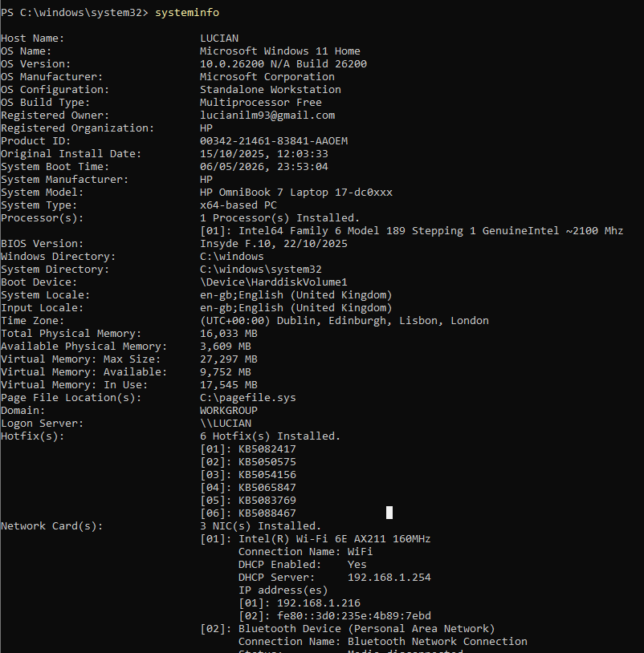
Figure 9: System info
Environment Variables:
Environment variables of the system are shown, created or edited using the set command. These variables are used by the operating system to store configuration settings.
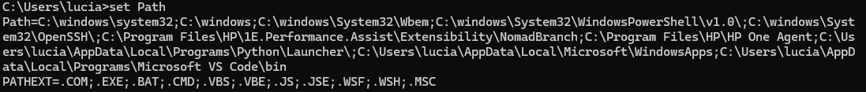
Figure 10: Environment Variables
File Permissions & Security:
Attrib command is the command that is used to display or alter the attributes of files like read-only, hidden or system files. It aids in controlling file exposure and security in the operating system.
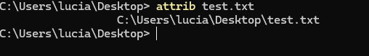
Figure 11: File Permissions & Security
System Monitoring:
The driverquery command is executed in order to provide the list of all the installed device drivers as well as their status and properties. It can be used in the diagnostics of a system and troubleshooting hardware-related problems.
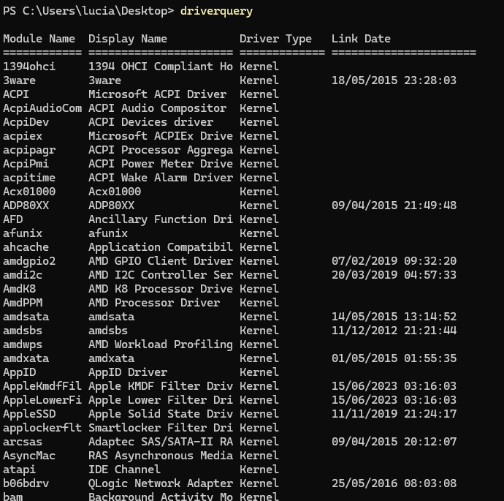
Figure 12: System Monitoring
To demonstrate the extensibility of Windows CL, these commands play a crucial role, permit user to effectively manage the procedure, networks, users, files, scheduled jobs. Automation of tasks and ability to carry out complex commands makes the CLI a necessary tool to both ordinary users and system administrators.

Use of Linux OS CLI Commands
The Linux Command Line Interface (CLI) is an administrators tool of immense power, whereby there is more control and flexibility than graphical user interfaces [7]. It allows users to directly execute commands, and is therefore important in automating tasks, file management and troubleshooting system errors. Some of the reasons why Linux CLI is always desirable by system administrators and developers are speed, efficiency and the ability to execute complex functions with minimal resources.
Bash Commands
Process Management:
ps command provides the list of processes that are currently running on the system, and top provides a dynamic view of what processes are currently running on the system, resource utilization and memory consumption.
ps aux top
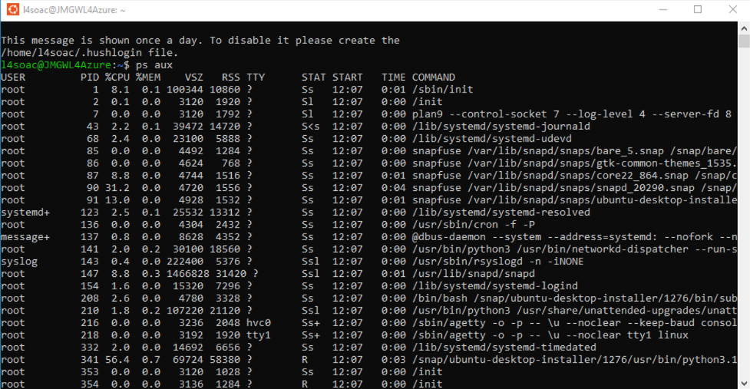
Figure 13: Process Management
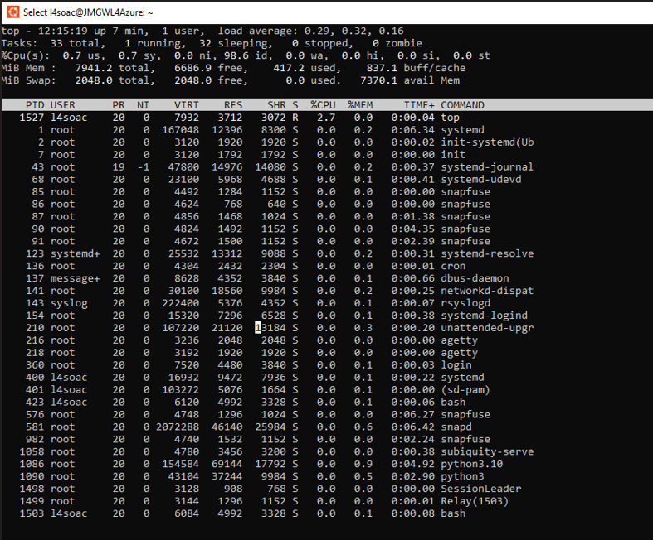
Figure 14: Process Management Output

File & Directory Management:
The ls command is used to show the contents of a directory; the cd command is used to change the directory and the mkdir command is used to create a new directory [8]. They are simple to navigate around and to organise files.
ls ~
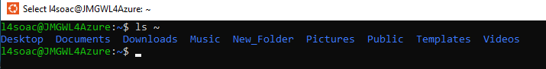
Figure 15: ls command
cd ~/Desktop

Figure 16: Change Directory
mkdir new_directory
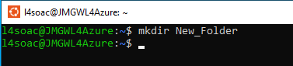
Figure 17: New Directory

Network Testing/Monitoring:
Ping command is used to test the connection of another network device whereas ifconfig is used to get detailed information about the network interfaces and configurations.
Example:
ping google.com
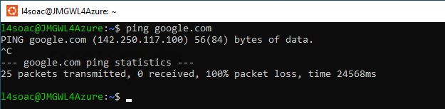
Figure 18: Ping
Ifconfig
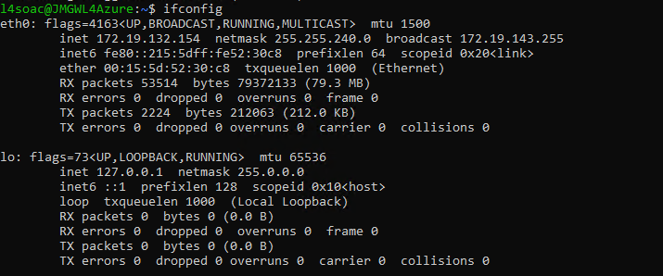
Figure 19: Ifconfig
User Management:
Useradd command is the one that is used to create a new user account whereas usermod is the one that is used to modify user information [9]. These are the orders that are required in managing users in a Linux environment.
Example:
useradd new_user
usermod -aG sudo new_user
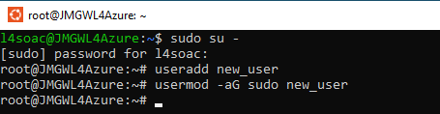
Figure 20: User Management

Sorting Text from a file:
Example:
Sort file_name.txt
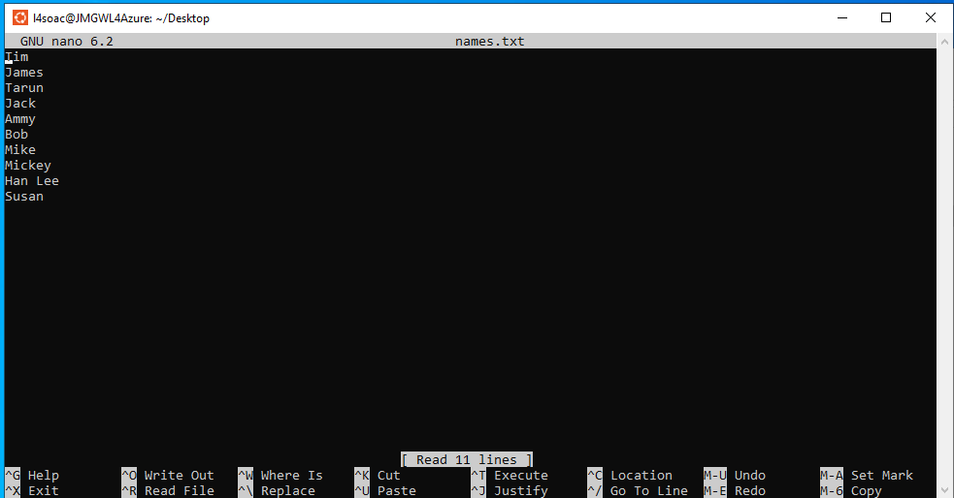
Figure 21: Sorting Command
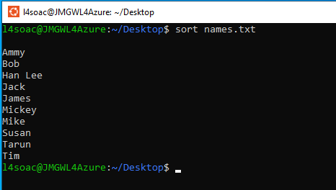
Figure 22: Sorting Output

Disk Usage Monitoring:
df utility is used to provide the distribution of disk space between all active filesystems. The -h flag will convert raw blocks into a format that is easy to read (MB or GB), and as a result, it will be easier to analyse the data on the storage intuitively.
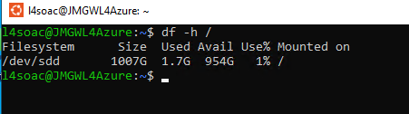
Figure 23: Disk Usage Monitoring

File Content Viewing:
The cat command can be used to display the internal data of a file in the terminal interface directly. It is a highly effective tool in quick scanning of short text files without having to open a specific editor.
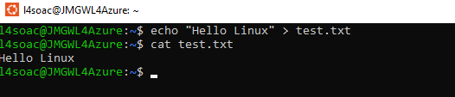
Figure 24: File Content Viewing

System Information:
The uname command is a diagnostic utility that can be used to determine the core system characteristics. By running it with the -a option, one can get a general overview of the kernel version and hardware setup.
Figure 25: System Info

File Permissions:
Security of the system is ensured through the use of chmod that alters the level of authorization of reading, writing or executing files. As an illustration, the owner of a setting with a 755 setting will have all the permissions but will deny others the right to access the setting.
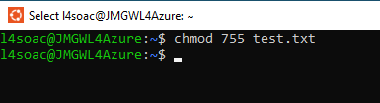
Figure 26: File Permission

Help & Documentation:
To obtain instruction on syntax and functionalities of the command syntax, the man command will allow access to reference manuals of the system.
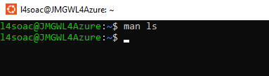
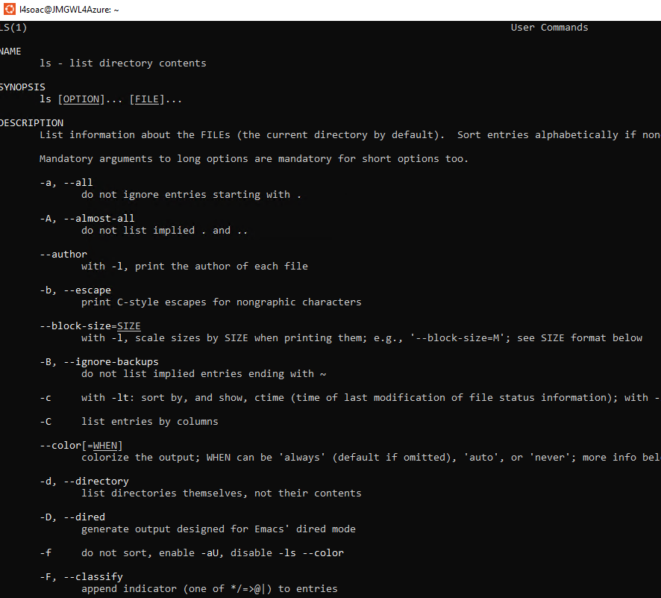
Figure 27: Help and Documentation
These commands show the flexibility of the Linux CLI making it an essential tool in controlling processes, files, networks, users as well as automated processes. Bash scripting is powerful, enabling users to carry out complex operations effectively, and make it a preferred choice when administering Linux systems.

Use of Windows OS Scripts

Windows scripting can be done through applications like Batch and PowerShell, which enables the users to automate repetitive workflows, as well as more effectively manage system configurations [10]. Simple tasks, such as file handling, are also automatable using batch scripting, whereas more complex tasks can be automated in PowerShell, which also provides access to underlying system management tools of Windows. The two scripting languages are a requirement among system administrators who need to streamline processes like file handling, task scheduling and user management.
Batch Script
Automation of file management functions such as copying files between one directory and another can be easily automated using a simple Batch script. Below is an example of a script, which creates a backup of a directory by copying all the files of a single directory to another one:
@echo off
:: This script backs up files from the source to the destination folder
xcopy C:\Source\* C:\Backup\* /E /H /C /I
echo Backup Complete!
pause
Explanation:
- @echo off: Suppresses the output of the command used, leaving the window
- xcopy: This command copies files in the source to the destination directory. The /E option to include subdirectories and /H to include hidden files.
- pause: Suspends the script to give a user time to view the result prior to closing the window.
PowerShell Script
A PowerShell script can be used to manage user accounts. As an example, the following script can add a new user to the system and add him/her to the Administrators group:
New-LocalUser "JohnDoe" -Password (ConvertTo-SecureString "Password123" -AsPlainText -Force)
Add-LocalGroupMember "Administrators" -Member "JohnDoe"
echo User 'JohnDoe' added and added to Administrators group.
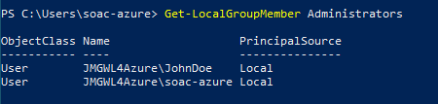
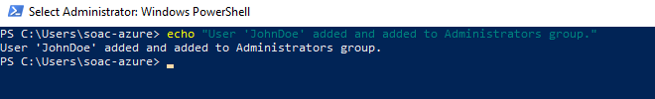
Figure 28: Windows Script
Explanation:
- New-LocalUser: Creates a new local user with a specified username and password.
- Add-LocalGroupMember: Adds the user to the Administrators group, giving them elevated privileges.
- ConvertTo-SecureString: Encrypts the password to keep it secure.
Both scripting languages are potent tools in automating tasks in Windows, and they give system administrators a chance to easily handle complex workflows.

Use of Linux OS Scripts
Bash Linux scripting is a highly effective means of automating tasks, managing system configurations, and enhancing the effectiveness of system administration. Simple or complex tasks, including but not limited to files backups, system updates, and process management can be automated using bash scripts [11]. Administrators widely use them to manage repetitive work, make habitual maintenance, and make sure that systems run without any human intervention.
Bash Script
The following is a sample Bash script that will automate a file backup process by copying files in a source directory to a backup directory. The script also looks to see whether the backup directory exists or not, and where needed, the script creates the backup directory:
#!/bin/bash
SOURCE="$HOME/documents"
BACKUP="$HOME/backup"
if [ ! -d "$BACKUP" ]; then
mkdir -p "$BACKUP"
echo "Backup directory created"
fi
cp -r "$SOURCE"/* "$BACKUP"
ls "$BACKUP"
echo "Backup completed successfully!"
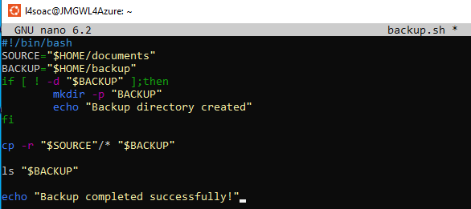
Figure 29: Linux Script
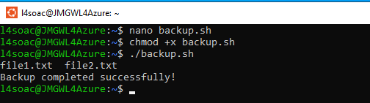
Figure 30: Runn Script

Explanation:
- #!/bin/bash: This line tells the system that the script should be run using the Bash shell.
- SOURCE="$HOME/documents"- This line sets the source folder. The source folder is where the original files are stored. In this script, the files are taken from the documents folder in the user’s home directory.
- BACKUP="$HOME/backup. - This line sets the backup folder. This is the folder where the copied files will be saved.
- if [ ! -d "$BACKUP" ]; then - This line checks if the backup folder already exists. If the folder does not exist, the script will create it.
- mkdir -p "$BACKUP" - This command creates the backup folder. The -p option helps avoid errors if the folder already exists.
- echo "Backup directory created" - This message appears when the backup folder has been created. It lets the user know that the script has completed this step.
- fi - This line ends the condition that checks for the backup folder.
- cp -r "$SOURCE"/ "$BACKUP"* - This command copies all files from the documents folder into the backup folder. The -r option allows the script to copy folders as well as files.
- ls "$BACKUP" - This command shows the files inside the backup folder. It is useful because it lets the user confirm that the files were copied.
- echo "Backup completed successfully!" - This final message tells the user that the backup process has finished successfully.

Benefits of Bash Scripting
One of the requirements in automating daily or routine tasks on Linux systems is a bash script. They can be run with cron to run regularly and make them invaluable to system administrators who need to automate system testing and streamline their systems [12].

Conclusion
The report has indicated the most important functions of operating systems, including: process management, memory management, file system management, and hardware coordination. It also discussed how to use Command Line Interface (CLI) commands in both windows and Linux and how these commands can be used to automate and manage system tasks. Also, the scripting languages such as Batch and Bash were demonstrated to be essential in automating the processes within the system. Operating systems play a vital role in the effective management of hardware, software and system resources ensuring smooth operations and enabling automation, security and system maintenance in both personal and professional set ups.

Reference
[1] A. S. Thyagaturu, P. Shantharama, A. Nasrallah, and M. Reisslein, “Operating Systems and Hypervisors for Network Functions: A Survey of Enabling Technologies and Research Studies,” IEEE Access, vol. 10, pp. 79825–79873, 2022, doi: https://doi.org/10.1109/access.2022.3194913.
[2] K. Kanellopoulos et al., “Virtuoso: Enabling Fast and Accurate Virtual Memory Research via an Imitation-based Operating System Simulation Methodology,” pp. 1400–1421, Mar. 2025, doi: https://doi.org/10.1145/3676641.3716027.
[3] M. Sharma, “Optimizing Embedded Systems: Harnessing the Power of Linux in Resource-Constrained Environments,” Mar. 2024, doi: https://doi.org/10.1109/ic-cgu58078.2024.10530823.
[4] K. A. Cochran, “Operating Systems: The Brains Behind the Screen,” Apress eBooks, pp. 253–278, Jan. 2024, doi: https://doi.org/10.1007/979-8-8688-0867-8_9.
[5] B. Choi, “Linux Fundamentals I – Linux File and Directory Mastery,” Apress eBooks, pp. 351–473, Jan. 2024, doi: https://doi.org/10.1007/979-8-8688-0146-4_7.
[6] M. A. Abed et al., “Smart Scheduling Application,” Artificial Intelligence Learning Facilitators, pp. 261–271, Sep. 2025, doi: https://doi.org/10.1201/9781003621416-24.
[7] W. E. Shotts, The Linux command line. San Francisco: No Starch Press, 2019.
[8] V. Rai, Expert Linux Administration Guide. BPB Publications, 2022.
[9] I. Sokolov, S. Porshnev, V. Baklanov, K. Sherbakova, and D. Kuts, “Features of Creating Accounts in Linux OS,” 2024 IEEE Ural-Siberian Conference on Biomedical Engineering, Radioelectronics and Information Technology (USBEREIT), pp. 257–260, May 2024, doi: https://doi.org/10.1109/usbereit61901.2024.10584024.
[10] C. Dent, Mastering PowerShell Scripting. Packt Publishing Ltd, 2024.
[11] S. O. Olabanji, “Advancing Cloud Technology Security: Leveraging High-Level Coding Languages like Python and SQL for Strengthening Security Systems and Automating Top Control Processes - Grantha Library,” Journals4promo.com, Sep. 2023, doi: http://repository.journals4promo.com/id/eprint/1572/1/Olabanji2992023JSRR105817.pdf.
[12] A. Wibowo, A. Fathimah, D. Waskito, and R. A. Aprilianto, “Cron Job Implementation for Automated Data Processing and Transfer in Cloud Infrastructure,” Sainteknol : Jurnal Sains dan Teknologi, vol. 23, no. 1, pp. 11–20, Jun. 2025, doi: https://doi.org/10.15294/sainteknol.v23i1.22649.

Appendices

Appendix 1- OS tutorial activity
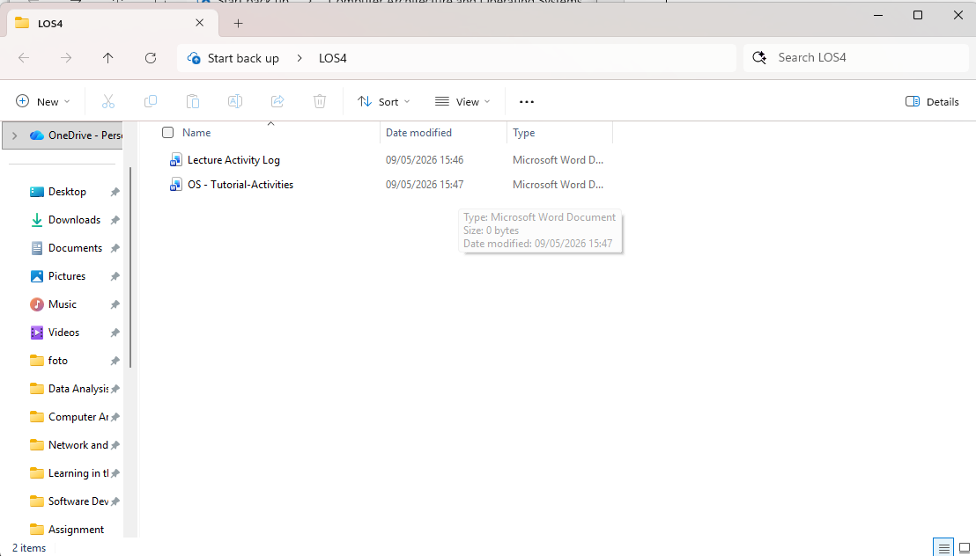

Appendix 2. Lecture Activities
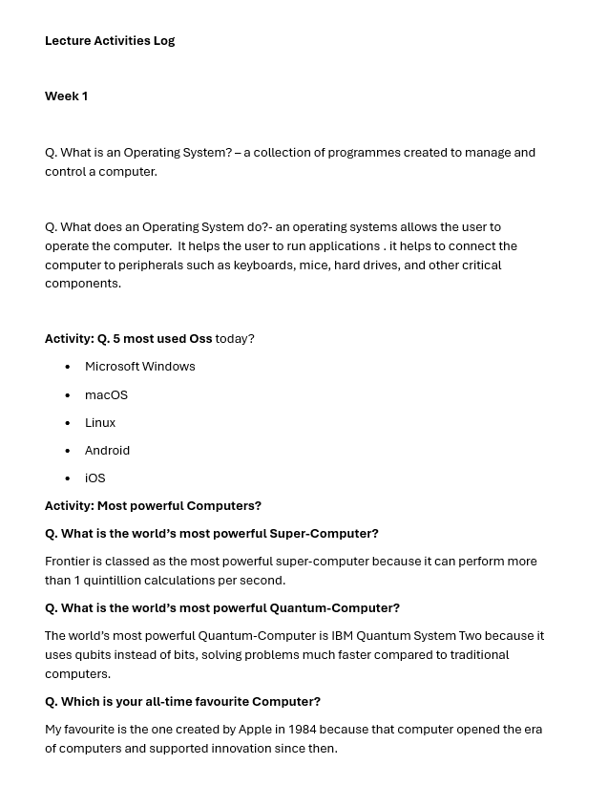
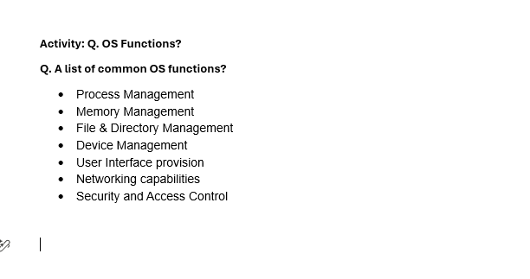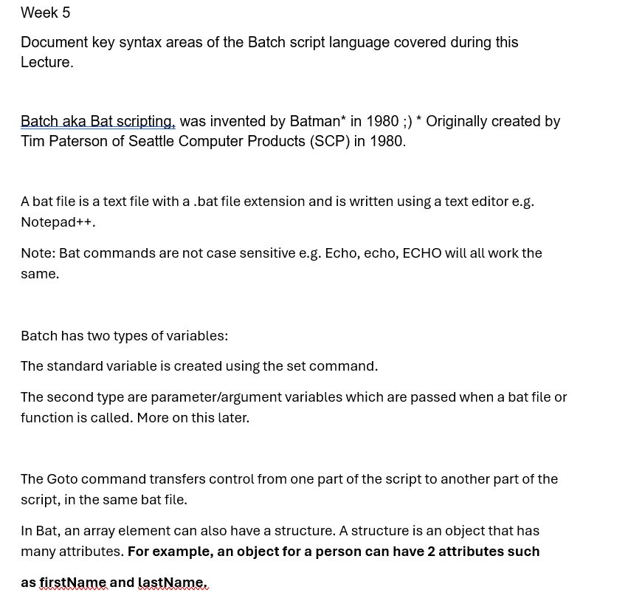

Appendix 3- certified course



