PROFESSIONAL CAREER DEVELOPMENT
BMSW4005, LCHS4005_LON

Student: Raluca Roman 2113735
Lecturer: Laila Surani


Abstract
The purpose of this report is for me to analyse the role play from the first assignment, a critical introspection on my transferable skills and skills that I need to develop for me to obtain the job of my dreams. After working over 6 years in health and social care industry the job I wish to proceed is as a case worker.
Case worker duties and responsibilities:
- Supporting service users to apply for benefits or other financial assistance
- Empowering service users to continue with training and education
- Attending home visits for families, elderly individuals or others in need
- Observing client's behaviour and identifying area where human support can be provided
- Establishing treatment and care plans along with other health care professionals
- Being the first line of response for service users in emergency situations.
Case workers have often experience seeing people in crises, distress and despair, so they need to keep themselves calm, reassuring and compassionate especially when dealing with clients who are very emotional and upset. At the same time, as a case worker you have must be understanding, active listener, emphatic but still professional.

Gibbs reflective cycle to assess the skills I have and what I need to improve

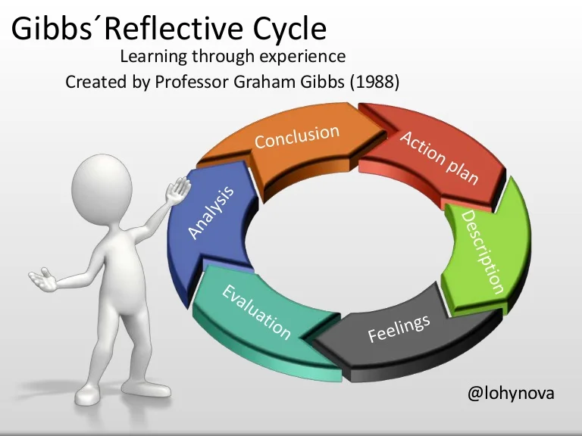
Picture 1
Gibbs cycle is one of the most famous cyclical models of reflection, the working through the 6 stages of it would allow us to explore our experiences and evaluate what we do very well, what we need to improve and how we can improve.
When Gibbs conducted the study called ‘Learn by Doing’ he was encouraging people to think systematically about the experiences they had during certain situations, event or activity and assess what went well and what needs to be improved.

According to Gibbs if we do not reflect on our own experience, knowledge and learning we cannot see what is not working as it should and try to re-evaluate and improve. Going through reflection after each learning experience could raise your performance and improve it for the future. Without reflection on our experience could lead to us making the same mistakes repeatedly and feel that we got stuck in a place with no perspectives over the future.
The six stages of Gibbs reflection cycle are:
- Description
- Feelings
- Evaluation
- Analysis
- Conclusion
- Action plan
I will use Gibbs reflective cycle to assesses the skills I have now after 6year of experience in my workplace and, I will try to establish what other skills I have to develop in order to be successful as a case worker, the job I have been interviewed for.
I will assess the following skills that I believe I already have to a certain point, most of them coming from my previous work experience.
Advocating, as a health care worker I always try to speak up for my service users who cannot express themselves appropriate due to medical conditions. This hasn’t been very easy, as management try to avoid analysing the situation and admit that we cannot provide the care they need. Also, I try to be near my colleagues when they try to report things that are not right, and everything blows back in their face to a point they are accused of lying.
Active listener, a part of care is also listening to what people have to say, make them comfortable to open to you, give them time, do not put pressure on them with a lot of questions, when they are ready, they will tell you. When communication can be difficult due to medical problems look for their body language and what makes them happy or sad.
Working as a part of the team, care work cannot be done individually, there is a high number of health care professional involved in a patients care, and they all must work together in order to provide appropriate person-centred care.

Multitasking: the ability to engage into different work activities at the same time, while shifting attention from a task to another. Is very important as a healthy care professional as you could easily get distracted while interacting with patients or service users asking for you attention. It usually happens to me while administering medication to residents suffering with Dementia, they all ask me questions about family, medication, why they are here, and I could easily commit a medication error.
Critical thinking, problem solving and working under pressure. Care sector is always under pressure, health care professionals must assess the situation quickly and give the right advice or make the right decisions for their patients. Working under pressure is also very common in health sector due to shortage of staff, lack of infrastructure, lack of support from management and local authorities.
Patience and the ability to be an active listener, this could be very helpful in case of abuse as service users find it hard to open and trust someone. On the other hand, we should never promise not to tell anyone when it comes to abuse.
Have a non-judgemental approach when it comes to assessing people from different backgrounds, suffering with health illnesses or disabilities, don’t believe you know what is best for them before consulting their opinion. Avoid imposing your own solutions and try to work around what is more suitable for the service user.
My dream job and the one I went for the mob interview, was as a case worker for individuals at risk in the community. I will be supporting vulnerable people and children, protect them from abuse, neglect, domestic violence. Also, people suffering with mental health illnesses or community members with financial hardship.
Earlier in this report I have described the skills that I believe I already have due to my work experience and now I would like to describe the skills that I need to develop for me to be a good candidate to a case worker position.
First and foremost, I should complete my bachelor's degree in health and social care, and I plan to continue my studies to level 5 and 6, maybe a master's degree after.
Communication skills, I need to improve this skill as sometimes I find it difficult to express myself and really what I have to say and this has caused me trouble during the years, as English is not my first language.

Interpersonal skills or employability skills, something that all hiring managers are looking for in the right candidate. Even though I have experience working with vulnerable adults, each individual and each case is different, and I believe there is always space for more experience and more learning. If I can develop good and strong interpersonal skills, I could build a good relationship with co-workers and service users.
Is also important to be able to work as a part of the team and support the team when required. You could be very good in your work but if your employer believes that you are a disaster to work with is highly unlikely to get the job.
Crisis intervention: support the families with advocacy, behaviour management and crisis intervention in adolescent matters in an intensive residential treatment centre. Provide support for families of service users with acute episodes of mental illness and suicidal history in the community an in their home.
Community resources: establish and maintain collaborative working relationships with homeless shelters and other supportive service providers. Connect families to appropriate services and community resources to facilitate stability and reduce recidivism. Work closely landlords and housing associations to maintain a safe roof for service users.
Child abuse, I need to learn more about the legislation regarding child abuse and safeguarding of children and if possible, I would like to join the council team that deals with child abuse and neglect, even if it would be as voluntary work.

Personal reflection about the way the interview for case worker position
Description: today I have attended the interview for case worker position with X company and I believe that the interview went well, and it is a good experience for me even if I don’t get the job.
Feelings: I felt comfortable and confident in my skills and any questions that the interviewer asked felt accessible and did not cause me any troubles. I did not have a feeling that I am not prepared for this job position. I have study well the job description for the case worker position and I felt confident about the answers I would give related to this position.
Evaluation: I felt that the interview went well, I looked confident, and I knew what the position was about. I was prepared to show my skills during the interview and made myself look like a good candidate and a well asset to the team I will be working with.
Analysis: the interview was a good experience for the ones coming and it would be much easier to prepare for one in the future. Even if I don’t get this position, it was a good opportunity to experience the way an interview for this position takes place also, the questions that I should be ready for. Next time I will know what to expect and maybe perform better and even get the position.
Conclusion: maybe I could have performed better during the interview and bring up my skills more. Also, my work experience could have changed the outcome of the interview, I need more experience working around social workers in the community.
Action plan: I will continue to apply for case worker position and even attend more interviews for this position to gather more experience. On the other had I will continue my studies in Health and Social care level 5 and 6and maybe look for voluntary work in organisations that offer support for victims of domestic violence, abused children or vulnerable adults in order to extend my social work experience.

References

David Dickson, Avid Bamford, Improving the interpersonal skills of social work students: The problem of transfer of training and what to do about it, The British Journal of Social Work 25(1), 85-105, 1995.
Dona Hardina, Interpersonal social work skills for community practice, Springer Publishing Company, 2012.
Harry Ferguson, Lisa Warwick, Tarsem Singh Cooner, Tom Disney, The nature and culture of social work with children and families in long term casework: Findings from qualitative longitudinal study, Child & Family Social Work, vol25, issue 3 p. 694-703, February 2020
John Hayes, Interpersonal skills at work, Routledge, 2002.
Stephanie K Boys, Stephanie Q Quiring, Evan Harris, Carrie A Hagan, Social work and law interdisciplinary service learning: Increase future lawyers’ interpersonal skills, Journal of teaching in social work 35 (4), 410-424, 2015.
https://www.slideshare.net/lohynova/gibbsreflective-cycle-77394157 ( Accessed 22nd August 2022)
http://www.learningperformance.com( accessed 22nd August 2022)
http://www.indeed.com/hire/job-description/caseworker ( accessed 5th September 2022)
http://socialwork.buffalo.edu/admissions/is-social-work-right-career-for-me/list-of-essential-skills-in-social-work.html (accessed 5th September 2022)

Appendix
Caseworker Job Description Template
We are looking for a caseworker to help individuals in at-risk communities. You will be responsible for making regular home visits and assessing and reporting on the needs of families that you visit. In this role, you will be working with victims of child abuse, neglect, domestic violence, people suffering from physical or mental illness, or community members dealing with financial hardship.
To be successful in this role, you must be empathetic, but also be able to set boundaries. You will need to listen actively and ask pertinent questions. You will also have strong communication and persuasion skills.
Caseworker Responsibilities:
- Assessing cases and compiling case reports containing relevant information.
- Ensuring that case reports are kept up to date.
- Providing support, guidance, and counsel to families in need.
- Making referrals or introductions to other agencies.
- Scheduling and escorting individuals to appointments with legal aid workers, counsellors, doctors, etc.
- Monitoring visits between at-risk or fragile children and family members.
- Motivating individuals to participate in rehabilitation programs.
- Reporting abuse.
Caseworker Requirements:
- Bachelor's degree in social work.
A master's degree in social work may be desired.
- State licensure or professional registration with a government body may be required.
A valid driver's license.
- Basic computer skills.
- Must be socially perceptive to work with individuals who have difficulty expressing their needs.
- Knowledge of crisis-intervention methodologies.
- Must be organised and practical.
- Proven coordination skills to connect individuals/families with relevant services.
- Ability to compromise, negotiate, and work well with others.

