Cybersecurity
Networks and cybersecurity essentials
Harry keinzley (2401099)
2025
Contents
Introduction 2
Potential Threats 2
External Threats 2
Malware and Ransomware 2
Phishing and Social Engineering 2
Distributed Denial of Service (DDOS) 3
Internal Threats 3
Malicious Insiders 3
Accidental Insiders 3
Shadow IT 3
Security Policies[3] 3
Access Management policy 3
Purpose 3
Scope 4
Safeguards 4
Policy Sanctions 4
Email Management Policy 5
Purpose 5
Scope 5
Safeguards 5
Policy Sanctions 5
Password Construction Policy 6
Purpose 6
Scope 6
Safeguards 6
Policy Sanctions 6
Vulnerability Management Policy 7
Purpose 7
Scope 7
Safeguards 7
Policy Sanctions 7
Mitigation Measures 8
Monitoring and Response 8
Training and Awareness 9
Conclusion 10

Introduction
Throughout this project I will discuss some of the major cybersecurity threats that may arise for a financial services company such as FinSecure Ltd (FSL) and also expand on some of the countermeasures that can be taken in order to reduce the chance of further security incidents as well as ensuring that a comprehensive policy is put into place to ensure that any possible future threats are dealt with quickly and effectively.

Potential Threats

External Threats

Malware and Ransomware
One major form of threat that could be used to target an online banking service is malware or ransomware, where a malicious programme is either disguised as something else or hidden within something else in order to gain access to a network/device and disrupt it for various means, some of these means being, to key log for user information such as login details or banking information, to brick the device, or for monetary gain by forcing the infected systems owner to pay a ransom in order to get the malware removed. Some examples of these include LockBit, TrickBot and Conti.

Phishing and Social Engineering
Another major threat to businesses is phishing and social engineering, this is where a threat actor makes use of people with less knowledge on cybersecurity, such as older people, in order to gain something, the most common form of phishing is through emails disguised as something else, such as a password reset for a common service such as Amazon or Netflix that a user will be more likely to fall for, then when the link is clicked, what will often happen is that user data is collected by the threat actor before then being redirected to the service the link looked like it was for, such as Amazon in order to make the victim unaware of what happened. Social engineering is another threat that exploits people with less technical knowledge, but this method is often more direct, the most common form of social engineering is where the threat actor pretends to be someone such as a manager at the company or as a different customer in order to trick someone either on the phone or by email to give up information that they should not be able to access such as an email and password reset for another customer’s account or information about the company.

Distributed Denial of Service (DDOS)
A common form of DDOS attack is where a threat actor will use a large amount of devices, these being either infected by malware, or as part of a DDOS service in order to “force a website, computer, or online service offline. This is accomplished by flooding the target with many requests, consuming its capacity and rendering it unable to respond to legitimate requests.”[1] This type of attack is usually done in order to cause damage to the company either, financially, reputational or to just disrupt normal operation.

Internal Threats

Malicious Insiders
Malicious insiders are an employee or contractor for a company who intentionally misuse their access to parts of the company in order to cause damage, this could involve things such as selling user data to competitors, leaking private information such as financial information, or assisting external threat actors.

Accidental Insiders
Accidental Insiding is when an employee or contractor for a company accidentally causes harm through negligence, this can be done by doing things such as leaving a database public that people could access, clicking a phishing link, uploading important information to an unsecure site and other similar things. While all of these things may be done unknowingly, they can all still cause major damage to the company.

Shadow IT
Shadow IT is when unknown software or programmes are ran within an organisation. “Since these are not accounted for by asset management, nor aligned with corporate IT processes or policy, they’re a risk to your organisation. This could result in the exfiltration of sensitive data, or spread malware throughout the organisation.”[2]

Security Policies[3]

Access Management policy

Purpose
The aim of the Access Management Policy is to establish a framework for the usage of company property, such as devices, networks, applications and data, ensuring that there is a proper access management policy in place ensures that each individual within the company only has access to information that they need to complete given tasks ensuring that sensitive information such as financial data is kept protected.

Scope
This policy applies to:
- All employees, contractors, consultants, temporary workers, and third-party service providers
- All information systems, including on-premises, cloud, and hybrid environments
- All types of access, including but not limited to physical access to facilities, network access, application access, and administrative privileges

Safeguards
User Provisioning:
- All access requests must be approved by upper management
- Access must be removed within 12 hours of an employee leaving the company
Authentication Systems:
- All employees must have multi-factor authentication in order to access controlled systems or information
- Passwords must meet complexity requirements and must be changed every 60 days
Access Reviews:
- User access rights must be reviewed by IT team monthly
- Users with increased access rights must be monitored regularly to ensure that no misuse is taking place
- Account sharing is strictly prohibited
Access Logging:
- Access to any critical infrastructure should be logged to review for malicious intent

Policy Sanctions
Non-compliance with this policy may result in but is not limited to:
- Immediate removal of increased access privileges
- Termination from the company
- Legal action
- Financial Liability

Email Management Policy

Purpose
This aim of this Email Management Policy is to ensure that there are easy to follow standards for the usage of email for sensitive communications and to ensure that this sensitive information is correctly managed to ensure protection against threats.

Scope
This policy applies to:
- All employees, contractors, consultants, temporary workers, and third-party service providers
- All company owned and managed email accounts
- All devices used to access company email, including personal devices

Safeguards
Acceptable Use:
- Company emails must primarily used for business purposes
- Harassment, hate speech and transmission of unencrypted sensitive information is strictly prohibited
Security Measures:
- Multi-factor authentication must be used for all company email accounts
- Any email from a domain other than the companies must be tagged with a warning and any attachments must be automatically scanned for malware
- Sensitive information must be encrypted before being emailed
Email Retention and Deletion:
- All business critical emails must be retailed for a minimum of 7 years in accordance with financial regulations
- All archived emails should be stored securely and should be easily accessed in the case of an audit or review

Policy Sanctions
Non-compliance with this policy may result in but is not limited to:
- Termination from the company
- Legal action
- Financial Liability

Password Construction Policy

Purpose
The Purpose of this Password Construction Policy is to ensure that there is a minimum standard for how secure a password must be. A strong password is critical to ensure that sensitive information is kept secure from unauthorised access.

Scope
This policy applies to:
- All employees, contractors, consultants, temporary workers, and third-party service providers
- All systems, networks, databases, applications, and devices managed or used by the company.

Safeguards
Password Construction Requirements:
- Password must be at least 14 characters long
- Passwords must not be an easily guessable word/phrase such as date of birth or name
- Password must include the following:
- At least 1 uppercase character
- At least 1 lowercase character
- At least 1 number
- At least 1 special character
Password Management:
- Passwords must be changed every 60 days or instantly upon suspected compromise
- Password reuse is prohibited
- Default password must be changed before use

Policy Sanctions
Non-compliance with this policy may result in but is not limited to:
- Termination from the company
- Legal action
- Financial Liability

Vulnerability Management Policy

Purpose
This policy is in place to ensure that there is a structured and organised approach to managing any identified vulnerabilities protecting clients and critical systems from threats that the company may have been vulnerable to and ensuring that any possible vulnerabilities are documented

Scope
- All employees, contractors, consultants, temporary workers, and third-party service providers
- All systems, networks, databases, applications, and devices managed or used by the company.

Safeguards
Vulnerability Identification:
- Vulnerability scans must be done on all systems monthly
- Pen testing must be done every 6 months and after any major system change
- Threat intelligence vendors must be monitored for emerging threats
Risk Assessment:
- All vulnerabilities must be given a risk value depending on how major they are
Mitigation Timeline:
- All major vulnerabilities must be patched out within 1 week of discovery
- High priority within 2 weeks
- Medium priority within a month
- Low priority within 2 months

Policy Sanctions
Non-compliance with this policy may result in but is not limited to:
- Termination from the company
- Legal action
- Financial Liability

Mitigation Measures
The following mitigation measures have been designed in order to address specific threats identified earlier, each of these plans includes a plan on how it should be implemented to effectively mitigate any possible threats:
Threat | Risk | Mitigation Measure | Implementation Plan
Phishing Attack | Unauthorised access to company devices | Implement phishing awareness training for employees | Create fake phishing emails that will make the employee do a mandatory phishing awareness course if clicked
DDoS | Operational downtime | Implement systems that can reduce/stop effectiveness of DDoS | Deploy Cloudflare DDoS mitigation
Malicious Insider Threats | Leak of sensitive information and system sabotage | Ensure all privileged user accounts are monitored for suspicious activity and that employees know possible consequences | Conduct access audits monthly and ensure that all employees read company policy
Shadow IT | Installed programme contains malware | Don’t allow employees to download applications themselves | All requested applications must be approved before thy can be installed, insuring that only safe applications are installed

Monitoring and Response
To ensure that no threats make it into the business it is important to have a monitoring setup in place to ensure that any unknown programmes or suspicious activity is discovered and investigated, to do this an effective system needs to be put into place:
Monitoring Plan:
- Install threat detection software such as Splunk or Cisco Stealthwatch to look for any suspicious activity on the network and provide real time alerts of anything that it considers not normal
- Monitor for any malware like behaviour (unknown file execution, privilege escalation)
- Log any unusual log in patterns that may be indicative of phishing
- Log network traffic anomalies such as unusually high traffic (DDos) or unusually low traffic (network issues)
Response Plan:
- Any detected threat is given a severity class and escalated as needed
- Any programme that is suspicious is immediately quarantined and blocked from running
- Post incident review and documentation must be done withing a week of an incident being resolved

Training and Awareness
As a company it is important to ensure that all employees know how to prevent themselves from falling victim to various threats, whether it be phishing, downloading malware or just general negligence, consistent training helps ensure that the likelihood of any threats affecting the company is considerably lower than without, this is why the following training programme will be implemented for all employees:

Training Type | For Who | Content Included | Teaching Method | Frequency
New Hire Training | All new employees | General cybersecurity training discussing all the basics | Mandatory online module and test | Within 1 month of hire date
Refresher Training | All employees | Discussing any new threats that employees should be aware of | Short document to read through | Yearly
Fake Phishing Attempts | All employees | Real looking phishing emails | Emails sent to all employees, if fell for then mandatory awareness module and test | Randomly every few months
Shadow IT Awareness | All employees | Risks of downloading unknown software, how to request access to software | Short Module, then occasional email reminders | Module when hired, email reminder yearly

Conclusion
In conclusion I think I have created a sufficient cybersecurity document that covers all necessary points such as threats that the company may face, different ways to mitigate any threats that do arise including policy’s stating how different things should be dealt with such as passwords, data access and more. I also discussed the necessity of employee awareness training in order to reduce the likelihood of threats arising at all.

Appendix
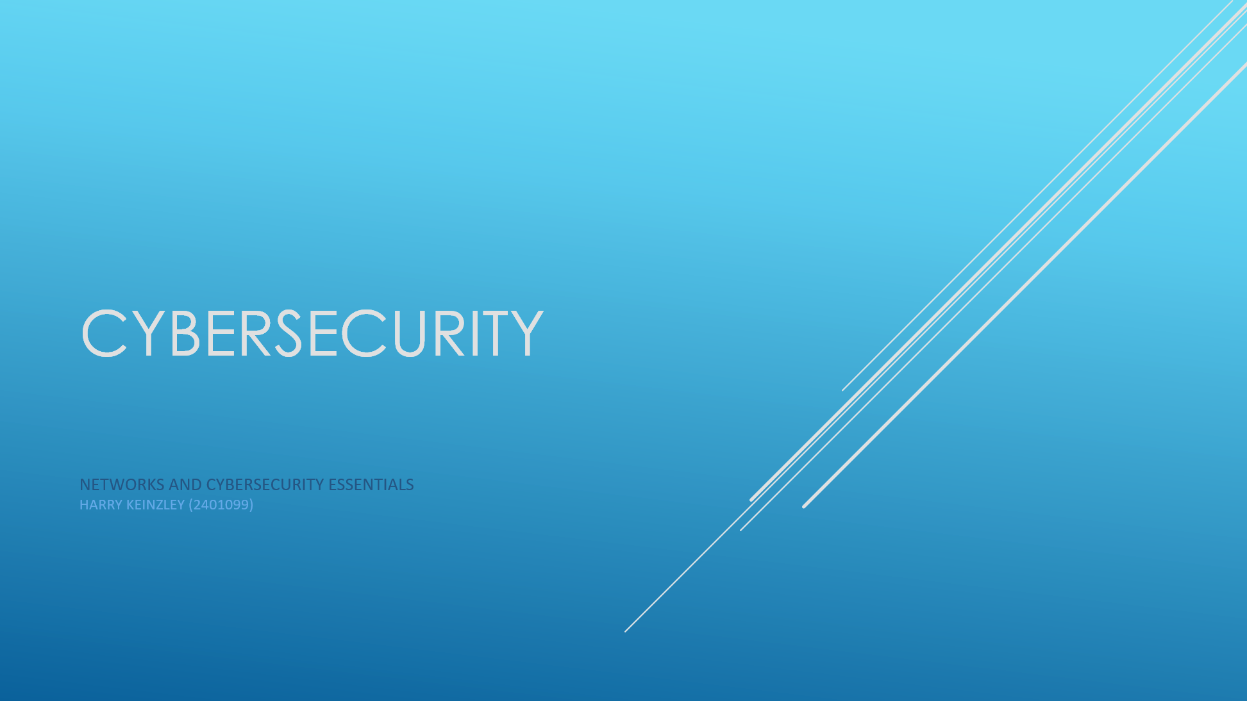
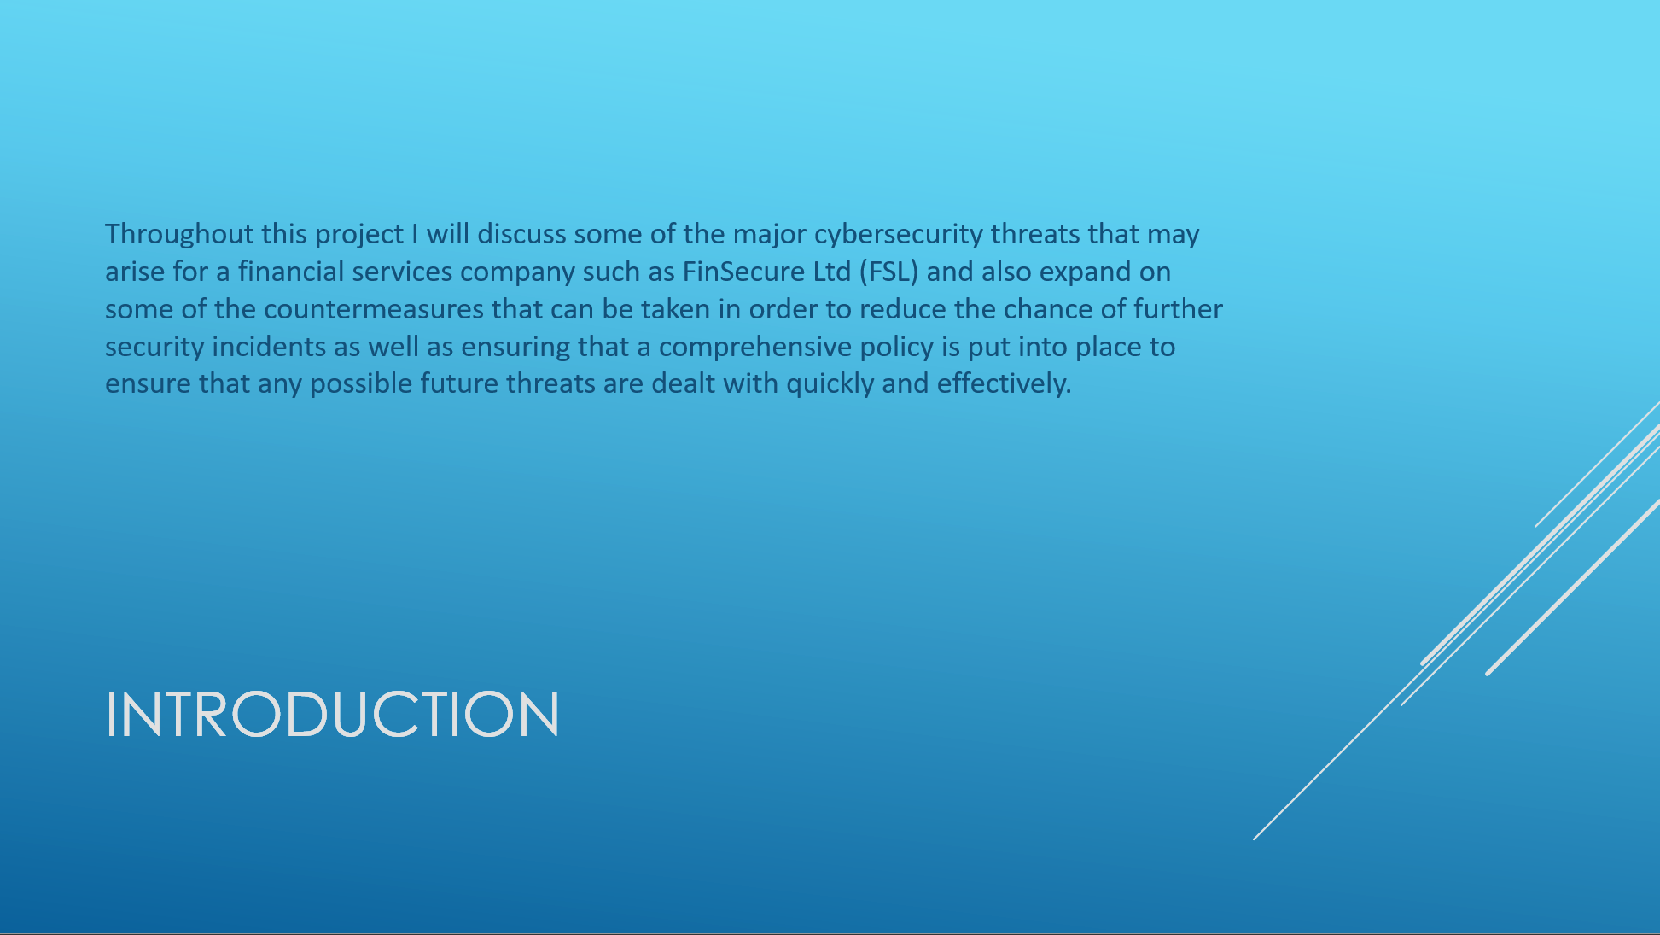
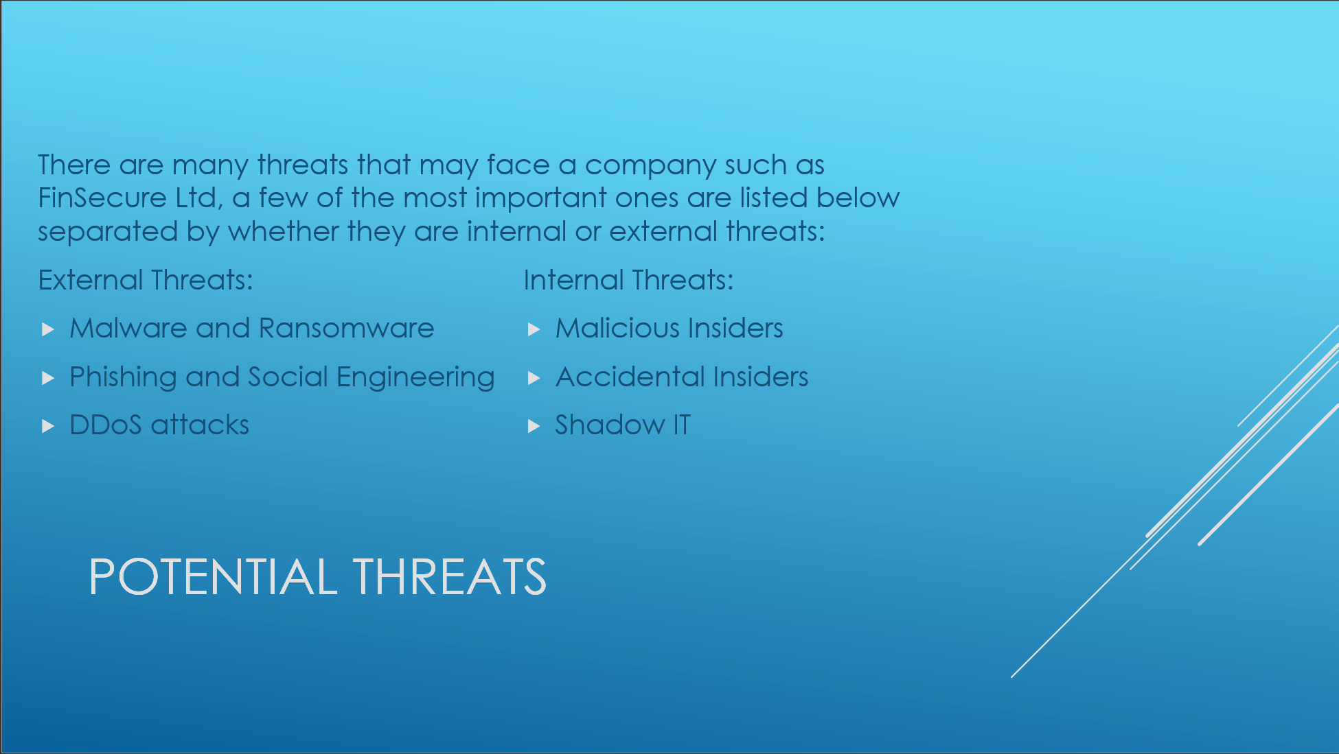
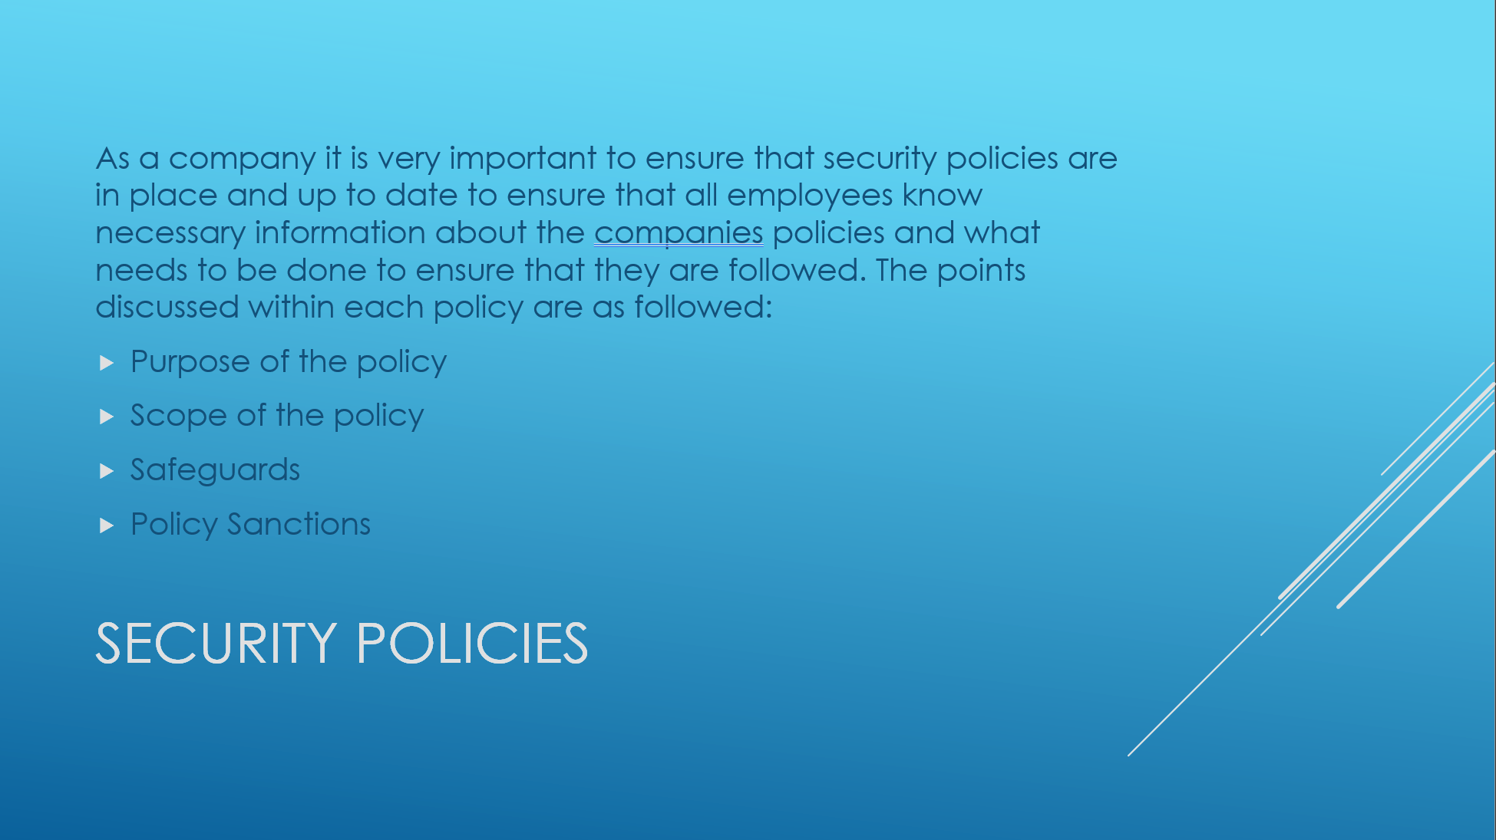
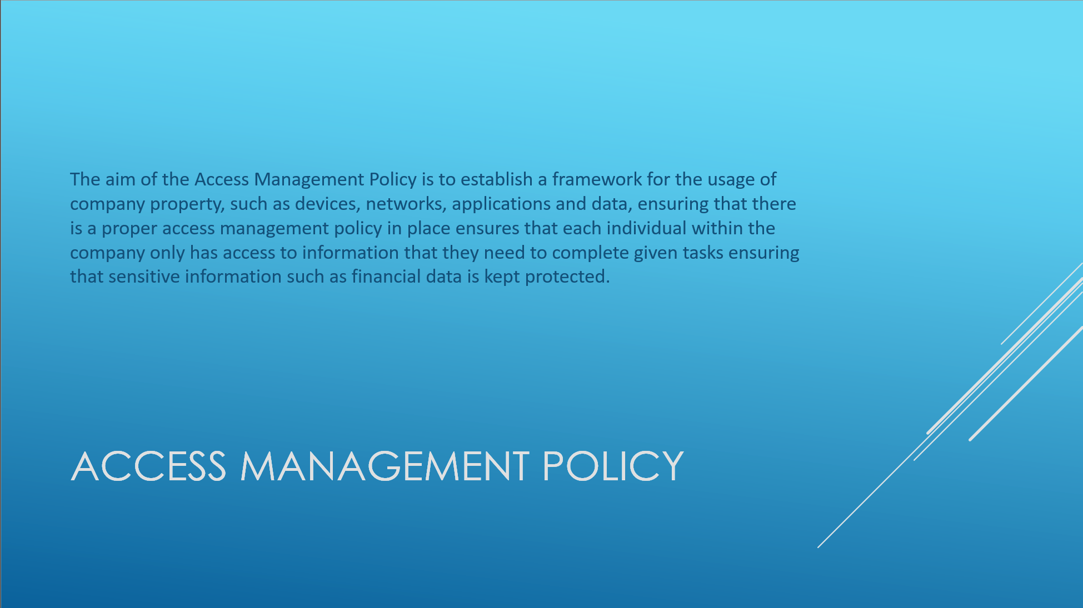
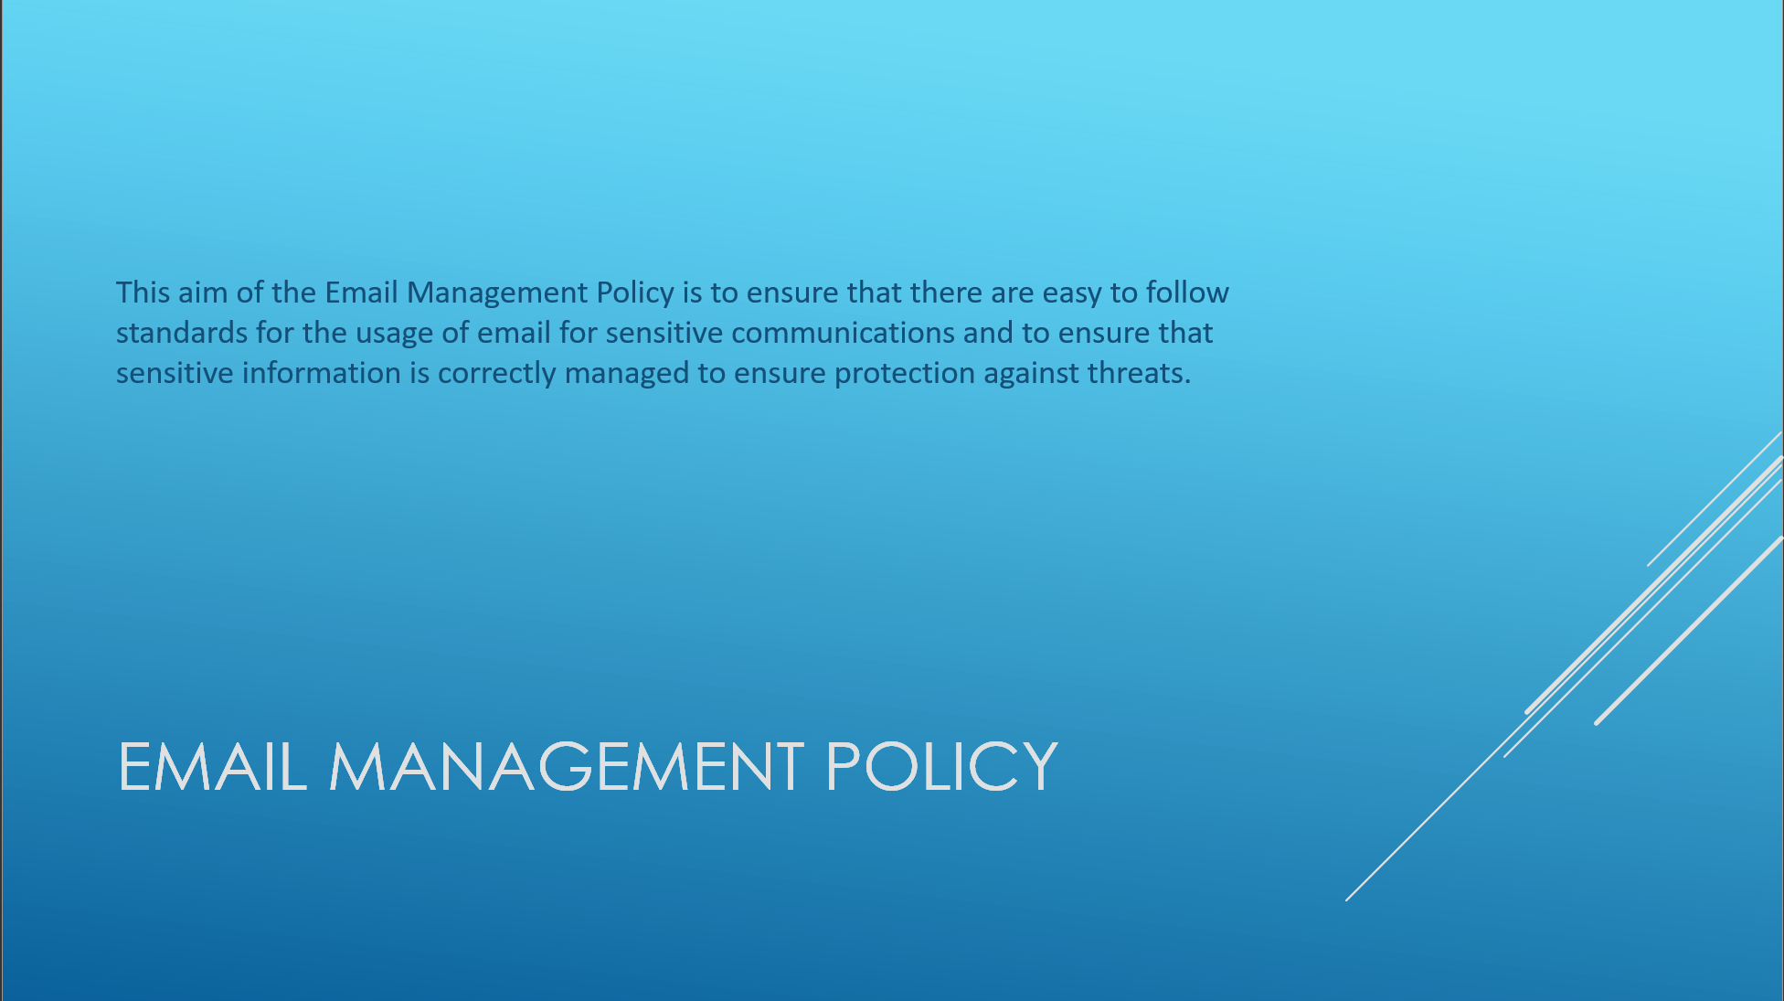
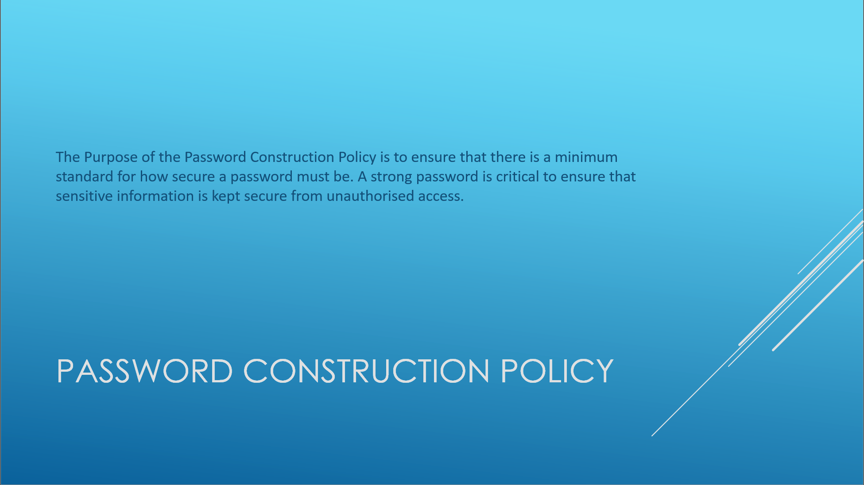
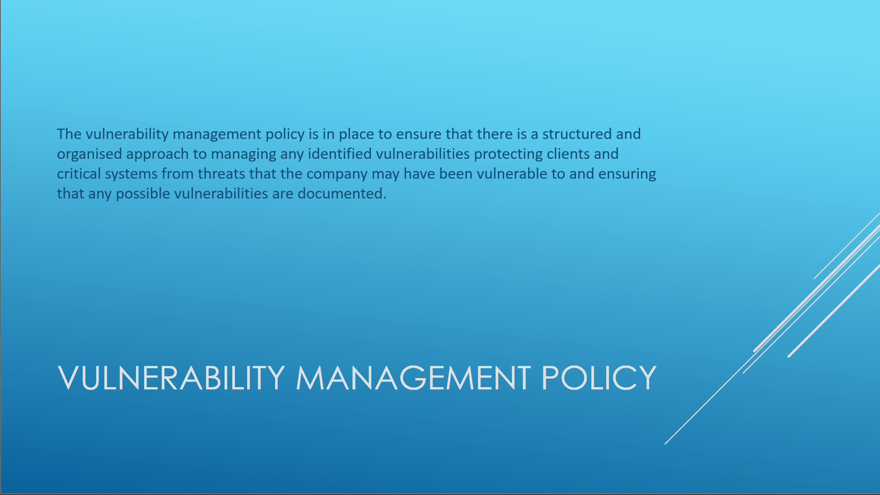
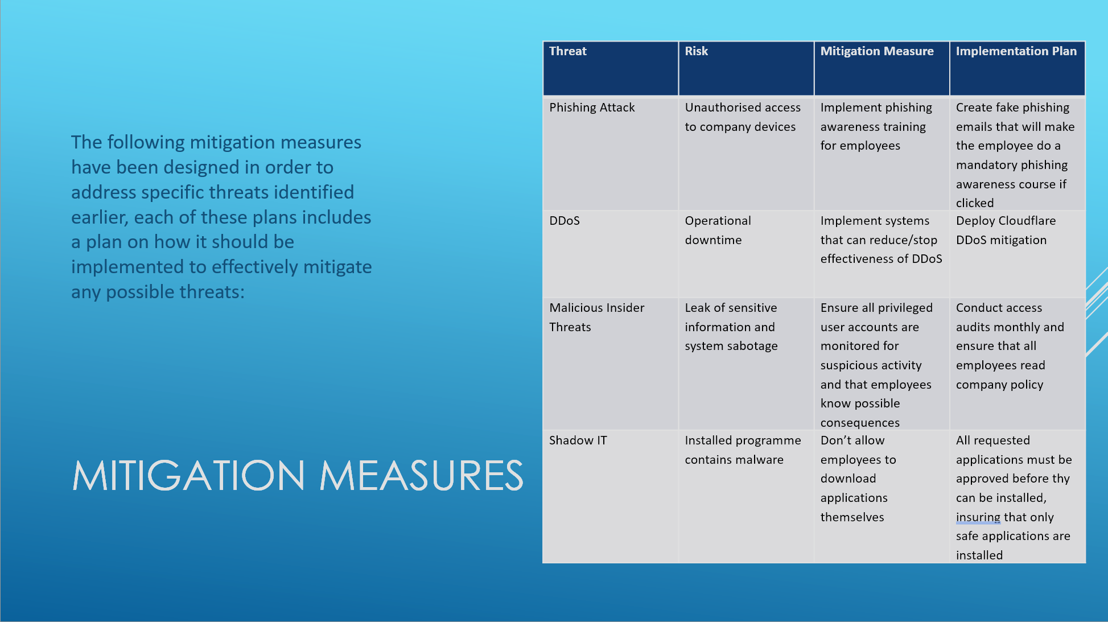
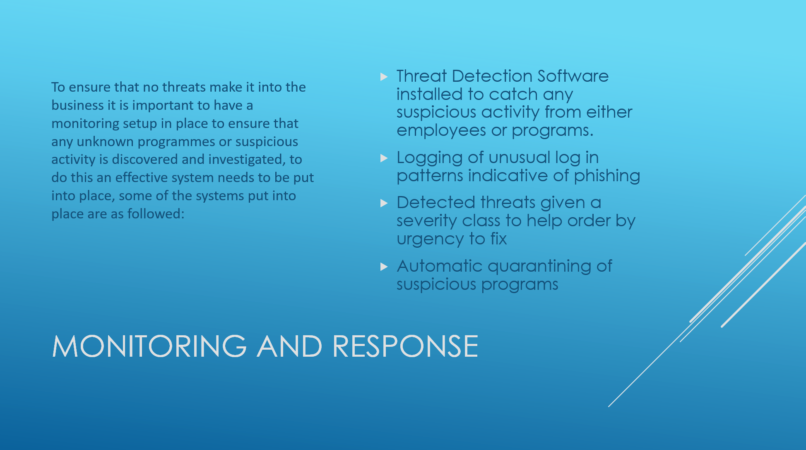
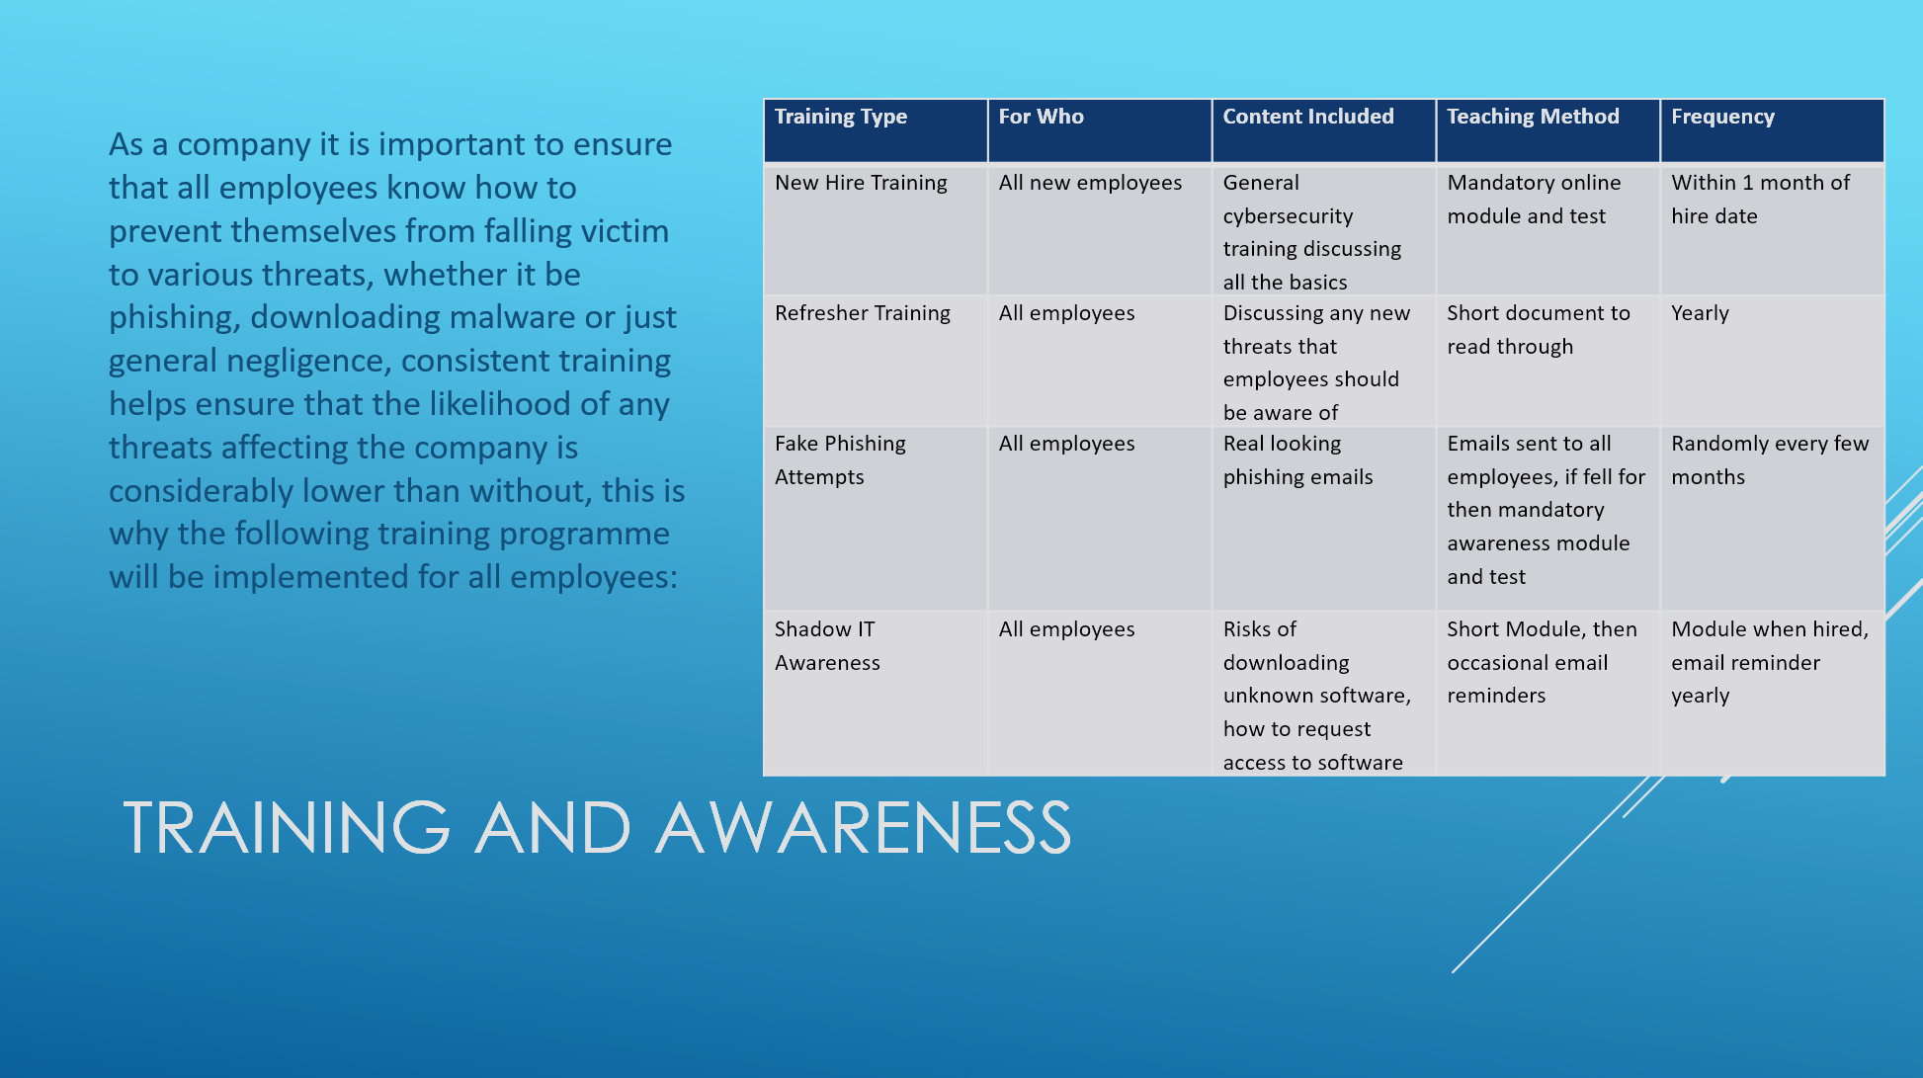
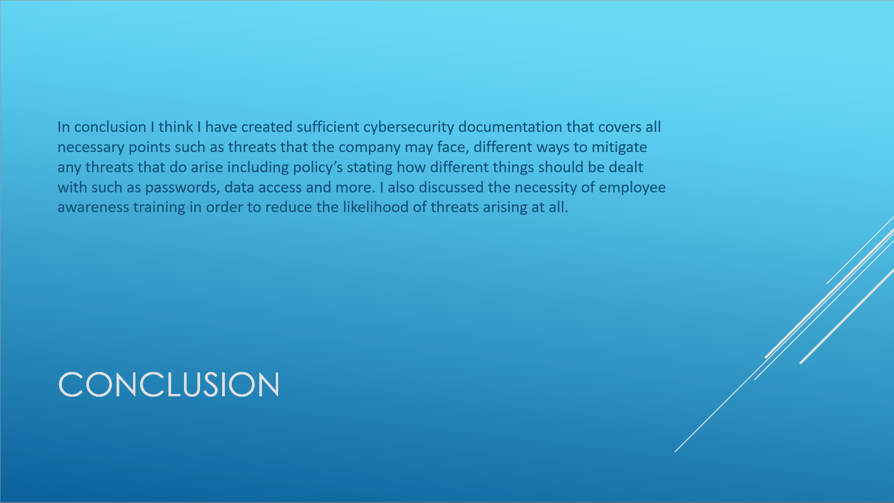

References
[1] "What is DDoS Attack? - Types of DDoS Attacks." checkpoint.com. https://www.checkpoint.com/cyber-hub/cyber-security/what-is-ddos/ (accessed May 11).
[2] "Shadow IT." ncsc.gov.uk. https://www.ncsc.gov.uk/guidance/shadow-it (accessed May 11).
[3] "Information Security Policy Templates | SANS Institute." sans.org. https://www.sans.org/information-security-policy/ (accessed May 12).

