Programme: BA Business Management
Module: Marketing Fundamentals
Module Code: LCBB4004
Lecturer: Afzal Munna
Assignment Title: Assignment 1
Date of Submission: 29/08/2022
Aleksandar Stanislavov Angelov
Student ID: 2125300

Blogging to communicate

Overview of Starbucks
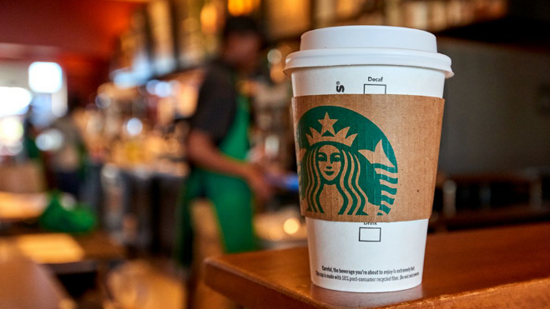
Starbucks was launched in Seattle in 1971 and has since revolutionized the way coffee is consumed in public places. Starbucks is credited for conceptualising the idea of a third space between a person's home and place of employment, where individuals may relax, enjoy a cup of coffee, and think about how pleasant the atmosphere is. (Michelli and Hill, 2007).
They have done a great job with their expansion into other countries. First international shop opened in Tokyo, Japan in 1996. In 1998, it made its debut in the United Kingdom. While in Mexico in 2002, the company opened its very first Latin American location in Mexico City (Murphy, 2013). Brunei became the brand's 64th worldwide and 15th Asia Pacific market in February 2014. A year later, the company opened its first shop in Panama, where it purchased 99% of its coffee from ethically sourced sources. Currently, the company has over 30,000 sites in 80 countries, and this expansion is expected to continue for some time to come (Austin and Reavis, 2002).
Upon Howard Schultz's departure as CEO of Starbucks on April 3, 2017, Kevin Johnson was selected as his replacement. Former Starbucks COO Kevin Johnson was a member of the board of directors from 2009 until 2015. Executives were able to carry out the company's strategic objectives, such as coffee innovation and cutting-edge food products when Kevin Johnson was CEO

The Mission of Starbucks

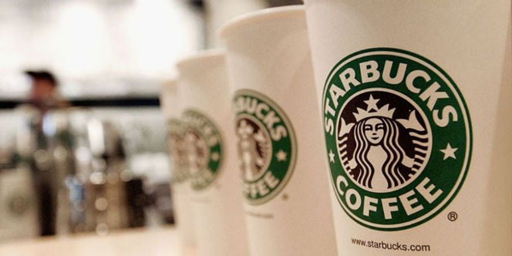As a coffee bean roaster in the 1970s, Starbucks has evolved into a coffee-inspired drink retailer in the present day.
“Establish Starbucks as the premier purveyor of the finest coffee in the world while maintaining our uncompromising principles while we grow (Dickinson, 2002)
In 1987, Howard Schultz acquired Starbucks, and ever since that time, the mission of the corporation has been to establish itself as the "Third Place." There is a third location between work and home that is referred to as the "third place After the “Third Place” concept was introduced, Starbucks came up with its new mission statement:

The Consistency of Starbuck Branding
Starbucks, being a globally known brand, always maintain brand consistency. This extends to every piece of marketing literature, each part of their in-store design and experience, and every message they communicate (Vishwanath and Hardin, 2000

Classic Siren Logo
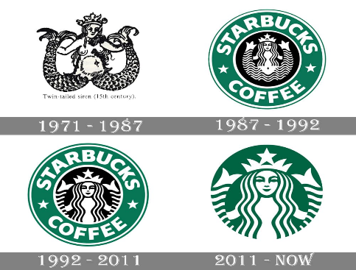
Let's get started with their logo and brand identity first. The Starbucks logo alone has undergone four changes over the period of 47 years, culminating in the famous symbol that now adorns your cup of joe. According to the Work Design Group, Starbucks had a unique problem when they wanted to rebrand in 2011.
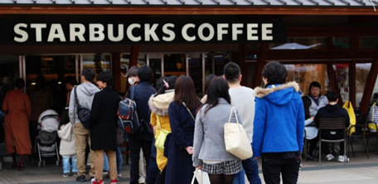
They wanted a brand design that will appeal to a wide range of people since they operate in 55 different countries. As a result, we now have a brand-new logo. This decision was made in order to allow Starbucks to possibly extend its product line beyond coffee.

Unbeatable Branding Consistency
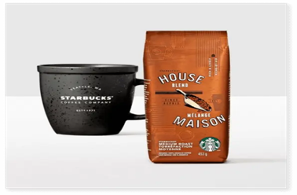
Everything they produce is characterized by a simple, contemporary aesthetic. Everything at Starbucks screams "Starbucks," from the decor in their shops to the digital content they produce to the advertisements they run. There is a sleek, contemporary look to even the mugs and tumblers you may purchase at the shop (Haskova, 2015).
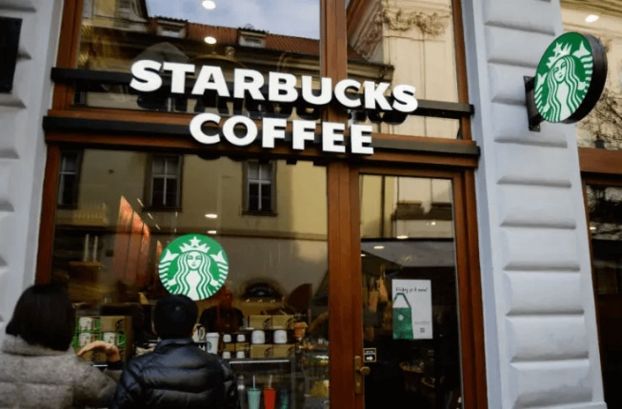
What happened? Whether you're reading a social media post, standing in line, or seeing an ad on TV, your Starbucks experience will always be the same no matter where you are or how you connect with the brand.
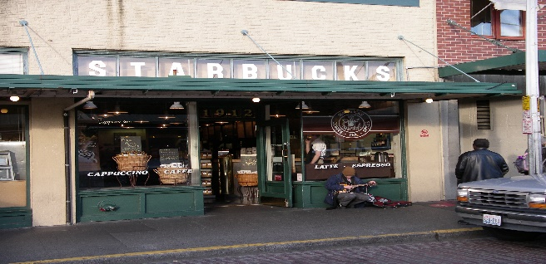

Marketing Mix of Starbuck

You will learn about the Starbucks Marketing Mix in this lesson (Starbucks 7Ps of Marketing). These are the seven Ps: people, place, pricing, product.
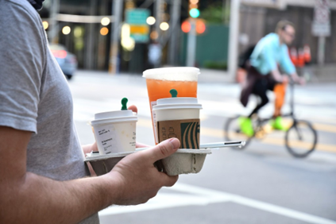
Products of Starbucks
Starbucks provides customers with a diverse selection of foods and drinks to choose from. Customers may choose from a wide range of options when it comes to their morning or afternoon pick-me-up: pastries and breads, coffees and teas (including espresso drinks), bottled soft drinks, and Frappuccino beverages. Coffee and tea from Starbucks are known for their high quality and generous preparation (Greenspan, 2015).
Prices of Starbucks
Businesses have a variety of pricing options at their disposal. The most common pricing structures are called going rate, premium, cost plus, and loss leader. Starbucks has decided to set its prices at a higher-than-average level. As was said earlier, the firm is well-known for the strong teas and coffees that it produces. A lot of people feel that if something is expensive, it must be good. Because of this view, Starbucks has made premium pricing the cornerstone of its pricing approach.
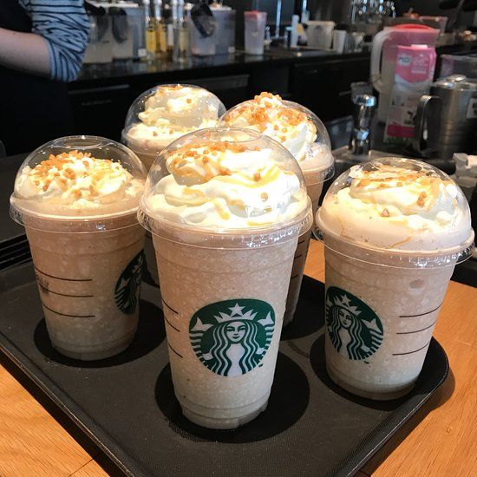
Places of Starbucks
Most Starbucks' goods are sold at its coffee cafes. As a premium self-serve beverage alternative, Starbucks on the go offers a wide variety of delicious hot drinks. Starbucks offers in-app services to the customers (Grossman, 2014).
Promotions of Starbucks
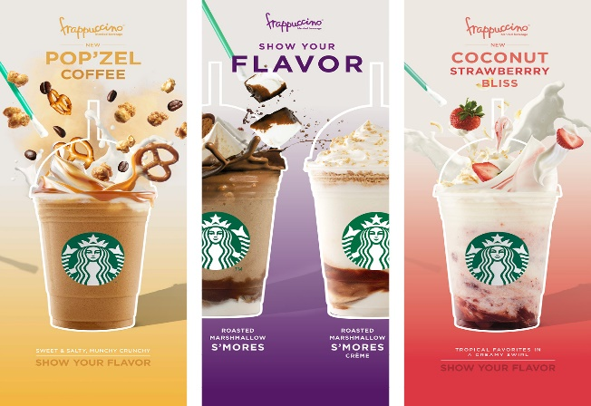
The company uses a wide range of promotional tactics to get out to its audience. For instance, advertising spending, which was $248.6 million in 2016, is projected to climb to $258.8 million by the conclusion of the fiscal year in September 2020. The purpose of Starbucks' loyalty programme, called "Starbucks Rewards," is to show appreciation to loyal consumers. It is possible to get two stars for every dollar spent in shops and online. It is possible to win a beverage or food item if they gather 125 stars.
People of Starbucks
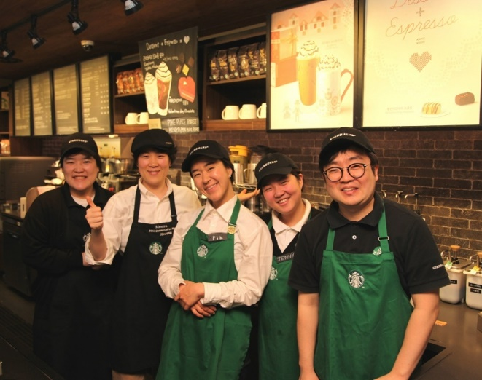
A diversified staff is already in place at Starbucks. By the year 2021, it expects to have employed over 240,000 employees across the globe. An equal opportunity employer, it strives to expand its workforce. Training and development for employees is a big part of what the organization does.
Processes in Starbucks
Each operational aspect of a Starbucks store follows a well-defined protocol. One prime example is the field of customer service. Due of Starbucks' popularity, all employees are required to provide excellent service to their customers. A member of the team greets a client as they arrive. Afterwards, customers will order and pay for their meals and beverages, as well. As a last goodbye, the package will be delivered with the order in hand (Schultz et al., 2011).
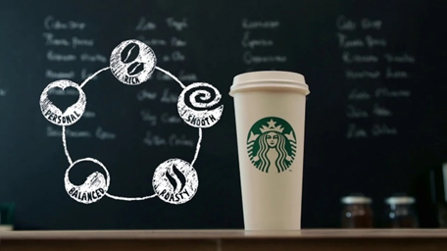
Physical environment of Starbucks
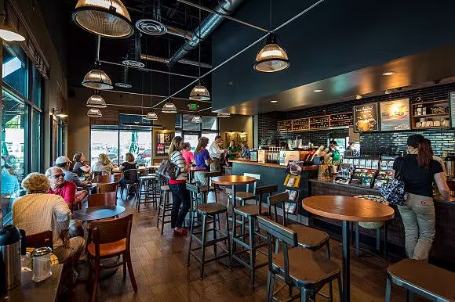
Starbucks goes beyond the standard fare of adorning its stores with coffee cups, logos, and napkins to create an inviting atmosphere for its customers. Starbucks designers have been tasked with coming up with unique regional aesthetics for each location as part of a ground-breaking new shop design idea.

Effective Starbucks Marketing Strategies

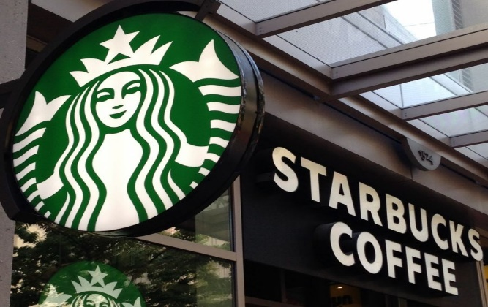

In-store marketing
Starbucks spends a lot of time and money on in-store marketing to improve the look, feel, and functionality of its retail stores.
Free Wi-Fi was implemented at all locations in 2002, which encouraged consumers to remain longer and met their need for constant connection (Fizgerald, 2013).
New products and the benefits of loyalty programs will be advertised to consumers in shops, increasing customer awareness and demand. For the brand's customer retention goals, this helps. Starbucks does market research by collecting and analyzing data from its retail stores on consumer purchases, behaviors, and preferences.
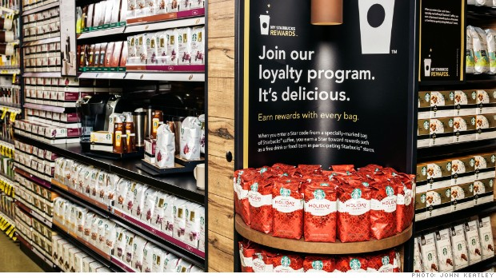

Usage of Social-Media
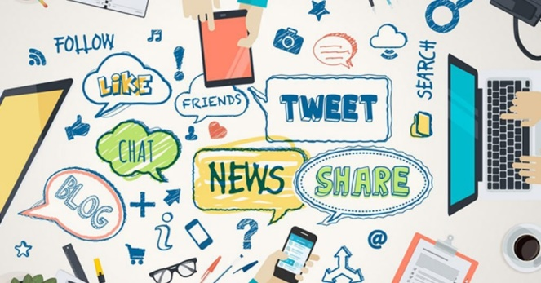
Marketing teams would be pleased of the social media culture that Starbucks has built. Massive social media platforms that spread information across all mediums and keep people interested are a priority for the organization. Smaller content pieces are employed across several media by Starbucks, which produces a lot of material. There are different kinds of material for different types of users on each social networking site. Friendly, distinctive, and approachable are just few of the adjectives that describe the language (Kotler and Armstrong, 2016).
Starbucks also encourages its customers to post images of their purchases and experiences on social media. Starbucks uses and retweets their tweets in their advertising. Starbucks uses their tweets. Previously, they couldn't discuss Starbucks-related offers, proposals, or other activities with one another. They can build brand advocates for both men and women because of their exceptional usage of social media.
User-generated material is 2.4 times more likely to be seen as authentic by customers than corporate content. This boosts consumer confidence in the brand, which in turn drives sales.
Additionally, the organization participates in a variety of social media campaigns and tournaments every day. As a part of Starbucks' larger appeal goals, which go beyond social media retail, this company is using social media for marketing purposes. In addition, the brand promises to respond quickly to social media complaints from consumers (Thompson and Arsel, 2004).

Communication with Customers

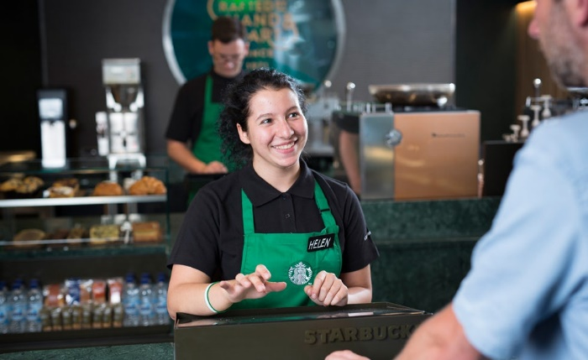
One of the most crucial aspects that directly and symbolically contributes to Starbucks' success is the way the firm engages with its consumers.
Consistent with the brand, every communication is courteous. Through its social media updates and in-store contact and purchase, Starbucks has built a consistent and engaging tone that supports its content and customer interactions.
To get a message through to customers, the company uses metaphor since it can't always use plain language. Even if they don't speak to one other, the words they use have an impact on the brand. This is something they often do, for example, in their printed materials. When describing a product, the brand may benefit even if there is no direct contact. Among Starbucks Reserve's offerings is a line of single-origin, small-batch coffees that are roasted on-site in Seattle and sold in stores and online. Each of Starbucks' products has a narrative behind it that explains why it was chosen for Reserve status in the first place.
Starbucks has used the power of words to create something that people can relate to on a variety of levels. The firm will be able to reach a broader audience even if not all messages are well received by consumers. Success in such a cutthroat business necessitates it.

Starbucks and its winning formula

Tweet-a-coffee
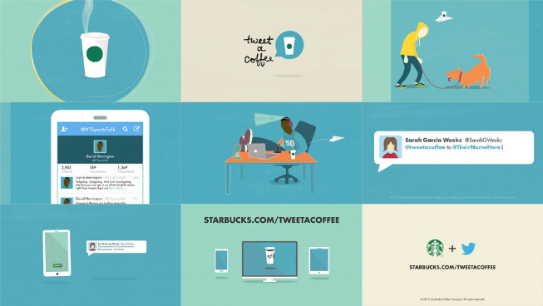
Participants in the Tweet-a-coffee initiative paid for their friends' coffees by tweeting @tweetacoffee and their Twitter handles. There's a $5 reward up for grabs if people link their Twitter and Starbucks accounts. In excess of 27,000 individuals tweeted about having coffee. More than $180,000 in sales were made in just a few short months because to this frenzy of activity (Awario, 2022).

#theredcupcontest
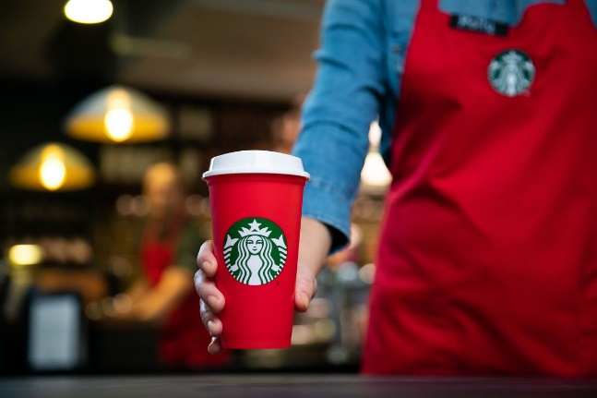
Coffee drinkers are familiar with the red cups of Starbucks, which have come to represent Christmas, as well as a source of excitement and controversy. Between 2014 and 2015, Instagram hosted the #theredcupcontest. All entries must have a red cup and be posted, tagged, and have the #theredcupcontest hashtag included to be considered for one of the five prizes. An Instagram photo was submitted every 14 seconds over the first two days of the 2015 competition, leading to a total of 40,000 entries (Takennotstirred, 2022).

Jumping on the trend
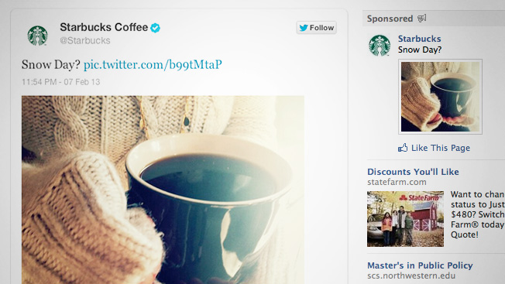
Starbucks launched a social media campaign in 2013 to celebrate the warmth of a cup of coffee in the wintertime. In response to the snowfall, Nemo, Facebook and Twitter were inundated with mentions about the brand. Nothing noteworthy - simply pictures of individuals bundled up against the winter chill, sipping hot coffee. Due to the fact that Facebook Ads and Sponsored Tweets pushed them, they were visible to users when they looked for weather-related hashtags such as #blizzard and #Nemo (Econsultancy, 2022).

Meet me at Starbucks
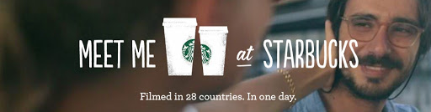
It would seem that Starbucks is an ideal location for any social gathering, whether it's a first date, second date, or just a group of buddies hanging out. The "Meet Me at Starbucks" social media campaign was so introduced in 2014. Free coffee for a year was provided in exchange for a customer's "How We Met" story at Starbucks. The #HowWeMet hashtag was used all throughout the year to collect contest submissions and let people read the stories of others. It allowed people from all around the world to participate and get a different perspective on Starbucks.

References:

Austin, J.E. and Reavis, C., 2002. Starbucks and conservation international. Harvard Business School Publishing.
Awario Blog. 2022. Starbucks: Top best and worst marketing campaigns. [online] Available at: <https://awario.com/blog/starbucks-best-and-worst-marketing-campaigns/> [Accessed 11 August 2022].
Bakeryinfo.co.uk. 2013. Costa launches new sustainable packaging - British Baker.
Blinkie dot org. 2012. Starbucks Drinks Simplified (Kinda).
Clegg, B., 2012. Now Appearing: Starbucks versus Costa. Brianclegg.blogspot.sg.
Dickinson, G., 2002. Joe's rhetoric: Finding authenticity at Starbucks. Rhetoric Society Quarterly, 32(4), pp.5-27.
Econsultancy. 2022. [online] Available at: <https://econsultancy.com/eight-awesome-social-campaigns-from-starbucks/> [Accessed 11 August 2022].
Greenspan, R., 2015. Starbucks Coffee’s Marketing Mix (4Ps)
Grossman, S., 2014. This Map Shows the Most Popular Starbucks Drinks Across the U.S.
Haskova, K., 2015. Starbucks marketing analysis. CRIS-Bulletin of the Centre for Research and Interdisciplinary Study, 1, pp.11-29.
Kotler & Armstrong. 2016. Principles of marketing. Boston: Pearson
Michelli, J. and Hill, D., 2007. The starbucks experience. AML/McGraw-Hill Audio.
Murphy, T., 2013. The History of Starbucks. Ted.me.
Schultz, Howard, and Joanne Gordon. 2011. Onward: How Starbucks Fought for Its Life without Losing Its Soul. New York, NY: Rodal.
Taken, Not Stirred. 2022. A Walk-Through Starbucks’ Best Campaigns. [online] Available at: <https://takennotstirred.com/news/a-walk-through-starbucks-best-campaigns/> [Accessed 11 August 2022].
Vishwanath, V. and Harding, D., 2000. The Starbucks Effect. Harvard business review, 78(2), pp.17-17.

