




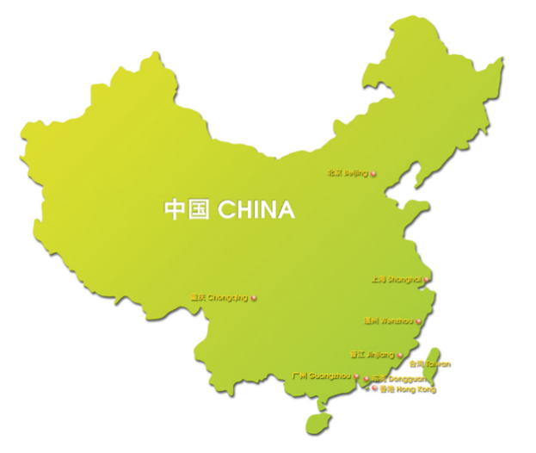


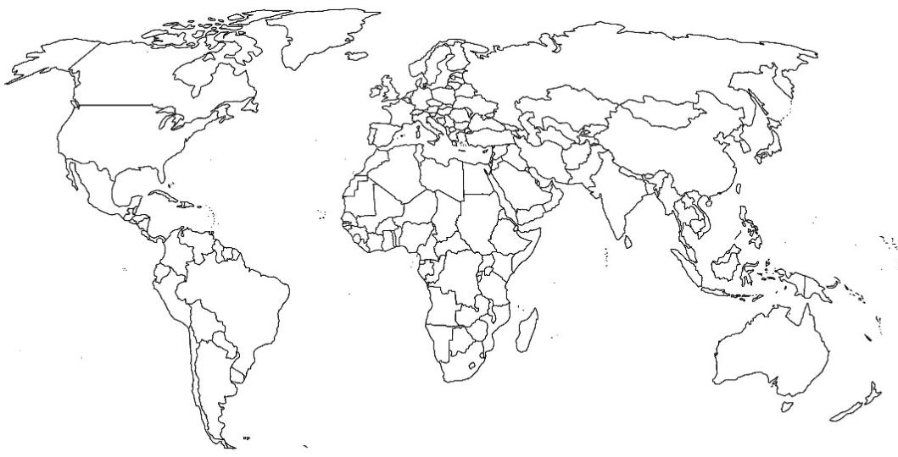



Four Great Inventions:
Paper Printing Compass Gunpowder
Some Chinese words or phrases:

Four fabulous facts:
- Capital city: Beijing
- Population: 1,400,000,000
- Language: Mandarin & Cantonese
- Currency: RMB
Draw a Chinese landmark:
Draw the Chinese Flag
Traditional Chinese food
Draw the most famous animal from China
Find and mark china on the map
China Snapshot

