Lewis Gronland
P148995

SFDM Major Project Stage 1
M6X018998

In this write-up, I will discuss my projects for the major project the steps that it took to mold this idea into one that I could take forward as a project that I could be confident in. I will also be stating the research that went into understanding what the look and feel of my animation would form the way they moved to the clothing they wore and why my research development leads me to these choices. The aim for the Major Project is to produce an artifact that draws on the resources of all the material that I have gained over the course of the program. The choice of the project could be derived from a wide and diverse range of resources from literature, exhibition, commercial opportunity, industrial liaison, staff-student discussions, and personal interest just to show some options. I will also want to try to apply and improve my technical skills that have learned over the program into the project to present the highest quality of production that I can produce at this time. I will also be looking into the design phase of the production, explaining how and why I came to these character designs, the relationship that they will have between them and how it affects the animation. As well as the actual location as it changed and developed over the cause of the project and how and why this was done.

Research

For my project I wanted to look into something I’ve been reluctant to attempt during my time on this program and that would be an action sequence, I've been cautious of doing this in the past as they need to feel fluid in the sequences during the fight for them to look the most believable to the audience with ever attack having the feeling of weight and power which is difficult to do which is why I’ve kept my distance from it for so long. However, I now want to try to move out of my comfort zone and try something a bit more technical for me to see how much I have improved over the course of the program and to hopefully build more confidence in my animation ability.
The idea for my fight sequence was to have two fighters battling throughout a large palace moving through large corridors, traversing through a large courtyard and through the stairways towards the throne room where the hero character would take a moment of opportunity to strike killing the enemy. However, from taking a step back and looking at just what I had hoped to accomplish through this project I came to understand that this idea was too large in scale for just one person to work which would likely have resulted in a project that was too big for me to accomplish to the desired standard that I hoped for, also that this was meant to be a short animation, making it difficult to tell a story if my characters are moving throughout this giant palace throughout the fight.
The conclusion that I came up with was to lower the size of the environment as it would then make it easier to design and wouldn’t take up as much time as with my original idea allowing me to focus more on the characters and their animations, which is what I truly want to display through my work on the module. One thing I also want to go through my animation is to give the audience a story to follow throughout the story which will be done through some small dialogue and through the environment with the sole goal of giving the audience a story of the kind of relationship these to fighters have between each other.
The story goes like this; the two characters meet at the bridge outside the palace one questions how this is possible however the other quickly attack leaving the other to counterattack knocking him down to the ground. Wanting to make sure of his suspicions he is moving in closer to check the fallen character only to become surprised as the fallen character suddenly attack catching his leg he stumbles to the floor as the other rises, turning to confront the injured fighter. Suddenly realizing that this enemy is no longer living and is only a mindless husk of what once was.
Even so, he is still slowly pushed back to the throne room where he is nearly defeated but seeing a small opening gain the upper hand throwing the undead fighter of the edge. He falls to the ground apologizing to his dead brother.

Design

In order to bring my characters to life I wanted to know what I wanted to the look like I looked at several different characters and looks trying to understand the look and feel of my characters, would they wear thick heavy armour such as European knights where every swing would be powerful however would not be as fast as someone who wore less like characters from games and films like the Witcher and lord of the ring which could work better with my fantasy styled story and felt more natural rather then having two heavily Armoured characters meeting for no reason, this would also allow for more dynamic movement and over the top moments in the animation.
With this in mind I decided to go with a thinner armor look however I wanted to give the characters some kind of historical style rather than the fantasy style leather clothing to try to produce a unique style for my characters thus I looked into Spanish, Roman and Japanese style soldier outfits however I decided to follow the Spartan/gladiator style as their armor looked relatively strong but still gave the flexibility the I wanted to show in my animation.
One of the particular reasons I decided on this design idea was due to the film Troy in which Achilles take on Hector in a one on one battle to the death in which they utilize Armor’s lightweight to the fullest with Achilles throwing his body into these grand attacks are an enjoyable skeptical to watch while they shift from spears to shield and sword. I believe this is the sequence that made me want to follow this style for my project's animation another piece of inspiration game from 300 with their intriguing fighting style as we watch one mango one a rampage through hordes of men is just a cool sight to see and is how I want to portray my undead character as he pushes the other fighter back.
When designing my characters, I wanted to test different colour options in order to find the style that fit the style that I wanted for my character I looked at greens, blue and grey tones however I decided to keep the gold and red depicted by most spartan films as it stands out as a memorable outfit that easily recognizable.
On the other hand, I wanted my undead character to keep the spartan style but to have a more unique look, in order to do this, I wanted to look at more evil fantasy style character. Upon my search through different designs, I found that most styles had very detailed amours as well as a darker color pallet which was the deciding way that I wanted to portray my character helping the audience recognize the hero and the villain character as soon as they see them. Following this plan a gave my undead character a darker color tone and followed a more rugged approach to the characters design then to the other warrior.
This steadily evolved throughout the design faze as I added more detail into the undead design with a hard leather styled armor connected together through circular rivets, with thick fur around the body and a shoulder guard across one of his shoulders, whereas the other fighter was kept to a more traditional style.
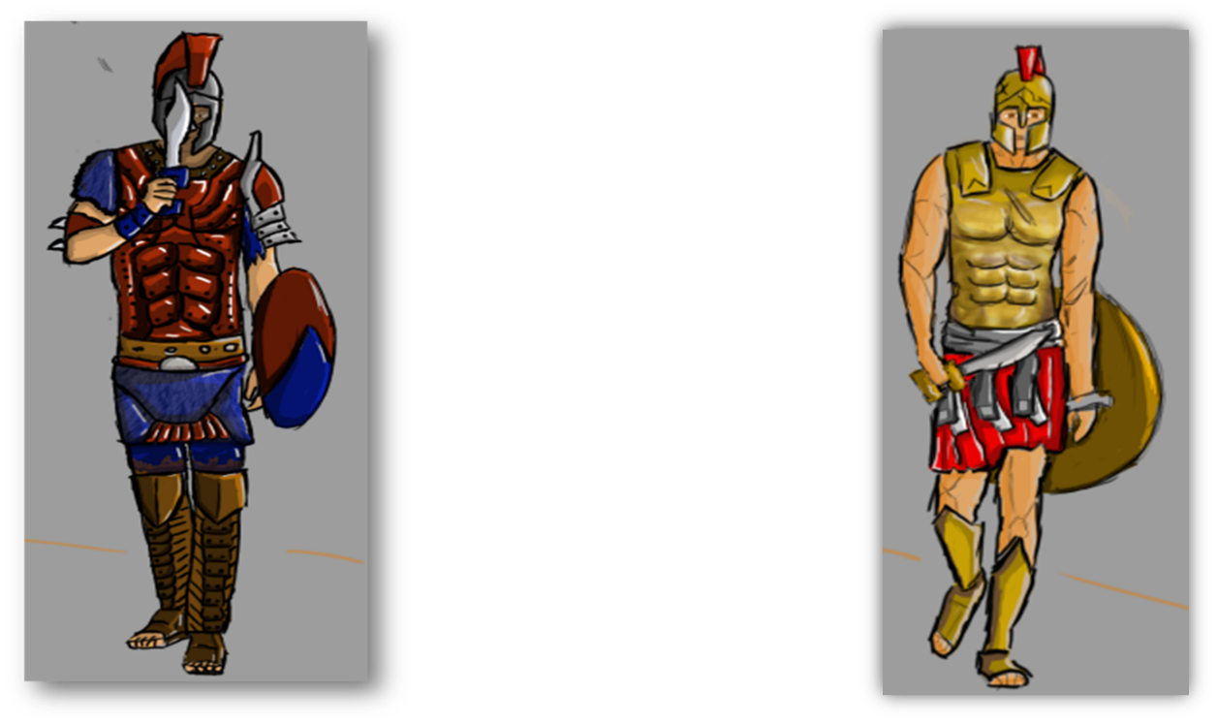

Technical

In order to understand how I wanted to scene to play our I used photoshop to create a rough time line of the animation sequence in order to get a better understanding of exactly what I wanted to show during my animation sequence. This would change over the course of the animation due to design changes and lecturer-student interactions, however, it still stuck to the same premise throughout Once I had the idea of how I wanted the sequence to play out I took my work over to Maya to design the location of the fight sequence. With the location, I wanted to have a grand looking palace with an early European look to it in which I then tried to put my own spin on it.
The outside of the entrance is lined with long rectangular pillars that will be replaced by the character model acting I large statues standing around a wide bridge which will be where the characters first meet before going up the stairway to the large door that towers over the characters. Inside we are brought to the throne room which will be a wide walkway with the corners cut off revealing a large drop with large pillars protruding water like a waterfall along the drop at the edge of the walkway sits a large throne that stands strong in the room.
I then used Maya's rigged character to act as my replacement characters as I started planning the animation sequence. To show this I created a short animatic of the first sequence of the animation, this was done in order for me to get a better understanding of how I want some scenes to look as well as drawing in markers on the body’s as to where the shield and swords would be to help get a better understanding of what's happening in the sequence as it's a bit harder to understand when there are no weapons shown in the animatic. This animatic games me an understanding of what kind of positions I wanted to show my characters in and how I wanted the camera to look in the sequence.
When starting to design the character in 3D I wanted to move away from modeling it completely in Maya as I had for my other projects rather I wanted to try to improve my ability's in Zbrush a software I only really used in the first year and have neglected till now, I know that Zbrush will help improve the quality of my characters design and as I want to make my characters look as good as possible in the animation sequence. As I worked on my characters design I seemed to struggle with the look of my characters as he would come out too blocky, this is mainly due to my lack of understanding in the body’s structure which will be something I will ned to improve on to help create a more realistic and believable design however, due to this I decided that I would instead take the OBJ file Zbrush have for a male character and edit him to create my character as it could take a much longer time for me to make a better original from scratch and also my characters design mainly comes from the outfit which is where I wanted to put most of my focus on in the characters design at the moment. It was an interesting experience for me as I slowly learned about the tools that would be able to help me design the character's armour in the way I wanted it to look, creating armor that looked durable and thick but would still give my character the flexible style that I wanted to show.
Finally I have come to my blocked out animation which shows how the characters will move throughout the location and the camera angles I will be using in the final animation the sequence looks relatively fine apart from some awkward animation sequences that damage the quality of the sequence which is something I wall want to improve upon on order for the completed animation to feel the weight of every strike and thrust in the way that I expect it to be.

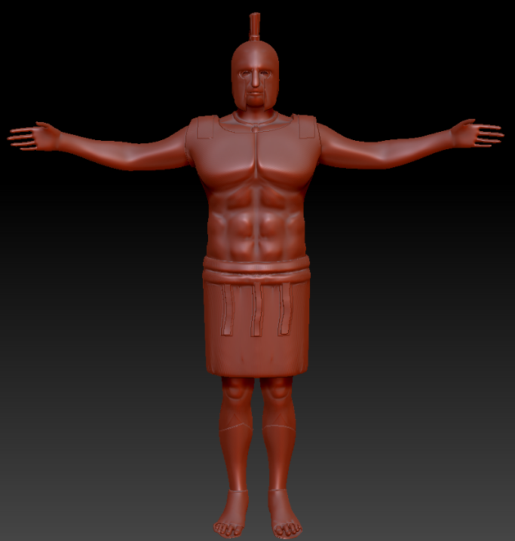

In the future

Moving on to next year there are a few things I will want to focus on in order to make sure my final animation is something I can be proud of, to do this the first thing I will want to do is prepare a plan of what I need to work on and for how long. This will greatly improve the quality of my work as I will become more structured towards the deadline. This would prevent any rushed work as I will be expected to have planed out each issue correctly with spare time in case it is necessary.
For that I will need to focus on come January, it would mainly be the character designs as they will need to be textured and given some more detail, something that will require some time for me to learn to present to a good quality. I will also want to investigate working with fur however this may not make it into my main character as it may be too difficult and time consuming for me at this time. Another issue I will need to work on is the character rigs when imported into Maya as from test I have found that the auto rig struggles to rig it correctly, meaning that the character will need to be rigged from the ground up which will be a time-consuming process.
I will also be looking to further develop the location design as I feel that its too blacked out and needs a bit more detail to give it a more unique and interesting design as when as texture to fit with the scene which will be important in order to give my sequence a location that is up to the same quality. And finally, the animation will most likely be redone rather then working with the existing animation as there are too many issues with the sequence that I feel it would be easier to rework it using the existing design as a template to work off.
Another thing I will need to keep in mind is the fact that I will want to give some dialogue in the scene, this will be my first time applying this in a animations so I will need to figure out how I will want to work around this weather I will do the speaking myself or if I will bring in an outside source. This is something I will need to decide on for my animation come January.
Overall, I feel like I still have a lot that I must work on however I hope that by applying myself to this plan that I will be able to surpass my expectations and show of an animation that stands out for all the right reasons.

References

Bobzeda. 2018. 300 Film (HD) -- Best fight / battle scene --. [ONLINE] Available at: https://www.youtube.com/watch?v=G1a3QpvFLN0.

Movie Scene Provider. 2018. Troy (2004) Hector vs Achilles [1080p HD]. [ONLINE] Available at: https://www.youtube.com/watch?v=tAtbzV8CTV0.

