Analysis of Moving Production Facilities of Jimmy Choo to India


Name- Amaan Malik
Student ID- 2246841
Module code- LCBB4005
Module Name- Global Business Environment
Lecturer- Hoang Nguyen

Table of Contents
Introduction 3
The chosen developing country (India) 4
Application of theories of business environment in the selected country (India) 5
PESTLE ANALYSIS 5
Porters Five Forces Framework 8
Porters Diamond 10
Evaluation of the opportunities and challenges 12
Management of important aspects in India 13
Analysis of barriers experienced by foreign countries in India 14
Strategies and Recommendations 15
Conclusion 16
References 17

Introduction
This essay sheds some light on the moving of the production facilities of Jimmy Choo (hereinafter referred to as “the company”) to a developing country which is chosen to be India. Further, it takes into account differences that the company is likely to face in terms of business environment and various other differences relating to business strategies, cultural insensitivity etc. which will have a major bearing on the operations of the company in India. Moreover, the business environment in India is thereafter being assessed keeping in view various theories including amongst others PESTEL, Porter's Five Model, and Porter Diamond. Additionally, it analyses several opportunities and challenges that the company will face in establishing its production facilities in India relating to important aspects of business strategies, corporate governance, and cultural sensitivity. The essay also pointed out some instances where the other foreign companies faced some barriers in India. Given the above analysis of various factors, the strategies and recommendations are hereby suggested that will enable the company to conduct its production facilities smoothly in India.

The chosen developing country (India)
India has been chosen here as the developing country where the company proposes to move its production facilities. The rationale for choosing this country is mainly the increasing population and further it is among the major growing economy. In addition, there is a huge labour force which will enable the company to hire labour easily. Also, the labour cost in India is quite low which implies that the company can get its production complete at a comparatively lower cost and will derive more profits. In addition, the rules, regulations and norms for shifting the production facilities to India are not so stringent in comparison to those of the United Kingdom or any other country.

Application of theories of business environment in the selected country (India)
This part of the essay throws light on the application of various theories relating to the business environment of the India. The three theories chosen here for the proposed analysis are PESTLE Analysis, Porters Five forces framework and Porters Diamond.

PESTLE ANALYSIS
The PESTLE ANALYSIS consists of six components that are political, economic, social, technological, environmental and legal. These are further elaborated hereunder keeping in mind the business environment of India:
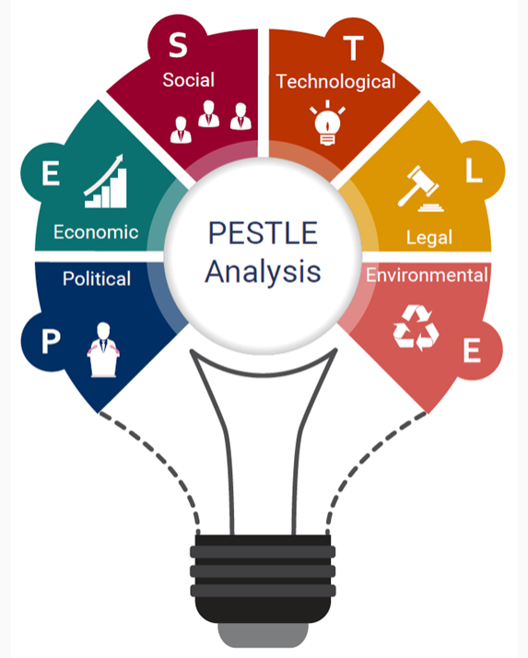
Figure 1: PESTLE Analysis
Source: (IBIS World, 2023).
Political: Political factors imply those factors that are related to the governance political system, government budget sizes, changes in the policy, democratic systems etc. India is one of the largest democracies in the world as it has a federal government. Further, there are factors with which it gets influenced including politicians’ interests, policies of government, and ideologies of political parties. Therefore, in India, these political factors have a major bearing on the business environment. Further, there is a well-developed system for the imposition of various taxes like service tax, income tax, Goods and services tax, and sales tax which are imposed by the Central Government. Other taxes are imposed by the local authorities (Rastogi, et al., 2016) Further, the company needs to take into account instability, tax remains, competition policy, labour and business regulations, and incentives that may have a major bearing on the operations of the company.
Economic: The Indian economy is considered to be a stable one and this is mainly because of the formation of FIBP, liberalization of foreign capital, and reduction in the licensing of various industries. This has improved the economic conditions of India to a great extent. Therefore, it can be said to be favourable for the company to start its production in India (Sridhar, et al., 2016).
Social: This implies changes in the trends that have a major bearing on the business environment. It further includes expectations, cultural norms, age distribution, health, safety, health consciousness, growth in the rate of population, and career attitudes. It helps companies to plan their business strategies and marketing analytics.
Technological: These relate to logistics, e-commerce technologies, marketing, production, informal and communication. In India, there are 4G and 5G technologies that greatly facilitate various projects. In addition, the IT sector of India is considered to be one of the strongest in the whole world as it promotes the upgradation of software, development of IT consistently, and much other advancement in the technologies that will enable the economy of India to grow and prosper. Thus, the company can benefit from operating its production facilities in India due to the advanced and improved level of technology (Agnihotri, et al., 2017).
Environmental and Legal: The legal regime of India keeps on updating itself from time to time or as and when required. For instance, the recent legal changes included disability discrimination, an increase in the minimum wages, recycling of material, etc. These have greatly impacted the business environment. Further, various laws relating to the environment have also been implemented to ensure that the increasing level of industrialization and urbanization does not cause harm to the environment beyond a certain limit as this can cause various health issues. There are various environmental pressure groups, waste control and disposal regulations, and noise controls in India (Lang, 2021).
Thus, it can be analyzed that the company should take into account these factors before deciding the move its production facilities to India.

Porters Five Forces Framework
The company needs to assess and analyse the business environment of India by recognizing Porter’s Five Forces Framework which encompasses the five forces namely the threat of substitution, the threat of new entrants, the bargaining power of customers, competitive rivalry, and the bargaining power of suppliers. These are further elaborated hereunder for better conducting of the analysis of the business environment in India:
The threat of substitution: Undoubtedly, substitutes for almost every product are available in the market. Likewise, India also has the availability of substitutes that fulfil the needs of the customers almost in the same manner as that of the original product. This needs to be considered by the company as this can weaken its power and position (Bhatia, 2016).
Threat of new entrants: This means that new companies may enter the market which can have a major bearing on the operations of the company. In India, there are no limitations or barriers to entry, therefore any company can establish its presence in India. Although in some industries, there are barriers to entry and this is fruitful for the established companies in India (Isabelle, et al., 2020).
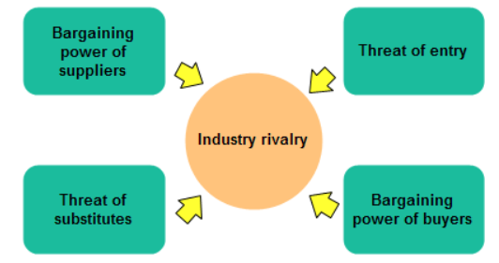
Figure 2: Porter’s Five Forces Framework
Source: (wondershare, 2023).
Bargaining power of customers: This implies the power of the buyers or the customer to influence the price. A small number of customers means that the customers have the power to negotiate and get the deals as per their desire.
Competitive rivalry: It implies the prevailing competition of the company. It is one of the most relevant factors to be considered by every company before making a final decision. Thus, the company should consider the degree of competition that exists in India and develop its strategies to deal with the same fairly (Kharub & Sharma, 2017).
Bargaining power of suppliers: This force entails the power of the suppliers that impact the cost of inputs. It depends on the number of existing suppliers in the country. Therefore, if there are a smaller number of suppliers, the company will heavily depend on the supplier and vice versa (Gubbi, 2015).
Porters Diamond
This model points out those factors that reflect the competitive advantage of one economy over the other one. It resembles the shape of a diamond and encompasses four factors namely firm strategy, structure and rivalry, demand conditions, related industries, and factor conditions.
Firm strategy, structure and rivalry: It implies that a high degree of competition leads to an increased level of production and technological innovations. Further, it is influenced by the high degree of competition, concentration of market power, and ability of rival firms.
Demand conditions: These refer to the nature and size of the customer for the products of the companies in a particular country. This further driver improvement in the product and innovation (Pawar & Veer, 2016).
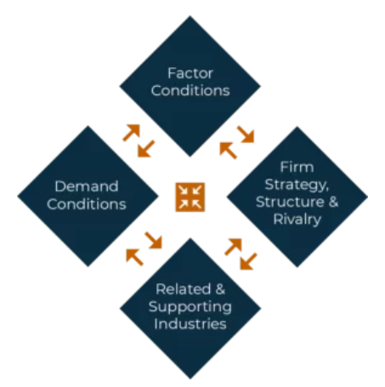
Figure 3: Porter’s Diamond
Source: (SlideTeam, 2023).
Related industries: It takes into account the downstream and upstream industries to facilitate innovations through the exchange of ideas. It can also spur innovations based on the transfer of knowledge and transparency level. The market scale will increase due to more innovations (Tsiligiris, 2018).
Factor conditions: This factor is considered to be the most important one and this implies those factors that believe that a country can itself create the required factors like technological innovation, capital, infrastructure, and skilled labour.

Evaluation of the opportunities and challenges
It is hereby evaluated that there are vast opportunities for the company to start its production facilities in India as the population of India has been increasing rapidly. Moreover, the labour cost in India is very low. The proposed commencement of the production facilities in India will generate more employment and can contribute to the economy of the country.
However, it will have to face several challenges that relate to the regulatory framework of India, as it will have to conduct its operations as per the framework laid down by the authority. Further, the other challenges include differences in cultures, languages, etc. This may be resisted by the employees of the company who have been transferred to India as they may not accept the Indian culture (Mezzadri & Srivastava, 2015).

Management of important aspects in India
It is imperative for every company operating in India to follow corporate governance practices to ensure that it complies with the laws of the land, and follows ethical and moral values and principles in letter and spirit. It also reflects that the company should ensure that its production is conducted in such a manner that ensures the optimum utilization of the resources thereby maintaining its effectiveness and efficiency. Almost every company in India takes into account the theories relating to the business environment that include among others Porter's five forces framework, PESTLE analysis, SWOT analysis, and many others that reflect the companies regarding various important factors that have a major bearing on its business operations (Prajogo, 2016).
In addition, the major problem that every company faces in India is that it fails to account for cultural differences. This implies the differences relating to religions, castes, nationality, sex, gender, education, etc. Therefore, the company should recognize the cultural issues as these are very sensitive before deciding to move its production facilities to India. Therefore, it should be endeavoured by the company to reduce these differences through effective communication and laying down policies and procedures about these issues.
For instance, several companies including Netflix, Microsoft, and Zappos changed their culture from a hierarchical model to an innovative, and agile one that emphasizes freedom and responsibility, thereby fostering a culture of empathy, inclusion, and diversity (Machery, et al., 2017).

Analysis of barriers experienced by foreign countries in India
Several foreign companies have expanded their operations to India to establish their presence in the global market and to capture every market to derive more profits. However, the benefits they can by the expansion are also accompanied by various barriers that are important to be recognized to avoid any surprises and losses at a later stage. These include cultural sensitivity issues that fail to accommodate the foreign and Indian employees and hence this leads to a reduced level of productivity.
For instance, MG Motors established a unit for manufacturing in Gujarat. However, several operational barriers came its way that included problems with the distribution network and continuity of the supply chain between red green, and orange zones. Further, the company assured its employees of their safety and rendered them the necessary training.

Strategies and Recommendations
The company should develop necessary strategies before commencing its production facilities in India that include making the employees aware of the culture of India and respecting the same. Further, it needs to understand the perspectives and attitude of the Indian employees and workers to retain them to ensure that they can realize their full potential and adds the necessary value to enhance production. Further, it should also ensure that the company has obtained the necessary licensing and permits to start its production unit in India. For this, it is often preferred to incorporate the company as a private limited company. Further, it should also frame a diversity, inclusive, and equality policy to consider these aspects are recognized by the company (Nölke, et al., 2015).
Furthermore, it is hereby recommended that the company should understand the culture of India and ensure that it will be able to minimize the negative impacts, if any, and maximize the positive ones. It should acknowledge that there is a world of difference between the cultures, legal and regulatory framework, economy, attitudes, and behaviour of the people two countries. In addition, it should also analyze the Porter diamond, Porter's five forces model, SWOT analysis, PESTLE analysis, and various other theories and models to understand the business environment of India clearly and unambiguously. This will further help the company to develop its plans and strategies accordingly. Therefore, the company should thoroughly research the market it proposes to enter for its expansion of business activities to make sure that it has clearly understood all the necessary aspects to ensure that it is fit for the said purpose. It should be borne in mind that patience, consistent follow-up, due diligence, strategic planning, and commitment are paramount for conducting any business operations in India. Further, its efforts should be such that aims to address languages, and cultures, and contribute to economic development.

Conclusion
It can be concluded by considering all the above points that the company can commence its production facilities in India due to a vast number of available opportunities in terms of low production costs, low labour costs, and increasing rate of population. Moreover, the Indian economy is considered to be a stable one to commence business operations. However, the analysis suggests that the company needs to take into account the challenge that may be posed by the company in the proposed commencement of production. Further, the analysis of various models and theories have been conducted and it depicts that the company should consider the political, legal, regulatory, environmental, social, and economic aspects of the business environment of India to understand the Indian aspects clearly and unambiguously.

References
Agnihotri, R., Trainor, K.J., Itani, O.S. and Rodriguez, M., 2017. Examining the role of sales-based CRM technology and social media use on post-sale service behaviors in India. Journal of Business Research, 81, pp.144-154 https://d1wqtxts1xzle7.cloudfront.net/58027056/Social_CRm-libre.pdf?1545212782=&response-content-disposition=inline%3B+filename%3DExamining_the_role_of_sales_based_CRM_te.pdf&Expires=1693079103&Signature=OK1uqlSCJhiXhp4sySjvDhtLPq4LZmkl0Fb7wufXiqp2zODFkryoY81rhat6BQndSsR1osQC~1R8m2H-Pqd0-mvJ28~XYxcNIyBcPe~dIHVnZD~kQJBYBK7rfPpW105HyeOv3-PqqsddMp-crEJIlAFjbnenTiV~p4qoXovU86B16ig58MFoV5Tmgl-ZH2hURyB845eNa13A4GrSax4c7-DwpQpkCsyzScC-dmQskG5-RzAEUn4Rs5MgscNxKboHTonu2ybu4matI00fOXQNmUhBxGP-Cb4q8up29aV1~67xLCZIYdRTXf4zFzSmRN0hK1Dn5tIG5x7M1eBaz2mxCA__&Key-Pair-Id=APKAJLOHF5GGSLRBV4ZA
Bhatia, J., 2016. Porter's Five Forces Industry Analysis of Indian Passenger Car Industry. Pacific Business Review International, 8(7), pp.113-123 http://www.pbr.co.in/2016/2016_month/January/13.pdf
Chalkhill Blue., 2023. The Chalkhill Blue Tool Kit. [ONLINE]. Available at: https://chalkhillblue.org/blogs/our-tool-kit/ [Accessed on 26th August, 2023].
EMBA Pro., 2023. How to Conduct a PESTLE Analysis. [ONLINE]. Available at: https://www.ibisworld.com/blog/3-step-pestle-analysis/99/1127/ [Accessed on 26th August, 2023].
Gubbi, S.R., 2015. Dominate or ally? Bargaining power and control in cross-border acquisitions by Indian firms. Long Range Planning, 48(5), pp.301-316 https://pure.rug.nl/ws/portalfiles/portal/98628605/Dominate_or_ally_Bargaining_power_and_control_in_cross_border_acquisitions.pdf
Isabelle, D., Horak, K., McKinnon, S. and Palumbo, C., 2020. Is Porter's Five Forces Framework Still Relevant? A study of the capital/labour intensity continuum via mining and IT industries. Technology Innovation Management Review, 10(6) https://timreview.ca/sites/default/files/article_PDF/TIMReview_2020_June%20-%203.pdf
Kharub, M. and Sharma, R., 2017. Comparative analyses of competitive advantage using Porter diamond model (the case of MSMEs in Himachal Pradesh). Competitiveness Review: An International Business Journal, 27(2), pp.132-160 https://www.researchgate.net/profile/Manjeet-Kharub-3/publication/313573949_Comparative_analyses_of_competitive_advantage_using_Porter_diamond_model_the_case_of_MSMEs_in_Himachal_Pradesh/links/5f1d611fa6fdcc9626b39225/Comparative-analyses-of-competitive-advantage-using-Porter-diamond-model-the-case-of-MSMEs-in-Himachal-Pradesh.pdf
Lang, M., 2021. Introduction to the law of double taxation conventions. Linde Verlag GmbH https://www.ibfd.org/sites/default/files/2021-08/20_007_Introduction_Law_Double_Taxation_Conventions_3rd_edition_final_web.pdf
Nölke, A., Ten Brink, T., Claar, S. and May, C., 2015. Domestic structures, foreign economic policies and global economic order: Implications from the rise of large emerging economies. European journal of international relations, 21(3), pp.538-567 https://d1wqtxts1xzle7.cloudfront.net/82799948/1354066114553682-libre.pdf?1648459257=&response-content-disposition=inline%3B+filename%3DDomestic_structures_foreign_economic_pol.pdf&Expires=1693078857&Signature=Wa7FGVIZcGGk63p-4Owynl9lUmpTLHqIHYKfdsbS6siYpaw-9q7MTW~wNH9Qq9ZB1aGf8b~rnGWkKtT2Eij5uLAPd6IUhyMddhpLKXNanLCZsvAgF14XZHfRDShLYRV5NT5UJaWgbji-cqZhE16ezSWbBY9L55Q1u-ZLcchffKb9lw0F2p-psoXEXktSn2h2X5GVVybD0nrO1ZzfkK02C-916iigjZc7xY~cOIQNEs6532LPTo2IN30WUUhDsF0ohYwaAbyM0zeLhazgX5xNv55oz9j206OT8F6T5OixbzhqnDCsk0hQhMI0fTkfnmgXXl~HrRgp8SnFCBUlYesqUA__&Key-Pair-Id=APKAJLOHF5GGSLRBV4ZA
Pawar, P. and Veer, N., 2016. Competitive Advantage of India for FDI in Retail: A Porter's Diamond Approach. In Competitive Advantage of India for FDI in Retail: A Porter's Diamond Approach: Pawar, Prafulla| uVeer, Nitin. [Sl]: SSRN https://www.zbw.eu/econis-archiv/bitstream/11159/299104/1/EBP075224925_0.pdf
Prajogo, D.I., 2016. The strategic fit between innovation strategies and business environment in delivering business performance. International journal of production Economics, 171, pp.241-249 https://e-tarjome.com/storage/panel/fileuploads/2019-03-03/1551598962_E11869-e-tarjome.pdf
Rastogi, N.I.T.A.N.K. and Trivedi, M.K., 2016. PESTLE technique–a tool to identify external risks in construction projects. International Research Journal of Engineering and Technology (IRJET), 3(1), pp.384-388 https://www.researchgate.net/profile/Manoj-Trivedi-2/publication/363640549_PESTLE_TECHNIQUE_-A_TOOL_TO_IDENTIFY_EXTERNAL_RISKS_IN_CONSTRUCTION_PROJECTS/links/6326de560a70852150026dfc/PESTLE-TECHNIQUE-A-TOOL-TO-IDENTIFY-EXTERNAL-RISKS-IN-CONSTRUCTION-PROJECTS.pdf
Sridhar, R., Sachithanandam, V., Mageswaran, T., Purvaja, R., Ramesh, R., Senthil Vel, A. and Thirunavukkarasu, E., 2016. A Political, Economic, Social, Technological, Legal and Environmental (PESTLE) approach for assessment of coastal zone management practice in India. International Review of Public Administration, 21(3), pp.216-232 https://d1wqtxts1xzle7.cloudfront.net/56931817/india-libre.pdf?1530781077=&response-content-disposition=inline%3B+filename%3DInternational_Review_of_Public_Administr.pdf&Expires=1693078402&Signature=Rdqh5GGJ4-S-qa2362ngJQOSqKpp8KVDZPg85sRPmzYckDhPDmP3fE-PZIao0R-EdtjBvKG-F5Gh8c8-y1s7U1D07tCBQLVy7X9kA6zU6vFs~jI5qR1s4lEN~4hcglT9m0YPuc~rqgYy3zAR37uiJEjvSQsOOw8z0WfRzaWiWAis3uLEtMNRT5WBJe9-dqBgAbQdYMWiyyTfQJXPOiyh4xE8cEb3uYOhlcmJswFfnXZMulP5fsa-gwx6CGfp2lMKRSoRimlJWoTYIE9sAZ3KwoAWZ53tK7uKBNRiK4Uz1DY1Jyu4SG26kWgr5mnoXNHdi7zwM1Av0mrOmwAeM8akEg__&Key-Pair-Id=APKAJLOHF5GGSLRBV4ZA
Tsiligiris, V., 2018. An adapted Porter Diamond Model for the evaluation of transnational education host countries. International Journal of Educational Management, 32(2), pp.210-226 https://irep.ntu.ac.uk/id/eprint/32739/1/PubSub10258_700a_Tsiligiris.pdf
Wondershare., 2023. Porter’s Five Forces Analysis. [ONLINE]. Available at: https://www.edrawsoft.com/five-forces-chart.html [Accessed on 26th August, 2023].

