Canada Tourism Review by Michael Harvey (1803239)






Introduction

Occupying a land-mass of 9.985 million km², Canada is a large and proud country. Our culture is unique and the country is comprised of British, French and Native Canadian heritage. This report aims to promote Canadian tourism and offer a glimpse into our spectacular country.
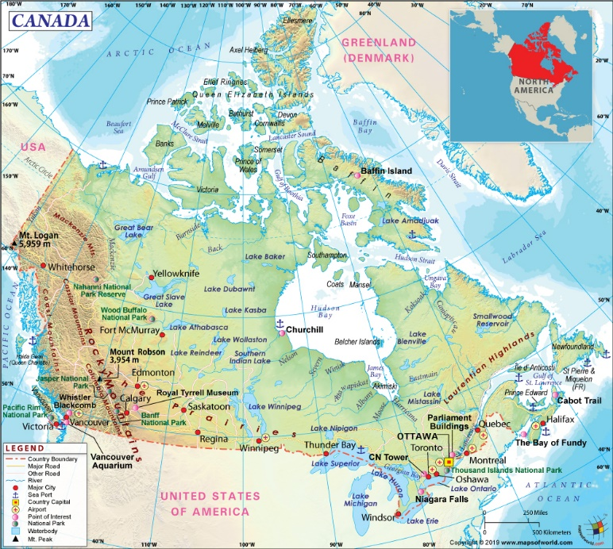

Source – Maps of the World

Transport

Without reliable transportation methods, Canada would not be able to run a tourism industry at all. Due to our innovation, Canada boasts one of the most efficient and far reaching transport systems in existence.

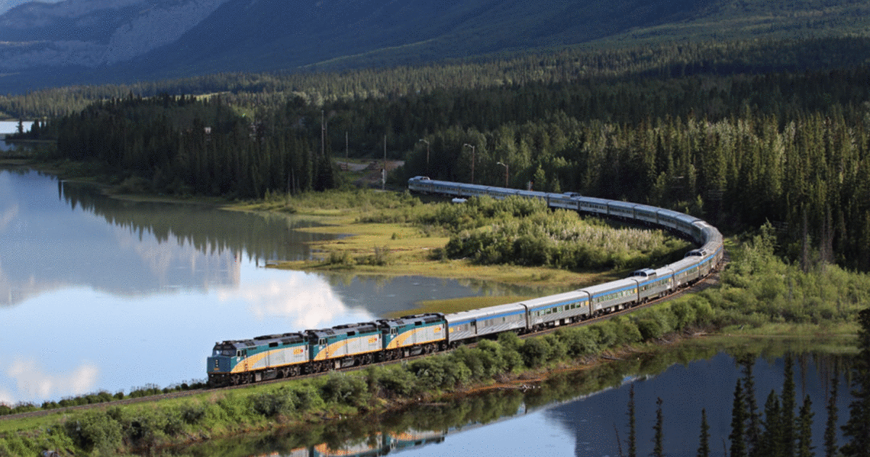
Source – Narcity.com

VIA Rail Canada operates an extensive network of railway services and passenger trains across the country. Due to the size of Canada, many of the train services are sleeper trains which can provide an alternate way of travelling across Canada and viewing our incredible scenery. A journey of note includes the famous Great Western Way which connects Vancouver and Toronto. As observed by Via Rail (2020) this trip between “two cotemporary cities” has been described as near perfect because it takes passengers into the heart of Canada. During the journey, visitors will experience the monumental Canadian Rockies and unspoiled nature reserves. At certain points, the beauty of Canada’s wildlife will be evidenced as passengers will be able to see bald eagles, moose and bears. With the luxurious sleeper accommodation and unforgettable views, VIA Rail’s trains have a unique selling point which will not be matched by any other country.

Amtrak, the United States’ rail operator also operates a service to Canada. Every day, the famous Maple Leaf Express runs from Toronto to New York City via Niagara Falls, Ontario. One of Amtrak’s most important trains, this historical service is a symbol of the everlasting union between Canada and the United States. As reported by Amtrak (2020), the journey lasts over 12 hours. While this may seem like a long time compared to a flight, it serves a different market entirely. The international train service will appeal to rail enthusiasts as the Amtrak service uses traditional, streamlined passenger cars and the conductors are friendly and they enjoy having like-minded individuals onboard their services.


Source -Michael Harvey (Author)

In the skies, Canada is well connected with Air Canada, the largest Canadian airline and provider of high-end international flights. As the flag carrier, Air Canada is an ambassador for the country to foreign markets and great care is taken to align the airline with our government’s ethos. For a more cost-effective option, Air Transat also fly to international destinations. There is another player in the Canadian aviation industry whose rapid expansion is set to be a game-changer -West Jet. Fun, footloose and free, the low-cost airline seeks to provide good value for money for domestic tourists.

A tale of two destinations

Due to Canada’s enormous size, it would be impossible to cover all of our wonderful destinations in a brief report. Therefore, it has been decided that the review will cover two destinations -Niagara Falls, Ontario and Vancouver, British Columbia. These have been chosen with variety in mind as one resides on the west coast (Vancouver) and the other on the east coast (Niagara Falls) of Canada.

Niagara Falls

Niagara Falls is a “melting pot” for adventures, sightseeing, attractions, culture and many other types of tourism. There is definitely something for everyone and tourists will be spoilt for choice when they visit one of Canada’s most beloved destinations. According to the official Niagara Falls website (2019), the tourism revenue generated at the destination is worth $2.4 billion, a staggering total which highlights the enduring popularity of Niagara. In 2017, around 12.9 million people visited the destination and Niagara Falls (2019) listed several reasons why they chose to visit the falls. 60% of people came to the falls seeking a pleasurable experience which would suggest that many tourists are looking to fulfil the need for self-gratification based on Freud’s theory when they visit Canada. As a multifaced destination, there are several different areas to visit, all of which are very pleasurable.
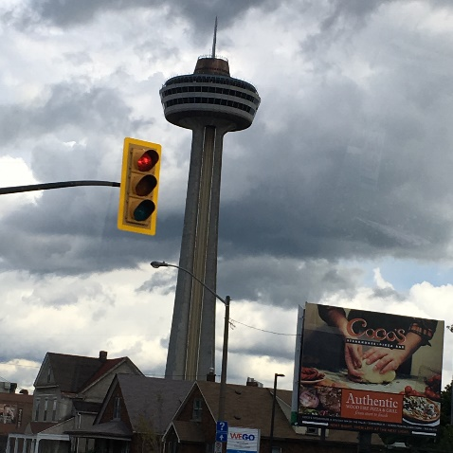



Source -Images by Michael Harvey (author)

The titular Niagara Falls is the most well known and important attraction. An impressive feat of nature, the falls are famous for their beauty and magnificence. The falls straddle the U.S. -Canada border and each country owns one. According to Niagara Parks (2020), over 6 million cubic ft of water pours over the falls every minute. Although the falls can easily be seen from a vantage point, Canada offers boat tours to its dedicated fall- the Canadian Horseshoe Fall. Visitors board the famous Hornblower boat and are greeted by copious amounts of mist when they get close to falls. Tourists can also view the falls in a daring abseiling mission. The appropriately named Mistrider zip wire gives customers a grandstand view of the falls as they fly through the air. The futuristic Skylon tower is also a great place to watch the never-ending stream of water due to its height and dedicated observation decks.

Clifton Hill focuses on the attractions side of tourism with a myriad of arcades, shops, restaurants and cinemas. With major brands such as Sheraton, IHop and Burger King being well represented, Clifton Hill will appeal to the mass tourist. Fans of music and delicious food will enjoy the Niagara Falls branch of the world-renowned Hard Rock Café, which has been open for over two decades. The Hard Rock Café’s appeal is broad as it can also appeal to the niche tourist. Dedicated fans will travel across the globe to visit of all the different Hard Rock properties, which include casinos and hotels as well as the iconic cafes. The hospitality side of the Hard Rock Café is also important as often, the servers take on the role of unofficial ambassadors and can provide a glimpse into the local scene and culture.


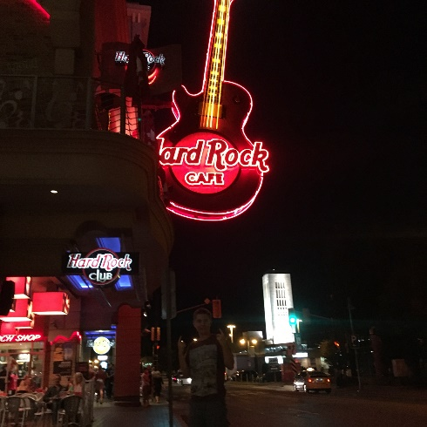

Source -Images by Michael Harvey (author)
Classifying different types of tourists is useful when trying understand why people visit certain places. Cooper (2005) discusses Stanley Plog’s theories on the personality of different tourists. According to Plog, there are two extremes. A psychocentric tourist can be described as anxious, reluctant to try new experiences and will usually choose to go on the same type of holiday over and over again. On the flipside, an allocentric tourist actively seeks out new and exciting destinations. It could be argued that Niagara Falls is a “safer” destination for psychocentric tourists. Although there is provision for allocentric tourists with the natural wonders and adventure style zipwire, Niagara Falls will mostly appeal to psychocentric tourists due to the influx of recognisable chains and stock-standard accommodation such as Marriott owned Sheraton On the Falls. Niagara Falls is also ingrained into popular culture which will also appeal to psychocentric tourists as they know what to expect. For example, Niagara Falls has been featured in many films (both on the American and Canadian side) including Superman II (1980) and according to Marriott (2014), other notable films such as Niagara (1953) Camille (2008) also filmed key scenes at the falls. Torkildsen (1999) suggests that popular culture is marketed towards middle class nations like the United States, United Kingdom and Japan. Therefore, it can be assumed that the majority of foreign visitors to Niagara Falls will be from these countries.

Vancouver

Vancouver is truly a city of diverse and rich cultures. Film tourism is well catered for with the highly regarded Vancouver International Film Festival. As observed by Tourism Vancouver (2020), the festival attracted over 140,000 film enthusiasts and 4000 industry experts, an impressive total which highlights how niche tourism can develop into something larger. An event of this scale also benefits local businesses due to a massive increase in tourists, thus boosting Vancouver’s regional economy. Another important part of Vancouver’s culture is the theatre. Due to the stunning weather, performances often take place outside. As reported by Lonely Planet (2008), a Shakespeare themed festival on the Vancouver waterfront has been increasing in popularity. The Bard on the Beach performance demonstrates that Vancouver’s cultural scene has strong focus towards the outdoors and this may appeal to allocentric tourists, who may be looking for a unique and energetic performance within a new environment as the plays use Canada’s raw beauty as scenery instead of an enclosed theatre.

On the whole, Canada is committed to the exchange of cultures, particularly within the French-Canadian community. Although Vancouver is over 2000 miles away from Quebec, the French language is celebrated in every territory of Canada. As stated by the Office of the Commissioner of Official Languages (2020) there are French-Canadian themed events and festivals all across British Columbia. In June, Vancouver hosts the Festival d’ete Francophone, a popular and fashionable event which celebrates the long-standing diversity in Canada.

Sport and Adventure Tourism

As observed by Torkildsen (1999), activity-based leisure has been on the rise since the early 1980s and Canada is no exception. Lonely Planet (2008) reports that British Columbia is a hotspot for thrill seekers looking to try their hand at a new activity. Watersports, hiking and camping have all become extremely popular. The rugged landscape of British Columbia lends itself well to adventure tourism and the sense of isolation can be very satisfying. Paddle boarding across a wide lake amongst the mountains and forests has to be one of the memorable experiences a tourist could ask for.

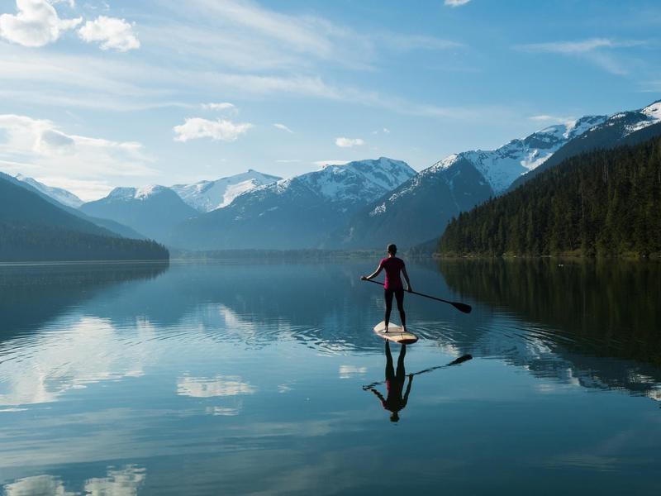
Source -Far and Wide

Participating in adventure tourism may fulfil the need for self-actualisation based on Maslow’s hierarchy of needs. Torkildsen (2005) refers to Maslow’s theories and it could definitely be said that doing sporting activities makes a person more complete individual. Torkildsen (1999) suggested that people may be searching for an identity through leisure and adventure tourism. He noted that the rise in tri-athletes, climbers, fitness fanatics and ski enthusiasts is no coincidence and they are all looking for a brand-new experience which will improve their mental health as well as the physical. Torkildsen (1999) also mentions that Maslow referred to this as a “peak experience” (pg 91) as often, the leisure seekers try to find the most immersive and thrilling activity e.g. off piste skiing. Using both Torkildsen and Maslow’s theories, it could be said that adventure tourists seek out new destinations as a way of self-actualisation and to carve out an identity. This identity is strongly tied to the enrichment and well-being which comes from participating in sport related activities. The so called “athletes high” is well documented and leisure enthusiasts may gain a sense of satisfaction from visiting extreme locations, pushing their bodies to the limit and discovering who they really are.

Issues facing tourism in Canada.

Although Canada is sometimes seen as the premier North American destination, there are problems with how the tourism industry operates in the country. Canada is not on the WTO top 10 destinations list. However, this could be seen as a positive as it may suggest that Canada is an emerging market. As described the BBC (2020), Butler’s product life-cycle is a way of plotting the lifespan of a particular destination or country in terms of tourism. Canada could still be at the consolidation stage which means that expansion is still very much possible.

As outlined by the Tourism Industry Association of Canada (2020), Canada levies a tax on foreign visitors, making it one of the only countries to do so in the entire world. The tax may alienate potential visitors and deter them from travelling to Canada. While this tax does have some negative points, the revenue generated is essential to the local economy and the usefulness of the tax should not be underestimated as the funds could be used to improve the tourism provision in Canada.

The representation of ethnic minorities and indigenous cultures is also issue which Canada needs to face when discussing tourism. The culture of native Canadians is truly special and it should be promoted as a unique selling point to attract visitors. Lonely Planet (2008) reports that over 50 languages are spoken amongst the aboriginal people in Canada, demonstrating that Canada’s indigenous culture is diverse and needs to be preserved.

People forget that a number of natives still practice their customs and their traditional way of life has remained unchanged across the centuries. As noted by Archer (2020), New Zealand has successfully integrated The Maori culture into the its tourism industry. Canada could follow a similar model where the indigenous cultures are given more attention to promote tourism. As Lonely Planet (2008) notes, the promotion of aboriginal tourism will benefit the natives as they can share their culture with a new audience and at the same time, receive a substantial financial benefit. Allocentric tourists will enjoy this kind of experience as they may consider it to be a “truer” form of tourism. For the past couple of years, Canada has been making steps in the right direction. The establishment of Nunavut territory meant that the rights of Native Canadians has been at the forefront of Canada’s tourism agenda.

2137 Words

References

Archer, B. (2020) ‘Our Home And Native Brand’ [Online] Available: https://nationalpost.com/features/canada-has-a-tourism-problem-that-can-only-be-fixed-by-embracing-indigenous-culture Accessed 2020, March 6th.

BBC. (2020) ‘Changing patterns of Tourism’ [Online] Available: https://www.bbc.co.uk/bitesize/guides/z2nnqty/revision/2 Accessed 2020, March 6th.
Cooper : Cooper C, Fletcher J et al (2005), Tourism Principles and Practice (3rd Edition), England: Pearson Publication
Lonely Planet. (2008) Canada. 10th edn. Victoria: Lonely Planet Publications
Marriott. (2014) ‘Top 5 Niagara Falls Movies’ [Online] Available: https://www.marriottonthefalls.com/blog/2014/09/04/top-5-niagara-falls-movies/ Accessed 2020, March 6th.
Niagara Falls. (2019) ‘New report shows tourism impact on Niagara’s economy’ [Online] Available: https://niagarafalls.ca/news/281-new-report-shows-tourism-impact-on-niagara-s-economy.news Accessed 2020, March 6th.
Niagara Parks. (2020) ‘Niagara Falls Geology Facts and Facts’ [Online] Available: https://www.niagaraparks.com/visit-niagara-parks/plan-your-visit/niagara-falls-geology-facts-figures/ Accessed 2020, March 6th.
Office of the Commissioner of Official Languages. (2020) ‘The French presence in British Columbia’ [Online] Available: https://www.clo-ocol.gc.ca/en/statistics/infographics/french-presence-british-columbia Accessed 2020, March 6th.
Torkildsen, G. (1999). Leisure and Recreation Management. London: E & FN Spon.
Torkildsen, G. (2005) Leisure and Recreation Management. London: E&FN Spon Publisher
Tourism Industry Association of Canada. (2020) ‘The Issues’ [Online] Available: https://tiac-aitc.ca/The_Issues.html Accessed 2020, March 6th
Tourism Vancouver. (2020) ‘Arts and Culture’ [Online] Available: https://www.tourismvancouver.com/activities/arts-culture/ Accessed 2020, March 6th.
VIA Rail Canada. (2020) ‘The Great Western Way’ [Online] Available: https://www.viarail.ca/en/explore-our-destinations/trains/rockies-and-pacific Accessed 2020, March 6th.

