Estates / Location management
Hospital example

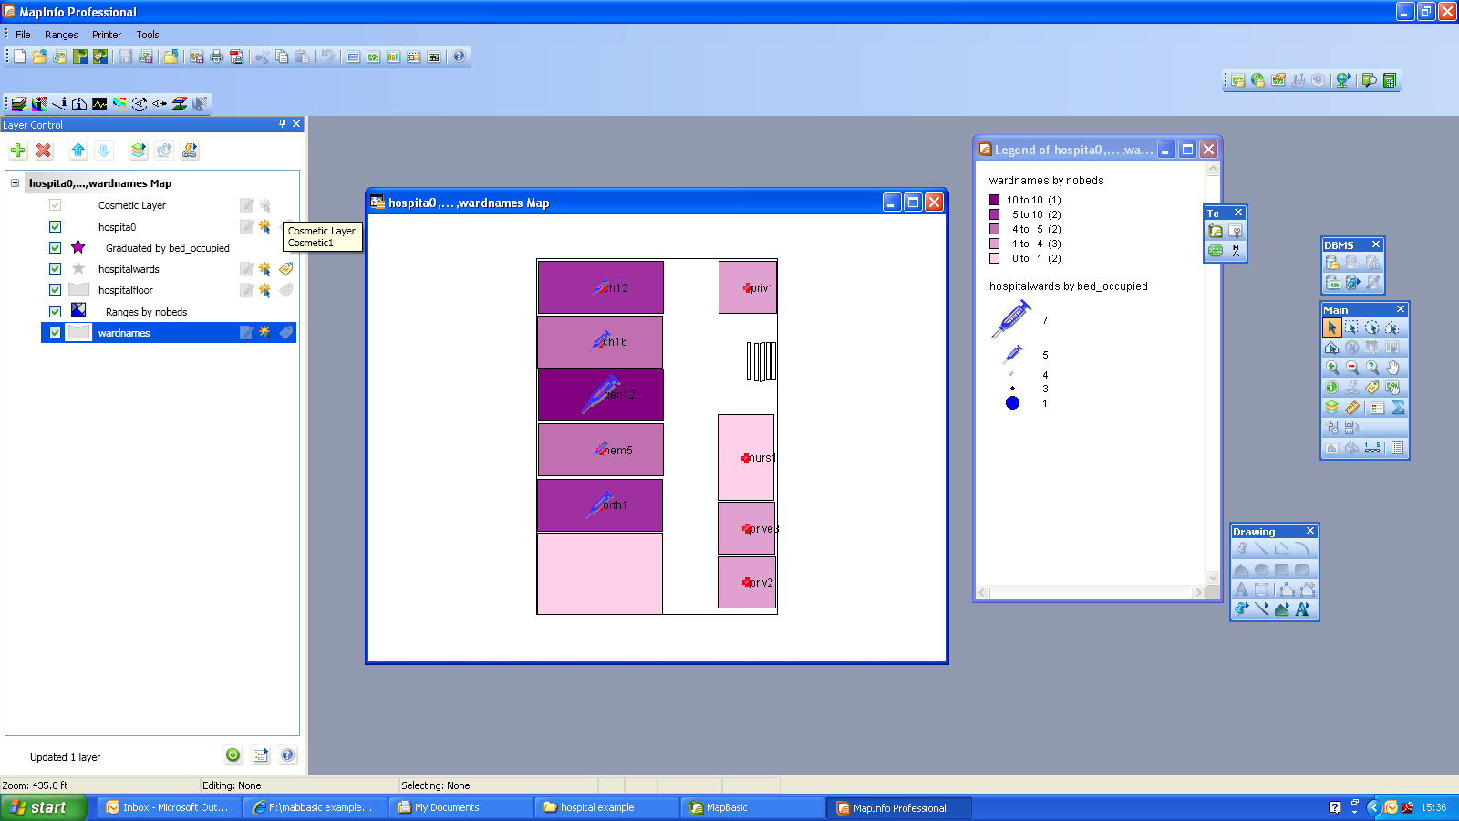

The following program used a table created in .dxf format and imported into MapInfo. IT demonstrated how we can use MapBasic to help with estates management or location service management.

'** Include header files

Include "mapbasic.def"
Include "menu.def"
Include "icons.def"

Declare Sub Main

Declare Sub Newmen
Declare Sub ByeBye
Declare Sub NoRange
Declare Sub Range1
Declare Sub Range2
Declare Sub ChangeRange
Declare Sub HideRangeBut

' Integer variables for layers

Dim PrevRange,CurrentRange as integer

' Creates a new menu by removing all parts of the original menu not required

Sub Newmen

Create Menu Bar as "File","Ranges","Printer","Tools"
Create Menu "File" As
"Exit hospital Wards" Calling ByeBye,
"Run Map Basic Program" Calling M_FILE_RUN

Create Menu "Ranges" As
"No Ranges" Calling NoRange,
"number of beds" Calling Range1,
"beds occupied" Calling Range2
Create Menu "Printer" As
"Page Setup" Calling M_FILE_PAGE_SETUP,
"Layout" Calling M_WINDOW_LAYOUT,
"Print" Calling M_FILE_PRINT

end sub

' Closes program and reverts to old menu

Sub ByeBye
CLOSE ALL INTERACTIVE
Create Menu Bar as Default
end sub

' changes the range layer ie move up and down the layers to change view

Sub ChangeRange
Set Map
Layer PrevRange
Display off
Set Map
Layer CurrentRange
Display Value
end sub

' Hides the range layer

Sub Norange
PrevRange=currentRange
CurrentRange=0
Set Map
Layer PrevRange
Display off
end sub

' Range layer conrol

Sub Range1
PrevRange=CurrentRange
CurrentRange=1
Call ChangeRange
end sub

Sub Range2
PrevRange=CurrentRange
CurrentRange=2
Call ChangeRange
end sub

The rest of the code comes from the workspace that you save

Sub Main

PrevRange=0
CurrentRange=0

Open Table "wardnames" As wardnames Interactive
Open Table "hospitalfloor" As hospitalfloor Interactive
Open Table "hospitalwards" As hospitalwards Interactive
Open Table "hospita0" As hospita0 Interactive
Add Column "wardnames" (nobeds) From hospitalwards Set To nobeds Where COL1 = COL1 Dynamic
Map From hospita0,hospitalwards,hospitalfloor,wardnames
Position (0.0520833,0.0520833) Units "in"
Width 6.59375 Units "in" Height 5.10417 Units "in"
Set Window FrontWindow() ScrollBars Off Autoscroll On
Set Map
CoordSys NonEarth Units "ft"
Center (105.2120965,146.2090768)
Zoom 435.8330069 Units "ft"
Preserve Zoom Display Zoom
Distance Units "ft" Area Units "sq ft" XY Units "ft"
Distance Type Cartesian
shade 4 with nobeds ranges apply all use color Brush (2,8388736,16777215)
0: 1 Brush (2,16765160,16777215) Pen (1,2,0) ,
1: 4 Brush (2,14721232,16777215) Pen (1,2,0) ,
4: 5 Brush (2,12611760,16777215) Pen (1,2,0) ,
5: 10 Brush (2,10498208,16777215) Pen (1,2,0) ,
10: 10 Brush (2,8388736,16777215) Pen (1,2,0)
default Brush (2,16777215,16777215) Pen (1,2,0)
' # use 1 round 0.1 inflect off Brush (2,16776960,16777215) at 3 by 0 color 1 #
shade 2 with bed_occupied graduated 0.0:0 7:36 Symbol (103,3158271,36,"MapInfo Miscellaneous",33,0) vary size by "CONST"
Set Map
Layer 1
Display Graphic
Label Line Arrow Position Right Font ("Arial",0,9,0) Pen (1,2,0)
With ID
Parallel On Auto Off Overlap Off Duplicates On Offset 2
Visibility On
Layer 2
Display Value
Selectable Off
Layer 3
Display Graphic
Label Line Arrow Position Right Font ("Arial",0,9,0) Pen (1,2,0)
With ward
Parallel On Auto On Overlap Off Duplicates On Offset 2
Visibility On
Layer 4
Display Graphic
Label Line None Position Center Font ("Arial",0,9,0) Pen (1,2,0)
With ID
Parallel On Auto Off Overlap Off Duplicates On Offset 2
Visibility On
' Object 1 Anchor (109.687458500036,107.651905647846)
Layer 5
Display Value
Selectable Off
Layer 6
Display Graphic
Label Line None Position Center Font ("Arial",0,9,0) Pen (1,2,0)
With ID
Parallel On Auto Off Overlap Off Duplicates On Offset 2
Visibility On
set legend
layer 2
display on
shades off
symbols on
lines off
count off
title auto Font ("Arial",0,9,0)
subtitle auto Font ("Arial",0,8,0)
ascending off
ranges Font ("Arial",0,8,0)
auto display off ,
"0" display off ,
"1" display on ,
"3" display on ,
"4" display on ,
"5" display on ,
auto display on
set legend
layer 5
display on
shades on
symbols off
lines off
count on
title auto Font ("Arial",0,9,0)
subtitle auto Font ("Arial",0,8,0)
ascending off
ranges Font ("Arial",0,8,0)
auto display off ,
auto display on ,
auto display on ,
auto display on ,
auto display on ,
auto display on
Set Window FrontWindow() Max
' Name "hp deskjet 3820 series" Orientation Portrait Copies 1
' Papersize 9
Create Cartographic Legend
Position (7.58333,0.208333) Units "in"
Width 2.79167 Units "in" Height 5 Units "in"
Window Title "Legend of hospita0,...,wardnames Map"
Portrait
Frame From Layer 5
Border Pen (0,1,0)
Frame From Layer 2
Border Pen (0,1,0)
Set Window FrontWindow() Printer
' Name "hp deskjet 3820 series" Orientation Portrait Copies 1
' Papersize 9

Call Newmen

end sub

Location management of the UNI site

We could try to do the same thing with the UNI site. We have created a table from a selection off master map. We need to edit the table structure and choose a spatial reference. We could add a table that would pick the points and place the x,y coordinates for them using centroidx or centroidy

EG

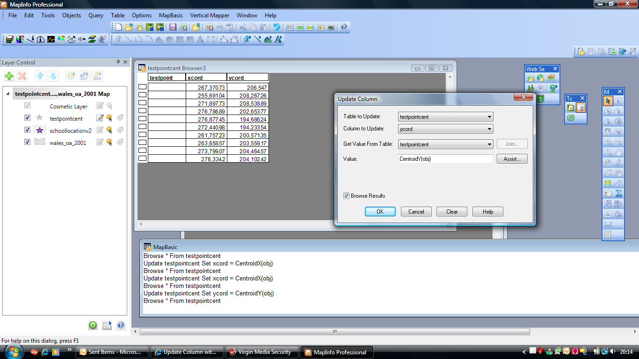

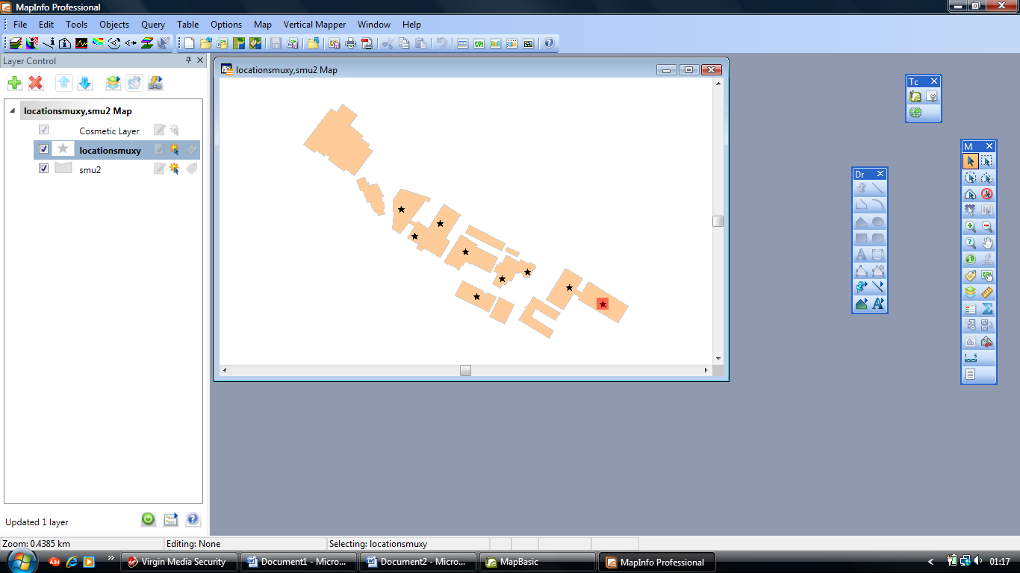

include "mapbasic.def"
declare sub main
type nodelist
fltx as float
flty as float
end type
sub main
dim objSel as object
dim intRow,intCounter,intNumNodes,intCounter2,intFWin, intNumpoly as integer
dim fltBegx,fltBegy,fltEndx,fltEndy as float
dim logFirstRow,intFirstRow as logical
dim nlist(1) as nodelist
dim strTabname,strLname as string
dim i as integer
intRow = SelectionInfo(sel_info_nrows)
if intRow = 0 then
note "No lines were selected."
end if
intFirstRow = True
intFWin = FrontWindow()
strLname = LayerInfo(intFWin,0,layer_info_name)
for i = 1 to intRow
if intFirstRow = True then
fetch first from selection
else
fetch next from selection
end if
objSel = selection.obj
for intNumpoly = 1 To ObjectInfo(objSel, OBJ_INFO_NPOLYGONS)
intNumNodes = ObjectInfo(objSel,obj_info_npolygons+intNumpoly)
redim nlist(intNumNodes)
for intCounter2 = 1 to intNumNodes
'Array is populated with Longitude a nd Latitude coordinates.
nlist(intCounter2).fltx = ObjectNodeX(objSel,intNumpoly,intCounter2)
nlist(intCounter2).flty = ObjectNodeY(objSel,intNumpoly,intCounter2)
print "x="+nlist(intCOunter2).fltx+"y="+nlist(intCounter2).flty
insert into strLname (obj)
values(CreatePoint(nlist(intCounter2).fltx,
nlist(intCounter2).flty))
next
next
logFirstRow = False
next
end sub

