Professional Career Development Module (BMSW 4005)
Reflective portfolio

Jazmin Dawes
Student Number: 2015980
Lectura: Betsy Jose

Contents Page
Page 3: Introduction
Page 4: Cover Letter / Interview Skills
Page 5: SWOT Analysis
Page 6-7: Personal Development Plan
Page 7: Career Development Plan
Page 7: Progression routes in my career
Pages 8-9: Skills required to be an ‘Effective’ Manager in a care home
Page 10: Assess the concepts you have learned from this module
Page 11: Employment Laws
Page 12: Learning Styles
Page 13: Self Awareness Tools
Page 14: Gibbs Reflection Cycle
Page 15: Conclusion
Page 16-17: Appendix
Page 18: References
Page 19: References

Introduction
Within this reflection I will look at what I have learned through this module for example how to create a CV, cover letter and interview skills. I will also discuss the feedback on received from my lecturer, the different tools that I have learned like SWOT, CDP, PDP and how I can use these tools in my future life. This reflection will look at the skills need for management and the gaps that I have within these areas and how I can fill those gaps. I will discuss the knowledge I have learned from goals and objectives, employment laws, learning styles and self-awareness tools.

Cover Letter writing skills
The primary role of a cover letter is to give a self-evaluation that incorporates methods such as strengthening the individual's skills and knowledge and exhibiting their passion in a certain post (Hou, 2011, p. 5).
Reflecting on what skills I have learned through this module, firstly I would say that learning the format of how a cover letter is put together and the key elements that must be included to support my CV to better give myself a chance of being called for an interview. Gaining these skills have given me more insight on what the employer is looking for and how to best sell myself to give me the best chance of being asked for an interview which I can now use in the future applications that I may apply for.
Interview Skills
Interviews are used to obtain information and assess character. During a job interview, the company initially chooses those candidates that appear to be worthwhile meeting (Corfield, 2009, p. 2).
Skills that I have also gained further knowledge on is interview skills and how to prepare for them and what questions may be asked and how to best answer the questions. My previous experiences with interviews have always had me feeling nervous and anxious about what to say and what they may ask and by learning from this module the Interview skills and the mock interview have grown my knowledge and understanding and given me more confidence in these areas.
Reflecting on the feedback I received from my interview skills and my CV, my interview feedback was good highlighting that I had prepared well for the interview and completed appropriate research into the company overall my interview was successful with me being offered the job in the chosen field and a score of 78%. Areas in which I need to improve on is to change a little of the layout of my CV as certain areas were cluttered paragraphs which needs to be changed to bullet points.

SWOT Analysis
SWOT analysis, a popular planning technique, is a kind of brainstorming. Strengths and weaknesses are internal (manageable) elements that help or hinder a company's ability to execute its objective. Opportunities and Threats, on the other hand, are external (unmanageable) elements (Phadermrod, Crowder and Wills, 2019, p. 2.1).
I have used a SWOT analysis to evaluate my own personal strengths and weakness and opportunities and threats below is my SWOT and I have Identified what I need to work on with my weaknesses and what to look out for regarding the threats and how to try and avoid them.
Figure 1
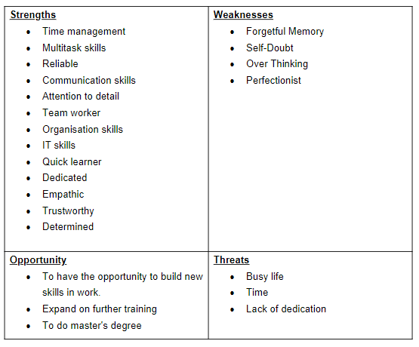

PERSONAL / PROFESSIONAL DEVELOPMENT PLAN
A PDP is an assessment tool used by employees to reflect on and to document the achievements and progress you have made and to also plan for the next steps of progression for further development in your life (Beausaert, Segers and Gijselaers, 2011).
Below is a PDP that I have created planning what development I want to make in my future and a time scale as to when to achieve these goals, creating this PDP has helped me to have a plan and a timescale to keep me focused and determined to reach the goals that I have listed.
Figure 2

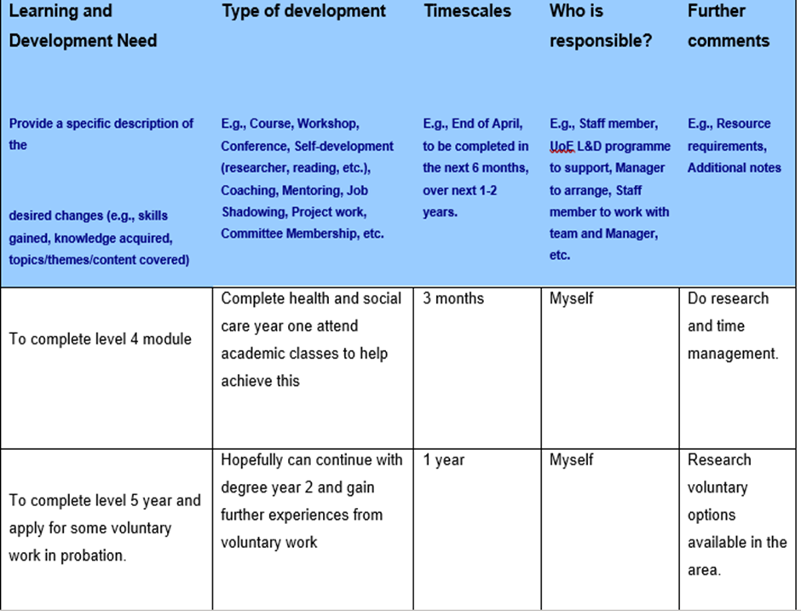
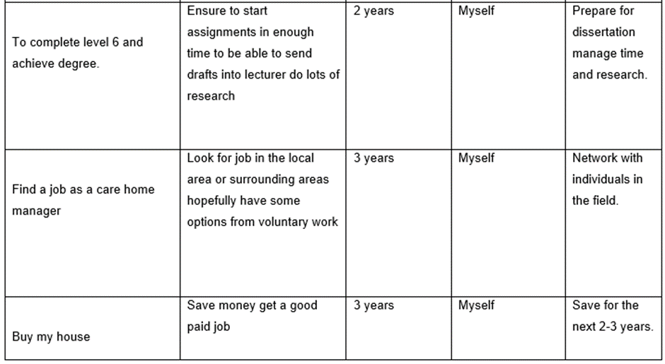

My Career Development Plan
I have a created a career development plan see appendix figure 3 to set out a plan of how I am going to grow in my career and set out what qualifications and experiences I need to go up the ladder in management and a timescale in which to complete.

Progression routes in my Career
Progression in my career can be a varied in different management areas within care from clinical manager, operational manager to a consultant manager from completing the rest of this course and gaining my level 5&6 and even completing my masters can open the doors to many roles and I can enhance this by voluntary work also to gain experience.

Skills required to be an ‘Effective’ Manager in a care home
Effective management skills you require are to have to be able to handle the various aspects of running a home, you'll need leadership skills. When the team faces problems or obstacles, the care manager leads by example. Leaders are responsible for leading their teams to victory (Goppe and Galloway, 2017, p. 4-5). Ability to maintain good levels of care while controlling expenses are critical components of a manager's job, and a decent leader must be able to inspire and grow personnel (Curtis and O'Connell, 2011).
The gaps that I have currently regarding leadership is that I have no experience with leading a team currently and would need to apply for a shift leader role to gain these skills and could shadow current shift leaders to learn from whilst on the job I can follow my CDP to fill the gaps.
Referring to CQC (2021) and their quality's that they expect a manager to have discuss the need to have a good character and communication skills. A manager must have the knowledge for the role and have earlier experience have competence to update all Care Plans/care records policy and audit care records in line with policy to guarantee compliance. Managers also need to have the right qualifications for the role.
The gaps that I have with the skills that CQC state a manager should have been that I do not have experience with updating care plans and auditing care records, or knowledge of a manager's role or the duties and responsibilities. I also do not currently have the qualifications that you need to be a manager and would need to complete my level 5&6 in health and social care degree and to also gain experience by applying for deputy manager roles.
Management is learned by knowledge in the field, and by understanding the problems and opportunities that come with management. Managers are introspective, professionals who are acutely aware of their own conduct, beliefs, and practises, as well as the influence they have on their co-workers (Walshe and Smith, 2011).
Gaps that I have identified with this skill is I'm not yet a professional who is aware of the full conduct or knowledge of management or how to lead a team and direct co-workers. To gain knowledge and experience in these areas I can apply for voluntary work and shadow management in the company, look at shift leading and senior roles to familiarize myself leading a team. Completing my degree will give me further confidence in being a professional and supply me with the tools needed in management to maintain a company's foundations and culture.

Assess the concepts you have learned from this module
Setting goals and Objectives
Setting goals and objectives from early on can help assist you later in your manager role as it can help you deal with budgets and deal with reaching goals for the company that you are working for. Setting goals and objectives helps outline what you need to achieve and how to go about doing this to improve your company and highlight what areas to focus on for success (Macleod, 2012).
SMART stand for strategic/ specific, Measurable, Attainable, Result based, Timebound. Every one of these factors are included into a SMART goal of supporting you reach your goals and boost your probability of victory. (O'Neill et al. 2006,)

From the learning in this module, I have set my own goals and objectives in appendix figure 3 by creating a CDP to set out goals and objectives in my professional career to increase the chances of success.
I have also created a PDP to outline what I want to achieve in my personal life also, if you look a figure 1 my PDP shows what I want to achieve and the steps in need to take, having this plan gives me guidance to look at to keep myself focused.

Employment Laws

A concept that I have learned through this module has been learning what the employment laws are and how they protect you in your working environment.

Employment rights apply to all individuals in employment legislation, an individual's employment status influences their rights and the duties of their employer (Taylor and Emir, 2015).

Employment law covers several areas here are some of the areas covered, Health and Safety, Holiday pay and entitlement, Working time, Employment contract, Maternity and parental rights, Discrimination, Terms and conditions of employment, Recruitment, Data protection, Discipline and grievance,

Here are some of the laws I have learned that are covered in the employment Law:
- The Data Protection Act 2018 is the UK’s implementation of the General Data Protection Regulation (GDPR). Everybody liable for utilizing individuals' information needs to adhere to severe guidelines (The Data Protection Act, 2018)
- The Equality Act 2010 lawfully shields individuals from segregation in the working environment and more extensive society. It changed past laws with one Act, making the law clearer and reinforcing security. It sets out the various manners by which it's unlawful to treat somebody (Equality Act guidance, 2010).
- Employment Rights Statute of 1996: This act, is an update to earlier Workplace Laws, protects employees' rights in instances like termination, wrongful dismissal, paternity leave, maternity leave, and redundancy (GOV.UK, 2021).

Learning Styles
Kolb’s learning style is made up of four stages Experience, Reflect, conceptualise and plan. An individual's favoured style is influenced by a variety of things, for instance, the individual`s background, academic skills, or underlying cognitive structure (Mcleod, 2017).
Honey and Mumford's learning style is formed by creating a questionnaire for individuals to be able to see what they're learning style is and how they prefer to learn. The advantages of recognising and establishing your chosen learning style and putting this information into practice encourages the person and develops their grasp of their viewpoint and learning style (Aljaberi, 2015).

Reflecting on this module I completed an activity in week 2, the questionnaire that Honey and Mumford created, and my results are below:
Personality type: Protagonist (ENFJ-A)
As a protagonist I prefer to learn whilst being shown what to do like working on the job, which is true, I find that I learn much easier and quicker when doing the job. Before completing this questionnaire, I was unaware I had a learning style and from this module I have now discovered this which I can use in the future.

Self-awareness tools
Johari Window is a ground-breaking theory that offers practical advice on how to improve interaction by increasing self-awareness and perspective. Johari Window is a unique tool which allows us to examine how we perceive ourselves and how people we are around perceive us. It serves as an example for establishing various channels of interaction with those around. It demonstrates how, as we become comfortable with individuals, we release personal information and grow quite friendly to people around you (Saxena, 2015).
Human conduct is fundamentally based on personality. An individual's personal engagement and interests are influenced by their personality. To determine somebody's personality, individuals can take a personality test (Pratama and Sarno, 2015).
Reflecting on what I have learned from the self-awareness tools in this module is that I completed an activity to fill out Johari windows questionnaire and my family member also filled out questionnaire answering questions about myself, and the results were that I am a seeker and found out skills that I can improve myself awareness. I completed another activity in which I also filled out a personality test and my results was that I am a protagonist.

Gibbs Reflection Cycle

Reflection is critical for learning evaluation is regarded as a fundamental tool, since it encourages contemplation. Gibbs' reflective cycle is a 6-stage conceptual model which is used to promote reflection (Husebø, O' Regan and Nestel, 2015).
I have used Gibb's cycle to reflect on what I have learned through this module.
Figure 3
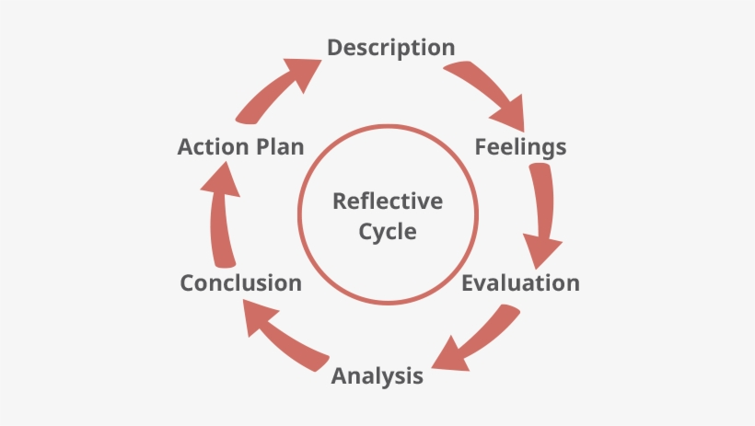
(Gibbs Reflection cycle model, 1998)

Conclusion
This reflection paper has identified what I have learned through this module and the knowledge I have learned through creating CDP, PDP, SWOT I have been able to set out a plan for both my personal life and career path and the swot has identified my strengths, weakness, opportunities, and threats.
I have identified what skills you need to be a manager and what skills I need to attain. I have reflected on the knowledge I have gained from learning about setting goals and objectives, learning styles and the use of self-help tools that help me reflect on what i want to achieve in and put in place a plan to do it.

Appendix
CAREER DEVELOPMENT PLAN
CURRENT JOB- Support Worker
TITLE- Bank HCA
DESCRIPTION- Assisting individuals with day-to-day care and supporting them with their personal care
GOAL JOB- Care Home Manager
COMPANY- Private Care/ NHS
DESCRIPTION- Registered Manager
Figure 4

GOAL (SMART) | SKILLS | GAPS | RESOURCES | ACTION | STATUS
Short Term (1 Year)  1 Complete Health and social care degree level 4 | Complete assignments at correct time | To complete 3^{rd term} and pass assignments | Time management, Multitasking | Do appropriate research for assignments hand in on time. | Completed 1st and 2nd term awaiting to complete final term
2.Starting a new HCA job | Care certificate | Completed care certificate but need to complete mandatory training when in the post | Time, Training | Complete all required training | Awaiting
Mid Term (Within 2 Years)  1.Complete 2nd year level 5&6 | Complete the 3 terms in both years | Take lectures and attend study skill | Time management, Study and research | Complete and pass modules assigned | On going
2. Apply for progression in work for senior role | Complete on the job training and gain experience | Gain experience | Apply for on-the-job training | Complete all training required | Awaiting
Long Term (3 to 5)  Voluntary | Look into skills needed to become a care home manager | Identify what training needs to be done to achieve this | Need time to complete this apply for jobs networking with individuals who are in the field | Look online for appropriate voluntary roles | Ongoing
2. Apply for care home manager roles | Look for positions online | Identify what training needs to be done to achieve this | Time to find position and complete training | Networking with individuals in the industry for vacances. | Ongoing

References

Beausaert, S., Segers, M. and Gijselaers, W., 2011. ‘The use of a personal development plan and the undertaking of learning activities, expertise-growth, flexibility and performance: the role of supporting assessment conditions’. Human Resource Development International, [online] 14(5). Available at: <https://www.tandfonline.com/doi/abs/10.1080/13678868.2011.620782> (Accessed 29 November 2021).
Corfield, R., 2009. Successful Interview Skills How to prepare, Answer tough questions and get your ideal job. 5th ed. [ebook] London: Kogan Page, p.2. Available at: <https://books.google.co.uk/books> (Accessed 23 November 2021).
Curtis, E. and O'Connell, R., 2011. ‘Essential leadership skills for motivating and developing staff’. Nursing Management, [online] 18(5). Available at: <https://journals.rcni.com/nursing-management/essential-leadership-skills-for-motivating-and-developing-staff-nm2011.09.18.5.32.c8672> (Accessed 27 November 2021).
Goppe, N. and Galloway, J., 2017. Leadership and Management in Healthcare. 3rd ed. [ebook] London: SAGE publications Inc, pp.4-5. Available at: <https://books.google.co.uk/books?hl=en&lr=&id=GRgjDgAAQBAJ&oi=fnd&pg=PP1&dq=management+healthcare&ots=R5Psz8xKA4&sig=N0SJZUBvM5v0ge28hE-RzyD_XjQ#v=onepage&q=management%20healthcare&f=false> (Accessed 21 November 2021).
GOV UK, 2021. Employment Status. [online] Available at: <https://www.gov.uk/employment-status/worker> (Accessed 29 November 2021).
GOV.UK. 2010. Equality Act 2010: guidance. [online] Available at: <https://www.gov.uk/guidance/equality-act-2010-guidance> (Accessed 29 November 2021).
GOV.UK. 2018. The Data Protection Act. [online] Available at: <https://www.gov.uk/data-protection> (Accessed 29 November 2021).
Hou, H., 2011. ‘A Contrastive Rhetoric Analysis of Internship Cover Letters Written by Taiwanese and Canadian Hospitality Majors’. International Journal of Linguistics, [online] 3(1), p.5. Available at: <https://citeseerx.ist.psu.edu/viewdoc/download?doi=10.1.1.1003.8063&rep=rep1&type=pdf> (Accessed 13 November 2021).
Husebø, S., O' Regan, S. and Nestel, D., 2015. ‘Reflective Practice and Its Role in Simulation’. ScienceDirect, [online] 11(8), pp.368-375. Available at: <https://www.sciencedirect.com/science/article/abs/pii/S1876139915000389> (Accessed 7 December 2021).
legislation.gov.uk. 1970. Equal Pay Act 1970. [online] Available at: <https://www.legislation.gov.uk/ukpga/1970/41/section/1/enacted> (Accessed 29 November 2021).
Macleod, L., 2012. ‘Making SMART Goals Smarter’. ProQuest, [online] 38(2), pp.68-70. Available at: <https://www.proquest.com/openview/259baaca492d360bcf2d0fcf02b684eb/1?pq-origsite=gscholar&cbl=36212> (Accessed 2 December 2021).
Mcleod, S., 2017. ‘Kolb's Learning Styles and Experiential Learning Cycle’. Simply Psychology, [online] Available at: <https://midatlantic.compact.org/wp-content/uploads/large/sites/61/2021/04/Kolb-Learning-Styles-Website.pdf> (Accessed 4 December 2021).
Phadermrod, B., Crowder, R. and Wills, G., 2019. ‘Importance-Performance Analysis based SWOT analysis’. International Journal of Information Management, [online] 44, pp.2.1. Available at: <https://www.sciencedirect.com/science/article/pii/S0268401216301694?> (Accessed 18 November 2021).
Pratama, B. and Sarno, R., 2015. ‘Personality classification based on Twitter text using Naive Bayes, KNN and SVM’. International Conference on Data and Software Engineering (ICoDSE), [online] pp.170-174. Available at: <https://ieeexplore.ieee.org/abstract/document/7436992> (Accessed 5 December 2021).
Saxena, P., 2015. ‘JOHARI WINDOW: An Effective Model for Improving Interpersonal Communication and Managerial Effectiveness’. SIT Journal of management, [online] 5(2), p.2. Available at: <https://d1wqtxts1xzle7.cloudfront.net/57905519/journal13-with-cover-page-v2.pdf? (Accessed 5 December 2021).
Seekpng. 1998. Gibbs Reflection cycle model. [online] Available at: <https://www.seekpng.com/ipng/u2w7u2a9y3q8o0a9_gibbs-reflective-cycle-model-explained-gibbs-reflective-cycle/> (Accessed 7 December 2021).
Taylor, S. and Emir, A., 2015. Employment Law. 4th ed. [ebook] Hampshire: Ashford Colour Press. Available at: <https://books.google.co.uk/books?hl=en&lr=&id=VrK6BwAAQBAJ&oi=fnd&pg=PP1&dq=employment+law+uk&ots=2xjdJVqTNF&sig=cQ5YRPD2mcknaqL3PdC8Sg_UEzc#v=onepage&q=employment%20law%20uk&f=false> (Accessed 29 November 2021).

The independent regulator of health and social care in England’. 2021. Care Quality Commission. [online] Available at: <https://www.cqc.org.uk/> (Accessed 23 November 2021).

Walshe, K. and Smith, J., 2011. Healthcare Management. 2nd ed. [ebook] Glasgow: Bell & Bain, p.1. Available at: <https://books.google.co.uk/books?hl=en&lr=&id=_TRFBgAAQBAJ&oi=fnd&pg=PR7&dq=healthcare+management+what+skills+do+you+need+&ots=zrb4QCWJA9&sig=dQkW9COMzMZMcoEWYoHG51quX8s#v=onepage&q=healthcare%20management%20what%20skills%20do%20you%20need&f=false> (Accessed 26 November 2021).

