Create strategies to support inclusive classroom practice and a reflection of their effectiveness in the classroom’ (4,000 words).
Inclusive education has become a central focus in contemporary educational policy and practice, both in Wales and internationally. Its aim is to remove barriers to learning by promoting equitable opportunities for all learners and ensuring that diversity is valued rather than marginalised. Reflecting the principles of the Salamanca Statement’s vision of “schools for all” (UNESCO, 1994), Wales has demonstrated a strong commitment to reform through the introduction of the Additional Learning Needs and Education Tribunal (Wales) Act. This legislation establishes a new statutory framework for supporting learners with Additional Learning Needs, signalling a significant shift toward a more inclusive and learner-centred approach (Welsh Government, 2018). For this shift to be successful, it is essential that all pupils can access common learning opportunities in ways that support their individual needs, and that all stakeholders are meaningfully involved in the decision-making processes that shape this provision. When implemented effectively, such practices can enhance overall wellbeing—particularly learners’ sense of belonging and being valued, their self-worth, autonomy, ownership, and independence (Estyn, 2024). Despite this intention however, the inconsistencies currently present across Wales are hindering the full implementation of the ALNET Act. As highlighted by Odeh and Lach (2024), many barriers to inclusive education remain, including attitudes towards inclusion, inaccessible environments, ineffective communication, a shortage of staff training, and unclear policies.
Overview of Setting
According to Welsh Government data, the average percentage of children with ALN in mainstream schools is 11.2%, however some areas, namely Powys have an average percentage of 19.6%, much higher than that of the national average (Welsh Government, 2024). Based in Powys, Brynllywarch Hall School is a state special school split across two sites, one at the North of Powys in Newtown and one in the South in Ystradgynlais. Of its 95 pupils aged 7-19, 95% of learners have ALN, the majority of those with a local authority maintained IDP, 35% of learners are FSM. Inclusivity is central to the practices of Brynllywarch Hall School. As implied in its vision, its focus is on providing a ‘fresh start’ to enable the pupils to take their place in society as lifelong learners. Through robust communication systems with all stakeholders, quality teaching and nurture, pupils are designed and provided a highly personalised curriculum in line with the objectives set within the Curriculum for Wales. These bespoke education opportunities offered reflect the governments’ ongoing commitments to promoting a person-centred practice (Welsh Government, 2015) and provide numerous opportunities for the learners to enjoy a rich and diverse curriculum as well as a plethora of purposeful learning activities which focus on their individual strengths and interest. As stated by Gray (2021), the implications of such an ethos can centre the voices and experiences of SEMH pupils and potentially improve their engagement, behaviour and wellbeing.
Brynllywarch Hall School’s philosophy and policies around inclusion centres primarily around teacher attitude and approach and as a result it invests heavily into the professional development of all staff. With thorough consideration for the concerns raised by Knight et al. (2022) regarding the potential for teacher attitude being a real barrier to inclusive practice, the school aims to bridge the gap and alleviate tensions between what is perceived as ideals and realities by ensuring staff are equipped with the most research backed and contemporary approaches to supporting ALN learners. However, as suggested by Knight et al. (2022) the lack of coherent and consistent policy and guidance in Wales lend itself towards risking inclusive practice to be more of a political aspiration than a reality in the classroom, this is true of Brynllywarch Hall School, whereby difficulties remain present. Despite the school’s heavy investment in staff and its focus on enabling what is deemed a suitable environment and curriculum for all learners, the continued emphasis on progression often leads to deficit framing and therefore continues to put ALN learners at risk of further exclusion in practice.
Implementing inclusive strategies using reflective practice models.
With inclusive practice in Wales at risk of becoming aspirational rhetoric, I aim to show how my own practices demonstrate inclusion as rather a lived reality. The pupils within the class I teach consists of 6 pupils aged 8-11. Each of these has an IDP with 2 of these children recognised as being CLA with LA maintained IDP. Of the 6 children, all have a diagnosis of Neurodivergence, and each have several adverse childhood experiences or recognised Pathological Demand Avoidance pertaining to complex behavioural and emotional profiles. The strategies implemented in the class aim to ensure the children can access learning activities and make progress across each progression stage. By implementing the strategies noted in this essay, I aim to remove both emotional and academic barriers identified for each pupil. To support the critical examination of both the success and limitations of my strategies, I will use Gibbs’ (1998) Reflective Cycle which encourages systematic exploration of experiences through description, evaluation, analysis and action planning. Through this cycle of reflection, I hope to show a thorough consideration of how the practices noted influence learners’ access, participation and wellbeing.
Intentional Design of the Classroom Environment
Critical Incident, Description of Strategies and Rationale
The first inclusive strategy implemented within my classroom was the intentional design of the physical learning environment. Due to the complexity and diversity of learners’ profiles, it became increasingly evident that the classroom environment I inherited was not conducive to meeting pupils’ academic, emotional, or sensory needs. The classroom reflected a traditional model, with desks arranged in rows and learners expected to remain seated for extended periods while completing tasks independently. Each child was positioned facing away from their peers, significantly limiting opportunities for collaboration, communication, and peer interaction.
As the satellite site in Ystradgynlais was a relatively new setting, still in its early stages of development, limited consideration had been given to purposeful classroom design. This appeared to have a tangible impact on the learners, contributing to increased negative behaviours, disengagement, and missed opportunities for the development of social skills and positive relationships. Learners frequently demonstrated reluctance to engage with activities and, in some cases, an apparent apathy towards learning and school more broadly. These observations prompted critical reflection on whether the physical environment was supporting not only academic progress but also learners’ emotional wellbeing and overall development.
Research indicates that classroom layout can significantly influence learner engagement, motivation, and participation. Maintaining pupils in rows without considering the impact of seating and spatial organisation can result in learning becoming a rigid and predictable process, often overlooking learners’ strengths and preferred ways of working (Fisher, 2023). Conversely, environments that promote autonomy and self-direction have been shown to support deeper engagement and enhanced learning outcomes.
Barrett et al. (2017), in their exploration of the holistic impact of classroom spaces, argue that pupil-centred individualisation fosters greater engagement and commitment to learning. Key elements of this include flexibility, ownership, and responsiveness to learners’ perspectives. This aligns with Deci and Ryan’s (1985, as cited in Storey, 2025) self-determination theory, which suggests that learners thrive when three psychological needs are met: competence, autonomy, and relatedness. Classrooms that allow freedom of movement, access to resources, and meaningful choice are more likely to promote self-directed and intrinsically motivated behaviour. Intentional classroom design therefore supports both learning and motivation, making educational experiences more meaningful and personalised.
The redesign of my classroom began with a structured observation of how learners interacted with the existing environment. This was supported by pupil voice questionnaires and teacher observations, enabling the identification of which areas of the classroom were most frequently used and how preferences varied across subjects and activities. Clear patterns emerged. During writing tasks, learners tended to gravitate towards tables positioned near staff, often preferring to work alone or in pairs where direct instruction and reassurance were available. In contrast, creative subjects such as Art and Technology saw pupils choosing to work standing at worktops or collaboratively on the carpet. These preferences appeared linked to feelings of vulnerability associated with creative expression, with learners seeking smaller, more private spaces to manage discomfort and uncertainty.
Engagement levels were notably higher in Mathematics when learners could work on the carpet or in small groups supported by staff. Similarly, during Digital Competence Framework (DCF) lessons or one-to-one tasks involving iPads or laptops, pupils consistently selected informal, quiet areas with soft furnishings and reduced lighting. In these contexts, learners were more able to tolerate proximity to peers, and interactions, while limited, were noticeably more positive.
These observations align with Salend’s (2015, cited in Storey, 2025) assertion that seating arrangements should be adapted to subject matter, as classroom organisation has a significant impact on interaction and engagement. Salend suggests that smaller group arrangements support peer relationships and cooperation, while row seating may be beneficial for brief teacher-led instruction or whole-class discussion. Similarly, Bassey and Ogobi (2021) highlight the effectiveness of semi-circular seating arrangements in promoting freedom of movement, improved teacher–learner interaction, and cooperative learning, all of which are key features of inclusive environments. While they note potential challenges in larger classes where individual needs may be harder to meet, this was not a limitation within my setting due to the small class size.
In addition to observational methods, the Leuven Scale of Wellbeing and Engagement (Main, 2021) was implemented to evaluate the impact of the classroom environment on learners’ emotional state and involvement in learning. The Leuven Scale is widely used in inclusive and early years contexts to assess the quality of learning environments, rating pupils on a five-point scale from low to high levels of wellbeing and engagement. This tool provided structured insight into how environmental changes influenced learners’ experiences and supported ongoing reflective evaluation of the classroom design
Evaluation and Analysis of the Strategies
Following initial observations, targeted changes were made to the seating arrangements and overall layout of the classroom. Although desks arranged in rows facilitated ease of movement for staff, this configuration did not create the warm, inclusive environment required to engage this particular cohort of learners. Research suggests that semi-circular or grouped seating arrangements are more effective in fostering cooperation, communication, and a sense of community, while also making more efficient use of classroom space (Patton et al., 2001, as cited in Bucholz and Sheffler, 2009).
For my class, the introduction of semi-circular desk arrangements supported more intimate learning interactions, which proved particularly beneficial for pupils requiring high levels of support. Many of these learners present with Pathological Demand Avoidance (PDA) profiles and therefore benefit from personalised, low-demand approaches that incorporate collaboration with trusted adults, flexibility, creativity, and opportunities to influence their own learning. This seating arrangement enabled staff to provide targeted support while maintaining learner autonomy. As a result, there was a noticeable reduction in anxiety, alongside increased resilience and motivation. These outcomes align with research highlighting the importance of safety, autonomy, and trusted relationships in supporting learners with PDA profiles (Behaviour Help, 2025).
Reconfiguring the desks into a semi-circular layout also created additional space within the classroom, allowing for the development of alternative working areas. These included increased usable floor space, the introduction of standing desks, and the incorporation of soft furnishings within a designated calm and quiet area. All spaces were purposefully designed with learners’ sensory, emotional, and learning needs in mind. Olsson and Hansson (2025) suggest that furniture can play a significant role in enabling students to self-regulate their physical, psychological, and learning needs. Observations within my classroom supported this, particularly in relation to pupils’ vestibular and proprioceptive needs and how different furniture choices influenced levels of arousal and engagement.
Recent research has identified dynamic seating as an effective intervention for supporting neurodivergent learners, particularly through the use of standing desks and stability balls, which can facilitate self-regulation and increase time on task (Bagatell et al., 2017). In my setting, pupils with Autism Spectrum Condition (ASC) frequently displayed self-stimulatory behaviours such as pacing, rocking, and flapping. When given autonomy to choose their preferred workspace, these learners consistently selected standing desks. This choice was associated with a reduction in self-stimulatory behaviours and a corresponding increase in sustained engagement. Alternative interventions, including wobble cushions and chair bands, had limited impact, likely due to their perceived restriction of movement compared to the freedom afforded by standing desks.
In contrast, another pupil with ASC and a PDA profile responded more positively to the introduction of a cushioned chair. This learner experiences significant sensory processing differences and was observed to benefit from tactile and deep-pressure input when overstimulated. Due to over-responsiveness in vestibular and proprioceptive systems, a more stable seating option was selected to support regulation. The pupil also demonstrated a preference for working seated on the carpet, a strategy often recommended to increase proprioceptive input. Following this adjustment, the learner was able to remain calm and engaged for longer periods. Sadr et al. (2017) suggest that stable seating reduces the need for postural muscle activity, allowing learners to focus cognitive resources on learning rather than balance, thereby decreasing arousal levels.
These contrasting responses highlight the importance of individualisation and learner autonomy within inclusive classroom design. While dynamic seating and opportunities for movement can be regulating and motivating for some learners, they may result in sensory overload and dysregulation for others. Providing choice enabled each learner to identify and access the environment that best supported their needs.
The impact of these environmental adaptations was evidenced through the use of the Leuven Scale of Wellbeing and Engagement. As shown in Table 1, there was an overall increase in both wellbeing and engagement scores following the intentional redesign of the classroom. Although individual variation remained, no pupil scored below level 3 post-intervention, indicating a shift from low to moderate–high engagement. Prior to the changes, the majority of learners demonstrated low engagement levels (levels 1–2), characterised by task avoidance and emotional dysregulation. Post-intervention observations indicated consistent movement towards levels 3–4, with pupils displaying increased persistence, calmer affect, and greater independence.

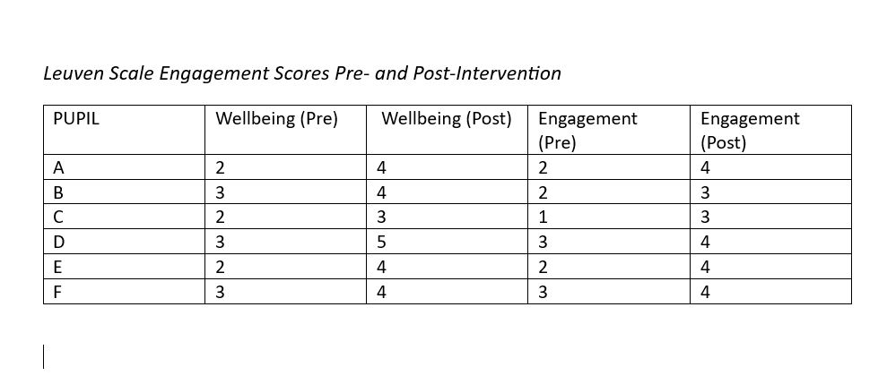

One notable example is Pupil C, whose engagement score increased from level 1 to level 3 when accessing a standing desk and quiet working area. While the Leuven Scale does not capture moment-to-moment fluctuations or external influences such as emotional state or prior experiences, triangulating this data with pupil voice and behavioural observations strengthens the validity of these findings.
Reflection:
This experience demonstrates that intentional classroom design is a critical component of inclusive education. By responding to individual needs, providing choice, and promoting autonomy, the classroom became a responsive environment that enhanced engagement, participation, and wellbeing. It highlights the importance of grounding interventions in both research and reflective practice. As suggested by Eslit (2023) there is a need for further research into the impact of intentional classroom design on specific learning contexts, therefore, moving forward there is a need for ongoing monitoring, pupil voice, and flexible adjustments will be essential to sustain and optimise the inclusive potential of the environment.

Pedagogical Approach and Adaptive Teaching
Critical Incident, description of strategies and rationale.
The impact of intentional classroom design inspired the development of my second inclusive practice. With the perceived positive effects of adapting the classroom layout on the learners it was reasonable to consider adaptive teaching as a purposeful pedagogical approach to develop within the classroom to support the learners’ progress further. As Olsson and Hansson (2025) argue, pedagogical approach is intertwined with classroom design, and both contribute equally towards the impact of the environment and motivation seen in the learners. Similarly, Cowley (2025) conceptualises the classroom as a resource for adaptive teaching, suggesting that how space is used, navigated, and organised can either enhance or limit learning. She refers to the classroom as the “third teacher”, positioning resources and pedagogy alongside the teacher in shaping learning experiences.
A growing body of research supports the view that cognitive processes are influenced not only by physical environments but also by pedagogical approaches, particularly in classrooms characterised by diverse learning profiles (Cornuault, 2025). In line with Brynllywarch Hall School’s inclusive vision, recognising individual differences and understanding diverse learning styles enables the adaptation of instructional practices while fostering a strong sense of belonging. This understanding led to the adoption of adaptive teaching, placing the learner at the centre of the learning process and enabling staff to respond flexibly to individual progress and need.
Evaluation and Analysis of the Strategies
Adaptive teaching has been identified as an effective approach for improving the quality of teaching and learning, particularly in diverse classrooms (Harvey, 2022). It involves the use of prompts, instructional support, feedback, and ongoing adjustments informed by learners’ responses. This approach was especially relevant in my classroom due to the wide range of needs present within the cohort. Observations indicated that pupils were most engaged when they were able to visualise, manipulate, and experiment with concepts. Conversely, traditional instructional methods—such as prolonged sitting, listening, and written tasks—often resulted in disengagement, heightened anxiety, and increased conflict.
One explanation for this lies in developmental neuroscience. Fisher (2023) highlights that children’s brains are still developing and therefore respond differently to learning experiences than adults. While formal instruction may be effective for mature learners, younger learners benefit more from experiential, creative, and play-based approaches. This presents both a challenge and an opportunity: although traditional classroom models may not align with how children learn best, understanding these differences allows educators to design learning experiences that capitalise on strengths rather than deficits.
Reflective consideration was also given to generational learning differences between myself, as a Millennial educator, and my pupils, who largely belong to Generation Z and Generation Alpha. Hannans et al. (2017) suggest that Millennials tend to learn effectively through collaboration, communication, and shared problem-solving. In contrast, Gen Z and Gen Alpha learners have grown up immersed in technology, resulting in preferences for highly personalised, technology-enhanced learning experiences that connect directly to their interests and strengths. These learners are often autodidactic and benefit from self-paced learning opportunities; however, without appropriate guidance, this can create barriers to accessing suitable content, necessitating teacher support to scaffold and filter learning experiences effectively (Acacia University, 2025)
Despite these generational differences, research also identifies important commonalities. Hannans et al. (2017) note that both cohorts benefit from kinaesthetic learning and from engaging with real-life contexts, which enhance relevance and motivation. By considering the neuroscience, generational influences, and complex learner profiles present within my classroom, adaptive teaching enabled learning experiences to be matched more closely to learners’ needs. This approach reduced the emphasis on content coverage alone and instead foregrounded skills, strengths, and interests, ensuring that all learners could access the curriculum and demonstrate progress regardless of prior attainment or additional needs. While the Curriculum for Wales supports this skills-based approach to some extent (Welsh Government, 2025), concerns remain regarding potential inconsistencies in curriculum coverage and challenges in assessing progress (British Educational Research Association, n.d.).
A central component of adaptive teaching within this context was scaffolding. Scaffolding involves providing structured support—such as prompts, models, or feedback—which is gradually withdrawn as learners gain independence. Jen Foster’s concept of “pathways” aligns closely with this principle. Pathways refer to structured routines and sequences designed to guide learners towards sustained engagement and active participation (Foster, 2025). Within my classroom, pathways functioned as a scaffold, breaking learning tasks into manageable stages while maintaining high expectations for all learners.
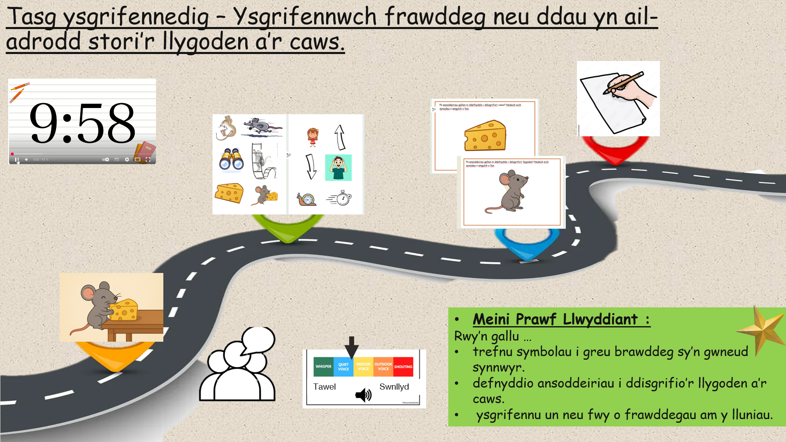

The introduction of pathways (as seen above) resulted in increased engagement and independence. By explicitly outlining expectations, required resources, and steps for completion, pathways reduced cognitive overload and uncertainty. Autonomy was a key feature of this approach; learners were encouraged to identify their own needs and make informed choices about how to engage with tasks to achieve learning goals. This was particularly significant given that many pupils displayed Pathological Demand Avoidance (PDA) profiles, where perceived demands and excessive choice can trigger anxiety and task avoidance (Kerbey, 2023). Pathways proved effective in mitigating these responses by offering structure without imposing rigid demands.
While whole-class pathways supported collective engagement, some learners required more personalised versions tailored to their specific needs. These individualised pathways supported the creation of autonomy-supportive environments, allowing learners to make meaningful choices while remaining within clear boundaries (Fisher, 2025). Additionally, pathways contributed to the development of executive functioning skills, which are often delayed or uneven in neurodivergent learners. Gopnik (2017, as cited in Fisher, 2025) argues that schools frequently fail to provide opportunities for self-control systems to develop, resulting in later difficulties with risk-taking and regulation. By encouraging planning, decision-making, and reflection, pathways supported the gradual development of these skills within a safe and supported context.
As Fisher (2025) notes, the opportunity to practise autonomy, problem-solving, and self-regulation during childhood enables learners to better manage the complex demands of adulthood. However, it remains important to balance structure with challenge. Reiser (2004, cited in Hardy et al., 2002) cautions that excessive structuring can limit engagement, while insufficient structure can lead to frustration and disengagement. In practice, adaptive teaching required ongoing reflection to ensure that learning experiences remained appropriately scaffolded while still promoting independence and critical thinking.
While the impact of adaptive teaching was largely positive, several limitations were identified. One key challenge related to the time required to design, adapt, and implement individualised pathways, particularly within the constraints of limited staffing. The availability of additional adults in the classroom was inconsistent, which at times restricted the extent to which personalised pathways could be developed and facilitated effectively. Furthermore, it became evident that for adaptive teaching strategies to have sustained impact, they need to be embedded consistently across practice rather than applied in isolation. This reflects the findings of Hardy et al. (2022), who suggest that while adaptive teaching can be effective in one-to-one and small-group contexts, it is often not implemented adaptively in everyday classroom practice. Furthermore, the limitations also suggested a wider systemic issue including the practical constraints of the classroom and workload. For this to be sustainable, it would require a wider whole school approach which supported collaboration, planning and consistency of practice, rather than reliance on individual teacher capacity.
Reflection:
Adaptive teaching, when combined with a thoughtfully designed classroom environment, facilitates meaningful engagement, autonomy, and inclusion. This approach highlights the importance of flexibility, responsiveness, and continuous reflective practice in meeting the diverse needs of learners. By balancing structure with autonomy and grounding pedagogical decisions in research and observation, adaptive teaching can support inclusive practice as a lived reality rather than a theoretical aspiration.
Application of Strategies in a Wider Context:
As both strategies were implemented within my own classroom, it was important to consider how their effectiveness could be strengthened beyond the immediate setting. Through collaborative practices—including the development of shared language and understanding, consistent implementation, and reflective dialogue with others via working groups and discussions with pupils—the strategies were positioned for longer-term impact rather than remaining isolated classroom interventions.
Initial collaboration took place primarily with the teaching assistant. As the adults working most closely with the pupils, it was essential that a shared understanding of the rationale underpinning environmental adaptations and flexible approaches to learning was established. Through professional discussion, reflective dialogue focused on observational insights into learners’ responses, enabling adaptations to remain responsive and dynamic rather than fixed. As a result, responsibility for inclusive practice was shared rather than resting solely with the class teacher.
These strategies subsequently contributed to wider professional development within the setting. Due to the developing nature of the satellite centre, there was an opportunity to embed inclusive practices as emerging norms rather than challenge established systems. Observed improvements in learner engagement and wellbeing prompted professional dialogue with senior staff regarding the potential for these strategies to be implemented more consistently across the school. This aligns with inclusive education literature, which emphasises systemic change over isolated examples of effective practice. However, as highlighted by Bandara et al. (2024), such developments raise important questions regarding contextual limitations, particularly in relation to staffing, resource allocation, physical space, and class size. In settings where budgets are constrained, these factors necessitate reflective adaptation based on professional judgement rather than prescriptive replication of strategies.
Consideration was also given to how these inclusive strategies could support parental engagement. For learners with PDA profiles, consistency between home and school is particularly important in reducing anxiety and supporting emotional regulation. In response, a parent support group, Navigating Neurodiversity, was established, offering half-termly sessions to develop shared understanding of autonomy-supportive, low-demand approaches used within the classroom. Parents reported that these sessions informed their approaches to behaviour at home, with some noting positive outcomes from offering alternative seating or working positions and structured choices. However, these discussions also highlighted the importance of clear communication to ensure that flexibility is understood as a structured, intentional approach rather than an absence of boundaries or expectations.

Conclusion:
Through this essay I have attempted to critically explore inclusive practice through focus on intentional classroom design and adaptive teaching framed using Gibbs’(1998) reflective cycle and Welsh Government policy. This reflection demonstrates how the emotional, sensory and academic barriers for learners with Additional Learning Needs can be reduced through purposeful environmental adaptations and flexible approaches and engagement, wellbeing and autonomy can be increased and improved.
Findings indicate that inclusion is effective when informed by learner voice, observations and reflective tools such as the Leuven Scale. However, there were limitations to this in terms of staffing, resources and time and therefore to be sustainable there needs to be a consistent systemic approach to inclusion. With continued reflective practice, professional judgement, collaboration with key stakeholders and a focus on adaptability, inclusive practices do have the potential to influence change and support for learners to thrive.

Acacia University (2025) How Gen Z and Gen Alpha Learn Differently and What Teachers Must Do About It. Available at: https://acacia.edu/blog/how-gen-z-and-gen-alpha-learn-differently-and-what-teachers-must-do-about-it/ (Accessed: 22 December 2025).
Bagatell, N., Mirigliani, G., Patterson, C., Test, L. & Allen, A.A., 2017. The impact of dynamic seating on classroom behavior of students with autism spectrum disorder. Journal of Autism and Developmental Disorders, 47(6), pp.1653–1664. Available at: <https://pmc.ncbi.nlm.nih.gov/articles/PMC5329757/> [Accessed 14 December 2025].
Bandara, K.M.N.T.K., Hettiwaththege, C.R. & Katukurunda, K.G.W.K. (2024) An overview of teaching methods for fostering Generation Alpha (Gen Alpha) learning process. International Journal of Research Publication and Reviews, 5(8), pp. 1446–1461. (Accessed: 22 December 2025)
Bassey, E.O. & Ogobi, N.F., 2021. Inclusive classroom arrangement and the development of social skills in early childhood care and education. Prestige Journal of Counselling Psychology, 4(1), pp.178–189.
Behaviour Help (2025) Ten effective classroom strategies for teachers supporting students with Pathological Demand Avoidance (PDA). Available at: https://behaviourhelp.com/a-z-conditions-disorders/pathological-demand-avoidance/ten-effective-classroom-strategies-for-teachers-supporting-students-with-pathological-demand-avoidance (Accessed: 13 December 2025).
British Educational Research Association (n.d.) Curriculum reform and inequality: The challenges facing Wales. Available at: https://www.bera.ac.uk/blog/curriculum-reform-and-inequality-the-challenges-facing-wales (Accessed: 22 December 2025).
Foster, J. (2025) Classroom Engagement: The Unwritten Code. London: Sage Publications Ltd
Gray, A. (2021) Person-centred planning within education: What does the research say and how can it be used to support vulnerable pupils with SEMH needs? Doctoral thesis, The University of Manchester. Available at: https://pure.manchester.ac.uk/ws/files/208482602/FULL_TEXT.PDF (Accessed: 10 December 2025).
Hannans, L., Johnson, J., Litton, B. and Torres, I. (2017) How do millennials learn? An investigation of the learning styles, strategies, and perceived academic success among college-aged millennials. Papers & Publications, 7, pp. 28–35.
Hardy, I., Meschede, N. & Mannel, S. (2022) Measuring adaptive teaching in classroom discourse: Effects on student learning in elementary science education. Frontiers in Education, 7, 1041316. doi: 10.3389/feduc.2022.1041316 (Accessed 23 December 2025)
Knight, C., Clegg, Z., Conn, C., Hutt, M. and Crick, T., 2022. Aspiring to include versus implicit ‘othering’: teachers’ perceptions of inclusive education in Wales. British Journal of Special Education. [online] Available at: <https://doi.org/10.1111/1467-8578.12394> [Accessed 10 December 2025].
Main, P (2021, November 03). Leuven Scale: A teacher's guide. Retrieved from https://www.structural-learning.com/post/leuven-scale-a-teachers-guide (Accessed 13 December 2025)
Odeh, K. and Lach, L.M. (2024) ‘Barriers to, and facilitators of, education for children with disabilities worldwide: a descriptive review’, Frontiers in Public Health, 11, 1294849. doi:10.3389/fpubh.2023.1294849. Available at: https://pmc.ncbi.nlm.nih.gov/articles/PMC10824976 (Accessed: 8 December 2025).
Olsson, A & Hansson, S, 2025. Designing for diversity: teacher’s strategies for creating inclusive learning environments. Learning Environments Research. Available at https://doi.org/10.1007/s10984-025-09561-0 (Accessed on 13 December 2025)
Sadr, N.M., Haghgoo, H.A., Samadi, S.A., Rassafiani, M., Bakhshi, E. and Hassanabadi, H. (2017) ‘The impact of dynamic seating on classroom behavior of students with autism spectrum disorder’, Iranian Journal of Child Neurology, 11(1), pp. 29. Available at: https://pmc.ncbi.nlm.nih.gov/articles/PMC5329757/ (Accessed: 14 December 2025).
UNESCO (United Nations Educational, Scientific and Cultural Organization) (1994) The Salamanca Statement and Framework for Action on Special Needs Education. Adopted by the World Conference on Special Needs Education: Access and Quality. Salamanca: UNESCO.
United Nations Committee on the Rights of Persons with Disabilities (2016) General comment No. 4 on the right to inclusive education, CRPD/C/GC/4, 25 November. Geneva: United Nations. Available at: https://tbinternet.ohchr.org/_layouts/15/TreatyBodyExternal/Download.aspx?symbolno=CRPD/C/GC/4&Lang=en (Accessed: 8 December 2025).
Welsh Government. (2018) Additional Learning Needs and Education Tribunal (Wales) Act 2018: Explanatory Memorandum. Cardiff: Welsh Government. Available at: https://www.gov.wales/sites/default/files/publications/2018-04/additional-learning-needs-and-education-tribunal-wales-act-2018-explanatory-memorandum.pdf (Accessed: 8 December 2025).
Welsh Government (2025) Curriculum for Wales. Available at: https://hwb.gov.wales/curriculum-for-wales (Accessed: 22 December 2025).

