ABC Consulting & Co
Members:
- ID:1906862 - Benefits Of Team Working - Ovidiu- Dragos Stinga
- ID:1916777 - Stages Of Team Development – Cristina Alexandra Niculescu
- ID:1916790 - Team roles - Kinga Julia Gisca
- ID:1915720 - Managing conflict - Osman Sessay
- ID:1915714 - Successful team development - Horia Trif

Benefits of Team Working
- Working Collectively
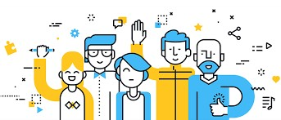
- Encourage and Support Each Member During Difficult Times
- Built Strong Relationships and Trust
- Improves Team Spirit and Work Ethic (https://mktg.az/6w/)
- Employee Ownership
- Stimulate Employees to Share Their Ideas and Experiences
- Overcome the Conflicts
- More Flexibility
- Make Fun at work
- Improved Customer Service
- Easy to Take Risks

- More Excitement
- And now my colleague Cristina will talk about Stages Of Team Development
(http://www.conferenciasliderazgo.com/establece r-una-cultura-compromiso-los-empleados/)

Bruce Tuckman's 1965 TeamDevelopment Model
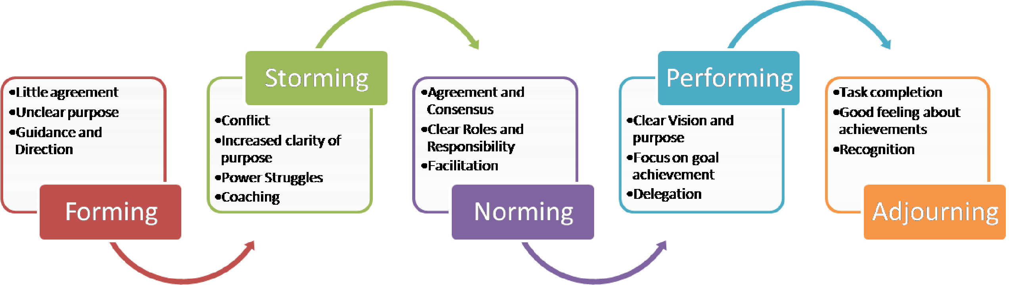
- Bruce Tuckman (1965) He is best known for his five stages of group development:
(
http://www.mspguide.org
)
- Forming
- Storming
- Norming
- Performing
- Adjourning
Bruce Tuckman’s stages of team formation
Forming :
- Team members meet for the first time
- High dependence on the leader for guidance
- Little agreement on team objectives
Storming :
- The team needs to focus on its goals
- Compromises may be required to enable progress
- Clarity of the team’s purpose increases but many uncertainties persist
Norming :
- Roles and responsibilities are clear and accepted
- Commitment and unity are strong • Big decisions are made by group agreement
Performing :
- Team members looking after each other
- The shared vision of the team
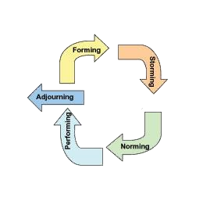
- The team’s increased strategic awareness Adjourning:
(
https://emmablount.wordpress.com
/
)
- Bittersweet sense of accomplishment
- Reluctance to say good-bye
- Many personal relationships formed
- And now my colleague Julia will talk about
Team Roles


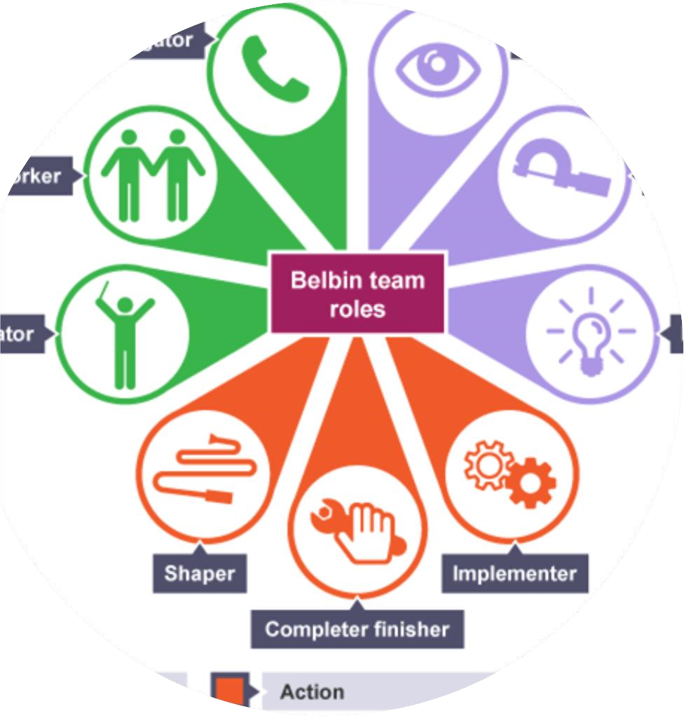
Team Roles
Belbin
-
Tuckman
-
Hershey and
Blenchard
•
Tuckman studied teams from
initiation to realization
•
Belbin’s statements of teams made
public nine Team Roles
•
Hersey and Blanchard have both
present four stage models
(
https://www.bluemercury.co.nz/tea
m
-
course
s
)
- First Stage Forming
- Team members behave independently
- Team workers in particular might be uncomfortable about arguments
- Focus is on routine
- A good Coordinator can bring the team together
- Telling Leadership Style
• Second Stage Storming
- The team begins to suggest ideas
- Characteristics of this stage include experimentation
- There is a risk of team politics.
- Leadership style still needs to be directive
• Third Stage Norming
- Responsibilities are made clear
- Team members may compromise
- Clear understanding of who should do what
- Leadership style becomes more participatory
• Fourth Stage Performing
- Characteristics of this stage
- Team has worked together for a while
- New goals and plans are made
-Leadership at this stage is delegating
And now my colleague Osman will talk about Managing Conflict

Managing Conflict
- Dr. Kenneth Thomas and Dr. Ralph Kilmann’s 1974 THOMAS-KILMANN INSTRUMENT (TKI)
- Measure person’s behaviour in conflict situations.
- TKI has two dimensions when choosing how they take action in a conflict situation :
- Assertiveness
- Cooperativeness
  - These two measurements of human behavior are used to define five different ways for responding to conflict:
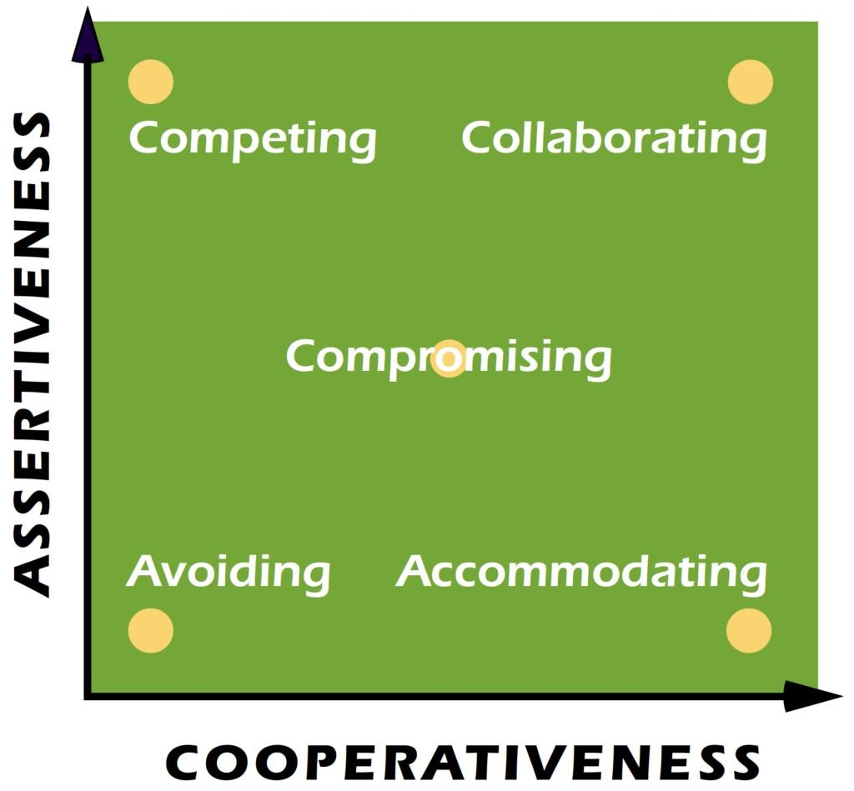
  - Competing
  - Accommodating
  - Avoiding
  - Collaborating
  - Compromising
(https://kilmanndiagnostics.com/overview-thomas-
Now my colleague Horia will talk about Successful Team Development kilmann-conflict-mode-instrument-tki/)
Successful team development
Effective team development requires:
  - finding time, selecting team members, empowering team members, providing training in relevant skills and knowledge
  - developing shared goals
  - facilitating team functioning - particularly in the early stages of the team's work.
Steps in Building a Strong Team
  - Have common goals
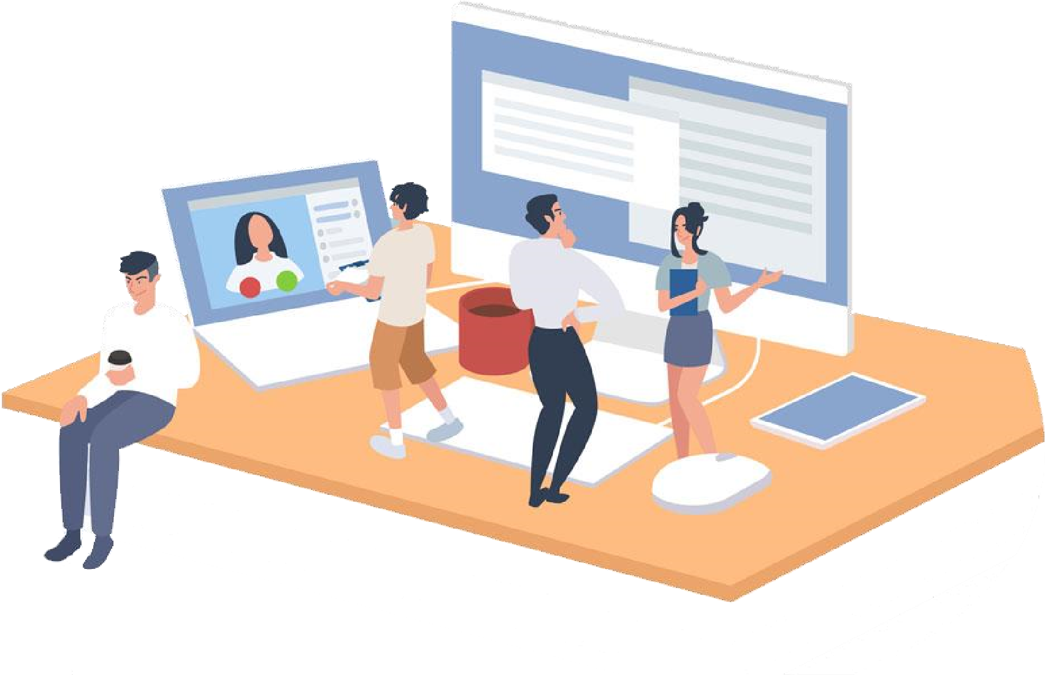
  - Communication
  - Cooperation
  - Clarity of Expectations and Objective
(https://www.kinkarsaha.com/remote-development-
  - Creative Improvement team-building-5-tips-and-1-pug/)
  - Dedication
  - Capability
  - Adapt
  - Perspective
  - Develop trust
  - And now my colleague Ovidiu will finish our presentation with the conclusion
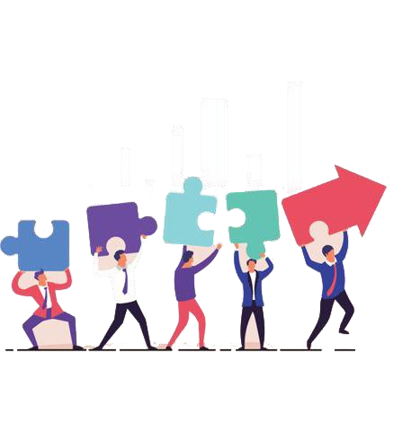

Conclusion
•
In
conclusion,
Teamwork
is
one
of
the
vital
pillar
in
our
contemporary
organisations
,
and
as
long
as
teams
are
formed,
implemented
and
managed
correctly,
can
improve
productivity,
create
and
innovate!
(
www.vecteezy.com
)
Champan, A., 2017. Tuckman: Forming, Storming, Norming, Performing model. References[Online]
Available at: https://www.businessballs.com/team-management/tuckman-forming-storming-norming-performing-model/#--------bruce-tuckmans-1965-team-developmentmodel
(Accessed 06 August 2020).
Leitch, C., 2020. 10 Powerful Benefits of Teamwork in the Workplace. [Online] Available at: https://www.careeraddict.com/5-benefits-of-teamwork-in-the-workplace (Accessed 06 August 2020).
ProofHub, 2018. Top 11 Benefits of Teamwork in Workplace. [Online]
Available at: https://blog.proofhub.com/top-11-benefits-of-teamwork-in-workplace-24a55b8ab46e (Accessed 06 August 2020).
Team, T. R., 2019. 8 Benefits of Teamwork in the Workplace. [Online]
Available at: https://www.reflektive.com/blog/8-benefits-of-teamwork-in-the-workplace/ (Accessed 06 August 2020).
Vliet, V., 2014. Biography Bruce Tuckman. [Online]
Available at: https://www.toolshero.com/toolsheroes/bruce-tuckman/ (Accessed 06 August 2020).
Karabeleski, S. and Avdic, D., 2018. Pairing Belbin’s Team Roles towards Productivity. [Online] Available at: http://fileadmin.cs.lth.se/cs/Education/EDAN80/Reports/2018/AvdicKarabeleski.pdf (Accessed 10 August 2020).
Atorough, P. and Martin A., 2012. The politics of destination marketing: Assessing stakeholder interaction choice orientations toward a DMO formation, using the Thomas-Kilmann Conflict Mode Instrument. [Online]
Available at: https://www.ingentaconnect.com/content/mcb/jpmd/2012/00000005/00000001/art00003 (Accessed 10 August 2020).
Thomas, K and Kilmann, R., 2015. “The Joy of Having Created the TKI Assessment!”. [Online]
Available at: https://kilmanndiagnostics.com/overview-thomas-kilmann-conflict-mode-instrument-tki/ (Accessed 16 August 2020)
Faponhunda, T., 2013. Towards Effective Team Building in the Workplace. [Online]
Available at: https://www.researchgate.net/publication/258344173_Towards_Effective_Team_Building_in_the_Workplace [Accessed 02 August 2020].

