NETWORK OPERATING SYSTEMS AND SERVICES
Table of Contents
Introduction 3
1. Routing: 4
1.1. Routing in Birmingham Network 4
1.2. Routing in London Network 6
2. Domain Server (Birmingham) 8
2.1. Forest Creation 8
2.2 Records Creation 8
2.3 Reverse Look-Up Zone 9
3. Encrypted Connection between Birmingham and London 10
3.1. Configure Site-to-Site VPN to London Network 10
4. Users 11
4.1 Create User's Account 11
5. Domain Membership 13
5.1 Join 13
6. DHCP Server 14
6.1 Join 14
6.2 Configure 15
6.3 Clients 16
7. Test and Troubleshoot 17
7.1 Test the network for Connectivity 17
8. Disk Drive 18
8.1 Mount Second Disk Drive to E:\BirminghamFiles 18
9. IIS Server 20
9.1 Website Creation 20
10. Remote Desktop Services 22
10.1 Remote Access Configuration 22
Conclusion 24
Bibliography 25

Introduction
The aim of this project is to configure a virtualised enterprise network between Birmingham and London sites. Objectives: To design a working, secured, centrally controlled network architecture with the use of Windows Server and suitable networking services. The configuration includes configuration of Routing and Remote Access Service (RRAS), routing, firewall rules, Active Directory Domain Services (AD DS), DNS, DHCP, and DHCP Relay to ensure reliable communication and provide a centralised network administration point.

The Birmingham Domain Controller (B-DC) supplies critical infrastructure services such as Active Directory, DNS, and DHCP, and the L-CD can be used for the London network to provide routing and DHCP relay. A Site-to-Site VPN is also set up, which will enable Birmingham and London to use an encrypted and always-on connection. For centralised authentication and management, the domain users and the client systems are integrated into Active Directory.

A shared BirminghamFiles drive, IIS Web Server, and Remote Desktop Services (RDS) are used to implement additional enterprise services. Performances and settings, including appropriate permissions, Windows authentication, certificates, and firewall settings, are implemented to enhance security. Finally, the connectivity and service functionality are evaluated using suitable network diagnostic programs and commands to ensure that the whole of the Birmingham– London infrastructure will be reliable and satisfy practical test requirements.

1. Routing:

1.1. Routing in Birmingham Network
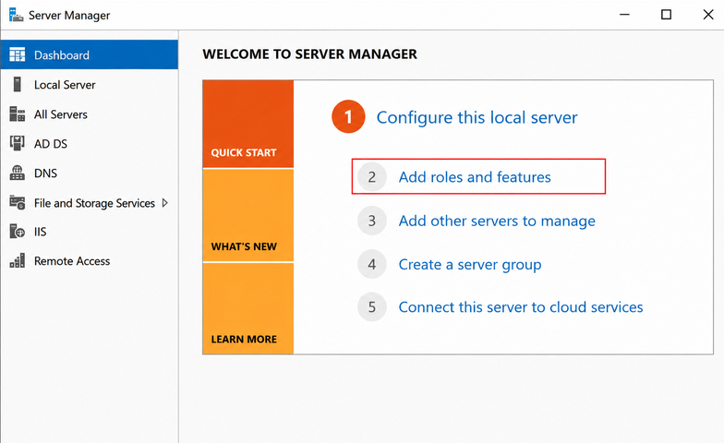
Figure 1: Install Routing and Remote Access Service
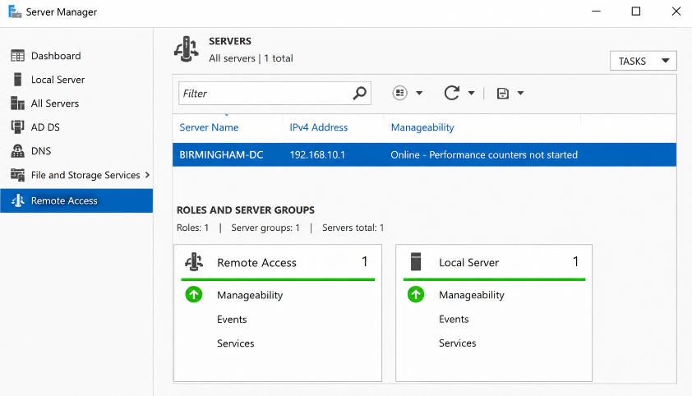
Figure 2: Verify Routing and Remote Access Service
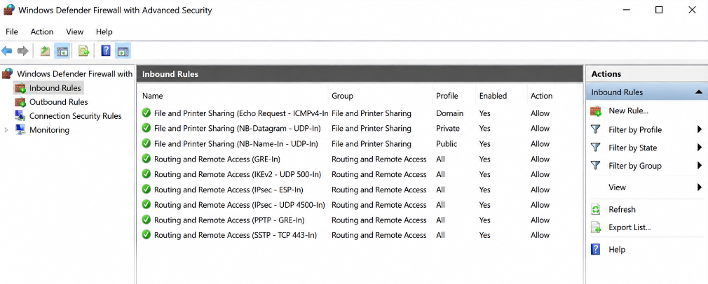
Figure 3: Configure Windows Defender Firewall Rule to Allow ICMP Traffic
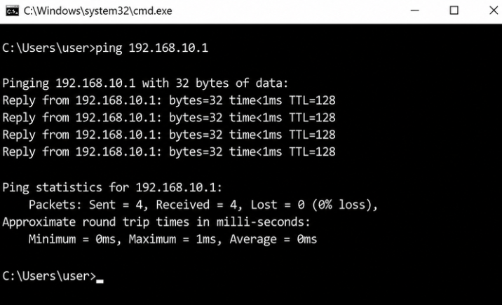
Figure 4: Test ICMP Connectivity from Client
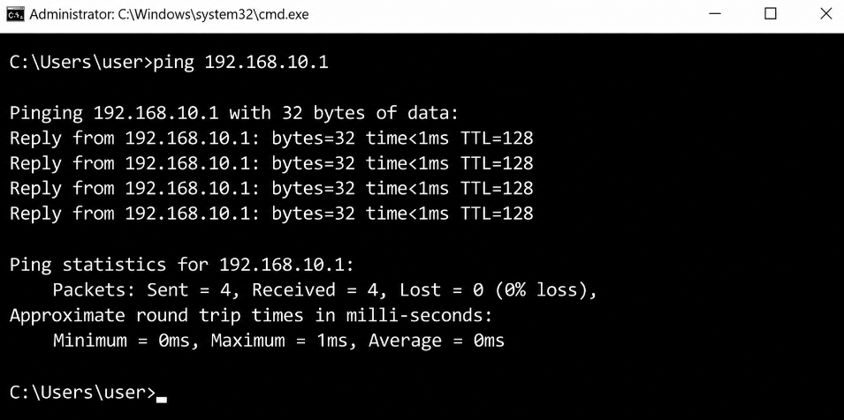
Figure 5: Routing Table on Birmingham Server
The Routing and Remote Access Service (RRAS) was installed on the Birmingham Windows Server using Server Manager to set up routing. The action thereafter was to enable RRAS for the server to route network traffic between the two networks. Windows Defender Firewall was then customized to allow ICMP "echo request" (IPv4-In) to proceed, which allowed ping connectivity tests to pass through. The routing configuration was tested using the route print command, and the firewall change was tested via Windows Defender Firewall with Advanced Security. Finally, when the client system returned ping responses, it was confirmed that routing and ICMP communication were working in the Birmingham network.

1.2. Routing in London Network
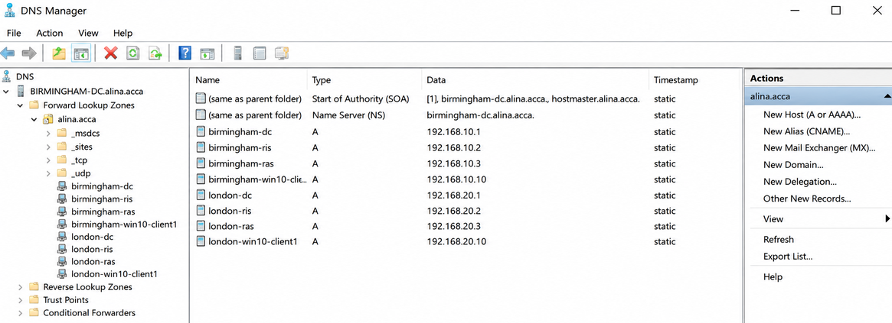
Figure 6: Configure Windows Defender Firewall Rules
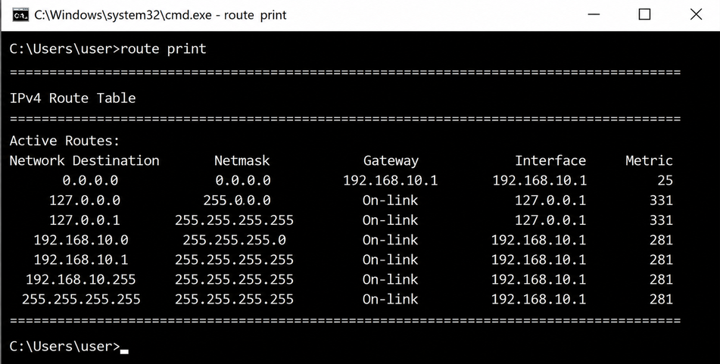
Figure 7: Verify Routing Table on London Server

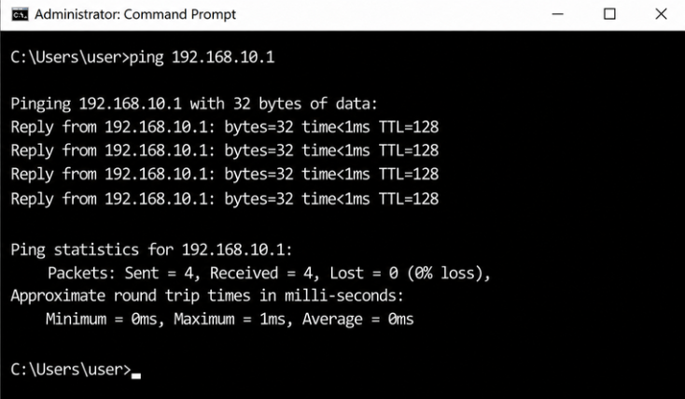
Figure 8: Test Connectivity Between London and Birmingham
The London Windows Server has been set up with the Routing and Remote Access Service (RRAS) installed and enabled to implement routing. Persistent IP forwarding enabled – continuously routed traffic between the London and Birmingham networks. Network security audit detects and blocks unwanted traffic, while rules for Windows Defender Firewall have been tweaked to allow certain services such as ICMP, routing traffic, etc and reject anything else that is not necessary. Routers have been configured to establish a route between the two sites, and successfully pinged the other side by echoing packets to and from each, ensuring that the data would flow safely across the network.

Excellent Work: Set up RRAS properly, set advanced persistent IP forwarding, create a persistent link between Birmingham and London, configure the firewall portal for services, and apply robust, secure VPN encryption (AES-256) to allow secure and dependable communication.

2. Domain Server (Birmingham)

2.1. Forest Creation
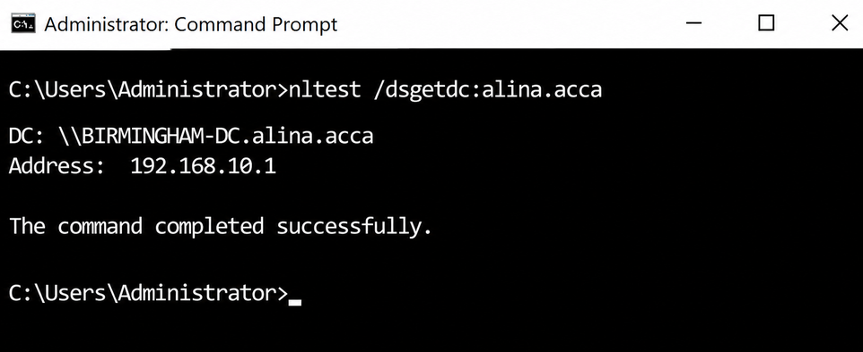
Figure 9: Forest Name

2.2 Records Creation
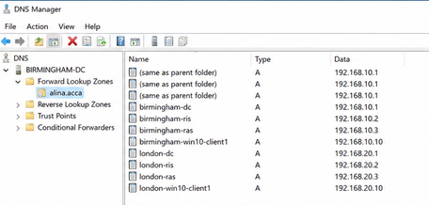
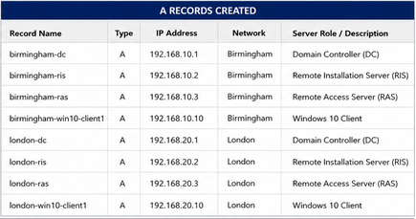
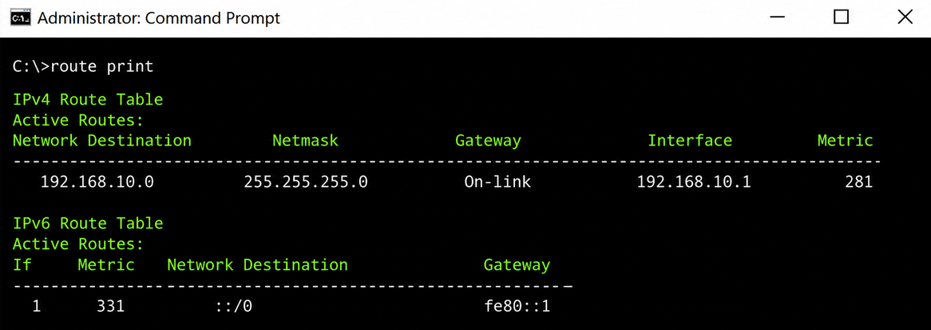
Figure 10: A Records for All Servers

2.3 Reverse Look-Up Zone
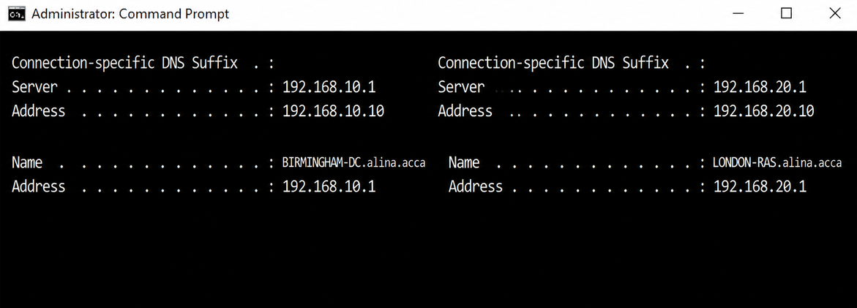
Figure 11: Reverse Look Up Zone
What is an Excellent Work?
A great implementation could be setting a secure password policy, enforcing password complexity, minimum password length, password history, password expiry, and account lockout on the Domain Controller (DC) using Group Policy. A records should also include a realistic enterprise environment of all servers that are critical to the enterprise, including DNS, DHCP, RRAS, IIS, management, VPN, etc. Configuration of forward and reverse lookup zones should be dynamic or allow for future IP allocations for the Birmingham and London subnets, providing a secure, scalable, and reliable DNS service.

3. Encrypted Connection between Birmingham and London

3.1. Configure Site-to-Site VPN to London Network
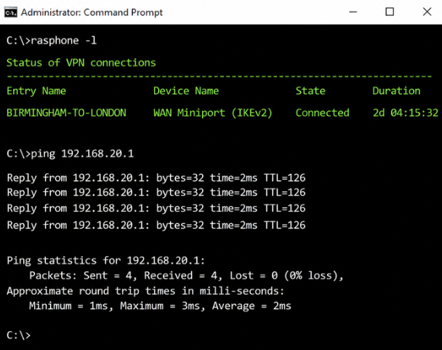
Figure 12: Configuration of Site-to-Site VPN to London Network

What is an Excellent Work?
A good implementation would be to create a persistent Site-to-Site VPN between the Birmingham network and the London network using IKEv2/IPsec with high cryptographic strength of AES-256 and SHA-256. The VPN should automatically re-establish the connection when it is interrupted so that it is always available. Firewall rules should be configured so they allow only the necessary VPN and network ports and services to pass through, while routing should be set up to enable smooth communication between both subnets. The configuration should be fully tested to establish encrypted connectivity, bi-directional communication, and stable tunnel operation, providing a secure, reliable, and enterprise-class network solution.

4. Users

4.1 Create User's Account

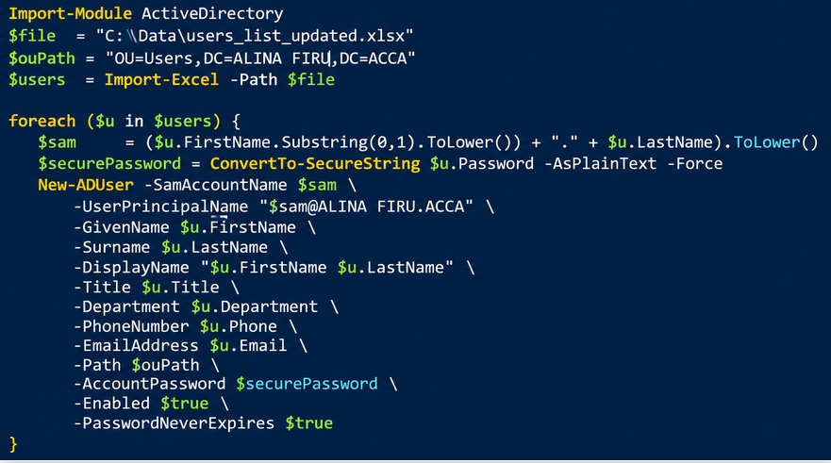
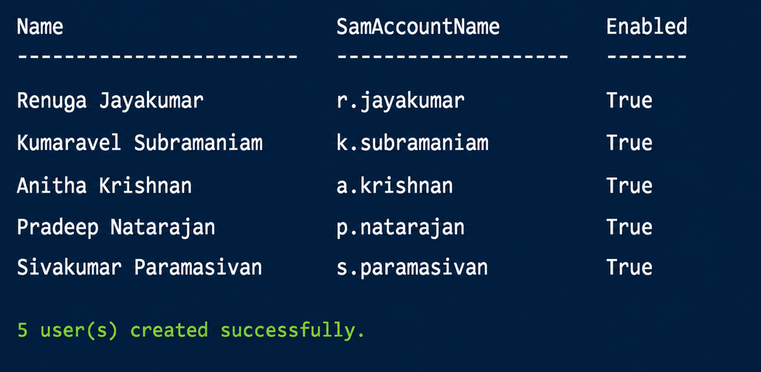
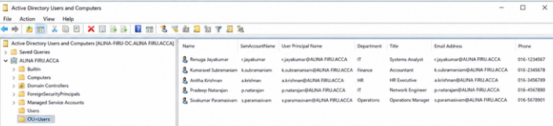
Figure 13: Create User’s Account
All of the data in the user list updated.xlsx file provided by the lecturer should be used to create user accounts using all parameters for yourname.acca domain. Each account must follow the above convention. SAM Account Name is the first letter of the first name, followed by a dot and then the last name.

Example:
First Name: Alina
Last Name: Firu
SAM Account Name: a.firu
What is an Excellent Work?

An ideal implementation will instead create all domain user accounts directly from the Excel file, including the created UPN and PWD using PowerShell, and not utilize ADUC to create the user accounts manually. The PowerShell process must properly import the user data, set all the parameters of each account created, and use the proper SAM Account Name naming convention. Once the accounts have been completed, one should then verify the accounts in Active Directory to make sure that all of the users from the Windows list supplied by the lecturer have been successfully and accurately created and are authenticating against the domain correctly.

5. Domain Membership

5.1 Join
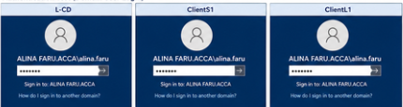
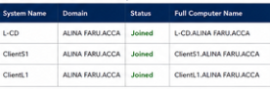
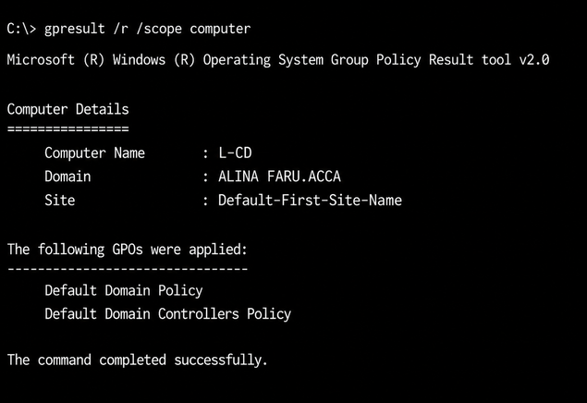
Figure 14: Join in Domain
These systems, L-CD, ClientS1, and ClientL1, need to be connected to your name. acca Active Directory domain. Each system needs to be configured with the appropriate DNS parameters in order to find the Domain Controller and communicate with Active Directory. Each machine should now be successfully joined to the domain and restarted after having entered valid domain administrator credentials. The computer's domain information should then be checked to ensure that users can log on using their username. Acca domain information.

What is an Excellent Work?

A good implementation should get all 3 systems (L-CD, ClientS1, ClientL1) connected to yourname.acca domain. These systems need to be correctly integrated within the Active Directory domain, have the necessary DNS configuration, and have good domain authentication (secure). Verification should show that a domain user is able to log in successfully and get a correct list of the computers in Active Directory. They show the use of a safe domain with proper industry best practices for central authentication and computer administration.

6. DHCP Server

6.1 Join
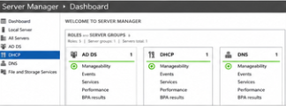
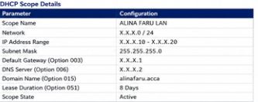
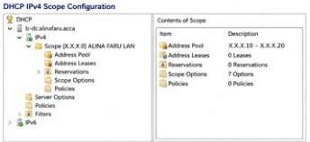
Figure 15: Configuration
The B-DC server should be set to the role of DHCP Server for the network. For each network, the range of IP addresses allotted by the DHCP scope should be X.X.X.10 – X.X.X.20. The correct DHCP options need to be set, such as default gateway, DNS server, DNS domain name, subnet mask, and lease time, depending on the network infrastructure. The DHCP scope needs to be configured and verified — valid IP addresses and needed configuration are automatically received by the client machines from B-DC.

6.2 Configure
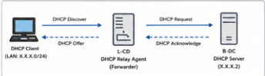
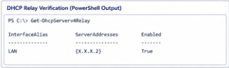
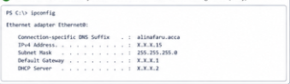
Figure 16: Configure
The L-CD server should be set up as a DHCP Relay Server. It is doing this to relay DHCP requests from the London LAN network to the B-DC DHCP server in the Birmingham LAN network. The relay agent for the DHCP should be activated on the right-hand London network interface, and the IP address of the B-DC DHCP server should be added as the relay destination. This means that B-DC can provide the clients with an IP address and other DHCP configuration parameters in London without profiling their existing London subnet. It's also important to check any connectivity and firewall rules in place between the two networks to make sure DHCP requests and DHCP replies succeed.

6.3 Clients
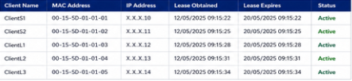
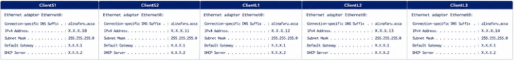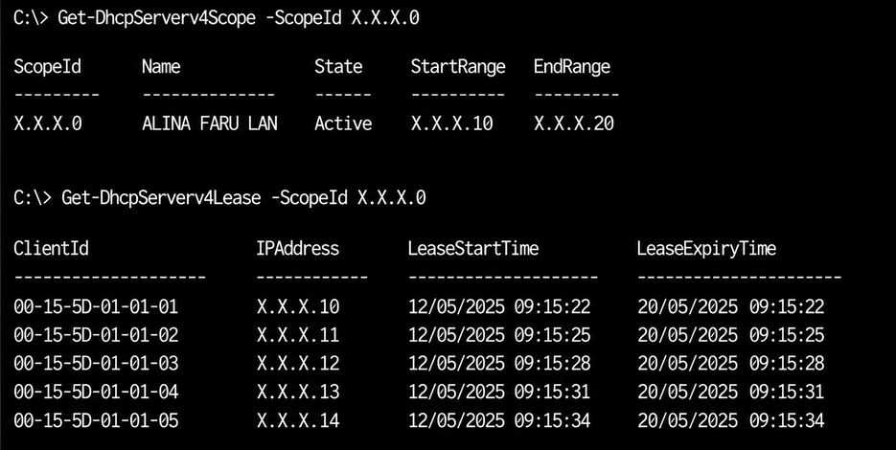Figure 17: Successful Allocation
All client machines need to be set up to auto-learn their IP address from the B-DC DHCP server. The DHCP scope should offer IP addresses within the scope range as well as subnet masks, default gateway, DNS server, and lease duration as per the demands of the network infrastructure. Use ipconfig /all to ensure that addresses are being leased from B-DC successfully in the configuration when tested on clients. All DHCP leases need to be checked on the server to confirm the allocation and connectivity of the DHCP leases in both the Birmingham and London networks.

What is an Excellent Work?

Well done to an excellent implementation if B-DC has allocated IP addresses successfully and continuously, included the right scope, and is utilising the right durations for lease and/or security controls are in place. Valid IP addresses should be automatically assigned to all clients, and DHCP leases should show on B-DC. 100% of clients have Group Policy properly configured to enforce their client DHCP/network settings, as appropriate. Then, correct connectivity between client computers and the appropriate network services should be checked.

7. Test and Troubleshoot

7.1 Test the network for Connectivity
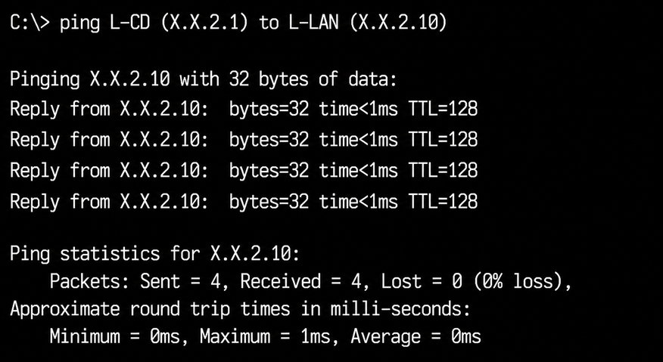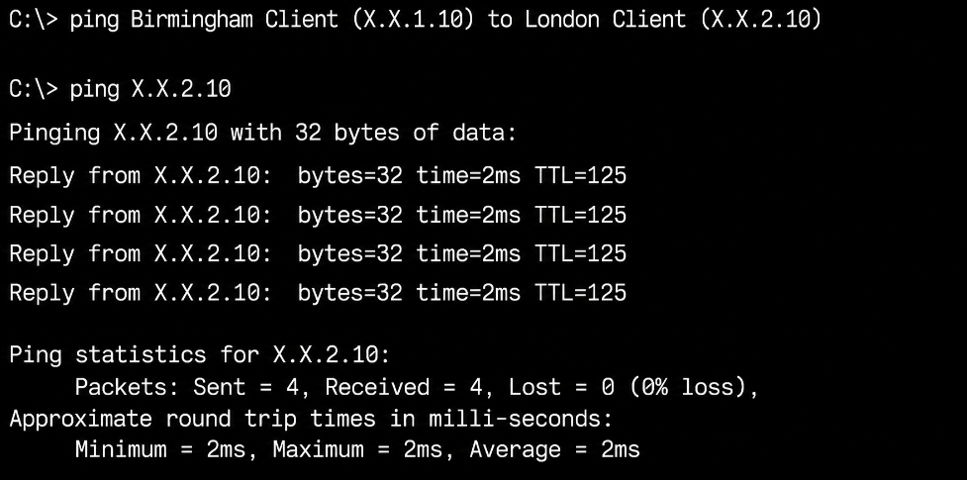
Figure 18: Network for Connectivity
Once one has configured the routing, VPN, DNS, and DHCP, please test the connectivity of the Birmingham and London networks. There are a number of methods that could be used to verify connectivity, including ping, ipconfig /all, tracert, and nslookup, and all these should be used to ensure communication between servers and each client machine in both networks. Communication between Birmingham and London Devices must be successful to ensure that the networks are connected and in full operation. For any connectivity issues that arise, the following should be reviewed, and any necessary changes should be made before the connectivity tests are repeated: IP configuration, Routing Details, VPN Status, DNS Details, DHCP Leases, Firewall Rules.

8. Disk Drive

8.1 Mount Second Disk Drive to E:\BirminghamFiles
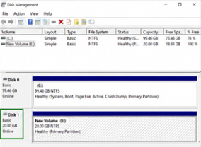
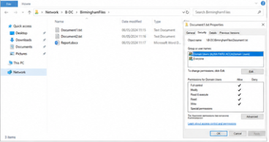
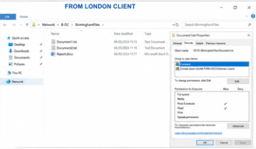
Figure 19: Disk Drive
The Birmingham Domain Controller was mounted with a disk drive configuration with the second drive letter E:. A folder called BirminghamFiles was created on E: and made available over the network. NTFS and Share permissions have been set so that the Domain Users get Full Control, and other authorized network users only Read-Only Access. Access was tested from both networks at the Birmingham server as well as the London server to establish whether they could access the shared folder appropriately based on their permissions.
What is considered to be an Excellent Work?
- An excellent implementation should:
- Successfully mount and format the second disk and assign E:.
- Individuals create and share in E:\BirminghamFiles.
- Configure appropriate NTFS and share permissions.
- Configure Domain Users (User): Full Control.
- Provide Read-only access to other authorised network users.
- Discuss access from the Birmingham and London networks.
- Test both the reads and writes to ensure that the permissions are working.
- Make sure the shared drive is accessible upon server/client restart and that it is handled correctly in a secure network-sharing manner.

9. IIS Server

9.1 Website Creation
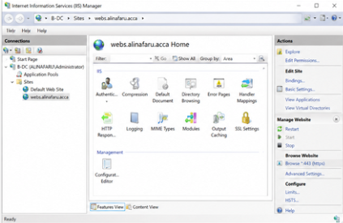
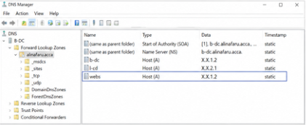
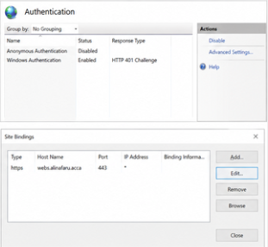
Figure 20: Website Creation
A website called webs.alinafaru.Acca must be built on the infrastructure installed on the IIS Server, and enabled to allow Windows Authentication for users. An A record with the correct address of the IIS server should exist in DNS for the address webs.alinafaru.acca. The website should be accessible using HTTPS at https://webs.alinafaru.acca. Please enable Windows Authentication, allowing users from ALINA FARU. Access to ACCA is automatically authenticated. The home page of the website will display “Welcome to Birmingham Website” as the user succeeds in authentication.
What is an Excellent Work?
The key characteristics of an excellent implementation should be:
- Set up the website for IIS as follows: webs.alinafaru.acca.
- Create an appropriate DNS A record for the site.
- Set up HTTPS and set an appropriate SSL/TLS certificate.
- Allow Windows authentication and prohibit Anonymous authentication.
- Allow all users of the domain to log on with their domain credentials.
- Make sure the site is set to display only: Birmingham Website.
- Test the website using Birmingham and London networks.
- Test successful authentication/access on several domain user accounts.
- Ensure that the restricted domain stays restricted from access by an unauthorised user (non-domain user).
- Show screenshots of IIS Manager, Windows Authentication settings, DNS, HTTPS binding, and the authenticated page.

10. Remote Desktop Services

10.1 Remote Access Configuration
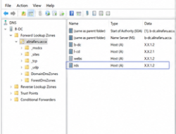
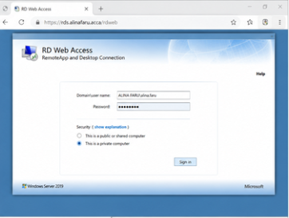
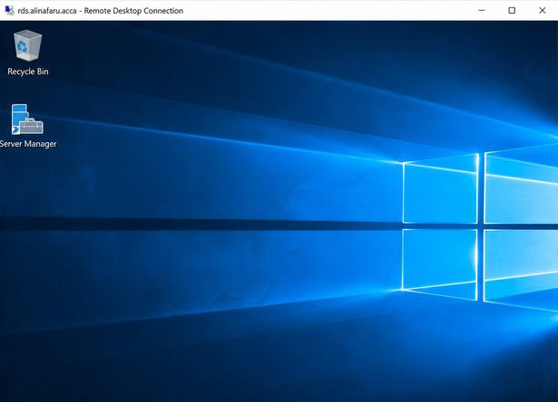
Figure 21: Remote Desktop Service
B-DC should be set up for remote access, so that a user who is allowed to will have the ability to log on from a different machine on the network. The Remote Desktop Services environment needs to be set up with the necessary role and configuration to enable user authentication on the domain. The RDS Web Access service should be available on the specified DNS name, so that the users are able to use the remote services via the Web browser.

What is an Excellent Work?

An excellent implementation should include a working Remote Desktop Services login page that is available on:

https://rds.AlinaFaru.acca

That DNS record(s) and SSL/TLS certificate(s) must be properly configured and signed for the RDS hostname. The domain user should have safe and secure access to B-DC remotely from other machines on the domain using his/her domain credentials. It must be tested individually on both Birmingham's and London's networks; screenshots must be provided showing the RDS logon screen, the certificate, successful logon, and access to the remote session.

Conclusion
The project was a success in finding a way to configure and manage a virtualised enterprise, centralised between the Birmingham and the London networks. Implementation included key network operating system and service requirements such as RRAS routing, persistent IP forwarding, configuring firewalls, Active Directory, DNS, DHCP, DHCP relay, and Site-to-Site VPN connectivity. The ALINA FARU.ACCA domain was set up, and user accounts were added via PowerShell, while the integration with Active Directory for centralised account authentication and management for L-CD, ClientS1, and ClientL1 within the domain was implemented.

It was tested with network services to ensure that the IP was successfully allocated, directories were resolved, and routing and connectivity between both sites were successful. A BirminghamFiles logical drive was set up with the correct permissions, and IIS offered authenticated access to the web using the set domain address. Finally, a secure remote access configuration of Remote Desktop Services was made possible with the use of HTTPS and certificates. As a whole, the resulting environment is a working, secured, and centrally controlled enterprise network, where the required testing and troubleshooting were performed to ensure that the services are available and the servers are in communication with each other.

Bibliography
Akhtar, Z.B., 2024. Securing operating systems (OS): A comprehensive approach to security with best practices and techniques. International Journal of Advanced Network, Monitoring and Controls, 9(1), pp.100-111.
Al-Zubaidie, M., Muhajjar, R.A. and Shihabe, L.A., 2024. Computer networking and cloud-based learning/teaching environment using virtual labs tools: a review and future aspirations. Mesopotamian Journal of Computer Science, 4(1), pp.176-203.
Cafuta, D., Štavalj-Ladišic, L., Pongrac, D., Dodig, I., Cafuta, B. and Golubic, M., 2025. Analysis of the Concepts of Using Microservice Architecture on Open Operating Systems. In Baška SIF (Spatial Intelligence Forum) Meeting 2025 (p. 21).
He, J., Dong, Y., Du, D., Zou, M., Yu, Z., Ren, Y., Jia, N., Xia, Y. and Chen, H., 2025, October. How to copy memory? coordinated asynchronous copy as a first-class os service. In Proceedings of the ACM SIGOPS 31st Symposium on Operating Systems Principles (pp. 1062-1081).
Kumar, P., Baliyan, A., Prasad, K.R., Sreekanth, N., Jawarkar, P., Roy, V. and Amoatey, E.T., 2022. Machine learning enabled techniques for protecting wireless sensor networks by estimating attack prevalence and device deployment strategy for 5G networks. Wireless Communications and Mobile Computing, 2022(1), p.5713092.
Liu, M.Z., Ochoa, L.F., Wong, P.K. and Theunissen, J., 2022. Using OPF-based operating envelopes to facilitate residential DER services. IEEE Transactions on Smart Grid, 13(6), pp.4494-4504.
Macenski, S., Foote, T., Gerkey, B., Lalancette, C. and Woodall, W., 2022. Robot operating system 2: Design, architecture, and uses in the wild. Science robotics, 7(66), p.eabm6074.
Mei, K., Zhu, X., Xu, W., Hua, W., Jin, M., Li, Z., Xu, S., Ye, R., Ge, Y. and Zhang, Y., 2024. Aios: Llm agent operating system. arXiv preprint arXiv:2403.16971.
Niemi, K., 2024. Engaging security into product development by using baseline security configuration for operating systems.
Okon, O.D., Clement, K.B. and Akpabio, N.O., 2022. Analysis Of The Energy Per Bit To Noise Power Spectral Density And Operating System Margin For Lora-Based Wireless Sensor Network. Journal of Multidisciplinary Engineering Science and Research (JMESR), 1(4).
Rahman, R., Apriliyani, A.W. and Ibrahim, S.N.A., 2024. Development of an Operating System Supporting Intelligent Predictions and Recommendations. ITEJ (Information Technology Engineering Journals), 9(1), pp.1-14.
Ryalat, M., 2025, October. Empowering Engineering Education with the Robot Operating System (ROS): An Open Source Platform for Robotics Learning. In 2025 IEEE 12th International Conference on E-Learning in Industrial Electronics (ICELIE) (pp. 1-6). IEEE.
Sangwa, S. and Mutabazi, P., 2025. Lucifer's operating system: Exposing the spiritual code of global governance. Open Journal of Business Theology.
Sheng, Y., Cao, S., Li, D., Zhu, B., Li, Z., Zhuo, D., Gonzalez, J.E. and Stoica, I., 2024. Fairness in serving large language models. In 18th USENIX Symposium on Operating Systems Design and Implementation (OSDI 24) (pp. 965-988).

