Essential Academic and Employment Skills

June, 2026 (Hannah Munns)

[1]IEEE Referencing & written summary on essential academic and employment skills (350 words):

1.a Produce a written summary with some supporting visuals (images/figures), on the topic of essential skills for study and employment (approx. 250 words) in your Career area?

The development of academic skills is fundamental to supporting student achievement, wellbeing, and success in higher education. These skills encompass a broad range of competencies that enable students to engage effectively with disciplinary knowledge, deepen their understanding, apply critical thinking, and communicate ideas clearly and appropriately Key competencies include information literacy, critical evaluation, problem-solving, academic writing, and metacognitive strategies that promote self-regulated learning. Through the development of these capabilities, students are better positioned to engage meaningfully within academic communities, enhance their learning, and realise their academic potential For the purposes of this review, academic skills development is used as an umbrella term to describe interventions aimed at strengthening students’ capacity for academic study. Such interventions may address general study skills, English language development, or discipline-specific literacies. While recognising ongoing debates regarding the definition and scope of these concepts, this review adopts a broad and inclusive perspective that accommodates diverse theoretical approaches. This position aligns with Blaj-Ward’s (2022) conception of academic literacies provision as learning opportunities that enrich students’ academic experiences by developing both academic communication practices and language proficiency. Drawing on insights from applied linguistics, language education, and higher education research, this review explores approaches to academic support that respond to the varied needs, backgrounds, and aspirations of contemporary students.

This diagram illustrates the 9 essential skills.
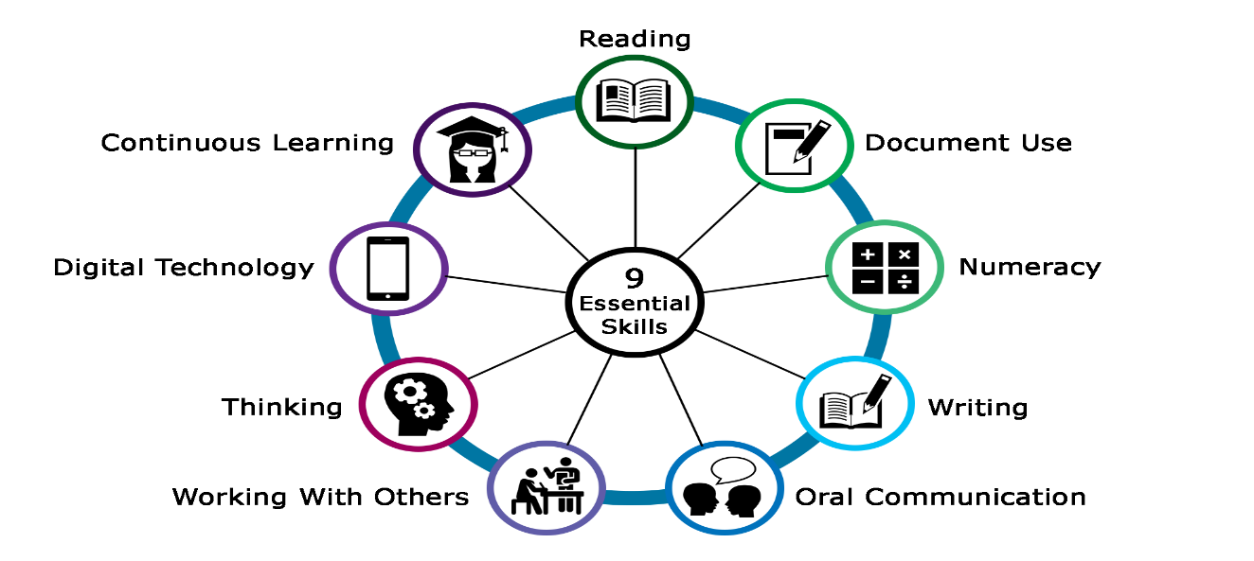
Essential skills are part of our everyday life. It is hard to do just one essential skill at a time, because all 9 of them are interconnected and built into almost any task at home, in learning, or in the workplace. For CALP staff, being able to identify which essential skills a learner needs to use to complete a task can be a really great way to help learners in their everyday life and support them in their learning journey

1b ) Submit your work to the Turnitin link (labelled: Task 1b - Turnitin Similarity check practice) on Moodle and check your similarity score. In the same document as your summary above, include a reflection of approx. 100 words on: • Your similarity score and how you could improve it next time. • Using the ‘Generic Assessment criteria / GAC’ as a guide, state the mark out of 100% you would award yourself and briefly explain why. The ‘Generic Assessment criteria’ is located at the bottom of the Assignment Specification below.

Bibliography

[1] | D. J. de, "Academic Skills," October 2024. [Online]. Available: https://www.ctl.ox.ac.uk/sites/default/files/ctl/documents/media/academic_skills_literature_review.pdf.
[2] | B. -. Ward, "Conception of Academic literacies," 2022. [Online]. Available: https://www.ctl.ox.ac.uk/sites/default/files/ctl/documents/media/academic_skills_literature_review.pdf.

