Research project into how autistic (ASD) students transition into higher education and within the business department of UWTSD University of Wales Trinity Saint David.
Introduction
Having worked with autistic students in a secondary school environment, it seemed prudent to explore how autistic students make the transition from secondary education into higher education institutions. It seems from the literature review that many students with autism spectrum disorder (ASD) find the transition difficult or in the least very challenging (Bell, et al., 2017, Sefotho & Onyishi, 2021, Smith, et al., 2021, MacLeod, et al., 2018, Van Hees, et al., 2014, Van Hees, et al., 2018). The qualitative research conducted through questionnaires gives a real-life context to the phenomenon (Cohen, et al., 2018) and is relevant to University of Wales Trinity Saint David where the participants are employed. Having developed an interest in teaching autistic students at this higher level, it was decided to do some research into how many ASD students have a successful transition, how and what accommodations are made and how many are successful in gaining a degree in their chosen subject.
The primary features of autism spectrum disorder (ASD), a lifelong developmental disorder are social-communication deficits with possible repetitive patterns of activity, sensory sensitivities and stereotypical patterns of interest (Cai & Richdale, 2016). However, typically students with ASD present with one or all of the diagnosed symptoms and therefore, each experience will differ from each other one (Sharma, et al., 2018). According to literature reviewed as part of the action research project there is a higher demand for students entering higher education institutions due to the success of their achievements in mainstream education (Morina, 2018). So, in order to advance personal knowledge, initial research through academic literature demonstrates that these students do not always manage the transition, however the questionnaires conducted with staff from UWTSD sought to confirm this phenomenon with real-life data and how the universities accommodate their needs and what the teachers’ experiences have been with students with additional learning needs in general. This research was conducted through the use of dichotomous questions which help generate analysable statistical data (Cohen, et al., 2018) and a couple of multi choice questions, which whilst they can be ambiguous, they can also give a more personal viewpoint (Cohen, et al., 2018).
Literature Review
There is an abundance of literature relating to students with additional learning needs, in particular those with ASD in higher education, however, for the purposes of this action research project the review will be restricted to specific keywords or phrases within the data analysis, those keywords and phrases are ‘transition from compulsory education to post compulsory education’, ‘accommodations made by higher education institutes’ and ‘teachers’ personal experiences’ (Cohen, et al., 2018). It seems that in order to have accommodations made for these students in higher education they need to be registered as disabled (Lister, et al., 2020, Southward & Davis, 2020, Davis & Southward, 2021 & Lindsay, et al., 2018). This can cause problems as some students with additional learning needs feel uncomfortable registering as disabled (Smith, et al., 2021) while other students with ASD don’t see themselves as disabled, so fail to disclose their diagnosis until after enrolment (Cai & Richdale, 2016 & Shattuck, et al., 2014). This means that some students don’t always get the accommodations they need, which can affect their transition and success in their chosen subject (Smith, et al., 2021).
In order for institutions to ensure inclusivity within their lessons, which align with UK professional standards of ‘respecting individual learners and diverse learning communities’ (UKPSF, 2011) teachers need to ensure their teaching strategies encompass strategies to address these challenges, while ensuring that ‘universities support changes to policies, procedures and curriculum design (Grimes, et al., 2018). Grimes et al (2018) suggest that accommodations need to be built into the curriculum design in order to address the non-disclosure by some students which then leads to non-application of appropriate accommodations that might affect the academic outcome. Researchers in Australia believe that implementing evidence-based policies, curriculum design, pedagogy and appropriate assessment that responds to individual differences, removes the need for disclosure (Grimes, et al., 2018). Not all ASD students choose non-disclosure when attending a higher education course and the ones who decide to disclose their perceived disability seem to transition well, which can result in several benefits (Van Hees, et al., 2014).
It seems that many students are not successful in their transition into higher education due to five main factors (Sefotho & Onyishi, 2021) academic functioning difficulties, social difficulties, structural issues, mental health problems and lack of resources and supports (Sefotho & Onyishi, 2021). Even though Sefotho and Onyishi (2021) conducted their survey with students in Nigeria, other academic literature reached similar conclusions on the reasons why some students find the transition difficult (Cavendish, et al., 2020, Davis, et al., 2021, Anderson, et al., 2017 & Tops, et al., 2017) and this could be because a transition plan is not put in place during the student’s time at secondary school (Ciccantelli, 2011). If a student knows what to prepare for when entering higher education, the transition is much smoother, however, not totally without problems (Ciccantelli, 2011). In the USA, The Individuals with Disabilities Education Improvement Act (IDEA, 2004) states that schools should provide a Summary of Performance (SOP) to students leaving secondary education and moving on to higher education with recommendations to help students reach their potential in higher education (Southward & Davis, 2020). In the UK similar documents are only active during the transition from primary education to secondary education, with no formal document for transitioning onto higher education (Smith, et al., 2021). In the UK there is the Special Educational Needs and Disability Act (Northern Ireland) 2016 (SEND, 2016) which ensures that the views of the child are always taken into consideration when deciding on an education plan. When plans are put in place for the transition including disclosure of ASD prior to attending university then accommodations can be made for the student which enhances their chances of a successful transition and increases their potential for obtaining the desired outcome (Smith, et al., 2021). The types of accommodations made for individual students will depend on individual needs but will improve outcomes for the autistic students (Sarrett, 2018). Most students who present with ASD have different requirements when it comes to accommodations made for them, so it seems that the best way is to ensure that personal and environmental characteristics should be taken into account when deciding on the types of accommodations to provide to each individual (Janson, et al., 2017). With appropriate accommodations and support, ASD students can be successful academically and socially when making the transition to higher education which has not always been the case with many ASD students having had more no-shows in the second year than their peers (Bakker, et al., 2023).
Some of the research literature reviewed had used an action research approach by using surveys which asked autistic students and their families how they felt about higher education and the accommodations made for them within the institutes in which they were studying, this gives a more organic view of the statistics (Sarrett, 2018, Cai & Richdale, 2016, Sefotho & Onyishi, 2021, Mullins & Preyde, 2013 & Brown, 2017). A small survey of sixty-six participants was conducted in the USA with thirty-one taking part in a follow up survey and focus group at a later date which discovered that over 50 % of the students were happy with accommodations made and did not realise until meeting with their co-ordinator what was available (Sarrett, 2018). Typical accommodations made by institutions tend to be for disabilities in general and not specific to ASD and involve extended test time, distraction free testing, flexible assignment due dates, breaks during class, the use of technology, note takers, the use of visuals and optional group activities which can sometimes be misaligned due to them being identified by the practitioner rather than the student (Sarrett, 2018). The students surveyed within the studies felt that most of their educational needs were met but few of their social needs were met (Cai & Richdale, 2016 & Sarrett, 2018). A study in the Journal of Autism and Developmental Disorders (Sarrett, 2018) looked at accommodations provided and accommodations desired. So, while the university provided accommodations to students who had registered with the disabled services team, only 63% received accommodations of the 65% registered disabled, many of the remaining students did not get an autism diagnosis until after the age of 22 (Sarrett, 2018). The students who received the accommodations reported that they only managed to do well in their classes because of those accommodations, however the professors did not always comply which made it very difficult for some (Sarrett, 2018). 31% felt that the accommodations did not meet their expectations and felt that some accommodations were unnecessary while others were lacking. It seems that most of the students reported lack of compliance by faculty staff was the biggest hurdle. When it came to the most frequently cited need from focus groups and the survey, it was raising the awareness of autism on the campus and at the university. One student was quoted as saying “Actually listen to autistic students” with more training for university staff in autism as another desired accommodation (Sarrett, 2018). Similar findings have occurred in other studies that asked the students for their feedback (Cai & Richdale, 2016) (Sefotho & Onyishi, 2021).
A common theme which was evident in most of the literature reviewed within academic journals from the UK and from many other countries was the fact that the prevalence of autism is rising, exponentially in some countries (White, et al., 2017, Sefotho & Onyishi, 2021, Mullins & Preyde, 2013, Brown, 2017, Ciccantelli, 2011, Smith, et al., 2021, Tops, et al., 2017, Bakker, et al., 2023, MacLeod, et al., 2018, Pesonen, et al., 2023, Wing & Potter, 2002 & VanBergeijk, et al., 2008) which indicates that possibly more ASD students will be entering higher education institutions now and in the future (Pesonen, et al., 2023). In the USA ASD affects 1 out of 88 people, so it seems that due to the fact that there are more people being diagnosed with ASD it makes sense that there will be more high functioning autistic students particularly keen on a university education (Gelbar, et al., 2014). It seems that many students already in university show signs of ASD but have yet to be diagnosed and a UK survey found that 1% of older adolescents and young people were living in the community with undiagnosed ASD (Cai & Richdale, 2016). The intellectual potential for high functioning ASD students is high provided they receive appropriate educational supports (VanBergeijk, et al., 2008). So, it seems that universities need to prepare for and listen to the ASD students to ensure their needs are being met instead of creating one-size fits all policies that don’t always create an inclusive environment.
Methodology
The methodology, being action research, included a mixed method approach involving a literature review and a questionnaire given to fellow teachers within the University of Wales Trinity Saint David, this qualitative research was done to try and determine how to improve teaching strategies and lesson plans for students with autism spectrum disorder. This gives a qualitative dialogue between the two methods chosen (Cohen, et al., 2018). Firstly, a literature review was conducted based on three questions which are relevant to improving teaching strategies and practices which enables a more inclusive environment for students with ASD and aligns with professional standards of inclusivity (UKPSF, 2011). The three questions involved the transition from secondary education to post-secondary education, secondly the investigation considered accommodations made by various universities. Thirdly the project researched if those accommodations made a difference to the number of students that were able to achieve their goals and gain their academic degree.
The constructivist approach uses new knowledge to construct a reality, therefore, examining the phenomenon in question through multiple lenses including those of the individuals involved, creates a more inclusive approach to teaching (Cohen, et al., 2018). Constructivism looks at the social nature of learning (Cohen, et al., 2018) even though the methodology used in this project does not involve personal interactions with people, some of the journal articles have conducted investigations into how the autistic students feel about their transition, accommodations and experiences in a higher education environment. Symbolic interactionism tells us that human beings have developed meaning for things based on their own experiences (Cohen, et al., 2018) and by conducting research this enables them to not make prior assumptions about how autistic students develop within a higher education institution but rather respecting the individual experiences (Cohen, et al., 2018).
The questionnaire was devised on Google forms and sent to 15 business faculty staff members with questions including a mixture of multiple choice and open questions. The survey was anonymous and 7 responses were received back within a week. The six questions were based around the same themes as the literature review of ‘transition from secondary education to higher education’, ‘accommodations made’ and ‘personal experiences’ with ASD students. The following 6 questions formed the questionnaire:
- Have any of the classes you have taught had students with additional learning needs, in particular Autism Spectrum Disorder ASD?
- What is your classroom experience with the ASD students? If applicable?
- Interaction through class lessons
- Interaction through third party assistant
- Knowledge of presence in class
- No difference to lesson due to being unaware of any specific accommodations to be made
- Not sure
- Have any students with ASD dropped out of any of your classes before the end of the module?
- What accommodations do you make for students with additional learning needs, in particular ASD?
- How are you made aware of the need for accommodations?
- Informed by College prior to the start of the course
- Informed by student prior to the start of the course
- Informed by student as and when a problem arises
- Might not always be aware
- Other
- In your own experience how many ASD students are you aware of that go on to gain a business degree?
By conducting research using mixed methods this will enable better teaching through better prepared teaching strategies fom the generation of new knowledge presented in the results of the questionnaire which was directed at the teachers and their experiences working with ASD students in the business school of University of Wales Trinity Saint David.

Discussion
Autism Spectrum disorder is affecting more young people on an ongoing basis (White, et al., 2017, Sefotho & Onyishi, 2021, Mullins & Preyde, 2013, Brown, 2017, Ciccantelli, 2011, Smith, et al., 2021, Tops, et al., 2017, Bakker, et al., 2023, MacLeod, et al., 2018, Pesonen, et al., 2023, Wing & Potter, 2002 & VanBergeijk, et al., 2008) which means that teachers in higher education need to be aware that ASD students are likely to be a part of their current and future classes and in order to ensure inclusivity this research project will compare the literature review findings with the results of the questionnaire. From personal experience it has been noted that more secondary and primary schools have special units attached to them to house students with additional learning needs that cannot cope in mainstream education, due to various issues but might still be very capable academically (Goodall, 2018). Others make a slow transition into mainstream education with a teaching assistant, starting slowly with single classes, then weekly until they are fully transitioned or contrarily, until they feel overwhelmed and have to return to the safety of the unit, the point being, that more students with additional learning needs, in particular ASD are entering the education system (Smith, et al., 2021) (Sefotho & Onyishi, 2021). Therefore, more students with ASD might need to transition to higher education.
According to most of the studies in the literature review many students find it difficult transitioning from secondary to higher education for various reasons, including non-disclosure of disability to university faculties (Cai & Richdale, 2016), inadequate accommodations made (Janson, et al., 2017), non-compliant professors (Sarrett, 2018) and sometimes the students themselves become overwhelmed or lack that sense of belonging (Pesonen, et al., 2023). However, when analysing the data from UWTSD it seems that the opposite is true, when asked about the transition to higher education 42.9% of participants said that they had had experience of teaching ASD students who went on to gain their business degree, while a different 42.9% said that none of the students with ASD had dropped out of any modules they were teaching. When asked about their classroom experience of students with ASD, there was a mixed result:
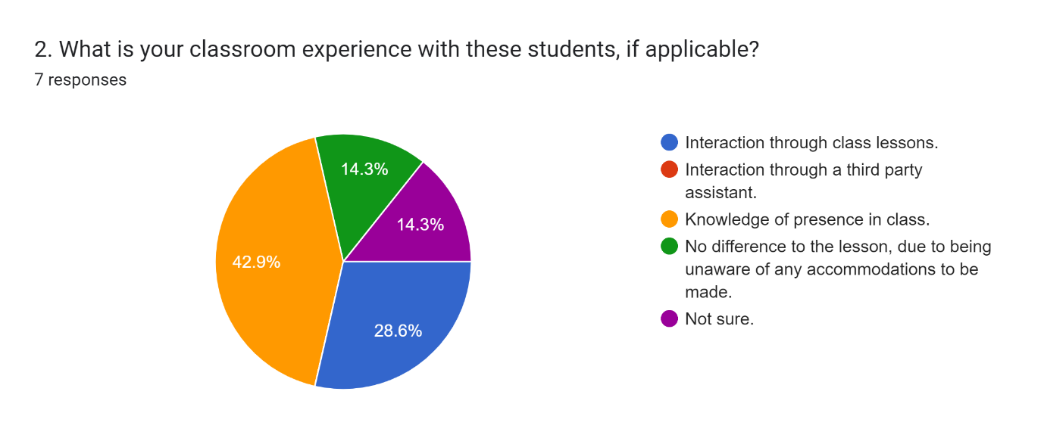
Three people had knowledge of their presence in the class, two people interacted through the class lessons, one person said it didn’t make any difference to the lesson and the other one person was not sure if there was anyone with ASD present in the class. This question was asked in order to determine if there was any difference to classes taught, when students with ASD were present, in order to determine own teaching practises through better inclusivity, meaning that teaching strategies need to be inclusive and varied (Race, 2019) in order for the ASD students to feel comfortable in the lesson.
When asked about any students dropping out of any classes before the module ended, the response was reassuring in that 42.9 % said no and only 14.3% said yes, there was also a couple unsure and one that said yes but for other reasons.
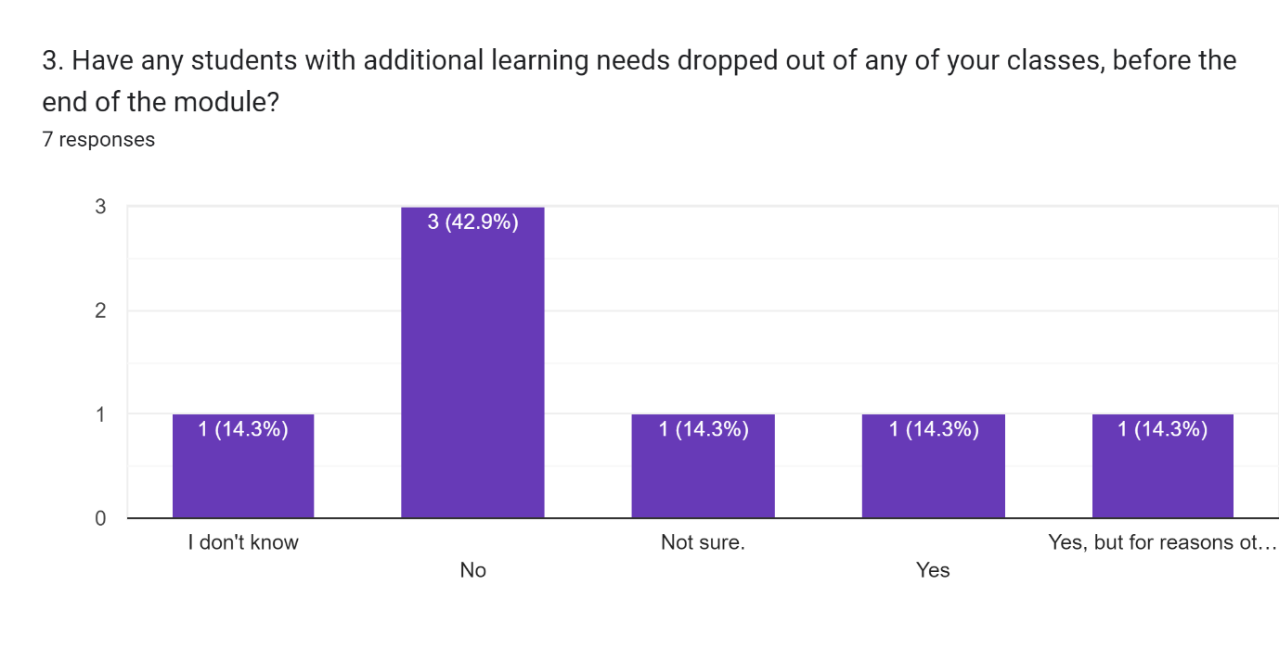
The accommodations made for each student seemed to be very specific and were tailored specially on request for certain individuals. These accommodations involved the following:
“If they make me aware of their additional needs, I ask them about whether there are any adjustments I can make to ensure their inclusion/ability to access the class”,
“Should I suspect there to be ALN present, I like to ensure a number of different approaches to learning objectives and learnings styles”,
“I would work within the TEF but I am unaware of anyone identifying these needs at this level of study (therefore, this probably identifies me !!)”,
“Differentiated delivery, additional support”,
“I always try to reflect on different needs and preferences in all my lessons. This includes through small group interactions and reflections”,
“Style of slides, recording lectures (where necessary), and following any requirements set out in the Statement of Compensatory Measures”
“Work to the SEN for the student where aware of the needs & always check they are engaging”.
As this action research project is so small there doesn’t seem to be a need to be coding or categorising the data (Cohen, et al., 2018) so for the purposes of analysis, the data will be discussed as it appears in the results. The statements made above refer to how the person feels about what is happening in the lesson rather than the following of particular protocols. Only one answer refers to the Statement of Compensatory Measures which is given to students with additional learning needs at UWTSD (UWTSD, 2023). However, all answers indicate an attitude of inclusivity, in that, the needs of the student are paramount to each participant teacher who took part in answering the questionnaire.
When the participants were asked about how they were made aware that students with additional learning needs might be in their class, there was a varied result in that everyone said something different.
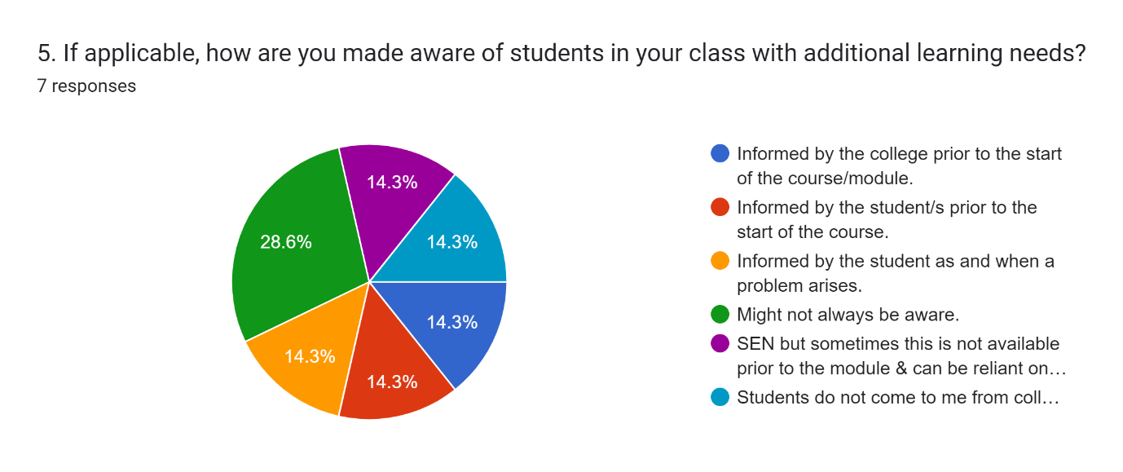
The final question regarding how many students achieved their goal of obtaining a business degree, the results are:
“A large number, with very good degree results being achieved. With the support of academic staff and the provisions put in place by student services, any limiting factors related to the students SpLD are catered for to help them through the process”.
“I don't know”
“Not part of business programmes so not aware of this data”
“All have progressed with support to graduate”
“Not long enough in post”.
“I dont know”.
“All of them”
Two people don’t know about whether their students have obtained their degree or not, one person has not been long enough in their post to know but the other three people claim that all ASD students have graduated with support which is very reassuring.
The questions were devised around the same three questions of transition, accommodation and success rate as was discovered from the literature review with comparisons made and conclusions reached on how to improve practice (James & Augustin, 2018). The literature review studied the phenomenon of difficult transitioning to higher education for ASD students whereas the data collected from the questionnaire seemed to oppose that phenomenon. Therefore, a “characteristic to the phenomenological ethnomethodological, symbolic interactionist and constructivist perspectives” (Cohen, et al., 2018, pp.23) which make educational researchers appreciate the information found in the classroom, is that it is in a natural organic way that the information is obtained, as well as the way that the researcher analyses the data and reaches conclusions without any influence on the situation (Cohen, et al., 2018). “Learning is situated in the Learners’ own experience” (Lave & Wenger, 1991 in Cohen, et al., 2018, pp. 54). The nature of ASD students is that they are all individual and the accommodations made for one student might not be suitable for all students with ASD (Sarrett, 2018), however, by conducting research or looking at the ontology of the phenomenon we can learn to accommodate these students more fully (Koshy, 2010).
Conclusion
A common theme that came from much of the literature was the fact that autistic students find it difficult to transition from secondary education to post-secondary education due to common factors which include a lack of preparedness for the transition (Kim, et al., 2021). This seems to be the opposite with the data from the questionnaires, which are directly related to UWTSD only. Another common theme is that there has been a huge increase in students with Autism entering higher educational institutions (MacLeod, et al., 2018), this will continue to rise according to various studies (Cai & Richdale, 2016) (Pesonen, et al., 2023). It seems that the pressure that affects autistic students comes from the higher educational institutions themselves with their rigid structures and procedures which autistic students find difficult to navigate (MacLeod, et al., 2018). When autistic students receive a more prepared plan for transition to higher education, they seem to transition better than if not, therefore, it would benefit us, as practitioners to learn more about autistic students and their individuality in order to accommodate their needs when we encounter these students in a university setting, without making the students feel disengaged with higher education. As part of our teaching strategies, we need to put together a comprehensive plan for teaching ASD students in higher education (Roberts, 2010) which we can carry with us wherever we teach in the future. Tailored support for students is available through predictor analysis (Bakker, et al., 2023). More universities need to differentiate between students with additional learning needs and those students with ASD, each ASD student is different and should be treated different just like every other individual.

Recommendations
“The literature review helps us build on what has already been done” (Cohen, et al., 2018, p. 177). Having gained knowledge through action research (Cohen, et al., 2018) I would recommend that accommodations for ASD students are built into the curriculum (Grimes, et al., 2018) in order to address the non-disclosure of disability by some students with ASD (Grimes, et al., 2018) while encouraging the university where I will work in the future to support changes to policies and procedures (Grimes, et al., 2018). The research conducted has given me a deeper insight into the transitional difficulties for ASD students which I would hope to address when working in a higher education capacity. I would also recommend liaising with secondary schools in the local area to where my employment will be to prepare for any challenges that may arise when an ASD student is moving on to higher education. If a student knows what to prepare for, the transition is much smoother (Ciccantelli, 2011).

References
Anderson, A. H., Stephenson, J. & Carter, M., 2017. A systematic literature review of the experiences and supports of students with autism spectrum disorder in post-secondary education. Research in Autism Spectrum Disorders, Volume 39, pp. 33 - 53.
Bakker, T. et al., 2023. Predicting academic success of autistic students in higher education. Autism, 27(6), pp. 1803 - 1816.
Bakker, T. et al., 2023. Study progression and degree completion of autistic students in higher education: a longitudinal study. Higher Education, Volume 85, pp. 1 - 26.
Bell, S., Devecchi, C., McGuckin, C. & Shevlin, M., 2017. Making the transition to post-secondary education: Opportunities and challenges experienced by students with ASD in the Republic of Ireland. European Journal of Special Needs Education, 32(1), pp. 54 - 70.
Brown, K. R., 2017. Accommodations and Support Services for Students with Autism Spectrum Disorder (ASD): A National Survey of Disability Resource Providers. Journal of Postsecondary Education and Disability, 30(2), pp. 141 - 156.
Cai, R. Y. & Richdale, A. L., 2016. Educational Experiences and Needs of Higher Education Students with Autism Spectrum Disorder. Journal of Autism and Developmental Disorders, Volume 46, pp. 31 - 41.
Cavendish, W., Connor, D. J., Olander, L. & Hallaran, A., 2020. Preparing for their Future: Perspectives of High School Students with Learning Disabilities about Transition Planning. A Special Educational Journal, 28(5), pp. 349 - 361.
Ciccantelli, L. A., 2011. College Navigation For Students With Autism Spectrum Disorder: The Need For Advanced Preparation. Global Education Journal, 11(2), pp. 53 - 63.
Cohen, L., Manion, L. & Morrison, K., 2018. Research Methods in Education. 8th ed. New York: Routledge.
Davis, M. T. & Southward, J. D., 2021. Summary of Performance Portfolio: Supporting Post Secondary Transition for Students with Learning Disabilities. The Clearing House: A Journal of Educational Strategies, Issues and ideas, 94(4), pp. 188 -195.
Davis, M. T., Watts, G. W. & Lopez, E. J., 2021. A systematic review of first hand experiences and supports for students with autism spectrum disorder in higher education. Research in Autism Spectrum Disorders, Volume 84, pp. 1 - 15.
Gelbar, N. W., Smith, I. & Reichow, B., 2014. Systematic Review of Articles Describing Experience and Supports of Individuals with Autism Enrolled in College and university Programmes. Journal of Autism and Developmenttal Disorders, Volume 44, pp. 2593 - 2601.
Goodall, C., 2018. Mainstream is not for all: the educational experiences of young autistic people. Disability and Society, 33(10), pp. 1661 - 1665.
Grimes, S., Southgate, E., Scevak, J. & Buchanan, R., 2018. University student prespectives on institutional non-disclosure of disability and learning challenges: reasons for staying invisible. International Journal of Inclusive Education, 23(6), pp. 639 - 655.
IDEA, 2004. Individuals with Disabilities Education Act 2004. [Online]
Available at: https://files.eric.ed.gov/fulltext/ED495879.pdf
[Accessed 10 March 2024].
James, F. & Augustin, D. S., 2018. Improving teachers' pedagogical and instructional practice through action research: potential and problems. Educational Action Research, 26(2), pp. 333 - 348.
Janson, D. et al., 2017. Functioning and participating problems of students with ASD in higher education: Which reasonable accommodations are effective?. European Journal of Special Needs Education, 32(1), pp. 71 - 88.
Kim, S. Y., Crowley, S. & Bottema-Beutel, K., 2021. Autistic undergraduate students' transition and adjustment to higher education institutions. Research in Autism Spectrum Disorders, Volume 89, p. No pagination.
Koshy, V., 2010. Action Research for Improving Educational Practice. 2nd ed. London: SAGE Publications.
Lindsay, S. et al., 2018. A systematic review of post-secondary transition interventions for youth with disabiities. Disability and Rehabilitation, 41(21), pp. 2492 - 2505.
Lister, K., Coughlan, T. & Owen, N., 2020. Learning neeeds, barriers differences and study requirements: How students identify as 'disabled' in higher education. Widening Participation and Lifelong Learning, 22(1), pp. 95 - 111.
MacLeod, A., Allan, J., Lewis, A. & Robertson, C., 2018. 'Here I come again': the cost of success for higher education students diagnosed with autism. International Journal of Inclusive Education, 22(6), pp. 683 - 697.
Morina, A., 2018. Postsecondary Educational Opportunities for Students with Special Education Needs. 1st ed. London: Routledge.
Mullins, L. & Preyde, M., 2013. The lived experience of students with an invisible disability at a Canadian university. Disability and Society, 28(2), pp. 147 - 160.
Pesonen, H. V. et al., 2023. A socio-politcal approach on autistic students' sense of belonging in higher education. Teaching in Higher Education, 28(4), pp. 739 - 757.
Race, P., 2019. The Lecturer's Toolkit: A Practical Guide to Assessment, Learning and Teaching. 5th ed. London: Routledge.
Roberts, K. D., 2010. Topic Areas to Consider When Planning Transition from High School to Postsecondary Education for Students with Autism Spectrum Disorder. Focus on Autism and Other Developmental Dissabilities, 25(3), pp. 158 - 162.
Sarrett, J. C., 2018. Autism and Accommodations in Higher Education: Insights from the Autism Community. Journal of Autism and developmental Disorders, Volume 48, pp. 679 - 693.
Sefotho, M. M. & Onyishi, C. N., 2021. Transition to Higher Education for Students with Autism: Challenges and support Needs. International Journal of Higher Education, 10(1), pp. 201 - 213.
SEND, 2016. Legislation.gov.uk. [Online]
Available at: https://www.legislation.gov.uk/nia/2016/8/contents
[Accessed 10 March 2024].
Sharma, S. R., Gonda, X. & Tarazi, I. F., 2018. Autism Spectrum Disorder: Classification, diagnosis and therapy. Pharmacology and Therapeutics, Volume 190, pp. 91 - 104.
Shattuck, P. T. et al., 2014. Disability Identification and Self-Efficacy among College Students on the Autism Spectrum. Autism Research and Treatment, Volume 2014, pp. 1 - 7.
Smith, S. A., Woodhead, E. & Chin-Newman, C., 2021. Disclosing accommodation needs: exploring experiences of higher education students with disabilities. International Journal of Inclusive Education, 25(12), pp. 1358 -1374.
Southward, J. D. & Davis, M. T., 2020. Summary of performance: bridging the transition from high school to Post-Secondary education for students with SLD. Preventing School Failure: Alternative Education for Children and Youth, 64(4), pp. 316 - 325.
Tops, W., Van Den Berg, A., Noens, I. & Baeyens, D., 2017. A multi method assessment of study strategies in higher education students with an autism spectrum disorder. Learning and Individual Differences, Volume 59, pp. 141 -148.
UKPSF, 2011. The UK Professional Standards Framework for teaching and supporting learning in higher education, London: Advance HE, Guild HE, Universities UK 2011.
UWTSD, 2023. Services for Disabled Students. [Online]
Available at: https://www.uwtsd.ac.uk/services-for-disabled-students/
[Accessed 28 February 2023].
Van Hees, V., Moysen, T. & Roeyers, H., 2014. Higher Education Experiences of Students with Autism Spectrum Disorder: Challenges, Advice and Support Needs. Journal of Autism and Developmental disorder, Volume 45, pp. 1673 - 1688.
Van Hees, V., Roeyers, H. & De Mol, J., 2018. Students with Autism Spectrum Disorder and Their Parents in the Transition into Higher Education: Impact on Dynamics in the Parent-Child Relationship. Journal of Autism and Developmental Disorders, Volume 48, pp. 3296 - 3310.
VanBergeijk, E., Klin, A. & Volkmar, F., 2008. Supporting More Able Students on the Autism Spectrum: College and Beyond. Journal of Austism and Developmental Disorders, Volume 38, pp. 1359 - 1370.
White, S. W. et al., 2017. Development of a College Transition and Support Programme for Students with Autism Spectrum Disorder. Journal of Autism and Developmental Disorders, Volume 47, pp. 3072 - 3078.
Wing, L. & Potter, D., 2002. The epidemiology of autistic spectrum disorders: is the prevalence rising?. Mental Retardation and Developmental Disabilities Reviews, 8(3), pp. 151 - 161.

