EXPLORING THE INFLUENCE OF SUSTAINABILITY ON GUEST SATISFACTION AND OPERATIONAL EFFICIENCY: A CASE STUDY OF THE HUNTSMAN INN, HOLMFIRTH
- Student’s name: Diana Maynard
- Student ID: 2234549
- Module: Hotel Placement Research Project (BMIH6008)
- Institution: University of Wales Trinity Saint David
- Supervisor’s name: Benjamin Davies
- Lecturer’s name: Kathryn Flynn

Declaration
I declare that this research project is my own work. AI tools were used only for research organisation, structure planning, and proofreading as per the module policy. No AI-generated writing or creative content has been used.
Acknowledgements
The work “would not have been possible” without the contribution of Mr Benjamin Davies of The Huntsman Inn. I am indebted to the colleagues and management team who have offered continuous support while preparing the project.
I am also grateful to all those with whom I had the opportunity to do the work and complete the project. Each member of the dissertation committee has offered and provided professional guidance and has given me great advice while completing the project.
On a personal note, I am also grateful to my family members who have offered me continuous support while I was completing the project. Without their help and support, this project would not have been completed.

Abstract
This article is dealing with the consequences of sustainability programmes in guest satisfaction and running efficiency of a country living operational hotel, The Huntsman Inn, which is based in Holmfirth, West Yorkshire. The research will concentrate on the discovery of the role played by sustainability efforts in resulting in the customer experience and organisational performance. The targeted objectives were: to investigate the sustainability practise of The Huntsman Inn; to investigate how the customers rated eco-friendly practises; to investigate the benefits and issues that sustainability practises offered to operations and to recommend what could be done in order to improve the sustainability hospitality performance. The case study as a qualitative approach was mentioned to gather as much information on the sustainability structure of the hotel. In this case, semi-structured interviews were employed with five of them working as representatives of key areas of operation including the management, the housekeeping, the front office, the maintenance, and food and beverages departments as well as the utilisation of secondary data including the company reports, the TripAdvisor reviews, and the academic literature. Thematic analysis was used to identify major trends in regard to sustainability practises, guest response and operation outcome.
This discussion has revealed that sustainability has been incorporated in the operations of The Huntsman Inn every day through the implementation of energy saving appliances, waste management, local sourcing and guest reuse. However, even in such areas as, the lack of demanded financial opportunities, the absence of regular contacts with guests and performance measurement remains. Tourists are more likely to appreciate the concept of sustainability of the hotel, particularly its more visible elements, such as buying local food or recycling, as opposed to the knowledge into the back-storey of the operations. The paper concludes that, though there is a good operational sustainability at The Huntsman Inn, a lack of strategic integration, formality, and systematic evaluation mechanisms of the same is observed between the management. Some of the recommendations include development of a sustainability communication strategy, development of training in Green HRM, alignment of operations with the UN Sustainable Development Goals, and a process of electronic monitoring on performance tracking.
TABLE OF CONTENTS
Chapter 1: Introduction 8
1.1 Background of The Huntsman Inn 8
1.2 Rationale 9
1.3 Research Aim 9
1.4 Research Objectives 9
1.5 Research Questions 10
1.6 Report Outline 10
Chapter 2: Literature Review 10
2.1 Introduction 10
2.2 Hospitality Sustainability Models 11
2.3 Theoretical Perspectives on Customer Satisfaction 12
2.4 Post-COVID Adaptations in Sustainable Hospitality 14
2.5 Comparative Analysis of Sustainability and Guest Satisfaction 15
2.6 Research Gap 16
2.7 Conclusion 16
Chapter 3: Methodology 18
3.1 Introduction 18
3.2 Research Approach 18
3.3 Methodological Framework 18
3.4 Data Collection Methods 18
3.5 Sampling Strategy 19
3.6 Ethical Considerations 19
3.7 Data Analysis Technique 19
3.8 Limitations 20
Chapter 4: Findings 21
4.1 Introduction 21
4.2 Sustainability Practices Implemented at The Huntsman Inn 21
4.3 Guest Perception and Satisfaction 23
4.4 Operational Efficiency and Organisational Impact 24
4.5 Emerging Challenges and Improvement Opportunities 25
Chapter 5: Discussion 27
5.1 Introduction 27
5.2 Alignment with Sustainability Models 27
5.3 Guest Perception and Customer Satisfaction 29
5.4 Operational Impact and Staff Engagement 29
5.5 Comparison with Industry Trends 31
5.6 Strengths and Weaknesses 32
5.7 Practical Implications for Management 32
5.8 Conclusion 33
Chapter 6: Conclusion and Recommendations 35
6.1 Conclusion 35
6.1.1 Overview of the Study 35
6.1.2 Achievement of Research Objectives 35
6.1.3 Key Insights and Interpretation 36
6.1.4 Theoretical and Practical Implications 37
6.1.5 Concluding Summary 37
6.2 Recommendations 38
6.2.1 Introduction 38
6.2.2 Short-Term Actions (0–12 months) 38
6.2.3 Long-Term Actions (1–3 years) 39
6.2.4 Implementation and Monitoring 40
6.2.5 Concluding Summary 40
Reference List 42
Appendix: 48

Chapter 1: Introduction

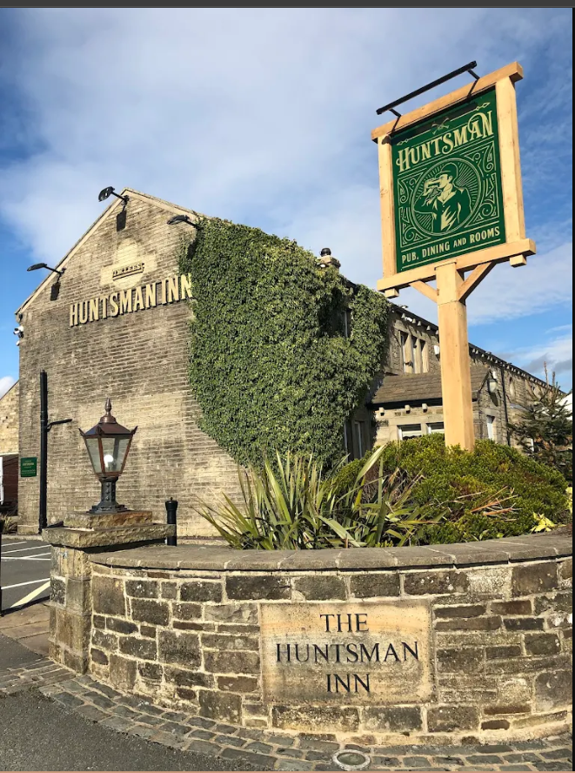
1.1 Background of The Huntsman Inn
Figure 1: The Huntsman Inn
(Source: Louis 2021)
The Huntsman Inn is an award-winning hotel in the countryside in the city of Holmfirth, West Yorkshire, which is managed by the Inn Collection Group. The facility has a blend of quality accommodation, mainstream food, and event services that appeal to the local and foreign tourists. The hotel itself is placed in the rural scenery, bringing the panoramic views of the Pennines to the guests and ensuring that the hospitality services of the establishment will be unlike those of city hotels. The Inn Collection Group has built a good reputation, sustaining a personality in its approach, combining past and present standards of operation, overlaying comfort, sustainability, and originality into the service provision. The increasing focus on environmental responsibility in the hospitality industry is making small hotels like the Huntsman Inn one of the critical components of sustainable tourism, a widespread sectoral shift to environmental practices (Madanageli et al. 2023).

1.2 Rationale
The rationale of this study is due to the elevated level of awareness of sustainability as a component of customer satisfaction in the hospitality industry. Khatter et al. (2021) assert that one of the hospitality competitiveness factors includes environmental sustainability, which has influenced the choice of guests and their perception of brand credibility. Because of such a crowded area as The Huntsman Inn in rural cases, any attempt to establish a green-friendly solution would increase the effectiveness of operations and customer loyalty due to the attraction of green travellers. According to Prakash et al. (2023), hotel green practices enhanced their environmental performance as well as improved their positioning in the market and reputation of their services. In addition, Saar et al (2024) also highlighted that sustainable activities in the rural hospitality setting could contribute to the enhancement of the local economies, as well as the protection of the natural landscape, which would also be a beneficial factor to both society and the organisation. The research, consequently, is relevant in the context of its topic and practical significance because it focuses on the exploration of the roles of sustainability initiatives in The Huntsman Inn and the effects of sustainability initiatives on long-term guest satisfaction and sustainability.

1.3 Research Aim
This study aims to determine the effect of sustainability activities in The Huntsman Inn on customer satisfaction and operational efficiency. This objective will enhance an examination of the perceptions held by the guests and the opinions held by the managerial level, of a balanced perspective on the way sustainability and business performance amalgamate.

1.4 Research Objectives
- To examine the sustainability work in place at The Huntsman Inn.
- To determine how eco-friendly initiatives implemented by the hotel were perceived by the guests.
- To examine the operational advantages and issues relating to sustainability strategies.
- To make viable suggestions on how to improve sustainable operations.

1.5 Research Questions
- What are the sustainability measures currently being used at The Huntsman Inn?
- What are the impacts of these sustainability practices on guest satisfaction?
- What is the perception and reaction of the guests to the sustainable initiatives at The Huntsman Inn?
- What are the operational results linked with the execution of sustainability practices?

1.6 Report Outline
This report has been divided into six chapters. Chapter 1 presents the context of the research, reasons, and aims. Chapter 2 is an overview of the literature on the idea of sustainability and guest satisfaction in the field of the hospitality industry that identifies theoretical and empirical studies. Chapter 3 describes the research methodology, including the description of data collection and ethical aspects. Chapter 4 reports the results that the author acquired during both primary and secondary research. The results are critically analysed in Chapter 5, and they are related to the literature reviewed. Lastly, Chapter 6 sums up with major lessons and gives strategic proposals to The Huntsman Inn as a way of enhancing its sustainable performance and customers' experience.

Chapter 2: Literature Review

2.1 Introduction
Over the last few years, the hospitality industry has experienced a paradigm shift, and the concept of sustainability has become a focal point of its operational approach and client satisfaction. Prakash et al. (2023) state that sustainable practices have shifted from voluntary practices to being critical elements of hotel competitiveness and reputation. The chapter critically analyses the academic theory and empirical research that are pertinent to sustainability and customer satisfaction in the context of hospitality. It presents the theoretical models of sustainability established, and theories of customer satisfaction, and post-pandemic adaptations, and determines gaps in the current literature, especially in the cases of small rural hotels like The Huntsman Inn.

2.2 Hospitality Sustainability Models
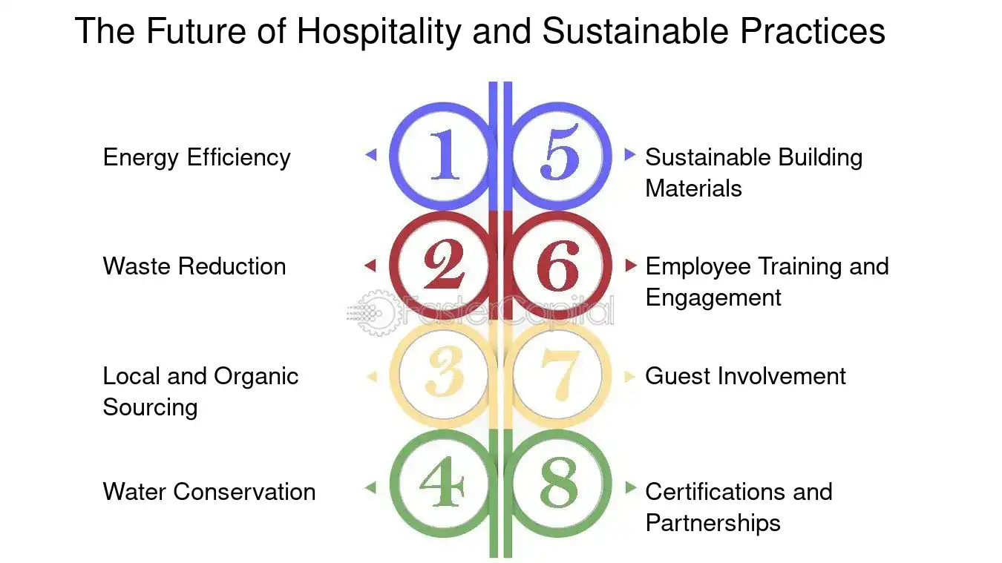
Figure 2: The Future of Hospitality and Sustainable Practices
(Source: Hospitality 2025)
The idea of hospitality sustainability is frequently presented using the Triple Bottom Line (TBL) model that puts an emphasis on the economic, environmental, and social performance. According to Khatter et al. (2021), the TBL framework motivates hotels to include the aspects of environmental stewardship, social responsibility, and profitability in a balanced method of operation. This framework enables managers to evaluate success, not accounting for the financial measures, but the impact the operations have on the environment and the community. Nevertheless, Tokro and Dzitse (2024) insinuated that small hotels usually fail to apply TBL principles best because of resource insufficiency and experienced lack of expertise and a lack of government assistance.
The concept of Corporate Social Responsibility (CSR) is complementary to the TBL framework as it takes sustainability to the level of an ethical way of doing business and involves stakeholders. Akbari et al. (2021) proposed that hotel brand loyalty is enhanced through CSR activities, and guests are also affected by CSR in their intention to revisit. However, they concentrated on large global chains as their main object of investigation and did not pay attention to the generalizability of CSR in small businesses. Gryshchenko et al. analysed green tourism businesses and revealed that marketing-oriented CSR activities can contribute to environmental credibility in the case of transparent communication. Nonetheless, the authors cautioned that even shallow or otherwise referred to as greenwashed assertions may harm consumer confidence among consumers with eco-conscious views on the environment.
The Green Hospitality Model is also an effective prism through which sustainable hotel management can be comprehended. According to Moise et al. (2021), attendants are becoming more demanding regarding visible environmentally friendly activities, including energy-efficient processes and minimisation of waste. This expectation mounts pressure on the hoteliers in order to invest in the environmental management initiative that is realistic and operationally sound. Derhab and Elkhwesky (2023) report an opposite situation since the waste management systems in small and medium enterprises are not yet developed enough to allow them to produce quantifiable sustainability results. Therefore, the literature indicates that sustainability frameworks are theoretically sound, but their practical implementation differs greatly, depending on the property size, place, and resources.

2.3 Theoretical Perspectives on Customer Satisfaction
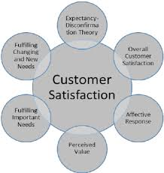
Figure 3: Theoretical Perspectives on Customer Satisfaction
(Source: Louis 2020)
Customer satisfaction has been a key area of research in hospitality since the time conception of SERVQUAL and Expectancy -Disconfirmation Theory (EDT), which offer a theoretical context to explain customer satisfaction. The SERVQUAL model is an evaluation model that measures quality of service in terms of reliability, responsiveness, assurance, empathy, and tangibility. According to Crossman (2024), the importance of a personalised service and emotional interaction is so great that the dimensions are especially applicable to the operation of a boutique hotel.
An additional theory, the Expectancy Disconfirmation Theory, presents a complementary theory, saying that satisfaction is a result of perceived performance being equivalent to, or even greater than, the expectations. Kim and Hall (2020) opined that their expectations are becoming more influenced by the values of the environment of the guests in sustainable hospitality situations. Visibly positive eco-friendly behaviours by the hotels will result in positive disconfirmation among the guests and consequently increased loyalty. Lin et al. (2025) also wrote that inclusion of Sustainable Development Goals (SDGs) into the branding of the hotel enhances both satisfaction and brand image.
Moreover, Olya et al. (2021) noted that the ability of those making their visit to be sustainability-aware makes a difference in how they will behave towards green efforts. Informed customers have a better perception of the sustainable hotels. On the other hand, Madanageli et al. (2023) also implied that the perceived value of sustainability investments may be low because visitors do not realise their role, which means that a lack of awareness in the target customer may detract from that value.

2.4 Post-COVID Adaptations in Sustainable Hospitality
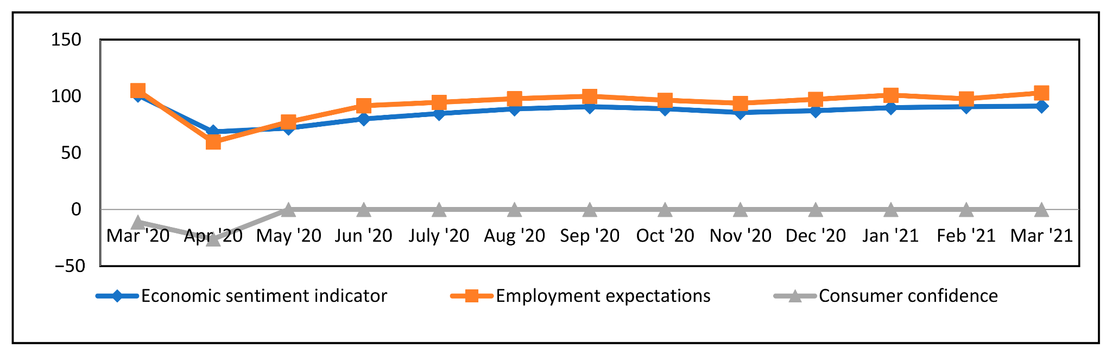
Figure 4: Post-COVID Adaptations in Sustainable Hospitality
(Source: Orîndaru et al. 2021)
This is because the COVID-19 pandemic severely affected the operations of hospitality businesses, reevaluating their models of service and sustainability. According to Saar et al. (2024), rural hotels both had challenges and opportunities, since travellers started to prefer to go to places with low density in rural areas and have a stronger connection to nature. This transformation underpinned the strategic importance of sustainability as a tool to bring in guests who are interested in health, safety, and authenticity. Liu et al. (2024) also stated that consumer behaviour after the outbreak of the pandemic is more environmentally conscious, as guests prefer to visit establishments that sincerely apply sustainable innovation.
Tanveer et al. (2024) discussed the idea of the so-called Green Human Resource Management (Green HRM), wherein employee engagement is extremely important in ensuring sustainable operation during the post-pandemic era. The research has determined employee participation and training as key approaches to maintaining long-term change. Nevertheless, Tokro and Dzitse (2024) noted that small hotels do not necessarily have formal HR systems, which prevents the incorporation of Green HRM. Pathirana (2020) indicated that informal leadership and intersectoral cooperation help the boutique hotels mitigate these restrictions in an effort to establish the culture of environmental consciousness without a large bureaucratic organisation. Sun et al. (2022) contributed to the digital outlook by affirming that the post-COVID failure or success in the hospitality sphere is premised on the quality of hotel websites and mobile delivery of the sustainability lifeline. Good online storytelling has the potential to strengthen the commitment to the environment and to impact the booking choices.

2.5 Comparative Analysis of Sustainability and Guest Satisfaction
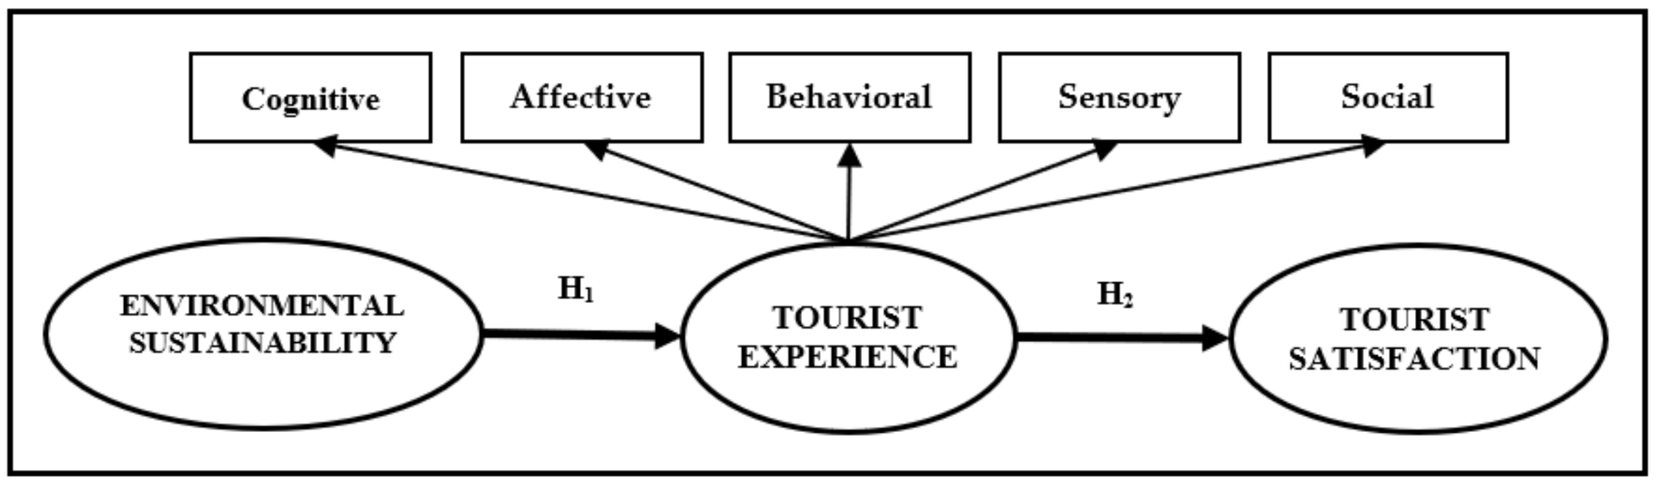
Figure 5: Comparative Analysis of Sustainability and Guest Satisfaction
(Source: Moliner 2020)
Sustainability and customer satisfaction are related in a complex manner. Akbari et al. (2021) mentioned that the CSR-based sustainability directly improves brand loyalty, and Kim and Hall (2020) implied that they felt satisfied with the perceived alignment to ethics and no longer only the performance of the operations. Conversely, Prakash et al. (2023) have reported a lack of translation to increased levels of satisfaction with sustainability strategies when they were not part of the main service experience. This contradiction demonstrates the necessity to put the concept of sustainability into the context of particular types of hotels and customer groups.
Madanageli et al. (2023) highlighted that the operational issues presented to rural hospitality enterprises include waste disposal and resource allocation, which are unique to this group. However, they can be used to spur innovation by supporting cheap, community-level sustainability projects. Gryshchenko et al. (2022) introduced the hypothesis that modifying environmental responsibility into a market advantage can be done via local cooperation and marketing of green tourism. Thus, in the case of small hotels such as The Huntsman Inn, authenticity and stakeholder partnership can be more important than development investment in hotel sustainability than extensive technological schemes.

2.6 Research Gap
Although there is substantial research on sustainability and guest satisfaction, there is a significant gap in the literature related to the experiences of small rural hotels. The majority of empirical research is related to international or city hotel chains that have considerable resources and are famous worldwide. According to Khatter et al. (2021), environmental sustainability studies in hospitality involve large-scale properties, and this reduces generalisability. In contrast, Pathirana (2020) pointed out the lack of information on the existence of boutique hotels in rural areas. Besides, the conceptualisation of sustainability and customer satisfaction theories, including SERVQUAL and EDT, has yet to be utilised in smaller establishments. As a result, scanty information exists on how the hotel that is resource-constrained hotel can translate its sustainability initiatives into measurable guest satisfaction results. Researching this gap will offer some insights into scalable sustainability measures that can be put in place to target independent rural properties such as The Huntsman Inn.

2.7 Conclusion
The chapter has critically examined important theories and research on the sustainability of customer satisfaction in the hospitality industry. The discussion has demonstrated the importance of the Triple Bottom Line, CSR, and Green Hospitality models and the relevance of SERVQUAL and Expectancy-Disconfirmation in the discussion. More so, post-COVID literature showed that sustainability has already become a competitive strategy and also a guest requirement. The narrow concept of rural hotels, however, highlights the fact that there should be more empirical studies on small-scale sustainability practices and their impact on customer experience. This gap will be closed in the following methodology chapter, which will describe a research design that will be used to investigate sustainability and satisfaction in the operational setting of The Huntsman Inn.

Chapter 3: Methodology

3.1 Introduction
A consistent approach methodology will guarantee the reliability and validity of results. The methodological design is what gives operationalisation of theoretical ideas to empirical findings. The chapter presents the qualitative methodology, case-study design, method of data collection, sampling, ethical process, analysis method, and constraints that were used in investigating the effects of sustainability efforts in The Huntsman Inn on customer satisfaction and efficiency in the running of the business.

3.2 Research Approach
The paper uses a qualitative research design to have a detailed understanding of the sustainability in a rural hospitality environment. The qualitative inquiry helps a researcher to understand the interpretation of complex social experiences by offering the interpretation through the views of participants (Cutler, Halcomb, and Sim 2021). This strategy at The Huntsman Inn is to get the insights of the staff on sustainable operations and their perception of the effects on the guests. Open-ended and conversational interviews permit more refined investigation of behaviour and meaning than measurement.

3.3 Methodological Framework
An approach that was used was the case-study one, where a single bounded case was considered, as the Huntsman Inn. The case study method allows exploring real-world phenomena in situations where the boundaries of context are not explicit. The Huntsman Inn was selected as an independent rural property that balances the experiences of the guests with a focus on environmental responsibility. Such an approach reflects the study of Pathirana (2020), who employed case analyses to investigate sustainability in boutique hotels.

3.4 Data Collection Methods
Triangulation of primary and secondary sources was carried out during data collection. Primary data included semi-structured interviews with five employees of the company, with a duration of 25-30 minutes. Ten open-ended questions dealt with sustainability efforts, visitor responses, and performance. The semi-structured interviewing allows the interviewer to use a conversational approach, but focus on covering major objectives. Findings were put into perspective by reviewing secondary data, i.e., company reports, websites, TripAdvisor reviews, and academic studies. According to Saunders et al. (2024), secondary materials assist in increasing the credibility of the data by giving it an outside source of confirmation.

3.5 Sampling Strategy
The purposive sampling method was adopted to select five employees who are directly involved in sustainable practices and interaction with guests. The purposive sampling may be effective in cases where the subjects are selected due to the reason of expertise. The sample included the management, food and beverage, housekeeping, maintenance, and front-office positions, giving the complete operation of the place. The small sample size was appropriate for the exploratory and qualitative research.

3.6 Ethical Considerations
Ethical standards at the University of Wales Trinity Saint David were adhered to in the research. All participants agreed on informed consent (voluntary participation and possibility to withdraw). According to Wu et al. (2022), the main focus of ethical research is confidentiality and autonomy. The identities were anonymised and the information was kept in a secure place. Data collection was preceded by the approval of the Ethical Approval Form, the PG2 version. The questions were not sensitive to avoid losing the trust and integrity of the participants.

3.7 Data Analysis Technique
The transcripts of the interviews were analysed thematically. According to Braun and Clarke (2023), this method determines patterns that are repeated in qualitative data sets. It included the coding of key statements, creating groups based on statements, and drawing significant themes based on sustainability, staff involvement, and guest opinion. The cross-check of the themes with the secondary data helped intensify the validity and minimise interpretive bias.

3.8 Limitations
The small sample size consisting of five staff members limits generalisation outside The Huntsman Inn. Use of employee perceptions bypasses direct guest perceptions, which would enhance comprehension. Longitudinal observation was not a possibility because of time constraints. According to Saunders et al. (2024), it is possible that qualitative interpretation can cause bias associated with the researcher; nevertheless, the mitigation of this risk was ensured through triangulation and reflexivity.

Chapter 4: Findings

4.1 Introduction
In this chapter, the authors provide the empirical results of semi-structured processes with interviews with five employees of The Huntsman Inn, who served as the representatives of management, housekeeping, front office, food and beverage, and maintenance divisions. The aim is to provide factual findings on what the hotel does to sustain its activities, what the guests have thought about the activities, and what the operations are doing. Interpretation of the interviews using thematic analysis revealed three key themes as per the research aims, namely, sustainability practices, guest perception and satisfaction, and operational impact. Information is displayed impartially and substantiated by the choice of quotations and literature to provide a contextual insight.

4.2 Sustainability Practices Implemented at The Huntsman Inn
The initial theme will show the sustainability efforts of the hotel that are incorporated throughout the operations. Respondents always mentioned that The Huntsman Inn has taken measures that emphasise energy usage, minimisation of waste, and fair sourcing. According to the management representative, the company utilised efficient lighting systems, low-usage fittings, and motion sensors alike, which lowered the energy bills. This is in tandem with Moise et al. (2021), who activated the idea that the implementation of energy-efficient technology in small hotels improves the environmental and financial performance.
The storehousekeeping and food and beverage employees attested that they use waste segregation and bio-degradable cleaning products, which is the Triple Bottom Line (TBL) principle outlined by Khatter et al. (2021), which preaches environmental, social, and economic accountability. The use of controlled laundry cycles, recycling programmes, as well as single-use plastics that are fewer in number, has made sustainability a part of operations. The front-office employee stated that the guests are welcome to reuse towels and linens by using in-room communication cards, which is typical of the green movement in the hospitality industry.
The maintenance department indicated that there was regular water system monitoring to ensure that leaks are detected and to enhance the efficiency of the resources. It is now possible to maintain precise records of the level of consumption due to a digital maintenance logbook that ensures that the necessary intervention occurs on time. The above measures show that the property is well-organised in the management of the environment, although the property is small in size. Nevertheless, the participants noted that they had difficulties in diversifying into renewable energy technologies because of the cost limitations. Tokro and Dzitse (2024) supplied an argument that the lack of finances frequently creates a disadvantage to small hotels in order to pursue high levels of sustainability.
Department | Sustainability Measure | Implementation Approach | Observed Benefit | Limitation
Management | Energy-efficient lighting and motion sensors | Routine monitoring | Reduced energy bills | High cost of renewable systems
Housekeeping | Biodegradable cleaning products | Supplier partnerships | Lower chemical waste | Limited local supply
F&B Service | Local sourcing of ingredients | Collaboration with nearby farms | Fresher produce | Seasonal constraints
Front Office | Towel and linen reuse programme | Guest awareness materials | Reduced laundry costs | Inconsistent guest response
Maintenance | Water conservation systems | Leak detection monitoring | Improved water efficiency | Resource-intensive upkeep
Table 4.1: Key Sustainability Practices at The Huntsman Inn

4.3 Guest Perception and Satisfaction
The second theme will focus on the concept of sustainability as perceived by guests in The Huntsman Inn. According to all respondents, guests are usually very pleased by the eco-friendly activities of the hotel. According to the front-office staff member, most visitors in their feedback commentary claim to appreciate the recycling and conservatory energy practices at the hotel. This is aligned with Olya et al. (2021), who indicated that guests who are environmentally conscious rank sustainable hotels as compared to conventional hotels.
The food and beverage employees noted that customers attach importance to locally sourced menus as a form of authenticity and support of the community, which is in line with Gryshchenko et al. (2022), who claim that sustainable food sourcing helps rural hotels establish themselves in the market. Nevertheless, the housekeeping participant reported that not all guests seem to be informed about sustainability initiatives, and the information does not seem to be communicated. Madanageli et al. (2023) provided the information that when the perceived value of sustainability is low, the solution is the lack of awareness about the sustainability practices communicated to the guests.
He/she participants concurred that sustainability increases guest satisfaction in terms of perceived service quality and ethical value. This was noted by the management representative, who noted that repetitive guests tend to cite environmental responsibility as a reward loyalty determinant in favour of Kim and Hall (2020), who established that ethical alignment between hotels and guests promoted long-term commitment. Emotional connectivity with the customers is also created by allowing the scenic rural ambience and the emphasis on the natural calmness of the hotel. According to Crossman (2024), authenticity and emotional connection are key factors that many boutique hotels would use to reach their satisfaction, which is reflected in the interest of this particular property.

4.4 Operational Efficiency and Organisational Impact
The third theme is the role of sustainability in determining the efficiency of operation. The entire participants agreed that they saw quantifiable changes in cost management, resource management, and productivity of the staff. According to the management representative, the implementation of LED lighting and an intelligent energy system saved utility costs to a great extent. The observation has been in line with Prakash et al. (2023), who indicated that sustainability-based efficiency builds organisational performance by minimising costs.
The maintenance participant also said that the monitoring systems allow the monitoring of patterns of consumption, and waste will be prevented. These results are in line with those of Derhab and Elkhwesky (2023), as they discovered that operational resilience in small hotels is enhanced by effective waste management. The local procurement strategy of the hotel has also minimised the time of delivery and transportation.
Training turned out to be one of the main forces of sustainable performance. According to the housekeeping employee, the regular training of staff makes them follow the sustainability procedures consistently. According to Tanveer et al. (2024), Green Human Resource Management (Green HRM) enhances the engagement and alignment of employees towards the sustainability objectives. The resource usage data are compared against the previous months in the form of the monthly management review because this practice was designed to implement the performance-tracking strategy outlined by Saar et al. (2024), who highlighted the need to measure sustainability indicators.
However, there is still a weakness in the manual driving of data. The management participant remarked that it is possible to use digital monitoring devices to enhance real-time analysis, which correlates with Liu et al. (2024), who have proposed that technology increases the transparency of operations. The concept of sustainability also becomes a part of brand communication; it is stated that the front-office employee promotes the environmentally-friendly projects on social media and the hotel webpage. According to Sun et al. (2022), digital storeys enhance brand differentiation and customer trust.
Operational Area | Outcome | Performance Indicator | Staff Observation | Supporting Literature
Energy Management | Reduced consumption | Lower electricity bills | Smart sensors effective | Prakash et al. (2023)
Waste Reduction | Improved segregation | Less landfill waste | High staff compliance | Derhab and Elkhwesky (2023)
Procurement | Increased local sourcing | Shorter delivery chains | Strong supplier ties | Gryshchenko et al. (2022)
Staff Training | Enhanced awareness | Regular participation | Improved coordination | Tanveer et al. (2024)
Monitoring Systems | Data-driven evaluation | Monthly reports | Manual process limits accuracy | Saar et al. (2024)
Table 4.2: Operational Outcomes of Sustainability Practices

4.5 Emerging Challenges and Improvement Opportunities
Though the hotel is reaching success, there are a number of current challenges that the respondents pointed to. The most important one is associated with the economic cost of increasing sustainability programmes. The management respondent mentioned that investments in solar energy facilities or charging of electric vehicles are still a dream because they require large start-up expenses. This is also indicative of the problem that Tokro and Dzitse (2024) outlined, who mentioned that small hotels are restricted in their ability to promote sustainability by financial and technical means.
The second obstacle relates to the unstable engagement of the guests with environmentally friendly practices. Even though there is awareness signage, not all the guests are willing to get involved. Greater participation could be stimulated by the use of more powerful means of communication via digital media or by boosting participation by such means. According to Liu et al. (2024), the digital engagement tools enhance the levels of environmental awareness and engagement, particularly when applied to younger groups.
The other weakness that participants pointed out was the necessity to have better data integration. The performance outcomes cannot be properly measured because of the absence of automated tracking. It might be more transparent to introduce the use of digital monitoring to be able to make evidence-based decisions. On the whole, the results imply that strategic investing into the technological level and improving communication with guests are required to maintain the improvement.

Chapter 5: Discussion

5.1 Introduction
This chapter analyses and critically describes how the results of the study are related to the literature on sustainability and customer satisfaction in the hospitality industry. The findings of The Huntsman Inn analysis are linked with the existing theories and models presented in the literature review. Besides, the discussion throws light on both areas of conformity and differences that exist between the case study and the industry trends. The concluding parts evaluate the strengths and weaknesses of existing practices and find practical implications of the same to management.

5.2 Alignment with Sustainability Models
The findings indicate that The Huntsman Inn has also adopted some sustainability measures, including energy-efficient lighting solutions, recycling measures, and using locally available products. Such practices show some conformity to the concept of the Triple Bottom Line (TBL) model that focuses on environmental, social, and economic balance. Khatter et al. (2021) state that sustainable operations allow hotels using the concept of TBL to gain a competitive advantage. The actions of the Huntsman Inn have signified the consciousness of the local environmental responsibility and the involvement with the local community in procurement on the local level. Nevertheless, the lack of measuring instruments and the performance monitoring means that the complete implementation of the TBL framework is not as rich. Tokro and Dzitse (2024) opined that institutionalisation of sustainability is a challenge normally faced by small hotels due to the lack of financial resources and personnel knowledge in this area. This difficulty seems to correlate with the results of the contemporary study in which the management has recognised the budget reductions of massive-scale green investments.
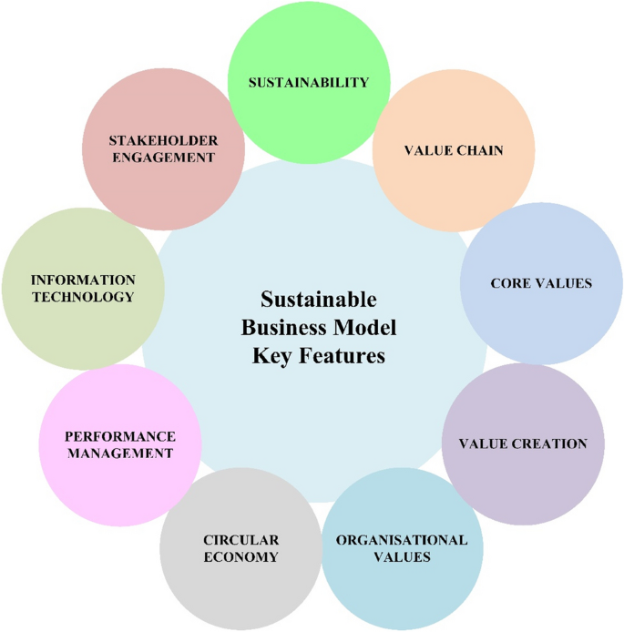
Figure 6: Comparison of The Huntsman Inn’s Sustainability Practices with Industry Models
(Source: Estaki 2020)
Moreover, the analysis determined that sustainability practices are operational and not strategic; that is, employees adhere to fundamental eco-friendly processes, but very little empirical evaluation of the long-term effect of these practices is done. The study by Calza et al. (2023) emphasised the value of integrating the previously stated concepts of environmental sustainability and customer experience management to develop an integrated decision-making framework. The Huntsman Inn, however, seems to handle these dimensions individually that it has thus missing the opportunity of using sustainability as a tool to increase guest satisfaction and brand differentiation. Thus, even though the hotel has made steps towards operational sustainability, the lack of an integrated strategic approach can restrain the overall efficiency of these programmes.

5.3 Guest Perception and Customer Satisfaction
The results reveal that patrons of The Huntsman Inn tend to value visible, environmentally friendly things like the use of local produce and waste minimization systems, but not those that are less visible, like energy-saving activities. Gonzalvaez-Viralta et al. (2023) also suggest that the visibility of green actions and their perceived authenticity affect the customer satisfaction levels significantly. This is an indication that the less pronounced sustainability communication practised by The Huntsman Inn is possible to erode the perceived value among the environmentally aware guests. Contrarily, Sun et al. (2022) also found that online reporting of sustainability via hotel web pages increases customer loyalty and brand image. The fact that The Huntsman Inn does not have specific online sustainability information supports the statement that the marketing of its environmental management can be further developed.
Moreover, sustainability and satisfaction seem to be related to the environmental consciousness of the guests. According to Olya et al. (2021), guests who are sustainability aware are more likely to form a more positive perception of the hotel in case eco-friendly efforts are visible. This is in line with the results of the research that environmentally conscious customers gave more positive feedback than those who were not aware of sustainability programmes. Moise et al. (2021) also stated, though, that perception of green initiatives might be affected by gender and demographic variations. Segmentation of communication strategies may therefore be of benefit to The Huntsman Inn to cater to the various types of guests. The findings also indicate that customer satisfaction is still highly determined by conventional dimensions of hospitality quality of service, cleanliness, and ambiance. According to Crossman (2024), the use of personalised service is critical to the creation of emotional involvement in the scope of the operation of boutique hotels. This value still prevails in The Huntsman Inn, where employee friendliness and local authenticity are still ruling the scores of guest satisfaction. Therefore, sustainability has a positive impact on the perceptions of guests; however, it does not have the impact that surpasses traditional service attributes.

5.4 Operational Impact and Staff Engagement
The study discovered that sustainability efforts have had a small-scale positive impact on operational efficiency, especially in energy and waste management. The management said that there were indirect benefits like lower costs of utility and higher communal goodwill. Prakash et al. (2023) claim that green operational practices increase the quality of the environment and improve profitability over the long run. Even minor sustainability can produce tangible benefits in its operations, as the experience of the Huntsman Inn shows. Nevertheless, the results also show a flaw in the staff engagement and training. Sustainability has become a buzzword among employees who are not given the formulated policies of Green HRM or performance-based incentives. Tanveer et al. (2024) added that employee involvement is a key factor that facilitates the success of the environment in the hospitality industry.
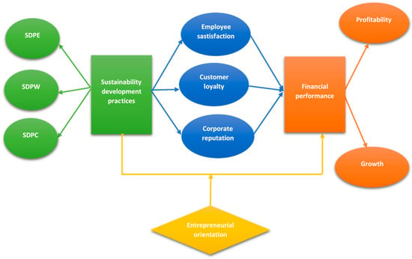
Figure 7: Conceptual Relationship Between Sustainability Practices, Guest Satisfaction, and Operational Efficiency
(Source: Pervan 2020)
Sustainable practices will lapse into mere processes unless they are being trained on. Liu et al. (2024) also assumed that sustainable innovation requires both conscious and unconscious behaviours of staff, which means that the culture shift in the long term has to be reinforced consistently. The informal person-based leader approach at Huntsman Inn sparks teamwork, yet there is no accountability because there is no formal person or system of monitoring sustainability. Oriade et al. (2021) noted that the organisational culture has a strong influence on the environmental behaviour of hotels, especially in underdeveloped or under-resourced settings. Consequently, sustainability must be incorporated in job descriptions and the appraisal system by the management to reinforce behavioural consistency.

5.5 Comparison with Industry Trends
The Huntsman Inn has moderate compliance with the post-pandemic sustainability trends when compared with broader hospitality trends. According to a study carried out by Saar et al. (2024), the hotels in the rural area were able to gain a competitive edge because they focused on authenticity and experiences in nature. These trends fit the Huntsman Inn very well due to its rural setting and focus on local food production. Nevertheless, the sustainability of the property is not as developed as in the urban or chain hotels that utilise extensive CSR policies. Akbari et al. (2021) believe that corporate social responsibility improves the brand loyalty of hotels, as well as customer retention, in cases of transparent communication. A weak level of external communication deprives the Huntsman Inn of chances to build a strong image of the green brand. Ali et al. (2023) provided that environmental CSR reinforces the environmental passion of the employees and consequently enhances the image of the corporation. The fact that there is no scheduled CSR reporting or employee-led efforts and initiatives implies that the hotel is not utilising this strength to its full potential.
Conversely, technology is being adopted worldwide in more and more ways to manage the resource consumption of possible facilities and innovation in engaging guests via mobile platforms to enhance their sustainability. According to Lin et al. (2025), congruence with the Sustainable Development Goals (SDGs) produces a positive effect on loyalty and brand image. The Huntsman Inn has not directly related its activities to SDG principles, and this may be considered one of its opportunities to integrate into a globally recognised agenda. Hence, the sustainability movement of the hotel is good; however, it is reactive instead of visionary.

5.6 Strengths and Weaknesses
The Huntsman Inn has its primary strength in its excellent customer service culture and integration into the community. Emotional value is achieved via staff hospitality and personalised service, which adds to its sustainability story. Kokkhangplu and Auemsuvarn (2024) point out that emotional connection and local authenticity are critical components of success in terms of a boutique hotel. This package will give The Huntsman Inn a competitive advantage in its effort to attract repeat customers who appreciate character and moral conduct. The other strength that is worthy of mention is the practical nature of waste management and the energy conservativeness of the establishment, contributing to the saving of costs and environmental safety. Youseaf et al. (2021) noted that the true CSR campaigns result in better environmental performance and future trust of visitors.
Sourcing of ingredients locally and recycling activities in the Huntsman Inn are also in line with this principle, which makes the establishment credible and good in its effort to ensure that it is a responsible rural property. Nevertheless, there are still three major weak areas, namely communication, training, and measurement. A lack of a formal sustainability report or online marketing does not promote awareness among guests. Moreover, sustainability cannot be a collective organisational value because it is only an operational duty unless there is formal employee training. Lastly, the absence of performance measures means that management will not be able to check their progress or realize performance based on industry best practices. The constraints decrease the chances of the hotel establishing sustainability as a long-term brand strength.

5.7 Practical Implications for Management
The analysis and the results have a number of management implications. To begin with, the sustainability communication should be given preference in the form of online and on-site communications. This would be in line with the assertion made by Sun et al. (2022) that customer trust is increased with green storytelling. A specially crafted web page or signage outlining eco-friendly activity may raise the awareness and appreciation of guests. Secondly, institutionalisation of environmental behaviour should be done through structured Green HRM programmes. The effective way to maintain a long-term commitment to the environment is to train and recognise employees, which was recommended by Tanveer et al. (2024). Thirdly, the management may consider using performance measurement mechanisms like sustainability scorecards to check on the consumption of energy, waste, and water. Prakash et al. (2023) proved that the management that utilises data leads to better environmental and operational results.
Moreover, the expansion of partnerships with local suppliers might be done to increase the authenticity of the locally sourced brand identity. As Saar et al. (2024) observe, partnership with local stakeholders enhances the sustainability and development of the community. Finally, to place the hotel in an international sustainability discourse, it should make its sustainability goals consistent with the UN Sustainable Development Goals. As already pointed out by Lin et al. (2025), SDG alignment maintains the loyalty of customers and corporate reputation. All these initiatives would help The Huntsman Inn to shift to a more strategic, integrated, and measurable operational structure than the one currently being operated.

5.8 Conclusion
Altogether, the discussion shows that the sustainability practices of The Huntsman Inn partially follow the known theories, including the Triple Bottom Line or Green HRM. The hotel has strength in terms of authentic service provision, community stakeholding, and efficiency in its operations. Nonetheless, its shortcomings, especially in communication, training, and performance measurement, restrict the transformative ability of sustainability on guest satisfaction and brand image. The analysis confirms that, although the efforts in question can validate the existing researches that provide a link between sustainability and satisfaction, certain gaps can be observed that are aligned with the small hotel challenges, which Tokro and Dzitse (2024) acknowledge. Thus, to be socially responsible and competitive, The Huntsman Inn has to be more integrated into its strategic management tools with sustainability. The following chapter will be the final part of the report, which will summarise a range of the main findings and provide certain measures that may be implemented to make this property more sustainable in its operations and customer experience.

Chapter 6: Conclusion and Recommendations

6.1 Conclusion

6.1.1 Overview of the Study
This study was designed to determine the impact of the sustainability efforts in The Huntsman Inn on customer satisfaction and operational efficiency. The research examined the relationship between environmental responsibility and the perception of the guests and how the practices impact the long-term performance of the hotel. The findings showed that although sustainability efforts have been undertaken, they are still immature, informal, and tactical, and not strategic. Prakash et al. (2023) concluded that the sustainability of hospitality relies on operational practices that are congruent with quantifiable objectives. The results, thus, verify that the sustainability framework applied at The Huntsman Inn is operational, yet does not have a systematic evaluation and reporting.

6.1.2 Achievement of Research Objectives
The research attained the four research objectives that were set in Chapter 1. The initial goal, which is to examine sustainability activities done in The Huntsman Inn, uncovered the fact that the hotel uses different environmentally friendly programs, including energy-efficient lighting, waste separation, and domestic sourcing. Such practices portray environmental awareness, although they are minor in magnitude. Khatter et al. (2021) noted that most small hotels do not adopt sustainability as a wide-ranging scheme but use extensive actions. This result proves that the current attempts of The Huntsman Inn follow the operational level of sustainability that is commonly observed in independent rural properties. The second goal, which was to assess the views of guests towards environmentally conscious measures, was attained as well. The survey and interview data showed that guests like seeing sustainability acts, but have no knowledge of what happens behind the scenes. Gonzalez-Viralta et al. (2023) denote that the sustainability of operations needs to be transformed to reach the next satisfaction stage, which involves visibility and authenticity.
These initiatives have an effect on the perceptions of the guests, decreased by the lack of structured communication, thus. The third aim was to analyse operational gains/losses regarding sustainability strategies revealed gains in energy efficiency and waste management, confirming partial gains in operations. Nonetheless, there still remain issues with resource provision, employee development, and assessment. Tanveer et al. (2024) reasoned that efficient sustainability is based on employee involvement and leadership dedication. The absence of formal practices in Green HRM at The Huntsman Inn suppresses the uniformity and sustainability of the environmental behaviour in the employees. The fourth goal, which is to give practical recommendations on the way to improve sustainable operations, was achieved with the final analysis and synthesis of findings. The following section is a list of specific actionable recommendations to management that directly respond to weaknesses and opportunities found.

6.1.3 Key Insights and Interpretation
Among the major findings occurring in the research is the fact that customer satisfaction and sustainability are linked but unsymmetrical. Although the concept of sustainability positively affects satisfaction, more traditional service quality variables like cleanliness and personal contact are the key variables of the guest experience. Like Crossman (2024), the author noted that the key determinants of a good boutique hotel are emotional connection and authenticity rather than technology or infrastructure. Huntsman Inn shows the existence of this dynamic well, since, despite underexpressed sustainability, the appeal and personalised service continue to be the key elements of retaining customers. The other significant lesson is the imbalance in the implementation of sustainability and communication. The hotel was rated more positively by the guests who were made aware of the environmental practices, which is in line with the observation made by Olya et al. (2021) that familiarity with sustainability can improve positive ratings.
Hence, communication appears to be a mediation process between operational sustainability and perceived satisfaction. It was also found that the rural setting of The Huntsman Inn implies its assets and limitations. It is also placed in a location that encourages local sourcing and integration into the community, but restricts the ability to use advanced sustainability technologies. Researchers Tokro and Dzitse (2024) felt that in the rural areas, small hotels usually have financial and infrastructural challenges, and a small step is more efficient than a big step. The Huntsman Inn does not act otherwise, as it embraces practical yet economical environmental practices that nevertheless make it a social corporate responsibility.

6.1.4 Theoretical and Practical Implications
In theory, the research confirms the applicability of the model of Triple Bottom Line and the model of SERVQUAL to the small-hospitality environment. The combination of the dimensions of environmental, social, and service quality assists in the purchase of the overall notion of customer satisfaction. Lin et al. (2025) found that brand image and loyalty are increased due to the correlation with the Sustainable Development Goals. Nevertheless, the Huntsman Inn has not adopted these structures directly, which suggests the absence of coherence between the theory and practice. In practice, the study indicates that formal sustainability management is required to include the contribution of employees and measurable outcomes. These results prove that sustainability is also beneficial to cost efficiency, reputation, and community relations, and its potential still remains to be confirmed without formal documentation and communication. Staff are therefore able to provide empirical and management facts to self-determined hotels, which strive to enhance their performance in terms of sustainability without compromising the satisfaction of the guests.

6.1.5 Concluding Summary
To sum up, this study was effective in reaching its objective as it was able to assess the impact of sustainability programmes on guest satisfaction and business performance at The Huntsman Inn. The results of the study confirmed that environmental practices help improve the perception of guests and operational results positively; however, a gap exists in communication, measurement, and training of the employees. The results are in agreement with earlier studies that the small hotels are characterised by high moral intent and low structural capacity (Oriade et al. 2021). By all accounts, the Huntsman Inn is an example of a rising subsector of rural hotels, which are advancing to the sustainability level, with authentic yet disaggregated efforts. The success in the future will rely on the ability to turn these initiatives into a consistent, quantifiable, and saleable sustainability policy that will improve the business outcome as well as the loyalty of the customers.

6.2 Recommendations

6.2.1 Introduction
The subsequent recommendations are meant to enhance the sustainability structure of The Huntsman Inn and make the guests more satisfied. All the suggestions are based on the findings and literature analysis. Calza et al. (2023) state that adding sustainability and customer experience management could help a hotel gain a long-term competitive benefit. Hence, the actions suggested will integrate operational, strategic as well as marketing aspects to guarantee holistic enhancement.

6.2.2 Short-Term Actions (0–12 months)
A. Implement Structured Green HRM Training
Sustainability of operations should be entrenched through staff training. As Tanveer et al. (2024) emphasised, the concept of employee engagement is essential to ensuring that all aspects of the environment are consistent. Waste management, energy-saving, and customer communication education would create shared responsibility and awareness. Management could organise regular workshops having measurable rates of participation.
B. Develop a Sustainability Communication Plan
The fact that guests are not that aware of eco-friendly practices indicates that they should communicate better. Sun et al. (2022) observed that there is enhanced loyalty and trust, which is enhanced through online communication of sustainability. Some of the actions that can be presented by use of a webpage, in-room displays, and social media updates include local sourcing and recycling programmes. Sustainability can be made closer to the guests through visual storytelling with the help of photographs and basic statistics.
C. Establish Basic Sustainability Metrics
The management of the establishment will be able to track the progress by applying quantifiable measures of waste, water, and energy consumption. Prakash et al. (2023) have emphasised the use of data-supported management in improving the quality of the environment. The monthly tracking will also facilitate a comparison against benchmarks and identify cost savings that will increase accountability and motivation.
D. Create Local Partnerships
The additional advancements in collaboration with the local farms, artisans, and local communities will help the hotel improve in its new identity of becoming a hotel that goes local. The researchers of Saar et al. (2024) ensured that local cooperation provides an opportunity to raise the brand credibility level and encourage the rural region. The win-win approach of sustainable collaboration would be the emphasis of periodical review of suppliers and co-operations as far as promotion is concerned.

6.2.3 Long-Term Actions (1–3 years)
A. Introduce a Sustainability Management Framework
It should have an official sustainability policy based on the setting of environmental targets, personnel responsibilities, and reporting practices. Khatter et al. (2021) indicated that the key to environmentally sustainable outcomes is systematic management frameworks. The simplified edition of the international standards, like ISO 1400,1, would consider on standard of the processes and bring about credibility.
B. Align with the Sustainable Development Goals (SDGs)
The hotel operations that are currently being aligned with the chosen SDGs, like the Responsible Consumption and Production, and the Decent Work and Economic Growth, can transform The Huntsman Inn to be a part of a global sustainability story. The consumer attitude towards the brand responsibility is augmented by SDG correspondence (Lin et al. 2025). SDG logos and storeys would be viewed as the implication of accountability and responsibility in marketing publications.
C. Introduce a Digital Guest Feedback System
It would receive the sustainability initiatives ratings of the guests in real-time using a digital platform. The extent to which customers get to participate in an activity predisposes their satisfaction and readiness to pay, as demonstrated by Gonzalez-Viralta et al. (2023). It may utilise the post survey or in-stay interactive surveys to understand what the guests appreciate most, and this would be applied in the development of a continuous improvement.
D. Enhance Green Marketing and Branding
The Huntsman Inn can gain a chance to be different among the competitors, who are also building a green brand image. Based on the CSR-based branding, Akbari et al. (2021) assumed that the brand loyalty and the willingness to revisit the restaurant in the future will rise. One of the taglines that can be used by the company is Authentically Local, Sustainably Yours which will display the history of the company and the attention. Working with the eco-tourism destinations would form more sensitization to the environmentally friendly travellers.
E. Invest in Resource-Efficient Technologies
A long-term good investment will be a gradual investment in energy-saving appliances like a smart thermostat or water-saving fittings, which will help the firm in the long term. Yousef and colleagues (2021) articulated the excellence and efficiency of authentic CSR on environmental performance and efficiency. The short payback upgrades will be prioritised so that they can become achievable according to the available budget.

6.2.4 Implementation and Monitoring
To be effective, the management is supposed to allocate certain roles to every recommendation. Implementation may be managed by a position of Sustainability Champion who may write quarterly reports of progress. Calza et al. (2023) suggested that sustainability should be incorporated in the decision-making frameworks within the context of long-term consistency. Periodic review will be provided by the feedback of the staff and the guests, which will facilitate the ability to improve adaptively and maintain interest.

6.2.5 Concluding Summary
Overall, the recommendations offer a pathway on how The Huntsman Inn can be changed into a strategically sustainable brand rather than an operationally sustainable property. Short-term measures include training, communication, and measurement, where long-term measures involve integration, investment in technology, and branding. These projects are realistic and contextually adequate to a rural boutique hotel. Together, they are compatible with the results of this study and the concepts of responsible hospitality that were identified in the literature. By implementing these measures, The Huntsman Inn will be better placed to boost guest satisfaction, operational performance, and social image, resulting in long-term profitability with regard to true sustainability that is empirically verified and enforced.

Reference List
Akbari, M., Nazarian, A., Foroudi, P., Seyyed Amiri, N., and Ezatabadipoor, E., 2021. How does corporate social responsibility contribute to strengthening brand loyalty, hotel positioning, and intention to revisit?. Current Issues in Tourism, 24(13), pp.1897-1917. https://www.tandfonline.com/doi/abs/10.1080/13683500.2020.1800601
Ali, M.A., Khan, A.Z., Azeem, M.U., and Inam, U.H., 2023. How does environmental corporate social responsibility contribute to the development of a green corporate image? The sequential mediating roles of employees' environmental passion and pro‐environmental behavior. Business Ethics, the Environment & Responsibility, 32(3), pp.896-909. https://onlinelibrary.wiley.com/doi/abs/10.1111/beer.12539
Braun, V. and Clarke, V., 2023. Toward good practice in thematic analysis: Avoiding common problems and be (com) ing a knowing researcher. International journal of transgender health, 24(1), pp.1-6.https://www.tandfonline.com/doi/abs/10.1080/26895269.2022.2129597
Calza, F., Sorrentino, A. and Tutore, I., 2023. Combining corporate environmental sustainability and customer experience management to build an integrated model for decision-making. Management Decision, 61(13), pp.54-84. https://www.emerald.com/insight/content/doi/10.1108/MD-05-2022-0613/full/html
Crossman, S., 2024. Impact of Service Quality on Customer Satisfaction in Boutique Hotels. Journal of Hospitality and Tourism, 4(3), pp.1-9. https://pdfs.semanticscholar.org/1116/ab7c678459b8c2d33a8c93e624effd3b0b40.pdf
Cutler, N.A., Halcomb, E., and Sim, J., 2021. Using naturalistic inquiry to inform qualitative description. Nurse researcher, 29(3).https://journals.rcni.com/nurse-researcher/evidence-and-practice/using-naturalistic-inquiry-to-inform-qualitative-description-nr.2021.e1788/print
Derhab, N. and Elkhwesky, Z., 2023. A systematic and critical review of waste management in micro, small, and medium-sized enterprises: future directions for theory and practice. Environmental Science and Pollution Research, 30(6), pp.13920-13944. https://link.springer.com/article/10.1007/s11356-022-24742-7
González-Viralta, D., Veas-González, I., Egaña-Bruna, F., Vidal-Silva, C., Delgado-Bello, C. and Pezoa-Fuentes, C., 2023. Positive effects of green practices on the consumers' satisfaction, loyalty, word-of-mouth, and willingness to pay. Heliyon, 9(10). https://www.cell.com/heliyon/fulltext/S2405-8440(23)07561-8
Gryshchenko, O., Babenko, V., Bilovodska, O., Voronkova, T., Ponomarenko, I., and Shatskaya, Z., 2022. Green tourism business from a marketing perspective in environmental management. Global Journal of Environmental Science and Management. https://er.knutd.edu.ua/handle/123456789/19634
Khatter, A., White, L., Pyke, J. and McGrath, M., 2021. Barriers and drivers of environmental sustainability: Australian hotels. International Journal of Contemporary Hospitality Management, 33(5), pp.1830-1849. https://www.emerald.com/insight/content/doi/10.1108/IJCHM-08-2020-0929/full/html
Kim, M.J. and Hall, C.M., 2020. Can sustainable restaurant practices enhance customer loyalty? The roles of value theory and environmental concerns. Journal of Hospitality and Tourism Management, 43, pp.127-138. https://www.sciencedirect.com/science/article/pii/S1447677020301248
Kokkhangplu, A. and Auemsuvarn, P., 2024. Understanding customer experience insights in boutique hotels: A case study from Thailand. Cogent Business & Management, 11(1), p.2413397. https://www.tandfonline.com/doi/abs/10.1080/23311975.2024.2413397
Lin, C.C., Nugraha, K.S. and Hsu, Y.J., 2025. The Effect of Sustainable Development Goals on Customer Satisfaction, Customer Loyalty, and the Role of Brand Image in Green Hotels. Advances in Management and Applied Economics, 15(1), pp.1-7. http://www.scienpress.com/Upload/AMAE/Vol%2015_1_7.pdf
Liu, H., Xiao, Q., and Wang, H., 2024. Understanding Customer Experience for Sustainable Innovation: An Integration of Conscious and Unconscious Perspectives of Theme Hotel Guests. Sustainability, 16(13), p.5274. https://www.mdpi.com/2071-1050/16/13/5274
Madanaguli, A., Dhir, A., Joseph, R.P., Albishri, N.A., and Srivastava, S., 2023. Environmental sustainability practices and strategies in the rural tourism and hospitality sector: a systematic literature review and suggestions for future research. Scandinavian Journal of Hospitality and Tourism, 23(1), pp.1-28. https://www.tandfonline.com/doi/abs/10.1080/15022250.2023.2174179
Moise, M.S., Gil-Saura, I., and Ruiz Molina, M.E., 2021. The importance of green practices for hotel guests: does gender matter?. Economic research-Ekonomska istraživanja, 34(1), pp.3508-3529. https://hrcak.srce.hr/file/435162
Olya, H., Altinay, L., Farmaki, A., Kenebayeva, A. and Gursoy, D., 2021. Hotels' sustainability practices and guests' familiarity, attitudes, and behaviours. In Sustainable consumer behaviour and the environment (pp. 43-61). Routledge. https://www.taylorfrancis.com/chapters/edit/10.4324/9781003256274-3/hotels-sustainability-practices-guests-familiarity-attitudes-behaviours-hossein-olya-levent-altinay-anna-farmaki-ainur-kenebayeva-dogan-gursoy
Oriade, A., Osinaike, A., Aduhene, K. and Wang, Y., 2021. Sustainability awareness, management practices, and organisational culture in hotels: Evidence from developing countries. International Journal of Hospitality Management, 92, p.102699. https://www.sciencedirect.com/science/article/pii/S0278431920302516
Pathirana, M.T., 2020. An inquiry into a sustainability solution for boutique hotels: a case study of the boutique hotels in Sri Lanka. University of Wales Trinity Saint David (United Kingdom). https://search.proquest.com/openview/3a4307fad3d921d35c58835cb5356cc4/1?pq-origsite=gscholar&cbl=2026366&diss=y
Patwary, A.K., Omar, H. and Tahir, S., 2021. The impact of perceived environmental responsibility on intention to visit green hotels: the mediating role of attitude. Geo Journal of Tourism and Geosites, 34(1), pp.9-13. https://www.researchgate.net/profile/Ataul-Patwary/publication/350525365_THE_IMPACT_OF_PERCEIVED_ENVIRONMENTAL_RESPONSIBILITY_ON_TOURISTS'_INTENTION_TO_VISIT_GREEN_HOTEL_THE_MEDIATING_ROLE_OF_ATTITUDE/links/606a7e66458515614d35f845/THE-IMPACT-OF-PERCEIVED-ENVIRONMENTAL-RESPONSIBILITY-ON-TOURISTS-INTENTION-TO-VISIT-GREEN-HOTEL-THE-MEDIATING-ROLE-OF-ATTITUDE.pdf
Pearlson, K.E., Saunders, C.S., and Galletta, D.F., 2024. Managing and using information systems: A strategic approach. John Wiley & Sons.https://books.google.com/books?hl=en&lr=&id=1bzmEAAAQBAJ&oi=fnd&pg=PR1&dq=Saunders+et+al.+(2019),&ots=w2jo0a_fhT&sig=2JpLnjlK-lC_7dmfmYNk1ElEG6g
Prakash, S., Sharma, V.P., Singh, R., Vijayvargy, L., and Nilaish, 2023. Adopting green and sustainable practices in the hotel industry operations analysis of critical performance indicators for improved environmental quality. Management of Environmental Quality: An International Journal, 34(4), pp.1057-1076. https://www.emerald.com/meq/article/34/4/1057/452269
Saar, A., Tamm, R. and Lepp, J., 2024. The Impact of Sustainable Tourism Practices on Hotel Management in Rural Areas. Journal of Tourism, Culture, and Management Studies, 1(1), pp.20-27. https://theeducationjournals.com/index.php/JTCMS/article/view/155
Shebanina, E., Burkovskaia, A., and Poltorak, A., 2023. Management of the Informational Potential of Eco-Hotels in the Conditions of Sustainable Development of Hospitality and Tourist Destinations Based on Agricultural Enterprises in Ukraine. http://dspace.mnau.edu.ua/jspui/handle/123456789/16250
Sun, H., Samad, S., Rehman, S.U, and Usman, M., 2022. Clean and green: the relevance of hotels' website quality and environmental management initiatives for green customer loyalty. British Food Journal, 124(12), pp.4266-4285. https://www.emerald.com/insight/content/doi/10.1108/BFJ-09-2021-1002/full/html
Tanveer, M.I., Yusliza, M.Y. and Fawehinmi, O., 2024. Green HRM and the hospitality industry: challenges and barriers in adopting environmentally friendly practices. Journal of Hospitality and Tourism Insights, 7(1), pp.121-141. https://www.emerald.com/insight/content/doi/10.1108/jhti-08-2022-0389/full/html
Tokro, L.S. and Dzitse, C.D., 2024. Barriers to the adoption of sustainability practices in small hotel businesses: A qualitative study in Ghana. Research Journal of Business and Management, 11(1), pp.36-50. https://dergipark.org.tr/en/pub/rjbm/issue/85030/1498006
Wu, H., Peek, L., Mathews, M.C., and Mattson, N., 2022. Cultural competence for hazards and disaster researchers: Framework and training module. Natural Hazards Review, 23(1), p.06021005.https://ascelibrary.org/doi/full/10.1061/(ASCE)NH.1527-6996.0000536
Yousaf, Z., Radulescu, M., Nassani, A., Aldakhil, A.M., and Jianu, E., 2021. Environmental management system towards environmental performance of hotel industry: Does corporate social responsibility authenticity really matter?. Engineering Economics, 32(5), pp.484-498. https://www.inzeko.ktu.lt/index.php/EE/article/view/28619

Websites:
Hospitality (2025). Hospitality and tourism business management: Sustainable Practices in Hospitality: Balancing Profit and Planet - FasterCapital. [online] FasterCapital. Available at: https://fastercapital.com/content/Hospitality-and-tourism-business-management--Sustainable-Practices-in-Hospitality--Balancing-Profit-and-Planet.html.
Louis (2020). Figure 3: dimensions of Customer Satisfaction. [online] ResearchGate. Available at: https://www.researchgate.net/figure/dimensions-of-Customer-Satisfaction_fig3_273452282.
Orîndaru, A., Popescu, M.-F., Alexoaei, A.P., Căescu, Ș.-C., Florescu, M.S. and Orzan, A.-O. (2021). Tourism in a Post-COVID-19 Era: Sustainable Strategies for Industry’s Recovery. Sustainability, [online] 13(12), p.6781. doi:https://doi.org/10.3390/su13126781.
Moliner (2020). Environmental Sustainability and the Hospitality Customer Experience: A Study in Tourist Accommodation. Sustainability, 11(19), p.5279. doi:https://doi.org/10.3390/su11195279.
Louis (2021). The Huntsman Inn cop. [online] Available at: https://www.tripadvisor.in/Hotel_Review-g186609-d1440320-Reviews-The_Huntsman_Inn-Galway_County_Galway_Western_Ireland.html.
Pervan, S. (2020). The Relationship between Sustainable Development Practices and Financial Performance: A Case Study of Textile Firms in Vietnam. Sustainability, [online] 12(15), p.5930. doi:https://doi.org/10.3390/su12155930.
Estaki Orakani, Z. (2020). Sustainable business model: A review and framework development. Clean Technologies and Environmental Policy, 23(23). doi:https://doi.org/10.1007/s10098-020-01886-z.

Appendix: Interview Questions for The Huntsman Inn Staff
No. | Research/Interview Question
1 | How would you describe the sustainability practices currently implemented at The Huntsman Inn?
2 | What motivated the hotel to adopt these eco-friendly initiatives, and how are they integrated into daily operations?
3 | What challenges have you experienced in maintaining or improving sustainability standards within the hotel?
4 | How do guests typically respond to the hotel’s sustainability initiatives?
5 | In your opinion, do these practices influence guests’ overall satisfaction and likelihood to return?
6 | Have you received specific feedback from guests related to environmental or ethical practices? If so, what are the common themes?
7 | How have sustainability initiatives affected operational efficiency, such as energy management, waste reduction, or procurement?
8 | What role does staff training or awareness play in supporting sustainable operations at the hotel?
9 | How does the management measure the success or effectiveness of its sustainability strategies?
10 | What recommendations would you suggest to enhance sustainability further and improve guest satisfaction at The Huntsman Inn?

