REPORT WRITING
CRITICAL ANALYSIS AND EVALUATION OF IMPACT OF COVID-19 AND STRATEGIES ADOPTED BY STARBUCKS
( Plamen Pelov – 2024898 )
INTRODUCTION:
Covid-19 had an impact on all the businesses throughout the world. It affected the economy of all the countries. Every industry faced negative impacts due to covid-19. Some of the businesses could not survive the pandemic and got shut down. On the other hand, some of the organizations adopted favourable strategies during covid 19 to save their businesses. There was a significant reduction in business owners in the United States during the pandemic. Some people were made to work from home, and many were fired. Most of the people lost their jobs due to lockdown and became a victim of poverty. (Fairlie, 2020). But now the situation is much better. According to KPMG 2021 report, restrictions due to covid-19 have been lifted. This is because the vaccination Programme has decreased the cases of covid-19. GDP, investment, unemployment rate, and customer spending was decreased when the coronavirus was at its peak, i.e., in 2020.
But in comparison to those improvements are seen in these factors in 2021. Also, many industries have learned to adapt and compete in times of crisis (Selfin, 2019). Starbucks had also faced an economic crisis during the pandemic. As I am the marketing manager of Starbucks, therefore I am supposed to manage the sales in a time of crisis. I need to use different models and strategies to make my organization stand in times of crisis.
DISCUSSION:
History of Starbucks:
Starbucks is one of the biggest and best-selling coffee chains in the world. The store aims to sell high-quality coffee to its customer. Starbucks was founded in 1971 by three fellows Zev Siegel, Gordon Bowker, and Jerry Baldwin. All of them were very fond of Tea and Coffee. With time, they continued to upgrade their menu. They came up with the idea to customize new flavours of coffee and tea to meet their customer satisfaction. They expanded their business gradually through the world. Now, there are 18000 branches of Starbucks providing high-quality coffee and drinks to their customers (Voigt, Buliga, and Michl, 2016).
Impact of Covid 19 on Starbucks:
Like all other organizations and companies, Starbucks also faced an economic crisis in the time of the pandemic.
- External Factors faced by Starbucks:
The people were asked to maintain social distancing to stop the spread of the virus. All the public places, including the restaurants, were temporarily closed. Most of the stores of Starbucks were closed in 2020 when covid-19 was at its peak. Some of the stores were operational but only for a few hours. This reduced the overall sale of the stores. Covid 19 caused the customer behaviours to change. Most of the regular customers didn’t visit the store due to the fear of a pandemic. But still, some loyal customers couldn’t keep themselves from visiting Starbucks (Salsabila, 2021).
Moreover, the company needed to observe social distancing, but some customers don't follow the SOPs. This creates a problem for the company. Also, many customers come to Starbucks just to relax or to make business deals. They didn't prefer home delivery and takeaway. This reduced the overall sale, and the company got a significant hit during the pandemic.
Moreover, as the unemployment rate increased during the pandemic, people didn't prefer to spend their money on Starbucks (Sinha et al., 2021). Also, there are a lot of competitors offering the same services at a much lower price as compared to that of Starbucks. So, Starbucks needs to keep pace with them. Also, some of the consumers consider that Starbucks is unhealthy. But still, people consider buying Starbucks as it has many loyal consumers. Also, people think that Starbucks has been successful in delivering the best quality products (Shim et al., 2021). Starbucks consumers have positive views about the Starbucks drinks during the pandemic. Response of consumers to purchase Starbucks drinks and its services during the pandemic are shown in tables given below:
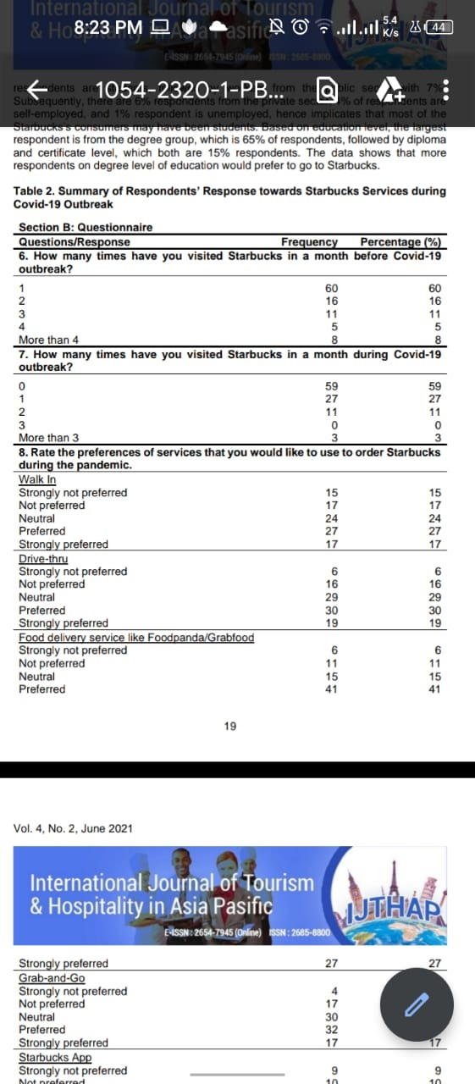
Figure 1 Analysis of customer decision to purchase Starbucks
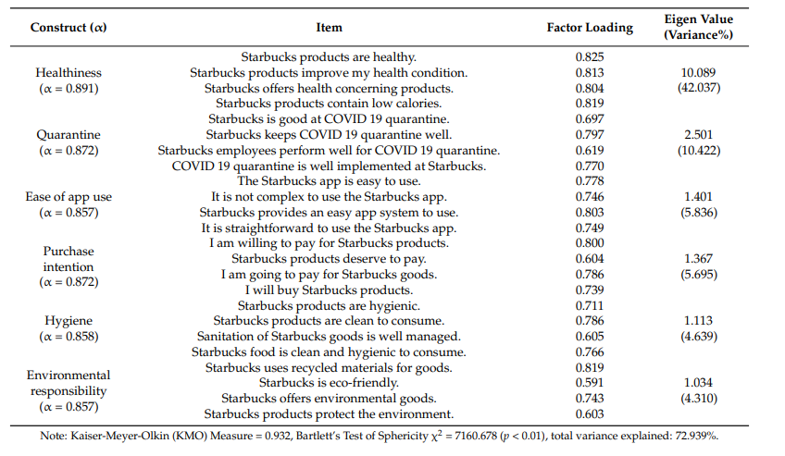
Figure 2 Response of Starbucks consumers about the quality of products, easy use of Starbucks app, hygiene, good environment-friendly provision, purchase of Starbucks drinks
- Internal Factors faced by Starbucks:
The income of employees was also reduced as the company's overall revenue was reduced. Further, some of the employees got covid 19 and were quarantined. Also, most of the employees resigned from their job because they were not paid well in times of pandemic. Therefore, the company faced a shortage of employees. Sanitization and disinfection of the stores had become an essential part of the daily routine. It added up to the cost of the company. Also, the stores were needed to be kept close for disinfection purposes (Salsabila, 2021). Moreover, the company was forced to close some stores due to a shortage of customers and employees (Sinha et al., 2021).
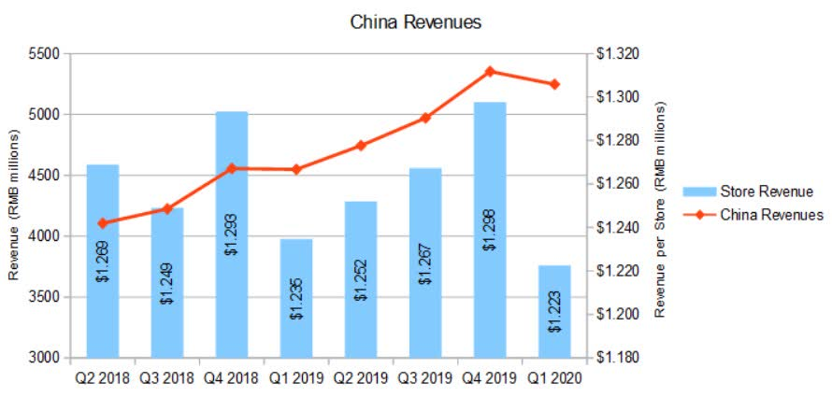
Figure 3 Graph shows a reduction in revenue of Starbucks during the pandemic
Models used for Situation Analysis of Starbucks:
- SWOT Analysis of Starbucks: (Dac Teoli and An, 2019)
SWOT analysis defines the strength, weaknesses, opportunities, and threats faced by an organization. This type of analysis highlights the external and internal factors influencing the organization positively or negatively. Here I have highlighted Starbucks's strengths, weaknesses, opportunities, and threats during the pandemic period.
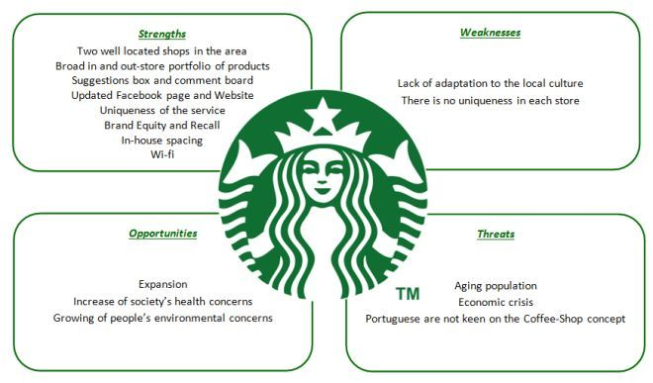
Figure 4 SWOT ANALYSIS OF STARBUCKS
Strength: (Baldwin et al., 2021)
- If we talk about the strength of Starbucks, our company is the best, well known and demanded by all the people in the world. It’s a brand that no one can neglect. A brand that is most wanted by the public.
- Our stores are distributed throughout the world apart from the united states and are licensed.
- Our company also acquired many of the famous coffee stores of time and have proved successful in expanding our business. Some of these famous stores include Tazo, Ethos water, and Evolution Fresh.
- Starbucks uses the profit gain to expand its services.
- Starbucks treats its employees with respect and gives benefits to their employees.
- Starbucks have a lot of loyal customers
Weaknesses: (Baldwin et al., 2021)
- Starbucks offers a very high price to the customers. Most people cannot afford to buy an expensive cup of coffee. If we talk about the pandemic, most people have lost their jobs. The financial status of most people in the US has become low. So, Starbucks can lose a customer because of their very high price.
- Moreover, some of the consumers think that Starbucks drinks are not healthy to be consumed more often.
- Some people also criticize Starbucks that our company is buying low quality coffee beans at cheap rates. Fame comes with bad comments.
- Many companies like McDonald’s etc. have copied our many products. They are selling those products at cheaper rates. Therefore, customers prefer going to those stores as they are affordable to them.
Opportunity: (Baldwin et al., 2021)
- Starbucks is a very famous and most demanded brand of all. Therefore, we can reopen our closed stores that we need to close at the time of the pandemic. Also, the company is profitable so we can easily expand our business.
- Starbucks is continuously focusing on research and development to design more products. It aims to increase its flavours and blends to efficiently meet customer choices.
- Our company can make a strategy to attract customers belonging to all the social classes. We can offer different price ranges and standards for middle-class and high-class customers. We need to design basic coffee and drinks at affordable prices for our customers who are not able to afford the premium drinks. In this way, we would be able to compete with the other brands that are offering low prices.
- Starbucks can focus on building its delivery services. It will help build more customers as they would be facilitated.
- As covid 19 has stuck Starbucks badly, we can not provide the customer at our stores concerning the SOPs. Consumers are bound to Starbucks to order a drink. But they can sit here. They are supposed to take their coffee home. To facilitate our customers, we can build an online app or page so that customers can directly order from our stores while sitting at home.
- Starbucks had a great loss during the pandemic. So, we can together bring our position back. Therefore, we can also think of collaborating with other major companies in the UK.
Threats: (Baldwin et al., 2021)
- Many famous brands offer drinks at affordable prices, such as McDonald's, Nestle, Coffee, Donut, etc. These brands could be a create threat to the company. It is because the customer always prefers the cheaper brands.
- Starbucks doesn’t have any complex drinks that are hard to make. Competitors are always trying to copy our drinks. They offer these drinks at a lower price. The customers are always attracted to the low price.
- Starbucks was forced to close many of its stores during the pandemic. Our company was greatly affected by the pandemic.
- The mindset and priorities of the people have changed following the covid-19. The company fears losing many customers.
- PESTLE Analysis of Starbucks: (Fosher, 2018)
Pestle analysis is also a situation analysis model. It measures the chances of growth of an organization. It involves analysis and impact of political factors, economy, technology, social factors, ecological factors, and legal that influence the growth of an organization.
Political Factors:
Starbucks can feel difficult to expand their business due to various pollical policies implemented by various counties. Many countries have ideal tax policies and laws to provide better conditions for Starbucks to expand its business (Edrawsoft, n.d.).
Economic Factors:
People are mostly poor in developing countries. They visit those stores that offer lower prices. The increased price of the raw materials and increased labour cost can affect the development and expansion of business in an area. Starbucks has many competitors offering affordable prices. Therefore, this can cause a threat to our company and reduce our profit (Edrawsoft, n.d.).
Social Factors:
Social factors can affect the sale of Starbucks. It is because the preferences and food choices of people change over time. Therefore, our company needs to add new flavours and other food to our menu to keep ourselves following the people's choices. Above all, covid has changed the mindsets and choices of the consumers (Edrawsoft, n.d.).
Technological Factors:
We have introduced ourselves to technology when the pandemic started. Only food orders, shopping, online payment, and online education have become an essential part of our lives. Therefore, technology can be effective to expand our business. We can introduce new and advanced machines to facilitate our employees and customers. This will also help us to expand our service and reduce our delivery time. Moreover, we can build mobile applications and web pages to facilitate our customers (Edrawsoft, n.d.).
Legal Factors:
Legal factors are needed to be given importance. Starbucks needs to comply with all the laws and regulations of the country. The rights of the employees must be safeguarded. Also, all the stores should have a license and supply good quality drinks to their customers. Otherwise, the company may lose customers due to negative impacts (Edrawsoft, n.d.).
Ecological Factors:
The environment doesn’t affect the company outlet. But Starbucks can suffer if the coffee beans field gets destroyed due to any environmental factors. Also, the company needs to focus on environmentally friendly packaging and contribute to controlling pollution (Edrawsoft, n.d.).
Marketing Strategies used following Covid-19:
- Tailored Marketing Strategies: (Camilleri, 2017)
- Segmentation
Some so many customers have different choices. All the companies know that it is hard to satisfy all the customers' needs. Each company can satisfy a specific group of customers. The companies make strategies to satisfy the class of customers. Customers are distributed based on location, demography, and behaviour. The strategies are then designed focusing on a particular segment or group (Kotler and Armstrong, 2014) as covid-19 has changed the mindset and behaviour of the people. The people have become economically poor. Therefore, here in Starbucks, we need to focus on the post covid behaviour of the people. We need to analyze is purchasing behaviour of the people after covid-19. Based on which we need to segment people and make strategies to attract them to Starbucks. For this, tailored marketing strategies are used. This strategy aims to increase sales and cover the losses of the company during the pandemic (V. Lombardi, T. Chidiac, and C. Record, 2021).
- Targeting:
To target, a specific group, the attractiveness and interest of each segment are studied. The company evaluates itself effectively to analysis that how many segments of the society it can serve in a better way. The plans are made accordingly to serve the groups selected as per their interests (Kotler and Armstrong, 2014). Herein Starbucks, we are planning to use Tailored Marketing Strategies to target various groups of customers. We aim to target regular customers, first-timers, and groups that are not our customers yet. We aim to make strategies that satisfy the needs of the customers (V. Lombardi, T. Chidiac, and C. Record, 2021).
Positioning:
The product must have a distinct position in the mind of the customer, and it should not be like other competitive products in the market. Otherwise, the customer will be attracted to cheaper products and have the same quality. The product must be designed to attract the customer, and customers should perceive better as compared to the other products already available (Kotler and Armstrong, 2014). Considering this, our company Starbucks needs to consider product positioning following pandemic (V. Lombardi, T. Chidiac and C. Record, 2021).
- Alternative Marketing Mix Strategies:
Our company Starbucks uses marketing mix analysis. This analysis utilizes 4 P, i.e., product, price, promotion, and place (Al Badi, 2018).
Product: This includes what are features the product must have to attract the customers and how the product is needed to be promoted. We need to make sure that our product is best enough to compete in the market with other products launched by our competitors. Our product must be of high quality, and it must taste better as compared to that of the other competitors.
Price: The price of our product must be as per the quality and customers should be willing to pay it. Starbucks has a greater price as compared to other competitive companies. But the fact is that the services and tastes you get here at Starbucks are found nowhere else. Also, Starbucks offers a discount on various days, holidays, or special occasions for Starbucks lovers who can not pay their regular price.
Promotion: The promotion of a product is very important in every business. Starbucks participates in these promotion activities by internet or other means. They specifically promote their product during special occasions and specific times of the year when their drinks are sold the most. These promotion activities make their product stand out and make it most wanted by the people.
Place: We need to select a proper place where the demand for our product is very high. If the customers are looking for it online, they should get it if they are planning to visit our store and have a cup of coffee. They should get it. We focus on creating a similar relaxing environment in all our stores so our customers can enjoy their drinks in their required environment. Our place should be welcoming to a customer and motivate them to visit frequently.
Use of Marketing Mix Strategies during the Pandemic:
To make our company stand in the times of pandemic. We need to make a mixed marketing strategy. Some of the strategies that Starbucks adopts are discussed. Starbucks has already developed a range of products, including hot and cold drinks, different flavoured coffee, tea, and many others. Our customers are in love with our products and flavours. Therefore, we are not required to focus on product development or variation in our existing products. We can focus on smart product positioning to increase the sale and benefits of our company. We need to make a thorough analysis to find out our most selling drinks during the pandemic year. So, we need to focus on the sale and marketing of our most running products. We also assume that our customers love our product, and they will continue to buy our product at the previous price. Therefore, we will not reduce the price. We can only make minor changes in the price. Also, we focus on giving discounts more often. We aim to focus on promoting and boosting our services to increase sales. We need to advertise on media, the internet and by other means about our discounts and product quality. This is done to make our company stand in the competitive market and restore its position even after the pandemic. We also need to increase our delivery services here in Starbucks through online means. This is done to facilitate our customers and motivate them to shop from Starbucks stores. Many of our stores got shut down during the pandemic. Now, as the world is recovering from the corona therefor, we also need to focus on opening new stores and hiring new employees to meet our customer satisfaction (V. Lombardi, T. Chidiac, and C. Record, 2021).
CONCLUSION:
Starbucks is one of the leading companies in the UK. It has successfully expanded its business throughout the world. But the year 2020 led the company to face a major hit. Covid-19 shocked the world. All the businesses fell into an economic crisis. Starbucks has also felt the impacts of Covid-19. This report gives the situation analysis about the consumer behaviour and point of view following the pandemic. Various models are discussed, which highlight the strength, weaknesses, opportunities, and threats faced by Starbucks in the present era. Different marketing strategies are needed to be implemented. These strategies aim to reestablish the drink selling business, meet customer satisfaction, and attract more customers. This company needs to make a little bit of adjustment in its price, redesign products, increase advertisement, create the same environment in all its branches, launch products for middle-class customers, and give discounts on various occasions. If the company implements the suggested strategies. It is hoped that the company will come out of the economic crisis and restore the company's losses during the pandemic.
REFERENCE:
- Fairlie, R. (2020). The impact of COVID‐19 on small business owners: Evidence from the first 3 months after widespread social‐distancing restrictions. Journal of Economics & Management Strategy, [online] 29(4). Available at: https://www.ncbi.nlm.nih.gov/pmc/articles/PMC7461311/.
- Selfin, Y. (2019). Fog in Channel | KPMG United Kingdom. [online] KPMG. Available at: https://home.kpmg/uk/en/home/insights/2018/09/uk-economic-outlook.html.
- Voigt, K.-I., Buliga, O. and Michl, K. (2016). Globalizing Coffee Culture: The Case of Starbucks. Management for Professionals, pp.41–53.
- Salsabila, M. (2021). Starbucks took a major hit due to covid 19. English Diploma 3 journal Compilation.
- Sinha, R., Ganatra, V., Pandey, P., Arumugan, DDLA, Kee, D.M.H., Lekha, G.S., Kumar, N., Kew, S.D., Dhupad, A., Nair, R.K., Tenh, Y.Y., and Yue, H. (2021). Impact of Covid-19 on Business Performance: A Case Study of Starbucks. International Journal of Tourism and Hospitality in the Asia Pacific, 4(2), pp.13–27.
- Shim, J., Moon, J., Song, M., and Lee, W.S. (2021). Antecedents of Purchase Intention at Starbucks in the Context of Covid-19 Pandemic. Sustainability, 13(4), p.1758.
- Kotler, P. and Armstrong, G. (2014). Principles of marketing. 15th ed. Boston: Pearson.
- V. Lombardi, C., T. Chidiac, N. and C. Record, B. (2021). Starbucks coffee corporation’s marketing response to the COVID-19 pandemic. Innovative Marketing, 17(2), pp.177–188.
- Al Badi, KS (2018). The Impact of Marketing Mix on the Competitive Advantage of the SME Sector in the Al Buraimi Governorate in Oman. SAGE Open, [online] 8(3), p.215824401880083. Available at: https://journals.sagepub.com/doi/full/10.1177/2158244018800838.
- Dac Teoli and An, J. (2019). SWOT Analysis. [online] Nih.gov. Available at: https://www.ncbi.nlm.nih.gov/books/NBK537302/.
- Baldwin, J., Siegl, Z., Bowker, G., emeritus), H.S. (chairman​, Ullman (chairman), ME and Johnson (CEO), K. (2021). Starbucks Swot Analysis - Swot Analysis of Starbucks. [online] Available at: https://swotanalysis.website/starbucks-swot-analysis/.
- Edrawsoft. (n.d.). Detailed PESTEL Analysis of Starbucks | EdrawMax Online. [online] Available at: https://www.edrawmax.com/article/starbucks-pestel-analysis.html
- Fosher, H. (2018). Understanding the Marketing and Management of trails using PESTEL Analysis Recommended Citation. [online] Available at: https://scholars.unh.edu/cgi/viewcontent.cgi?article=2182&context=thesis.
- Camilleri, M.A. (2017). Market Segmentation, Targeting, and Positioning. Tourism, Hospitality & Event Management, [online] 1(1), pp.69–83. Available at: https://link.springer.com/chapter/10.1007/978-3-319-49849-2_4.

