Karate Membership PID Document
Andrew Humphreys - P148043
BSC Computer Games Development
Project Management (M5X00615)
UWTSD School of Applied Computing
Lecture’s Name: Sue Maw
09/11/17

Contents
Contents 2
1. What the project is trying to achieve 4
1.1 Purpose 4
1.2 Objectives 4
1.3 Scope 4
1.4 Deliverables 4
1.5 Constraints 5
1.6 Assumptions 5
2. Business case 5
2.1 Benefits 5
2.2 Options 5
2.3 Cost and Timescale 5
2.4 Cost/Benefit Analysis 6
3. Risk Analysis 6
3.1 Risk Identification 6
3.2 Risk Prevention 6
3.3 Risk Management 6
3.4 Risk Monitoring 7
4. Organisation and Management 7
4.1 Project Organisation chart 7
4.2 Project Sponsor 7
4.3 Project Manager 7
4.4 Project Team 8
Andrew Humphreys 8
Kyle Thomas 8
Oli Jordan 8
5. PID 8
5.1 Assignments 8
5.2 Schedule 8
5.3 Human Resources 9
5.4 Project Control 9
5.5 Quality Control 9
Appendix 9

1. What the project is trying to achieve
Below will outline what the project is trying to achieve.

1.1 Purpose
The purpose of this project is to facilitate the entry and management of members by adding them to electronic form.

1.2 Objectives
A database will be designed that will capture details of each member, the database will be large enough that it will store all the current members with room for more to be added at a later date as members join.
The database will need to be able to: -

- Add members
- Delete members
- Display members
- Search members

1.3 Scope
The scope of the project will only capture the details of current members with the allocation to add more members at a later date. The member data will not be added and will need to be added in manually by the user.

1.4 Deliverables
The project will deliver an application that will allow the user to add members, delete members, display current members and search for existing members in the database. The expected time frame of completion is two weeks.

1.5 Constraints
Backups of the database will be created every 24 hours just in case of a system failure where the database file becomes corrupted.

1.6 Assumptions
Assumptions made is that they have a working computer with a monitor which has power connected on a Windows based operating system.

2. Business case
This section will explain why the project is going ahead and what effects the project will have on the business.

2.1 Benefits
The benefits of the project are that it will facilitate the joining and leaving of members, it will also automate searches for members and their grades to make it easier when pulling up their details or entering into competitions.

2.2 Options
Other options that have been implemented were displaying members by grade or age. Options that have not been implemented as they were an afterthought after the system was developed were a modify function where rather than just delete a member and start again you could just modify a member’s name, home address etc.

2.3 Cost and Timescale
Expected timescale of the project will take 2 weeks, the only costs are running costs of electricity and potential costs if the computer fails and needs fixing/replacing.

2.4 Cost/Benefit Analysis
The benefit of the system is that it will save time in adding and removing members, it will also save time in searching for members rather than having to manually search though paper records. The system will also be beneficial to the company as it will make paper records redundant and the careful management of storing the papers also non-existent.

3. Risk Analysis
In the next section we will be identifying the risks involved during the process.

3.1 Risk Identification
Potential risks are: -
- Unrealistic time frame
- Database options might not be in scope or not enough options for the shareholder
- Layout might not be acceptable

3.2 Risk Prevention
To manage the time frame properly, steps will be broken up and given smaller time allocations and monitored on a regular basis. Initial meetings with stakeholders will take place to make sure that the project is in scope and what they want. Also, additional meetings will take place further down the line to make sure that their requirements have not changed. Finally, a mock program will be designed so the stakeholders can get a feel of the software and then changes can be made accordingly.

3.3 Risk Management
In a case where the client decides on modifications then we will assess the stage where we are with making the application and find out who is responsible for that part, then an assessment is done to work out if they have enough time to complete their current work or if other people need to be drafted in to assist in completion.

3.4 Risk Monitoring
Processes that will be put in place will be daily updates to check on progress of each person, making sure that they are up to date with what is required of them. This means that if there are any issues you will be able to notice them and try and fix them sooner than if you were to wait a week or so.

4. Organisation and Management
In this section we will be detailing the roles of jobs that are given to the staff and outlining what part they will be responsible for.

4.1 Project Organisation chart
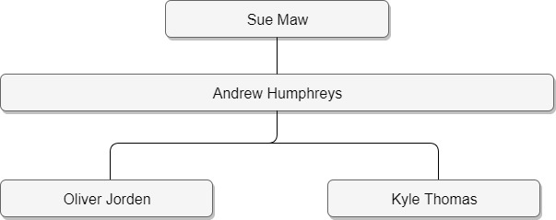

4.2 Project Sponsor
Sue Maw has ultimate authority and control of the project.

4.3 Project Manager
Andrew Humphreys is the project manager, his responsibilities are: -
- Getting daily updates from other workers on the project
- Overcoming problems when they arise
- Allocating jobs
- Managing workloads
- Reallocating people if problems occur
- Keeping track of deadlines
- Arranging meetings with the client and staff

4.4 Project Team

Andrew Humphreys
Role – Project manager
Email address – ahumphreys.148043@student.uwtsd.ac.uk

Kyle Thomas
Role – Tester
Email address – kthomas142469@student.uwtsd.ac.uk

Kyle will be part of the testing team, when new code is created by Oli it is then passed to Kyle to complete tests on the code to make sure that it does the job that it was intended and works with previous code.

Oli Jordan
Role – Coder
Email – ojordan.144588@student.uwtsd.ac.uk
Oli will be creating the code for the database based on the requirements that have been passed to him. The code is then passed to Kyle to test the code.

5. PID
In this section we will be giving a high-level overview on how the project will be implemented and give some indication of timelines.

5.1 Assignments
Assess what criteria is being held about members, Name, Age, Number etc
Create and show prototype
Redesign and complete application
Present application

5.2 Schedule
Plan a prototype – 1 day
Develop the prototype – 2 days
Show prototype and get feedback – 1 day
Redesign planning – 1 day
Develop application – 5 days
Present application – 1 day

5.3 Human Resources
11 days will be required to complete the work providing no issues arise, no more extra people will be required to complete the work unless issues arise.

5.4 Project Control
The progress will be monitored with updates of progression every 4 hours with and issues being flagged up. Meetings will be done face to face to remove any ambiguity.

5.5 Quality Control
Throughout the project once a piece of code has been completed it will then be given a version number and be tested to make sure that it fits in with other pieces of code. Any issues found are corrected changed and then documented as an iteration of that version.

Appendix
Here is a screenshot of the Gantt chart
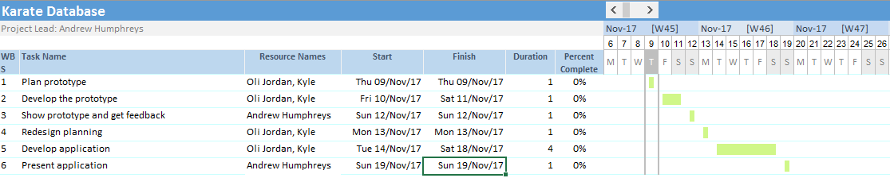

The code was also done to a working state, it was only found later after testing the program that it was perhaps missing an edit member feature which would help when modifications were required to a member. Below are the screen shots for the program.

Startup screen

Create member option
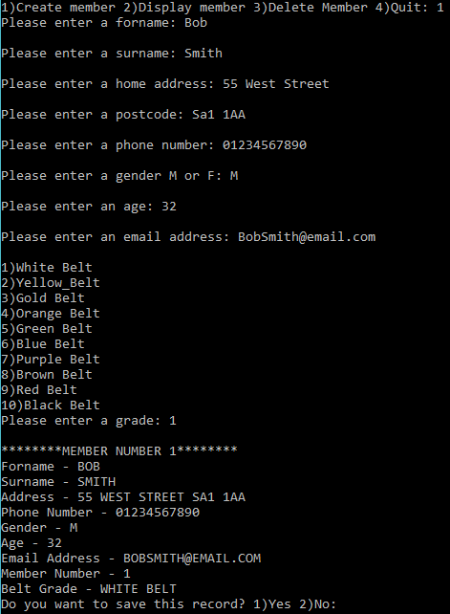

Display member
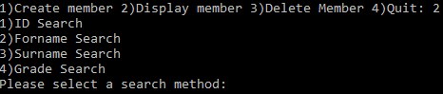
Surname Search
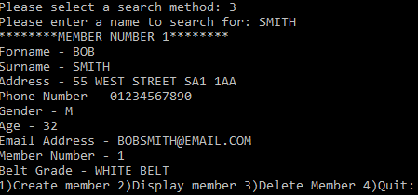

Grade Search


