E-BIKE Project

  - Student: Adam McGowan
  - Lecture: Sue Maw
  - Course: Electronic Engineering
  - Module: Project Management

Contents
Section 1: What is the project all about? 3
E-Bike 3
Project Definition 3
Objectives 3
Scope 3
Deliverables 4
Constraints 4
Assumption 4
Section 2: Business Case 4
Benefits 4
Options 4
Cost and Timescale 4
Risks and Analysis 5
Risk Identification 5
Risk Prevention 5
Risk Management 5
Risk Monitoring 6
Section 3: Who? 6
Roles and Responsibilities 6
Project Organization 6
Project Sponsor 6
Project Manager 6
Project Team 6
Section 4: How and When? 7
Assignments 7
Schedule 7
Human Resources 7
Project Control 8
Quality Control 8
References 9

Section 1: What is the project all about?

E-Bike

The solution of the e-bike is to make life easier for the Greenie Charity, as it benefit towards helping the charity to make their journey easier and quicker and healthy instead of walking some distance and then spending money on an everyday bus fare. This will help as the e-bike doesn’t give off harmful fumes that can affect people’s health, Greenie are against using combustion vehicles that gives of CO2, NOX and particulates. Greenie can rent out the e-bike to their employees and to encourage locals in the villages, towns and cities to look into buying their own e-bike as this would help to keep the human body healthy and less emissions polluted into the atmosphere [1], this will give locals and the rest of the world to think about the better impact that the e-bike would have on people’s health and the less taxes, insurance needed, less traffic and vehicles taking up space.

Project Definition

The purpose of the e-bike project is making people see the positive and the goodness the bicycle can give to their health and mental. The e-bike can also cover more ground than a regular bicycle. There also some negative about e-bike, this is duel battery, motor and other equipment’s on the e-bike can cause short time until out of power, this also depends on how the user of the e-bike is handling it, if the user has read the instructions this will help properly to avoid running out of power.

Objectives

- The Project is about Battery Monitoring, this will monitor the battery statues and how much power is left in the battery before it runs out.
- Once the battery is at full, the sensors will monitor the voltage and currents all the way when the battery is empty.
- This will also monitor on how much is been drawn from the battery and what is being used,
- Then it will monitor on what is being put back into the battery when the bicycle goes down road or braking.

Scope

The project design is going to be designed as a project group, not the whole e-bike going to be designed, only the add-ons such as small parts of the bicycle pieces, light sensors, Lithium Ion battery monitor, motor control, and Lithium Ion battery itself. These small individual add-ons will only benefit the e-bike as solving what hasn’t been made or came with the bicycle.

Deliverables
The project add-ons the small products such as:

- Lithium ion battery with a better capability life – 12 – 36v small battery
- Lithium Battery Monitor – 12 – 36v Small circuit device with a small display
- Motor control – small circuit device can handle 36v
- Light sensor – small circuit device with powerful display light
- E-bike,
- the documentations
- guide/manual
- demonstration

Constraints
- Time not known as it way too early to say.
- Currency
- Possible delays
- Unfinished
- Took longer than usual deadline

Assumption
- Lab access
- Equipment access – components
- Lecture available
- Software available
- Resources – materials
- Library access

Section 2: Business Case

Benefits
- Staff without driving licence, to use to get around
- Reduce spending on bus and taxi fare
- Improve health
- More parking efficient

Options
- Smart charger – charge the battery quicker and it was a smart way to keep the battery in safe and steady.
- Speed Sensor – monitor the speed of how fast the e-bike going
- GPS – track the bike in case it stolen

Cost and Timescale
- E-bike – z6 21-speed ultimate edition electric mountain bike £659.99 [2]
- Components - £50 - £100
- Cases - £10 - £20
- Circuit board - £100

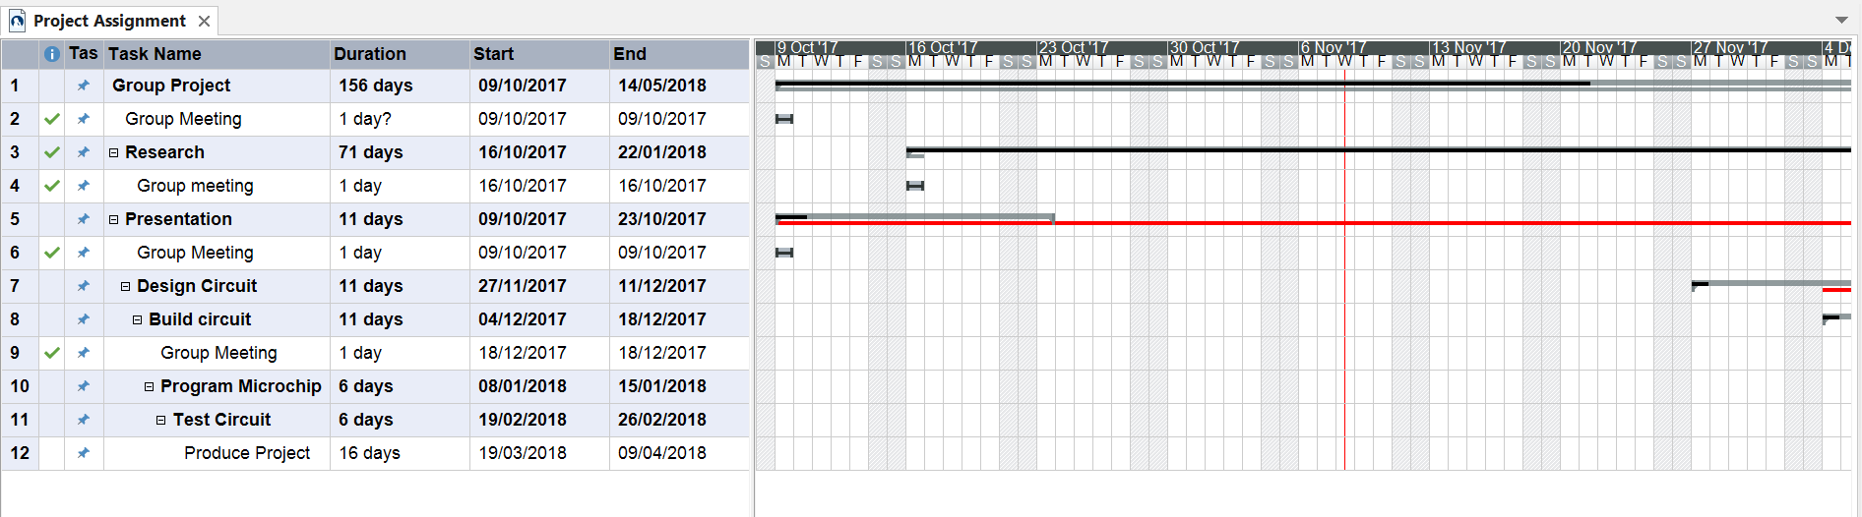
This is Mindview, a software program that is the same as using Microsoft, but this has the ability of creating mind maps, flowcharts, Gantt, etc… [3]

Risks and Analysis

Risk Identification
- Running out of funding
- Equipment’s failure
- University unexpected closures ( e.g. gas leak, power blackout)
- Natural disaster
- Illness
- Personal absent
- Data loss

Risk Prevention
- Have a backup plan – this will also be handy when it comes to unexpected events.
- Backup data and make copies
- Extended time and dates
- Another emergency location
- Saved on pen drive/extended hard drive
- Ensure everything charged and working
- Ensure everything up to date

Risk Management
- If computers in University were not working, go to the campus and use those computers
- Internet not working, use hotspot internet
- Backed in cloud in case data loss

Risk Monitoring
- Ensure there clear pathways so no accidents so no groups get hurt
- Ensure there are breaks to stress free for the whole group
- Have computers checked regularly to ensure they are working
- Send copies of up to date work to others in group.
- Send emails on to do list and protocol

Section 3: Who?

Roles and Responsibilities

Project Organization
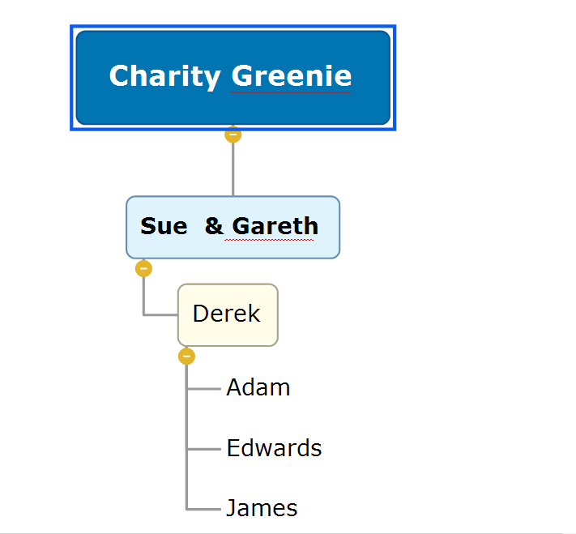
Everyone reports to the person above them, the three under Derek reports to Derek
Derek reports to Sue and Gareth,
Sue and Gareth reports to the Charity.

Project Sponsor
Sue Maw
Gareth Jones

Project Manager
Derek

Project Team
Edwards – Light sensors
James - Battery
Derek – Motor controller
Adam – Battery monitor

Section 4: How and When?

Assignments
- Lithium Battery
- Lithium Battery Monitor
- Motor Controller
- Light Sensor
- Prototype on a worktop
- Design cases
- Fix glitches
- Look for errors in circuits
- Make final modules
- Make documentation
- Make manual
- Give to customer
- Train customer

Schedule
Group project will take 160 – 200 days
Researching the information take 60 – 80 days
Meetings take 1 – 2 hours

Human Resources
4 people
2 hours a day each
10 hours a week each
320 hours total each
Or
4 people
4 hours a day each
20 hours a week
80 days total

Project Control
Meetings and Emails are used to communicate duel the project and sending work back and forward to each team member to keep everyone up to date.

Quality Control
Checking if the project doesn’t break in any way when dropping it.
Testing the impact and damage resistance that the project can take
Testing it over bumps, potholes and water to ensure it can resist environmental surroundings
Heat resistance test and cold resistance test
Checking for loose components and wires
Check is there are fail safes for safety

References

[1] | “Cycling benefits,” Queensland Government Department of transport and Main Roads, [Online]. Available: https://www.tmr.qld.gov.au/Travel-and-transport/Cycling/Benefits.aspx. [Accessed 09 November 2017].
[2] | “Z6 21-Speed Ultimate Edition Electric Mountain Bike 26" - White,” Nitro Tek, [Online]. Available: https://www.nitrotek.co.uk/ebikes/z6-21-speed-ultimate-edition-electric-mountain-bike-26-white.html. [Accessed 07 November 2017].
[3] | “Mind Mapping Tutorials,” Matchware Software creative minds, [Online]. Available: https://www.matchware.com/mind-mapping-tutorials. [Accessed 09 November 2017].

