University of Wales Trinity Saint David
School of Engineering
Series Hybrid Vehicle Requirements
Electric and Hybrid Propulsion Control
Christopher Robbins
P146163
B.Sc.
22/03/18
Motorsport Engineering

Abstract

In the first report, an off-road course for corporate use was designed and a duty cycle was made with Microsoft Excel.
This report shows the transition to a hybrid system where the components (generator, batteries, motor and controllers) are researched and chosen. All the components were chosen via data calculated and collected in the Excel spreadsheet. There were two graphs produced show the average power through the duty cycle and the battery drainage.

List of Figures

Figure 1: Shunt Type DC Motor (MCMA, 2018). 5
Figure 2: Series Type DC Motor (MCMA, 2018). 5
Figure 3: Compound Type DC Motor (MCMA, 2018). 5
Figure 4: Permanent Magnet Type DC Motor (Physics Tutor, 2018). 6
Figure 5: Synchronous Type AC Motor (Circuit Globe, 2018). 7
Figure 6: Induction Type AC Motor (Circuit Globe, 2018). 7
Figure 7: Power against time graph showing average power at around 3Kw. 8
Figure 8: Energy drawn from the battery against course time (KJ). 8
Figure 9: Air cooled electric motor- 3- 7.5Kw. 9
Figure 10: Electric Motor Specs. 9
Figure 11: Controller for the Electric Motor. 10
Figure 12: Specs for the Electric Motor Controller. 10
Figure 13: General wiring diagram for controller and electric motor. 10
Figure 14: 3.4Kw Diesel Generator with Specifications. 11
Figure 15: Chosen battery (12v, 52Ah) (Advancedbatterysupplies.co.uk, 2018). 12
Figure 16: Battery Specifications and drainage. 12
Figure 17: The chosen invertor and its specifications. 12
Figure 18: Showing the chosen Final Drive Ratio and the average and most efficient speeds. 13
Figure 19: Cost of the Components for the Hybrid System. 14
Figure 20: Electric Motor Test Curve. 17
Figure 21: Dynamic Test data of the Electric Motor. 17

Table of Contents

Abstract 1
List of Figures 2
Table of Contents 3
1. Introduction 3
2. Technology review 4
2.1 DC Motors 4
2.2 AC Motors 6
3. System Specification and Discussion 7
3.1 Power Requirements and energy draw from the battery 8
3.2 Electric Motor (5KW BLDC Motor) 8
3.3 Controller (5KW BLDC Motor Controller) 10
3.4 ICE and Generator Unit 11
3.5 Battery 12
3.6 Invertor 12
3.7 Final Drive Calculations 13
4. Preliminary costings 14
5. Conclusions and recommendations 15
6. References 16
7. Appendices 17

Introduction

An in-depth research into producing a series hybrid version of the recreational buggy that was theoretically used to create a duty cycle in the previous report. The buggy (POLARIS ACE) which is powered by a 150cc internal combustion engine (ICE) will be removed and replaced by a generator, energy storage and controller, and a smaller (ICE) e.g. motorbike engine with controller. For this to be achieved a report of different types of series hybrid applications will need to be undertaken and research into final drive solutions.
The internal combustion engine needs to supply sufficient power to achieve average power at the wheels. The engines RPM will remain constant at the maximum torque range as this is where it is most efficient.
Throughout, a preliminary report will be undertaken on the cost of each individual parts needed to convert the buggy to a series hybrid and the change in total mass will be theoretically calculated using an example mass of an engine and gearbox that will be removed from the buggies total mass.
A decision will be made on the type of generator for the ICE used and why it has been chosen and its benefits for the size of engine used.

Technology review

DC Motors

The main DC motors are known as shunt, series, compound, and permanent magnet types and are all commonly used. The starting current of a DC motor is much higher than its running current whilst the motor is operating at its rated speed. As the motor begins to reach its rated speed, the current being inputed is decreased until the motor reaches it rated speed. The armature current stops and residues constant thereafter (Keljik, 2013).

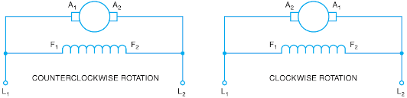
Shunt DC Motor- gives great speed parameters because the field can be excited independently from the armature windings.
Figure 1: Shunt Type DC Motor (MCMA, 2018).

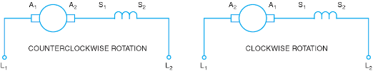
Series DC Motor- generates large amounts of starting torque, but can’t regulate its speed i.e. self-destructing- no load. Not a great choice for variable speed drive systems.
Figure 2: Series Type DC Motor (MCMA, 2018).
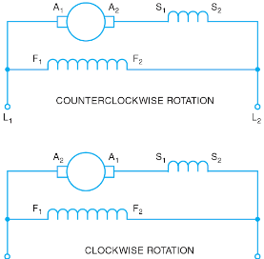

Figure 3: Compound Type DC Motor (MCMA, 2018).
Compound DC Motor- separate excited field. Good starting torque, can experience problems in variable speed drive systems (MCMA, 2018).
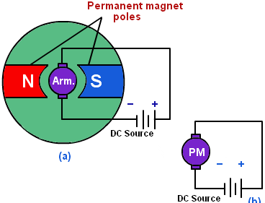
Permanent magnet motor- generates a field flux. Offers great starting torque and great speed regulation. Torque is narrow so usually found on low power systems (Physics tutor).
Figure 4: Permanent Magnet Type DC Motor (Physics Tutor, 2018).

AC Motors

More recently in automotive use, electric hybrid vehicles are using AC and brushless motors (Ḥusain, 2010).

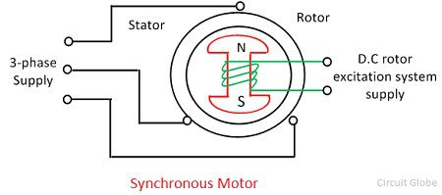
Synchronous motor, creates a rotating field. This field tries to pull the rotor with it, but can’t because of the rotors inertia. Therefore, no starting torque is created- synchronous motors are not self-starting.
Figure 5: Synchronous Type AC Motor (Circuit Globe, 2018).

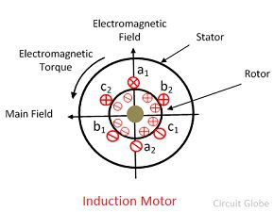
Induction Motor- Converts AC power into mechanical power by using an electromagnetic induction. The induction motor is mainly categorised into two types, the single-phase induction motor and the three phase induction motors.
Figure 6: Induction Type AC Motor (Circuit Globe, 2018).

System Specification and Discussion

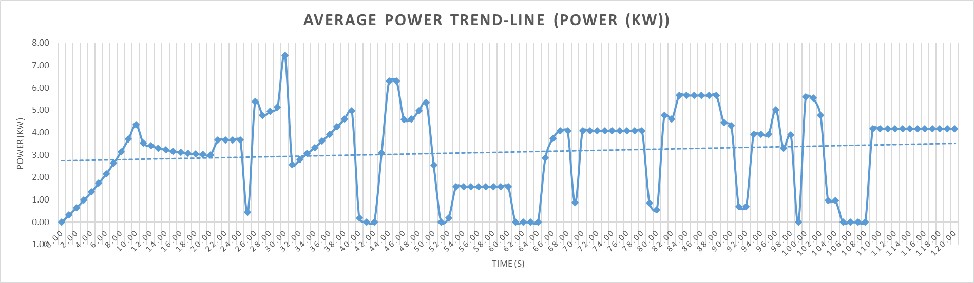
Power Requirements and energy draw from the battery
Figure 7: Power against time graph showing average power at around 3Kw (Excel, 2018).

The graph above shows the power out from the first report with a trend-line showing the average power at around 3Kw (3.13Kw).
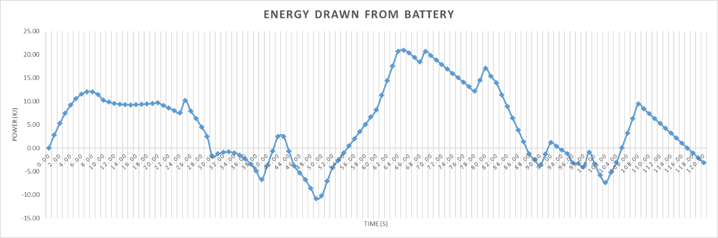
Figure 8: Energy drawn from the battery against course time (KJ) (Excel, 2018).

The course specified and made in the first report can be seen that it is not over-demanding on the vehicle’s battery as most of the time power is going into the battery and not out.

Electric Motor (5KW BLDC Motor)

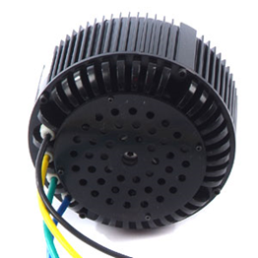
The motor specified is a DC type and has a rated power of between 3- 7.5Kw. This is ideal for the hybrid conversion as specified in the previous report the maximum power occurred was 7.43Kw and the average was 3.13Kw. The efficiency of the motor is recorded at 91% and the total weight is 11Kg for the air-cooled version.
Figure 9: Air cooled electric motor- 3- 7.5Kw (Golden-Motor, 2018).

The motor being 48V means that 4x 12v batteries are needed in this hybrid system.
Several positive to this motor is that it is brushless which reduces the chance of parts braking/ going wrong and less moving components. Furthermore, the motor being air cooled is to reduce weight and cost and as it is being fitted to an outdoor buggy it will always be in contact with the external air.

Figure 10: Electric Motor Specs (Excel, 2018).

Controller (5KW BLDC Motor Controller)
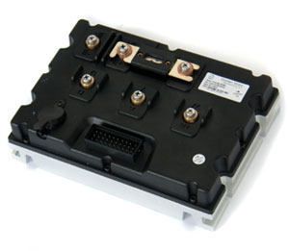
Figure 11: Controller for the Electric Motor (Golden-Motor, 2018).
The chosen controller comes from the same website/company (https://www.goldenmotor.com/frame-bldcmotor.htm) as the motor and is recommended for the use with the motor. Both are 5Kw units and the specifications can be seen below.
A wiring diagram can be seen at the bottom of the page for an example of how the controller and motor will be connected and work.

Figure 12: Specs for the Electric Motor Controller (Golden-Motor, 2018).
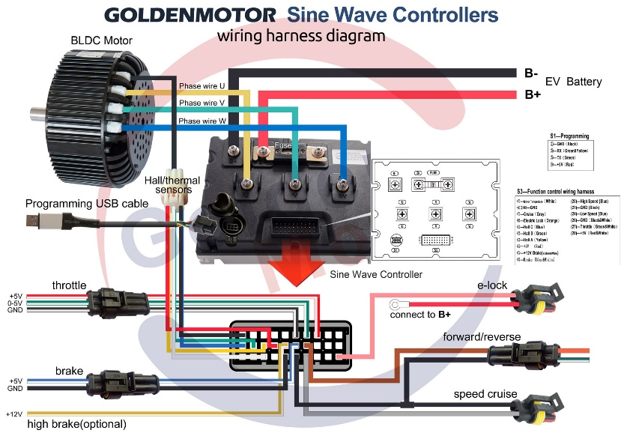

Figure 13: General wiring diagram for controller and electric motor (Golden-Motor, 2018).

ICE and Generator Unit

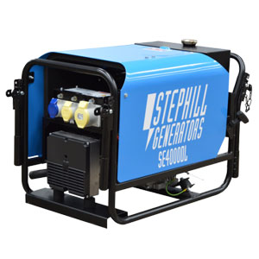
Before buying a Petrol/Diesel generator, it is critical to understand what power is required to drive the equipment. Nominal power links to the constant power distributed when the generator set is functioning (Groupes électrogènes Gelec, 2018).
Average power generator is 3.13Kw and the Clarkes’ generator produces a maximum output of 4KVA and a continuous power output of 3.2Kw.
Figure 14: 3.4Kw Diesel Generator with Specifications (Generators-direct.co.uk, 2018).
The diesel generator was chosen for the reasons-
- Designed to work under load for longer periods of time.
- More fuel efficient.
As the buggy’s will be run a lot for recreational use it is a great option to have a generator that can withstand constant running and loads applied to it.
Both the electric motor and generator are air cooled because of the use of the buggy and the limitation of body panels restricting cool air. With efficiency losses through the components in relation to heat, friction a slightly bigger generator was chosen compared to the average power demand. This is to maintain sufficient power to the battery even through efficiency losses.

Battery
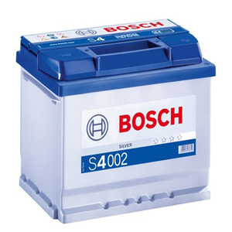
The chosen battery is a 12v, 52Ah Bosch unit. The power was calculated from the equation (P=V x A)/ (12 x 52 = 624) and then (624 x 60 x 60 = 2246400J or 2.25MJ).
Figure 15: Chosen battery (12v, 52Ah) (Advancedbatterysupplies.co.uk, 2018).
Four of these batteries will be used for the 48v electric motor used.

Figure 16: Battery Specifications and drainage (Excel. 2018).

Invertor
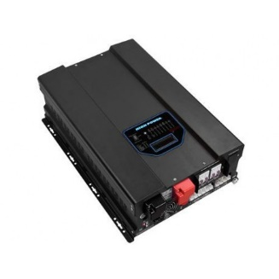
Figure 17: The chosen invertor and its specifications (Excel, 2018).
This invertor allows AC to be converted into DC power for the battery and other equipment that needs a DC supply. It’s the same principle as on automotive alternators. An alternator makes AC usually three waves to produce more constant power but a rectifier converts it to DC to be consumed by electronic components (30kW, 2018).

Final Drive Calculations

As seen in the Appendices the RPM at which the motor is most efficient is at 3861rpm. A final drive ratio was inputted and a total average work-out from the duty-cycle. It was found that a final drive ratio of 11.25:1 gave an average speed for the electric motor of 3853.49rpm/ 403.3316116m/s. This allows the electric motor to be at its most efficient for most of the time because of the average wheel speed during the duty cycle.
Figure 18: Showing the chosen Final Drive Ratio and the average and most efficient speeds (Excel, 2018).

Preliminary costings

Costs can be significantly saved especially when it comes to buying the generator. The equivalent petrol generator can be purchased for around a quarter of the price of the Diesel generator chosen. See 3.4 for reasons to why a Diesel generator was chosen.

Figure 19: Cost of the Components for the Hybrid System (Excel, 2018).

Conclusions and recommendations

Recommendations include using capacitors to store energy for instances where the input is lower than the output. This is to reduce weight and space of traditional batteries. A Diesel generator was chosen based on how much the buggies will be used for the recreational use and that how efficient and quiet modern technology has made small Diesel applications.
As no live testing has taken place it might be that a petrol generator made be a better application because of size and cost. Through research it showed that Petrol versions with equal power to Diesel generators can be up to a quarter of the cost.
A final recommendation would be to take advantage of regenerative braking through the duty cycle. As there are lots of down-hill sections which will require braking the energy created from this could be fed back to be stored to be used later where there is excessive load required from the electric motor. A motor would increase the potential but would also require excessive battery storage and a big generator to keep the battery topped-up.

References

- Ehsani, M., Gao, Y. and Emadi, A. (2010). Modern electric, hybrid electric and fuel cell vehicles. Boca Raton: Taylor & Francis Group.
- Keljik, J. (2013). Electricity 4. Clifton Park, N.Y.: Delmar, Cengage Learning.
- MCMA - Motion Control Online. (2018). 4 Types of DC Motors: An Introduction. [online] Available at: https://www.motioncontrolonline.org/blog-article.cfm/4-Types-of-DC-Motors-An-Introduction/39 [Accessed 27 Feb. 2018].
- Anon, (2018). [online] Available at: https://physics.tutorvista.com/ [Accessed 27 Feb. 2018].
- Groupes électrogènes Gelec. (2018). how to choose generator - Genset Gelec. [online] Available at: http://www.genset-gelec.com/purchasing-assistance-page/ [Accessed 10 Mar. 2018].
- PMGenerator. (2018). Series Hybrid Alternators. [online] Available at: http://www.pmgenerators.com/products/series-hybrid-alternators/ [Accessed 10 Mar. 2018].
- Engines.honda.com. (2018). Honda Engines | GX390 4-Stroke Engine | Features, Specs, and Model Info. [online] Available at: https://engines.honda.com/models/model-detail/gx390 [Accessed 10 Mar. 2018].
- Pdfs.semanticscholar.org. (2018). [online] Available at: https://pdfs.semanticscholar.org/pdf [Accessed 10 Mar. 2018].
- Advancedbatterysupplies.co.uk. (2018). Bosch S4002 Car Battery | ABS Batteries. [online] Available at: https://advancedbatterysupplies.co.uk/product/bosch-012/ [Accessed 10 Mar. 2018].
- Circuit Globe. (2018). What is AC Motor? Definition & Types - Circuit Globe. [online] Available at: https://circuitglobe.com/ac-motor.html [Accessed 15 Mar. 2018].
- 30kW, O. (2018). [online] VoltecEnergy. Available at: http://voltecenergy.co.uk/inverter-chargers-inverter-charger- 10kw-24v-12a-peak-30kw.html [Accessed 15 Mar. 2018].

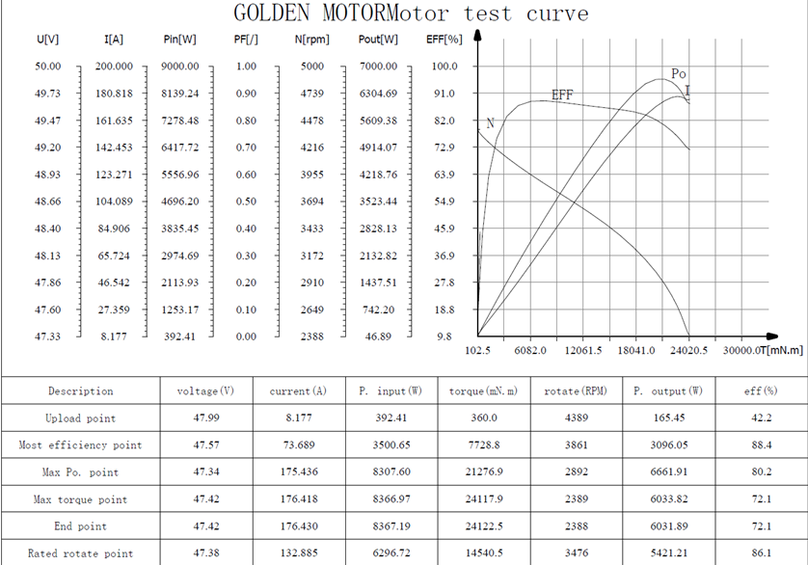
Appendices
Figure 20: Electric Motor Test Curve.
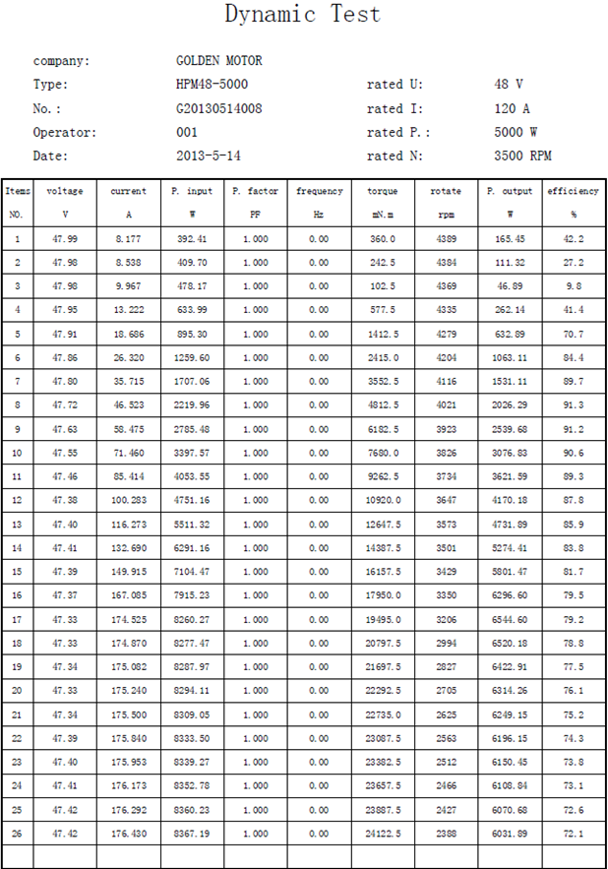
The electric motor test curve from the website- (https://www.goldenmotor.com/frame-bldcmotor.htm). The max torque and power point can be seen for specific RPM’s.
Figure 21: Dynamic Test data of the Electric Motor.

