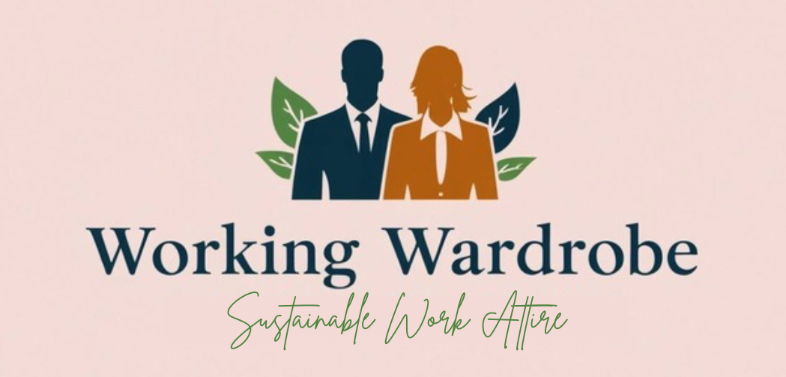

Working Wardrobe
Business Plan
By Alyssia Frampton, 2327857

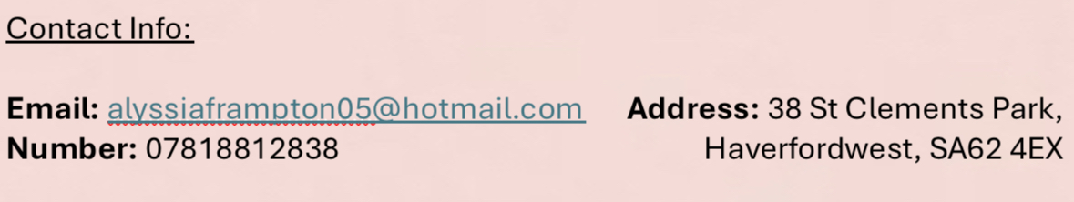
Contents Page
Executive Summary:
Objectives (SMART) | 3
Description | 3
Mission Statement | 3
Vision Statement | 3
Description of Business:
Ownership | 4
Location | 4
Hours of Operation | 4
Products/Service | 4
Contract Third Party | 4
Product Acquirement | 5
Sustainability:
Sustainable Focuses | 6
Marketing:
Market Research (Primary) | 7
Market Research (Secondary) | 8
SWOT Analysis | 8
PESTLE Analysis | 9
Market Segmentation | 10
Competition | 11
Ansoffs Matrix | 11
Product Life Cycle | 12
Financial Forecast:
Cash Flow Forecast | 13
Break Even Analysis | 13
Appendix | 14
Bibliography | 22

Executive Summary:
Objectives (SMART):
1. To create a customer base of 2.5% of our Cardiff target market by the end of the first year.
2. Increase brand awareness online within the first 6 months by gaining 300,000 followers on TikTok, Instagram and Pinterest.
3. To reduce subscription price from £40 to £35 after the first year, once costs are steadily covered after break even.
4. Receive 65% ‘5 star’ reviews within the first year.
5. Increase workforce by 40% over the end of year 1 to the end of year 2.
6. Collaborate with at least 1 firm and provide employees with work wear, every week for 3 months by the end of year 2.

Description:
Working Wardrobe is a reliable and sustainable service that gives ‘work appropriate’ clothes a second chance. It allows the busy professional to stay focused on their roles and reduce their spending as we take care of their appropriate attire for the working week. As a subscription service, our website will make choosing work outfits as easy as possible, tailoring to all sizes for both men and women. We provide our customers piece of mind that clothes are clean and stored for them with new options for them every week. We keep clothes on a constant cycle to ensure we meet fast fashion trends but in a minimalist and environmentally friendly way.

Mission Statement:
“Empowering busy lives with sustainable style. Working wardrobe delivers confidence, convenience, and comfort.”

Vision Statement:
“Making sustainable fashion an everyday choice.”

Description of Business:
Ownership:
Working Wardrobe is a Private Limited Company (ltd). I have made this decision based on being able to raise further capital through investment and allowing the possibility of Working Wardrobe to able to expand in custom over the next few years.
Location:
Working Wardrobe will initially be based in Cardiff due to the industry and market in the city. This will allow working wardrobe to gain a loyal customer following while also perfecting business practice over the first year. The location for storing washed clothing and packaging up deliveries will be in a warehouse located in Cardiff. See Figure 1 in Appendix. I chose this location as it has a close proximity to the city while being spacious enough to allow for business growth. The rent for this space is £1283.33 per month, very low cost compared to other areas.
Hours of Operation:
The hours of operation of the warehouse in particular will be influenced by demand. However, initial start up hours of the warehouse and delivery systems mean we can offer warehouse staff 20 hours a week at £13.00 an hour and delivery drivers 18 hours a week at £14.00. Our delivery days will be a Sunday, where fresh subscription packages and used subscription boxes will swapped out. The hours have been specifically chosen based on the ethical considerations for parents, who’s hours need to be flexible around school times. This comes from research that shows over 60% of men and women face work disruption due to lack of childcare. As a business we also want to promote a healthy work-life balance, this is why Saturdays are a non-working day, as data suggests 65% of job seekers prioritised balance over pay.
Product/Service:
Working Wardrobe offers clothing being delivered to your door every week in time for the average professionals working week. Not only is the clothing trendy but it is also work appropriate. Our sustainable focus means that clothing is given more than just a second chance. All clothing is professionally cleaned and stored for the convenience of our customers lifestyle.
Third Party Contracts:
Our professional laundrette services will be contracted to Cardiff Perfections Laundrette at 75 Broadway in Cardiff (see figure 2). They offer quick commercial laundrette services and are located 2.7 miles away from our warehouse (see figure 3). We are contracted with them for the first year of business in order to build a solid relationship and work together to work out any possible issues before contract renewal. For the first six months, we are contracted with them for £1000 the first 6 months for a 3-day turnaround in laundry and £2000 in the later 6 months, where subscription growth increases.
Product Acquirement:
Our clothing will be acquired through already second-hand websites such as EBay and Vinted. These items requirements will be in good condition, currently in style in all sizes from XS (6) to XXL (18). Eventually, the business can look at partnerships with sustainable brands as well donation points for preloved office wear.

Sustainability:
Sustainable Focuses:
In terms of sustainable practices, Working Wardrobe will take certain steps in order to promote our sustainable focus fairly and transparently to customers. The business will use hybrid vans for deliveries (see figure 7) in order to maximise efficiency over short distances over the city. Also, we will reuse all packaging; when subscriptions are picked up in the same packaging as they were delivered, they will then be reused in order to reduce waste. Working Wardrobe also wants to act with social sustainability by providing part time jobs to those who really need flexible hours, as well as using a local small business to contract our laundry operation to. We hope to be a benefit to the community as well as the planet with our pre-loved clothing and reduction in waste, consumerism and overall set more minimalist values.

Marketing:
Primary Market Research:
For my primary research, I created an anonymous questionnaire based on the likability of Working Wardrobe against potential demographics like shopping habits, environmental awareness, age and type of job. The questionnaire had 31 responses (see figure 4 for graph answers).
The responses show that 58% of responders are likely and most likely to become a customer of Working Wardrobe despite only 48% currently making sustainable fashion choices. The responses also show that the most valued features of Working Wardrobe are:
- Work-appropriate clothing (74.2%)
- Laundry and return convenience (64.5%)
- Ability to swap items before delivery (61.3%)
Looking at demographics, 20 respondents are aged 18-24 and 6 respondents are ages 25-34. While this means that most of the responses are from the younger demographic as opposed to our other target market, it means that future opportunities for growth are viable. It also means that younger people who are currently climbing the career ladder are interested in the brand and may want the companies support into finding appropriate workwear compared to struggling within the fast fashion market. This can be confirmed by looking at the occupation types of the respondents, more 18-24 are in fact in the office based professional setting.
In terms of marketing from a convenience perspective, the majority of respondents spend 1-2 hours (35.5%) or 2-3 hours maintaining laundry each week. This shows how much of an impact we can make into people's daily lives and potentially helping them save money on rising electricity and water bills.
In terms of consumer concerns that Working Wardrobe will need to be vigilant on, all the responses have a high percentage. To help conquer the concerns, we need to market in a way that shows how our business works. This could include videos on social media, such as a ‘Spend the day in work with me’ video trend, and including statistics on the website that show cleanliness, a wide choice of size options, the commitment to a weekly subscription and making the delivery and return process reliable. These are key things that Working Wardrobe will prioritise through all stages of growth and development.

Secondary Market Research:
There are 3 key areas that Working Wardrobe aims to help customers with: Sustainability awareness, costs of managing individually owned clothing and the lack of time for most career driven individuals for household chores, such as laundry and staying on top of a wardrobe. See figure 5 on the analysis of how well our brand is suited to the market and what features of the market are important to recognise going forward.

SWOT Analysis:
Strengths:
- Convenience for consumers to reduce time and money spent on household tasks.
- Sustainable focus with using second-hand clothing and new sustainable clothing.
- Enhance user experience based on website cookies and personal website profiles.
- Subscription model allows a steadier cash flow for the business.
- The dual market approach gives the business access to a wider demographic of potential customers.
Weaknesses:
- High initial costs in logistics, cleaning services and website development.
- Hygiene concerns from consumers over wearing rented clothing.
- Inventory management over a short span can be complex.
- High costs in marketing to change consumers traditional fast fashion habits.
Opportunities:
- Rise of sustainable fashion means a growing awareness for ethical practices.
- Possibility of partnering with corporate businesses to ensure people are dressed appropriately and ethically.
- Expansion to special events as a premium add on (such as formal party wear or graduation wear).
- Tech advancements mean a more unique customer experience implementing AI.
- Partnering with business entrepreneurs could accelerate growth.
- Student discounts can allow a bigger reach across the student target market.
Threats:
- Competition may pop up in other cities over the UK.
- Economic downturns mean consumers are more conscious of budgets and subscriptions.
- Logistical issues could affect our service and reliability.
- Consumer behaviour trends may mean people are more against renting clothing compared to owning items and selling on themselves.
- A limited supply or finding high quality pre-loved items could threaten quantity of stock.

PESTLE Analysis:
Political:
- Following regulations on sustainability, such as the UN Goals.
- Staying on top of tariffs and over-seas restrictions when they apply.
- Compliance with fair wages and working conditions. Only working with third-party contracts who also comply.
Economic:
- Subscription affordability needs to be a cheaper alternative for those who are struggling with bills and expenses.
- Need to effectively balance the cost of sustainable fashion when new ethically and sustainably made items are bought.
- Costs of cleaning, logistics, storage will rise over time.
Social:
- Changing consumer preferences mean as a business, Working Wardrobe will keep on top of fashion trends in order to stay ‘relevant’ in the fashion market.
- Workplace trends have changed, more people may require more casual wear compared to formal wear due to hybrid working or working from home.
- More consumers are opting for rental clothing due to fashion costs, wardrobe minimalism and sustainability.
Technological:
- Working Wardrobe offers a more personalised experience with matching styles of clothing to the consumer based on experienced buying.
- With tracking apps and route optimisation, we can improve delivery efficiency and reduce carbon emissions.
- Website development is essential for a user-friendly site and will be our first point of contact as a brand to consumers.
Legal:
- Consumer protection laws must be followed. Working Wardrobe will have clear and specific policies on damage, lost items, refunds and cancellations.
- Data privacy is key and will be stored correctly and safely.
- Clothing will be fully sanitised and cleaned to prevent hygiene issues.
Environmental:
- Working Wardrobe aims to reduce clothing waste by utilising second-hand and sustainably made clothing.
- Total transparency to consumers on the level of sustainability in practice to avoid effects of greenwashing and maintain a reputable brand image.

Market Segmentation:
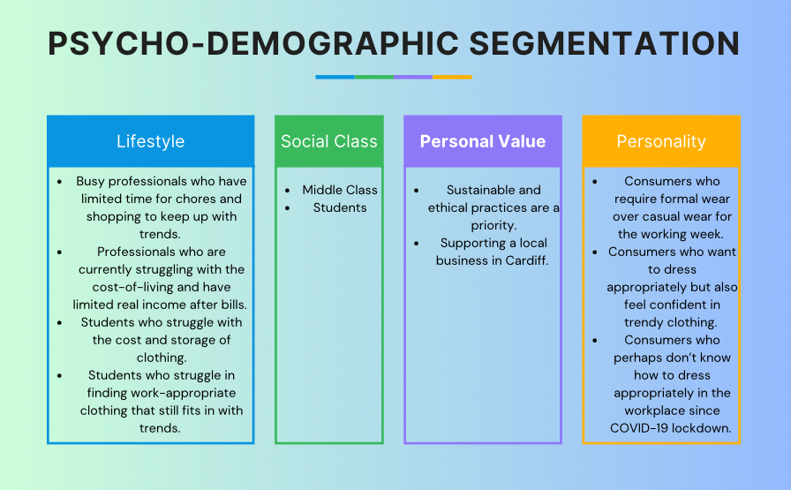
In terms of segmenting the market to make the brand more accessible, Working Wardrobe will use psycho-demographic segmentation. The break down of the market will include lifestyle, social class, personal values and personality. This is to ensure our service has maximum potential in an already growing market.
(Canva, 2025)

Competition:
Looking into competition, there is no direct business that offers the same features that Working Wardrobe does. However, there are two main business who offer similar ideas that could be a threat if they decided to diversify:
Baukjen- Baukjen is a sustainable clothing brand that offers high quality and ethically made suits and business-wear. To combat the issue of consumers switching to buying from them instead of renting for Working Wardrobe, we can work with them to include their items within our subscription options. This will help them gain word-of-mouth marketing as well helping them into our market without providing them too much traction.
Other fast fashion brands are also starting to realise a new more ethical ranges, such as H&M, M&S and ASOS. These are brands we can look to for trends and find pre-loved pieces for our own subscriptions.
Ansoffs Matrix:
Ansoffs Matrix is a framework that determines the attractiveness of a market. It is split into 4 categories that decide the risk of entering a product or service into that market. Working Wardrobe would fit into ‘Product Development’ (introducing a new product into an existing market) due to the fact that weekly clothing subscriptions specifically for the working environment are not yet mainstream, including the USP aspect following the cleaning, delivery and sustainability attributes. The key risks of introducing this product and service are the high upfront initial costs and preparation to be able to launch successfully.

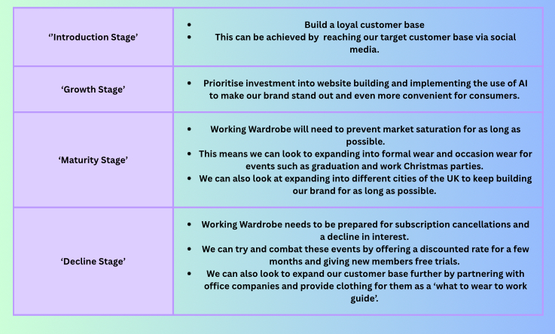
Product Lifecycle:
(Canva, 2025)

Financial Forecast:
Cash Flow Forecast:
The cash flow forecast (figure 6) shows gradual growth in sales as well as a realistic account for expenditure. While expenditure varies over each month as sales increase, this is vital to be able to meet our subscriptions. Working Wardrobe have also accounted for seasonal changes, with new inventory coming in with various seasons, and less sales revenue coming in over the Christmas period. As a growing business, we need to keep employment as minimal as possible until break even point, this is why for the first month there are zero staff wages, as I am running the business operations with zero pay in order to give Working Wardrobe the best chance.
The cash flow forecast lists Vehicles (figure 7), Storage Rails (figure 8), Packaging (figure 9) and Equipment (figure 10), which can all be found in the Appendix.
Break-even Analysis:
The table below shows break even figures, calculating break even to be at 3015 subscriptions. The cash flow table, figure 5, shows break even within the 12th month. While the cash flow table shows a constant profit, this is due to the initial help from the business loan at the beginning of trading.
Total Fixed Costs | £116719.96
Total Units Sold | 20700
Unit Price | £40
Total Variable Costs | £26727.74
Variable costs per unit | £1.29
Contribution per unit | £38.71
Break Even Point | 3015 subscriptions
While the fixed costs are fairly high for this operation, Working Wardrobe aims to address this within its second year of trading after finding out ways in which the business can be more efficient and sustainable. For instance, we can look into laundering our clothing within the warehouse to see if costs can be made cheaper, however, it is also important for Working Wardrobe to remain sustainable and ethical by supporting a small Cardiff business and keeping waste as little as possible.

Appendix:
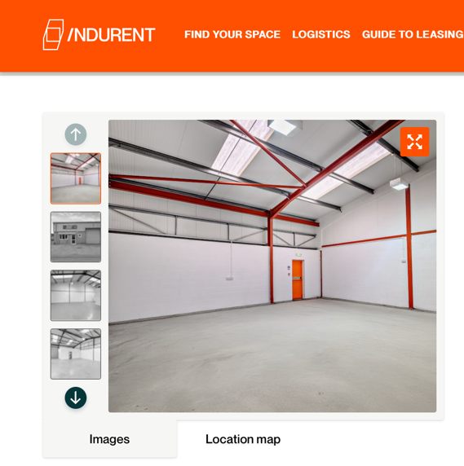
Figure 1:

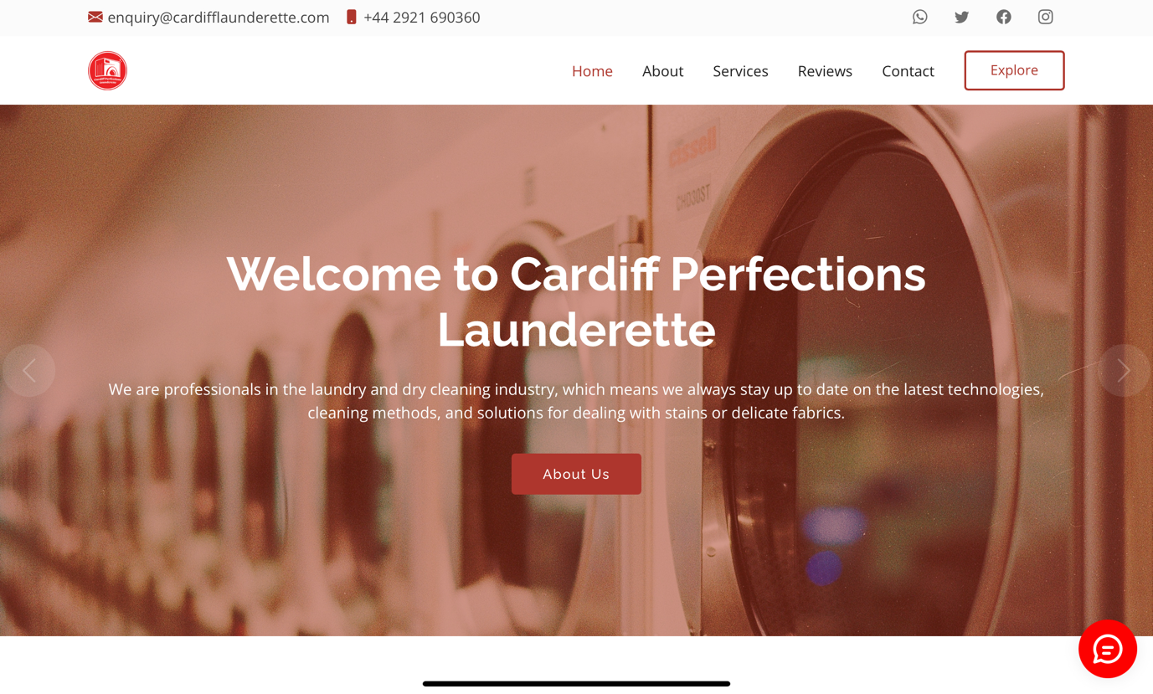
Figure 2:
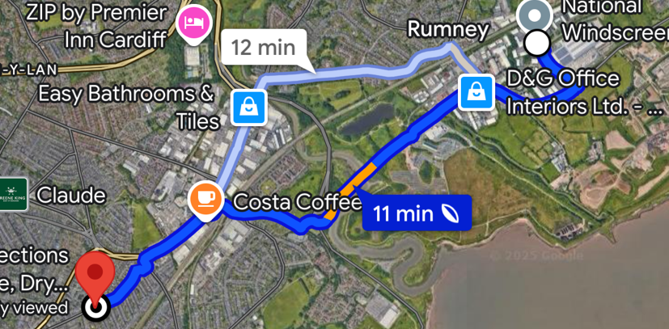
Figure 3:
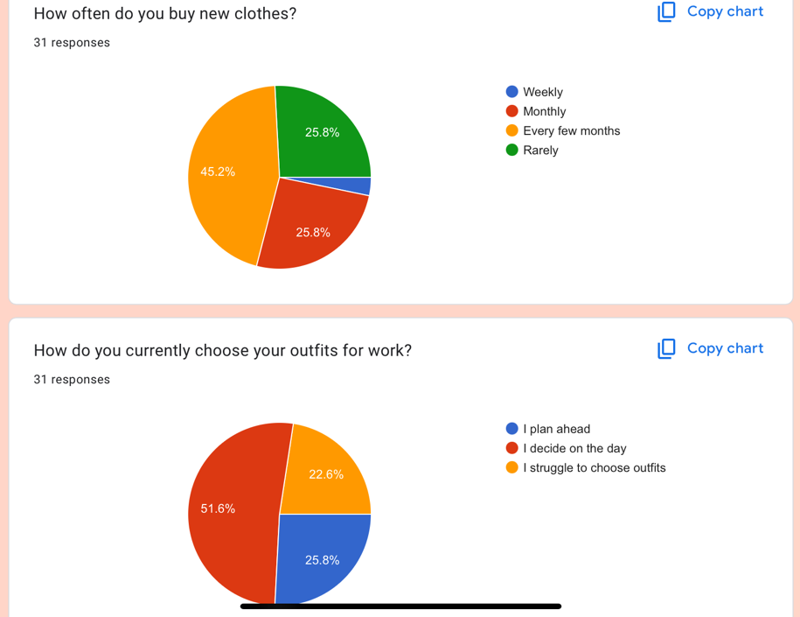
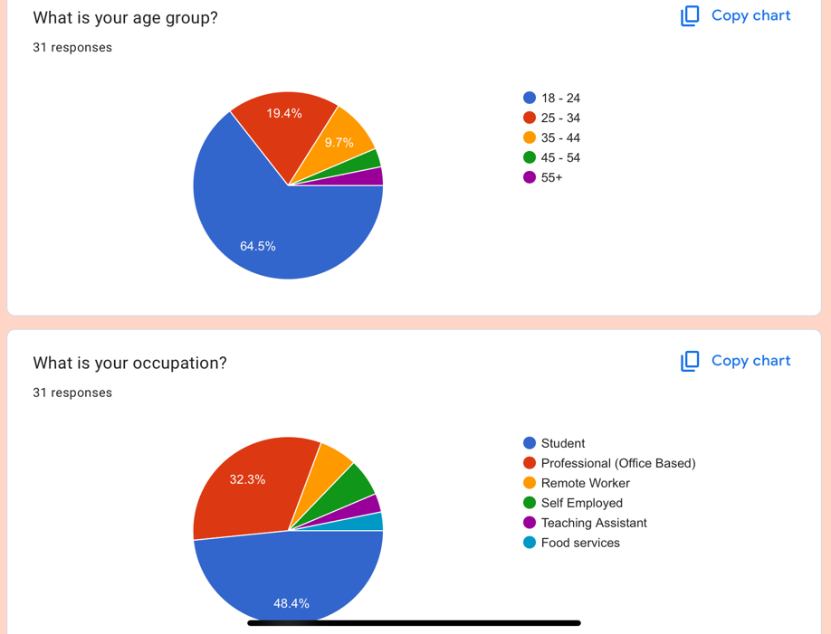
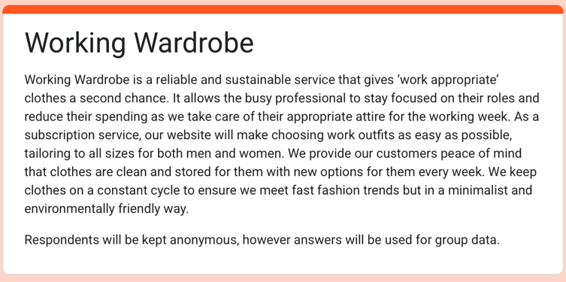
Figure 4:

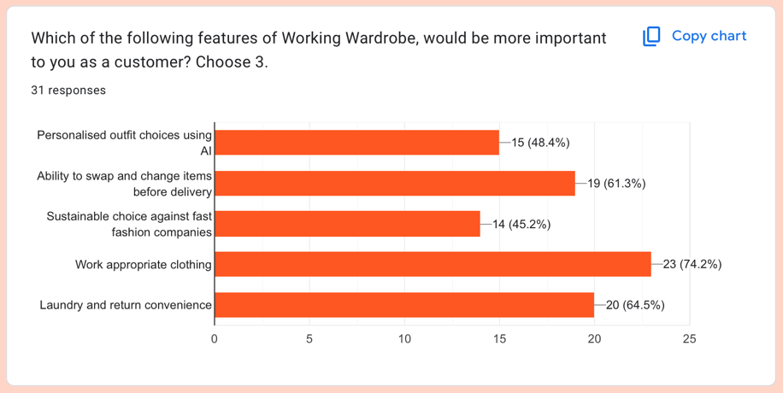
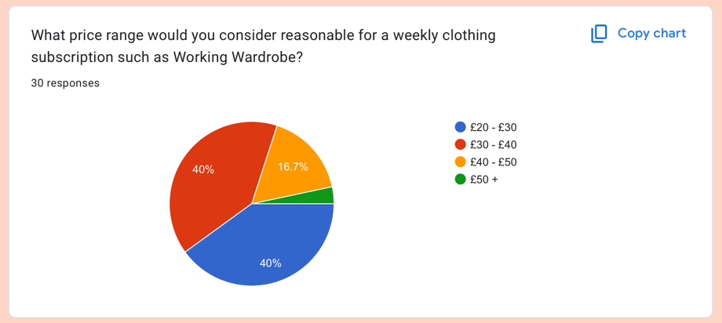
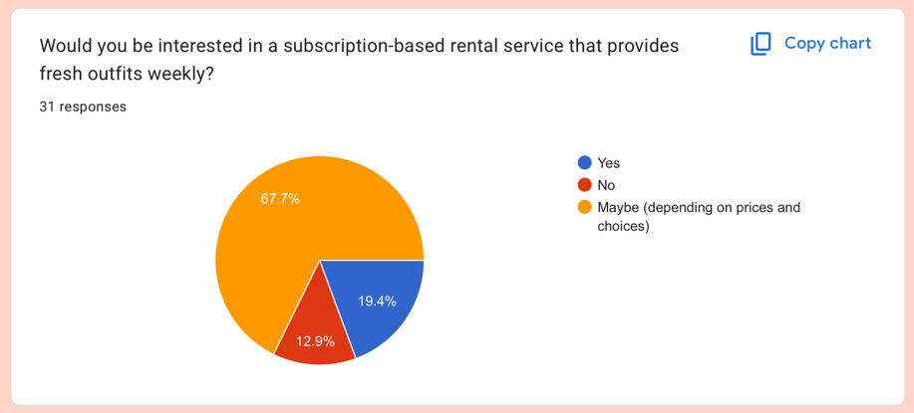
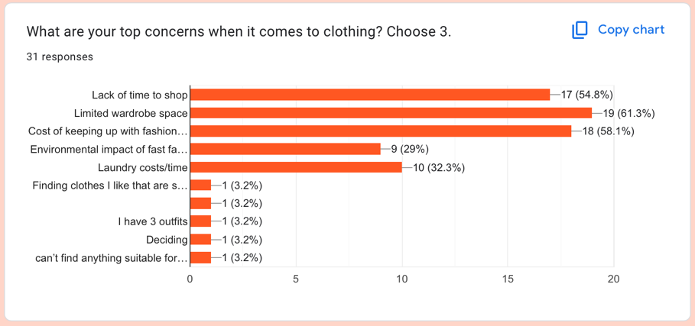
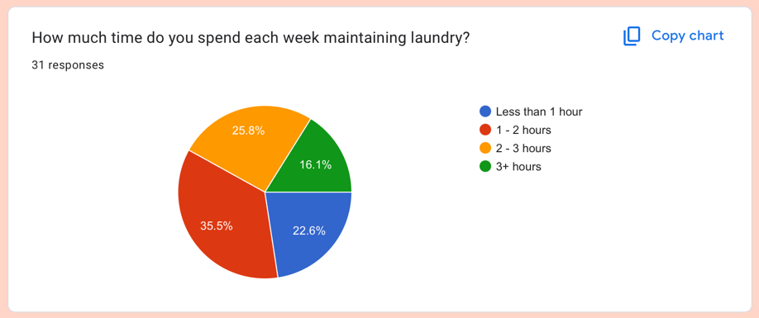
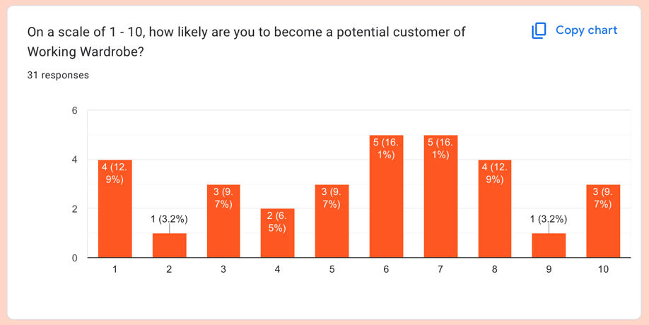
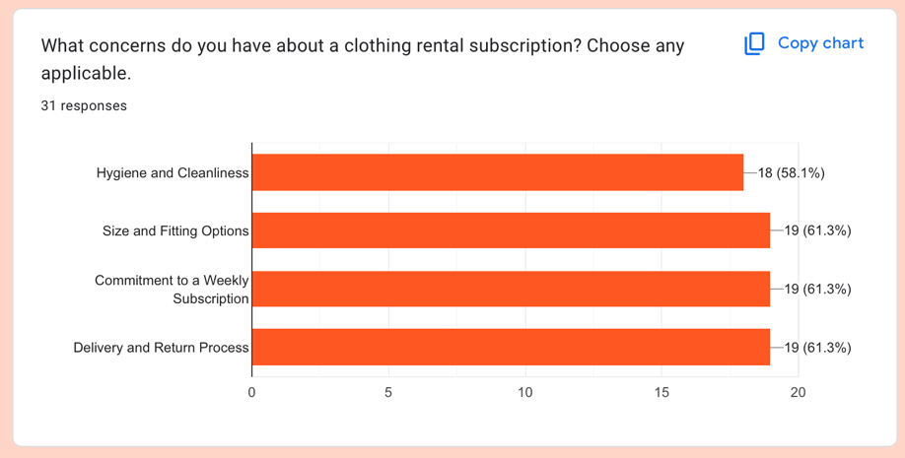
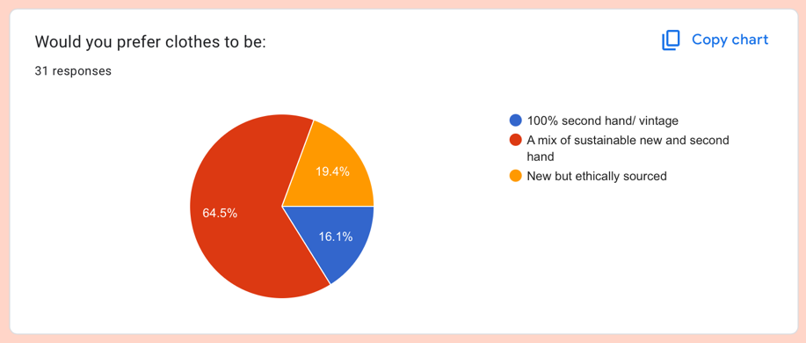
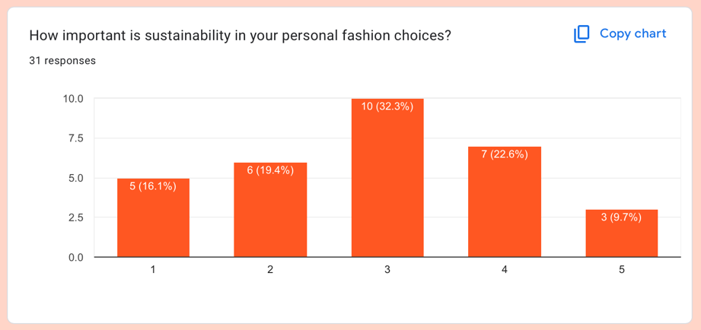

Figure 5:
Sustainability | Age: Generation Z, born between 1997 and 2013 are generally more concerned with the environment due to being brought up with the climate crisis as an urgent issue. However, with the expansion of technology and brands being able to deliver online, there is a huge rise of fast fashion and harmful products that Gen Z are consuming. While this age group now is relatively young, creating an established brand on online platforms such as TikTok and Instagram can help to create awareness of fast fashion and become a ‘home brand’ of where Gen Z can rent their future work clothing from without contributing to mass consumerism.77% of these young people are already experiencing financial concerns, as well as 88% of Gen Z not believing sustainable brands intentions. While this would be a hard market to sell to, Gen Z are very trend focused, and it can be very easy to grow the business by including their needs. Working Wardrobe would also target Millennials as majority are already in a professional role and have suffered through the financial crisis and the most recent cost of living crisis which we could target as a cheaper and more convenient choice.  Gender: Studies show that typically more UK women are more interested in sustainability and living in a more conscientious way, However, not by much. I think it is important to include men’s office wear needs within Working Wardrobe on the basis that sustainability is for everyone and to create more awareness of the business's goals we need to be inclusive of the fact that men’s clothing is a contributing factor.  Fashion: The general fashion market in the UK is worth $88.86 billion in 2025 and the sustainable fashion market is valued at $173.6 million in 2023 after a steady growth from 2018. Statistics also show that in 2024, revenue made from UK charity stores was £674 million, not to mention the increase in revenue in 2024 for top second hand selling by eBay with a revenue of $2.6 billion. As a market, second hand clothing is becoming increasingly more popular, as well charity stores and overall interest in sustainable fashion which means an overall interest in the business of Working Wardrobe.  Income: Taking into account if income makes a difference in sustainable choices, statistics show that in 2020, sustainable clothing shopping was a privilege in comparison to fast fashion when real income is decreased. However, the ethical fashion market is predicted at $9.81 billion over the year of 2025, which shows a slight decline in prices for ethical goods can mean a huge number of consumers will switch from their regular fast fashion brands. As a second-hand renting business, we can utilise good quality and appropriate garments made previously by fast fashion brands, while also including a selection of new sustainable clothing.
Household Costs | Clothing: The UK work apparel market was worth £15.07 billion in 2023, with 46% of that being corporate wear. This averages out to £475 per worker over the year. Working wardrobe can really tap into this demographic and offer a better and cheaper alternative with added benefits. This can help us generate a rapid growing market within the areas of Cardiff.  Laundry: Statistics show that the average UK household spends £91.80 a year on laundry, equaling 270 washes a year. However, research also shows that 60% of renters are finding it difficult to afford their energy bills. This is a key market for Working Wardrobe to target as the business aims to elevate some stress towards rising costs.
Time to Manage Chores | Laundry: A 2022 study found that the average time spent doing chores over an individual's lifetime in the UK is 2175 days. That equivocates to 88 hours per year, per person washing and drying clothes.  Storage: Research from 2022 showed that 90% of the UK believes they have too much clutter in their homes because of reduced housing. This also means that 47.2% of the UK are suffering with mental health due to the lack of storage available in their homes. Working Wardrobe can help minimise the work clothing clutter, as trends move on.

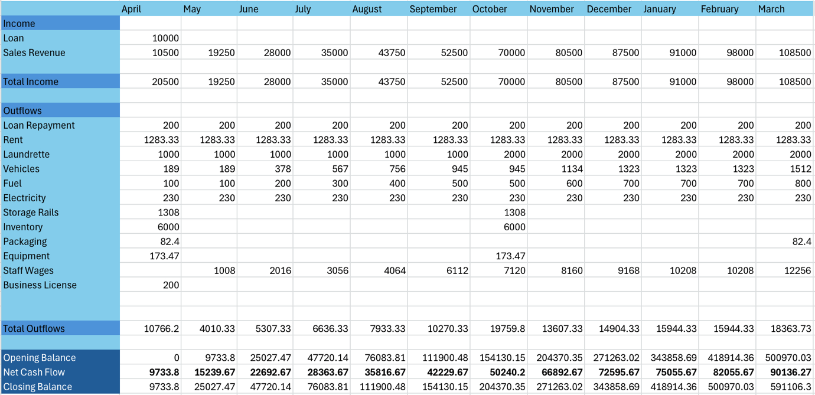
Figure 6:
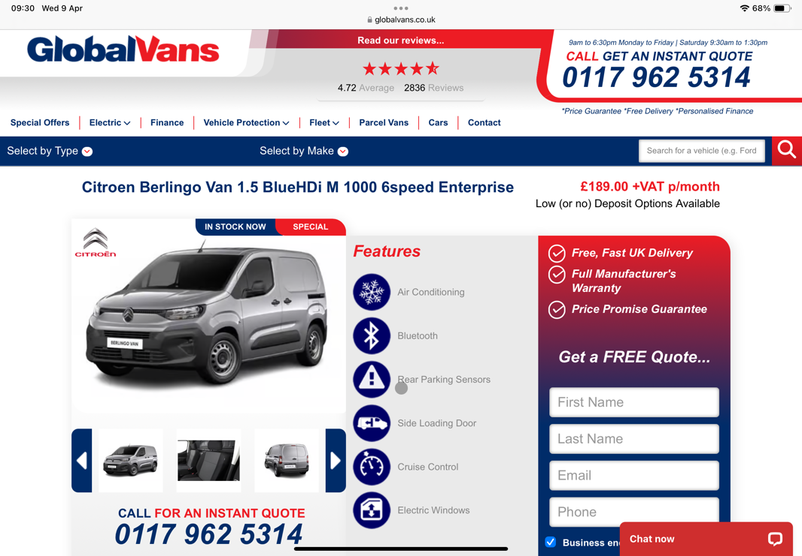
Figure 7:

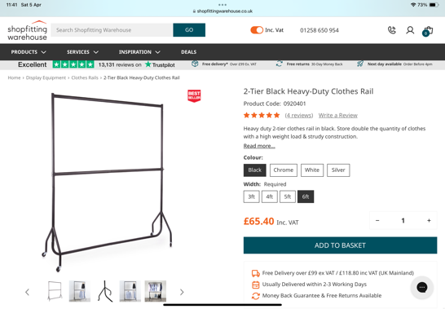
Figure 8:
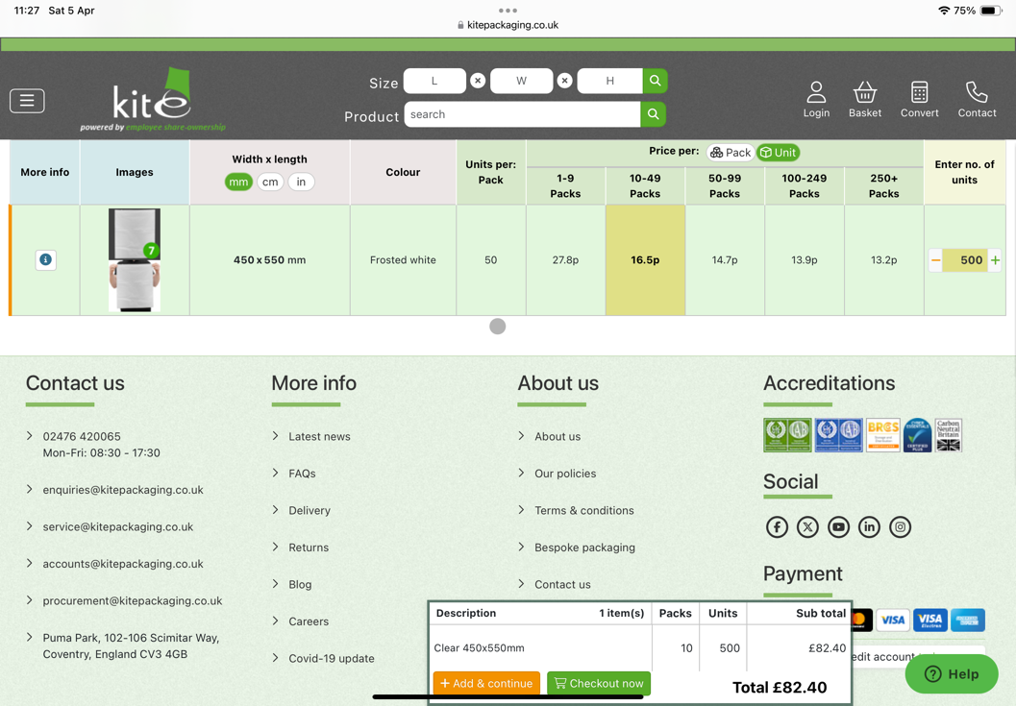
Figure 9:

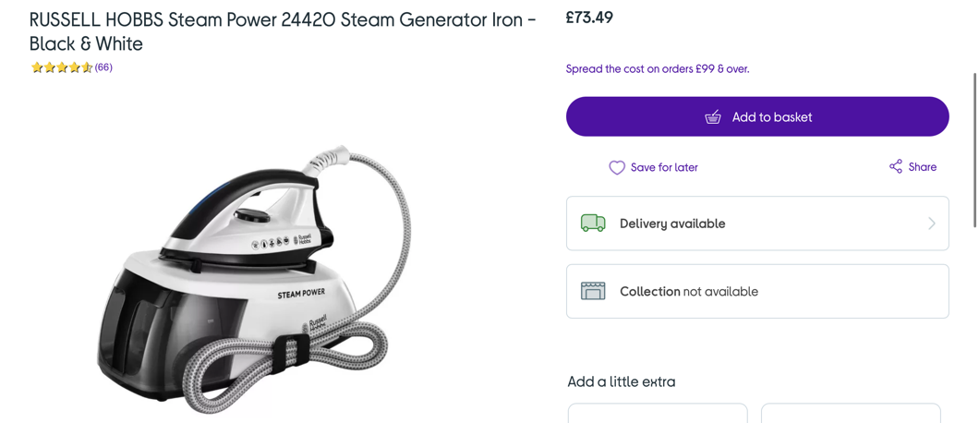
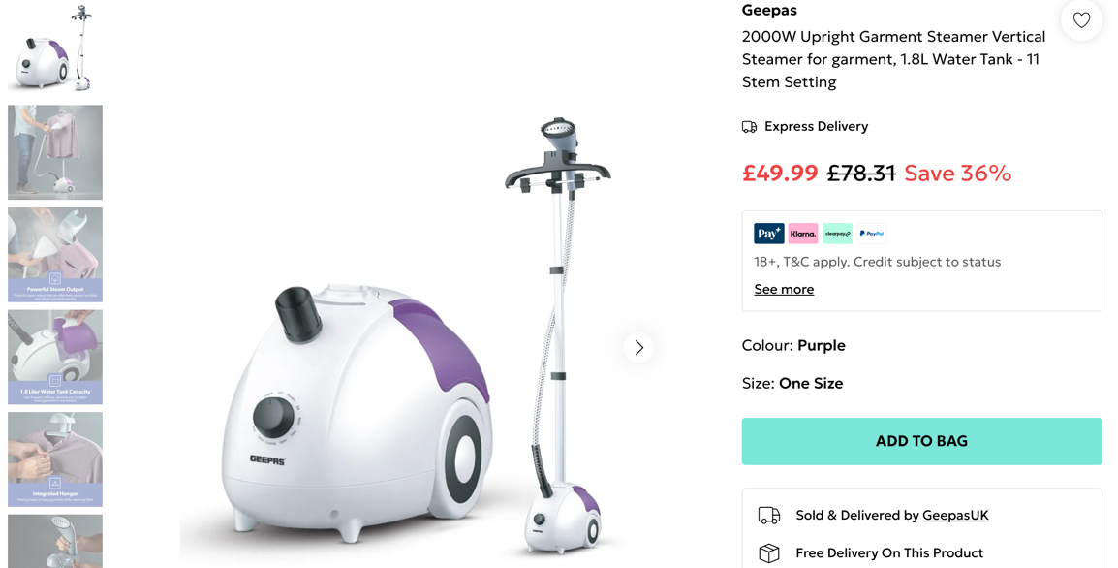
Figure 10:

Bibliography:
Access Storage Box. (2022). The UK’s Clutter Habits. https://www.accessboxstorage.com/blog/the-uks-clutter-habits-when-does-it-become-a-problem/.
AOV UP. (2024). Sustainable Fashion Statistics. https://aovup.com/stats/sustainable-fashion/.
Atkinson, M. (2020). To Shop Ethically is a Privilege Many Cannot Afford. https://www.palatinate.org.uk/to-shop-ethically-is-a-privilege-many-cannot-afford/.
Baldwin, C. (2024). What Is Market Segmentation And Why Is It So Important? https://useinsider.com/marketing-segmentation/.
Baukjen. (2025). Planet + People. https://www.baukjen.com/pages/our-purpose.
Business Electricity Prices. (2025). https://www.businesselectricityprices.org.uk.
Cardiff Perfections Laundrette. Welcome to Cardiff Perfections Laundrette. https://www.cardifflaunderette.com.
Currys. (2025). https://www.currys.co.uk/products/russell-hobbs-steam-power-24420-steam-generator-iron-black-and-white-10201886.html?istCompanyId=bec25c7e-cbcd-460d-81d5-a25372d2e3d7&istFeedId=4d7eb93e-055f-499d-8ee5-1cdcc50d67d1&istItemId=ipwrmamwr&istBid=t&gQT=1.
Davies, K. (2025). Second Hand Retail in the UK. https://www.statista.com/topics/4593/second-hand-retail-in-the-united-kingdom-uk/#topicOverview.
Debenhams. (2025). https://www.debenhams.com/product/geepas-2000w-upright-garment-steamer-vertical-steamer-for-garment-1-8l-water-tank---11-stem-setting_p-33f2fafa-2551-4484-b2d1-b3a17e000743?colour=Purple&size=One+Size&istCompanyId=76f7277d-6e78-4dc2-aaff-1eb77fae16b0&istFeedId=258a4886-8f3c-47ef-9369-d1eda8d84501&istItemId=qpiwwmipi&istBid=t&gclsrc=aw.ds&gad_source=1&gbraid=0AAAAABevdS4TL8M_VSiy596BR5ZVVKvSp&gclid=Cj0KCQjwqcO_BhDaARIsACz62vPXBVdR5JZnIcW3JyMSXz4TP5bku7pSvJVtnPtSsUXw1AMUOd3Hxz0aArlEEALw_wcB.
Duffy, M. (2022). Generation Z Members Say They Want Sustainable Clothes but Buy Fast Fashion Instead. https://www.shu.ac.uk/news/all-articles/latest-news/fast-fashion.
Garrett, K. (2022). The Average Brit Spends More Than 2000 Days Doing Chores in Their Lifetime. https://www.idealhome.co.uk/news/time-spent-doing-chores-181435.
Global Data. (2024). United Kingdom Green Fashion Market Summary. https://www.globaldata.com/store/report/uk-green-fashion-market-analysis/
Global Vans. (2025). https://globalvans.co.uk/vans/citroen/berlingo-van-1.5-bluehdi-m-1000-6speed-enterprise.html.
GOV.UK. (2025). National Minimum Wage and National Living Wage Rates. https://www.gov.uk/national-minimum-wage-rates.
Hargrave, M. (2024). What Public Limited Company (PLC) Means in the UK. https://www.investopedia.com/terms/p/plc.asp#:~:text=Advantages%20and%20Disadvantages%20of%20a,and%20takeover%20bids%20from%20rivals.&text=A%20U.K%20company%20can%20raise,pursue%20acquisitions%20by%20offering%20shares.
Indurent. (2025). https://www.indurent.com/find-your-space/?lat=51.483707&lng=-3.1680962&formatted_address=Cardiff%2C+UK&sqm=false&km=false&radius=40&min_space=0&max_space=99999999&min_price=1&max_price=99999999&include_vat=false&rent_type=Rent+per+month&facilities=&utm_source=google&utm_medium=cpc&utm_campaign=Cardiff_-_Loc&utm_content=703487475290&utm_term=industrial+unit+for+rent+cardiff&gad_source=1&gbraid=0AAAAAC_o4Ay_U0LjUrSgDoqZCe9mvPpty&gclid=CjwKCAjwvr--BhB5EiwAd5YbXp1IUOz4qNQ9Iki2u_nc4FP14sb3yMQQPyjHJkYs_4WXsfVzBlzc4hoC2IQQAvD_BwE&availability=.
Kenton, W. (2024). How To Perform A SWOT Analysis. https://www.investopedia.com/terms/s/swot.asp.
Kite. (2025). https://www.kitepackaging.co.uk/scp/polythene-bags/zip-lock-bags/?sfpartno=PBM250X300-ZIP-CPE&gad_source=1&gbraid=0AAAAAD_Y6cwG6yf1yQV3D0D8vy0LDxl3g&gclid=Cj0KCQjwqcO_BhDaARIsACz62vO7j21u1WVne4OLndF2BAT1R5JVLRHnWfpbmW6CA4W7Goo-kplX9NYaAuNQEALw_wcB.
Kopp, C. M. (2024). Product Life Cycle Explained. https://www.investopedia.com/terms/p/product-life-cyle.asp.
Love2Laundry. (2023). How Much Does It Cost to Do Laundry Per Week? https://www.love2laundry.com/blog/how-much-does-it-cost-to-do-laundry-per-week/.
Makkah, M., & Spry, A. (2024). Gen Z Supports Sustainability. https://theconversation.com/gen-z-supports-sustainability-and-fuels-ultra-fast-fashion-how-does-that-work-238874.
Mayne, M. (2025). Third of Working Parents Struggling with Severe Stress, Study Finds. https://www.peoplemanagement.co.uk/article/1902232/third-working-parents-struggling-severe-stress-study-finds.
Mintel. (2018). The Eco Gender Gap. https://www.mintel.com/press-centre/the-eco-gender-gap-71-of-women-try-to-live-more-ethically-compared-to-59-of-men/.
Mintel. (2024). UK Fashion and Sustainability Market Report 2024. https://store.mintel.com/report/uk-fashion-sustainability-market-report.
Morgan, K. (2023). What Does Work Life Balance Mean in a Changed World? https://www.bbc.co.uk/worklife/article/20230227-what-does-work-life-balance-mean-in-a-changed-work-world.
Nomis. (2024). Labour Market Profile- Cardiff. https://www.nomisweb.co.uk/reports/lmp/la/1946157397/report.aspx.
Office for National Statistics. (2023). How Life Has Changed in Cardiff. https://www.ons.gov.uk/visualisations/censusareachanges/W06000015/.
Our Tax Partner. (2024). Business Licenses and Permits Required to Start a Business in Cardiff, South Glamorgan. https://www.ourtaxpartner.com/business-licenses-and-permits-required-to-start-a-business-in-cardiff-south-glamorgan/.
Peterdy, K. Ansoffs Matrix. https://corporatefinanceinstitute.com/resources/management/ansoff-matrix/.
Roberts, L. (2025). A Complete Guide to Business Energy Bills. https://www.moneysupermarket.com/gas-and-electricity/business-energy/a/business-gas-electricity-bills/.
Shop Fitting Warehouse. https://www.shopfittingwarehouse.co.uk/clothes-rails/2-tier-black-heavy-duty-clothes-rail/?sku=0920401&cid=GBP&vat=true&campaign=20973838548&content=&keyword=&gad_source=1&gbraid=0AAAAAD-ZQ8kkmLyLho5lRrdnkmOUM0b2A&gclid=Cj0KCQjwhYS_BhD2ARIsAJTMMQZXvkeRJBKsNNUjZRQXIkWHPsY49-JzayLo_oC8bgxoBWWaNX7t7yoaAjSSEALw_wcB.
Statista. (2024). Apparel- United Kingdom. https://www.statista.com/outlook/cmo/apparel/united-kingdom.
The Spectator. (2024). How Much Do We Spend on Workwear? https://www.spectator.co.uk/article/how-much-do-we-spend-on-workwear/.
Washington State University. (2025). Industry Research. https://libguides.libraries.wsu.edu/c.php?g=294263&p=4358409.

