
LCBM7002
DAVID COKER
FINANCIAL MANAGEMENT
EMILY RODRIGUES ABREU
2327330
WORD COUNT: 5378

Introduction to Walgreens Boots Alliance, Inc (WBA): 3
Industry: 3
Business Model: 3
Marketplace: 3
Major Competitors: 3
Major Events (5-year timespan): 3
A Critical Review of The Company’s Financial Performance: 5
Profitability Ratio for Walgreens Boots Alliance, Inc (2023) 5
Liquidity Ratio for Walgreens Boots Alliance, Inc (2023) 5
Efficiency Ratio for Walgreens Boots Alliance, Inc (2023) 6
Gearing Ratio for Walgreens Boots Alliance, Inc (2023) 6
Comparison to CVS Health Corporation: 8
Profitability Ratio – WBA vs CVS (2023) 8
Liquidity Ratio – WBA vs CVS (2023) 8
Efficiency Ratio – WBA vs CVS (2023) 9
Gearing Ratio – WBA vs CVS (2023) 9
Recommendations: 10
Prospects for a range of new investment opportunities: 12
Pay Back Period: 12
Accounting Rate of Return: 13
Net Present Value: 14
Net Present Value (Recalculated with adjustments): 15
Advantages and Shortcomings of the PBP, ARR, and NPV: 16
Pay Back Period: 16
Accounting Rate of Return: 16
Net Present Value: 17
Non-Financial Factors: 18
References: 19
Appendix: 21

Introduction to Walgreens Boots Alliance, Inc (WBA):

Industry:
Walgreens Boots Alliance, Inc. (WBA) is a well-known participant in the healthcare sector, running a complex business that includes wellness, health, and pharmaceutical items. Established in 2014 because of the merger of Alliance Boots and Walgreens, WBA has grown to become a major player in the global healthcare industry, offering a wide range of products and services and operating in many countries. REF

Business Model:
WBA serves millions of clients globally through the thousands of Walgreens and Boots locations it runs as part of its core retail pharmacy business. These pharmacies provide a large selection of over-the-counter pharmaceuticals, prescription meds, cosmetics, health care items, and other services. With services including prescription refills, vaccinations, health screenings, and pharmacist consultations, WBA's retail pharmacies are positioned as easy-to-get locations for customers looking for healthcare solutions.

Marketplace:
WBA's business plan incorporates distribution networks and e-commerce in addition to traditional brick and mortar retail. The business runs online stores where clients can order prescription drugs and medical supplies for pickup or delivery. WBA also uses its broad distribution network to provide pharmacies, other shops, and healthcare professionals with medications and medical supplies.

Major Competitors:
WBA competes against competitors like CVS Health Corporation, Walmart Inc., and Amazon.com Inc. in the very competitive healthcare sector. Due to competition from these rivals for market share in e-commerce, retail pharmacy, and healthcare services, WBA is forced to constantly innovate and set itself apart from the competition. The core of WBA's competitive strategy is its emphasis on delivering individualised customer experiences by using technology and data analytics to customise services and product suggestions to meet the demands of specific customers.

Major Events (5-year timespan):
All information can be found on Walgreens Boots Alliance, Inc through press releases and more, other websites and news outlets have reported on the following events.
2019: WBA announced a strategic partnership with Microsoft to develop new healthcare delivery models, improve patient engagement, and enhance the efficiency of healthcare delivery (Wickware, 2019).
2020: Amid the COVID-19 pandemic, WBA saw increased demand for pharmaceuticals and healthcare products, leading to a surge in sales across its retail stores and online platforms alongside other companies (Kalish, 2022).
2021: WBA announced plans to divest its Alliance Healthcare business to AmerisourceBergen Corporation for $6.5 billion in cash and stock. This move aimed to streamline its operations and focus on its core retail pharmacy business (Samuel, 2021).
2022: WBA faced legal challenges related to opioid distribution practices, with several lawsuits filed against the company by states and local governments alleging its role in fuelling the opioid crisis. It was reported that the medication in question was falsely marketed, and the affects (long-term and short-term) were not presented appropriately to the consumers of this pill. Walgreens have paid $230 billion to the San Francisco state to settle the case. The company announced initiatives to address opioid abuse and support affected communities (Ivanova & Weicher, 2023).
2023: On the 23rd October, WBA appointed Tim Wentworth as the new CEO, marking a leadership transition aimed at driving growth and innovation in the rapidly evolving healthcare industry. The WBA focus was to appoint a new CEO with extensive healthcare understanding and experience (WBA, 2023).
In conclusion, Walgreens Boots Alliance, Inc. continues to be a powerful force in the healthcare sector, generating value for its stakeholders using its broad retail footprint, digital capabilities, and dedication to customer-centricity. WBA is committed to its goal of giving customers all around the world easily accessible, reasonably priced, and high-quality healthcare products and services, even in the face of obstacles and strategy shifts.

A Critical Review of The Company’s Financial Performance:
All figures used within the report have been taken directly from a credible source that displays the financial figures for Walgreens Boots Alliance, Inc (Nasdaq, 2023).

Profitability Ratio for Walgreens Boots Alliance, Inc (2023)
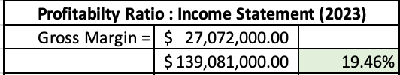
Table 1.1 – Gross Margin Ratio (Source: Author)
A profitability ratio evaluates a business's capacity to turn a profit in relation to its assets or revenue. Return on investment, net profit margin, and gross margin are examples of common profitability ratios. These indicators of financial performance evaluate the profitability of sales, the effectiveness of operations, and the total return on investments (O’Brien, 1996). From the latest income statement provided (see table 1.1), WBA saw a fluctuating year. The gross margin percentage of approximately 19.46% signifies that for every dollar of revenue generated, the company retains nearly 19.46 cents as gross profit after deducting the cost of goods sold (COGS). This indicates a moderate level of profitability in the company's core operations. While the gross margin is a key indicator of profitability, it only reflects the profitability before operating expenses, interest, taxes, and other non-operating costs are deducted. Therefore, while a gross margin of 19.46% is a positive sign, it's essential to analyse other profitability metrics such as operating margin, net profit margin, and return on investment to gain a comprehensive understanding of the company's financial performance. However, when comparing the gross margin from 2023 to 2022 calculation of 21.30%, there has been a slight decline in maintaining the profitability ratio. It is apparent that the year 2023 has seen a shift in the financial prosperity of the company.

Liquidity Ratio for Walgreens Boots Alliance, Inc (2023)
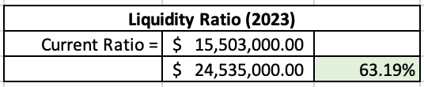
Table 1.2 – Current Ratio (Source: Author)
A liquidity ratio known as the current ratio assesses a company's capacity to settle short-term debt or bills that are due within a year. It provides information to analysts and investors on how a business might maximise its current assets on the balance sheet to pay down its current debt and other payables (Walsh, 2009, p. 117). WBAs has roughly $0.63 in current assets available to fulfil its commitments for every dollar in current liabilities, according to the current ratio of 63.19% (0.632). WBAs current ratio for the financial year falls below 1.0 (see table 1.2) this may show implications for the company as a value above 1.0 tends to be considered favourable. A current ratio less than 1.0, on the other hand, indicates that the company's current liabilities are more than its current assets, which raises questions about its capacity to pay short-term debt using its current assets. Additionally, a low current ratio could be a sign of liquidity issues, making it more difficult for the business to finance ongoing operations, settle debt, or seize expansion prospects. Comparing it to the previous year, there was a slight decline with 2022 presenting a ratio value of 74.84% (0.7480.) This is almost a 10% drop in liquidity ratio which could be a troubling sign that the company is headed into future problems with its figures.

Efficiency Ratio for Walgreens Boots Alliance, Inc (2023)
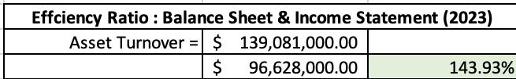
Table 1.3 – Assets Turnover Ratio (Source: Author)
An efficiency ratio evaluates how well a business makes use of its resources to produce income. It contrasts inputs, such as expenses or assets, with outputs, such as revenue or sales. A lower ratio emphasises operational performance by showing the organisation is producing more money with less resources, indicating superior efficiency (Patin, Rahman and Mustafa, 2020). The asset turnover ratio of 143.93% (see table 1.3) demonstrates a very high level of asset utilisation efficiency that leads to income generation. This shows that the corporation makes about $1.43 in revenue for every dollar of assets, demonstrating efficient asset management and utilisation. A percentage this high points to efficient use of resources and successful sales tactics, which could boost revenue and return on investment. A strong asset turnover ratio indicates that the business can make a substantial profit from its asset base, which supports overall financial stability and operational efficacy by optimising revenue production from available resources. Compared to the Asset Turnover in 2022 which was $1.47 in revenue for every dollar of assets, there has not been a considerable drop which shows that WBA has been able to retain similar figures from one year to the next.

Gearing Ratio for Walgreens Boots Alliance, Inc (2023)
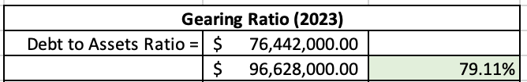
Table 1.4 – Debt to Assets Ratio (Source: Author)
The debt-to-assets ratio calculates the percentage of debt used to finance an organization's assets. By showing the proportion of total assets financed by borrowing, it sheds light on risk and financial leverage. A greater dependence on debt financing is indicated by a higher ratio, which could raise financial risk and have an impact on solvency and liquidity (Peterdy, 2020). According to the given debt-to-assets ratio of 79.11% (see table 1.4), debt is used to finance about 79.11% of the company's assets. This ratio illustrates how heavily the company's capital structure depends on debt funding. Debt can help businesses have access to capital for expansion, but a high debt-to-income ratio raises the possibility of dangers such as higher interest costs and heightened susceptibility to downturns in the economy. For financial stability to be maintained and risks associated with excessive debt levels to be minimised, effective debt management and balance with equity financing are essential. Compared to the ratio of 70.80% in 2022, this is a considerable jump which could show that there are issues being faced by WBA.
In summary, Walgreens Boots Alliance, Inc.'s (WBA) financial study shows that, in contrast to the prior year, performance varied across several important ratios in 2023. Although there has been a minor reduction from 2022, the gross margin ratio still reflects a moderate degree of profitability, suggesting a shift in financial prosperity. When the current ratio, which measures liquidity, is less than 1.0, it may be an indication of impending liquidity problems and a cause for concern regarding the company's capacity to fulfil short-term obligations. Furthermore, a notable decline from the prior year points to imminent problems with liquidity management. On the other hand, the efficiency ratio—which is best represented by the asset turnover ratio—shows a very high degree of asset utilisation efficiency, suggesting effective resource management on the part of WBA and supporting income production. Lastly, the debt-to-assets ratio, which represents the gearing ratio, indicates a substantial reliance on debt financing, which may increase financial risks and have an impact on solvency. The large rise from the prior year implies that WBA would have difficulties properly controlling its debt levels. All things considered, these results highlight how crucial it is to handle finances carefully and make strategic decisions to overcome obstacles and guarantee WBA's long-term success and financial stability.

Comparison to CVS Health Corporation:
All figures used within the report have been taken directly from a credible source that displays the financial figures for CVS Health Corporation (Nasdaq, 2023). CVS Health Corporation is a similar business that operates in the USA, they offer similar service such as health and beauty, pharmaceutical items, and wellbeing support. CVS is one of Walgreens biggest competitors in the market. For this part of the report, comparisons will be made to critically assess the financial structure of each business within the last four years, it will also conclude which company is progressing financially, utilising the same financial ratios as before. It is very important to note that both companies may have been affected positively or negatively due to economic factors such as the COVID-19 Pandemic, this is because both companies fall under the pharmaceutical industry and played a vital role during restrictions and changes of day-today living.

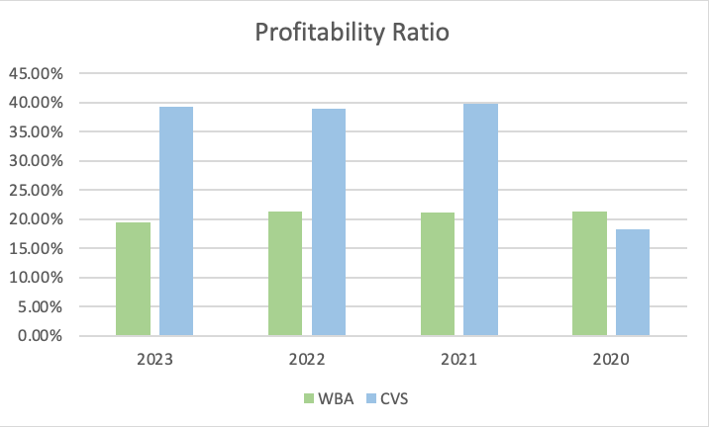
Profitability Ratio – WBA vs CVS (2023)
Table 2.1 – Gross Margin for WBA and CVS (Source: Author)
According to the table above (see table 2.1) Walgreens Boots Alliance has a 19.46% profitability ratio, but CVS Health Corporation has a far higher percentage—39.32% in the last recent statement released. This substantial difference indicates that CVS is more adept at making money in relation to its sales, assets, or equity—based on the underlying ratio of each. It is important to note however, that CVS and WBA both have a consistent figure of profitability over the last 3 years, this is a clear indication that both companies can maintain their profit margins. CVS saw an increase from the year 2020 to 2021, this may have been due to the pandemic which may not have impacted WBA directly. The difference highlights CVS's higher efficiency in turning revenue into profit, which may be the result of improved operational efficacy, pricing tactics, or cost control. This comparison demonstrates how, in the retail pharmacy and healthcare sectors, CVS outperforms WBA in terms of financial performance and efficiency measures.

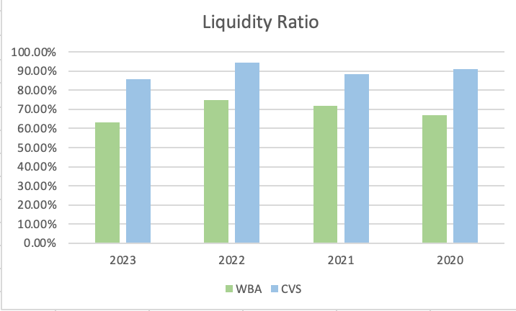
Liquidity Ratio – WBA vs CVS (2023)
Table 2.2 – Current Ratio for WBA and CVS (Source: Author)
From the statistics provided (see table 2.2), CVS Health Corporation liquidity ratio of 85.69% outperformed Walgreens Boots Alliance, which had a ratio of 63.19%. Furthermore, looking at past years, CVS had over 20% more each financial year. This shows that, in comparison to WBA, CVS is more equipped to satisfy short-term obligations using its short-term assets. In general, higher liquidity ratios signify improved flexibility and financial soundness. Individual business plans and industry standards, however, should also be considered. Even though CVS's higher ratio can indicate a better financial foundation, it's important to determine whether assets are being used to their fullest potential. All things considered; CVS looks to be in a stronger short-term financial position than WBA in 2023 based only on liquidity ratios.

Efficiency Ratio – WBA vs CVS (2023)
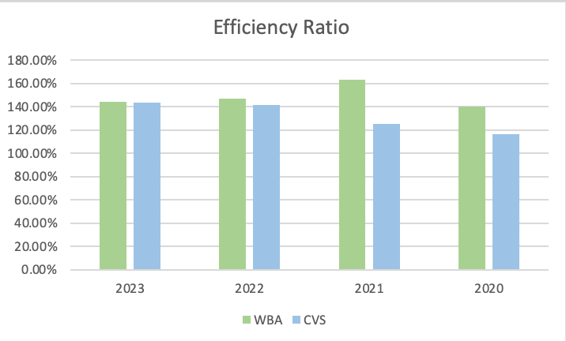
Table 2.3 – Asset Turnover for WBA and CVS (Source: Author)
Looking at the statistics (see table 2.3) above for the efficiency ratio, compared to CVS Health Corporation, which had an efficiency ratio of 143.27% in 2023, Walgreens Boots Alliance demonstrated a slightly higher ratio of 143.93%. The efficiency ratio calculates a business's revenue-generating capacity based on how well it uses its assets and liabilities. Even while WBA's higher ratio points to somewhat greater asset utilisation, the difference between both companies’ asset turnover is minimal which shows that in this criterion, both companies are most likely utilising similar strategies to keep them under control. However, when looking at the last three consecutive years, there is a clear spike then drop regarding WBA, whilst CVS is consistent with slight increases around 2022 onwards.

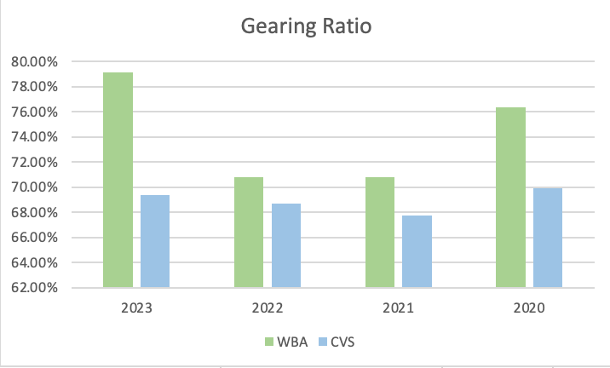
Gearing Ratio – WBA vs CVS (2023)
Table 2.4 – Debt – To – Asset Ratio for WBA and CVS (Source: Author)
Drawing from the source provided (see table 2.4) CVS Health Corporation, which had a gearing ratio of 69.38% in 2023, had a lower ration compared to Walgreens Boots Alliance which had a ratio of 79.11%, showing a larger percentage of debt in its capital structure. A greater gearing ratio implies that WBA depends more on debt financing, which could be a sign of heightened financial risk because of higher interest rates and possible difficulties repaying debt. CVS have always kept a low percentage, although, in 2020 there was a higher percentage, but this could have been due to COVID-19. The lower gearing ratio of CVS, on the other hand, suggests a more cautious approach to financing and may provide more stability and flexibility in handling the company's financial responsibilities and investment choices.

Recommendations:
For this part of the report, recommendations will be made to show how Walgreen Boots Alliance may navigate the complex financial landscape to keep ahead of competitors such as CVS Health Corporation, Walmart, and Target. It is important that WBA takes into consideration the most current financial year to introduce new strategies for improvement. The recommendations made should also reflect issues faced in the last 5 years within the company that could improve with a strategic change.
  - Profitability within a business is very important. If WBA is not able to remain profitable, it may face issues of liquidation in the future as organisations need to be able to cover finances in all areas of the business. It is also important that a business has a contingency fund for any issues that may arise. The first recommendation that can be made is maintaining and improving the strategy which allows WBA to preserve profitability. The way in which this can be achieved is through bringing in more money than the business spends on operations on a regular basis. WBA should keep concentrating on increasing its gross margin because it's a crucial sign of profitability for the retail pharmacy sector. A variety of techniques, including efficient cost control, strategic pricing, and product mix optimisation can be used to accomplish this. The success of WBA could also be dependent on cost management. It can lower its cost of goods sold (COGS) and raise gross margin by consistently improving cost structures, the efficiency of the supply chain, and production processes. Key tactics include renegotiating supplier contracts to obtain better conditions for price, streamlining operations to reduce waste and inefficiencies, and using technology to automate human work, this could be in the form of AI or systems that may help put provisions in place for better access and support. Furthermore, productivity and general efficiency are increased by investing in automation and improving production processes. This all-encompassing strategy guarantees cost-effectiveness across the board, increasing WBA's competitiveness and maintaining profitability. In the ever-changing retail pharmacy sector, WBA can position itself for long-term success by aggressively controlling costs and optimising efficiency throughout its operations (McKinsey & company, 2022).

  - Liquidity improvement may require a comprehensive strategy to increase the company's capacity to effectively fulfil short-term obligations to improve liquidity ratios. First, comparing the company's liquidity position to industry benchmarks and historical performance offers important information, by looking at competing companies such as CVS, Target, and Walmart, WBA can make calculated decisions regarding their strategy. It's critical to comprehend the variables affecting liquidity, such as terms of accounts payable, stock levels, and receivables collection schedules. After that, management must put customised plans into action to increase liquidity. This could entail short-term funding or improved cash flow management to strengthen cash reserves. Liquidity can also be increased by lowering inventory levels, negotiating advantageous terms of payment with suppliers, and streamlining the accounts receivable collection process. Furthermore, examining capital expenditure plans and discretionary spending contributes to short-term cash conservation and a strong liquidity position for the business (Brigham et al, 2020).

  - Efficiency improvement could require effort aimed at increasing operational effectiveness and optimising resource utilisation, this is needed to improve asset turnover in WBA. First and foremost, the focus ought to be on preserving this effectiveness if the asset turnover ratio is in line with or higher than industry norms. To further increase asset turnover and profitability, it is imperative to continuously optimise asset management procedures, such as inventory control, fixed asset utilisation, and accounts receivable turnover. Asset allocation and return maximisation are ensured when asset turnover ratio analysis is used to guide capital expenditure budgeting, asset acquisition, and divestment decisions. In addition, the incorporation of asset turnover analysis into strategic planning procedures facilitates the identification of prospects for operational improvements, cost containment measures, and revenue expansion endeavours, thereby augmenting the overall efficiency of asset utilisation in WBA (Heizer, 2019).

  - Gearing ratio within a business is important. Improving the ratio of debt to assets in WBA requires a thorough strategy that maximises the capital structure of the business and reduces financial risk. First off, to reduce financial susceptibility, it is imperative to establish a strong debt management plan to minimise dependency on debt financing and strike a balance with equity financing. Examining possibilities for advantageous refinancing of current debt can reduce interest costs and improve the debt-to-assets ratio. It is recommended that cost reduction measures be explored across the entire organisation to improve cash flow for debt repayment. This may involve renegotiating supplier contracts or optimising processes. Techniques for optimising assets, such rearranging portfolios or selling non-core assets, can increase cash flow and optimise asset value. Reducing reliance on debt involves broadening the range of funding alternatives beyond conventional loans, such as equity financing or strategic alliances. Strict risk management protocols are essential for proactively reducing the hazards linked to excessive debt levels, which calls for careful observation of interest rates, the state of the economy, and industry dynamics. Establishing and maintaining trust and confidence among stakeholders on the debt management plan and risk reduction initiatives is crucial for the overall financial well-being of WBA (Ross, 2019).

Prospects for a range of new investment opportunities:
Below are two new projects that have been presented as new opportunities, this part of the report will require some calculations that should conclude Pay Back Periods (PBP), Accounting Rate of Return (ARR), and the Net Present Value (NPV) with the company’s current cost of capital at 0.75 per cent. Then, for the second half of the calculations, all initial investments will increase by 10% and cashflows will decrease by 10%, the report should then include a new NPV and make comments accordingly. Lastly, the advantages and disadvantages of the PBP, ARR, and NPV will be critically assessed with the non-financial factors that management must consider.

Pay Back Period:
The PBP approach is predicated on the notion of how long the project will take to produce enough cash flows to pay the cost of its inputs. It can also be used as a criterion to distinguish between projects and determine whether to approve or reject them based on whether the PBP is higher or lower than a predetermined number of years (Kareem Al-Ani, 2024).
Years | Project A | Project B
0 | -£5000M | -£1000M
1 | £2500M | £1500M
2 | £2000M | £1000M
3 | £1000M | £1000M
4 | -£442M | -£470M
Table 3.1 (Source: Author)
According to the table above, the calculations is as follows:
Project A: An initial investment of £5000M will be made. Then the calculations will be as followed –
-£500M + £2500M = -£2500M (Year 1)
-£2500 + £2000M = -£500M (Year 2)
-£500M + £1000M = £500M (Year 3)
This concludes that the PBP for Project A is 3 years.
Project B: An initial investment of £1000M will be made. Then the calculations will be as followed –
-£1000M + £1500M = £500M (Year 1)
This concludes that the PBP for Project B is 1 year.
Project B appears to have a shorter Payback Period (PBP) than Project A, according to the estimates given. Project A has a 3-year PBP, whereas Project B has a 1-year PBP. In general, a shorter payback period means that the investment will return its initial cost more quickly. This can be helpful because it shortens the time needed to repay the initial investment and begin making a profit. Project B may therefore be deemed to be the superior choice if the Payback Period is the only factor taken into consideration, as it provides a speedier return on investment.

Accounting Rate of Return:
For this part, the ARR will be calculated for each project. The average net income an asset is predicted to provide divided by its average capital cost, presented as an annual percentage, is the Accounting Rate of Return (ARR). One formula used to determine capital budgeting is the ARR. It is applied when businesses are debating whether to invest in a project, purchase, or other asset based on the anticipated future net earnings relative to the capital cost (Vipond, 2023).
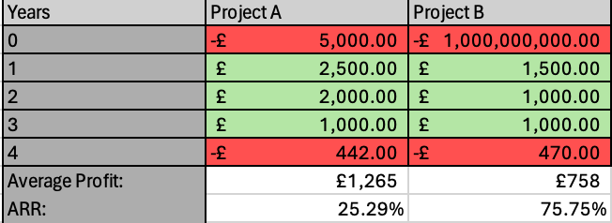
Table 3.2 – ARR (M) (Source: Author)
The calculations above were made as followed.
Project A: (£2,500+£2,000+£1,000+-£442) / 4 = £1,264.5
1,264.5 / 5000 = 0.2529
0.2529 x 100 = 25.29%
Project B: (£1,500+£1,000+£1,000+-£470) / 4 = 75.75
75.75 / 1,000 = 0.7575
0.7575 x 100 = 75.75%
Looking at the percentages for ARR, Project B is higher than Project A. Therefore, Project B, with an Accounting Rate of Return (ARR) of 75.75%, is the better investment option when compared to Project A, which has an ARR of 25.29%. There are various factors that influence this choice. First off, compared to Project A, Project B delivers a substantially larger return on investment, suggesting more profitability. Project B's annual rate of return (ARR) of 75.75% indicates that it has the potential to yield higher profits than its initial investment. Higher return investments are usually given preference by investors, which makes Project B a more alluring investment option. Because Project B has better accounting profitability than Project A, even when looking at the percentages of ARR alone, it is a more appealing investment prospect.

Net Present Value:
The value of all future cash flows, both positive and negative, discounted to the present over the course of an investment's lifetime is known as net present value, or NPV. A common technique in accounting and finance to ascertain the value of a firm, investment security, capital project, new endeavour, cost-reduction plan, or anything else involving cash flow is net present value (NPV) analysis (Corporate Finance Institute, 2023).
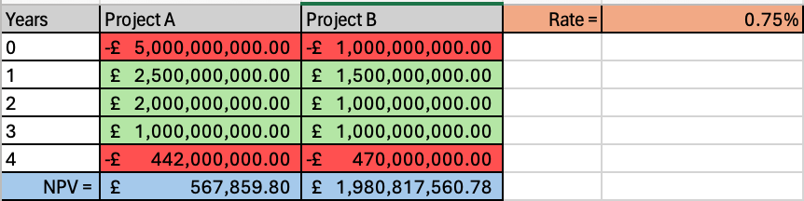
Table 3.3 - NPV (Source: Author)
The NPV was calculated using the specific formula incorporated into Excel.
The Net Present Value (NPV) analysis shows that Project B is the better investment choice than Project A based on the data that was provided. With a net present value (NPV) of £1,980,817,560.78, Project B has a far higher NPV than Project A, which is £567,859.80. When making investment decisions, net present value (NPV) is a crucial indicator that shows the current value of all future cash flows related to a project, reduced at the value of capital (0.75% in this example) for the company. NPV compensates for the time value of money by discounting future earnings back to their present value. This ensures that all cash flows are assessed consistently and accurately reflect their true economic worth. Even if the cash flows from both projects are steady in the latter years (Years 2, 3, and 4), Project B stands out since it had larger early inflows, especially in Year 1, which greatly increased its NPV. As a result, Project B is the better investment option because it provides a significantly larger return on investment than Project A.

Net Present Value (Recalculated with adjustments):
The next part of the report requires a recalculation of the NPV with the investments raised by 10% and the cashflows decreased by 10%. The calculations are as followed:
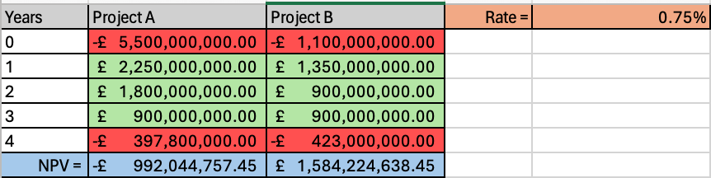
Table 3.4 – NPV recalculated (Source: Author)
The NPV was calculated using the specific formula incorporated into Excel.
Based on the recalculated cash flow data and NPV estimates, the analysis now shows a different result: even though Project A's initial investment was £500 million more than Project B's, Project A's net present value is negative—it is -£992,044,757.45. Even after accounting for the time worth of money at a 0.75% discount rate, Project A's negative net present value (NPV) indicates that it is not producing enough value to recover its initial investment. Project B, on the other hand, shows a notably positive NPV of £1,584,224,638.45, showing excellent profitability and potential for value generation. Project B has a positive net present value because of its steady cash flows over the course of the project, even though its beginning cash inflows were less than those of Project A. Project B therefore stands out as the better investment choice when the NPV analysis is performed using the most recent cash flow data. In comparison to Project A, it presents a significant opportunity for value generation and ought to be chosen for investment.

Advantages and Shortcomings of the PBP, ARR, and NPV:

Pay Back Period:
Advantages | Shortcomings
- Simple and Easy to Understand: Managers and stakeholders with different levels of financial competence can use PBP because it is easy to calculate and understand. It is especially ideal for small business’ due to the nature of the calculation.  - Pays Attention to Risk and Liquidity: PBP shows how quickly the initial investment can be recovered, which serves as a measure of liquidity. Because shorter payback periods result in quicker returns and less exposure to erratic future cash flows, it also provides insights into project risk. | - Ignores Time Value of Money: PBP regards cash flows received across a range of time periods equally because it does not take time value of money into consideration. It thus overlooks the potential associated with capital and may result in less-than-ideal investment choices.  - Ignores Cash Flows After Payback Period: PBP only considers the time needed to recover the initial investment, ignoring any cash flows that take place after the payback period. The potential worth and long-term profitability of initiatives with many revenue streams may be overlooked by this restriction (Team, 2024).

Accounting Rate of Return:
Advantages | Shortcomings
- Ease of Calculation and Interpretation: Managers and stakeholders without specialised financial understanding can easily calculate and comprehend ARR due to its relative simplicity.  - Considers Average Profitability: The average annual accounting profit produced by a project in relation to the average investment is determined by the ARR. It helps stakeholders evaluate the project's financial performance by giving them a measure of profitability over the course of the project. | - Ignores Time Value of Money: By treating cash flows equally regardless of when they occur, ARR, like PBP, ignores the time value of money. This may cause judgements of profitability to be biased, particularly in the case of projects whose cash flows fluctuate over time.  - Leaves Out Cash Flows Over Average duration: ARR only considers a project's average profitability; it makes no allowances for cash flows that happen over the project's typical duration. As a result, it can ignore the potential and long-term worth of projects with sustained revenue sources (Naik, 2021).

Net Present Value:
Advantages | Shortcomings
- Time Value of Money is considered: By applying a selected discount rate to future cash flows, net present value (NPV) accounts for the time value of money. This makes it possible to evaluate project profitability and investment returns with more accuracy.  - Considers All Cash Flows: Over the course of a project, net present value (NPV) accounts for all cash flows produced by the project, including both inflows and outflows. Better decision-making is made possible by NPV, which offers a thorough assessment of project value by considering the entire cash flow profile. | - Depends on Estimates and Assumptions: The determination of the discount rate and the cash flow predictions are just two of the estimates and assumptions that go into NPV calculations. Inputs that are too optimistic or inaccurate can result in inaccurate NPV calculations and poorly informed decisions.  - Choosing the Right Discount Rate: Choosing the right discount rate for the analysis of NPV can be difficult and random. It is vital to properly explain and verify the chosen discount rate because different rates can produce NPV values that are noticeably different from one another (NASDAQ, 2015).

Non-Financial Factors:
Within every business, management needs to consider which non-financial factors could affect them in a non-monetary way. Below are three factors that were believed to be the upmost important before considering starting on Project A or B:
Factor 1: Employee Well-Being, Diversity, Inclusion and Opportunity
The success of an organisation hinges on its workforce, as contented workers are more dedicated, productive, and engaged. Establishing a healthy work atmosphere with open communication, teamwork, and acknowledgment of achievements is crucial. Providing work-life balance initiatives, like flexible schedules, reduces burnout and boosts job satisfaction. Offering professional development opportunities demonstrates valuing employees' growth. Cultivating an inclusive and diverse workplace ensures every staff member feels valued. Addressing these aspects fosters a positive environment, promoting employee retention and organisational performance (Moss, 2023).
Factor 2: Customer Satisfaction
Gaining customer satisfaction is essential to fostering advocacy and brand loyalty. It is critical to comprehend client demands and to provide superior products or services together with first-rate customer support. To fulfil changing customer expectations, management should implement techniques to collect feedback and insights and use them to continuously develop products or services. Personalised experiences and careful attention to detail promote enduring connections, and swift problem-solving shows a dedication to client happiness. Prioritising client-centric processes helps firms build a devoted customer base that fuels long-term growth and success in addition to improving their reputation (Hult and Morgeson, 2023).
Factor 3: Innovation and Adaptability
For an organisation to remain relevant and competitive in fast-paced marketplaces, innovation and adaptability are essential. To spur innovation, management needs to foster an environment that values experimentation, risk-taking, and creative thinking. Research & development spending makes it possible to investigate novel concepts and create state-of-the-art solutions to satisfy changing client demands. Companies may take advantage of opportunities and overcome obstacles quickly by staying flexible and sensitive to new trends and technological developments. Businesses may foresee changes in the market, establish themselves as leaders in their field, and maintain long-term growth in a constantly shifting environment by embracing innovation and adaptation (Hamel, 2006).

References:
Brigham, E. F., & Ehrhardt, M. C. (2020). Financial Management: Theory & Practice. Cengage Learning.
Corporate Finance Institute (2023). Net Present Value (NPV). [online] Corporate Finance Institute. Available at: https://corporatefinanceinstitute.com/resources/valuation/net-present-value-npv/ [Accessed 18 Apr. 2024].
Heizer, J., & Render, B. (2019). Operations Management: Sustainability and Supply Chain Management. Pearson Education.
Kalish, I. (2022) Global Powers of retailing 2022, Global Economic Outlook. Available at: https://www2.deloitte.com/content/dam/Deloitte/at/Documents/consumer-business/at-global-powers-retailing-2022.pdf (Accessed: 08 April 2024).
Hamel, G. (2006). The Why, What, and How of Management Innovation. [online] Harvard Business Review. Available at: https://hbr.org/2006/02/the-why-what-and-how-of-management-innovation?registration=success [Accessed 22 Apr. 2024].
Hult, G.T.M. and Morgeson, F. (2023). 10 Ways to Boost Customer Satisfaction. [online] Harvard Business Review. Available at: https://hbr.org/2023/01/10-ways-to-boost-customer-satisfaction [Accessed 20 Apr. 2024].
Ivanova, I. and Weicher, C. (2023) Walgreens to pay San Francisco $229 million over opioid crisis, CBS News. Available at: https://www.cbsnews.com/news/san-francisco-opioid-settlement-walgreens-229-million/ (Accessed: 08 April 2024).
Kareem Al-Ani, M. (2024). A Strategic Framework to Use Payback Period in Evaluating the Capital Budgeting in Energy and Oil and Gas Sectors in Oman. [online] Google.com. Available at: https://www.google.com/url?sa=t&source=web&rct=j&opi=89978449&url=https://www.econjournals.com/index.php/ijefi/article/view/1127/pdf&ved=2ahUKEwixrI_fyNmFAxWyywIHHdMdCdkQFnoECC8QAQ&usg=AOvVaw10x3QeLg9ckTki6AHsMSWu [Accessed 16 Apr. 2024].
McKinsey & Company. (2022). "Pharmacy Retail: Navigating Cost Pressures and Driving Profitability." McKinsey & Company.
Moss, J. (2023). Creating a Happier Workplace Is Possible — and Worth It. [online] Harvard Business Review. Available at: https://hbr.org/2023/10/creating-a-happier-workplace-is-possible-and-worth-it.
Naik, S. (2021). ARR: Accounting Rate of Return-Advantages and Drawbacks. [online] Banking School. Available at: https://bankingschool.co.in/accounting/arr-accounting-rate-of-return-advantages-and-drawbacks/ [Accessed 22 Apr. 2024].
NASDAQ (2015). Advantages and Disadvantages of Net Present Value Method. [online] www.nasdaq.com. Available at: https://www.nasdaq.com/articles/advantages-and-disadvantages-net-present-value-method-2015-11-14 [Accessed 22 Apr. 2024].
Nasdaq.com. (2023a). CVS Health Corporation Common Stock (CVS) Financials. [online] Available at: https://www.nasdaq.com/market-activity/stocks/cvs/financials [Accessed 13 Apr. 2024].
Nasdaq.com. (2023b). Walgreens Boots Alliance, Inc. Common Stock (WBA) Financials | Nasdaq. [online] Available at: https://www.nasdaq.com/market-activity/stocks/wba/financials [Accessed 13 Apr. 2024].
Patin, J.-C., Rahman, M. and Mustafa, M. (2020). Impact of Total Asset Turnover Ratios on Equity Returns: Dynamic Panel Data Analyses. Journal of Accounting, Business and Management (JABM), [online] 27(1), p.19. doi:https://doi.org/10.31966/jabminternational.v27i1.559.
Peterdy, K. (2020). Debt to Asset Ratio. [online] Corporate Finance Institute. Available at: https://corporatefinanceinstitute.com/resources/commercial-lending/debt-to-asset-ratio/ [Accessed 13 Apr. 2024].
Ross, S. A., Westerfield, R. W., & Jordan, B. D. (2019). Fundamentals of Corporate Finance. New York, NY: McGraw-Hill Education.
Samuel, S. (2021) Walgreens Boots Alliance divests wholesale business, The Institute of Grocery Distribution . Available at: https://www.igd.com/Commercial-Insight/Retail-Analysis/Markets/Articles/Walgreens-Boots-Alliance-divests-wholesale-business/33471#:~:text=Walgreens%20Boots%20Alliance%20(Walgreens)%20is,in%20a%20%246.5bn%20deal. (Accessed: 08 April 2024).
Team, C. (2024). Payback Period. [online] Corporate Finance Institute. Available at: https://corporatefinanceinstitute.com/resources/financial-modeling/payback-period/?utm_source=google&utm_medium=cpc&utm_term=&utm_content=&utm_campaign=&utm_adgroup=&utm_funnel=&gad_source=1&gclid=CjwKCAjw26KxBhBDEiwAu6KXt21_Fym2Mi_AR0op3gmRov0jYNUIoDBfds0bF9usTDNkzLSRntCtvRoCpSwQAvD_BwE [Accessed 22 Apr. 2024].
Vipond, T. (2023). ARR - Accounting Rate of Return. [online] Corporate Finance Institute. Available at: https://corporatefinanceinstitute.com/resources/accounting/arr-accounting-rate-of-return/.
Walsh, C (2009), Key Management Ratios, Pearson Education, Limited, Harlow. Available from: ProQuest Ebook Central. [13 April 2024].
Wickware, C. (2019) Walgreens Boots Alliance partners with Microsoft to develop ‘new healthcare delivery models’, The Pharmaceutical Journal. Available at: https://pharmaceutical-journal.com/article/news/walgreens-boots-alliance-partners-with-microsoft-to-develop-new-healthcare-delivery-models (Accessed: 08 April 2024).

Appendix:
- The following formulas were used throughout the report: Part B (Ratios)
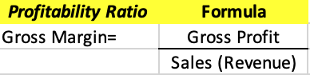
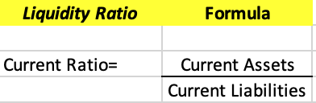
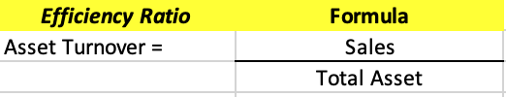
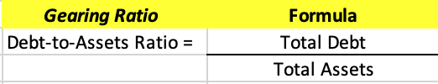

- WBA Income Statement:
Period Ending: | 8/31/2023 | 8/31/2022 | 8/31/2021 | 8/31/2020
Total Revenue | $139,081,000 | $132,703,000 | $132,509,000 | $121,982,000
Cost of Revenue | $112,009,000 | $104,437,000 | $104,442,000 | $95,905,000
Gross Profit | $27,072,000 | $28,265,000 | $28,067,000 | $26,078,000
Operating Expenses
Research and Development | -- | -- | -- | --
Sales, General and Admin. | $33,953,000 | $26,877,000 | $25,725,000 | $25,095,000
Non-Recurring Items | -- | -- | -- | --
Other Operating Items | -- | -- | -- | --
Operating Income | -$6,882,000 | $1,387,000 | $2,342,000 | $982,000
Add'l income/expense items | $2,043,000 | $2,998,000 | $558,000 | $77,000
Earnings Before Interest and Tax | -$4,839,000 | $4,385,000 | $2,900,000 | $1,060,000
Interest Expense | $580,000 | $400,000 | $905,000 | $613,000
Earnings Before Tax | -$5,419,000 | $3,985,000 | $1,995,000 | $446,000
Income Tax | -$1,891,000 | -$80,000 | $40,000 | $308,000
Minority Interest | -- | -- | -- | --
Equity Earnings/Loss Unconsolidated Subsidiary | $448,000 | $271,000 | $30,000 | $33,000
Net Income-Cont. Operations | -$3,528,000 | $4,065,000 | $1,955,000 | $138,000
Net Income | -$3,080,000 | $4,337,000 | $2,542,000 | $456,000
Net Income Applicable to Common Shareholders | -$3,080,000 | $4,337,000 | $2,542,000 | $456,000

- WBA Balance Sheet:
Period Ending: | 8/31/2023 | 8/31/2022 | 8/31/2021 | 8/31/2020
Current Assets
Cash and Cash Equivalents | $728,000 | $1,358,000 | $559,000 | $469,000
Short-Term Investments | $11,000 | $1,114,000 | $634,000 | --
Net Receivables | $5,381,000 | $5,017,000 | $5,663,000 | $4,110,000
Inventory | $8,257,000 | $8,353,000 | $8,159,000 | $7,917,000
Other Current Assets | $1,127,000 | $1,059,000 | $800,000 | $5,577,000
Total Current Assets | $15,503,000 | $16,902,000 | $15,814,000 | $18,073,000
Long-Term Assets
Long-Term Investments | $3,497,000 | $5,495,000 | $6,987,000 | $7,204,000
Fixed Assets | $33,254,000 | $32,988,000 | $34,140,000 | $34,249,000
Goodwill | $28,188,000 | $22,280,000 | $12,421,000 | $12,013,000
Intangible Assets | $13,635,000 | $10,730,000 | $9,936,000 | $10,072,000
Other Assets | $2,550,000 | $1,730,000 | $1,987,000 | $5,564,000
Deferred Asset Charges | -- | -- | -- | --
Total Assets | $96,628,000 | $90,124,000 | $81,285,000 | $87,174,000
Current Liabilities
Accounts Payable | $21,270,000 | $19,238,000 | $18,490,000 | $16,101,000
Short-Term Debt / Current Portion of Long-Term Debt | $917,000 | $1,059,000 | $1,305,000 | $3,265,000
Other Current Liabilities | $2,347,000 | $2,286,000 | $2,259,000 | $7,705,000
Total Current Liabilities | $24,535,000 | $22,583,000 | $22,054,000 | $27,070,000
Long-Term Debt | $8,145,000 | $10,615,000 | $7,675,000 | $12,203,000
Other Liabilities | $34,142,000 | $25,077,000 | $25,566,000 | $25,399,000
Deferred Liability Charges | $1,318,000 | $1,442,000 | $1,850,000 | $1,367,000
Misc. Stocks | $8,302,000 | $4,091,000 | $402,000 | $498,000
Minority Interest | $167,000 | $1,042,000 | $319,000 | --
Total Liabilities | $76,442,000 | $63,808,000 | $57,547,000 | $66,536,000
Stock Holders Equity
Common Stocks | $12,000 | $12,000 | $12,000 | $12,000
Capital Surplus | $33,058,000 | $37,801,000 | $35,121,000 | $34,210,000
Retained Earnings | -$20,717,000 | -$20,683,000 | -$20,593,000 | -$20,575,000
Treasury Stock | $10,661,000 | $10,950,000 | $10,988,000 | $10,761,000
Other Equity | -$2,993,000 | -$2,805,000 | -$2,109,000 | -$3,771,000
Total Equity | $20,020,000 | $25,275,000 | $23,419,000 | $20,637,000
Total Liabilities & Equity | $96,628,000 | $90,124,000 | $81,285,000 | $87,174,000

- CVS Income Statement:
Period Ending: | 12/31/2023 | 12/31/2022 | 12/31/2021 | 12/31/2020
Total Revenue | $357,776,000 | $322,467,000 | $292,111,000 | $268,706,000
Cost of Revenue | $217,098,000 | $196,892,000 | $175,803,000 | $219,660,000
Gross Profit | $140,678,000 | $125,575,000 | $116,308,000 | $49,046,000
Operating Expenses
Research and Development | -- | -- | -- | --
Sales, General and Admin. | $126,079,000 | $109,285,000 | $101,209,000 | $35,135,000
Non-Recurring Items | $507,000 | $5,803,000 | $1,789,000 | --
Other Operating Items | -- | -- | -- | --
Operating Income | $13,743,000 | $7,954,000 | $13,310,000 | $13,911,000
Add'l income/expense items | -$261,000 | -$2,364,000 | -$270,000 | -$1,234,000
Earnings Before Interest and Tax | $13,831,000 | $8,123,000 | $13,040,000 | $12,677,000
Interest Expense | $2,658,000 | $2,287,000 | $2,503,000 | $2,907,000
Earnings Before Tax | $11,173,000 | $5,836,000 | $10,537,000 | $9,770,000
Income Tax | $2,805,000 | $1,509,000 | $2,548,000 | $2,569,000
Minority Interest | -- | -- | -- | --
Equity Earnings/Loss Unconsolidated Subsidiary | -$24,000 | -$16,000 | $12,000 | -$13,000
Net Income-Cont. Operations | $8,344,000 | $4,311,000 | $8,001,000 | $7,201,000
Net Income | $8,344,000 | $4,311,000 | $8,001,000 | $7,179,000
Net Income Applicable to Common Shareholders | $8,344,000 | $4,311,000 | $8,001,000 | $7,179,000

- CVS Balance Sheet:
Period Ending: | 12/31/2023 | 12/31/2022 | 12/31/2021 | 12/31/2020
Current Assets
Cash and Cash Equivalents | $8,196,000 | $12,945,000 | $9,408,000 | $7,854,000
Short-Term Investments | $3,259,000 | $2,778,000 | $3,117,000 | $3,000,000
Net Receivables | $35,227,000 | $27,276,000 | $24,431,000 | $21,742,000
Inventory | $18,025,000 | $19,090,000 | $17,760,000 | $18,496,000
Other Current Assets | $3,151,000 | $3,544,000 | $5,292,000 | $5,277,000
Total Current Assets | $67,858,000 | $65,633,000 | $60,008,000 | $56,369,000
Long-Term Assets
Long-Term Investments | $23,019,000 | $21,096,000 | $23,025,000 | $20,812,000
Fixed Assets | $30,435,000 | $30,745,000 | $32,018,000 | $33,335,000
Goodwill | $91,272,000 | $78,150,000 | $79,121,000 | $79,552,000
Intangible Assets | $29,234,000 | $24,803,000 | $29,026,000 | $31,142,000
Other Assets | $7,910,000 | $7,848,000 | $9,801,000 | $9,505,000
Deferred Asset Charges | -- | -- | -- | --
Total Assets | $249,728,000 | $228,275,000 | $232,999,000 | $230,715,000
Current Liabilities
Accounts Payable | $37,086,000 | $33,583,000 | $30,214,000 | $25,381,000
Short-Term Debt / Current Portion of Long-Term Debt | $37,895,000 | $31,343,000 | $30,343,000 | $29,171,000
Other Current Liabilities | $4,208,000 | $4,495,000 | $7,250,000 | $7,465,000
Total Current Liabilities | $79,189,000 | $69,421,000 | $67,807,000 | $62,017,000
Long-Term Debt | $58,638,000 | $50,476,000 | $51,971,000 | $59,207,000
Other Liabilities | $30,954,000 | $32,593,000 | $31,570,000 | $32,996,000
Deferred Liability Charges | $4,311,000 | $4,016,000 | $6,270,000 | $6,794,000
Misc. Stocks | $175,000 | $300,000 | $306,000 | $312,000
Minority Interest | -- | -- | -- | --
Total Liabilities | $173,267,000 | $156,806,000 | $157,924,000 | $161,326,000
Stock Holders Equity
Common Stocks | $48,992,000 | $48,193,000 | $47,377,000 | $46,513,000
Capital Surplus | $61,604,000 | $56,398,000 | $54,906,000 | $49,640,000
Retained Earnings | -$33,838,000 | -$31,858,000 | -$28,173,000 | -$28,178,000
Treasury Stock | -- | -- | -- | --
Other Equity | -$297,000 | -$1,264,000 | $965,000 | $1,414,000
Total Equity | $76,461,000 | $71,469,000 | $75,075,000 | $69,389,000
Total Liabilities & Equity | $249,728,000 | $228,275,000 | $232,999,000 | $230,715,000

- PBP, ARR, and NPV Formulas:
Payback Period = Initial Investment / Net Cash Flow per period
Accounting Rate of Return = Average Annual Profit / Average Investment
Net Present Value = 

