Assignment 2 Construction technology

University of Wales Trinity Saint David’s

Ryan Tillman Davies

Ryan Tillman Davies

Ryan Tillman Davies

Ryan Tillman Davies
Student Number : 1910414

Student Number : 1910414

Student Number : 1910414

Student Number : 1910414
Subject: Architectural Technology (Year 1)

Subject: Architectural Technology (Year 1)

Subject: Architectural Technology (Year 1)

Subject: Architectural Technology (Year 1)


Table of Contents

0.0 The Substructure. 3
1.0 Suspended Timber Ground Floor 3
Table1 4
1.1 Ground Floor Detail 4
1.2 Ventilation 4
1.3 Thermal Bridging and Insulation Method 5
2.0 Intermediate Floor 5
Table 2 5
2.1 Herringbone Strutting 6
2.2 Joist Hangers 6
3.0 Wall Construction & Openings 6
3.1 Insulation Method and Thermal Bridging Method 6
3.2 Sill Detail 6
Diagram A 7
3.3 Wall & Lintel Detail 7
3.4 Cavity Tray 7
Diagram B 8
4.2 Double lapping tiles 9
4.3 Heap Lap and Tile Size 9
5.0 Main Roof Structure 9
5.2 Warm roof 9
References 10
Approved Documents 10
Sources 11
Appendixes 13

0.0 The Substructure.
As seen in Appendix A, a suitable foundation would be a strip foundation. The foundation will be suitable for the domestic building although may require steel reinforcement subject to the engineer’s calculations. The depth of the foundation has been drawn indicatively to be 1m depth which is a standard depth however this will be approved on site by a local authority building control inspector and in line with engineer’s advice and the guidelines of the BS 8004:1986 Code of practice for foundations. ‘A1. (1) The building shall be constructed so that the combined dead, imposed and wind loads are sustained and transmitted by it to the ground’ (Approved Document A - Structure, gov.uk)

1.0 Suspended Timber Ground Floor

The ground floor of the proposed domestic dwelling as specified in the brief is suspended timber floor. The floor is constructed of timber floor joists that span the width of the room and are connected to the external walls via steel joist hangers or can be built into the wall at set positions that bond the two elements. As seen in Appendix E, the decision to use steel joist hangers over building the joists into the wall was that it will be easier to maintain and replace defective joists in future by disconnecting from the hangar easily. The floor joists are additionally supported within this void with honeycomb sleeper walls.

As stated in approved document A of the building regulations I measured the spans for the floors and applied the Eurocode 5 Trada Technology Span Tables to calculate the suitable timber size to span the distances required(Eurocode 5 span tables, 2009).

Table1 – Suspended Timber Ground Floor Joist Sizes
Lounge | Span: 3.915m | Joist size C16 No partitions 50 x 195 = 3.94m | span @ 400mm Centers spacing with 0.25 - 0.50 load.
Hall and study | Span: 2.4m | Joist size: C16 partitions  38 x 145 = 2.437m | span @ 400mm Centers spacing with 0.25 - 0.50 load.
Kitchen/dining | Span: 3.915m | Joist size C16 No partitions 50 x 195 = 3.94m | span @ 400mm Centers spacing with 0.25 - 0.50 load.
Utility Room | Span: 2.565m | Joist size: C16 with partition 63 x 145 = 2.64m | span @ 400mm Centers spacing with 0.25 - 0.50 load.

1.1 Ground Floor Detail

The sleeper walls consist of bricks that create formation that allows gaps that allow for ventilation to travel within the void beneath the joists. A spacing of at least a minimum 150mm from the joists to the floor is required as stated in (Approved Document C, gov.uk)

Appendix E shows supporting the joists are wall plates beneath 50mm x 100mm is to form a greater bond between the sleeper wall and the floor joists to safely transmit the loads of the timber floor joists to the honeycomb walls similar purpose it serves in the eaves of the roof. The floor joists will require a herringbone strutting at mid span of floors that span between 2.5m - 4.5m as shown in Appendix D (Eurocode 5 span tables, 2009).

1.2 Ventilation

The suspended timber floor unlike a concrete slab floor requires ventilation. According to the Building regulations the void beneath the floor joists must achieve openings for ventilation not to be less than either 1,500mm2/m run of external wall or 500mm2/ m2 of floor area (Approved Document F, gov.uk).

Appendix B & C, the depth of the open void from floor joists to ground must be a minimum of 150mm to satisfy building regulations and 75mm to the wall plate. Brickwork style allows for the space to be easily ventilated through the honeycomb spacing built in the wall. Vents installed in the external wall are to incorporate a grill to defend against vermin/pests with the usage of air bricks at dpc level 150mm above external ground level. (Approved Document C, gov.uk)

1.3 Thermal Bridging and Insulation Method

Appendix C, demonstrates a method of combating thermal bridging through insulating with rigid 125mm Kingspan Kooltherm K103 floorboard which achieves the minimum U-value required by the building regulations for a domestic new build between the joists which is 0.13 W/m²K. If insulation was not installed it will cause a cold spot within the floor making is susceptible for moisture ingress and dampness (Approved Document L1A, Gov.uk)

They will be supported by 25mm x 25mm softwood timber battens and these battens should be installed to meet the insulation in order to support it and so the insulation lays flush with the top surface of the floor joists. (Approved document A, Gov.uk)

2.0 Intermediate Floor

As illustrated in Appendix H, to construct the first floor the method of using a traditional solid timber floor was chosen to construct the first floor which is a similar method as the suspended ground floor with floor joists supported on joist hangers and insulated between joists. The tongue and groove flooring will then be laid over the top of the floor joists. Appendix H demonstrates when partition walls connect to the floor additional support of a floor joist can be doubled up underneath.

Table 2 – Intermediate Floor Joists Sizes (Eurocode 5 span tables, 2009).

Bedroom 1 | Span: 3.915m | Joist size: C16 with partition 47 x 220 = 3.918m span | @ 450 mm spacing  0.25 - 0.50 load.
Bedroom 2 & 3 (Including Bathroom) | Span: 3.915 | Joist size: C16 with partition 47 x 220 = 3.918m span | @ 450 mm spacing  0.25 - 0.50 load.
Landing | Span: 2.4m | Joist size: C16 with partitions 38 x 145 = 2.437m | @ 450 mm spacing  0.25 - 0.50 load.

2.1 Herringbone Strutting

Herringbone strutting acts as bracing for the floor joists and are fixed between parallel rows of floor joists to keep them in place and to stop joists from twisting due to horizontal loads. Timber herringbone strutting should be at least 38mm x 38mm and can only be used where the spacing of the joists is less than 3 times the depth of the joists. The strutting is needed when joists exceed a 2.5 metre span and as all spans in the property are less than 4.5 metres then only one row and now two of herringbone strutting will be needed.

2.2 Joist Hangers

Joist hangers are the metal components that fix to the block and wall and to the timber and hold and support the timber joist. Joist hangers are fixed into the 10mm mortar joint within the blockwork and are fixed to the block wall during the construction of the external and internal block walls. Herringbone strutting and joist hanger detail visually shown in appendix.

3.0 Wall Construction & Openings

3.1 Insulation Method and Thermal Bridging Method

Appendix F shows the opening design must consider thermal bridging. Underneath the sill of the window where the opening begins in the cavity wall the decision to incorporate an insulated cavity closer which will reduce thermal bridging effects. If not installed it will create a cold spot in the wall which can lead to future moisture ingress issues in the wall and window. (Whale, 2020)

3.2 Sill Detail

The external sill will be installed set to a slight fall 1:60 to allow any rainwater to travel away from the building. The internal sill will be made good with an upvc timber effect sill to cover the plasterboard joint to the opening that will return into the internal jams. Mastic seals will be added in the necessary areas of the window and sill opening to eliminate risk of moisture penetration as shown in the appendix F & G. (Approved Document C, Gov.uk)

The internal wall will have the 12.5mm plasterboard return on the internal jams to seal the window further and achieve a better quality finish while the internal window sill will rest at the start of the opening with a minimum height between 800mm - 1100mm to comply with the building regulations. This height will aid people with disabilities or risks to children. (Approved Documents M & K, Gov.uk)

Diagram A
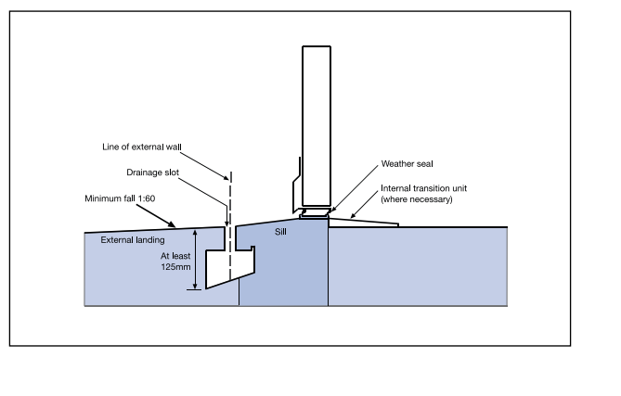 (Approved Document C, Gov.uk)

3.3 Wall & Lintel Detail

A steel lintel will be used to transfer the loadings of the intermediate floor and roof structures safely to the foundations. This detail will be required to be installed correctly to the manufacturer’s specification (Steel Lintel Products | IG Lintels – Standard & special lintels & wind posts, 2020). The steel lintel must be insulated internally and surrounding it to defend against thermal bridging with a form of cavity closer. The building regulations state ‘where the bearing length for lintels is 150mm or greater. Where a lintel has a clear span of 1200mm or less the bearing length may be reduced to 100mm.’ (Approved Document A, Gov.uk)

The wall is specified to be a dense concrete block for both skins, with a partial fill 75mm of rigid Kingspan Kooltherm K108 cavity board with a vapour control barrier internal skin (Kingspan, 2020) which achieves 0.18 W/m²K the minimum standard U-value in Wales. (Approved Document L1A, Gov.uk) The cavity will be 50mm wide with wall ties that have a tongue and groove lip that will deter moisture from travelling across that are installed between 10mm mortar joints to bond both skins together. (Approved Document A & C, Gov.uk)

3.4 Cavity Tray

As shown in Appendix G, the cavity tray will be installed above the lintel and will serve a similar purpose as the dpc which will be installed at the mortar joint above the window at a fall leaning towards the external skin of the cavity wall. It must achieve a minimum 150mm drop to the tray that will lead water to the weep hole. (Approved Document C, Gov.uk)

Diagram B
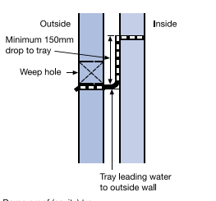
(Approved Document C, Gov.uk)

3.5 Window and Ventilation

The client has specified a double-glazed window which will achieve a u-value of 1.4 W/m²K. This will reduce the transfer of sound and thermal loss of the building as the glazing panels within the window will contain a noble gas that will act as insulation that will achieve compliance with the building regulations. (Approved Document L1A, Gov.uk)

The window will provide natural ventilation from the building to allow fresh air in while also incorporating a trickle vent system to the window that allows a constant flow of ventilation without the need of opening the window. While providing background ventilation this can improve security and safety of children by keeping windows locked that will satisfy Approved Document Q (Approved Document F, Gov.uk)

4.0 Eaves

The client has specified closed eaves as seen in Appendix I. Eaves have a role of protecting rainfall from running onto the external wall and snow by projecting away from the facade of the building with plywood or upvc to hold the gutter and downpipe. Incorporation of vapour control barrier present in the roof construction the eaves do not need ventilation meaning a closed eaves design can be used instead of open eaves. (Approved Document H, Gov.uk)

4.1 Soffit

The soffit shown in Appendix I, found underneath the eaves acts as ventilation for attic spaces. They allow background ventilation to circulate with aid of the vapour control barrier. (Approved Document F, Gov.uk)

4.2 Double lapping tiles

Illustrated in Appendix I & J are natural slate tiles as the roof covering. These tiles will be laid to have a double lap. Double lap refers to the way in which the roof tiles overlap each other twice. As slate tiles have no side interlocks it means that moisture can enter the gaps between the tiles. To allow this water to drain away safely there needs to be another tile below each joint therefore making the tiles double lapped. (Approved Document C, Gov.uk)

4.3 Heap Lap and Tile Size

Appendix I and J, showcase the roof of the dwelling will have a 40-degree pitch. The building regulation states that a roof with a 40-degree pitch needs to have a heap lap of 80mm, which refers to how much the tiles overlap each other by. The heap lap is calculated based on the type of slate chosen and its size. The product chosen was marchioness slates which are 600mm x 300mm in size.

Considering the average rainfall in Wales and the dimensions of the product 80mm heap lap was calculated to be needed from the heap lap table (Fixing tiles and slates - NHBC Standards, 2020)In order to comply with Document A of the building regulations the battens that the roof tiles sit on need to be sized appropriately for the spacing of the roof rafters. I calculated that the roof rafter for this dwelling to be placed at 600mm centres. To cover this span there needs to be battens with a width of 25mm x 25mm. (Approved Document A, Gov.uk)

5.0 Main Roof Structure

Appendix K highlights the main roof structure and the method of using a timber attic truss design was chosen in order to allow open space in the roof for the storage areas shown on the floor plans.

5.2 Warm roof

Appendix L, demonstrates the roof to be insulated between rafters with 150mm Kingspan Kooltherm K7 Roof Board with a 42.5mm insulated plasterboard that runs continuous underneath the rafter that eliminates the issue of cold bridging at the underside of the rafters that would have been exposed to achieve the minimum standard U-value of 0.13 W/m²K in Wales (Approved Document L1A).

This makes it a warm roof compared to a cold roof which only has insulation between the rafters that is not promoted in industry and requires ventilation. The benefit of a warm roof is that it's breathable which prevents dampness and mould from occurring. Warm roofs also have a vapour control barrier which sits beneath the insulation to stop any warm moist air from the interior of the house entering the insulation and condensing back into water forming condensation in the roof structure. There must be a 50mm gap between the felt and the insulation. (Approved Document, Gov.uk)

5.3 Rafter Sizing Building regulations

For the main central roof which has a total span of 7.5 metres I calculated that an appropriate rafter size for this span would be 47mm x 195mm using the C16 strength timber with each rafter placed at 600 centres. (Eurocode 5 span tables, 2009)

References

Approved Documents

Approved Document A - Structure (03/04/17)
https://gov.wales/building-regulations-approved-documents

Approved Document B - Fire safety(27/08/2015)
https://gov.wales/building-regulations-approved-documents

Approved Document C - Resistance to contaminants and moisture (03/04/2017)
https://gov.wales/building-regulations-approved-documents

Approved Document F - Ventilation (03/04/17)
https://gov.wales/building-regulations-approved-documents

Approved Document H - Drainage (03/04/17)
https://gov.wales/building-regulations-approved-documents

Approved Document K - Protection from Falling, collision and impact (3rd of April 2017)
https://gov.wales/building-regulations-approved-documents

Approved Document M - Access to and use of buildings (03/04/17)
https://gov.wales/building-regulations-approved-documents

Approved Document Q - Security (10/05/2018)
https://gov.wales/building-regulations-approved-documents

Standards

BS 8004:1986 - Code of practice for foundations

BS 5268-3:2006 - Structural Use of Timber

Sources

2009. Eurocode 5 Span Tables. 4th ed. Hughenden Valley: TRADA Technology.

IG Lintels. 2020. Steel Lintel Products | IG Lintels – Standard & Special Lintels & Wind Posts. [online] Available at: <https://iglintels.com/products/> [Accessed 28 April 2020].

NHBC. 2020. NHBC Standards 2011. [online] Available at: <http://nhbccampaigns.co.uk/landingpages/techzone/previous_versions/2011/Part6/section4/sitework.htm> [Accessed 28 April 2020].

Kingspan | Great Britain. 2020. Kooltherm K103 Floorboard. [online] Available at: <https://www.kingspan.com/gb/en-gb/products/insulation/insulation-boards/kooltherm/kooltherm-k103-floorboard?utm_source=uvalue-calculator.co.uk&utm_medium=referral&utm_campaign=uvalue%20calculator%20website> [Accessed 28 April 2020].

Kingspan | Great Britain. 2020. Kooltherm K7 Floorboard. [online] Available at: <https://www.kingspan.com/gb/en-gb/products/insulation/insulation-boards/kooltherm/kooltherm-k103-floorboard?utm_source=uvalue-calculator.co.uk&utm_medium=referral&utm_campaign=uvalue%20calculator%20website> [Accessed 28 April 2020].

Kingspan | Great Britain. 2020. Kooltherm K108 Cavity Board. [online] Available at: <https://www.kingspan.com/gb/en-gb/products/insulation/insulation-boards/kooltherm/kooltherm-k108-cavity-board?utm_source=uvalue-calculator.co.uk&utm_medium=referral&utm_campaign=uvalue%20calculator%20website> [Accessed 28 April 2020]

LABC. 2020. [online] Available at: <https://www.labc.co.uk/sites/default/files/labcpd0915_fire_detailing_guide.pdf> [Accessed 28 April 2020].

NHBC Standards 2020. 7.2.19 Fixing Tiles And Slates - NHBC Standards 2020. [online] Available at: <https://nhbc-standards.co.uk/7-roofs/7-2-pitched-roofs/7-2-19-fixing-tiles-and-slates/> [Accessed 28 April 2020].

Whale, L., 2020. [online] Available at:
<http://www.nhbc.co.uk/zmedia/filedownload,65040,en.pdf> [Accessed 28 April 2020].

Panels, C., 2020. Stacked Stone Cladding Panels | Get A Stone Wall Look. [online] Higgins Cladding. Available at: <https://www.higginscladding.co.uk/product/cusco-tan-splitface-panels-0-65m2/> [Accessed 28 April 2020].

Pim.strongtie 2020. [online] Available at: <https://pim.strongtie.eu/public/download/gb/en/product/343> [Accessed 28 April 2020].

Timloc. 2020. [online] Available at: <https://www.ribaproductselector.com/Docs/4/07504/external/COL31426.pdf> [Accessed 28 April 2020].

Appendixes

Appendix A – Substructure and Foundation Detail
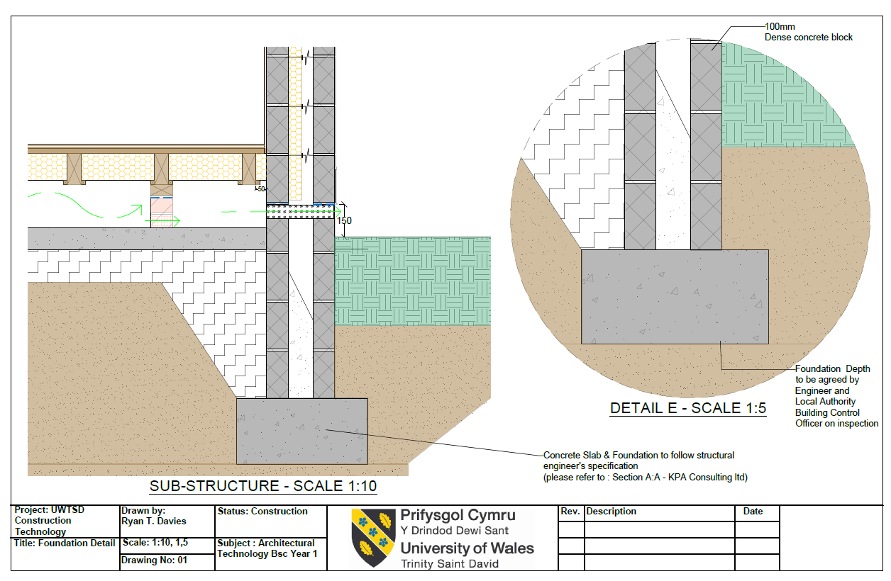

Appendix B – Ground Floor and External Cavity Wall
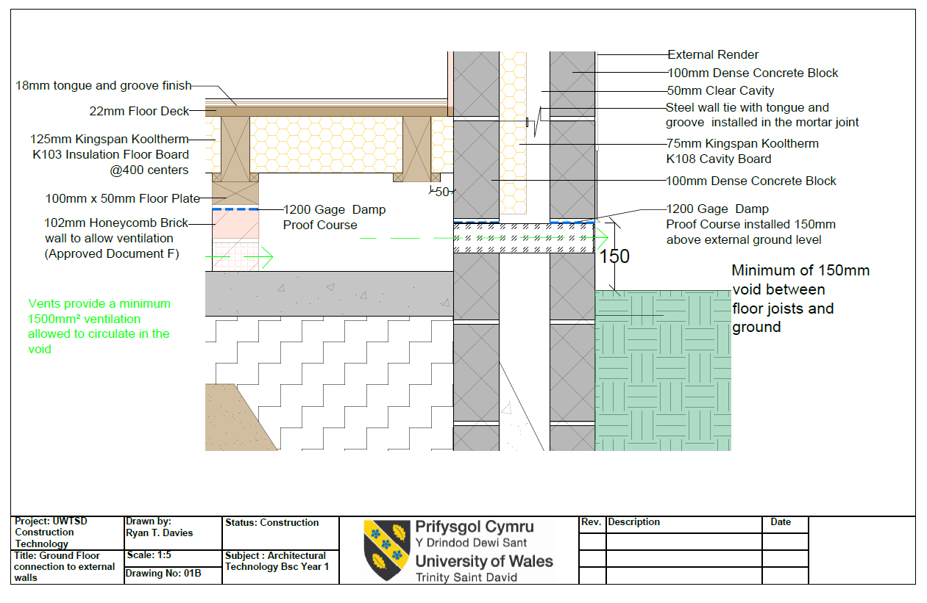

Appendix C – Suspended Timber Ground Floor Section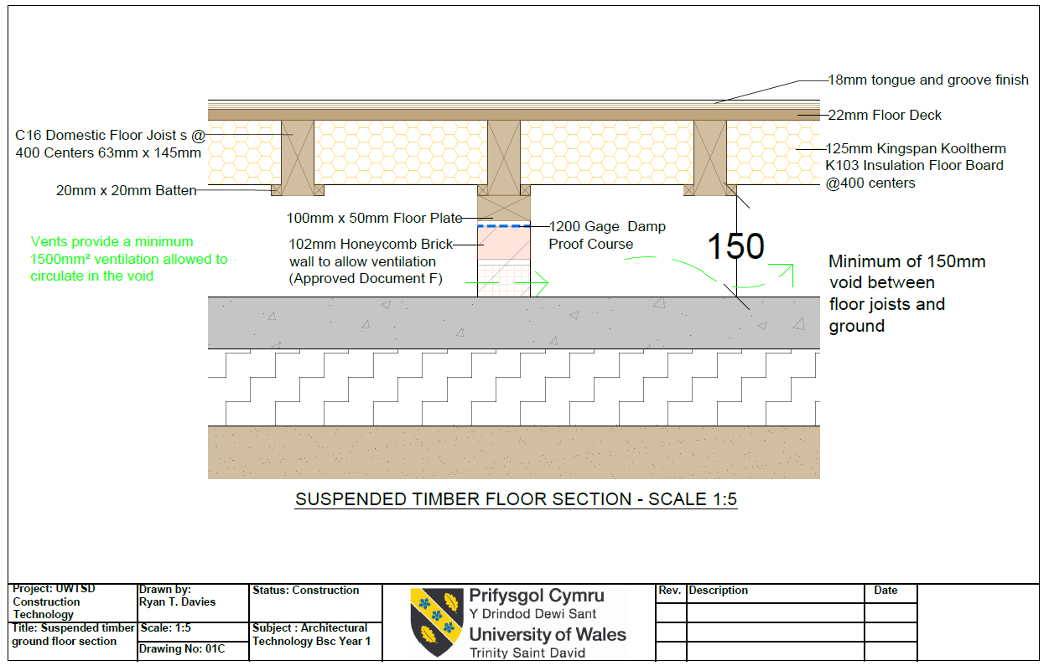

Appendix D – Suspended Timber Ground Floor Section
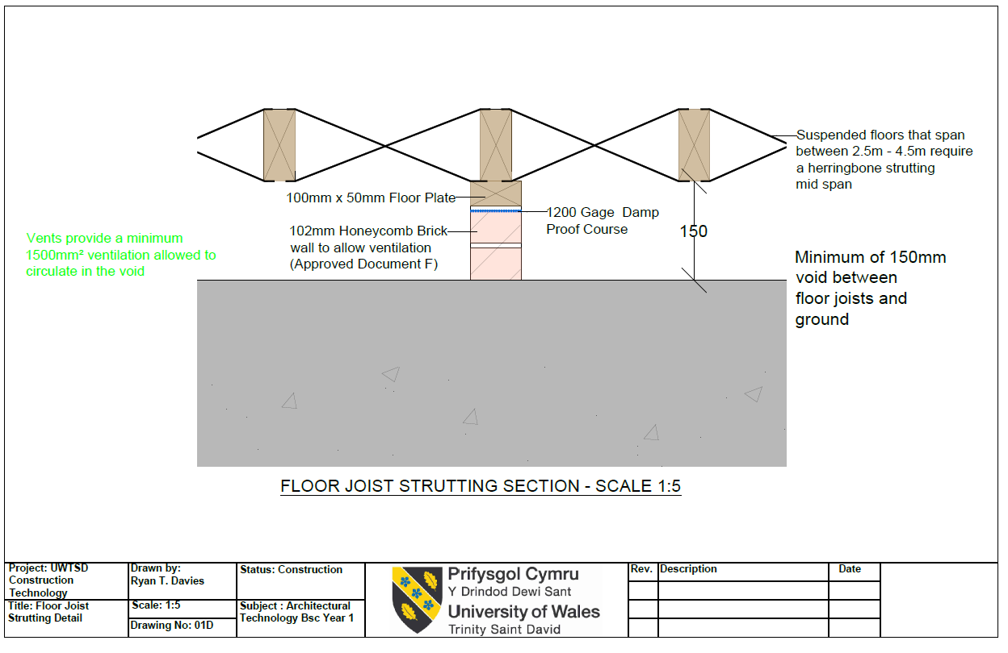

Appendix E – Honeycomb Sleeper Wall Section
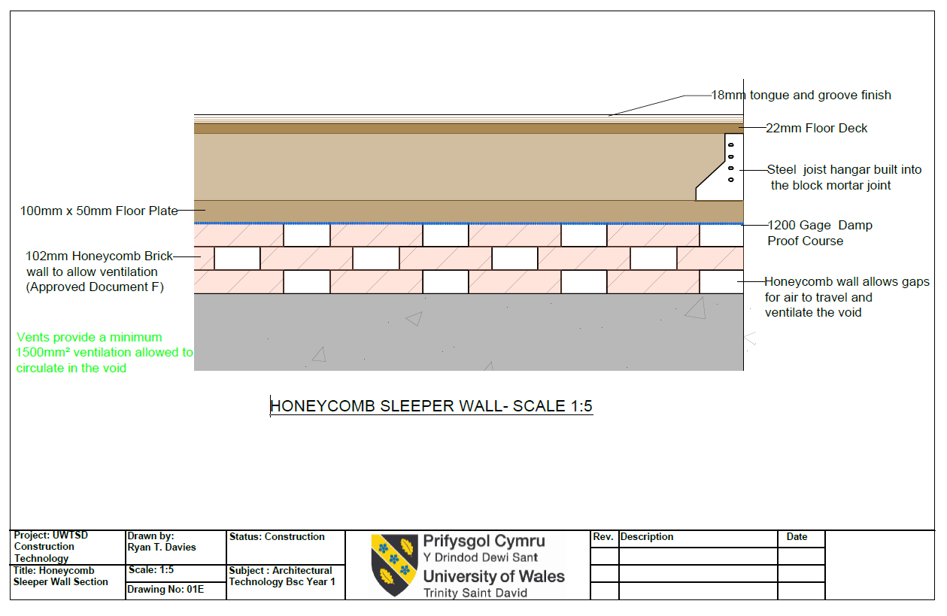

Appendix F – Wall Opening and Window Detail
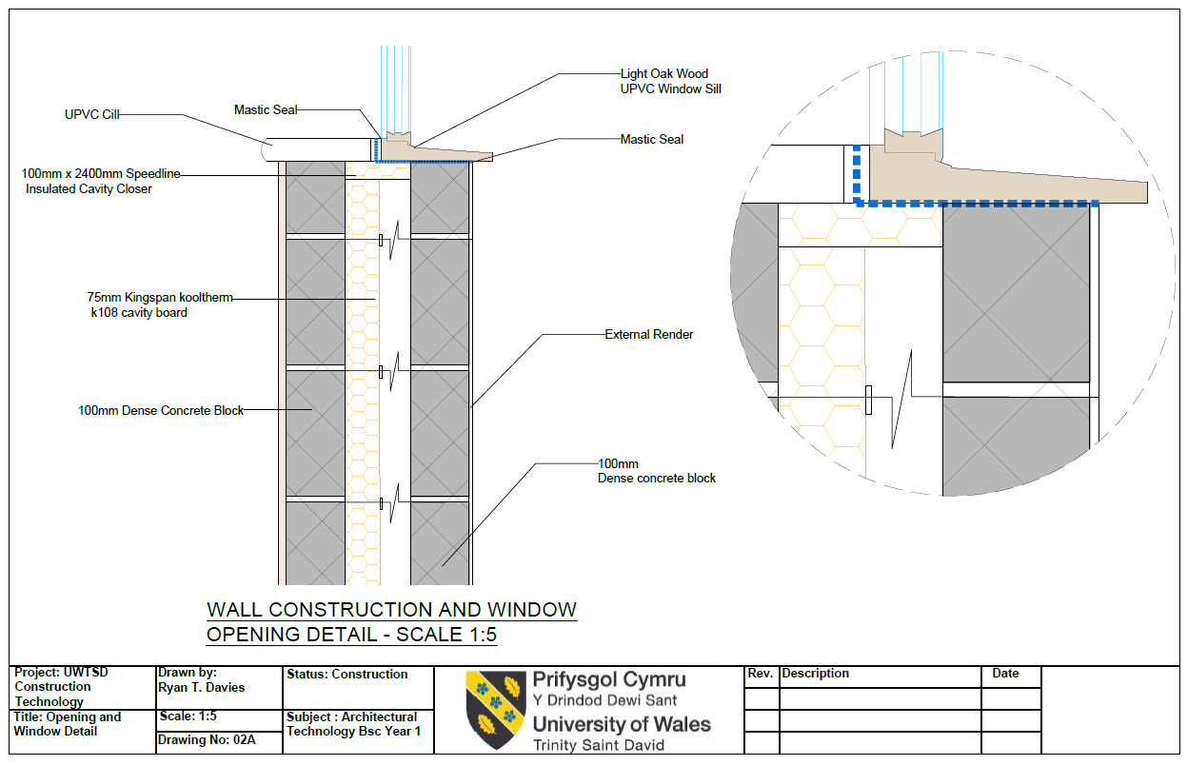

Appendix G – Lintel and Jam Detail
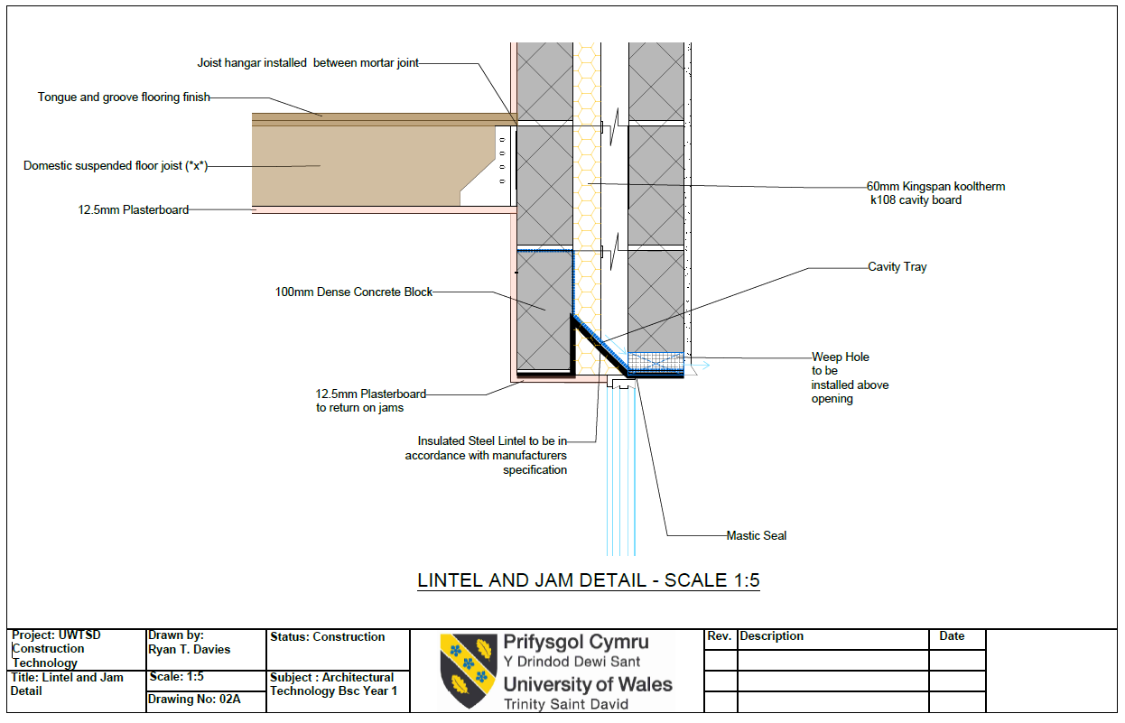

Appendix H – Intermediate Floor Detail
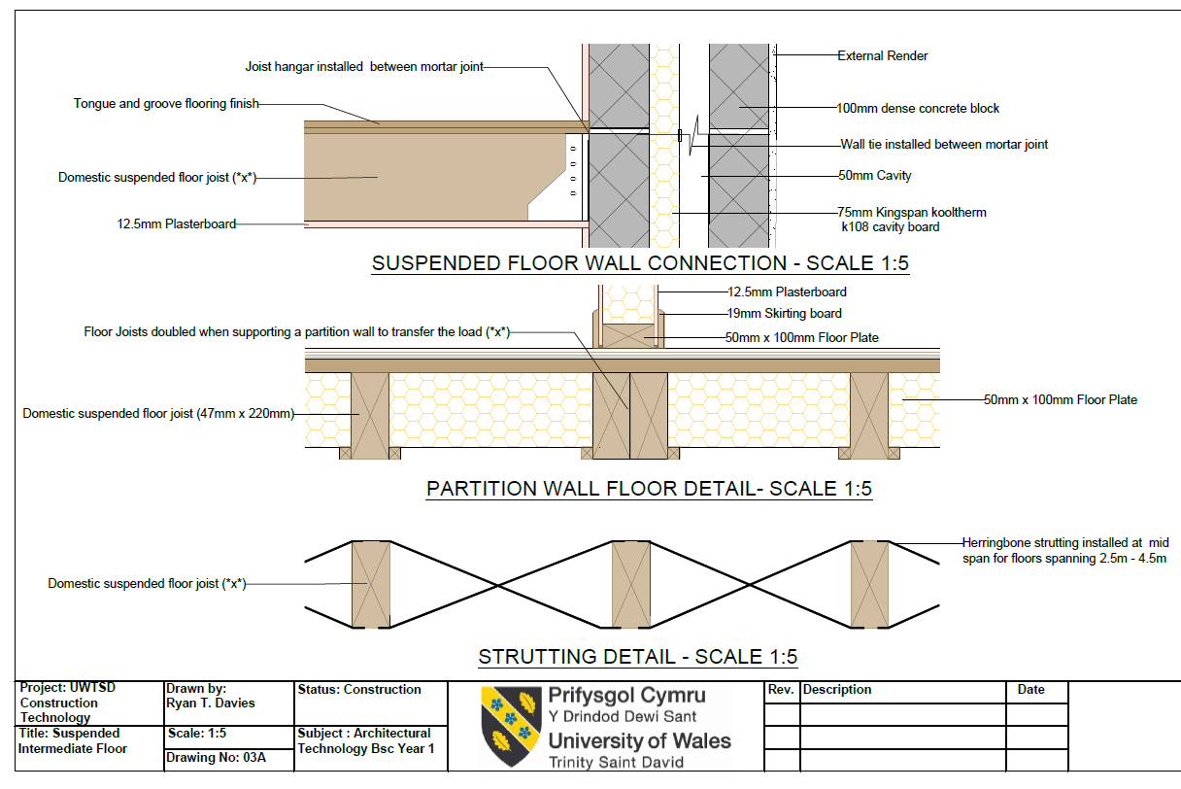

Appendix I – Roof Eaves 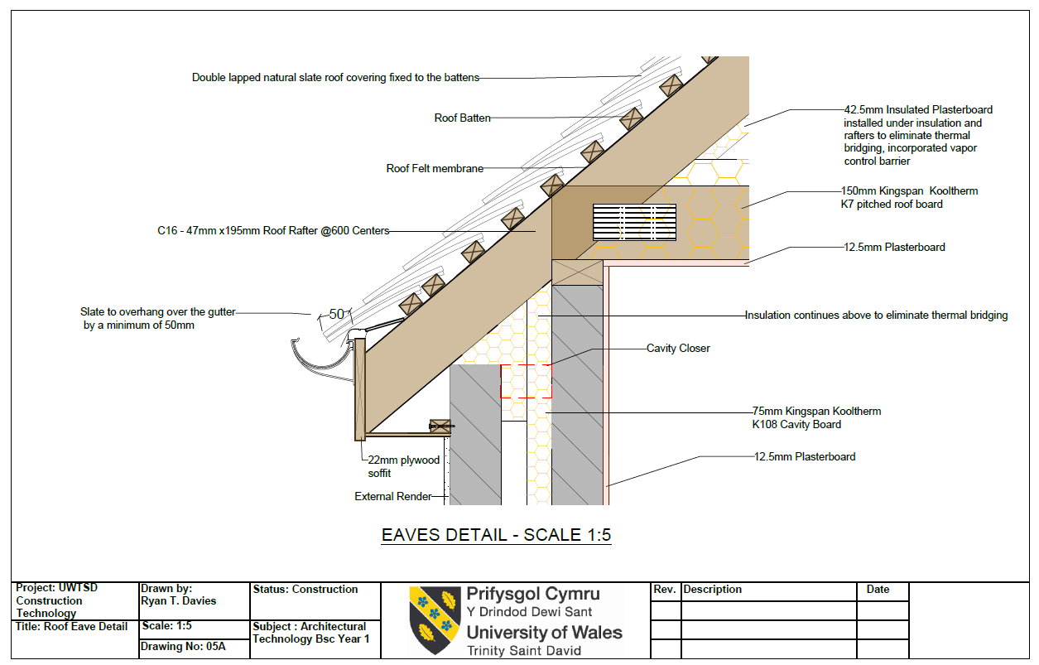

Appendix J – Ridge Covering Detail
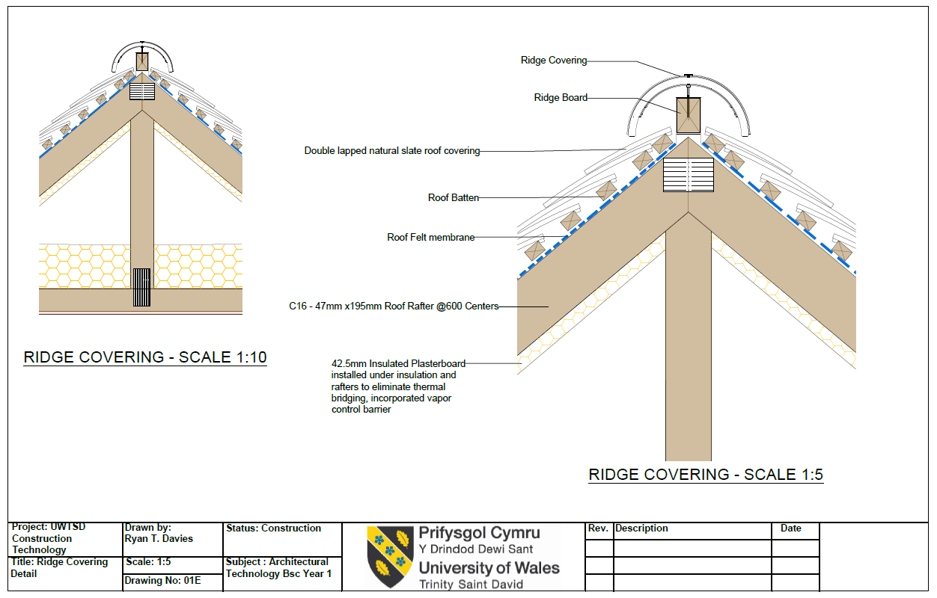

Appendix K – Attic Truss Main Roof Design
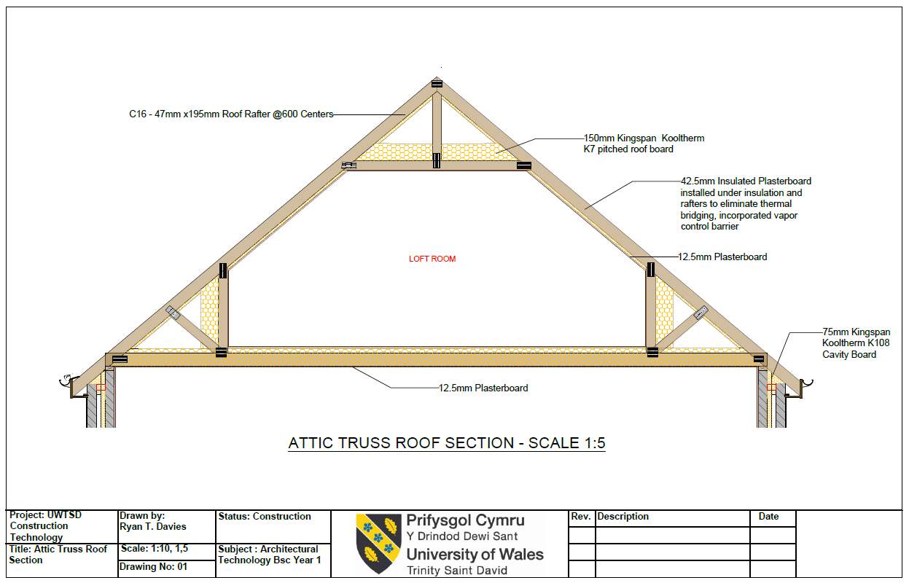

Appendix L – Roof Rafter Section


