
Etienne BOSSER
Business & Marketing
2018 - 2019

Digital Marketing Analysing
Assessment 1 - Component 2



March 15th of 2019
Supervising tutor: Julie Hayward

Content
Executive summary 3
Introduction 4
Part 1: Business context: Digital marketing issues 4
Part 2: Best competitor's channels analyse 5
A) Social medias 6
B) Google AdWords 8
Conclusion 10
Recommendations 10
References 11

Executive summary

The Picture Organic Clothing business owners asked to produce a report analysing the best practices about digital marketing. To answer as best as possible their request, this report will talk about digital marketing main practices in another market-leader company from the same sector and will advise Picture Organic Clothing to improve their digital strategy.

Introduction

Nowadays digital marketing practices are very important for every company. The Internet allows organisations to sale their products and services online, to make know their companies, to attract people around the business, to find new customers or even more to situate them in relation to the competitors. Chaffey & Ellis-Chadwick (2019. p12) said that “Over 3 billion people around the world now regularly use online services to find products, entertainment, friends and romance, and customer behaviour and the way companies’ market to both customers and businesses have changed dramatically”. Let’s see what are the main digital marketing practices used by a competitor from the Picture Organic sector.

Part 1: Business context: Digital marketing issues

First of all, here is a digital marketing definition. According to Fleming (2018), “Marketing is a customer centred approach to running an organisation. It has a number of functional responsibilities but ultimately is should be the responsibility of everyone”. In other words, marketing brings together buyers and sellers, it’s aim is to identify, anticipate, make profits and satisfy customers. To reach those objectives, companies mays find customer’s need and wants. “This definition emphasises the focus on the customer, while at the same time implying a need to link to other business operations to achieve this probability” (Chaffey & Ellis-Chadwick, 2019). The digital strategies make marketing more effective. Indeed, digital technologies influence it a lot because “they allow for individual attention, better campaign management, and better product, marketing design, and execution” (Urban, 2003). These digital technologies are an important issue which open new channels to sell product and services online. Customers are now easily able to access to a huge quantity and quality of information. They can choose between different price or value, have other customer experiences or make their own evaluation (Wind & Mahajan, 2002).
The risk by overlooking a digital marketing strategy is to lose business and miss some opportunities. It is a serious competitive advantage against a competitor to have a good market place online position. Ryan (2016. p20) said that “Without a coherent strategy of engagement and retention through digital channels your business is at best missing a golden opportunity, and at worst could be left behind, watching your competitors pull away across an ever-widening digital divide”. Implement a clear strategy will help to keep focus, ensure the business activities in a good way and targeting the right target. There are a lot of digital tools using for the marketing but the main one’s that use organisations are websites, social media, online advertising, e-mailing, partnership or even more digital posters (Thomas, 2017).

Part 2: Best competitor's channels analyse

Even if the brand is growing up very fast since 2009, Picture Organic Clothing is not the first brand on its market. Mountain and water textile are a very competitive sector and moreover, Picture is not the more powerful in digital marketing practices. Big companies as Patagonia, Burton, Quicksilver, Salomon or even more The North Face realize huge market share, realise more than 100 million dollars every year and have huge digital marketing channels (8montblanc, 2019). This graphic below (See figure1) made with Google Trends shows the research about these brands for the last 12-month, Picture Organic is almost invisible face to its competitors.
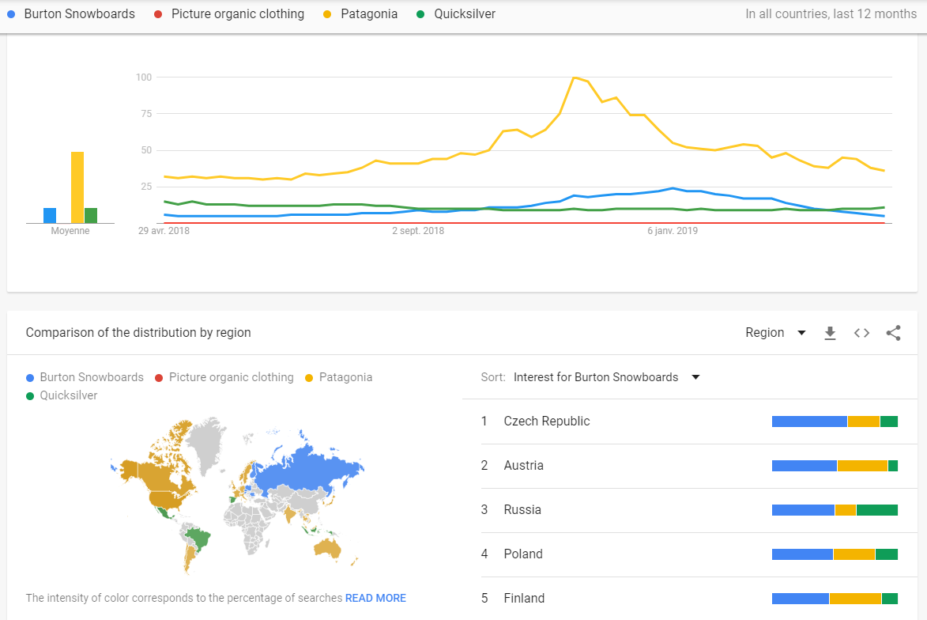
Figure 1: Google Trends (2019)
This second part will analyse the main digital practices already done by Burton, one of the bigger brands in the sportwear & snowboarding textile market. It is an American brand created in the ’70s, which is a leader on the snowboard industry and purpose high quality textile product and design. Their digital campaign cost them over $40 000 for their three seasons high months (McCloskey, 2015). The reason why it is a good comparative is that they use marketing digital channels that Picture Organic doesn’t.

Social medias
Burton is using Twitter since 2009. Today they have more than 161 thousand followers and 17 thousand tweets. They tweet to publish picture and snowboard movies every week and inform followers about the last competition and riders’ figures. It’s a way for them to promote their new textile and board trends and associate the brand to famous snowboard personalities during contests. Their tweet&reply section is very reactive, there publish several messages every day like it shows this capture (See figure2) from their profile.
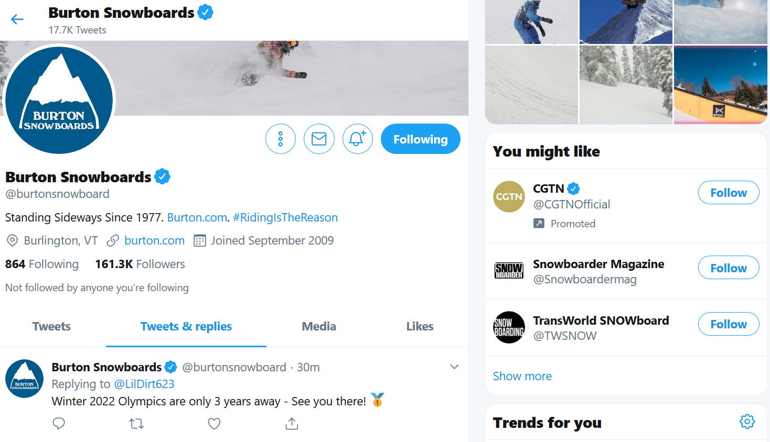
Figure 2: Burton’s Twitter (2019)

Twitter is a good way for business owners because to reach a lot of follower from different ages and every message can be seen by a lot of people in a short timelaps. Customer reactions or retweets are easily analysable, companies can then create graphics and see the comprehension rate. The problems are most of the time to make its own place between every brand from the same sector and if the users see that a company account is always looking for selling somethings it could happen to have a bad reputation. To deal with those problems, the aim is to create as entertainment content as possible (Gaille, 2016).
Burton is using another social channel which is LinkedIn. They have over 60 thousand followers and post publications every month to talk about brand activity, the products, the brand history and more interesting, job offers. LinkedIn in a good way for every company to recruitment new employees, access to different profiles and chose those which correspond the best to the brand. Burton purpose to send candidatures in order to apply for a job as it is shown in a Burton LinkedIn account capture (See figure3).
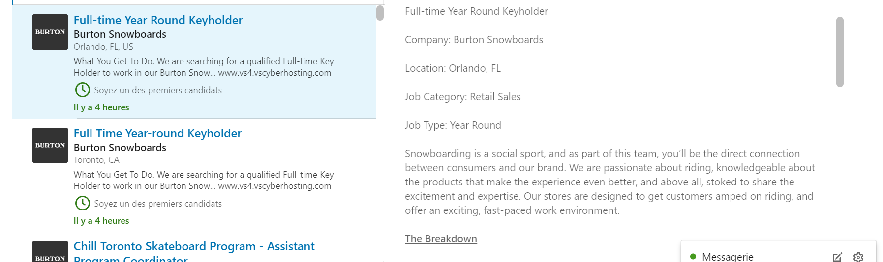
Figure 3: Burton’s LinkedIn (2019)

These candidatures allow them to find people that they could not find anywhere. Like Twitter, this tool gives the opportunity to a company to make their own professional reputation and make discover businesses opportunities. Just as Twitter again, LinkedIn is a good tool to communicate without financial cost. Inscriptions are free and the account is managed directly by the company. However, it is important to spend a lot of time there in order to be aware of the changes and what is happening (Burriss, 2016).

Google AdWords
Google AdWords is an advertising platform that works as a pay-per-click. Organisations use it to reach customers by the google search network and the google display. This channel allows every organisation to show their advertisement that will appear when a customer enters a keyword in the search bar or during a website visit as a banner (Baadsgaard, 2018). The concept is easy, companies will define a budget, dictate where they want the advertisement to appear and pay every time when a customer clicks in. This ads system helps companies to get potential customers that could never find the company on their own. To be sure that the advertisement will be seen by many people as possible, companies should have a huge budget. Big brands as Burton have this budget whereas smallest brands can't always have it (Rosso & McClelland & Jansen & Fleming, 2009).
During the high season, Burton spends $13,000 on their $40,000 budget for google AdWords campaign. They track successful keywords and advertisement in order to ensure high traffic levels on Burton’s website. Their main target is young people between 12 and 26 years hold that use new technologies as social medias. These ads allow to gain 30% more traffic on the website and social medias and win new customers (McCloskey, 2015). This capture (See figure4) from google research about a snowboard jacket shows the type of google AdWords they are using.
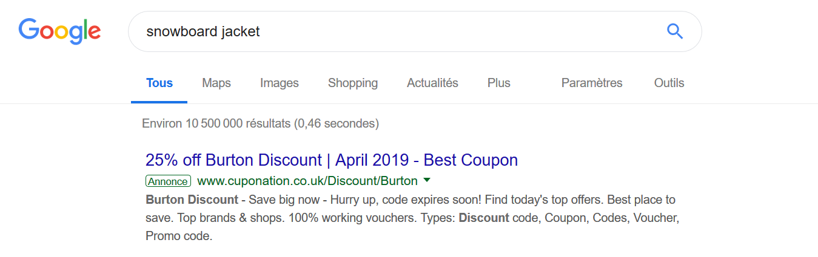
Figure 4: Burton AdWords (2019)

Conclusion

Digital marketing is an opportunity to make a company growing up very fast, especially today thanks to the digital technology evolution. Website, emails or social medias must be taking into consideration for every marketing campaign. It is easy for brands to collect information about customers, market or competitors, analyse it and finally, thanks to their conclusion, orientate a digital marketing strategy.

Recommendations

Picture Organic Closing is a young brand that has a huge potential on the market thanks to its sustainable environment product orientation. Their digital marketing strategy is well working with their emailing campaign, their website or even more their social medias channels such as Facebook, YouTube, Instagram, and Snapshat. What they should do to improve their visibility and reach other potential customers in to create a Twitter account to publish their activity, follow other pages from the same sector or pay attention to the mountain and sea sport activity. Moreover, a LinkedIn account should have the same results and could allow the brand to recruit new profiles. To finish, Picture should define a big budget for their google AdWords campaign in order to advertise over a larger area.

References

Brandon Gaille (2016) 22 Pros and Cons of Twitter for Business, Brandongaille small business & marketing advise. Available at:
https://brandongaille.com/22-pros-and-cons-of-twitter-for-business/

Burton Snowboard (2019) [LinkedIn]. Available at:
https://www.linkedin.com/company/burton-snowboards/

Burton Snowboarding (2019) [Twitter], Available at:
https://twitter.com/burtonsnowboard

Chaffey, D., & Ellis-Chadwick, F. (2019). Digital marketing. Pearson UK. Available at: https://books.google.fr/books?hl=fr&lr=&id=-1yGDwAAQBAJ&oi=fnd&pg=PT20&dq=digital+marketing&ots=XhUq3QjM57&sig=kpz33QUgL1WJKlIgMtXonVaYfwo#v=onepage&q&f=false

Fleming, W. (2018) Lesson 1, Introduction to marketing, Marketing Information System module, Swansea business school UWTSD

Geddes, B. (2014). Advanced Google AdWords. John Wiley & Sons. Available at: https://books.google.fr/books?hl=fr&lr=&id=1QKCAwAAQBAJ&oi=fnd&pg=PA259&dq=google+adwords&ots=Ecd8wTM6eh&sig=ceWWk-d-HBpp_LSYBio2POfSAIY#v=onepage&q=google%20adwords&f=false

Jacob Baadsgaard (2018) What is Google AdWords and Why Do I Need It? Disruptive advertising. Available at:
https://www.disruptiveadvertising.com/adwords/what-is-google-adwords/

Larry, J. K. (2014) The Early History of Burton Snowboards. Available at: https://www.youtube.com/watch?v=y__FY92a78U

Maire Yohan (2017) Picture Organic Clothing: A mix of marketing and the environment, Faculté des sciences du sport Strasbourg. Available at:
https://licence-pro-commerce-sport.jimdo.com/2017/02/23/picture-organic-clothing-un-m%C3%A9lange-entre-marketing-et-environnement/

Picture Organic (2019) Official website. Available at:
https://www.picture-organic-clothing.com

Rachel McCloskey (2015) [Linkedin], Mccloskey Burton Marketing Strategy. Available at:
https://fr.slideshare.net/mcclos23/mccloskey-burton-marketing-strategy

Rayan Gellert (2016) Picture Organic Clothing, the brand that drives the snow sports market, L’express l’entreprise. Available at:
https://lentreprise.lexpress.fr/creation-entreprise/idees-business/picture-organic-clothing-la-marque-qui-agite-le-marche-des-sports-de-glisse_1762708.html

Ryan, D. (2016). Understanding digital marketing: marketing strategies for engaging the digital generation. Kogan Page Publishers. Available at: https://books.google.fr/books?hl=fr&lr=&id=4pZlDQAAQBAJ&oi=fnd&pg=PR5&dq=digital+marketing+&ots=Pa4ZnB2S5n&sig=lv2n73EKLn_qNx54dMY6gczGkhU#v=onepage&q=digital%20marketing&f=false

Rosso, M. A., McClelland, M. K., Jansen, B. J. J., & Fleming, S. W. (2009). Using Google AdWords in the MBA MIS course. Journal of Information Systems Education, 20(1). Available at: https://pdfs.semanticscholar.org/8726/3b4280b1235de03c6c498227e831ce79e2b0.pdf

Teddy Burriss (2016) What's the advantage and disadvantage of LinkedIn? Quora. Available at:
https://www.quora.com/Whats-the-advantage-and-disadvantage-of-LinkedIn

Thomas, C. (2017) Lecture 1, Introduction and key terms, Digital Marketing module, Swansea business school UWTSD

Urban, G. (2003). Digital marketing strategy: text and cases. Prentice-Hall, Inc. Available at: https://dl.acm.org/citation.cfm?id=861615

Wind, Y. J., & Mahajan, V. (2002). Digital marketing: global strategies from the world's leading experts. John Wiley & Sons. Available at:
https://books.google.fr/books?hl=fr&lr=&id=Esrc5ZfQj3wC&oi=fnd&pg=PR9&dq=digital+marketing&ots=gbbJJHAd-l&sig=RWDcSLJcLK0qlgH5Yx6z0_iVgaQ#v=onepage&q=digital%20marketing&f=false

8montblanc Officiel (2019) Picture Organic Clothing, les 10 ans. Available at:
https://www.youtube.com/watch?v=dV5wM6yhnY8

