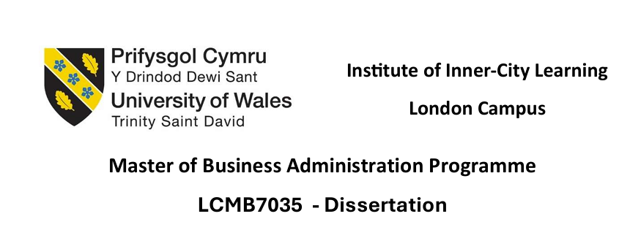

Student Name: - deepesh rankawat
Student ID: - 2420014
Supervisor: - Dladius Kulothungan
Word count: - 2478
Submission date: - 7' November 2025

topic:
Strategic Leadership and Organisational Change: Balancing Stability and Innovation in the Post-COVID Era

Table of Contents
Introduction 2
Literature Review 2
Methodology 4
Introduction to Research Methodology 4
Research Philosophy 4
Research Design 4
Sources of Data and Inclusion Criteria 5
Data Analysis Technique 6
Ethical Considerations 6
Rationalization of the Methodology 7
Expected Findings 7
Limitations 8
Reliance on Secondary Data 8
Diversity in Industry and Region 9
Data Accessibility and Likely Bias 9
Timeframe 10
Conclusion 10
References 12

Introduction
The COVID-19 pandemic had a considerable impact on the global business context, making organisations adjust very quickly without losing the balance in their operations (Gukasyan et al., 2022). The strategic leadership proved to be an important element of handling these competing demands. During the post-pandemic phase, leaders have a dual task in the form of encouraging innovation to stay afloat and at the same time maintaining organisational stability in an unpredictable environment. This study explains the role of strategic leadership in creating a balance between stability and innovation in the post-COVID organisational change era.
Research Aim
The paper will discuss the leadership practices that promote organisational flexibility and stability. It will address the question:
How do strategic leaders balance stability and innovation to drive organisational change in the post-COVID era?
Research Objectives
- To examine the strategic leadership practices that promote organisational adaptability and resilience in the post-pandemic environment.
- To identify the key factors influencing leaders’ ability to balance innovation and stability during organisational transformation.
- To evaluate how digital transformation and employee engagement contribute to successful post-COVID strategic change.
- To derive lessons and best practices from existing organisational case studies for guiding future crisis leadership and change management.

Literature Review
The COVID-19 pandemic reshaped the organisation operational practices and forced leaders to implement new strategies that support flexibility, digital transformation and employee involvement. The 21st-century strategic leadership has therefore moved beyond being command-and-control based towards one that focuses on the adaptability, resilience and innovation.
According to Ngoc et al. (2025) on e-leadership and adaptive performance in the emerging economies states that remote and hybrid working conditions mean that leaders must integrate digital competence with emotional intelligence to ensure they keep employees engaged and innovative. According to their research, the success of leadership in the post-COVID environment is largely determined by the use of communication technologies and cooperation in the virtual world, which is consistent with the general notion of strategic agility. Equally, according to Palmucci, Giovando, and Vincurova (2025), digital leadership plays a major role in boosting organisational performance and employee motivation when it fits with the shared vision. Their results support the fact that technology-based leadership enables innovation as well as organisational stability.
Since the problem that was discussed by Wankhede and Sharma (2025) is the difficulty of restoring the office culture after the COVID-19, it is possible to argue that leaders should focus on stability by reinforcing organisational values and innovation through flexible work arrangements and inclusive decision-making. This balance is indicative to the principle of ambidexterity in strategic management in which leaders maintain continuity and at the same time embrace change. Under the SME context, according to Wided (2024), information technology was identified by the author as the key driver of strategic flexibility and resilience, and this enabled small firms to pick up and respond more quickly after the pandemic.
Altogether, these research papers demonstrate that strategic leadership is currently in need of the combination of digital tools, flexible thinking, and people-oriented management. Though, the majority of the current studies are on digital qualities and motivation of employees, they do not provide information on how leaders maintain a balance between innovation and stability in various organisational contexts. The aim of the research is to fill this gap through synthesising secondary qualitative evidence to determine the leadership practices that will assist in long-term organisational transformation during the post-COVID era.

Methodology

Introduction to Research Methodology
The chapter of methodology explains in detail the research design, philosophical standpoint, data collection procedures and the methods of analysis that were embraced in the study. This part makes the research process systematic, transparent and replicable, thus showing academic rigour and credibility. The research design is a qualitative study based on secondary data since the study is aimed at comprehending how strategic leaders achieve balance between innovation and stability in a post-COVID setting. It is an agreeable design that complies with the interpretivist research philosophy that focuses on viewing social phenomena through various lenses, as opposed to numerical generalisations (Cheong et al., 2023).
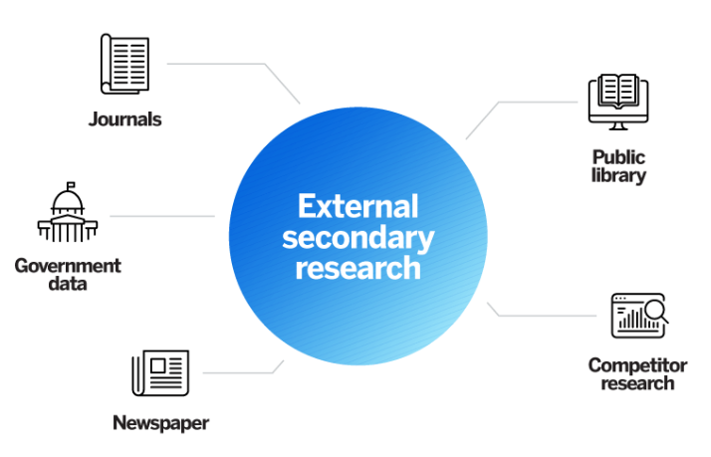
Figure 1 Qualitative Secondary Research
Source- Self-Created

Research Philosophy
The philosophical paradigm of the present study is based on the interpretivist paradigm that presupposes the socially constructed and subjective rather than objective and fixed reality (Pervin and Mokhtar, 2022). The approach that will be suitable in this study is interpretivism, since leadership and organisational change are human interpretative processes, individual and environmentally conditioned. The interpretivist approach will enable the researcher to understand how strategic leaders view and cope with the two-fold problem of innovation and stability in different organisational situations.
In contrast to positivism, which attempts to find measurable and objective facts, interpretivism appreciates gaining a better insight into the underlying meanings of leadership actions, decisions and strategies. In this way, an increased understanding of the dynamics of leadership in post-pandemic settings can be explored in a more profound and detailed way. The interpretivist position assists the validity of the research intent which is to analyse the leadership practices using qualitative studies instead of statistical inference.

Research Design
The type of research design is a qualitative secondary research design, where one gathers and examines the available information in order to come up with new information (Cheong et al., 2023). This design is also effective when direct access to the participants is low or when the research involves the need to incorporate a large array of documented evidence.
A qualitative study allows the researcher to generalize on the leadership patterns and behaviours within the real context of the situation through the study of the existing studies, reports, and cases. This method is defensible because it enables one to understand more about such complex organisational phenomena as strategic leadership and change management. Secondary qualitative research is also more efficient because it takes advantage of high-quality existing data, both academic and professional, to minimize the logistical and ethical problems in the context of primary research.

Sources of Data and Inclusion Criteria
The research will be based on secondary data source which is credible and reputable (Morgan, 2024). These include:
- Peer reviewed academic journals in the field of leadership, innovation and organisational change.
- Report of industry and consultancy by McKinsey and Company, Deloitte, PwC etc. global organisations.
- Business case reports that exemplify leadership practices in times of the COVID-19 pandemic and after it.
- Respected business magazines, such as Harvard Business Review, Forbes and The Economist.
The inclusion criteria for data selection are as follows:
- Publications of not older than 2020 to 2025 to guarantee the topicality and timeliness of data.
- Sources that specifically mention leadership responses, management of innovation or change during or after COVID-19 (Morgan, 2024).
- Research that provides qualitative information, theoretical framework, or ideas of leadership adaptation.
Such a systematic inclusion will guarantee the relevance and completeness of the dataset. All the data will be considered in terms of credibility, the expertise of the authors, quality of publication, and applicability to context.

Data Analysis Technique
The method of analysis of secondary qualitative data used in the study is the thematic analysis. Thematic analysis is a powerful method of finding, analysing, and determining recurrent patterns and themes in qualitative data sets. It helps the researcher to reduce the complexity of qualitative data to logical conclusions that support the research goals (Sandhiya and Bhuvaneswari, 2024).
The procedure will be analyzed according to the six steps suggested by Braun and Clarke:
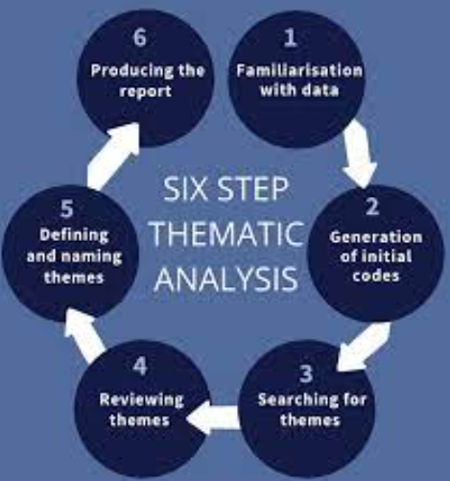
Figure 2 Six Steps Suggested by Braun and Clarke
Source- Self-Created
- Familiarisation with the data- reading and perusing through the chosen materials several times so as to have a comprehensive grasp of the material.
- Code generation- first the creation of data segmentation of the essential data pertinent to strategic leadership, innovation, resilience, and adaptability (Yardley, 2024).
- Search: Finding themes code is divided into broader themes, including adaptive leadership, strategic resilience, digital transformation, and innovation culture.
- Reviewing themes - streamlining the themes to reflect coherence and consistency of sources of data.
- Naming and defining themes - determining the final list of themes that demonstrate major findings.
- Producing the report - compilation of the themes into analytic narratives that are connected to the research purposes.

Ethical Considerations
Even though this study does not entail human subjects, ethical integrity is at the core of this study (Sadeghi and Smith, 2024). To meet the academic ethics of the study, the researcher will adhere to the following aspects:
- Appropriate attribution and referencing: UWTSD Harvard referencing system will be used to acknowledge all secondary materials.
- Credible use of data: Only the publicly accessible or referenced sources will be considered or used in a proper way to respect the intellectual property rights.
- Transparency in interpretation: The researcher will not engage in selective reporting, and it will be offered in an objective manner without manipulation and misrepresentation.
The study has very little risk in terms of its ethics as it uses only existing information. No concerns regarding informed consent, privacy and confidentiality. However, the researcher will not violate academic honesty and accuracy to the end of the study.

Justification for the Methodology
The methodology adopted is well-grounded as it is suitable to the objectives and limitations of the study. The qualitative, and secondary data approach allows one to gain a wide, multi-faceted insight into strategic leadership practice in various industries and locations. It especially helps to elicit leadership concepts in the post-COVID situation, where the availability of global leadership information via primary means can be limited.
Besides, secondary qualitative research enhances the integration of the various results into a single conceptual meaning of leadership adaptation and innovation. It erases time and resource constraints in large scale fieldwork and yet it is academically rich. Such a methodological approach therefore provides efficiency and rich analytical value and is well suited to the objective of the study which is to examine how leaders can maintain stability and at the same time innovate in the dynamic business environment.

Expected Findings
It is assumed that the study will demonstrate that adaptive capacity, digital transformation, and employee empowerment as an integrated approach are the main features of achievable strategic leadership in the post-COVID period (Palmucci, Giovando and Vincurova, 2025). Leaders that foster open interactions and promote learning-based cultures coupled with being flexible are probably to balance the tension between organisational stability and innovation better.
It is expected that the results will indicate the value of hybrid leadership practices that sustain business continuity by way of organised systems and policies and at the same time promote creativity and experimentation by decentralising decision-making processes and digital collaboration environments. This two-fold strategy helps organisations to be resilient in the uncertain environments to maintain constant innovation.
Moreover, the study anticipates a great relationship between the transformational and participative leadership and favorable change outcomes (Goens and Giannotti, 2024). By defining a definite vision and inspiring teams, transformational leaders will most likely improve flexibility, but by empowering the employees and encouraging shared responsibility, participative leaders will create innovation and involvement.
Comprehensively, the expected findings will highlight that strategic leaders with the ability to blend technological flexibility and humanised leadership behaviours are in a better position to experience a long-term performance and resilience in the post-pandemic business environment.

Limitations
All research projects are prone to limitations, which can affect the interpretation, scope and generalisability of the findings. Acknowledging such limitations is a sign of academic integrity and is a source of transparency in the methodological design of the study. The major limitations that were identified during this study are presented below.

Reliance on Secondary Data
The main weakness of the research is that it used secondary sources of data. Although secondary research is effective, and it provides access to the broad scope of the existing knowledge, it denies the ability of understanding the context in depth that can be achieved in the primary data collection procedures, including surveys or interviews (Cheong et al., 2023). This dependency limits access to first-hand information about the experiences of strategic leaders that they go through throughout and even after the COVID-19 pandemic. The researcher also has little control over the quality of the information, its reliability, and scope in its context because it solely relies on the quality and methodology of the original studies. Though the triangulation by various credible sources is aimed at increasing the validity, the lack of specific data makes it challenging to elaborate on the specific leadership views in particular organisational environments.

Diversity in Industry and Region
The other limitation is due to inclusion of data collected in various industries and geographical places (Fraske, 2022). The leadership practices and organisational dynamics are diverse depending on the sectors, cultures and economic environments. As a result, the diversity can present inconsistency which constrains the generalisation of results in various organisational settings. An example would be that, leadership practices that are successful in multinational corporations cannot be completely applicable in small or medium sized businesses in developing economies. However, the aspect of variety of cases offers comparative information which improves the general picture on strategic leadership behaviours.

Data Accessibility and Likely Bias
Another challenge is the availability and the quality of data that will be generated after 2020 (Whang et al., 2023). There has been disproportional reporting and lack of documentation especially in small organisations in the post-pandemic period. Such an imbalance can lead to a bias towards bigger established corporations with better-documented leadership practices that have been more widely studied. To contribute to this problem, the researcher will use data triangulation, which is the cross-checking of information on various and credible academic and professional sources, to guarantee balanced representation and reduce bias. Irrespective of these limitations, the study has been useful in generalising the world leadership practices and making significant contributions to the association between strategic leadership, innovation, and stability in the post-COVID period.

Timeframe
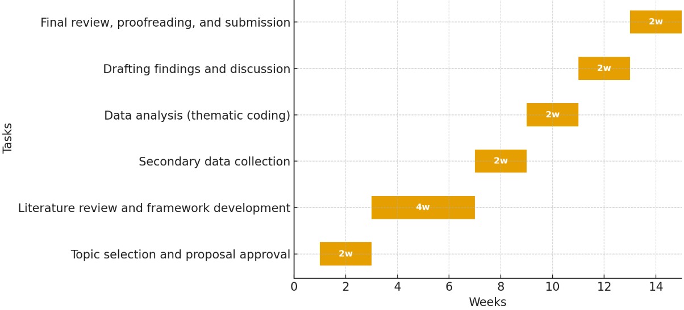
Figure 3 Dissertation Proposal Timeline
Source- Self-Created

Conclusion
This dissertation proposal presents a qualitative, secondary-data research that addresses the following research question: how strategic leadership strikes a balance between innovation and stability when organisations change in the post-COVID period? The study will make a contribution to theory and practice by advancing the knowledge on the effectiveness of adaptive and ambidextrous leadership in promoting organisational resilience and continued innovation. Through an examination of the modern leadership case studies and a combination of data on reputable academic literature and the business sector, the research will determine the tactics that allow leaders to operate in the sphere of uncertainty without compromising the overall stability of their operations.
It is hoped that the findings will be used to contribute to the existing theoretical understandings of strategic and transformational leadership, as well as to offer practical advice to the existing and new leaders. The ultimate aim of the study is to establish that successful strategic leadership in the post-pandemic environment must be balanced between human-centre values, the technological flexibility, and future-oriented decision-making to guarantee success in the business in the ever-changing global environment through the organisation.

References
Cheong, H., Lyons, A., Houghton, R. and Majumdar, A. (2023) Secondary Qualitative Research Methodology Using Online Data within the Context of Social Sciences. International Journal of Qualitative Methods, 22(1), pp.1–19.
Cheong, H., Lyons, A., Houghton, R. and Majumdar, A. (2023). Secondary Qualitative Research Methodology Using Online Data within the Context of Social Sciences. International Journal of Qualitative Methods, 22(1), pp.1–19.
Fraske, T. (2022). Industry 4.0 and its geographies: A systematic literature review and the identification of new research avenues. Digital Geography and Society, 3, p.100031. doi:https://doi.org/10.1016/j.diggeo.2022.100031.
Goens, B. and Giannotti, N. (2024). Transformational Leadership and Nursing Retention: An Integrative Review. Nursing research and practice, [online] 2024(1). doi:https://doi.org/10.1155/2024/3179141.
Gukasyan, Z.O., Tavbulatova, Z.K., Aksenova, Z.A., Gasanova, N.M. and Karpunina, E.K. (2022) Strategies for Adapting Companies to the Turbulence Caused by the COVID-19 Pandemic. Business 4.0 as a Subject of the Digital Economy, pp.639–645. doi:https://doi.org/10.1007/978-3-030-90324-4_102.
Morgan, H. (2024). Using Triangulation and Crystallization to Make Qualitative Studies Trustworthy and Rigorous. The Qualitative Report, [online] 29(7), pp.1844–1856. doi:https://doi.org/10.46743/2160-3715/2024.6071.
Ngoc, P., Ngoc, T., Duong, C.H., Giang, T.T., Linh, Y. and Nguyen, H.H. (2025) New ways of working dynamics post-COVID-19: E-leadership and adaptive performance in an emerging economy. European Journal of Innovation Management. doi:https://doi.org/10.1108/ejim-02-2025-0136.
Palmucci, D.N., Giovando, G. and Vincurova, Z. (2025) The post-Covid era: digital leadership, organizational performance and employee motivation. Management Decision. doi:https://doi.org/10.1108/md-04-2024-0865.
Pervin, N. and Mokhtar, M. (2022). The interpretivist research paradigm: a subjective notion of a social context. International Journal of Academic Research in Progressive Education and Development, 11(2), pp.419–428. doi:https://doi.org/10.6007/IJARPED/v11-i2/12938.
Sadeghi, N. and Smith, T. (2024). Ethics in qualitative research. [online] www.elgaronline.com. Available at: https://www.elgaronline.com/edcollchap/book/9781803927008/chapter8.xml.
Sandhiya, V. and Bhuvaneswari, M. (2024) Qualitative Research Analysis. Advances in library and information science (ALIS) book series, [online] pp.295–316. doi:https://doi.org/10.4018/979-8-3693-1135-6.ch014.
Wankhede, M. and Sharma, K. (2025) Leadership Challenges to Re-establish Office Culture Post-COVID-19. Contributions to Conflict Management, Peace Economics and Development, pp.55–68. doi:https://doi.org/10.1108/s1572-832320240000034016.
Whang, S.E., Roh, Y., Song, H. and Lee, J.-G. (2023). Data Collection and Quality Challenges in Deep Learning: A Data-centric AI Perspective. The VLDB Journal, 32(4), pp.791–813.
Wided, R. (2024) The Role of Information Technology in Strengthening Strategic Flexibility and Organisational Resilience of Small Medium Enterprises Post COVID-19. Journal of Information & Knowledge Management/Journal of information & knowledge management. doi:https://doi.org/10.1142/s0219649224500011.
Yardley, E. (2024). Braun and Clarke Thematic Analysis - How to Do the six-step Process in Your Qualitative Research Project. [online] Degree Doctor. Available at: https://www.thedegreedoctor.com/blog/braun-and-clarke-thematic-analysis-how-to-do-the-six-step-process-in-your-qualitative-research-project.

