

University Name | University of Wales Trinity Saint David (London)
Module Name | Cloud Computing Architecture
Programme | BSc Cloud Computing
Module code: | ACCA5025
Lecturer: | Koushik Modak
Student ID | 2113442
Word Count | 2500
Assessment | 2

Contents
Introduction 3
1. Explain the resources associate with a VM. 4
VM 4
Basic 4
Disks 5
Networking 5
Management 5
Monitoring 5
Advanced 5
Tags 5
Review and create 5
Network Security Group 6
Inbound Traffic 6
Outbound Traffic 7
Intra-subnet Traffic 7
Vnets 7
2. Demonstrate the use of images and explain their use in Azure. 9
3. Additional Exercise. 10
Conclusion 13
Bibliography 14

Introduction

Through this assignment, very basic concepts in Cloud Computing will be explained, such as: Virtual Machine, how they work and their different properties when configuring them, Security Network Groups, what they are, what their creation implies and that a series of resources are operating in it, the concept of Virtual Network will also be addressed, what it means and how it works; as well as what and how ISO image files work on the Microsoft Azure platform.

Explain the resources associate with a VM.

VM
One of the many on-demand, scalable computing resource types that Azure provides are virtual machines. A virtual machine is typically the best option when you want greater control over the computing environment than what the other options have to offer [1].
An administrator may benefit from virtualization's flexibility with an Azure virtual machine without having to invest in and maintain the necessary real hardware. But you still need to take care of things like installing, configuring, and patching the software that runs on the virtual machine.
In Azure portal can be created as many VMs as you need and all of them use these common configurations:
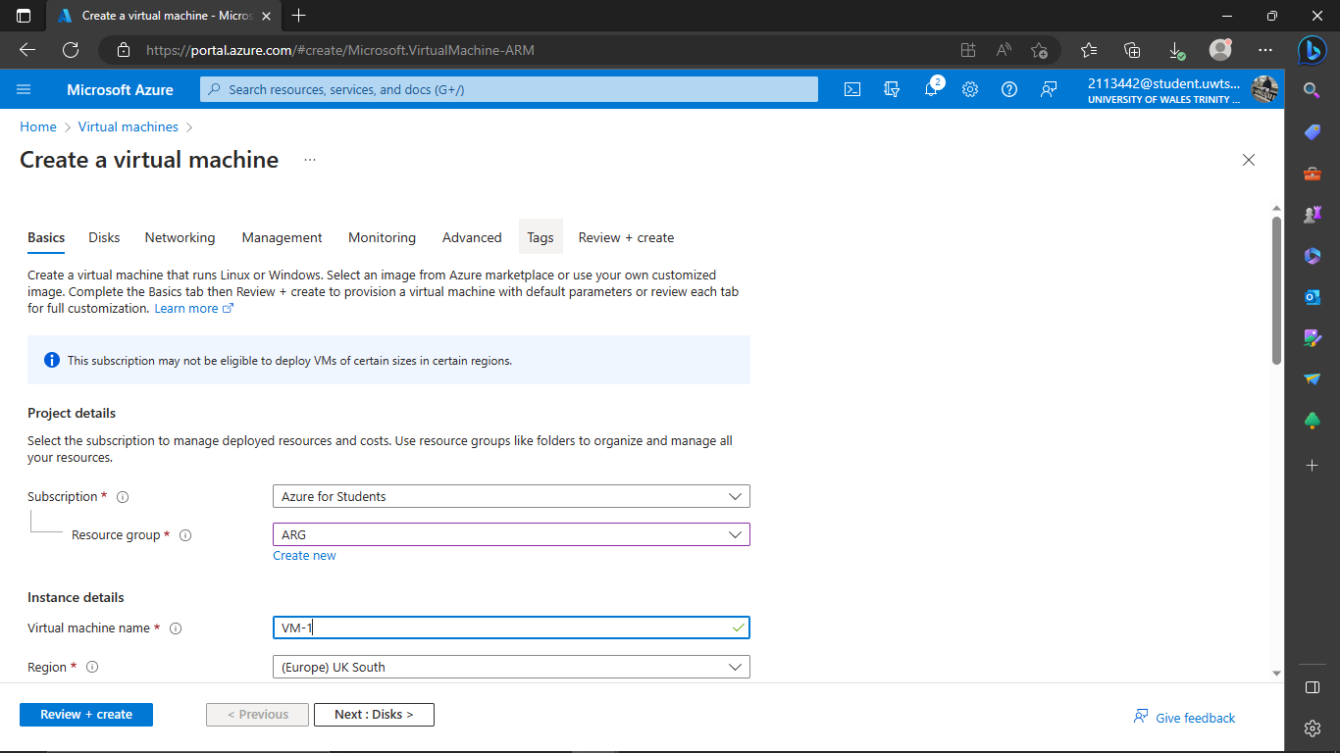

Figure 1. Creating a new VM - Basics

When creating a virtual machine, it is necessary to establish a series of configurations, which are divided into various categories, including Basic, Disks, Networking, Management, Monitoring, Advanced, Tags, Review + create. Let's start with the first of all:

Basic
This is where the most basic and main configurations that the virtual machine will have been established, such as name, which resource group it will belong to, what type of software will be installed on it, region, etc.
- Subscription: establishes the type of subscription with which we use Azure, in this case, it is the student version, also called: "Azure for Students".
- Resource Group: this option is to choose in which resource group the virtual machine being created will be working. You can create a new one or assign it to one already created, for this example one called: "ARG" had already been created.
- VM name: establish the name that the virtual machine will have, in this case: "VM-1".
- Region: Set the region of the world in which the virtual machine will operate. This is necessary since each region may have more limitations or access. Also, different regions have different time zones, and data such as date and time are important when upgrading the operating system, for this machine: "Europe (UK South)".
- ISO: in this section, you have to choose which software and which specific version you want to install in the virtual machine, specifically: "Windows Server Datacenter - x64 Gen 2".
After these basic configurations, whoever is going to administer the machine must establish his credentials to be able to access his configurations and any other elevated privilege actions that he requires. To do this, you must fill in the following sections:
- Username: here the name of the administrator user of the virtual machine is established, the administrator of this is: "azureuser1".
- Password: As an administrator user, a password is also required for the same.
In the ports section, this is for when you want to access through the public internet network, which port will be used by said virtual machine, for these actions the "RDP (3389)" protocol is usually used.

Disks
The most important configuration in the disk tab is to choose which type of disk is better for the necessities of the company, the most common are hard drives and solid-state discs. Also is important to say, that the SSD disk is better, but they cost significantly more, so, to choose one or the other, this feature should be considered.

Networking
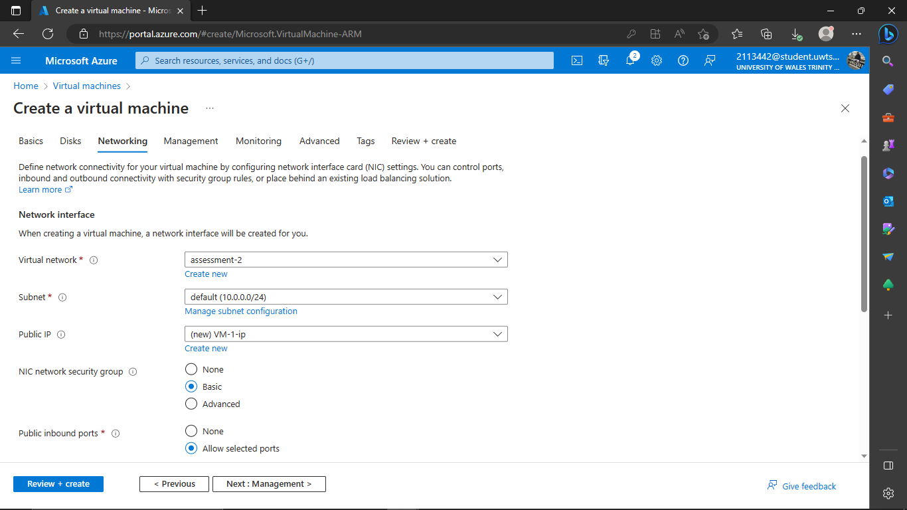

Figure 2. Creating a new VM - Networking

In the network section, the following must be established:
- Virtual network: through which network the virtual machine is going to be connected, one can be created or a previously created one can be assigned to it, in this case, it will be the latter since it was assigned to the network: "assessment-2".
- Subnet: this configuration comes by default once the virtual network has been chosen in the previous step.
- Public IP: this IP is taken from the virtual network that has already been previously created and chosen previously.
- NIC security network group leaves the option: basic.
- Public input ports: the "allow selected ports" option is checked to establish communication between public Internet networks and the virtual machine itself.
Once all these adjustments and configurations are done, the following sections:
Management: usually deselects any option for easier use.
Monitoring: Only the option that Azure recommends is left selected. For general purposes, no more is needed.
Advanced: this section is for those who want to establish more advanced configurations, not applicable in this case.
Tags: here specific labels are defined to be able to identify this virtual machine more easily, they are generally associated with the type of purpose for which they were created.
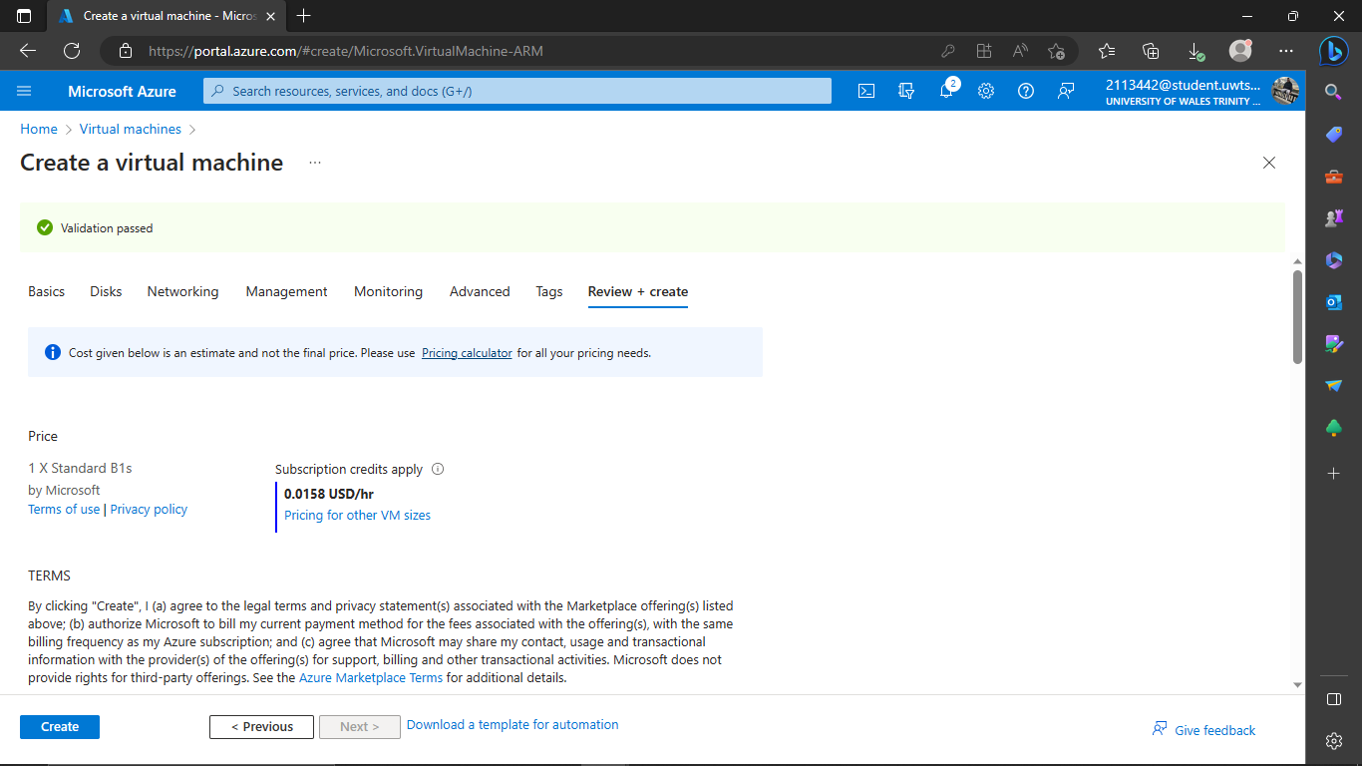
Review and create: Finally, if everything is correct, in this tab, will show a summary of all the configurations chosen in each section and Azure also does a check to verify that all the options match and are allowed according to the subscription chosen in The "basic" section will also show the cost of creating and having this machine available and operational on the Azure platform.

Figure 3. Creating a new VM – Review and Create

After the verification, all that remains is to click on "Create" and Azure will begin the process of creating the virtual machine. Once finished, this machine can be viewed in the "Virtual Machines" or "All Resources" section.

Network Security Group
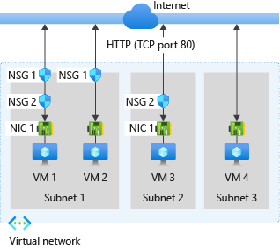
Network Security Group (NSG) is a Microsoft Azure product, that makes virtual network security simple by enabling managers to quickly group, filter, and route various types of network traffic. Any Azure virtual network may be added to a security group, where various incoming and outgoing rules can be set up to permit or restrict particular types of traffic [3].

Figure 4. Example of a Deploying a Network Security Group (NSG). [4]
A network security group comprises security rules that permit or prohibit outgoing network traffic from certain Azure resource types as well as inbound network traffic to those resource types. You can define source, destination, port, and protocol for each rule [4]. Multiple Azure services' resources can be deployed into an Azure virtual network.
The administrator will have the opportunity to manage each of its separate rules after constructing this Azure NSG. To determine if network communication is secure and should be allowed via the network or not, a rule is utilised [3].

So, we have that, for example, the virtual machines in the previous image act as follows depending on the type of traffic that occurs in them:

Inbound Traffic
If there is a network security group associated with a subnet, Azure processes the rules in that group first, followed by the rules in the network security group associated with the network interface; if there is another, intra-subnet traffic is also processed [4].
- VM1: Since VM1 is located in Subnet1 and NSG1 is connected to Subnet1, the security rules in NSG1 are processed. Since NSG2 is linked to the network interface, it never evaluates traffic that is rejected by the DenyAllInbound default security rule, unless a rule that permits port 80 inbounds has been written. NSG2 processes the traffic if NSG1 has a security rule that permits port 80. Both NSG1 and NSG2 need to have a rule that permits port 80 from the internet in order to allow port 80 to the virtual machine.
- VM2: Because VM2 is a part of Subnet1, the rules in NSG1 are applied to it. Since VM2's network interface isn't connected to a network security group, NSG1, it either accepts or rejects all traffic authorised through NSG1. When a network security group is connected to a subnet, traffic is either permitted or forbidden to all resources in the same subnet.
- VM3: Since NSG2 is linked to the network interface connected to VM3, traffic is permitted into Subnet2 and processed by it even though NSG2 is not associated with Subnet2.
- VM4: Traffic to VM4 is permitted since a network security group isn't linked to Subnet3 or the virtual machine's network interface. If a subnet and network interface don't have a network security group attached to them, all network traffic is permitted via them.

Outbound Traffic
Azure evaluates the rules in the network security group associated with the network interface first, if there is one, followed by the rules in the network security group associated with the subnet, if there are any other groups; this includes traffic inside a subnet. So, the behaviour of each VM will be [4]:
- VM1: The NSG2 security rules are being applied. The AllowInternetOutbound default security rule in both NSG1 and NSG2 permits the traffic unless you write a security rule that forbids port 80 outbound to the internet. The traffic is rejected if NSG2 has a security rule that forbids port 80, and NSG1 is never notified of this. Either one, or both of the network security groups, must contain a rule that forbids port 80 from being used by the virtual machine.
- VM2: Since the network interface tied to VM2 doesn't have a network security group associated with it, all traffic is routed through it to the subnet. The NSG1 rules are applied.
- VM3: The transmission is blocked if NSG2 has a security rule that forbids using port 80. If not, traffic is permitted by NSG2's AllowInternetOutbound default security rule since Subnet2 isn't connected to a network security group.
- VM4: No network security group is linked to the network interface connected to the virtual machine or to Subnet3 therefore all network traffic from VM4 is permitted.

Intra-subnet Traffic
The connection between VMs inside a subnet may be impacted by security rules in an NSG connected with that subnet, it is crucial to know. Due to a default NSG rule that permits intra-subnet traffic, virtual machines within the same subnet can automatically connect with one another. VM1 and VM2 won't be able to connect with one another if a rule is put to *NSG1 that forbids all incoming and outbound communication.
By viewing the effective security rules for a network interface, it is simple to see the aggregate rules that have been implemented to that interface. To ascertain if communication is permitted to or from a network interface, you may also utilise the IP flow check functionality in Azure Network Watcher. You may find out if a communication is permitted or prohibited by using IP flow verification, as well as whether network security rule permits or prohibits the traffic [4].

Vnets
Your private network in Azure is called an Azure Virtual Network (VNet). It stands in for your personal cloud network. Using the virtual network, you set up, your Azure virtual machines (VMs) may safely connect with one another.
You have the option to split a VNet into many subnets for increased protection. This serves as a brief introduction to the Azure virtual network. Let's talk about the prerequisites required to construct a VNet in Azure now that you have a basic understanding of what a VNet in Azure is.
Steps to create a VNet in Azure through graphic interface [5]:
- Access the Azure Portal by logging in at https://portal.azure.com.
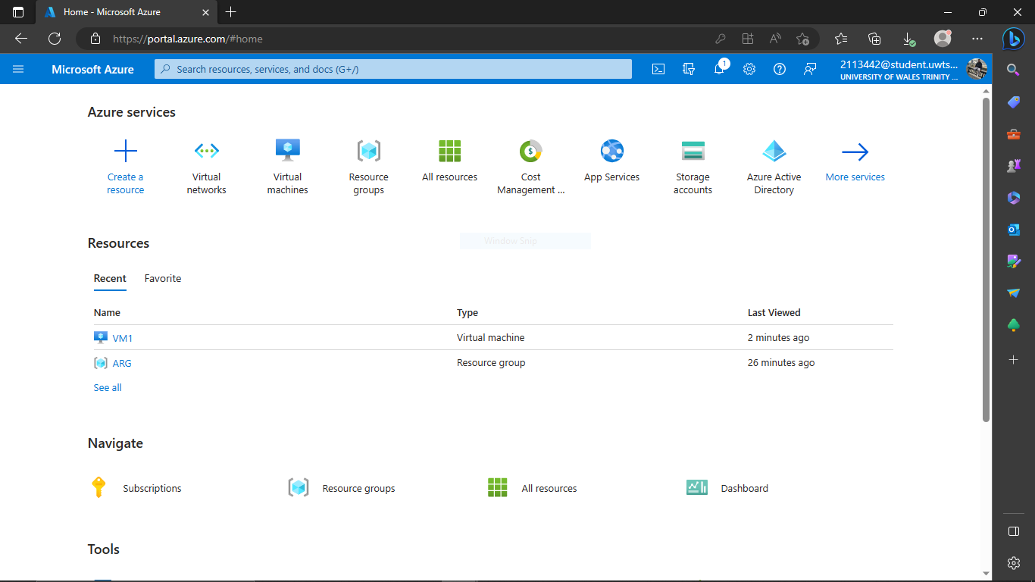

Figure 5. Deploying a Virtual Network Step 1

- Click the search result for Virtual Networks after searching for it.
- Click on the Create button on the Virtual Network window.
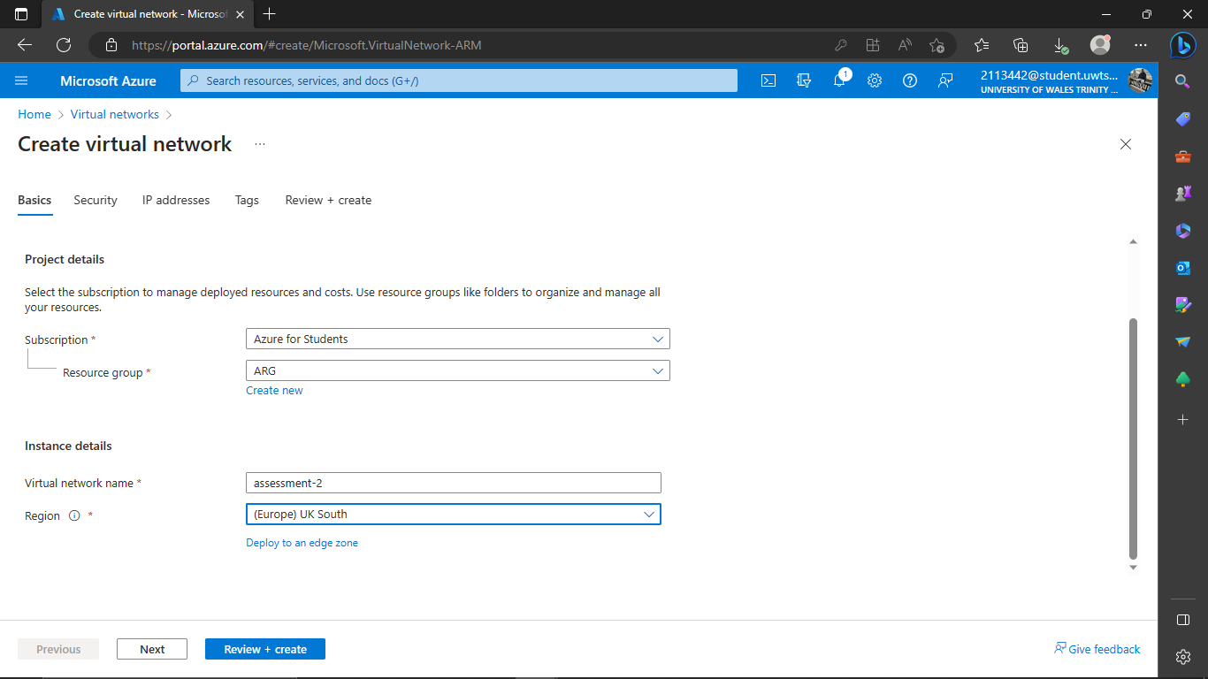

Figure 6 Deploying a Virtual Network Step 2 and 3

- To fill the options that are required, subscription, is for the subscription that you have, resource group which resource group this VNet belongs, region in which region is going to work, and so on.

After this, go to IP addresses, here select the range of the IP address that the virtual network is going to run, if it is necessary, the range of the IP addresses can be edited clicking in the small pencil in the down right corner. When everything is OK, then click on “Review and Create”.
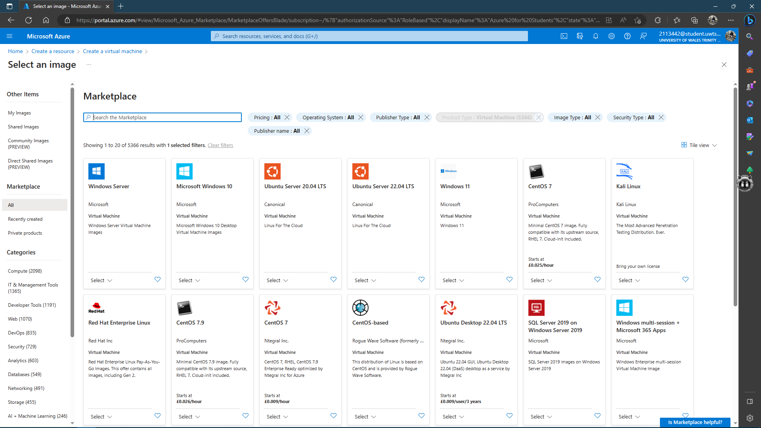

Figure 8. Marketplace for ISO Image Files

Demonstrate the use of images and explain their use in Azure.
An optical disc, such as a CD or DVD, holds data that is identically duplicated in a file format known as an ISO file (also known as an ISO image). These are typically used to install software using extractable devices or create backup copies of optical discs [6].
While generating backups of their optical discs is a common application for ISO images, these days the format is mostly used to distribute huge programmes and operating systems since it allows all the data to be stored in a single, easily accessible file. The decision to mount the image or utilise it to create an optical disc is then up to the user [6].
In the Azure store there are a lot of ISO file images available to install in a virtual machine, ranging from different operating systems such as Windows its different versions as well as the possible architectures available for them, such as Linux versions, such as Kali, Ubuntu, Red Hat Linux, Cent OS, Debian 11, Windows Server, etc.
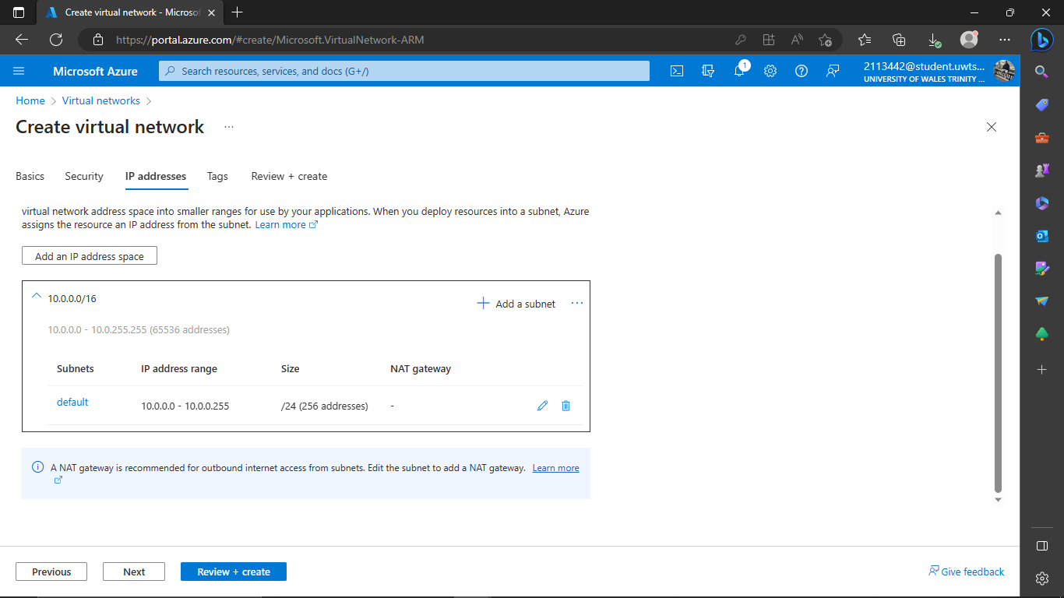

Figure 7. Deploying a Virtual Network Step 4

When creating a virtual machine, you have to choose the type of ISO file to be installed in the VM. Here is a sample of some possible choices available to install.
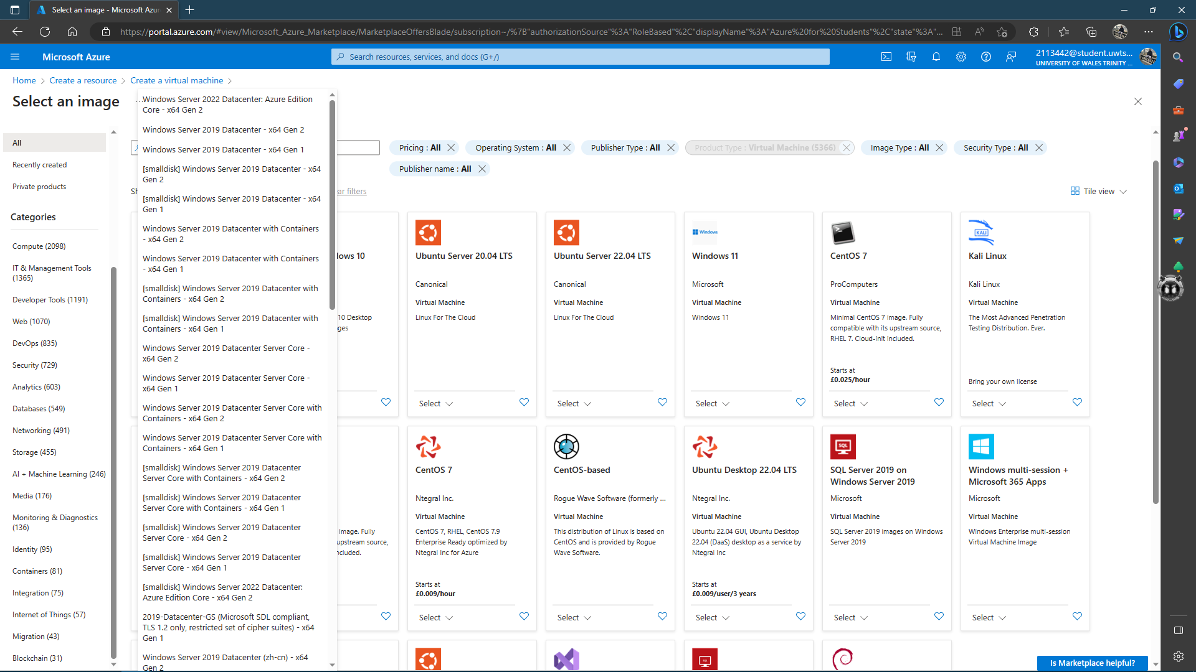

Figure 9. Marketplace for ISO Image Files. Versions

Here, for example, there are some different versions of Windows Server, from all these versions are available to choose and install it.
After finished the process of create VM is possible to use it and running this version of VM.

Additional Exercise.
In this exercise are require connecting two virtual machines and they can make ping each other.
To create the VMs are necessary to follow the same steps explained here.
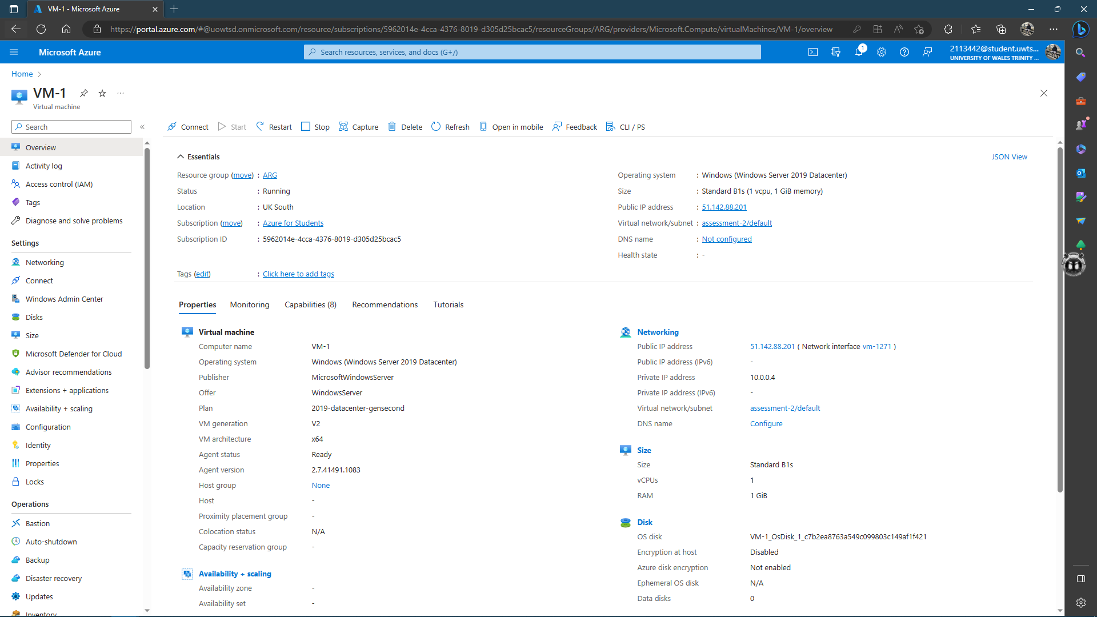

Figure 10. Creating a Connection between two VMs. Step 1

After creation the first VM go to the tab, “Connection” click on the bottom: “Download DRP File” this allows the administrator connected through in remote mode. The DRP file means, Desktop Remote Protocol.

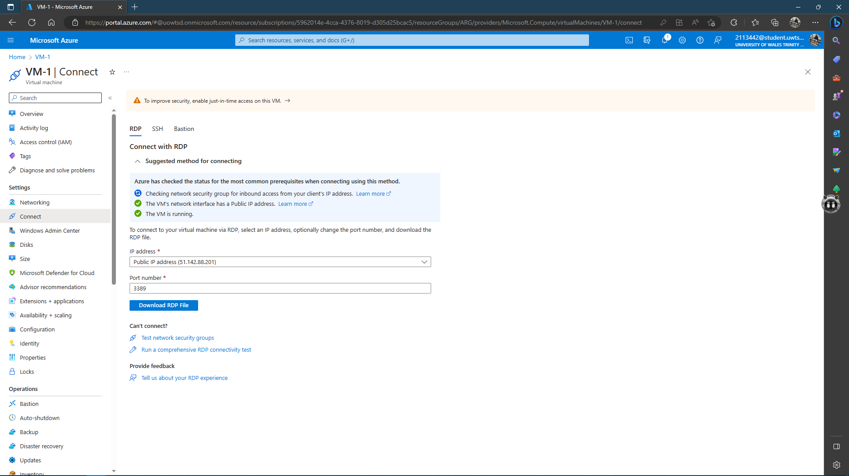

Figure 11. Creating a Connection between two VMs. Step 2

After downloading the file, click on it to run it, after that the credentials of the administrator will be requested, so put it to continue. After that, the connection will begin and, also the setting up will start. When the desktop finished the setting up all the features in the VM, go to “PowerShell” and type the following command line:
New-NetFirewallRule -DisplayName “Allow ICMPv-4-In” -Protocol ICMPv4. As it showed below. This command will show the information showed in the screenshot.
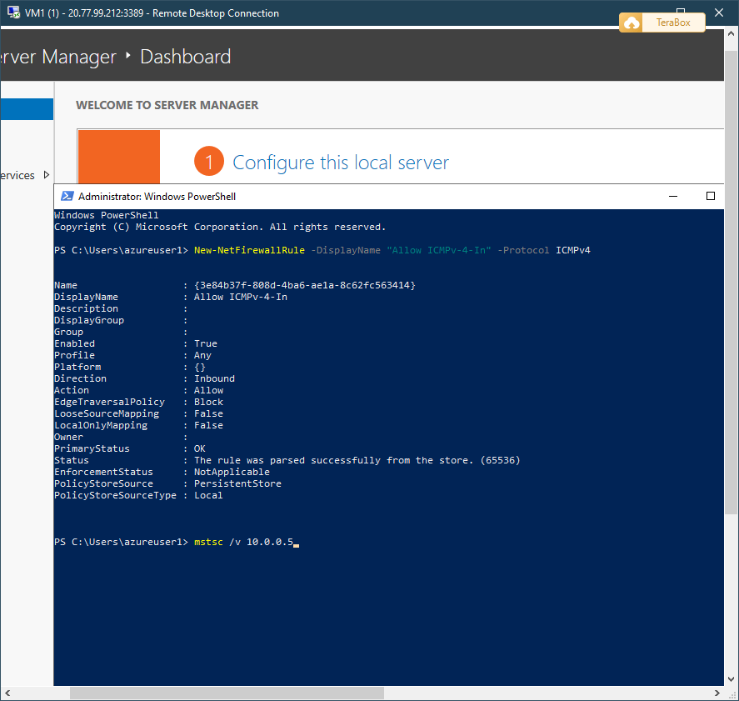
After this, type the command: mstsc /v 10.0.0.5.

Figure 12. Creating a Connection between two VMs. Step 3
This command allows to connect with the VM with this specific IP address.

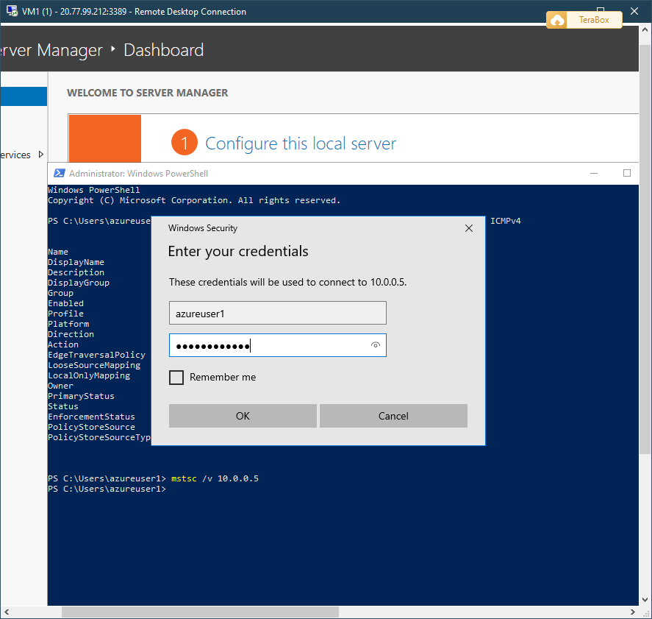

Figure 13. Creating a Connection between two VMs. Step 4

To stablish the connection is necessary to type and validate the credentials of the administrator. Once time did this will be in the other VM.

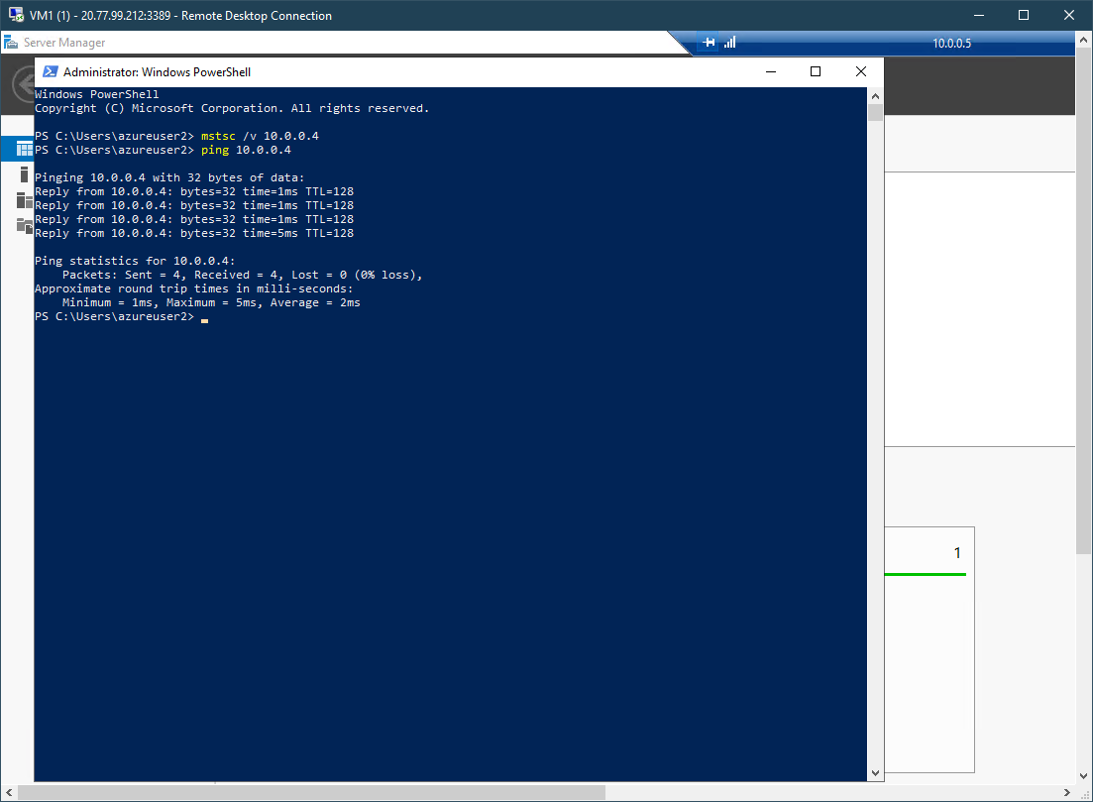

Figure 14. Creating a Connection between two VMs. Step 5
Now to prove the connection between them, type the command ping to the other VM through the IP address, which is 10.0.0.4.
Like the screenshot shows, the connection is successful because 4 packages were sent and 4 were received in the other VM.

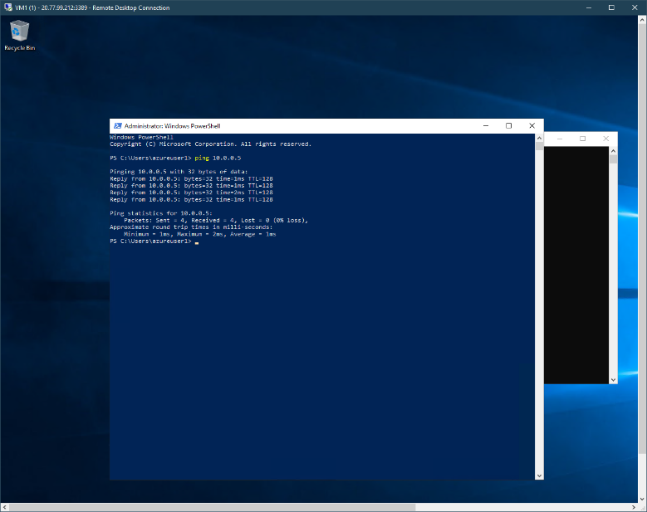

Figure 15. Creating a Connection between two VMs. Step 6
Now, from the other VM, do the same, go to, “PowerShell” or the “Command Prompt” whatever and type the command ping 10.0.0.5; because this is the address of the other VM.
Like the screenshot shows the packages are sent and receiving successfully, which means the connection between them is ok.

Conclusion

As part of the learning path of a systems developer or cloud computing engineer, it is essential to know how it works and what are the different types of services that Microsoft offers through its Azure platform. This offers us a number of tools of different types and purposes to satisfy the needs of services and almost any other type of software need that a company requires to carry out its commercial activity, these range from offering storage in the cloud to providing services and Manage machine systems, all from Azure. The exercise carried out shows how the connection between two different machines should be established, this can be a perfect example of how a client-server connection can be established.

Bibliography

[1] cynthn, ronsanchez-ms, liljack17, and mimckitt, “Overview of virtual machines in Azure - Azure Virtual Machines,” learn.microsoft.com, Feb. 28, 2023. https://learn.microsoft.com/en-us/azure/virtual-machines/overview (accessed Apr. 26, 2023).

[2] B. Kumar, “What Is Resource Group In Azure - Azure Lessons,” Azurelessons, Dec. 28, 2021. https://azurelessons.com/what-is-resource-group-in-azure/ (accessed Apr. 26, 2023).

[3] S. Perriman, “Introduction to Azure Network Security Groups (NSGs),” Altaro DOJO | Hyper-V, Apr. 25, 2019. https://www.altaro.com/hyper-v/azure-network-security-groups-nsgs/ (accessed Apr. 26, 2023).

[4] asudbring, GaratiniSharma-MSFT, and DavidCBerry13, “Network security group - how it works,” learn.microsoft.com, Feb. 10, 2023. https://learn.microsoft.com/en-us/azure/virtual-network/network-security-group-how-it-works (accessed Apr. 26, 2023).

[5] Rajkishore, “How To Create VNet In Azure - Azure Lessons,” Azurelessons, Dec. 23, 2021. https://azurelessons.com/vnet-in-azure/ (accessed Apr. 27, 2023).

[6] B. Gavin, “What Is An ISO File (And How Do I Use Them)?,” How-To Geek, Jun. 25, 2018. https://www.howtogeek.com/356714/what-is-an-iso-file-and-how-do-i-open-one/ (accessed Apr. 27, 2023).

https://www.youtube.com/watch?v=Bqch2Qf8nuQ&t=278s&pp=ygUeaGFjZXIgcGluZyBjb24gZG9zIHZtIGVuIGF6dXJl

