Switzerland Review
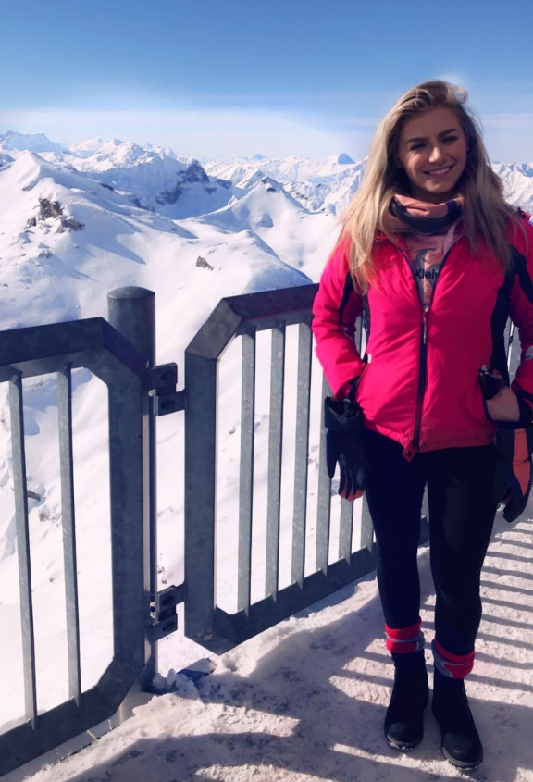

Introduction
Switzerland is a mountainous European country. ‘Tourism in Switzerland has a long history, and the industry was already well established in the late ninetieth century’( Worldwide destinations, 2001, 147). Switzerland is a popular location that has many visitors from all over the world. The most popular overnight visitors that come to Switzerland are travelling from inbound countries such as Germany, United Kingdom, United States of America, France and China.

Financial figures and statistics
In 2015 there were 35.6 million overnight stays in Switzerland. This then generated around 2.8% of the country’s gross domestic product, this is then also generating around 4% of the working population, which means more than 170,000 people are working in the Swiss tourism industry.
Switzerland is bringing in more excursions and not just focusing on skiers, as the snow is unpredictable and isn’t also reliable due to the climate changes creating a decrease in the number of skiers going on to the slopes and dropping tourist visitor numbers. As a result, in the decrease of snow that the Swiss slopes are seeing it is decreasing the ski seasons by 37 days shorter since 2016. In 2005/2006 there was an average of 28K skiers going up and down the slopes, where as in 2015/2016 there has been a decrease to 22k skiers. There is also increasing competition from other snow countries such as France as there is a price difference e.g France is cheaper, and they also create snow all year around as some slopes are manmade. Places like French alps also appear for a younger audience as they offer more night life entertainment. This is then opening the French alps target market for more then just one group, it can be offered to families, golden ages, adventure tourists and teen market of 18-30s.

Introduction to destination and excursion experience
Switzerland has many outstanding places within the country for example Zϋrich, Geneva, Bern, Interlaken and many more, but one place that stood out from the rest was Jungfraujoch.
Jungfraujoch is at 3454 meters above sea level with breath-taking views over the Mittelland to the Vosges and over the Aletsch glacier which is bordered by 4000 metre peaks. The icy air puts colour into visitors cheeks and excitement into skiers eyes. 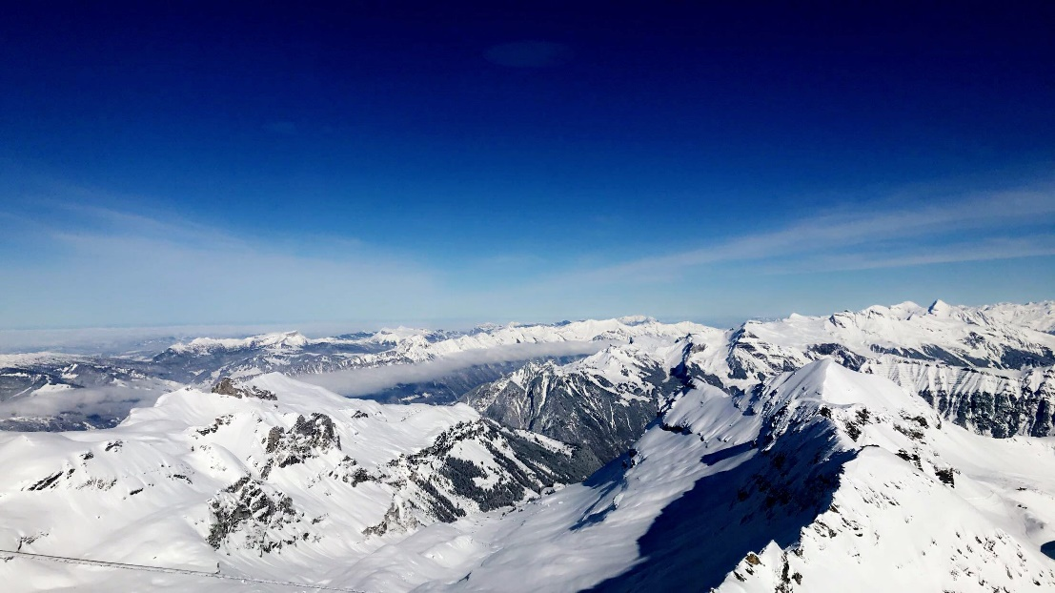
Jungfraujoch is a destination with lots to offer and not just a beautiful view at the top of Europe. There is the Ice palace, Lindt chocolate shop, Bond 007 museum, 360° Restaurant Piz Gloria, Skyline top shop, 007 walk of fame, Piz Gloria view and more. At the top of the Jungfraujoch mountain at one of the highest points of Piz Gloria, there is the Inferno-race track that has been running ‘ since 1928 that is open to 1850 participants’ (name and date) However the track opens to public skiers throughout the rest of the year.
Moving slightly further down the mountain there is the Igloo village that offers experiences that people may of never seen before and the chance to explore the insides of actual igloos. In the village they also offer visitors some cheese fondue or a delicious refreshing drink.
At the same level of this mountain slope there is a light catching sun terrace with delicious food on offer with a just as beautiful view of Egier, MÖnch and Jungfrau mountains. After lunch with a view there is also the option of getting back down the mountains vis the steepest Piste also known as Run No.9- Direttissima and the skyline snowpark. Run No.9- Direttissima is a guaranteed adrenaline rush for whoever wishes to take it on, with the slopes at an 88% incline this is the steepest slope in the Jungfraujoch region.
If skiers or snowboarders fancy some spectacular thrilling jumps to try with different kickers, rails and boxes Skyline Snowpark offers them. This also a very adrenaline rush course with more than just incline to excite them, it is a course which is open to anyone who wishes to take on the excitement of more than just a ski run.

Travel up and down the mountain
When it comes to travelling up and down Jungfruajoch there is just one route of transport available however there is a number of ways to do so.
There are many different passes available to buy, to help you to travel to the top of Europe, Via train/ cable cart. On the Jungfrua official website there are currently an option of 11 different passes available to purchase for what best suites you.
A ticket from any station destination to Europe’s highest station in Jungfraujoch starting price is 91.00 CHF, this gives you access up and down in the day whatever date you choose to do so. This pass covers you all the way up and down to your original station so on the way down if you fancy you can stop for something to eat in one of the restaurants or cafes, or just for stopping to have a refreshing drink.
For a children’s ticket promotion, which is available for ages 6-15, who is accompanied by an adult can purchase this ticket for a starting price of 25.00 CHF. This ticket doesn’t just give a pass to Jungfreajoch but to all other stations available around the around, for example Grindelwald, Interlakaen and many more. Compared to an adult ticket there is a very big different between the two, as this ticket offers the other locations around Switzerland available for the young traveller, not just the one location. This also helps families save money on days out or just their travels, this is then could create an increase in Switzerland’s public transport.
For any traveller who loves an early start to the day or just wants to see a spectacular sunrise that some could only dream about seeing. The good morning pass would be perfect, get up early and travel up to Jungfraujoch between 08:00-08:30. This ticket is only available between May 5th and October 21st, starting at 85CHF You only have your return valued until 1:30pm that day to travel back down. This ticket allows travellers to start the morning day with something magnificent, and then time to continue the adventure down and throughout the rest of Switzerland. 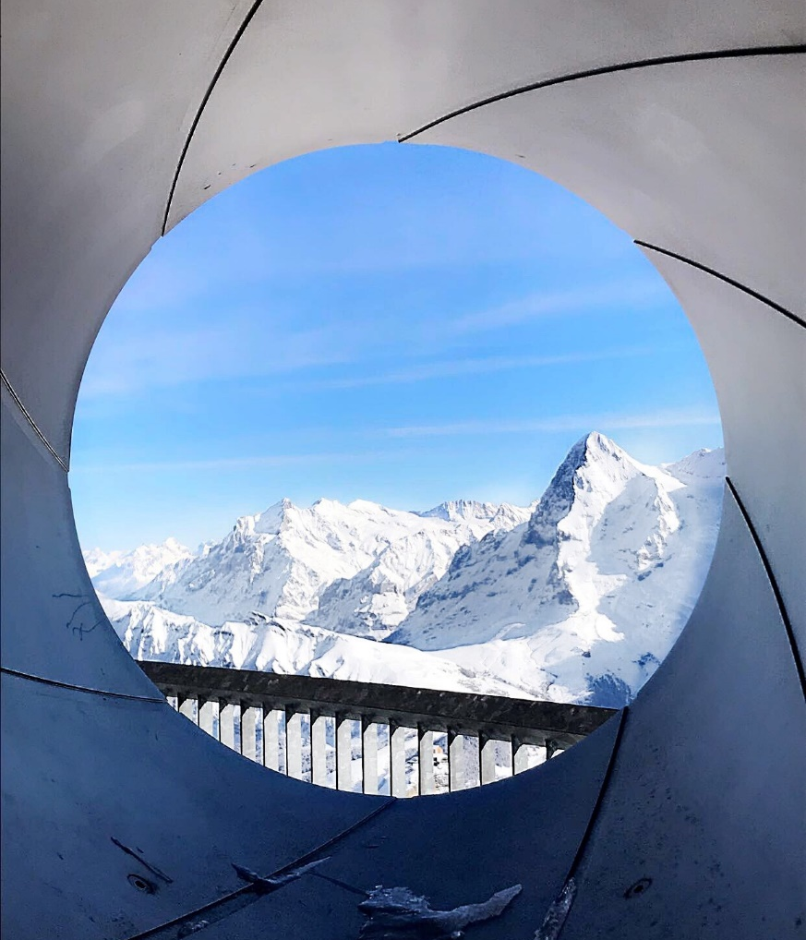

Improvements for travel
When it comes to travelling up and down Jungfraujoch there is a just one route up and down however there is several ways to do it.
When trying to improve the transport to and from the highest point in Europe, there isn’t that much more that can be done, since Switzerland is a very eco friendly country and does whatever they can to try and protect the environment. The trams & trains are a pubic transport meaning it is keeping Switzerland’s carbon footprint down and that the use of less biofuels. This also allows for more visitors to go up and down, meaning there are more visitors going to the 007 museum, looking at the breath-taking views and dining in the 360° restaurant.
The cable carts might not be everyone’s favourite choice of transport due to the height however it does offer amazing views as the cart slowly travels up over the alps to the top of the mountain. As soon as the first steps are taken off the cart a cold low altitude blows in visitors faces creating rosy cheeks and watery eyes.

Customers service
A negative to travelling up to top of the Europe and whilst up there was the customer service. There was a lack of communication between each station point on the mountain and there was a lack of respect for customers in the 360° restaurant at the highest Europe point.
At the first station there was an issue with the group pass ticket, this was resolved with a member of staff, who gave us further directs of what to do whilst going up the mountain as well. This staff member was helpful and kind, who gave us access to the cable cart, to start out journey up the mountain. The ticket was still an issue further up the mountain, where the customer service team was located, the customer service wasn’t very helpful and didn’t show much interest in the matter and was rude about it, whilst raising their voice. However, the issue did finally get resolved and the group carried on travelling together on the one ticket up the mountain to the breath-taking view.
Whilst up the peak point of the mountain in the 360° restaurant the service of the staff was abrupt and dismissive. They didn’t let anyone in the revolving seats and wanted to take orders as soon as everyone was seated, although the drinks and experience was unforgettable.
Once after capturing and taking in the views and experience, travelling back further down the mountain there was an outdoor American take away food station, this offered hot dogs and burgers served with chips, where you could also pick your own salad and fillings. There was also the option of a warm soup of the day. The two ladies working/ cooking on this stations was very helpful, friendly and kind with generosity to every customer.

Strategies of Switzerland
From tourism strategy of the Swiss confederation the four strategy goals that Switzerland are trying to complete are ‘Improving framework conditions, promoting entrepreneurship, Exploiting the opportunities presented by the digital economy and enhancing the attractiveness of tourism offerings and market presence’.
By Switzerland’s Federal Council’s tourism aims they aim to improve the framework conditions to help enable the different tourism sector businesses to broaden their entrepreneurial scope and bring down their costs.
Promoting entrepreneurship, the Federal government of Switzerland puts a large importance to promoting the different entrepreneurship. This is then looking into the focusing on the productivity, increasing and improving the different skills and strengthening the tourism labour market.
Exploiting the opportunities presented by the digital economy is aiming to be improved by the Confederation’s tourism policy by trying to help the tourism industry of Switzerland take full advantage of the opportunities being provided to them by the digital economy.
The enhancing of attractiveness of the tourism offerings and market presence has the focus of wanting to have development of the investment incentives, and the exploitation of the different momentum being provided by different events that take place for example sporting events like the Inferno Race, the winter Olympics and more.
Destinations like Jungfraujoch are trying to meet these different strategy targets to follow by trying to keep up to date with what travellers want. For example there are apps available to download of maps of the mountains, live web cam feeds of the alps so people can check on the weather or even the population of the mountains that day. There is also 360° restaurant apps you can download to order food or drinks to your table, check the menu out or to check the availability or to keep up to date on what’s happening in the 007 restaurant.
They are keeping up with different entrepreneurship by adding more than one place to eat, shop and drink whilst going up and down the mountain. The facilities aren’t just one company linked there are different companies owning different shops.
Jungfraujoch tries to offer different entertainments and events for people to participate in around the area. For example the Inferno Race has been running since 1928 which offers 1850 places for applicants to apply to join in the race, creating it into an event attracting not just the competitors but also the supports and other visitors who are keen in the winter sports.

Conclusion
In conclusion of all these different things that Switzerland offer to their different target markets like skiers, bond fans or bloggers they do provided to all. They offer something for everyone to enjoy for example families can enjoy exploring the igloo village, skiers can dare themselves on the steep and jumps slopes and breath-taking views to people wanting to see something that they will never forget.
Switzerland is a country that gives off the impression that they are number one when it comes to what they have to offer their residents and their guests, however they do need to look at improving on their customer service. Customer service is such a important thing and something that visitors will remember out of their trip and its what makes people want to return from how they have been treated whilst being away.
Switzerland is a beautiful location that captures many eyes. The snow makes Switzerland a beautiful location however even without the snow Switzerland can capture peoples looking for a holiday with natural beauty. With the snow Switzerland is one type of holiday destination with certain activities to offer however without the snow it’s like a completely different location with different excursions to participate in.
Even though Switzerland has a lot to offer they can improve by trying to market to the 18-30 target market. There isn’t much nightlife or places to have night time entertainment, when the slopes close there isn’t much to offer. This could be where Switzerland is losing some of their customers to the French alps as in France, they offer night-time entertainment and with events taking place at reasonable prices.

Reference

Dimitri Kas, 28/03/2018, A Future In Protecting The Environment, Website
https://www.houseofswitzerland.org/swissstories/environment/future-protecting-environment
Tourism Strategy of the Swiss Confederation, 12/06/2018, Website
https://www.seco.admin.ch/seco/en/home/Standortfoerderung/Tourismuspolitik/Tourismusstrategie_des_Bundes.html
https://schilthorn.ch/
Worldwide Destinations, The Geography of Travel and Tourism, Brian Boniface & Chris Cooper, 2001, Oxford.
https://schilthorn.ch/cmsfiles/winter-guide_18-19.pdf
Discover Switzerland Tourism
https://www.eda.admin.eh/aboutswitzerland/en/home/wirtschaft/taetigheitsgebiete/.html
https://www.jungfrau.ch/shop/en/tickets/bergbahn/angebote/jungfraujoch-top-of-europe/jungfraujoch-top-ticket-anschlussticket-zum-sportpass

