DS 1 by Desire Ble

My Screenshots/Photos
- Please add 4–6 screenshots or photos of your digital life.
- You can use your phone or laptop.
- For each screenshot, write one or two sentences explaining what it shows.

Screenshot/Photo 1
[Insert Photo/Screenshot below]
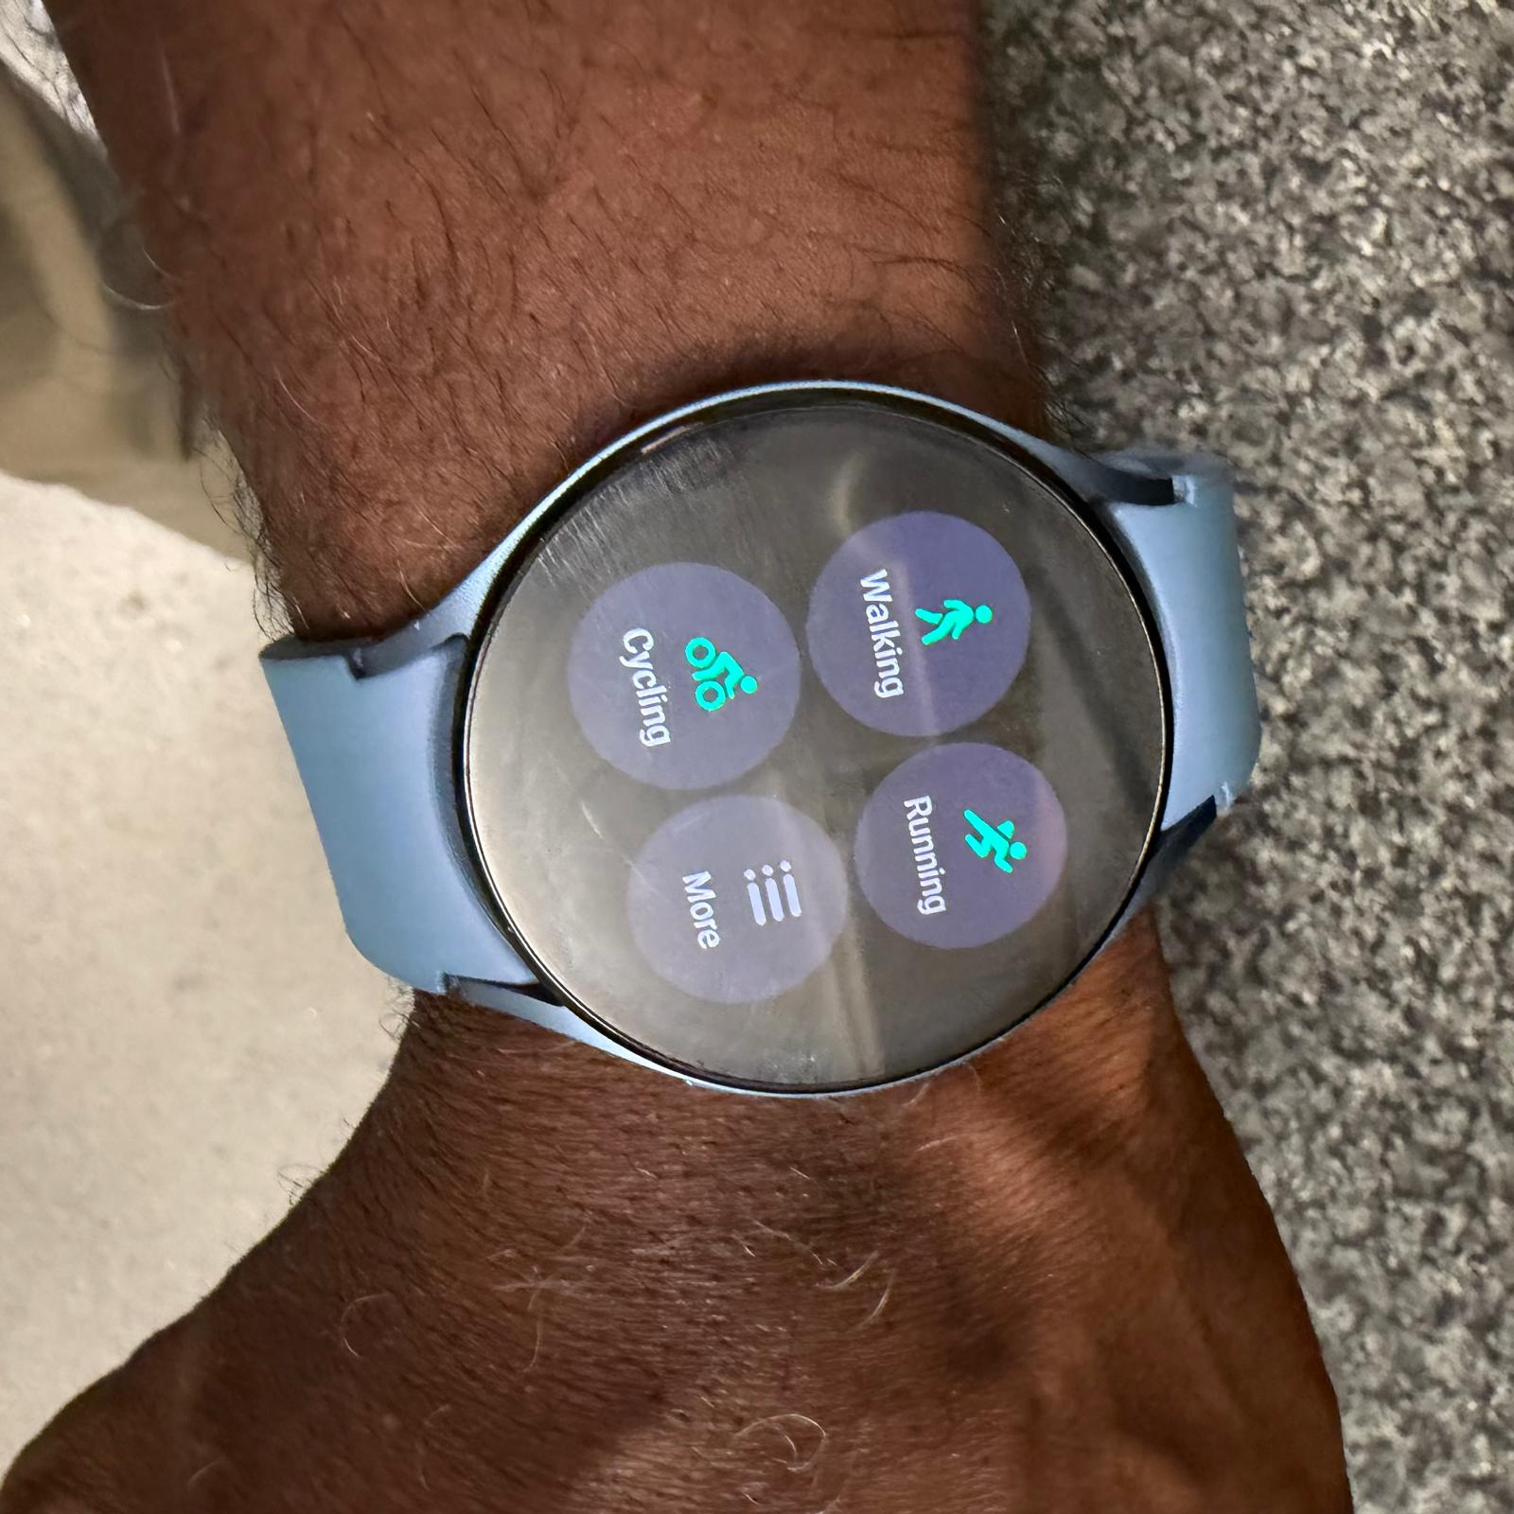
[My Digital Watch does provide accuracy on my walking steps and health monitoring.]

Screenshot/Photo 2
[Insert Photo/Screenshot below]
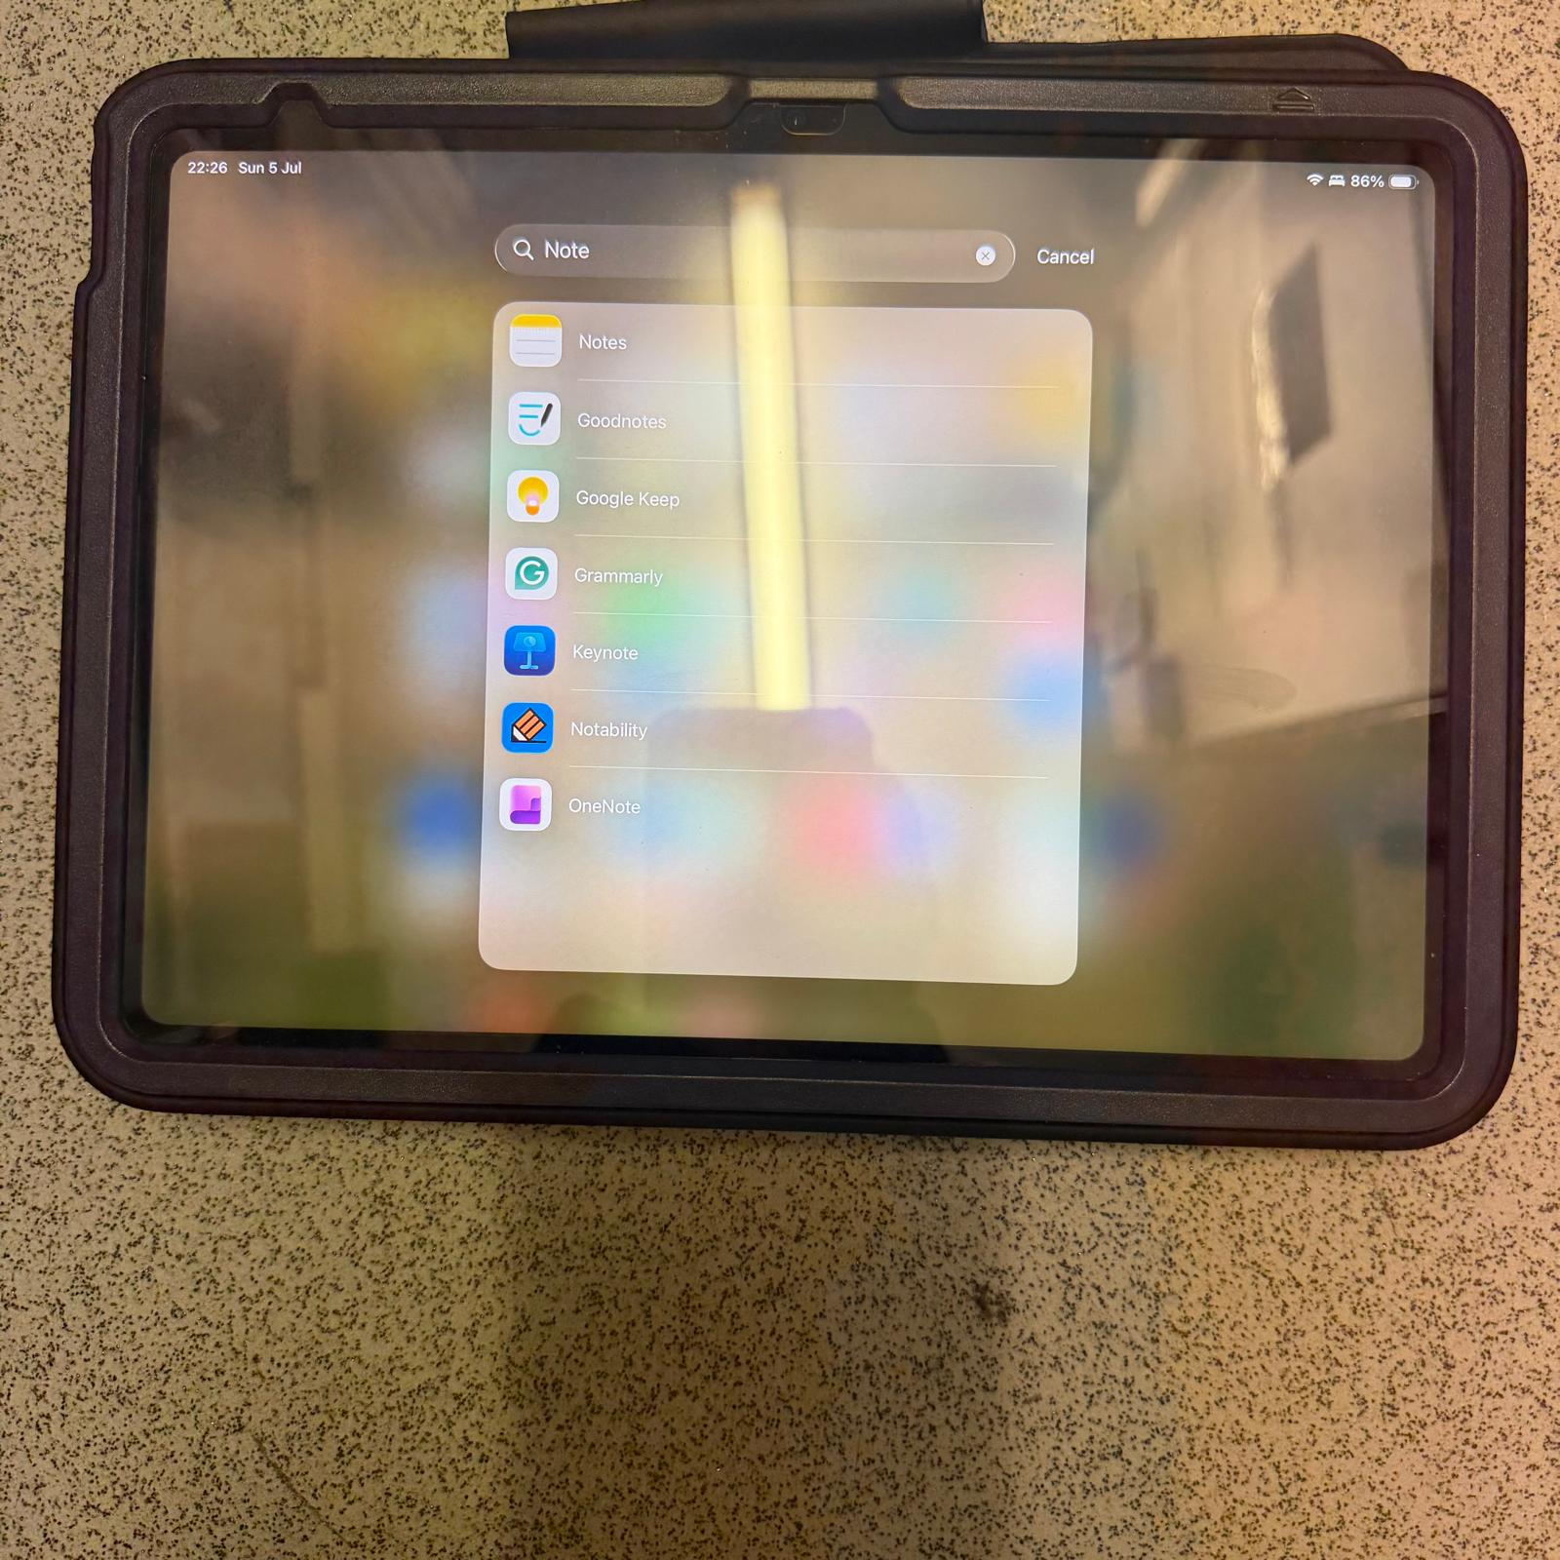
[My Ipad helps me taking digital notes.]

Screenshot/Photo 3
[Insert Photo/Screenshot below]
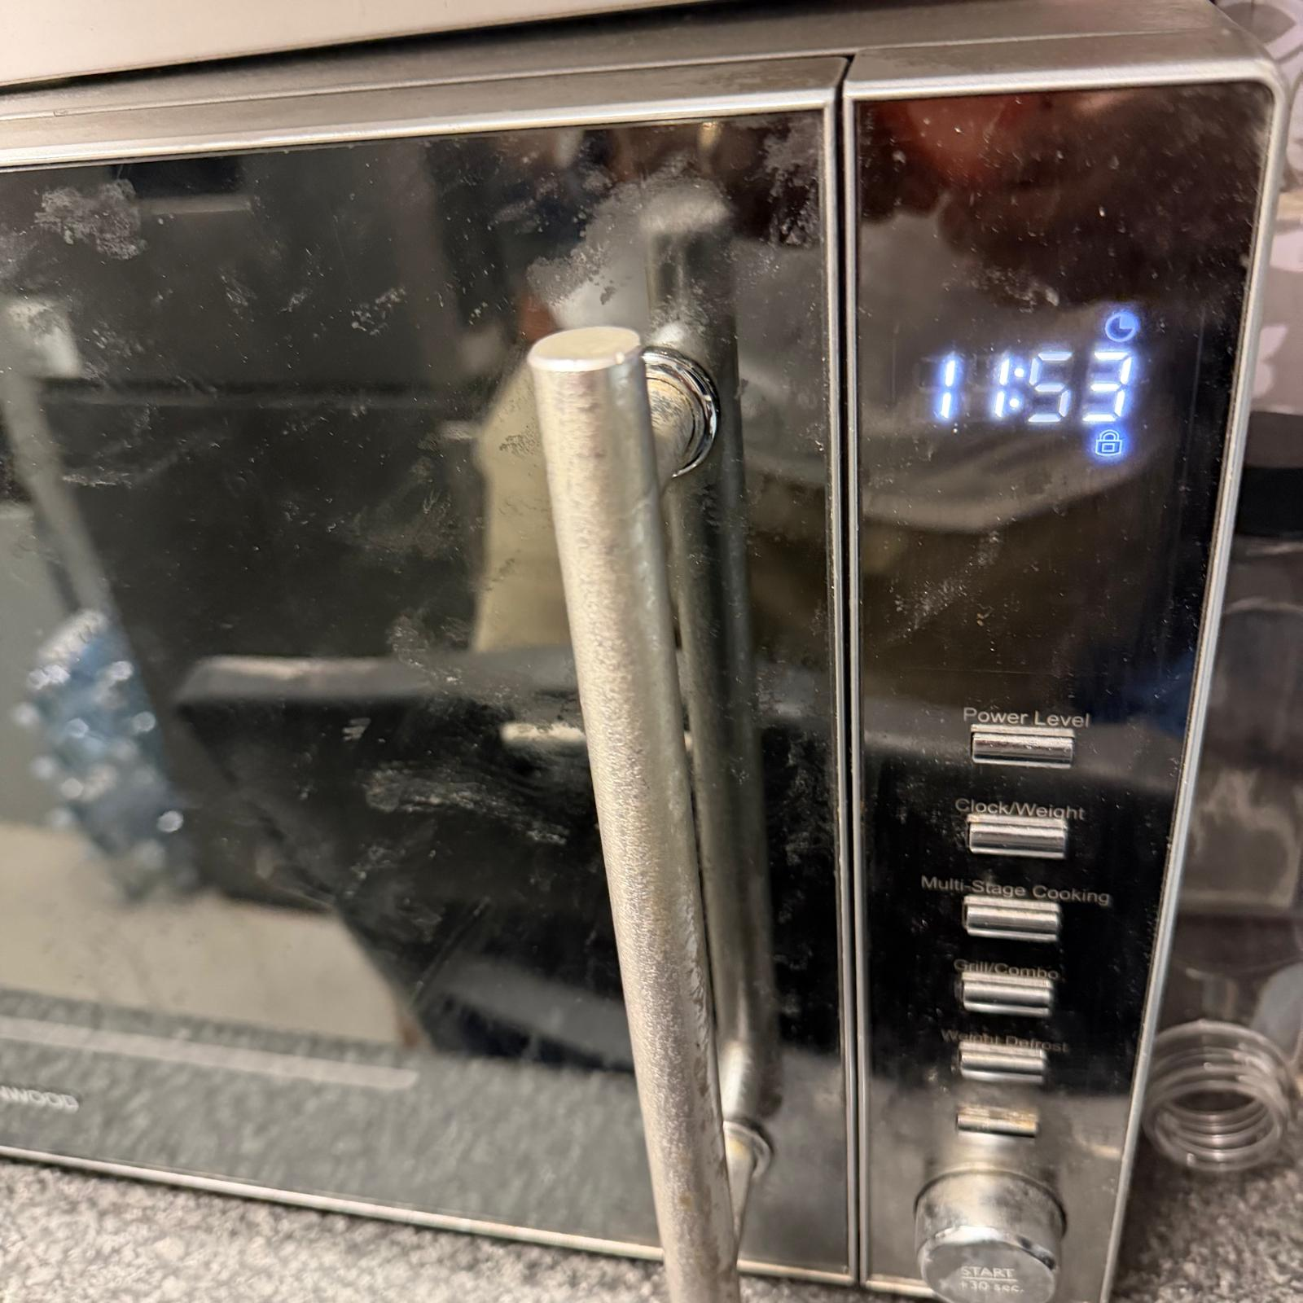
[My Microwave helps me warm necessary foods daily.]

Screenshot/Photo 4
[Insert Photo/Screenshot below]
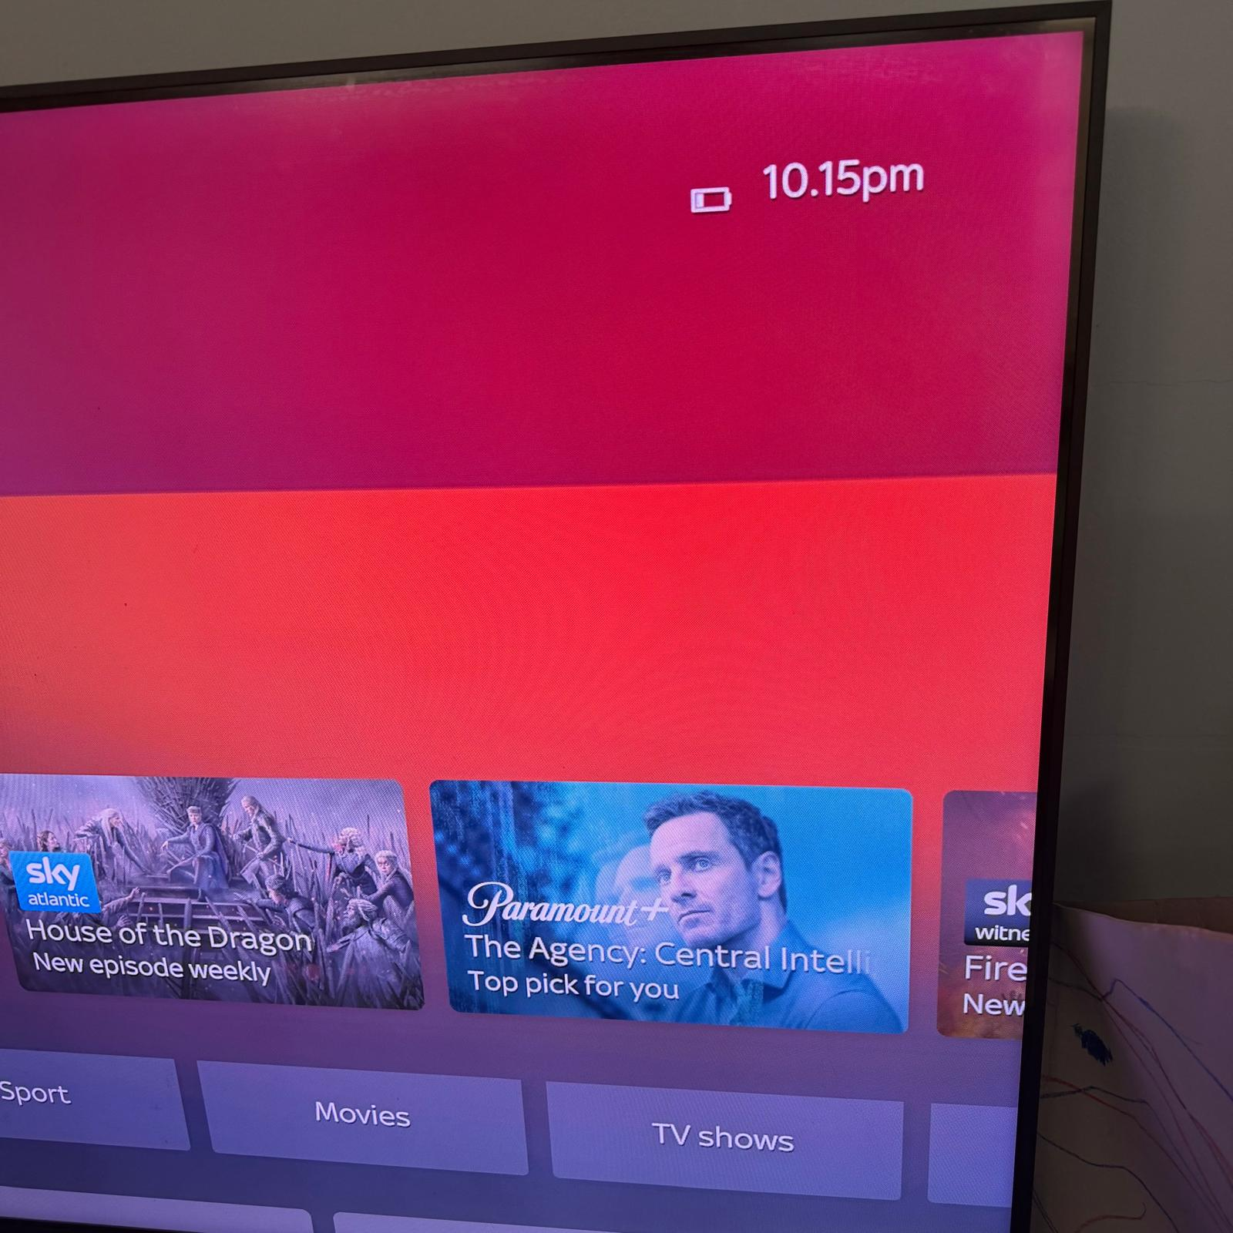
[my Television provide me daily time display.]

Screenshot/Photo 5
[In sert Photo/Screenshot below]

[Write what this shows of your digital life]

Screenshot/Photo 6
[Insert Photo/Screenshot below]
My Laptop serves everyday for my work and school activities.]

My Short Reflection
- Write 5–8 simple sentences about your digital life.
- You can use the sentence starters below if helpful.
-I use my Digital Watch everyday to monitor my sleeping hours.
-I use my Ipad to take digitally.
My Washing machine digital display help me monitor the progress while washing my clothes.
-My Fridge digital display shows the appropriate temperature.
-My Microwave helps me warm the necessary foods or liquids.

Sentence starters
- I use digital tools to have awareness of the time.
- I feel confident when I use my digital watch.
- I want to improve my digital skills.
- I often use these tools: help myself understanding more on the digital world.
- I sometimes feel nervous about new technologies.
- I hope this module will help me mastermind the digital skills.
- Digital skills are important for me because position myself in this new world.
You can write more if you want.

Submission Checklist
Before you submit, please check:
​​​ ☒ I added 4–6 screenshots
☒ I wrote short sentences for each screenshot
☒ I wrote my short reflection
☒ My work is my own
☒ My file opens correctly
​​☒ My file opens correctly

