ACBA 6004

Urban Renewal

By Ben Kneeshaw

SN: 1902457

Contents

1. Introduction…………………………………………………………………….Page 3
1.1 Project Overview………………………………………………………………Page 3
1.2 Aims & objectives……………………………………………………………..Page 3
2. Basement……………………………………………………………………….Page 4
2.1 Substructure…………………………………………………………………...Page 4
2.1.1 Retaining walls………………………………………………………………Page 4
2.1.2 Excavation & stabilisation………………………………………………….Page 5
2.2 Waterproofing considerations…………………………………………….….Page 6
2.2.1 Type B………………………………………………………………………..Page 6
2.2.2 Type C…………………………………………………………………...…..Page 6
3. Frame……………………………………………………………………………Page 8
3.1 Composition……………………………………………………………………Page 8
3.2 Stability…………………………………………………………………………Page 8
3.2.1 Core…………………………………………………………………………..Page 8
3.2.2 Connections…………………………………………………………………Page 9
3.3 Internal space…………………………………………………………………Page 10
3.4 Fireproofing……………………………………………………………………Page 10
4. External envelope…………………………………………………………….Page 11
4.1 Chosen solutions……………………………………………………...……...Page 11
4.2 Aesthetics………………………………………………………………..……Page 11
4.3 Inherent properties……………………………………………..…………….Page 12
4.3.1 External walls……………………………………………………….…...…Page 12
4.3.2 Roof cladding system………………………………………….….……….Page 12
5. Closing statement…………………………………………………..………..Page 14
6. List of figures……………………………………………...…….….………...Page 15
7. List of references……………………………………………………………..Page 16
8. Appendix A – Retaining wall………………………………………………..Page 17
9. Appendix B – Water-stop locations and substructure frame……......Page 18
10. Appendix C – Cavity details……………………………………………….Page 19
11. Appendix D – Superstructure frame…………………………………......Page 20
12. Appendix E – Frame connection detail (core to beam)……………...Page 21
13. Appendix F – Frame connection detail (column to foundation)…..Page 22
14. Appendix G – External wall cladding (Cross-section)……………….Page 23
15. Appendix H – Roof cladding (Cross-section)………………….………Page 24

1. Introduction

This report aims to sufficiently address concerns raised by the client and various lobbying groups regarding the development planned for St Mary’s street in Cardiff. Various diagrams are included in the attached appendixes; these have been produced using AutoCAD 2020.

1.1 Project Overview

The project is a high-rise mixed-use development. Situated at 29 St Mary’s street in Cardiff it sits on the site of a fairly dated retail/office structure. Planned to be 16 storeys overall with a deep basement comprised of 4 storeys, the structure will be home to many amenities being mixed-use. These include: 2 storey retail units at ground level, offices, apartments, three storey underground carpark and attached gymnasium/spa.

1.2 Aims & objectives

This report aims to clearly outline all considerations taken as part of detailed design for the aforementioned project. In order to allay concerns raised by the client and lobbying groups, specific attention has been applied to the following areas:
- Sustainability
- Impact on conservation area & surrounding listed buildings
- Impact on streetscape
- Aesthetic contribution to skyline
- Internal area
- Inclusive design
- Waterproofing
- Fireproofing

2. Basement

The basement required for this project is a deep basement (more than 3m deep). Designed to be comprised of four floors it houses parking amenities, as well as an attached gymnasium and spa. As such, it should be considered inhabited. Key considerations for this part of the project are:
- Structural stability
- Impact on surrounding structures and streetscape
- Habitability

2.1 Substructure

Due to the constrained nature of the site, with surrounding buildings and busy pedestrianised streets, the methods used in the substructures construction are crucial and must avoid any potential damage to said surroundings.

2.1.1 Retaining wall

The key foundational element for the substructure is the piles; these will act as the foundations for the building as a whole whilst also forming part of the retaining wall, stopping soil and water from entering the basement.
The retaining wall will take the form of a secant pile wall; with the piles themselves cast in-situ using the ‘Stent wall system’. This involves using varying grades of concrete to form an overlapping wall of piles (known as a secant pile wall) with some structural and some solely present to retain soil/water influx. Illingworth (2000, page 202) states this can be carried out via the following steps:
- Guide wall constructed at ground level to show where piles should go.
- Bentonite-cement-PFA piles driven (using CFA method) with space between each for the reinforced concrete piles.
- Reinforced concrete piles driven (using the CFA method) between the previous piles, done so as to overlap slightly forming a watertight joint between piles.

In this case the bentonite-cement-PFA piles will extend to 2m below the planned basement depth to allow for a 1m thick floor slab to be poured. Reinforced concrete piles will extend further below to depths required for proper load transfer to the substrata/bedrock. A diagram detailing the retaining walls is included in Appendix A.
This is the best solution for the piles due to the following reasons. CFA piles negate possible damage to the surrounding structures and streetscape, this is because traditional driven piles cause vibrations that can travel through soil and damage existing structures/infrastructure, this method keeps noise and vibration to an absolute minimum (Chudley & Greeno, 2020). The chosen solution also provides a strong structural base for the project, capable of transferring the large loads required of it in a safe manner.

2.1.2 Excavation and stabilisation

With the secant pile walls complete, the next step is excavation of the basement and structural stabilisation.
During the excavation works, temporary supports will be used to ensure the stability of the retaining walls. Water pumps will likely be required during this phase of works in order to dewater the excavation as it progresses (due to the low-lying nature of the site). The secant pile walls will also be sprayed with shotcrete during this phase to prevent water ingress.
Once excavations have reached the required depths, piles and pile caps can be installed in three places using the CFA method, providing support for elevator shafts. A basement floor slab will then be poured on top of a damp proof membrane before waterproofing methods and screed is applied (detailed further in the following section). Reinforced concrete shafts will then be built upwards from the pile caps using the ‘slipform’ method; these will house elevators and stairs as well as providing overall support for the superstructure. Whilst the shafts are built a network of reinforced columns and beams will also be cast in-situ, providing support for the basement’s floors and retaining walls. Once this is complete the structure can be considered stable as the retaining walls will be held in place by the beams. At this point, the temporary supports can be removed and work on the aboveground superstructure can begin. A diagram detailing the substructure as a whole is included in Appendix B.

2.2 Waterproofing considerations

As the basement is required to be classified as habitable, two methods of waterproofing will be provided to ensure this. Types B and C. Bsi (2009) defines these as:
- Type B – Structurally integral protection. Provided by the structure (often in the form of monolithic concrete as used in the basement in question).
- Type C – Drained cavity protection. Provided via a drained cavity built into the structure, allowing any ingress past the type B protection to be dealt with swiftly.

2.2.1 Type B waterproofing

This will be provided by the monolithic concrete used for both the retaining walls and reinforced basement floor slab. The retaining wall will be sprayed with shotcrete and rendered into a smooth surface to ensure additional protection and an easy surface to work with. In line with bsi (2009), water stops will be utilised at all points where the internal framework meets the retaining walls, as shown in Appendix B. The reinforced concrete basement floor sab will be laid upon 100mm of blinding and a ‘damp-proof-membrane’ (DPM), shown in Appendix C. All concrete utilised will be of the water-resistant variety. These measures will ensure any ingress still present will not permeate the internal structure, allowing it to be drained through the cavity as detailed in the following section.

2.2.2 Type C waterproofing

This will be provided via an internal cavity designed to redirect any ingress towards sump pumps where it will be pumped away. This will wrap the whole basement ensuring habitability throughout. In line with bsi (2009) this will include the following components:
- Cavity created between the retaining wall and internal spaces through use of a non-structural blockwork wall.
- Cavity lined with a cavity drain membrane (CDM) and vapour proof membrane (VPM) on the blockwork side.
- Cavity created between the floor slabs and flooring through the use of hollow concrete tiles designed to direct water flow towards sump pumps.
- DPM below the floor slab, required to provide protection for columns and elevator shafts.
- Sump pumps in corners of floor slab will redirect water away from the structure.
- Where beams are present in the cavity in order to support the retaining wall, they will be lined with the same CDM and VPM as the blockwork wall to prevent ingress.
A detailed diagram of the cavity system and its many components is included in Appendix C.

3. Frame

Due to the high-rise nature of the proposed structure, its frame is a key consideration. This must be designed with consideration to the following factors:
- Structural stability
- Impact on neighbouring structures and infrastructure
- Internal space
- Fireproofing

3.1 Composition

The chosen frame is of composite design, consisting of both reinforced concrete and steel. The subterranean section of the frame will be cast in-situ as previously discussed in section 2.1.2 and detailed in Appendix B. The elevator shafts, cast using ‘slipform’ method, will rise to the full height of the building. These will provide support for the rigid steel frame which will make up the bulk of the structure. A diagram illustrating this is included in Appendix D.

3.2 Stability

The best way to ensure the frame has minimal impact on the surrounding structures and streetscape is to ensure its stability and resistance to external loads. This allows the structure to withstand serious pressures without risking damage to its immediate vicinity. This has been ensured through the use of a strong structural core (detailed in Appendix D) and properly detailed connections between the concrete and steel structural elements (detailed in Appendixes E & F).

3.2.1 Core

The UK experiences fairly strong wind on a regular basis, due to its geographical location. As such, consideration must be made to ensure a structure can resist said lateral loads. Gov.uk (2013) cites the average wind speed in Cardiff as 22.5-23 m/s, shown below in figure 1.
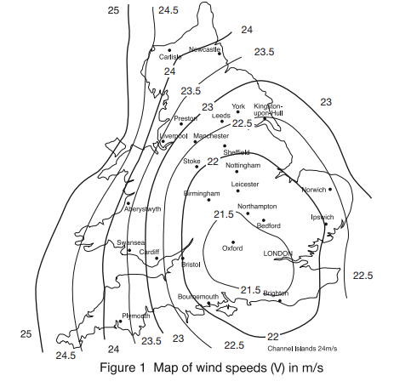
Figure 1: Diagram showing wind loads across England and Wales (Gov.uk, 2013, diagram 6)

In order to counteract the significant wind loads, a rigid core comprised of reinforced concrete will be utilised, as shown in Appendix D. Chudley & Greeno (2020) cite that this can aid in the resistance of lateral loads by transferring them through the cladding and flooring, into the structural core. Coupled with a rigid steel frame this will ensure the structure does not sway or bend in high winds, preventing damage to its immediate surroundings.

3.2.2 Connections

As the frame is required to be rigid, specific attention must be applied to any joints present (especially at places where the frame meets reinforced concrete elements at the base and core). These are required to be ‘moment-resistant’. Therefore, all connections will be bolted. Details of how this would work when connecting to reinforced concrete elements are included in appendixes E & F.

3.3 Internal space

The client has expressed a desire to have as much internal space as possible, with less structural columns cluttering up the internal layout of the structure. As such, the superstructure has been designed with a rigid steel frame. This allows for larger spans in the beams used due to the inherent tensile strength of steel. The beams used will be cellular in design (allowing services to be installed throughout) as detailed in figure 2 below. Use of this form of beam allows for 14-16m spans as needed, reducing the space required for columns (Buxton, 2016).
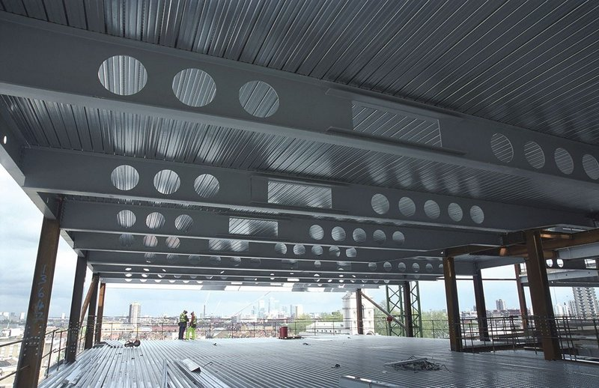
Figure 2: A form of cellular beam, tapered girders (Buxton, 2016)

3.4 Fireproofing

BSI (2010b, page 61) cites the requirement that all buildings must be designed and constructed in such a way that, in a fire event, its stability will be maintained for a reasonable period. Generally with steel frame high-rise structures this equates to 90mins more than it would withstand with no protection. In order to achieve this intumescent paint will be applied to all steel components. A thick layer of this should add 90mins to the stability of the structure should a fire break out (clmfireproofing, 2020).

4. External envelope

The external envelope is an important part of the design and must be designed to meet the following considerations:
- Aesthetics
- Waterproofing
- Fireproofing
- Insulation

4.1 Chosen solutions

Due to uncertainty surrounding certain forms of cladding used in Grenfell, metal panel systems will be avoided. The chosen exterior wrap cladding is the terracotta rain-screen developed by ‘Taylor Maxwell’ using Argeton tiles. A diagram illustrating this is included in Appendix F.
The roof cladding will utilise a metal and mineral wool system, detailed in Appendix G. This will be designed to provide protection against: water, fire and noise.

4.2 Aesthetics

The cladding utilised for the external walls of the structure is a terracotta rain screen system, shown in Appendix G. An advantage of this form of cladding is it comes in various different colours and can be designed to emulate traditional brickwork (Taylor Maxwell, 2022). This is a particular boon for the project as the surrounding streetscape (particularly adjacent properties) is largely brickwork. Therefore, this allows the building to blend in with surrounding listed buildings and the overall feel of the area.

4.3 Inherent properties

As the cladding provided is designed to be multi-functional, this section details the performance of each type used and their various functions. Fireproofing is a key consideration for the external envelope of the structure as any combustibles present without protection have the possibility to cause a ‘Grenfell-style’ incident. As such, both ‘Kingspan K15’ and ‘Celotex RS5000’ (both combustible insulations used in Grenfell) along with any other forms of combustible insulation will be avoided at all costs.

4.3.1 External walls

The external wall cladding is designed to be multi-functional providing the following benefits: waterproofing, fireproofing and insulation.
Rain-screen cladding aims to prevent water ingress via its outer layer, a cavity (lined with a CDM) is also provided to ensure that any ingress during severe weather is dealt with efficiently, either through evaporation or drainage (proteus, 2022). This is ultimately sufficient to keep the structural frame and insulation components dry, detailed in Appendix F.
The insulation used will be mineral wool. This is non-flammable and thus allows the cladding to provide insulation whilst preventing spread of external fire. Additionally all other components utilised as part of this system are classified as ‘non-combustible’ under UK law (Taylor Maxwell, 2022).

4.3.2 Roof cladding system

The roof cladding will utilise a built-up metal roof system, providing the following benefits: waterproofing, fireproofing, noise insulation and thermal insulation. A detailed diagram including all components is included in Appendix G.
Waterproofing will be provided via the outer metal sheet of the system, additionally the roof will be designed so as to tilt slightly towards the edge of the building. This will allow water to run safely off the side of the building preventing pooling. A DPM will also be present within the roof to prevent any ingress towards the installed insulation.
The insulation provided will be mineral wool. Knaufinsulation (2022) cite this can provide competitive thermal and noise insulation in addition to being non-flammable. As the other materials used in the roof are non-combustible this will help to eliminate external fire spread. The noise insulation provided is also a boon as rain may be particularly noisy on the metal roof.

5. Closing statement

It is believed that this report has sufficiently addressed concerns in the following areas:
Sustainability – Addressed through the use of strong materials and long-lasting cladding. This means maintenance to the structure will be very sparse, with only the cladding and roofing likely to need any replacements. However, with a 25-30 year lifespan this will not be a regular occurrence.
Impact on streetscape: Addressed through the use of vibration-limiting methods during substructure construction. This limits any negative effects on nearby buildings and infrastructure.
Aesthetic contribution to skyline: Addressed through the use of a cladding style that blends with the existing streetscape.
Stability: Addressed through the use of a strong structural frame, capable of withstanding all loads required of it.
Internal area: Addressed through the use of a steel frame superstructure with reinforced concrete core. This allows large spans to be present in the beams whilst remaining rigid and capable of withstanding the loads required of it. Large spans in the beams allow for maximised internal area.
Inclusive design: Addressed through the use of three structural cores. As these house elevators, it ensures elevators are available throughout the building. This helps in terms of inclusivity as it means disabled people will never be far from an elevator.
Waterproofing: Addressed via various elements in both the substructure and superstructure. Cavities throughout the building prevent any significant ingress, allowing basement levels to be classified as habitable.
Fireproofing: Addressed through the use of non-combustible elements in the exterior envelope, this means external fire spread can be limited. Internally, the steel frame will be treated with intumescent paint to allay structural failure. However, it is hoped sprinkler systems included internally can prevent this from ever being a possibility.

6. List of figures

- Figure 1: gov.uk (2013) Building regulations: Approved document A. [Online] Available at: https://assets.publishing.service.gov.uk/government/uploads/system/uploads/attachment_data/file/429060/BR_PDF_AD_A_2013.pdf (Accessed: 05.03.22)
- Figure 2: Buxton, P (2016) How far can you go?. RIBA. [Online] Available at: https://www.ribaj.com/intelligence/how-far-can-you-go (Accessed: 17.03.22)

7. List of references

- BSI (2009) BS 8102:2009. Code of practice for protection of below ground structures against water from the ground. [Online] Available at: https://products.ihserc.com/tmp_stamp/656286413/NBPJPCAAAAAAAAAA.pdf?sess=656286413&prod=CIS1 (Accessed: 05.03.22)
- Buxton, P (2016) How far can you go?. RIBA. [Online] Available at: https://www.ribaj.com/intelligence/how-far-can-you-go (Accessed: 17.03.22)
- Chudley, R and Greeno, R (2020) Building construction handbook. 12th ed. Oxon: Routledge.
- Clm fireproofing (2020) Our guide to structural steel fire protection. [Online] Available at: https://clmfireproofing.com/our-guide-to-structural-steel-fireproofing/ (Accessed: 17.03.22)
- gov.uk (2013) Building regulations: Approved document A. [Online] Available at: https://assets.publishing.service.gov.uk/government/uploads/system/uploads/attachment_data/file/429060/BR_PDF_AD_A_2013.pdf (Accessed: 05.03.22)
- gov.uk (2020) Building regulations: Approved document B. Vol.2 [Online] Available at: https://assets.publishing.service.gov.uk/government/uploads/system/uploads/attachment_data/file/937932/ADB_Vol2_Buildings_other_than_dwellings_2019_edition_inc_2020_amendments.pdf (Accessed: 05.03.22)
- Illingworth, J (2000) Construction methods and planning. 2nd ed. Oxon: Routledge
- Knauf insulation (2022) Insulation for built-up metal roofs. [Online] Available at: https://www.knaufinsulation.co.uk/applications/roof-solutions/built-up-metal-roof (Accessed: 28.03.22)
- Proteus (2022) Rainscreen cladding. [Online] Available at: https://proteusfacades.com/technical/rainscreen-cladding/ (Accessed: 27.03.22)
- Taylor Maxwell (2022) Argeton terracotta cladding. [Online] Available at: https://www.taylormaxwell.co.uk/facade-systems/terracotta-cladding (Accessed: 27.03.22)

8. Appendix A – Retaining wall

Guide wall acts as tie-beam
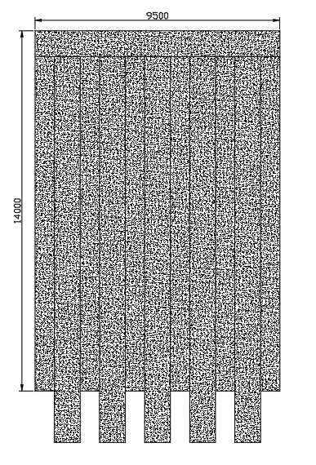
Ground level

Bentonite-
Cement-PFA
piles extend
2m below
basement
floor slab

Bentonite-cement-PFA piles act as water-stops

Reinforced concrete piles act as foundations, extending deeper than other piles
9. Appendix B - Water-stop locations and substructure frame
Cavities omitted

Elevator shaft
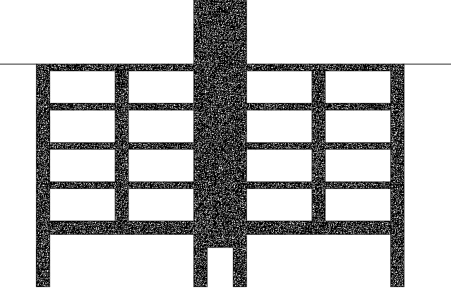
Ground level Ground level

Water-stops Water-stops

Retaining wall Retaining wall

Piles & pile cap for elevator shaft

Corner detail w/ cavity in appendix C

10. Appendix C – Cavity details
200mm cavity Interior blockwork wall
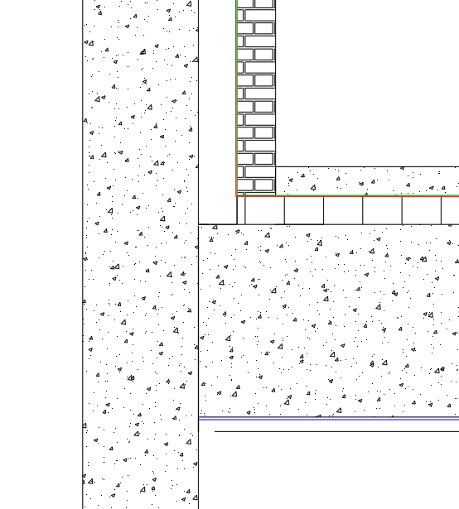
600mm =DPM
Pile wall =VPM
=CDM

Screed flooring

Hollow concrete tiles

1m thick reinforced concrete floor slab

100mm thick blinding

11. Appendix D - Superstructure frame
Actual building extends a further 5 storeys
Reinforced concrete elevator shaft

Steel frame Steel frame
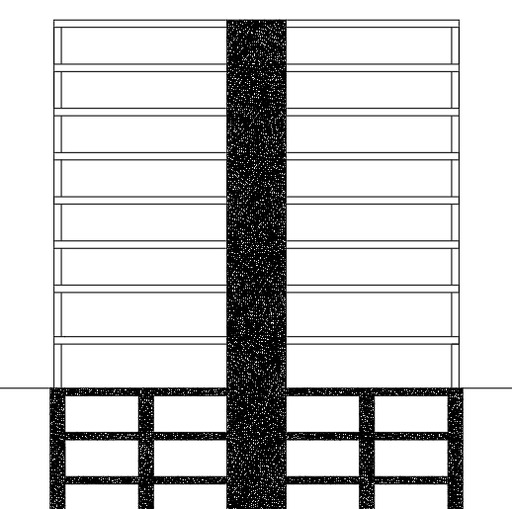

Detailed diagrams of these connections in Appendices E & F
Ground level
12. Appendix E – Frame connection detail (core to beam)

Core wall Steel beam

Lateral restraint
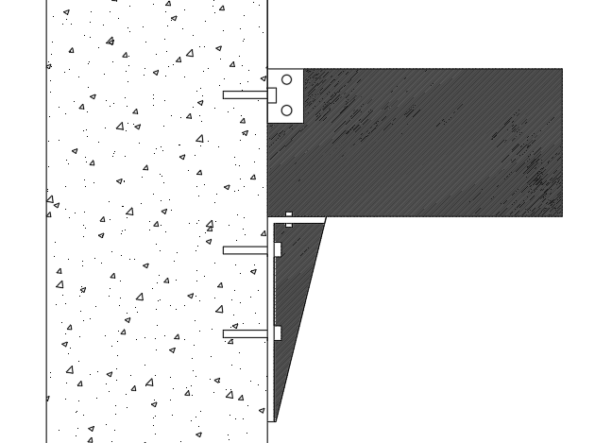

Bolt

Seating bracket on epoxy bed

Drilled and grouted bolts

13. Appendix F – Frame connection detail (Column to foundations)
Steel column

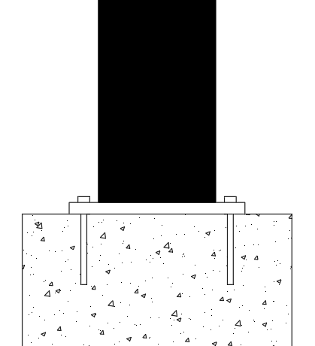

Base plate (steel)

Threaded rod, g grouted-in bolts

Concrete foundation (retaining wall)
Grout beneath base plate

14. Appendix G – External wall cladding system (Cross-section)
Drainage cavity

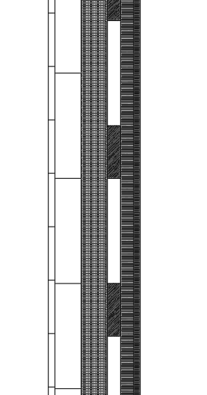
Internal plasterboard

Internal plaster render

Aluminium framework
for tiles Insulation

Lightweight gauge steel
frame provides support

=CDM
=VPM

Terracotta
rain-screen
tiles

15. Appendix H – Roof cladding system (cross-section)

High profile steel sheet tilts drains towards building edge

Insulation

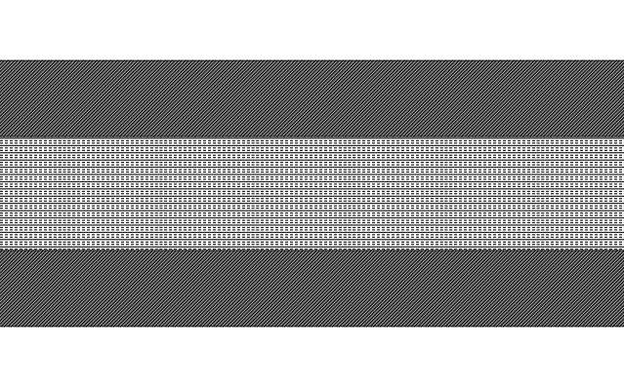

=DPM
Low-profile steel sheet below =VPM

