
APPENDIX GA36d

LEVEL 7 ASSESSMENT SPECIFICATION

Student name: | Jiawei Xu | Student ID number: | 2105968
Programme: | Professional Doctorate Art & Design
Module: | Approaches to Art & Design Research and Academic Communication
Module code: | ADAD7014 | Contribution to Overall Module Assessment (%): | 100
Lecturer: | David Jarvis and Timi O’Neill | Internal Verifier: | Robert Charters
Assignment Title: | Situating your research and practice | Word count (or equivalent): | 7500 words
Submission deadline: | December 13th 2021 | Return date of provisional marks & written feedback: | 10/01/22
Submission method: | All written assessments, where practical and possible, must be submitted via Turnitin unless otherwise instructed by the Lecturer. (Please DO NOT put this assessment specification into Turnitin or it will match many similarities with other students’ submissions.)  Alternative submission method (if applicable):  Late submission of the assessment will result in a late penalty mark. Penalties for late submission: Up to one week late, maximum mark of 50%. Over one week late, 0%. Only the Extenuating Circumstances Panel may approve a change to submission dates.
Academic honesty / referencing: | Academic honesty is required. In the main body of your submission you must give credit to authors on whose research and ideas your work is based. Append to your submission a reference list that indicates the books, articles, etc. that you have used, cited or quoted in order to complete this assessment.

Module Learning Outcomes
(from module syllabus)
- critically reflect on the role of theory, epistemology, ontology and axiology in shaping and interpreting the creative practitioners research;

- critically discuss approaches to reliability, validity and bias in social / cultural research;

- examine fully the ethical considerations in social/cultural research and develop designs for practitioner research that meet a high standard of ethical practice;

- critically analyse professional practice communications and communicate scholarship effectively.

1. What is knowledge?
In this chapter, knowledge will be discussed in terms of the definition of knowledge, the way that knowledge is formed, and the acquisition of knowledge, etc.

1.1 Definition of Knowledge
When we discuss the word “knowledge”, the first come to my mind is that knowledge can be anything. Knowledge floods our daily life, and it also affects us all the time.
According to Wikipedia, knowledge is a familiarity or awareness, of someone or something, such as facts (descriptive knowledge), skills (procedural knowledge), or objects (acquaintance knowledge) contributing to ones understanding.
According to Oxford Dictionary, knowledge is “the information, understanding and skills that you gain through education or experience”.
“Knowledge is a fluid mix of framed experience, values, contextual information, and expert insight that provides a framework for evaluating and incorporating new experiences and information.” (Davenport and Prusak, 1998)
Knowledge is the fusion of structured experience, value, relevant information, and expert insight, and provides a framework for evaluating and generating new experience and information.(Wu. Y, 2005)
From the above definition, we can see the keywords that appear, facts, skills, information, understanding, experience, etc. In addition to the sentences that define knowledge, describing the way in which knowledge is formed is a common practice in defining knowledge.

1.2 Formation of knowledge
Scholars think, knowledge refers to facts with attributional meaning, where meaning is a function of an individual's observation, learning, experience, and understanding of reality in a specific situation or context within a specific period of time. (Oladejo and Daivd and Osofisan, 2009, p. 3) Figure 1. summarizes their view.
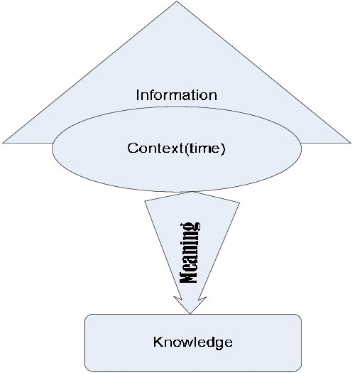
Figure 1. What is knowledge?

The DIKW system is a model of Date, Information, Knowledge, and Wisdom.
Thomas Sternas Elliott once put forward the DIKW theory, "DIKW is a model of data, information, knowledge and wisdom, in which each layer is endowed with certain characteristics than the next layer. The data layer is the most basic. The consulting layer adds content, the knowledge layer adds how to use it, and when does the wisdom layer add it. In this way, the DIKW system is a model that allows us to understand the limits of analysis, importance, and conceptual work."
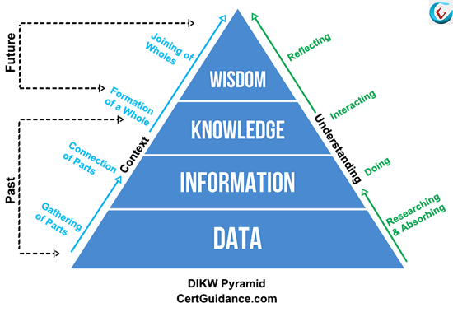

Data
Data is an entity that can be defined as meaning, and it relates to the existence of things. It is a set of discrete, objective factual descriptions of events, and is the original material that constitutes information and knowledge. Most of the data sources come from daily life.

Information
Information, which is effective, processes the data logically, and evaluates the value of the processed data. The collection of information is drawn from different aspects, such as school, family, society, and personal experience.

Knowledge
Knowledge is strongly related to information. People analyze information by induction, deduction, comparison and other methods, so that the valuable parts continue to be precipitated and combined with the existing knowledge system. This part is valuable Information is transformed into knowledge.
The process from information to knowledge, Figure 1, also has a expression.

Wisdom
On the basis of existing knowledge, people analyze, compare, and interpret the problems that arise in the real world to find solutions based on the information they have obtained. From this constitute a set of knowledge system.
The relationship between the four, for example, I have a pencil and an eraser in my hand. (Date) I found a sketch book where I can draw a picture with what I have in my hand. (Information) I keep practicing and make paintings that I am satisfied with. (Knowledge) I specially wrote a book on the history of painting, painting techniques of different countries, artistic value, appreciation of paintings, etc. (Wisdom)

The definition of data, information, and knowledge depends on the recipient, and there is no clear boundary between the three. Different people have different definitions of these three. For some people, pencils and erasers are data, while for others, sketchbooks are data. For different contexts, the value of information will also change. Therefore, it makes sense to process and apply data and information in a specific context (ie, people, tasks, etc.). Therefore, the DIKW system is considered by researchers to be too linear.

There is another nonlinear model of knowledge, the JTB model. When mentioning this model, We need to know Epistemology. Epistemology is the branch of philosophy that studies what is knowledge, what do we know, and how do we know. Although it is often regarded as the most basic branch of philosophy, it is not a very large branch of philosophy. The main research object is what knowledge is.

Justified true belief
Justified true belief is a definition of knowledge in the theory of knowledge, which believes that knowledge is "confirmed true belief." Specifically, it means that the proposition "S knows P" can be established if and only if the following three conditions are met (Figure 3):
P is true
S believes that P is true, and
S is justified in believing that P is true
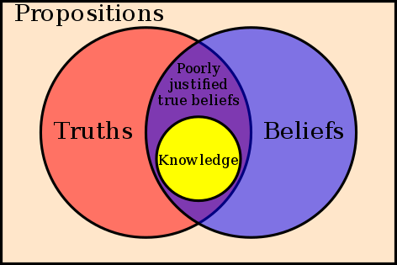
Figure 3. Justified true belief

Belief
The prerequisite for a theory to become knowledge is that you must believe in the theory. For example, I can say: "Spider-Man is a fictional character in Marvel comics." When I said this sentence, I believed it was correct. So for me, this sentence has the possibility of becoming knowledge. If it meets the two conditions of authenticity and provability, it becomes knowledge.

Truths

Truth is a metaphysical concept. As in the previous example, Iron Man is a fictional character in Marvel comics. I will never know whether this sentence is true or false, because I will never know whether there is a parallel world in which there is a flesh and blood Spiderman. No matter how many movies I watched and how many comics I have made up, I can only convince myself that the Marvel Universe is a fictional world, and I cannot know whether it is true or not.

But whether I believe it or not, that parallel world will be there or not, it will not come or go. Truth is like that parallel world, it is an objective existence, eternal, and unpredictable state. The expectation that we give knowledge "objectivity" and "authenticity" does not mean that knowledge itself is true, but represents people's yearning for truth.

Justification
The relationship between the two elements of proof and truth is very close. Because the truth is sought by others, the proof becomes especially important. If there is no proof, knowledge becomes pure faith—for example, the founder of Mormonism in the nineteenth century. He once vowed to claim that he had been visited by Heavenly Father, so he learned the contents of the holy book and founded Mormonism. The reason why we think this story is absurd is because it lacks sufficient proof.
There are actually many ways to provide proof of knowledge. The ones we come into contact with most in daily learning are the testimony of authority figures (Testimony), our logic (Reasoning), and our own sensory experience (Sensory experience).

1.3 Acquisition of knowledge
From baby to adult, how do we acquire knowledge?
The first is to learn knowledge from the family environment and the education of parents. Then in the school, teachers, textbooks, reference answers, and outstanding students. At work, bosses, colleagues with strong working ability, training courses, etc. These authoritative people and things provide testimony for the knowledge we have absorbed.
Each person is a separate individual with his own set of thinking logic, but it is difficult for us to rely on our own logic without listening to other testimonies. Of course, to a certain extent, it is also possible to do this, for example, a mathematics genius who knows nothing about it, derives all formulas and solves the unsolved mysteries of the world. But even a mathematical genius cannot exist without Euclid's mathematical axioms. Axioms lay the foundation for all derived knowledge, if in another mathematical system, the shortest distance between two points is no longer a straight line, all proofs will be invalid.
This is the biggest limitation of deductive reasoning. Deductive reasoning tells us that conclusions can be directly based on assumptions. If the assumptions are correct, then the conclusion must be correct. The following figure is a proof of everything from the perspective of whether the hypothesis is true:

Birds can fly.
I am a bird.
Therefore I can fly.
I can fly because I am a bird.
This method can be established in mathematics, because the axioms of mathematics are self-evident. However, in other areas of knowledge, it is not necessarily true. For example, Newtonian mechanics is based on the assumption that space and time are absolutely flat. When we first learned about various accelerations, gravitations, forces, and reaction forces, we also thought it was absolutely correct. However, after learning quantum physics, I gradually discovered that Newtonian mechanics is not necessarily correct.
The basic assumptions of science are different from the axioms of mathematics. Mathematics is very high handed: in mathematics, once a system is established, within this system, it is the god who rules everything. But scientific research is such a vast world, completely independent, and will not change because of our assumptions or definitions. The hypothesis in science is just a cautious temptation in the process, like the blind man and the elephant.
The third way to acquire knowledge is to use our senses. We know that the sky is blue because we see it is blue. Newton was able to discover gravity because an apple happened to fall on his head. We know the meaning of cold, know what the taste of sugar is, we will cry when we see Romeo and Juliet, all of this is due to our five senses.
There is an old Chinese saying, “seeing is believing.” It means that the things heard from the hearsay are not true, but the things you have seen and experienced are true. Knowledge acquired from sensory experience seems to be more reliable than knowledge acquired through testimony. But the appearance of optical illusions proves that sight is not necessarily true.
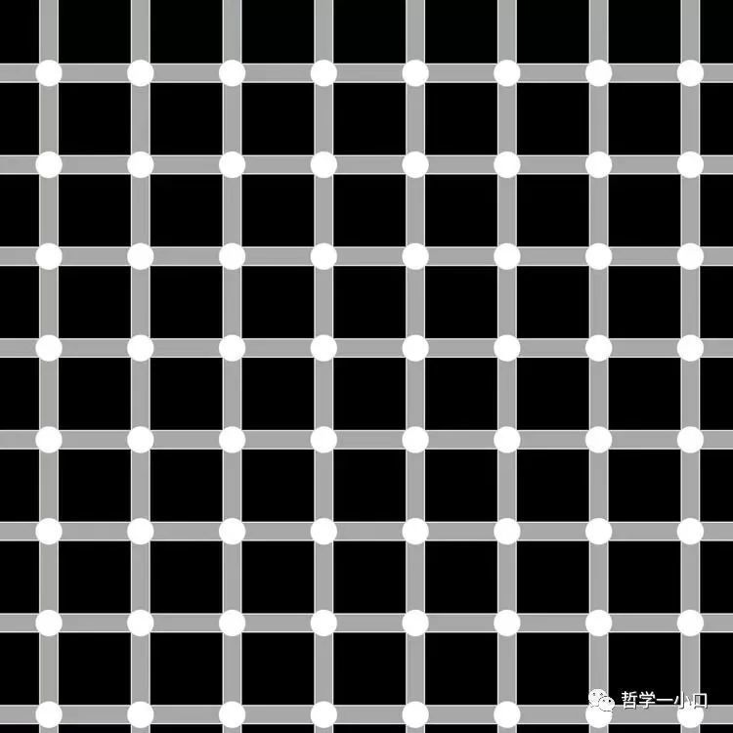
In contrast to the way humans acquire knowledge, research has also been conducted on acquiring knowledge in machines. Knowledge acquisition refers to the problem of how machines (computers or smart machines) acquire knowledge in artificial intelligence and knowledge engineering systems. (Forsythe. 1993) The way machines acquire knowledge: one is manual transplantation, the other is machine learning, and the third is machine perception.

1.4 Conclusion
Through the definition of knowledge, the way of knowledge formation, and the acquisition of knowledge, we can answer what knowledge is, combined with Karl Popper's division of the world. Karl Popper mentioned in the book "Objective Knowledge: An Evolutionary Study" that he divided this world into three worlds. The first world is the physical world or the world of physical states; the second world is the spiritual world or the world of mental states; the third world is the world of conceptual things. These three worlds form such a relationship: the first two worlds can interact, and the latter two worlds can interact. Therefore, the second world, the world of subjective experience or personal experience, interacts with either of the other two worlds. The first world and the third world cannot interact with each other except through the intervention of the second world, the world of subjective experience or personal experience. (Karl, 1972) I will assume that knowledge exists in these three worlds, and divide knowledge into three categories.

1.4.1 Known knowledge
Known knowledge, such as books, encyclopedias, or figurative system of human knowledge, is a set of knowledge or some series of information obtained through research, investigation, observation, or experience.
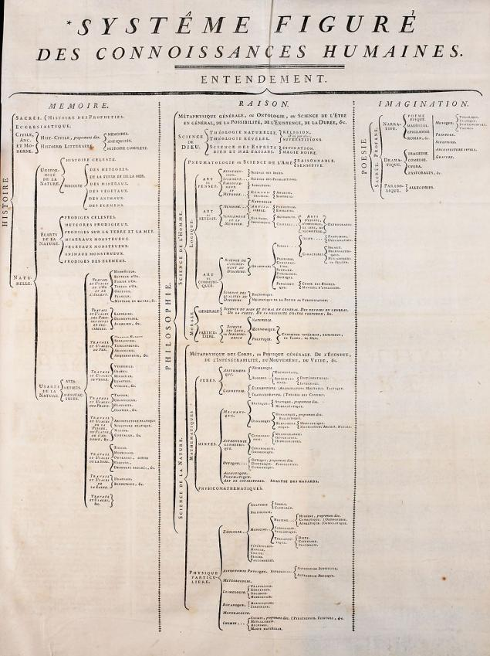
Classification chart with the original “figurative system of human knowledge”tree, in French.

1.4.2 Comprehensible knowledge
The word "knowledge" comes from the Greek epistme in Spanish. From the root of it, it means epi (above) + stem (standing), so directly derived from this word are “understand (verb) ”in English and“Verstand (noun)” in German, both words mean understanding.
This type of knowledge is human-centered, which is close to the definition of Wisdom in DIKW. On the basis of existing knowledge, people are based on their own experiences and experiences in the real world. When encountering problems, analyze, compare, and deduct solutions based on the acquired knowledge. So as to form a set of knowledge system.

1.4.3 Existential knowledge
The knowledge of existence can be explored from the perspective of the future, such as Carl’s interpretation of the world of the concept of the third world, that is, the world of ideas in the objective sense—it is the world of possible thought objects: the theory of freedom and its The world of logical relations, free arguments, free problem situations, etc.（Karl R. 1972)
For example, when designing, we often use a term called conceptual design. It is not our existing design rules to design, but there are many undeveloped design rules.
All in all, my understanding of knowledge is still very shallow. For the JTB model, there are skepticism, and the most famous doubter is Gettier. Gettier believes that these three conditions are not sufficient for knowledge. Therefore, the interpretation of knowledge can only be carried out under certain premises.
In Chinese traditional thought, there is no concept of "knowledge" in the epistemological sense, because the center of Chinese traditional thought does not lie in the actual conditions of objective things outside of people. Similar to the concept of "knowledge" is the ancient Chinese "knowledge", but this "knowledge" is human-centered and has more internality, including not only the understanding of dealing with others, but also the inner moral cultivation and personality state. The "study for knowledge" mentioned in "University" is not about observing and understanding the objective world, but by observing the interpersonal communication in daily life, stimulating the moral consciousness in the heart, and gaining in-depth understanding of morality. The same goes for Wang Yangming's "Unity of Knowledge and Action" and "To Conscience".
Therefore, from the different understanding of "knowledge", we can see the difference between Chinese and Western traditional thoughts. Western thinking is rational and objective, and has a strict distinction between subject and object; traditional Chinese thinking values people and culture, especially daily ethics and moral cultivation.
2. Reflections on previous research
2.1 The definition of reflection
Reflection, also called introspection and reflection, is a relatively widely used concept in modern Western philosophy. The British philosopher Locke believes that reflection or introspection is the human mind's attention and intuition to its own activities, and it is one of the sources of knowledge. People obtain ideas about them, such as intuition, thinking, doubt, belief, etc., by reflecting on the activities and methods of the soul. (Scharp. 2008) The German philosopher Hegel believed that reflection is a dialectical concept that grasps the development of absolute spirit, and that reflection is the concept of grasping the essence of the unity of opposites within things from the connection.
Everyone has their own set of rules of conduct. As mentioned in the previous chapter, the second way to hear testimony for knowledge is our logic. For example, in work, when there is a set of habitual thinking, you will be addicted to the habitual thinking, and there is no way to get out of your own thinking at this time. When we want to escape, we must go through reflection.

2.2 Design Thinking
My major is visual communication design, design thinking is the foundation, and design is to solve problems. Reflection is also a way to solve problems. I think the two have something in common. Design thinking refers to the method and process of investigating ill-defined problems in the field of design and planning, obtaining a variety of information, analyzing various factors, and setting solutions. Design thinking can be roughly divided into four types of thinking: reverse and forward thinking, divergent and focused thinking, conversion and displacement thinking, innovation and attention to detail thinking.
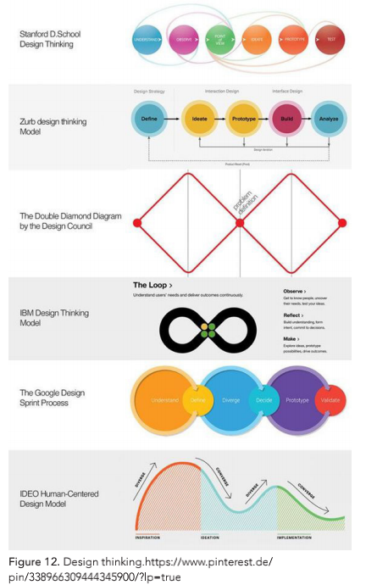
I think design thinking is a good way of reflection. Through design thinking, you can think about design work in many ways. Take my previous design cases as an example.

2.3 Previous work
The participation rate of young generation in Beijing Opera is rather low recent years. It can be said that people are willing to watch movies or go to concerts instead of attending Beijing Opera shows. According to the questionnaire, aging of the targeted group is from 20 to 30, 71% of them have not watched any live shows of Beijing Opera. In their point of view, many of them believes that this issue is due to lack of propaganda means of modern marketing. Aiming at this situation, this study focuses on the formation process and function of Beijing Opera mask and then redesigns it in the combination of common sense modern style from the perspectives of Beijing
Opera mask, which is the most representative in Beijing Opera. The primary function of Beijing Opera mask is to build the connection with audience and enable the audience to understand each actor of Beijing Opera mask. In such, I started from the communication between Beijing Opera mask and the audience, then conducted research and analysis based on the visual characteristics of Beijing Opera mask which is colour and graphics. Finally I simplified the original Beijing Opera mask by my experiment.
Herein, we combined the redesigned Beijing Opera mask with the modern product - the bottle of Nongfu Spring, planning to conduct cultural popularization of Beijing Opera jointly by Nongfu Spring and Zhezixi (opera highlights) from Mei Lanfang Theatre. This is aim to apply modern tools to influence more younger population audience to attend and get to know more about Beijing Opera.

2.3.1 The first part of my redesign of Peking Opera facial makeup
Based on four characteristics of colour and symbolic of pattern, like one plus one equals two, I refactor the construction of the masks by extraction the colours and representative patterns from masks. Before that, let’s do the color design part.
The first attempt is to use colour to represent different masks, and reorganize the masks according to the colour proportion. The Mask by scanning is removed eyes and ears to reduce errors and puted into
“The Image Colour Summarizer” (http://mkweb.bcgsc.ca/colour-summarizer/) tool to analyse the colours form this mask.
After removed the error colour I calculate the general proportions of colours. I redesign the mask by using the proportions of colours, like human’s DNA, that can create a mask’s DNA. Therefore, I use arc shape to expression. Also, I try another way to reconstruct the colours by using a circle of gradients. A source of inspiration for this design is a distant object by astigmatic eyes. If a person has a high degree of astigmatism, taking off his glasses and looking at his face is a fuzzy patch.
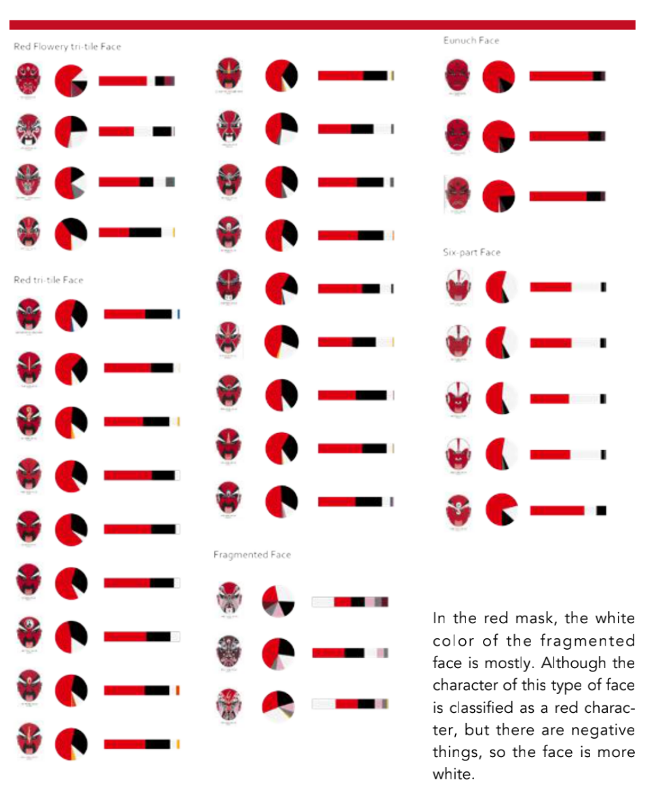
When people see a certain colour, the psychological response is generally close to or consistent with the colour itself. (Xi, Li, L, 2005) For example, it’s easy to make people think of the clothes of the medical staff when we see white, think of nature when we see green, think of traffic light when we see red and green, etc. But at the time of opera mask’s birth, people at that time felt something different from the current situation through colour.
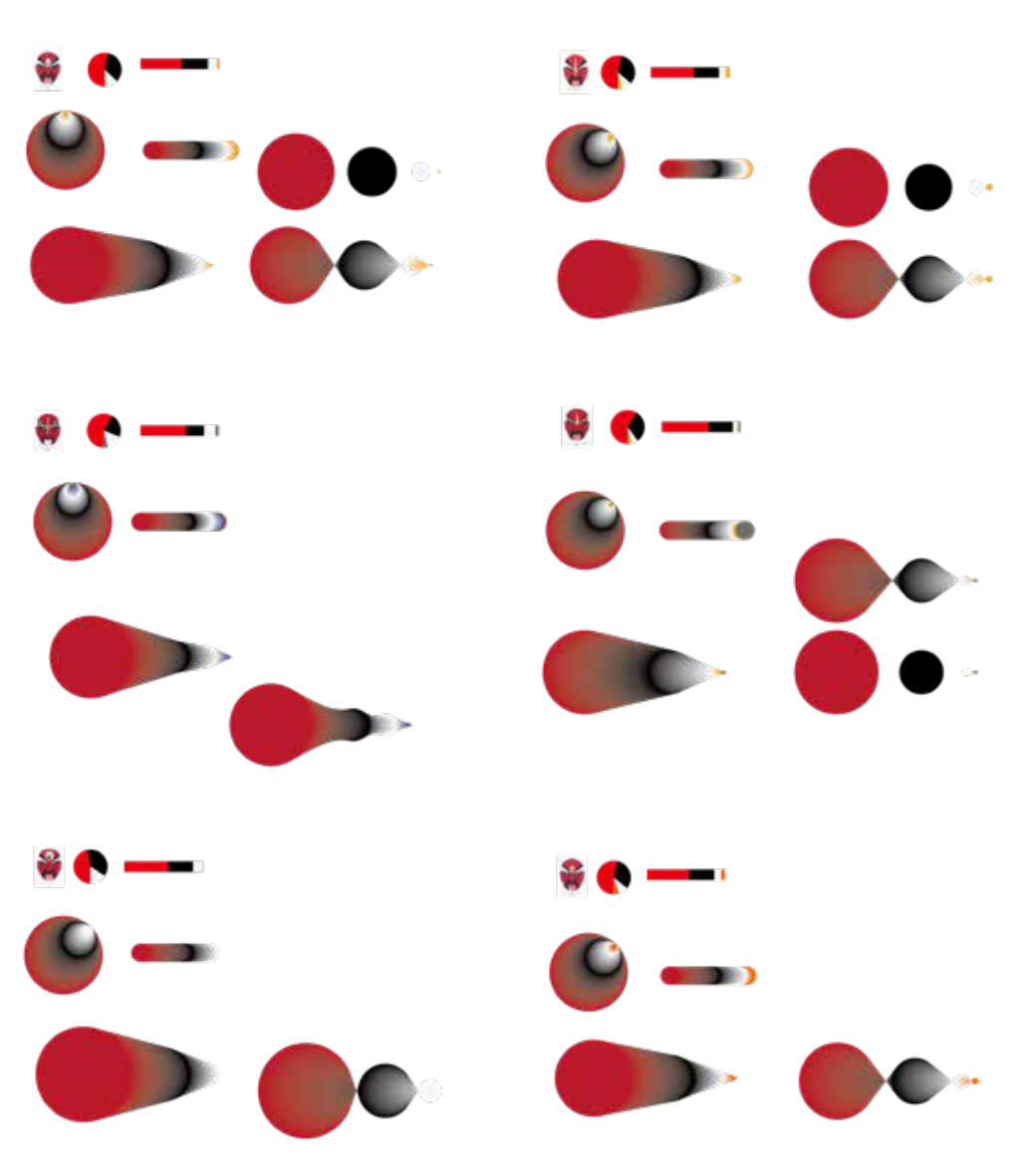
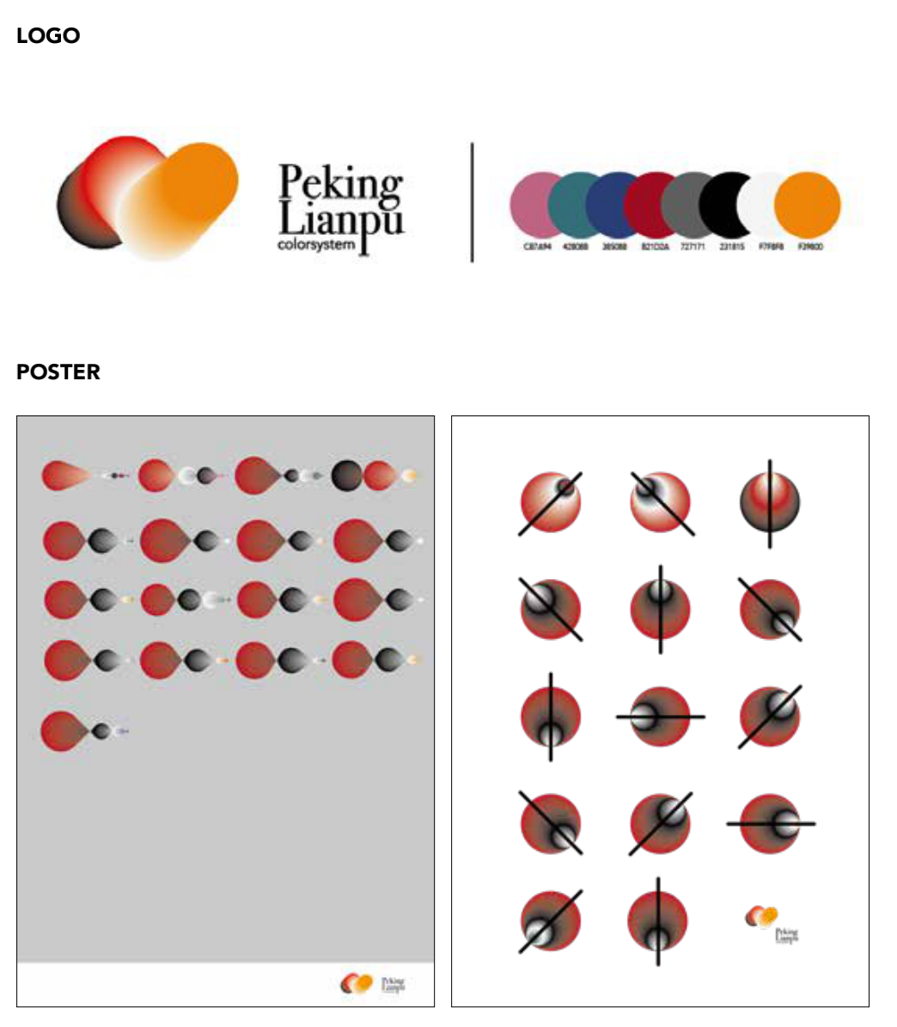
The second attempt is to use colour mix pattern to form a mask, which is also a simplified process. Remove the figures of eyes, nose and mouth, leaving the main colour of forehead and mask with the most recognizable degree.
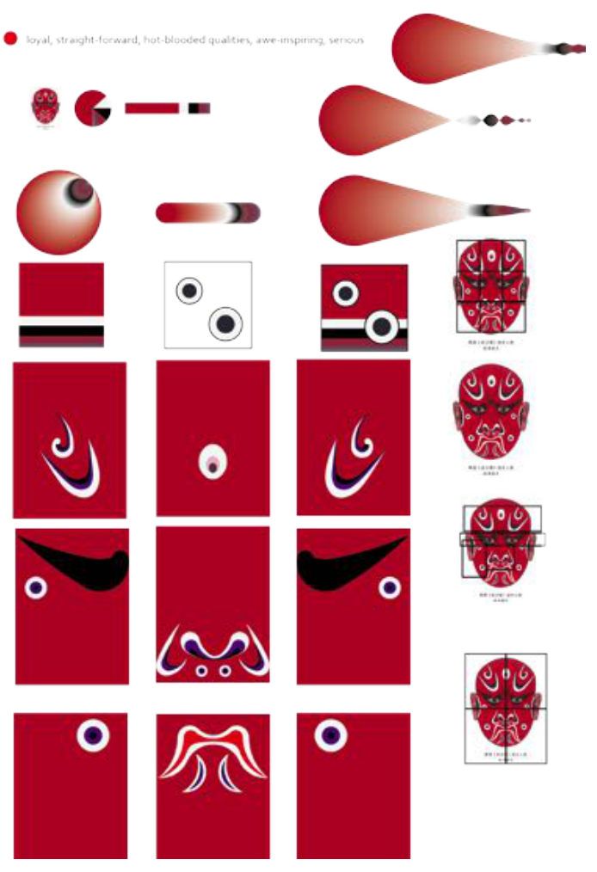

Reflection of the first part:
There is a lack of uniqueness in this design. In the mask with black as the main colour, there is a problem that white accounts for more than black, which is related to the spectral types and has become a factor that can not only explain different faces with colour. The combination of colour and graphics is not unique to every mask, so only a small amount of mask recognition can be achieved by this way. There are also some masks that have no features, such as Guan Sheng.The colours can only distinguish spectral patterns. It can not be applied to the actual role, that is, the generality can not be targeted for design.

2.3.2 Second part of the Peking Opera facial makeup
In the second part of the Mask design, I plan to reduce the time it takes for the audience to recognize Peking Opera facial makeup.
In this chapter, I used an experimental to reduce the complexity of Bejing Opera Mask. Ludwig Mies van der Rohem the Modernist architect in 1947 brought forth the idea “less is more”. In the Spring and Autumn period (700-476 BC), the great ideologist Laozi claimed in his book The Tao Teh King that having less means gains while having more confusion.In my survey, There are 29.4% people can not recognize Beijing Opera masks, and 66.7% people are able to know a few masks. They were basically unable to recognize it, even though they did not know that the red colour represents righteousness and courage. So I designed a small experiment to simplify the Beijing Opera Mask in this situation. I simplified the Beijing Opera Mask with people’s first impression of the opera mask, thus reducing people’s understanding of time.
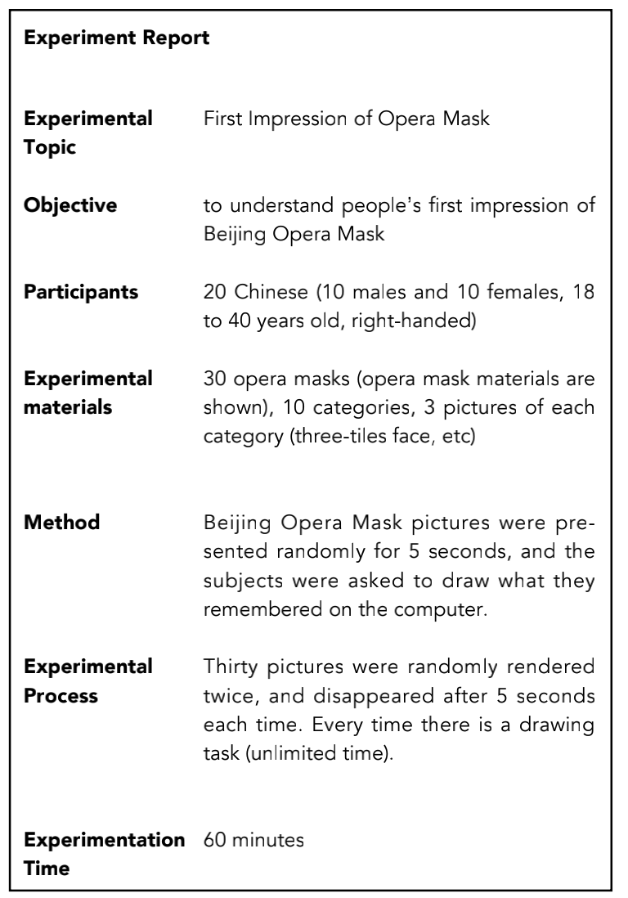
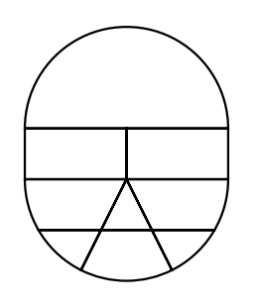
Analytical structure(Figure 6): forehead area, eyes area, cheeks area, nose and mouth area
In tests, there are only a few points that people can pay attention to in a short
time, so when I design the pattern from different part of a mask I will combine
several recurring elements.
Figure 6.
Analysis report:
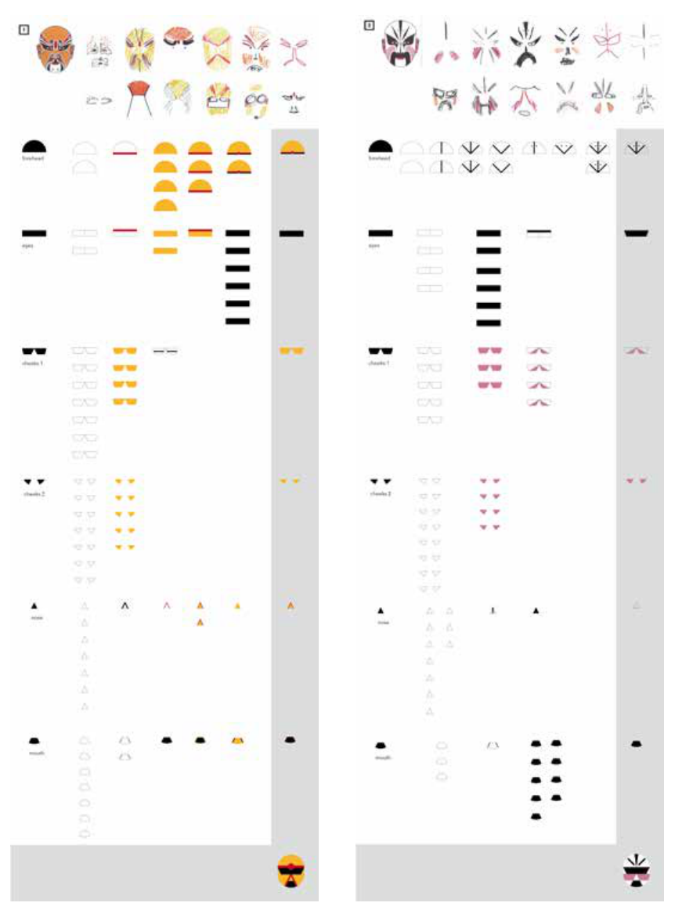
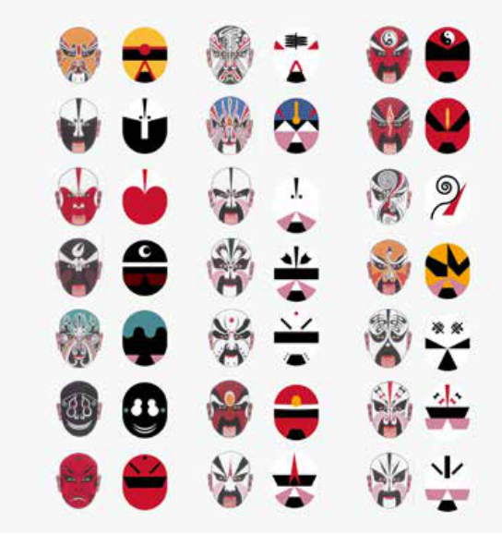
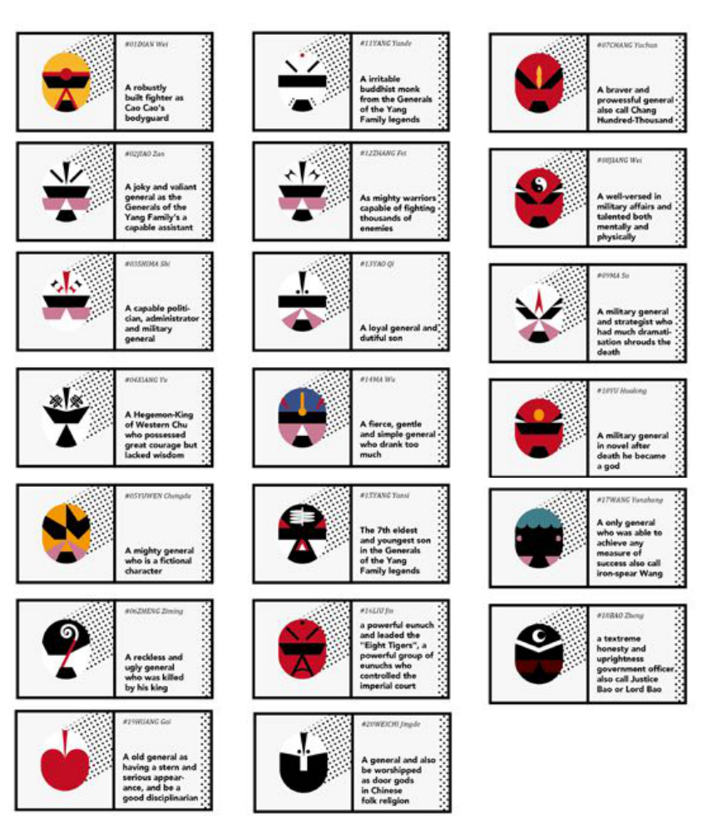
Reflection part：
Through observation, it is difficult for people in the experiment to remember shape and colour at the same time. Too complex images often lead to the neglect of other information, and most of the subjects take colour as the first memory point.
Inspiration comes from jigsaw and abstract paintings, but the target group works on adults. Since children’s toys have rich colours, they are easy to attract people.
When the experimental results come out, we must start to think about how to integrate the experimental results into the actual design.
First of all, the lack of motivation of participants makes it more difficult to simply protect and inherit the Beijing opera culture, which is originally out of line with the times.
Secondly, Beijing opera itself is the product of commercialization. The consumption of Beijing Opera in ancient times is just like the consumption of cinemas now. It’s just that through historical inheritance, Beijing Opera has become a culture. In addition, regardless of the commercial level, Beijing Opera is difficult to find a suitable position in the society. For example, one of the world-class intangible cultural heritages is Italian Sicilian puppetry. From the beginning of the 19th century to the middle of the last century, Sicilian puppetry was very popular. However, because of the emergence of TV, film and other diversified forms of entertainment, people’s traditional way of entertainment decreased a lot, leading to the relevant practitioners had to change careers. In order to protect this culture, the Italian government has implemented many measures, such as establishing the Sicilian Puppet Festival and awards, holding exhibitions, creating puppet plays to learn and so on, but this can not fundamentally solve the dilemma of traditional culture.
Therefore, the combination of traditional culture and business can promote the traditional culture. Also, it improves the enthusiasm of the public participation and enhance the goodwill of consumers to commercial brands.
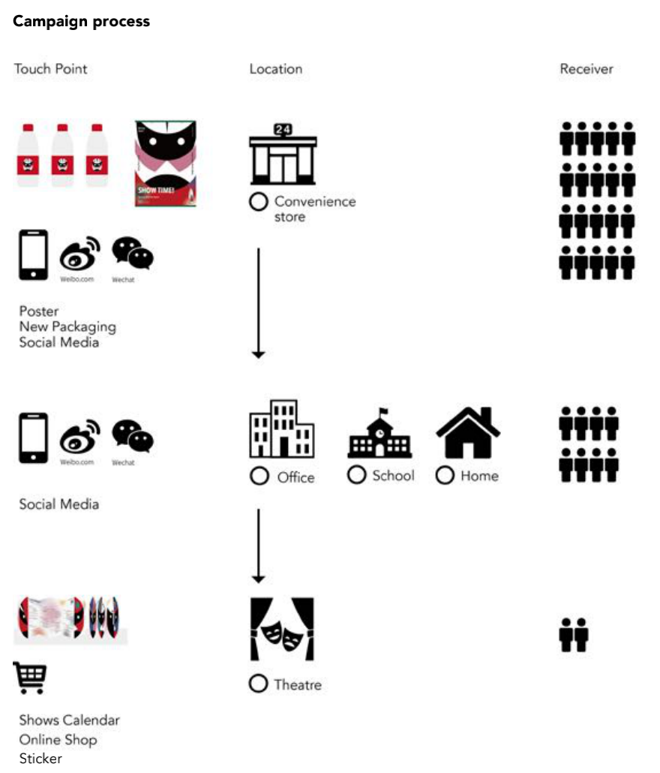
2.3.3 Final Design process:
Redesign of Beijing Opera Mask
Two times of redesign has been done based on the original masks in Beijing Opera. Firstly, the structure has been reconstructed in combination with the results of experiments. Secondly, mask was made to be more arc and the eye parts has been added to make it look more personified. It aldo allows people to better locate the position of the mask on the face.
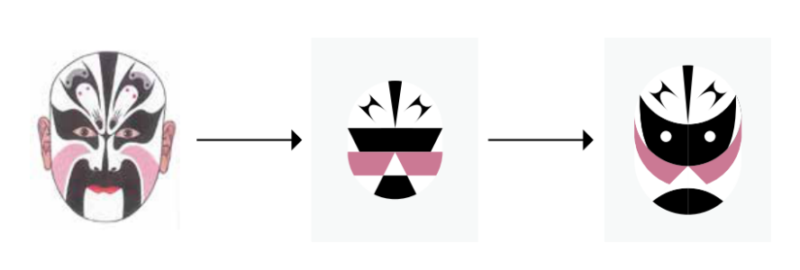
Campaign Logo
Aiming to combine these three element in design: Nongfu Spring, the logo of Mei Lanfang Theater and the campaign name “HAO”, many sketches have been done. The end version of Logo has been made out with the shape of the logo of Mei Lanfang Theater and the important slogan “Highlight at Nongfu Spring”, also the HAO is highlighted.
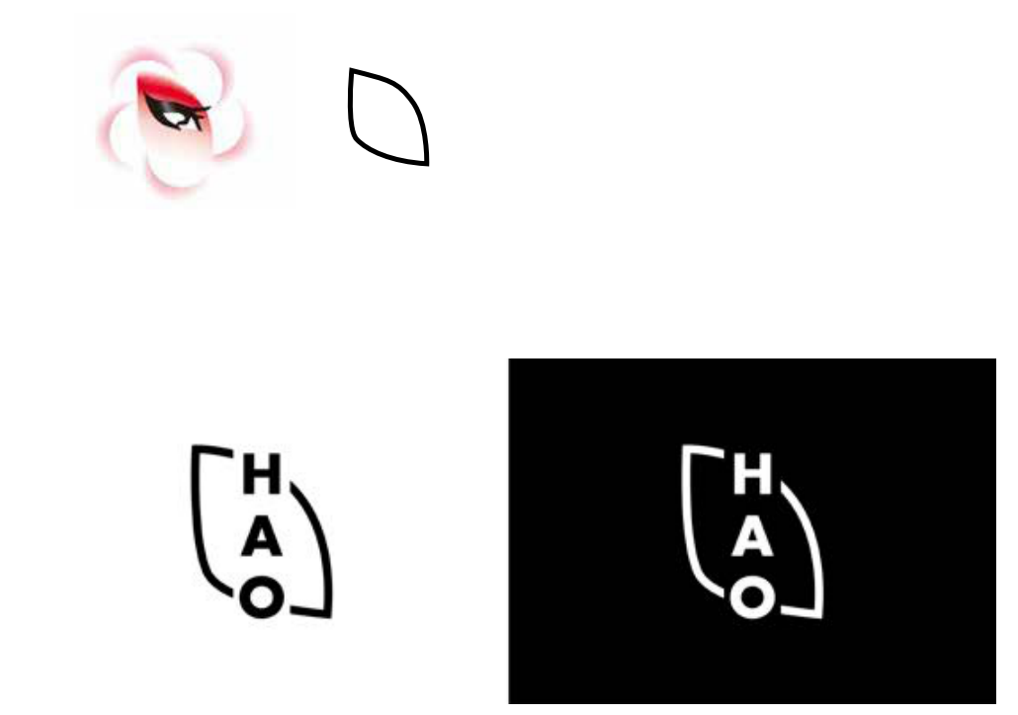

Combination of Logo and Masks
In the colour design for Masks, I extracted the colours of the masks and created the graphics according to the color components. Based on the shape of the sound wave that created by calling different characters’ name, I designed the different colour combinations of these 12 facial masks. Furthermore, they were combined with the logo, so that many variations can be shown.
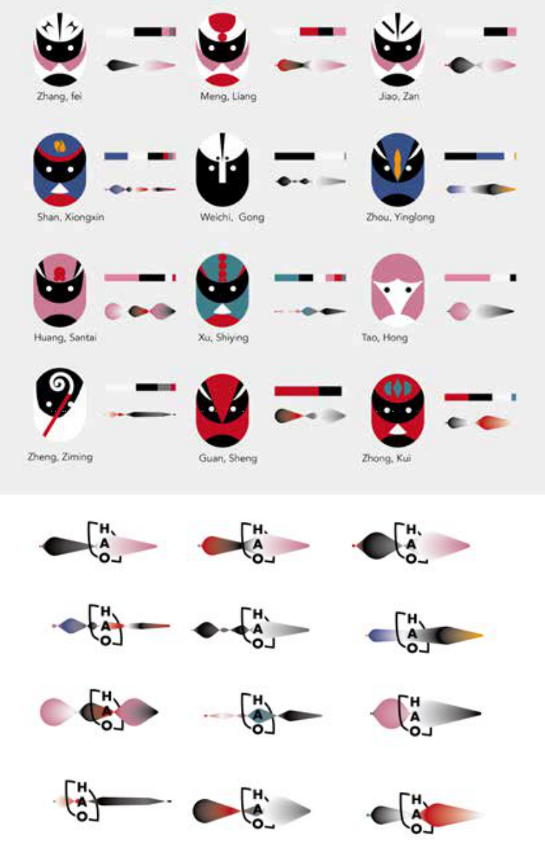
Packaging Design of Water bottled
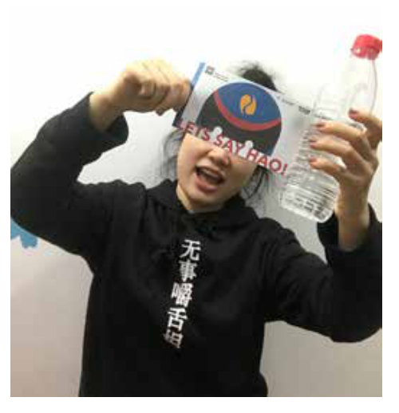
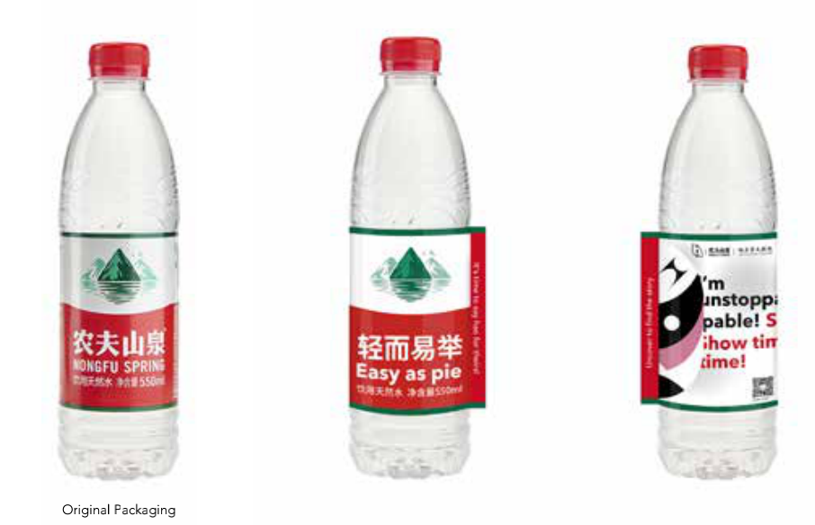
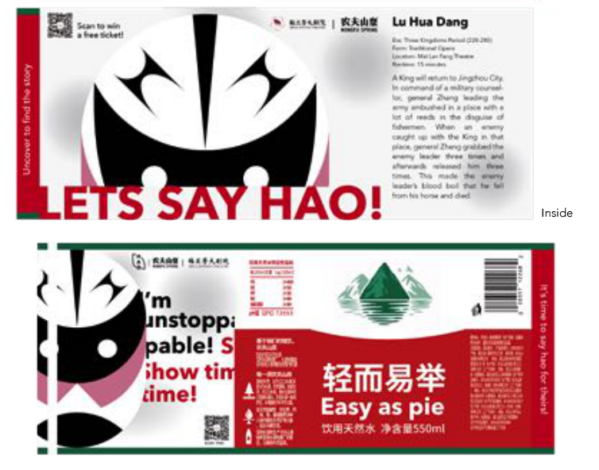

Campaign's poster Design
The target group for this campaign is the office workers and a group of students, so the poster will be in the convenience store where they everyday go.
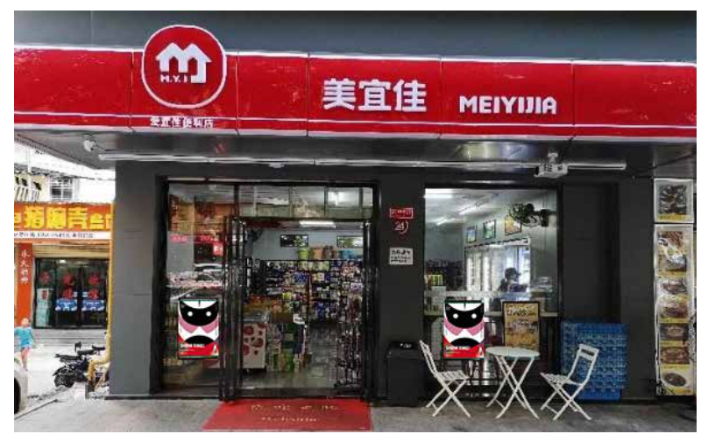
Social Media
The promotion takes place in China, therefore, I choose two of the most popular media platforms, Sina Weibo and WeChat public account. Sina Weibo is like Facebook. During the campaign, in the Weibo and WeChat official accounts, I will publish a little introduction of roles, to improve roles’ exposure and likability of the audience.
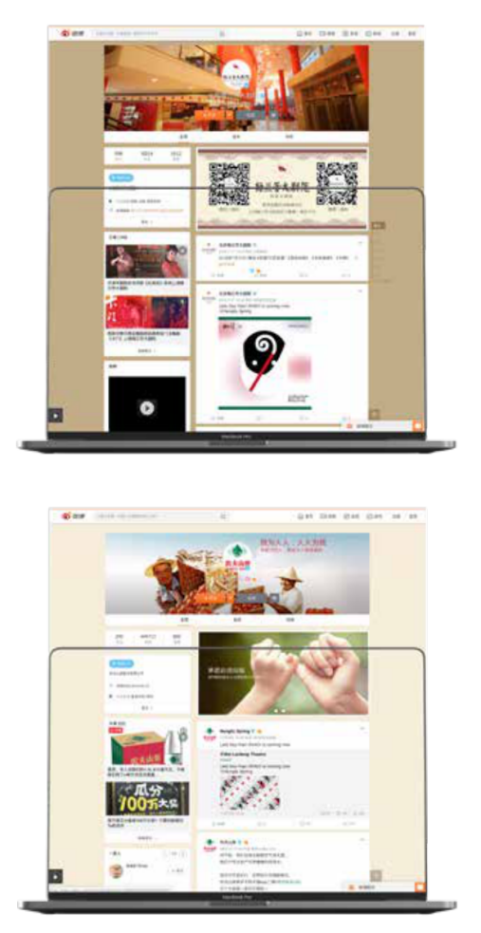
Shows' Calendar

The main purpose of the calendar is to inform the performance time of Highlight Beijing(Zhezi) Opera, because the Mei Lanfang Theater does not only perform Beijing Opera, but also many other performances like musical and symphony etc. Aimung to emphasize the Highlight Beijing Opera, It is better to provide the performance calendar.

Spin-off products
Because the Mei Lanfang Theater has its own store including online store, selling these peripheral products can play a role in promoting the Beijing Opera.
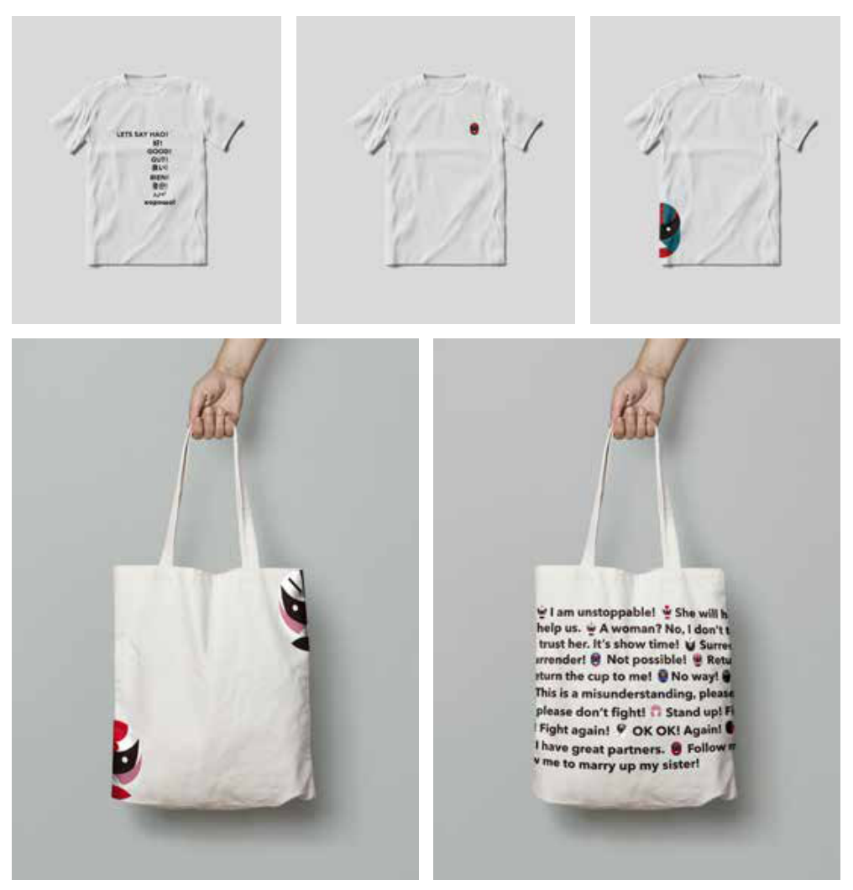

Stickers
Stickers are like a hacker, so people who are already interested in Beijing Mask can play stickers to get more attention or promotion the masks.
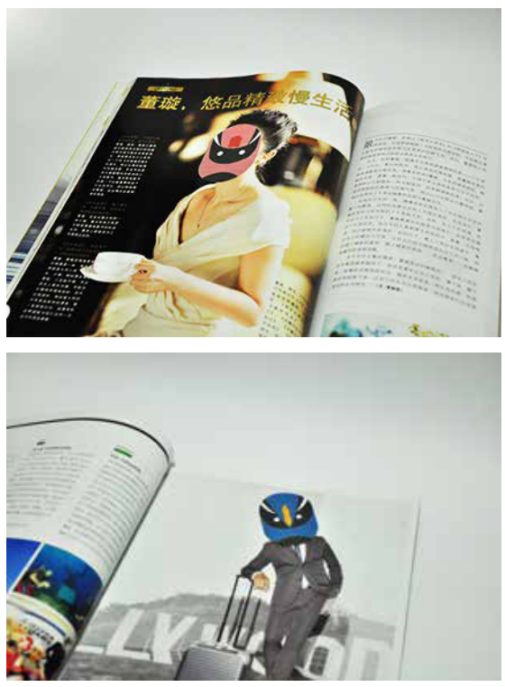
Design conclusion and reflection:
Research shows that the simplification of Beijing opera mask is a double-edged sword. Just like simplifying Chinese, when you eliminate the elements of mask, you will also delete some features of many Beijing opera masks. Simplified opera mask is just for people to better understand Beijing Opera, but I don’t think Beijing opera mask should be simplified nor the mask drawn by Beijing Opera masters is bad. My design is just a way to grab audience’s attention. The reason why Beijing opera mask can spread to this day is because of its complexity. When you decided to enter the world of Beijing Opera then you will get to know Beijing Opera more than you can imagine. More importantly you will find that the seemingly changeable and complex mask all has its own interests.The main target group of this study is the 20 to 30-year-old population, which is also selected in combination with the target population (office workers and students) of Nongfu Spring. Such crossborder cooperation, with Nongfu Spring as the carrier of communication, has sunk to many cities. For Beijing Opera and Mei Lanfang Theatre, it is large-scale exposure, which is undoubtedly an extension from traditional to modern.
For Nongfu Spring, the culture that carries the Beijing Opera mask adds a sense of history to the product itself. With the innovative way of expression, the brand has vitality, and also makes the life scene of drinking water more storytelling.Water is the source of our life and culture is our precipitation of the past, which are essential in life.
There was no design system when Beijing opera mask was created. It was designed by each performing artist according to the spectral types and the mask painted by predecessors. Now the spectral types we see is the summary of later generations. Therefore, I didn’t explain Beijing Opera mask according to the spectral types. In addition, there are some shortcomings in this paper. Because the information base of Beijing Opera Mask is too large, individuals can not complete it in a limited time. Thus, I choose to study the opera masks of official categories and heroes, hoping to complete the study of all Beijing Opera masks in the future according to the research ideas. Moreover, what I have learned is visual communication so it’s mainly analysed from the perspective of vision, without specific analysis and comparison of the historical story background of the characters and the aesthetics of different audiences. Limited by the actual situation, this study is based on text and image data. Without face-to face conversation with senior opera mask artists, there is inevitably a lack of depth in the detailed study of the opera mask.

2.4 Reflection conclusion
From the design process described above, the conversion and displacement thinking in design thinking is usually used when reflecting on the design. When designing, designers need to reflect from time to time, from different perspectives. In line with the development of the current market economy, people-centered, and the rise of user experience, design is often viewed from the perspective of users. I have heard a lecture. When a designer is working with a client, he should not try to persuade the client with design thinking, but to understand the client's business thinking and provide services to the client through the way of thinking of the client. This kind of thinking process is also a kind of reflection.
Everyone has their own rules for everything, and the process of reflection is to compare different rules to check for deficiencies. The design of the future should not only be confined to the human perspective, but should be considered from multiple dimensions in terms of time, space, technology, ecology, etc.

Reference
- Davenport, T.H. and Prusak, L. (1998) Working Knowledge: How Organizations Manage What They Know. Harvard Business School Press, Boston.
- Wu, Y. (2005) Fundamentals of Educational Management. Tsinghua University Press
- Oladejo, B. and David, A. A. and Osofisan, A. (2009) Representation of Knowledge Resource in the context of Economic Intelligence Systems. Available at: https://www.researchgate.net/publication/40700468/ (Accessed: 9 December 2021)
- Karl R. Popper. (1972) Objective Knowledge An Evolutionary Approach, Oxford University Press
- Forsythe. (1993) Engineering Knowledge: The Construction of Knowledge in Artificial Intelligence. Social Studies of Science, 23(3), 445–477. https://doi.org/10.1177/0306312793023003002/ (Accessed: 9 December 2021)
- Scharp. (2008) Locke’s theory of reflection. British Journal for the History of Philosophy, 16(1), 25–63. https://doi.org/10.1080/09608780701789285/(Accessed: 9 December 2021)
- Xi, Y. and Li, Z. and Li, H. (2005) Colour and design colour. Tsinghua University Press

