Understanding Autism Spectrum Disorder

1300113
SSAP4005
A Parent Guide
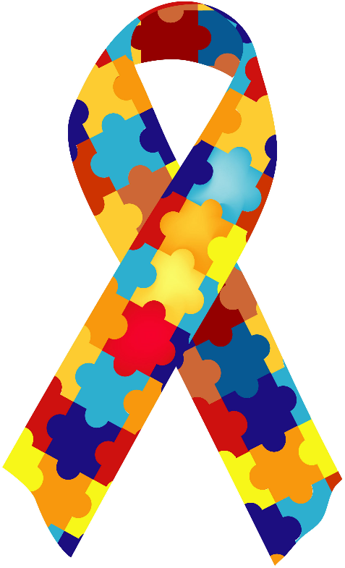
Issues with non-verbal and verbal communication
Issues with social interaction and communication

Unable to develop, maintain and understand relationships
Repeated pattern of behaviours
**

Moyson & Roeyers (2011)
Tonge & Brereton

What is Autism Spectrum
Disorder?

**
- Repetitive motor movement, speech or use of an object
- Routine in verbal or non-verbal behaviours
- Repetitive behaviour focusing on interests
- Hyper/hypo-reactivity to sensations
Kids’ Corner

How many words can you find?

Behaviour Social
Autism Interactions
Spectrum Communication
Disorder Repetitive
Verbal Patterns

a | u | t | i | s | m | f | c | o | m
d | h | j | i | p | l | v | b | r | r
q | a | s | z | e | y | i | n | t | e
g | s | o | r | c | t | h | b | e | h
g | r | f | t | t | w | y | y | u | h
k | v | v | e | r | b | a | l | d | v
i | p | l | j | u | k | b | n | t | r
s | d | f | g | m | n | p | a | t | t
m | u | n | i | c | a | t | i | o | n
e | p | e | t | i | t | i | v | e | w
r | a | c | t | i | o | n | o | l | k
a | v | i | o | u | r | p | a | t | t
e | t | t | h | f | k | i | l | c | a
v | f | h | n | k | d | a | x | z | c
h | d | i | s | o | r | d | e | r | j
e | r | n | s | u | y | t | s | o | p
The Impact of Autism Spectrum Disorder

Autism Spectrum Disorder can have an impact on many different aspects of the child’s life, for example:
According to Macks & Reeve (2007) the unpredictable and complex nature of Autism Spectrum Disorder can place a family at a higher risk for stress.
Parents have reported higher levels of stress and describe parenting as “an emotionally burdensome experience” (Hastings, 2007; Petalas, Hastings, Nash, Lloyd & Dowey, 2009; Rao & Beidel, 2009).
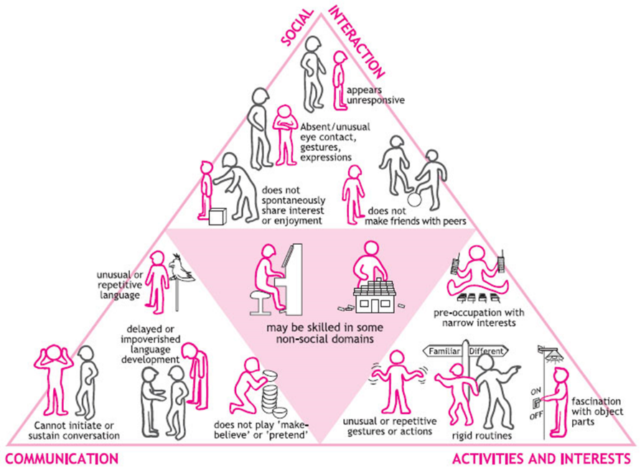
Autism Spectrum Disorder, also known as ASD is a neurodevelopmental disorder that can be characterised by the following (APA, 2000) :

In the past 20 years we have seen an increase in the rates of childhood Autism Spectrum Disorder (Boyle et al. 2011).

Rates of Autism Spectrum Disorder
Kaminsky & Dewey (2001) have also found that siblings reported low levels of nurture and intimacy from their brother or sister with Autism Spectrum Disorder.
Baron-Cohen et al (2009) estimated that 1.57% of children aged 5-9 years old were diagnosed with Autism Spectrum Disorder in 2004 using parent-reported clinical diagnosis.
According to research, around 700,000 people living with autism in the UK, that is more than 1 in 1000 (Brugha et al. 2012).
Using three separate, in-depth interviews where they asked each participant the following: - about themselves, what it is like to be sibling and to reflect on what is means to be a sibling.

They found nine areas of quality of life for siblings that came from this study:-
- Forbearance
- Mutual Understanding
- Joint Activities
- Private Time
- Trust in Well-being
- Acceptance
- Exchanging Experiences
- Social Support
- Dealing with the Outside World
(Moyson & Royers, 2011)
This is supported by a study carried out by Moyson & Roeyers (2011) where they focused on the siblings of children with Autism Spectrum Disorder.

But some people aren’t always believing of the child’s disability

This poses advantages and disadvantages for siblings, for example a sibling may welcome this type of invisibility as it means others will not comment in a negative way or stare at the child with Autism Spectrum Disorder (Moyson & Roeyers, 2011).
Moyson and Roeyers (2011) also found something called “the invisibility of ASD” where children diagnosed with Autism Spectrum Disorder presented with a “normal” appearance physically.

A number of children with Autism Spectrum Disorder can have a heightened intellectual ability, this is down to early intervention (Dawson et al, 2010).

It is thought that around 70% of children with Autism Spectrum Disorder have above average intellectual ability (Chakrabarti & Fombonne, 2005).

Children with Autism Spectrum Disorder are typically placed in classes with other school-aged peers and work towards similar academic ability and goals as their peers (Estes, Rivera, Bryan, Cali & Dawson, 2010).

Children with Autism Spectrum Disorder, classed as high functioning, currently do not have positive academic outcomes associated with factors that aren’t understood particularly well (Estes, Rivera, Bryan, Cali & Dawson, 2010).

Areas of challenge: Spelling and Reading (Gross,1994)
It has been reported by many that children with Autism Spectrum Disorder can have an impaired reading comprehension that may co-exist with normative reading accuracy (Minshew et al, 1994; O’Connor & Klein, 2004; Grigorenko et al, 2003; Nation et al, 2006).

This is supported by a study of children with Autism Spectrum Disorder to investigate academic achievement (Estes, Rivera, Bryan, Cali & Dawson, 2010).

With this study Estes et al (2010) wanted to answer three possible questions:

Estes et al (2010) found that school-aged children with Autism Spectrum Disorder showed differences between actual and predicited levels of academic achievement from overall intellectual ability.

90% showed differences in spelling, reading or basic number skills that were lower than predicted.

Further future research is needed to fully understand children with Autism Spectrum Disorder and high achievement (Estes, Rivera, Bryan, Cali & Dawson, 2010).

One of the main stressors for families is the behaviour issues shown by children with Autism Spectrum Disorder (Jenkins, Rose & Lovell, 1997 cited in Hastings & Brown, 2002).

American Psychiatric Association. (2000). Diagnostic and statistical manual of mental disorders (4th ed., text rev.). Washington DC. Author.
Bruce Tonge, M. D., & Brereton, A. DSM-5 Autism Spectrum Disorder. http://www.timeforafuture.com.au/factsheets/CDPP%20Factsheet%201.%20DSM%205%20Autism%20Spectrum%20Disorder.pdf
Estes, A., Rivera, V., Bryan, M., Cali, P. & Dawson, G. (2010). Discrepancies Between Academic Achievement and Intellectual Ability in Higher-Functioning School-Aged Children with Autism Spectrum Disorder. J Autism Dev Discord. (44). 1044-1052. DOI 10.1007/s10803-010-1127-3
Hastings, R.P., & Brown, T. (2002) Behaviour Problems of Children with Autism, Parental Self-Efficacy, and Mental Health. American Journal on Mental Retardation, 107(3), 222-232.
Moyson, T., & Roeyers, H. (2011). The quality of life of siblings of children with autism spectrum disorder. Exceptional Children, 78(1), 41-55.
Russell, G., Rodgers, L. R., Ukomunne, O. C., Ford, T. (2013). Prevalence of Parent-Reported ASD and ADHD in the UK: Findings from the Millennium Cohort Study. J Autism Dev Discord. (44). 31-40. DOI 10.1007/s10803-013-1849-0

