

PROGRAMME: BSC (Hons) Health and social care

Module Code: BMHP5015

Module: Changemakers: Building your Personal Brand for Sustainable Employment

Assignment Title:
Component 1: Online
Portfolio of Set Exercises

STUDENT NAME: Aliya Atik

STUDENT ID NUMBER: 2323993

LECTURERS NAME: Raheela Shaikh

Task 1 – Personal Brand
My personal brand is focused on professionalism, empathy, and a dedication to person-cantered care in the health and social care sector. I want to be known as a trustworthy and caring professional who values teamwork and lifelong learning. Now, my brand showcases strong communication and interpersonal skills that I have developed through academic study, paid and voluntary work, but I need to improve my leadership presence and digital literacy to increase my employability and achieve my long-term goal of becoming a health service manager.
Using professional sites like LinkedIn to highlight my accomplishments, look for mentoring, and participate in current health and social care discussions will be part of building my brand. In competitive marketplaces, an authentic personal brand helps people stand out, according to Azad et al. (2024), while Vallas and Cummins (2023) highlights the need of self-promotion and reflection for job advancement. By continuously exhibiting my principles via networking, professional behaviour, and continues learning, I can gain credibility and get closer to a leadership position that supports my goal of enhancing the well-being of the community.

Task 2 – Network Map and Rationale

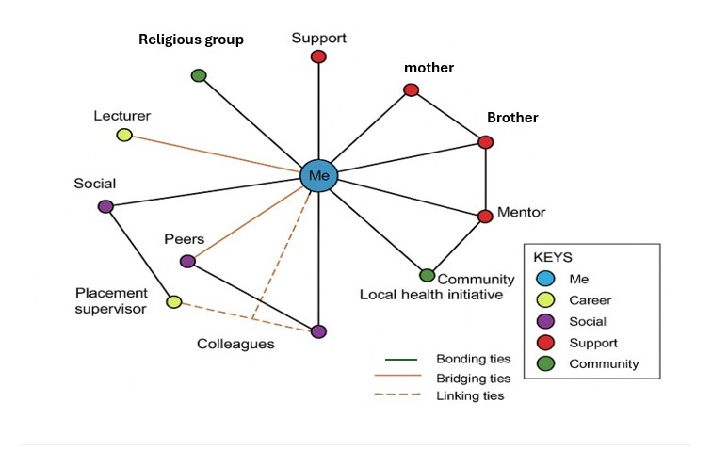
Figure 1. Network Map. Source (Author, 2025).
Rationale: My professional network, illustrated in Figure 1, is a hybrid network that integrates career, social, support, and community dimensions. Within the career category, my lecturer, placement supervisor, and colleagues provide academic and professional guidance that supports my development in health and social care. My social network, made up of peers and friends, offers motivation and informal advice that strengthens my confidence and wellbeing. The support network, including my mentor, mother, and brother, represents close and trustworthy bonding ties, which provide emotional encouragement and stability. Lastly, my community connections, such as my involvement in a local health initiative and a religious group, provide shared values and community engagement.
However, my network shows a greater emphasis on bonding rather than bridging or linking ties. As Eklinder-Frick et al. (2022) note, networks rich in bonding capital can limit access to new opportunities. To strengthen my linking capital, I plan to join professional organisations like the British Association of Social Workers and attend industry networking events. These actions will expand my professional reach, enabling me to build weak ties that, according to Jack (2021), often lead to new information and career advancement opportunities.

Task 3 – Blog
Title: Digital Inclusion in UK Health and Social Care: Bridging the Gap for Older Adults
Introduction.
Since the COVID-19 epidemic, the digital revolution of healthcare has advanced; yet many older persons are still not able to use digital services. I discuss why digital inclusion is crucial for fair service delivery in my article, which is targeted at health and social care workers, as well as steps that may be taken to bridge the gap.
For many, the NHS's shift to "digital-first" care which includes electronic prescriptions and online consultations improves accessibility and efficiency (NHS Digital, 2023). However, obstacles including inadequate digital literacy, cost, and accessibility to technology are common among older persons. According to a 2022 study by Age UK, 2.7 million senior citizens in the UK still do not have internet connectivity, which raises their risk of social isolation and limits their access to healthcare (Age UK, 2022).
Digital exclusion can worsen gaps in health, especially for people with long-term conditions that require constant observation. In response, community-based training programs and NHS England's Digital Skills Pathway are assisting older persons in developing their confidence in the use of digital health resources (Hider et al., 2023). By encouraging accessible digital design, providing blended (digital + in-person) treatment, and embracing inclusive communication, health professionals play a crucial role.
Conclusion
Improving digital inclusion is about equality and empowerment, not simply technology. Professionals can guarantee that all older persons gain from the digital health revolution by encouraging easily available digital literacy support, enhancing their independence and general well-being.

Task 4 – Blog
1) What is the primary goal of the NHS Equality, Diversity, and Inclusion Improvement Plan?
Its main goal is to enhance equality, diversity and inclusion across the NHS workforce and to foster a stronger sense of belonging among staff

2) How does the NHS EDI Improvement Plan propose to tackle the gender pay gap?
The plan aims to eliminate gender pay gaps by analysing pay by protected characteristic, implementing action plans, and aligning those plans with high-impact actions including fair job evaluation and transparent processes.

3) What is meant by the term ‘intersectionality’ as used in the NHS EDI Improvement Plan?
Intersectionality is the understanding that individuals have numerous identities and that multiple inequities (such as race, gender, and disability) can result in cumulative disadvantages that cannot be resolved by concentrating on a single trait alone.

4) Why is it important for the NHS to create a psychologically safe work environment?
Because staff must feel safe to speak up, admit mistakes, raise concerns or ask questions without fear of punishment, this builds trust, improves morale, and ultimately strengthens patient care.

5) How does the NHS EDI Improvement Plan suggest improving the experience of internationally recruited staff?
It proposes better induction and onboarding, clear guidance about employment and immigration, cultural awareness training for teams, and ensuring international staff have equal access to development and support

6) What role does leadership play in advancing EDI objectives according to the NHS Improvement Plan?
Leadership is essential: managers, executives, and board members need to set quantifiable EDI goals, be responsible, utilize data and personal experience to guide improvements, and provide a clear example of inclusive behaviour.

7) Identify one way the NHS EDI Improvement Plan aims to reduce health inequalities within the workforce.
One way is by working with community organisations and creating partnerships to improve social mobility and widen access, helping staff from underrepresented or disadvantaged communities to progress.

8) Why does the NHS EDI Improvement Plan emphasise the importance of collecting and analysing data on protected characteristics?
Because robust data helps reveal gaps, inequalities and patterns in pay, progression, harassment, or treatment, which is essential to target interventions and hold organisations accountable.

9) Explain how flexible working policies can contribute to equality and inclusion in the NHS workforce.
Flexible working lets people balance caring responsibilities, health needs or life circumstances, and thus reduces barriers (especially for women, disabled staff, etc.) and supports retention and inclusion.

10) What is one strategy mentioned in the NHS EDI Improvement Plan to combat bullying and harassment in the workplace?
One tactic is to set reduction targets by protected characteristic, review data on bullying and harassment, ensure staff who speak up are supported and protected, and embed safe speaking-up cultures

Task 5 – A Letter to My Younger Self
Dear Liya
I remember the moment during your first placement when you felt totally overburdened. The lengthy shifts, the unfamiliar faces, and the ongoing anxiety of making errors all felt too much. You frequently accused yourself of not handling things as well as other people seemed to. You were learning some of the most crucial lessons about resilience and emotional intelligence at the time, but you were unaware of it.
I would advise you to calm down and pay attention to yourself as well as to other people if I could talk to you right now. Being emotionally intelligent involves more than just comprehending other people; it also involves identifying and kindly handling your own emotions. You might have found strength in self-awareness and empathy if you had taken the time to think about your feelings rather than repressing them.
Additionally, resilience is developed by challenges. You were learning how to bounce back, adjust, and maintain your composure with each challenging day. All that was required of you was to continue studying; you did not need to know everything. It would have been easier for you to view mistakes as development opportunities rather than failures if you had developed these traits sooner.
Take pride in the kind and resolute person you were growing into. Remember that patience, not perfection, is the key to growth, and keep treating yourself with the same care that you show others.
Yours Faithfully,
Aiya

Task 6 – Gantt Chart
Table 1.1 Gantt chart
Key Task / Activity | Oct 2025 | Nov 2025 | Dec 2025 | Jan 2026 | Feb 2026 | Mar 2026 | Apr 2026 | May 2026 | Jun 2026 | Jul 2026 | Aug 2026
Update CV and LinkedIn profile
Research graduate roles and organisations
Complete final academic assessments
Undertake voluntary work or placement extension
Attend professional networking events
Apply for graduate or trainee roles
Prepare for interviews and assessment centres
Begin new employment

Table 1.1 outlines my 10-month strategy to secure a job in the health and social care industry. To develop my professional identity, I start by upgrading my portfolio, LinkedIn profile, and resume. Next, I look into graduate programs that fit my objectives. My final coursework will be finished. I will volunteer and participate in placement activities to obtain practical experience. I also intend to go to networking functions, apply for trainee positions, and get ready for interviews. My goal is to get a good job by August 2026 that encourages long-term career advancement and professional growth.

Task 7- Making Changes Report

As the manager of a residential care facility, I have determined that paper-based documentation has to be replaced with electronic care planning, or ECP. The goal of this modification is to increase resident safety and care quality while also improving staff communication, accuracy, and efficiency (Scott, 2022).
However, I will use Lewin's Change Management Model (1951 as cited in Levasseur, 2021), (Figure 2), which has three stages, unfreezing, modifying, and refreezing, to accomplish this. I will speak with staff members throughout the unfreezing period to discuss the necessity for digital transformation and how it will cut down on mistakes and duplication. Anxiety and change resistance can be lessened with the use of open dialogue and training sessions.
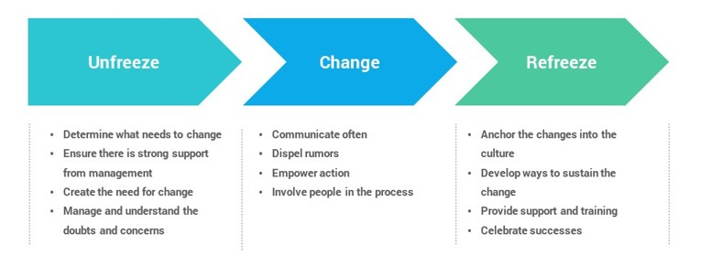
Figure 2. Lewin's Change Management Model. Source (Levasseur, 2021).

As the changing phase is rolled out progressively across shifts, employees will have access to technical assistance and practical digital training during the transition period. Peer mentors and clear instructions will guarantee confidence and consistency in use (Harrison et al., 2022).
Finally, through ongoing performance assessments, policy changes, and feedback, new processes will be incorporated into everyday routines during the refreezing stage. Leadership, effective communication, teamwork, and digital literacy are essential for this shift (Watson and West, 2023).
Staff disagreements, inexperience with technology, and minor delays to workflow are examples of potential obstacles. These will be handled via open communication, continuous assistance, and acknowledging the work of the employees. A safer, person-cantered care environment will be promoted, accountability will be enhanced, and record-keeping will be streamlined with the implementation of ECP (Lopez,2022).

Task 8 – Self-Reflection (Using Gibbs’ Reflective Cycle)
Gibbs' Reflective Cycle (1988), which consists of six stages, description, feelings, assessment, analysis, conclusion, and action plan, is what I used for my reflection.

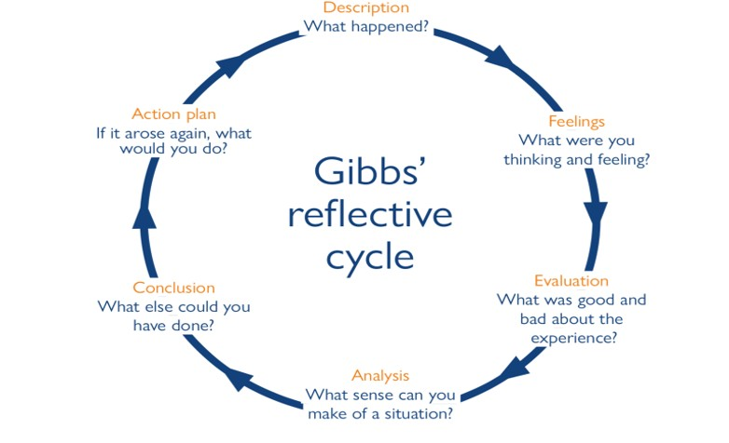
Figure 3. Gibbs’ Reflective Cycle. Source: (Adeani, 2020).
Description: I participated in exercises that prompted me to consider my employability, professional identity, and the values necessary for the health and social care sectors throughout this module (BMHP5015). I was able to evaluate my skills and pinpoint areas that required development after completing the personal brand, networking, and emotional intelligence assignments.
Feelings: At first, I was unsure of how best to convey my skills and professional aspirations. As I advanced, though, my confidence increased, and I realized how crucial reflection is to building skill and self-belief.

Evaluation: The resilience and emotional intelligence exercises were very beneficial, in my opinion. They made it easier for me to see how empathy and self-awareness affect the standard of care I provide and how I handle difficult circumstances.
Analysis: These encounters helped me realize that interpersonal qualities like listening, flexibility, and emotional control are just as important for success in the health and social care sectors as technical knowledge. Being aware of these factors has improved my ability to handle stress and my empathy for coworkers and clients.
Conclusion: I have discovered that ongoing introspection fosters both emotional and professional development. It promotes responsibility and aids in converting events into teaching moments.
Action Plan: I will use Gibbs' methodology to keep a reflective notebook for my next placements, documenting difficulties, feelings, and lessons discovered. Regularly reviewing it will improve my work as a professional and get me ready for leadership positions in the future.

References
Adeani, I.S., Febriani, R.B. and Syafryadin, S., (2020). Using GIBBS’reflective cycle in making reflections of literary analysis. Indonesian EFL Journal, 6(2), pp.139-148.
Age UK (2022) The Digital Divide: Older People’s Experiences of Exclusion. Available at: https://www.ageuk.org.uk. (Accessed: 8th October 2025).
Azad, T., Ahmed, S., Shovon, K., Razu, A., Sikder, S., Bhuyan, S.H. and Ahmed, M.S., (2024). Building a Personal Brand: Strategies for Standing out in a Competitive Job Market. International Journal of Novel Research in Marketing Management and Economics, 11, pp.147-154.
Eklinder-Frick, J., Eriksson, L.T. and Hallén, L., (2022). Bridging and bonding forms of social capital in a regional strategic network. Industrial Marketing Management, 40(6), pp.994-1003.
Gibbs, G. (1988) Learning by Doing: A Guide to Teaching and Learning Methods. Oxford: Oxford Polytechnic.
Royds, J. (2021) Gibbs’ Reflective Cycle Explained. Available at: https://www.skillsyouneed.com/ps/reflective-practice.html [Accessed: 15th October 2025].
Harrison, R., Fischer, S., Walpola, R.L., Chauhan, A., Babalola, T., Mears, S. and Le-Dao, H., (2022). Where do models for change management, improvement and implementation meet? A systematic review of the applications of change management models in healthcare. Journal of healthcare leadership, pp.85-108.
Hider, S., Muller, S., Gray, L., Manning, F., Brooks, M., Heining, D., Menon, A., Packham, J., Raghuvanshi, S., Roddy, E. and Ryan, S., (2023). Digital exclusion as a potential cause of inequalities in access to care: a survey in people with inflammatory rheumatic diseases. Rheumatology Advances in Practice, 7(1), p.rkac109.
Jack, S.L., (2021). The role, use and activation of strong and weak network ties: A qualitative analysis. Journal of management studies, 42(6), pp.1233-1259.
Levasseur, R.E., (2021). People skills: Change management tools—Lewin's change model. Interfaces, 31(4), pp.71-73.
Lopez, S.H., (2022). Culture change management in long-term care: A shop-floor view. Politics & Society, 34(1), pp.55-80.
Narayan, D., (2022). Bonds and bridges: social capital and poverty. Social capital and economic development: well-being in developing countries. Northampton, MA: Edward Elgar, pp.58-81.
NHS Digital (2023) Digital First: Improving Healthcare Access. Available at: https://digital.nhs.uk. (Accessed: 7th October 2025).
Scott, I., (2022). What are the most effective strategies for improving quality and safety of health care?. Internal medicine journal, 39(6), pp.389-400.
Vallas, S.P. and Cummins, E.R., (2023). Personal branding and identity norms in the popular business press: Enterprise culture in an age of precarity. Organization Studies, 36(3), pp.293-319.
Watson, D. and West, J., (2023). Managing the process of change in residential child care: A consultancy approach. Journal of Social Work Practice, 15(1), pp.91-101.

