A report focussing on:

Construction Detailing
(Module: Fundamentals of Construction Technology – ACBA4001)


Prepared for:
Juan A Ferriz-Papi

Created by:
Natalie Jopling
1911296

Date completed:
28th April 2020

Table of Contents
Page Number

1.0 Executive Summary 3
2.0 Ground floor, construction, detailing & junctions with external walls 3
3.0 First floor construction detailing junctions with external walls & restraints 3-4
3.1 Timber joist and joist hangers 4
3.2 Partition walls 4
4.0 Openings and solutions for lintels, sills and jambs 4-5
4.1 Lintels 5
4.2 Sills 5
5.0 Eaves detailing and roof covering’s 5-6
5.1 Roof covering 5-6
5.2 Eaves 6
6.0 Main Roof structure including detailing and fixing 6-7
6.1 Queen Post Truss 6-7
6.2 Roof structures for garage and front of property 7
7.0 Conclusion 7
8.0 References 7-8
9.0 Appendices 8 - 17

1.0 Executive Summary

Within this assignment, the Author will be drawing and detailing the build of a single, two-storey detached domestic house with a loft room. There are five sections which are broken down into each level of the build. The Author has produced sketches, which are found in the Appendices section of the assignment. Each part of the sketch is numbered and explained in each section of the assignment.

2.0 Ground floor, construction, detailing and junctions with external walls

The information below is explaining each part of a suspended timber ground floor which is the basic way to construct a house. The sketch is found under section A in the appendices. By calculating the number and size of joists needed, using the BS 8103-3 table timber class C16 for lightweight partitions, basing the requirement on the width of the room and the span between the joists, the Author is able to calculate the number of joists needed. As the dead load is no more than 0.25, the calculation of space between each joint will be 400mm. Based on the length and width between the joists as 8.430m divided by 40mm, the approximant number of joists required would be 20 for the lounge on the ground floor.

- Inner Wall – The inner wall is made with concrete blocks which will act as a suitable load bearing wall
- Outer wall – The outer wall is made with bricks which have dimensions of 225 x 112.5 x 75mm and are constructed using a stretcher bond wall. This will help create a cavity between the inner and outer wall (more information found in the appendices under section A1 on page 8).
- Damp Proof Course (known as DPC) – A DPC level will be placed for both the inner and outer wall to prevent any moisture getting into the walls.
- Joists – The best solution to use for this suspended timber ground floor is to screw the joists onto a joist hander which will be screwed into the inner wall. A joist is placed underneath the joist hander for extra support.
- Ventilation – The ventilation coming from the weep holes and honeycomb sleeper wall will be in-between the joists and concrete surface, which should be at least 150mm apart (Portal, 2020).
- Insulation – The insulation will be placed in-between the joists and the thickness of the insulation will depend on the thickness of the joists. This is to save room when building the house. Small rigid batons will be screwed underneath the joists to help secure the insulation.
- Floor boards – The floor boards will be screwed into place onto the joists prior to any flooring being placed on top for the finished look (NHBC Standards 2011, 2020). (More information found in the appendices under section A2 on page 8).
- Honeycomb sleeper wall – This wall is produced with the gaps in-between the bricks which help with ventilation on the ground floor. It is also classed as a good load bearing wall.
- Concrete surface – This is where the honeycomb sleeper wall will be produced on
- Metal Herringbone Strut – The metal herringbone struts are not supporting the joists but they are placed in-between the joists to help prevent lateral bending. They are equally spread out along the joists.

3.0 The First Floor – Construction sketch detailing junctions with external walls and constraints

In this section, the structure of the first floor is explained including the various partition walls and internal walls needed for the project. The sketch for timber joints is found under section B and partitions walls in Section C in the appendices.

3.1 Timber joists and joist hangers

- Outer wall
- Insulation
- Concrete inner wall
- Joist Hanger – The joist hanger is drilled into the load bearing wall (How to Choose a Floor Structure | Homebuilding & Renovating, 2020) (more information found in the appendices under section B1 on page 10).
- The joists – The joists are cut to shape and tightly fitted into the joist hanger. Metal herringbone struts are placed in between the joists to prevent bending. The floor boards are then placed on top of the joists and then, just like the ground floor, click timber flooring will be placed on top (NHBC Standards 2011, 2020)

3.2 Partition walls

There will be two load bearing brick walls in the property. They will be either side of the landing. The other walls which will be separating the rooms will be timber frame with plasterboard for the partition walls. The sketch is found in Section C in the appendices and the explanation for each section is found below.

- Head plate – The head plate is attached to the joists from the 1st floor and the 2nd floor (loft room). This will help attached the studs by screwing them in place (Non-Load-Bearing Timber Stud Partition Walls - A Construction Guide, 2020)
- Studs – The studs should have a centre place of either 600mm or 400mm. They are placed vertically and act as a loadbearing skeleton (6.3.9 Construction of timber partitions - NHBC Standards 2020, 2020)
- Plasterboard – The plasterboard is fitted in between the studs and onto the noggins (more information found in the appendices under section C1 on page 10).
- Sole plate – The sole plate is placed horizontally on the floor. It acts as an anchor and a support for the frame (NHBC Standards 2011, 2020)
- Noggin – The noggins is a smaller stud which is fitted horizontally in between the vertical studs. They are used to increase the strength of the frame and also used to help attached the plasterboard to the frame (Nogging, 2020)

4.0 Openings and solutions for lintels, sills and jambs

The information below is explaining each opening within the house and explaining how the lintels, sills and jambs should be constructed. The sketches can be found under sections D and E in the appendices.

4.1 Lintels

- Timber – The timber within this image is just to show where it would be placed once the lintel has been applied
- Concrete inner wall – Prior to the lintel being applied, the inner and outer walls must be level and mortar applied to the tops of the walls.
- Mortar – Spread equally on top of both the outer and inner walls and the lintel is placed on top. The mortar should be allowed to dry before any other work around the lintel commencing.
- Brick outer wall – Soldier Course will be above the windows and patio doors. This is when bricks are placed to stand on end, mainly used for decorative purposes. There should be at least two weep holes which are no more than 450mm apart. The brickwork should not have an overhang more than 25mm (6.1.12 Lintels - NHBC Standards 2020, 2020).
- Damp Proof Course – DPC is added on top of the lintel as it is the most exposed area for moisture to seep in and cause damp.
- Standard Cavity steel lintel – Metal elements for a lintel are a fast and cost effective solution when building a property (more information found in the appendices under D1). There should be 150mm bearing each end of the lintel and they will need to have stop ends.
- Opening – There are eighteen openings for this property including all doors and windows.

4.2 Sills

- Inner concrete wall – The outer wall is in this image to show where the window assembly would be attached
- The outer wall – Both the outer and inner walls should be equal in all openings
- The stone sill – This should be fitted by placing mortar on top of the outer wall and making sure it is the correct level (A step by step guide to level thresholds, 2020).
- Window screen – The window screen is placed into the window system. This will have to be sealed in order to stop any heat from escaping the area. As the windows are double glazed, the material used would be tempered glass. (Toughened and Laminated Glass Explained | Stevenage Glass Company, 2020). (More information on tempered glass found in the appendices under section E1 on page 12).
- Window system – The window system is attached to the outer wall and is also attached to wooden blocks which also act as window anchorage.
- Insulation – Showing that the insulation would be attached to the inner wall and also would be cut and placed throughout the different levels for the opening.
- Flashing – Flashing would be inserted prior to the sill as it is used for any moisture to escape and this will stop any dampness occurring in the area.

5.0 Eaves and Roof Covering

5.1 Roof covering

The project is to be built with a warm roof with a pitch of 40$°$. The Sketches under F and G, found in the appendices, shows the levels of construction from the rafters up to the slate tiles. A warm roof has many benefits which include conserving heat within the property (What is a warm roof? (Helifix,2020)

- Rafter – This rafter is a beam which is found from the roof truss. It will be the base for the roof coverings and also will have a compression load falling onto it.
- Breathable Membrane – The breathable membrane is placed on top of the rafter, but can also be placed above the insulation. Used to ventilate the roof area as if there was no membrane, air pressure could rise and cause ballooning which can dislodge tiles or slates and this could worsen with different weather conditions (Understand BS 5534 changes to roof underlay | LABC, 2020)
- Insulation – As this is a warm roof, the insulation is placed throughout the whole area of the roof. This does not cause gaps for any warm air to escape the building.
- In-screw fixings/nails – The counter batten, insulation and breathable membrane are all nailed into place to make sure they are secure.
- Counter Batten or roof joints - Placed vertically on top of the insulation and will be placed the whole length of the roof. The battens should be at least 1.2m long to ensure they span a minimum of three trusses (Labc.co.uk. 2020).
- Tile Battens – The tile battens are placed horizontally across the counter battens and are nailed ready for the slates to be placed on top.
- Natural slates – The property is having a finish of natural slate tiles on top of the roof. (The Benefits of a Slate Roof - Build It, 2020) (More information found in the appendices under section F1). Each sheet, as shown in the image, is laid on top of a tile batten and then on top of each tile.

5.2 Eaves

The image found in the appendices under section G is of a closed eave. Some of the sections within the image have already been explained in the image for the roof covering found in section F.

- Rafter – As mentioned in previous sketches
- Slates – As mentioned in previous sketches
- Battens – As mentioned in previous sketches
- Soffit – The soffit is found under the facia board. You can see the soffit board from the outside of a house. The board just under the soffit is a ventilation soffit board. This helps ventilate air around the roof area (Swishbp.co.uk. 2020).
- Fascia board – A fascia board is a terms given by a horizontal board that are fixed along the rafters on a roof which closes the gaps. Fascia’s help protect against weather. The material used is usually PVC and there is usually a lip at the bottom edge of a fascia board and this supports the soffit (Fascia boards – The jargon explained, 2020)
- Gutter – The gutter is to help collect and direct any access water which has fallen from the slate to a drain.
- Cavity Insulation – As mentioned in previous sketches
- Inner concrete wall – As mentioned in previous sketches
- Plasterboard - As mentioned in previous sketches
- Insulation - As mentioned in previous sketches

6.0 Main roof structure

6.1 Queen Post Truss

Within section I of the appendices, the sketch of a queen post truss and also the explanation as to why this would be the best truss to use for this project. Below is the information relating to each section:-

- Ridge board – The ridge board which is found at the tip of the roof is a structure that is used to support the end of rafters. It transfers the loads the gable end walls (Ridge Beam vs. Ridge Board, 2020)
- Rafter – The rafters are located at the each end of the structure. It is mentioned in previous notes above.
- Strut – The struts are found in between the queen posts and the rafters. They are in compression as the weight of the posts and rafters are pushing the weight onto the objects.
- Supporting wall – Showing where the walls would be located for support for the truss.
- Queen Post – Are found in the middle of the structure. They are tension members and are to prevent sagging of the tie beam. The upper end of the posts are kept in position by the straining beam (number 8)
- Tie beam – The tie beam is a cross frame where the rafters are jointed onto the tie beam which forms the shape of the truss (Traditional Timber Framing - A Brief Introduction, 2020)
- Wall plate – The wall plate within a truss supports the rafters and will be placed over the load bearing wall. They should be nailed or fixed to the rafters and be a minimum of 3m over at least three rafters (7.2.6 Wall plates - NHBC Standards 2020, 2020).
- Purlin and cleats – The purlins are horizontal wooden parts that are laid onto the rafters, above the queen posts, on a wall-to-wall to support the rafter and are fixed with a cleat.
- Straining Beam – Connects the truss to the rafters and keeps the junction in a stable position

6.2 Roof structures for garage and front of property

The structure of the roof is smaller than the main part of the property. The information is explained in the section under I1 in the appendices.

7.0 Conclusion

Within this assignment, the information the Author has found has helped understand and become more knowledgeable of the stages included to building a house. Having this insight has made the Author more aware of the different choices of structures available for each individual project. The author has enjoyed gathering the information and sketching the images for each stage of the build.

8.0 References

Assets.publishing.service.gov.uk. 2020

AZoBuild.com. 2020. Non-Load-Bearing Timber Stud Partition Walls - A Construction Guide

Build It. 2020. The Benefits Of A Slate Roof - Build It

Designingbuildings.co.uk. 2020. Domestic Roofs

Designingbuildings.co.uk. 2020. Nogging

Fet.uwe.ac.uk. 2020. Traditional Timber Framing - A Brief Introduction

Greatbarns.org.uk. 2020. Barn Size Comparison

Guttersupplies.co.uk. 2020. Fascia Boards - The Jargon Explained

Helifix.co.uk. 2020. What Is A Warm Roof? | Helifix

Homebuilding & Renovating. 2020. How To Choose A Floor Structure | Homebuilding & Renovating

LABC Warranty. 2020. A Step By Step Guide To Level Thresholds

Labc.co.uk. 2020

Labc.co.uk. 2020. Understand BS 5534 Changes To Roof Underlay | LABC

NHBC Standards 2020. 2020. 6.3.9 Construction Of Timber Partitions - NHBC Standards 2020

NHBC Standards 2020. 2020. 6.1.12 Lintels - NHBC Standards 2020

Nhbccampaigns.co.uk. 2020. NHBC Standards 2011

Portal, P., 2020. Building Regulations: Flooring | Extensions | Planning Portal

Shop.bsigroup.com. 2020. BS 5268-7.1:1989 - Structural Use Of Timber. Recommendations For The Calculation Basis For Span Tables. Domestic Floor Joists – BSI British Standards

Stevenage Glass Company Ltd. 2020. Toughened And Laminated Glass Explained | Stevenage Glass Company

Swishbp.co.uk. 2020. What Are Fascias? What Are Soffits? What Are Bargeboards? The Answers Are Here.

Trus Joist Technical Support. 2020. Ridge Beam Vs. Ridge Board

Uk.saint-gobain-building-glass.com. 2020. Technical Information | Glass And Safety | Saint-Gobain.

9.0 Appendices

- Suspended timber ground floor

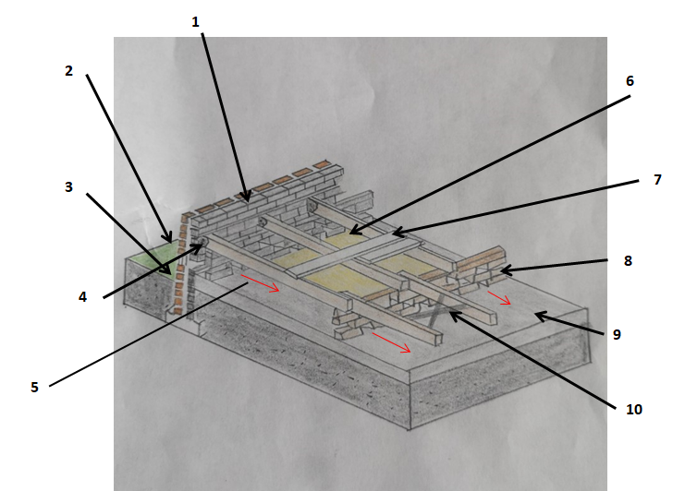

A1. Weep holes, metal ties and flashing are used to help ventilate the area. The flashing and metal ties are placed within the cavity as they allow any moisture to be released

A2. Click timber flooring will be the best solution as it is easy to install and doesn’t need to be glued or screwed to the floorboard underneath. If any issues occur in the future, it will be easier to resolve by using this type of flooring.

- Timber Joists

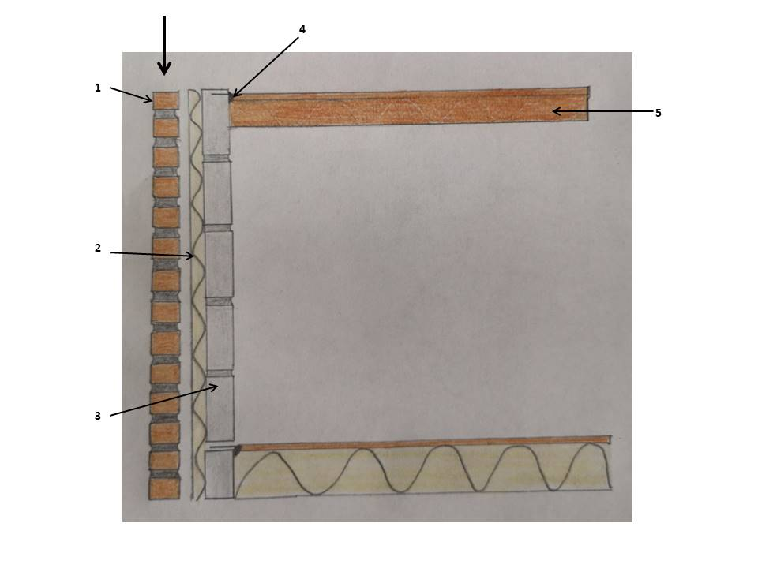

As recommended by the British Standards for structural use of timer (BS 5268-7.1) a calculation is required for the support of domestic floor joints and solid timber (BS 5268-7.1:1989 - Structural use of timber. Recommendations for the calculation basis for span tables. Domestic floor joists – BSI British Standards, 2020)

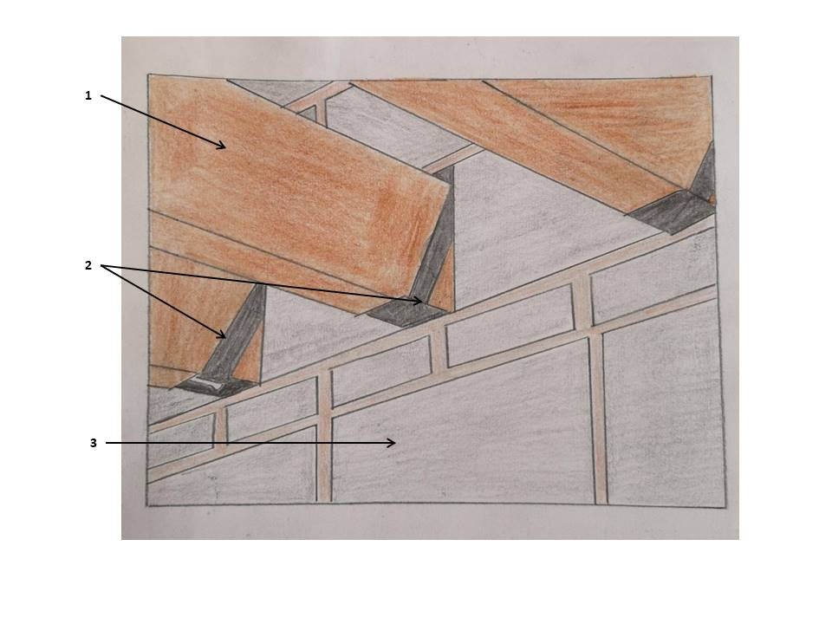

3.1.1 Picture of joint hanger

- Joist
- Joist hangers
- Load bearing wall

B1. By screwing joists into joist hangers are suggested to be the best solution as if there are any issues with the floor boards in the future, it is an easier way to amend or change any issues that may occur. Where a non-bearing partition wall will be placed, an extra joist will be placed directly under the location of the wall.

- Partition Walls

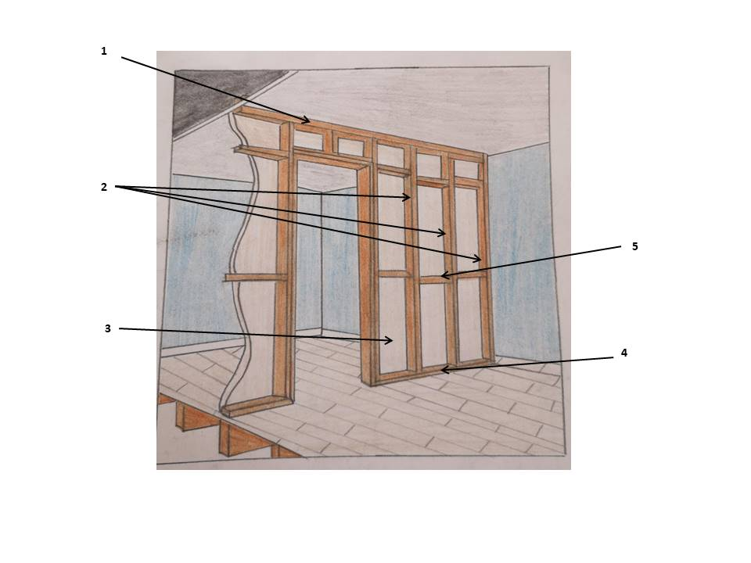

C1. Plasterboard is an inner layer of gypsum which is found between two layers of lining paper. Various additives can be found within the gypsum and this can amend the weight of the plasterboard. It is good for cutting down on noise transmission from one room to another and also acts as a good resistance to fire. It is covered under the requirements under Requirement B3 of the Building Regulations (Assets.publishing.service.gov.uk. 2020)

- Lintels

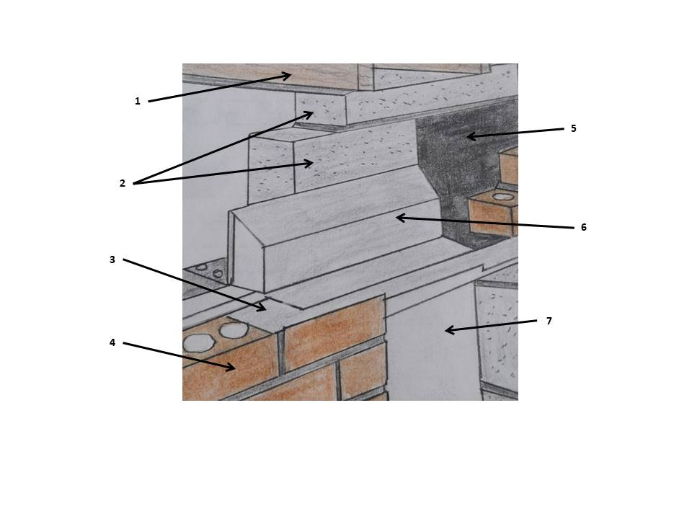

D1. Metal Lintels are light-weight which will help for less load bearing on the inner and outer walls. They should be correctly installed as thermal bridging could occur. This means heat from the inside of the building could escape through the gaps if not fitted correctly (Labc.co.uk. 2020)

- Sills

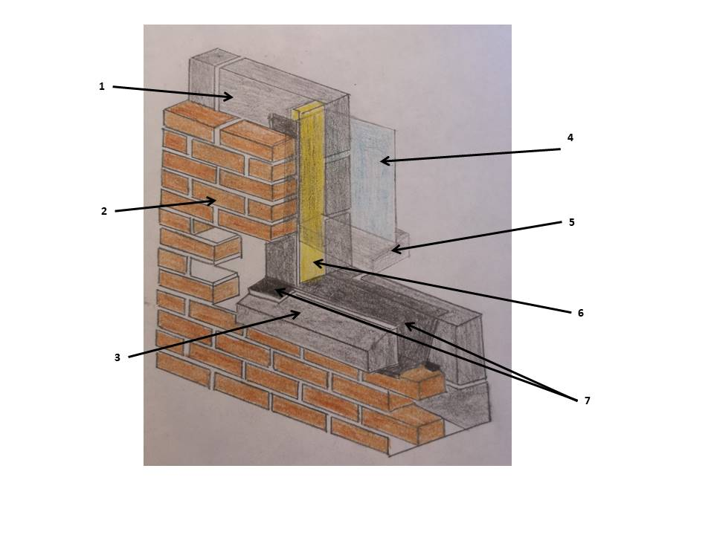

E1. Tempered glass is a good choice of glass as it is up to five times stronger than regular glass. It is made by heating regular glass and then cooled quickly, it more resistant to heat which helps with shock resistance. It is specially treated which, when broken, breaks into small bunt pieces which is a lot safer than other types of glass (Technical Information | Glass and Safety | Saint-Gobain, 2020).

- Roof covering
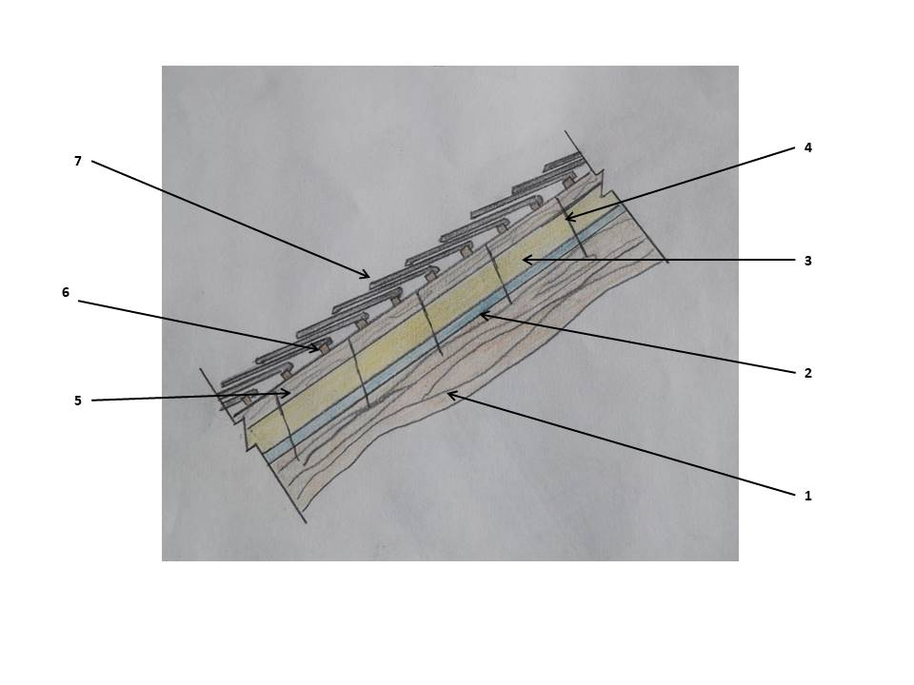

F1. Natural slates are a good choice as there are many positives. The material lasts a long time, which saves cost for the future and are also fire proof which makes them a popular choice within the industry. The material should be capable of safely withstanding the loads upon the roof structure (Assets.publishing.service.gov.uk. 2020).

- Eaves

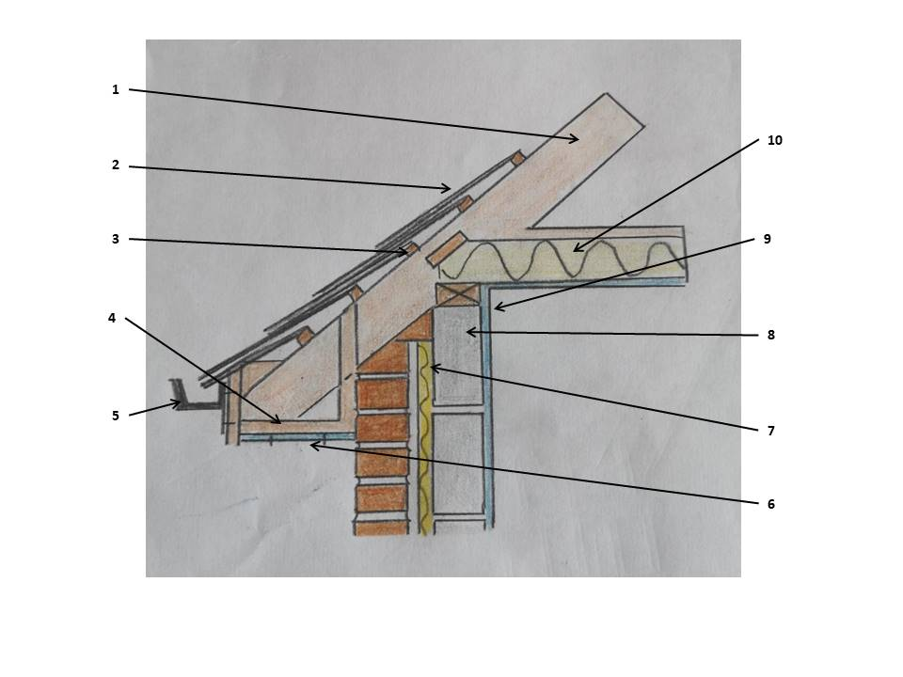

- Queen post truss

As there is a loft room within this building, the best option to build the roof structure would be to use a Queen Truss. As the length of the house for the main roof will be over 10 meters, this solution will suffice and also there will have to be two trusses for roof. One will be placed above the partitioning wall in between bed 1 and the landing and the other just above the partitioning wall above bedroom 3. A queen truss is a simpler and lighter truss and requires less material (Barn Size Comparison, 2020). It is quick to construct and helpful economically as there is little waste. The below image is an example of the structure of a queen post truss.

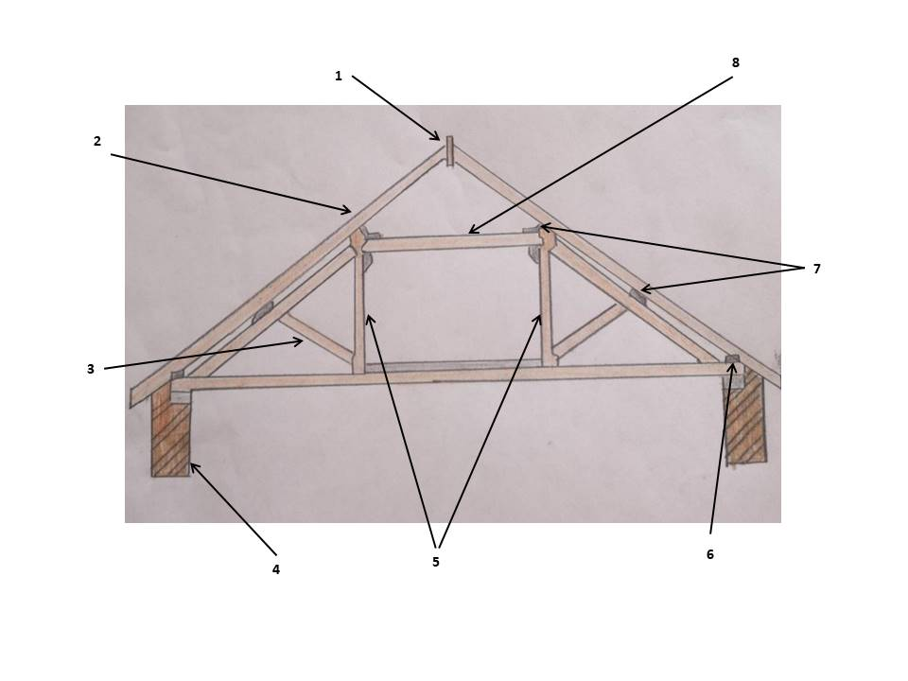

- Roof structure for over the garage and front of house
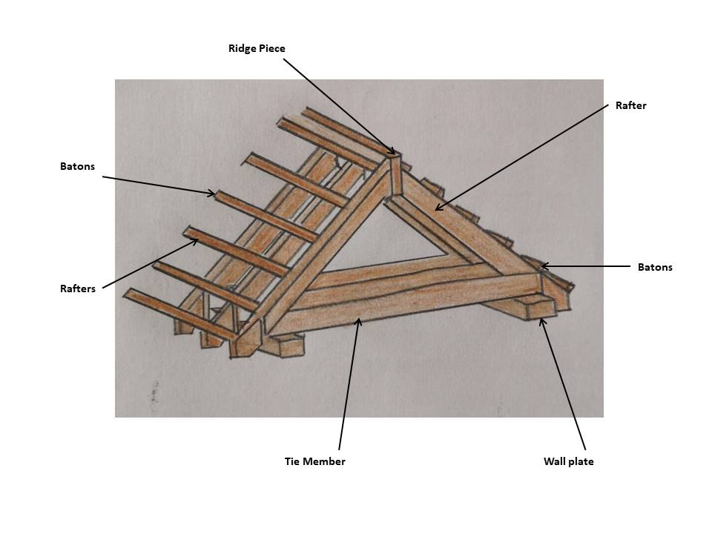
I1. As the area is smaller for the roof over the garage at the side of the property, and for the part that protrudes at the front of the house, the best option to use for the roof would be a close couple roof. This is a much simpler roof to construct and just consists of rafters, wall plate, ridge piece, tie member and batons. Using a tie member will help with the horizontal loads and the roof will perform much better (Domestic roofs, 2020).

