St Fagans - Miners homes Through time

By Charlie Mckenzie

Table of Contents
Introduction……………………………………………………………………………………………………3
Windows and Doors………………………………………………………………………………………3,4
Wall Coverings………………………………………………………………………………………………..5
Roof Coverings………………………………………………………………………………………………..6
Floor Coverings………………………………………………………………………………………………6,7
Internal Joinery……………………………………………………………………………………………….7,8
Appendices…………………………………………………………………………………………………9,10
Reference List…………………………………………………………………………………………………11

Introduction
6 houses were available to visit at St Fagans starting from the left, from 1805 to 1985 that we were able to visually see. Starting from the left of the terraces is the house from 1805 moving along to the end house which is from the year 1985. Due to the time difference/gap being so large between the terraces there was introductions made to improve floor coverings, windows and doors and roof coverings. The changes to key structure of the houses were for such reason as overcoming defects and improving durability and quality in such areas.

Windows and doors
Starting around the year 1805, from left side of the houses and the outside of this house with the windows. We can see that the window consisted multiple panes instead of a singular glass pane like wed see in modern buildings, the structure of windows used in this house would be called cross casement windows which were traditionally used around the 1800 period and was still further used in later years. This was desired at the time as it was deemed that if you had multiple glass panes it symbolised wealth and was used for decoration purposes. The window also holds wooden frames to support the large number of panes within the frame. Traditionally around the 1800s crown glass was used for window production and mainly used due to the resources and equipment that was present. The door to this 1805 terrace house is clearly made from wood, set within a stone wall. Looking closely at the ironmongery that is present, it shows a vertical door handle attached. “The simpler one consists of a handle of flat section with the ends expanded into decorative plates by which it is fixed to the door” (Buildingconservation.com), which gives us a brief understanding of the characteristics at this time.
Moving on 50 years, looking at the differences and the overcoming of issues from the previous years. The 1855 house windows and doors had near to no changes. The same design was used on the structure of the windows, with multiple panes of crown glass due to manufacturing purposes in the 1800s. Furthermore, taking a closer look at the front door there hasn’t been one large change to any aspect of the door compared to the 1805 terrace.
Looking now at the windows and doors for the 1895 we can see major changes to both aspects. Starting with the change to the windows, previously earlier in the 18th century as discussed, they used cross casement windows with due to the heavy production of crown glass which desired this design of the casement window. However, near the end of the 18th century in this terrace they have installed a multi pane sash window. Components such as the top rail have had significant changes to increase support.
“The top rail forms the uppermost horizontal element of the sash. This sturdy element gives structure to the window, supporting the glass panes and helping to maintain the overall integrity of the window” (Dowling, A. (2023). Patchett Joinery). Furthermore, looking closely at the 1895 door, we can see that just like the previous doors it is made from timber wood due once again to available cost-efficient resources at that time. The door also doesn’t have a threshold which can overall lead to structural damage to the door.
On the other hand, moving on 30 years (1925) there is an introduction to a door threshold as previously mentioned years before not having this advantage to the front door. The reason for this inclusion is the role it plays as a seal/barrier keeping external issues such as cold air and rain getting through the front door.
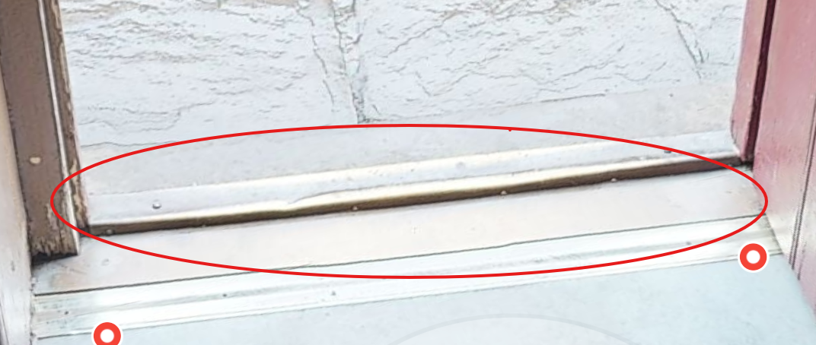
Image from: the museum of Wales : museum.wales.com
The windows on this terrace are the same structure and type of window sued in the house before, this window being a multi pane sash window.
Taking close attention to the 1955 terrace the door has had major developments and inclusions such a singular pane glass window sitting at the top of the door. Starting by looking at the frame of the door, both casing and threshold are present which unlike earlier years wasn’t present.

Key Benefits of Casing
- Protection: Guards edge surfaces of door and window units from damage
- Design Harmony: Maintains visual consistency within a space
- Architectural Integration: Brings together room elements cohesively
- Refinement: Adds a level of sophistication to any interior
- Durability: Quality casing stands the test of time
drillingbucket. (2025).
The window to this 1950s terrace, appears to be a casement window. As we can see it opens outward on a hinge. “This design was particularly popular in the 1950s, as it allowed for maximum ventilation and natural light to flood into the home” (Doorwinwindows.com. (2025). A Nostalgic Look at 1950s Casement Windows).
Finally, moving onto the most modern terrace of the 6 (1985). Externally we can see that this window has a multi pane design with a white wooden frame supporting it. Comparing this modern designed door to the oldest (1805) there has been major changes, such as the oldest door not having any sort of threshold, Lock rail and panels for design. Whereas the modern door has introductions to panels and top rails/bottom which will erase weak structure and have extra support to the multi pane window present within the door.
Wall coverings
Starting from the earliest terrace, from the outside it is seen to be ‘lime wash’ finish. Lime wash was used on this terrace to allow flexibility and to allow the stone wall to breathe in all sorts of environments. Roughcast could also be present as it was popular during the 1800s.
Moving onto the next terrace, the wall coverings have a slight change to the previous in that the main wall coverings would be the stone walls themselves, possibly mixed and held together with lime mortar to prevent penetration to the wall.
Again, looking at the next terrace (1895) we can only see minor changes to the wall coverings. Lime mortar still presents on the wall with the mix of lime, sand and water creating a fine finish to structure the stone-based wall. The only difference to the wall was the fine finishing.
The house presenting 1925, shows a plastered finish to the external walls also having a polished trim over the top of the window frame to protect any edges from being damaged by rain or wear and tear overtime.
Viewing the final terrace (1985), the render present is most likely to be cement based as it was most used on terraces in the 1980s. cement render was favourited during this time for its textured and durable finishing to walls. The differences from the eldest terrace (1805) to the more modern (1895) is the advantage from using a lime render to a more sturdy cement rendered finish with positives like, durability and its impact resistance to the weather conditions.

Roof coverings
Firstly, we can see that the eldest terrace on the left is using a common type of covering which is slate tiling to protect the roof in the 1800s. “Wales produced over four-fifths of all British slates in this period, with Caernarfonshire the biggest producer among all Welsh counties” (National Museum Wales). This tells us that not only was slate tiling used for its strength but also due its common availability in Wales during this period.
As we can see in the following terraces, slate tiling was again used due to the large mass production of this material in Wales in the 1800s. Due to slate having such advantages to terrace houses such as its environmental benefit as mentioned it is a naturally occurring material and alongside its low maintenance concluding it to be cost effective for most.
The real change that we can see in the terraces really starts at 1955, where the change from slate tiles to clay tiles was introduced. Slate tiles became more common in the 1950s due to its improved insulation rates to houses. Clay tiles also gave off a more traditional look during this era.
The largest change to the structure an design of the roof coverings comes in the most modern terrace at 1985. This is where the design and cut of the tiles has changed to a common concrete interlock, this was used later in the 1900s to improve defects like weathering and also to stop excess usage of materials. “This type of tile is usually larger than a plain tile, so fewer will be required to cover the roof. The installation process will therefore be quicker and more cost-effective than that of laying a plain-tile roof” (Superstore, R.).
Floor Coverings
Starting from the eldest of the houses, it consists of a natural stoned floor on the base of the house which could either have been sandstone or limestone. This floor covering was commonly used for ground floors and the kitchen areas. The upstairs floor covering would often have timber wood as a singular layer.
The slightest of changes have been amended to the floor coverings in the following terrace (1855) , this is where the irregular stone shapes have changed to measured and symmetrical slabs have been cut. Both Using the same resource but just with slight improvement for a more uniform thickness to the stone.
The same occurs in the latter years of the 1800s where the regular cut stone is used as a main flooring, looking up at the first floor also it is a single layered timber wood floor which has considered the contents of the room.
Moving from the Stone slabs to the next major change and this being the introduction of timber wood flooring:
‌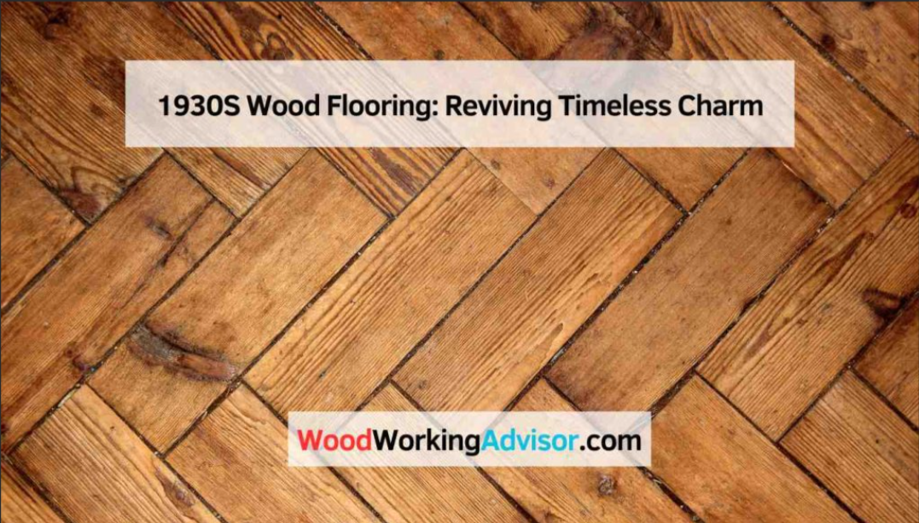
Image by: The Wood working advisor: WoodWorkingAdvisor.com
The timber wood flooring that has been put in place has introduced insulation to the floor and also put in place decorative rugs that will also act as an insulator throughout the terrace. Timber wood flooring was only particularly used upstairs as floorboards but as years have passed it has now become a main floor covering that sits above the natural stone.
Finally, the most modern out of the terraces is installed with fitted carpet wall-to-wall. This most likely would be laid on top of a subfloor which commonly around the 80s would be a timber wood base. The ultimate change from stone slabs to wall to wall fitted carpet is mainly due to the demand for insulation in houses throughout the years.
Internal Joinery
You can see that in the first terrace that there are roof joists and structural parts that are visible. Parts such as beams that help support the timber flooring are also clearly visible from ground floor in this terrace. Beams are very important for the single layered timber floor due to the stability multiple beams provide. All of this is visible from the ground floor of the terrace and is due to the lack of plasterboard or dry wall coverings in the 1800s.
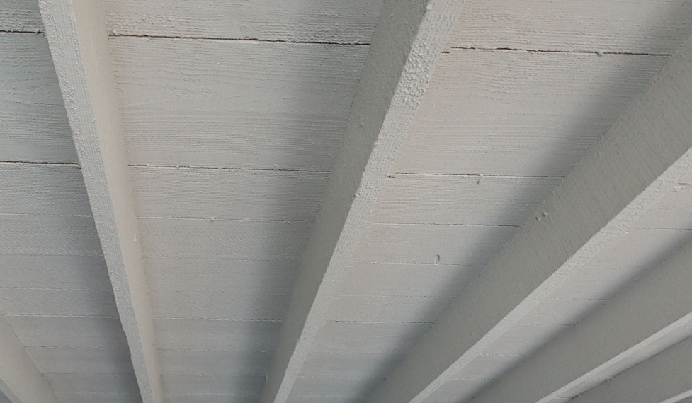
Image from: the museum of Wales : museum.wales.com
Moving onto the next terrace, there are no skirting boards on the ground floor as this type of joinery wasn’t included until the 1900s. Again, very similar to the first terrace the roof joists and structural beams are clearly visible from ground level. This terrace having little to no differences in terms of advanced joinery.
The most noticeable change to the late 18th century terrace, is the windows wooden joinery. It is most likely tenon and mortise used traditionally used to create a strong and sturdy joining of the wood. “A mortise and tenon joint is a simple yet ingenious way to connect two pieces of wood at an angle, typically 90 degrees. The joint consists of two primary components: the mortise and the tenon” (Tomaco.co.uk. (2025). What Is a Mortise and Tenon Joint and What Is It Used For?).
The next clear change to the joinery is the presence of skirting boards on the ground floor of the terrace. 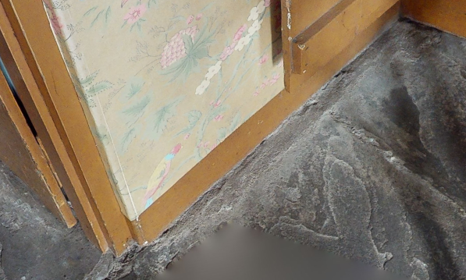
Image from: the museum of Wales : museum.wales.com
The introduction was to eliminate the issue of irregular gaps between walls and floor and to help with the movement of timber floor due to the humidity. This having a huge difference compared to the 1800s as recognising how humidity can affect the material used (timber) would then further help manage heat at certain periods of the year.
Looking closely at the ceiling in this terrace (1955), there has been a patterned finish between the beams as a decorative upgrade to the terraces post war. The next change for more structural purposes was that the joinery became squarer and thinner compared to the earlier beams where you could see how thick they had been cut. This was due to what was happening around the world with war and economic issues leading to a timber shortage.
To conclude, viewing the last terrace we can see there is simplistic skirting boards around the perimeter that can be easy to upgrade further down the line. Also, this terrace having a lower perceived ceiling height to previous terraces. Again mentioning the ceiling & structure, there is more bulk and seems to be frequent ceiling breaks.
Appendices
Pre 1919:
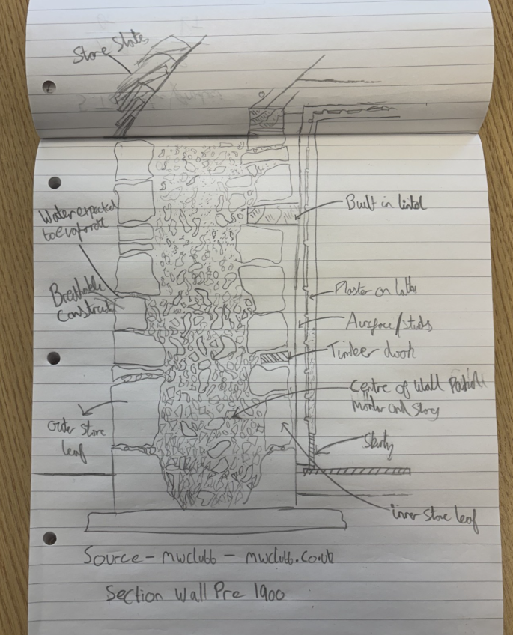
1950s:
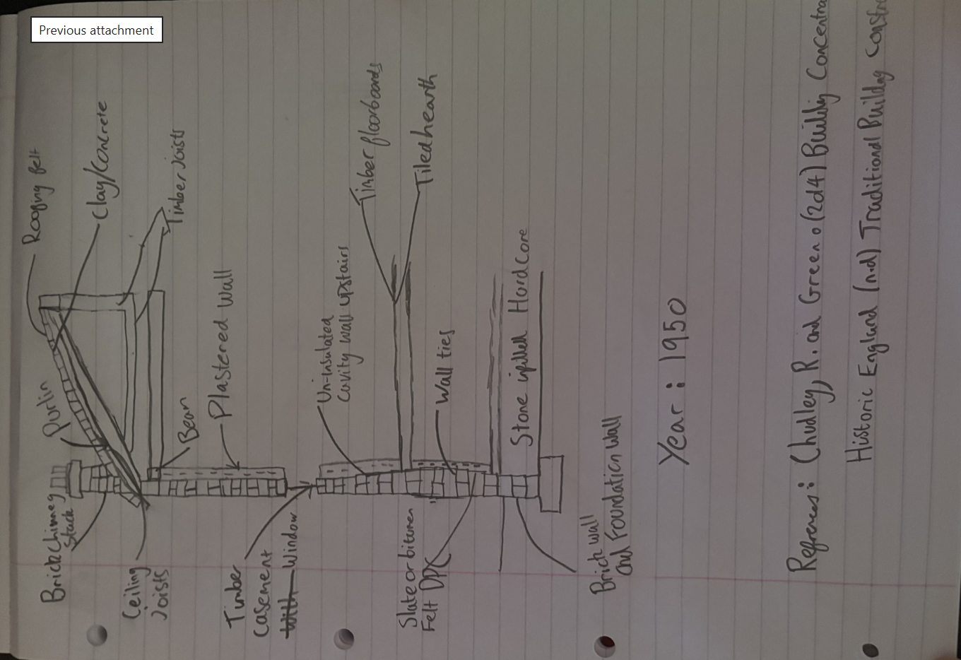
1985:

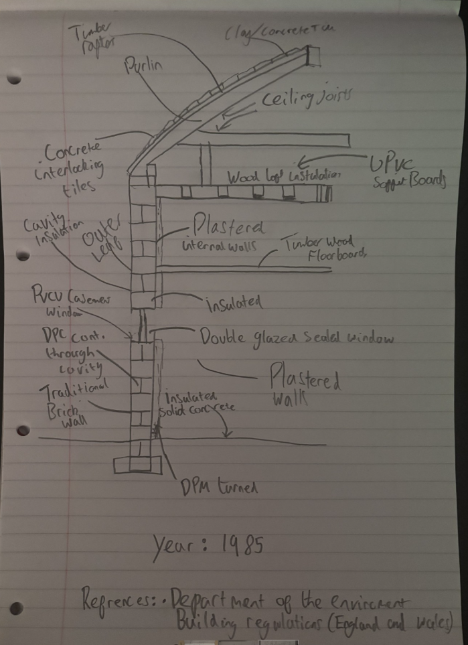

Reference list
Buildingconservation.com. (2019). Early and Vernacular Door Fittings - Linda Hall. [online] Available at: https://www.buildingconservation.com/articles/doors/door_furniture.htm.
Dowling, A. (2023). Patchett Joinery. [online] Patchett Joinery. Available at: https://www.patchett-joinery.co.uk/blog/anatomy-of-sash-windows/.
drillingbucket. (2025). What is Casing in Construction: Understanding Door Casing, Trim, and Molding. [online] Available at: https://drillingbucket.com/what-is-casing-in-construction/ [Accessed 23 Dec. 2025].
Doorwinwindows.com. (2025). A Nostalgic Look at 1950s Casement Windows: A Journey Through Time. [online] Available at: https://www.doorwinwindows.com/casement-window/a-nostalgic-look-at-1950s-casement-windows-a-journey-through-time [Accessed 28 Dec. 2025].
National Museum Wales. (n.d.). Story of Slate. [online] Available at: https://museum.wales/slate/story-of-slate/.
Superstore, R. (n.d.). Interlocking roof tiles buyer’s guide. [online] Roofing Superstore Help & Advice. Available at: https://www.roofingsuperstore.co.uk/help-and-advice/product-guides/pitched-roofing/interlocking-roof-tiles-buyers-guide/.
‌
Tomaco.co.uk. (2025). What Is a Mortise and Tenon Joint and What Is It Used For? – Tool Marketing Company. [online] Available at: https://www.tomaco.co.uk/what-is-a-mortise-and-tenon-joint-and-what-is-it-used-for/ [Accessed 4 Jan. 2026].

