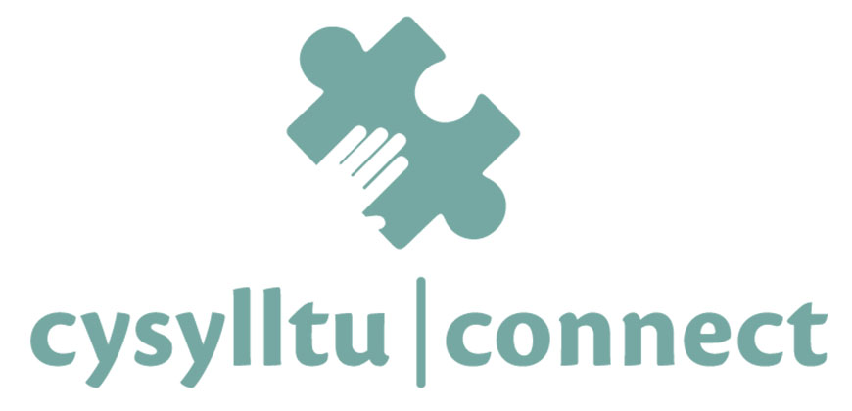

Corinna Afra

Reflective commentary

Using Gibbs’ reflective cycle (1988) I am going to reflect on my time spent volunteering with Connect which is my volunteering placement. I was looking forward to working with Connect but unfortunately, I have not had anyone to talk with yet. Due to Covid all the sessions took place online via teams. It means we need some information technology (IT) knowledge. Also, we need to think about issues related to wifi. First, I was worried what is going to happen if I cannot practice and I was already worried how it is going to happen, how would I help anyone professionally, how I am going to lead the conversation etc. All in all, as it is a new experience, I had a lot of questions about it and I also questioned myself and my capability to help. I still question myself but at least I accepted that I will be able to have a session one day. As an analysis I realised that I overthink it too much and in conclusion I need to be patient and prepare myself for my first session at least mentally. I always get anxiety before new experiences and I tend to overthink and think about negative outcomes. For the future I need to change my way of thinking and think about the positive outcomes and I need to trust myself that I am going to do my best and it is going to be more than enough. Mostly I am going to talk about the skills I would use and the feelings I would feel due to lack of volunteering. I would use basic counselling skills according to McLeod (2011) for example providing a safe place, listening skills, summarising, paraphrasing, decision making. Also it is important to mention the SOLER which is sitting squarely, open posture, lean slightly, maintain eye contact and relax (Egan; 1975). I would say I would manage basic counselling skills and SOLER well. I am interested in how my client feels and I like to listen, which would not be a problem. I would feel confident while I am listening. I know that sitting straight is a challenge for me. For the future I need to be more aware of my body. As I am there and listen, I would paraphrase and summarise well. All in all, I would feel nervous because I usually do not feel confident and it is all practice. Also I find it challenging to ask open questions. That is also practice. I did practice during counselling classes and doing it with an individual I do not know at all would be a new and terrifying experience. My fear is what if my mind blocks during a session because of my high nerves and I would seem unprofessional or if I could not say a word. I usually see myself as a maximalist and due to that I cannot handle failures. A strange experience would be someone with suicidal thoughts. Luckily Connect provided us training including that area of counselling. I feel that I cannot be prepared enough at the moment for that extreme topic in a real session. For these issues the solution is I think practice again. I would find language issues challenging as I am Hungarian. For example, if I do not understand a word that the client said. I would ask her to explain it or I would translate it but after that I would be nervous and maybe I would lose composure a little bit. I need to learn how to deal with nervousness. Also challenging would be giving help when I am struggling mentally. The right way to handle that would be if I learn how to separate my job and my personal life. At the beginning I was thinking how I am going to deal with time management as I am not good at it. I am also working, and I was a bit worried how I will cope with University, work and volunteering at the same time. For the future I need to practice time management. Knowing that I am responsible to them is a bit terrifying. I would be satisfied if I could help just a little bit and I could see the pain released from the client and I made their day better. If I did a session, I would experience nervousness, joy, scare, vocation, compulsion to conform.
All in all, I think I would do my best during a session using basic counselling skills McLeod (2011) correctly and also using SOLER Egan (1975) the right way. As I mentioned I have not had anyone to talk to but I can imagine how that would go. There would be challenges such as sitting straight, dealing with my own mental problems while I need to deal with others, handle suicidal thoughts. I need to focus on my thoughts and not overthink too much and also not let myself lead with my negative thoughts. My strengths are active listening, providing a safe place, showing empathy and being non-judgemental. Furthermore, I need more practice in general to be confident enough. Moreover, I need to accept that I am not perfect, and we all make mistakes and we learn from them and these makes us better in our job. I would say I should go to therapy too to handle my daily anxiety that could affect on my future. I am looking forward to having my first session with someone. My aims are helping as much as I can and giving a better time to someone on this planet.

References

CONNECT. (2021). Connect. https://connect-wellbeing.wales/

Egan, G., (1975). The Skilled Helper: A Systematic Approach to Effective Helping. Pacific
Grove CA, Brooks/Cole

Gibbs G (1988). Learning by Doing: A guide to teaching and learning methods. Further
Education Unit. Oxford Polytechnic: Oxford.

Mcleod, J. (2011). Counselling Skills: A Practical Guide For Counsellors And Helping Professionals: A practical guide for counsellors and helping professionals (2nd ed.). Open University Press.

Table of contents

Reflective commentary………………………………………………………………………………………………… 2
References ……………………………………………………………………………………………………………….3
Portfolio of evidence …………………………………………………………………………………………………….4
Evidence 1: Background information …………………………………………………………………………5
Section A: Information form ………………………………………………………………………………………5
Section B: Mission statement …………………………………………………………………………………….8
Section C: Values and strategic aims ………………………………………………………………………….10
Evidence 2: Reflective logs ……………………………………………………………………………………………...11
Evidence 3: Trainings/Meetings ………………………………………………………………………………………12
Section A: Certificates …………………………………………………………………………………………………12
Evidence 4: My connect profile …………………………………………………………………………………………14
Appendices ………………………………………………………………………………………………………………………15

Evidence 1 – Background information

Connect is a student wellbeing support for students from any campus on any course. They do not provide crisis support. There are connectors who can be students and staff members. Students understand students and I think this is a very good way of helping. They provide plenty of support but the main one is talking sessions. Connecters also provide company if a student does not want to go to an event alone. It is important to know that no one is a certificated doctor, counsellor or therapist. Summarising the aims are providing a safe place and a healthy mind for students. They have a very helpful application with audio-based videos about the mind, body and mental health. Connect works with other universities such as the Singleton campus (Connect; 2021).

Section A: Information form

Placement Information Form
Name of Student: | Corinna Afra
Proposed Placement Setting and Address: | CONNECT – online peer support  UWTSD
Proposed Dates of Placement: | From 18th August to January
Name of Contact for Venue:  Please also state their position: | Natalie Owens  CONNECT Project Coordinator
Email Address: | n.owens@uwtsd.ac.uk
Telephone Number for Contact at Placement: | N/A
Is a DBS required for you to attend this placement? | No  If Yes, have you applied for this?  - Yes applied on _________________  - No
Explain how your role in this organisation/on this placement meets the criteria for the assessment for the module | (e.g., what duties/tasks will you be undertaking that are relevant for the module assessment)  I am going to support students who are at risk of social isolation, experiencing loneliness or need help with developing social integration skills.  I am going to use my listening skills, my ethical knowledge about counselling. I am also going to use my patience and a great understanding of other people.

Section B: Mission Statement

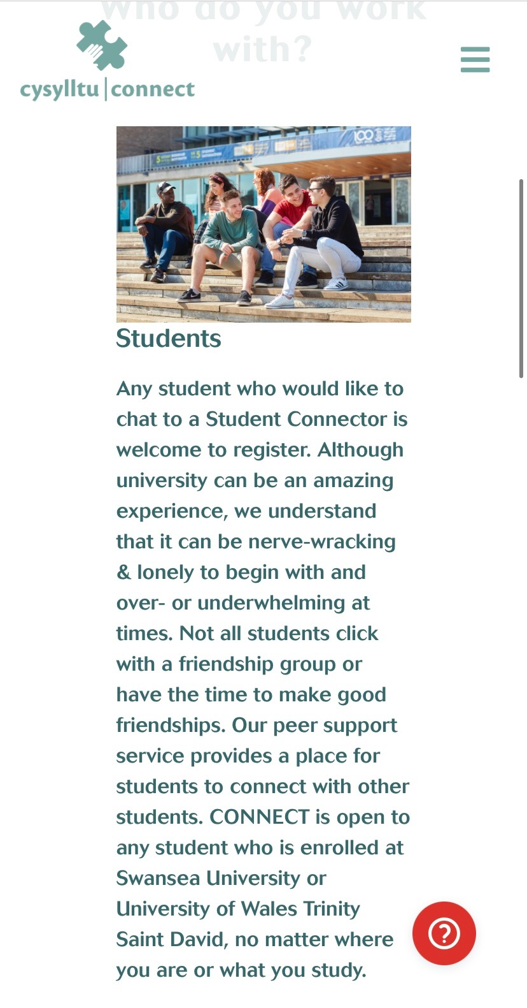

Section C: Values and strategic aims

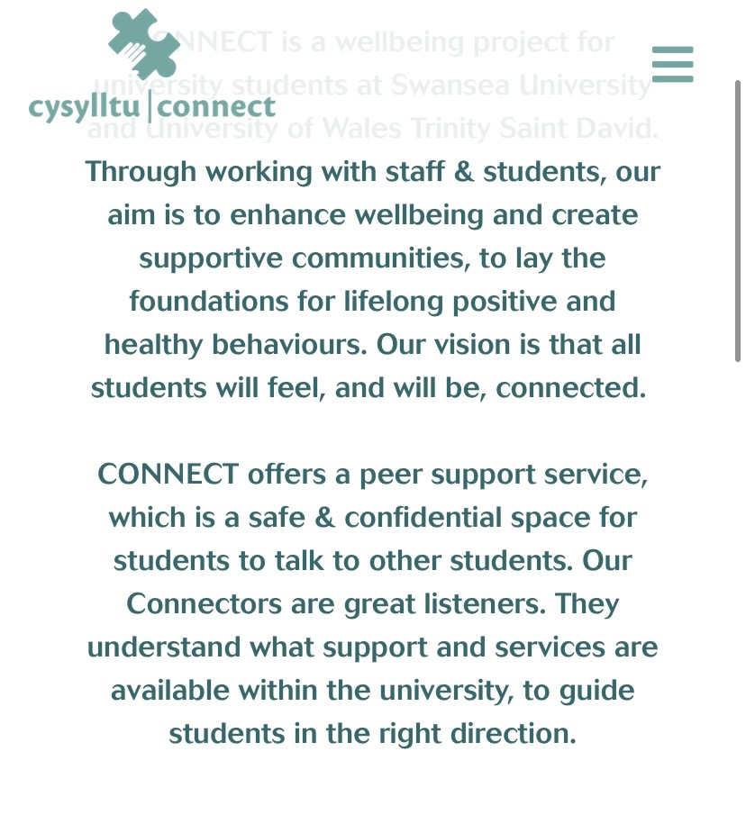
Their aims are highlighting the fact that lot of students are struggling with loneliness, homesickness or stress about exam. Their mission is to help student mental health and help them connect to others.

Evidence 2: Reflective logs

Example Log Book
Student Name: | Corinna Afra
Name of Host Employer: | N/A

Record of project work carried out (add more entries as needed)
Date: | 17.08.21
Tasks completed: | Look after your mate training
Reflection: | We got a brief information about mental health issues and how important it is to take care of your mental health. The training was interactive, so we had the possibility to share our ideas about how I would help someone. I liked the exercises because we could discuss the right ways of helping. We also talked about communication techniques that are going to be helpful in the future. We got examples of starting a conversation which is a risky and scary part for me. We discussed what is helpful if students are not ready to speak, discussed the right listening skills. Moreover, how can we motivate others and basically use the counselling skills that we learnt in the lectures. All in all, this training was very helpful and well structured. It mentioned the important parts of helping and gave us a brief description how to be empathic and lead the session.

Date: | 25.08.21
Tasks completed: | Connect introductory training
Reflection: | We talked about Connect in general, what the aims are, expectations of volunteering. Furthermore, we talked about proper listening skills, how to keep things safe and what to follow to make boundaries. We discussed confidentiality and also how to help in a crisis. All in all it was a brief introduction of Connect and how it works. It was interesting and helpful.

Evidence 3: Trainings/Meetings

As I only did the trainings at the beginning, I described in the log book how they went and what they were about. Connect provides trainings most of the time.

Section A: Certificates

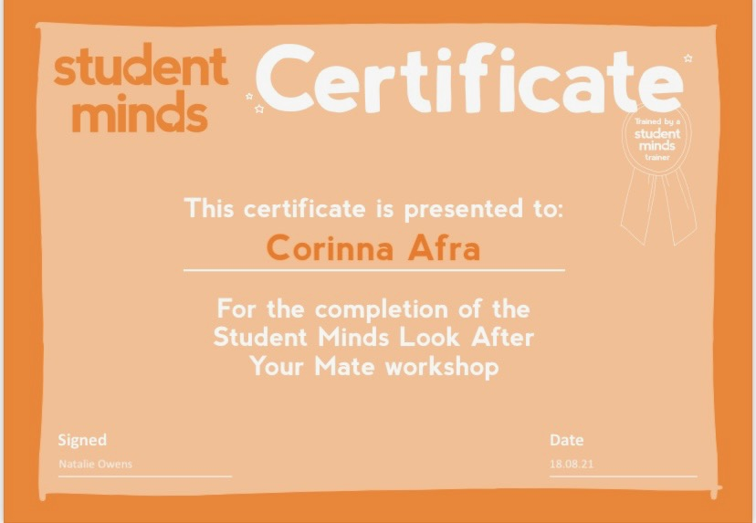
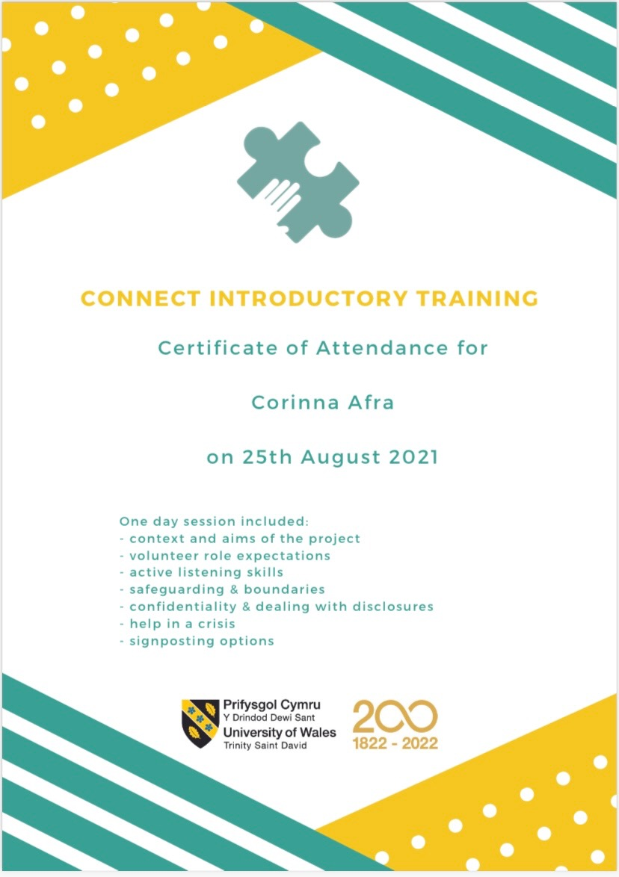

Evidence 4: My Connect profile

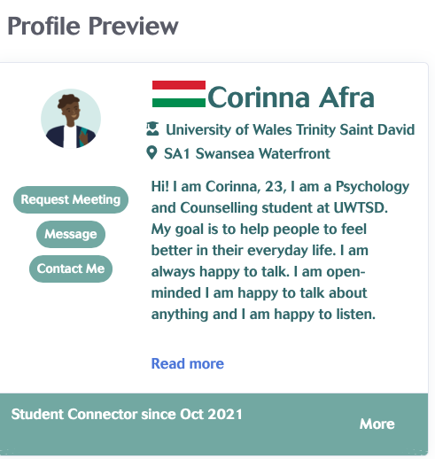

Appendices

Appendix A

“The letter or email that you have sent to the organisation requesting to spend your time working with them on your placement, plus their response in order to demonstrate that your placement was approved.”

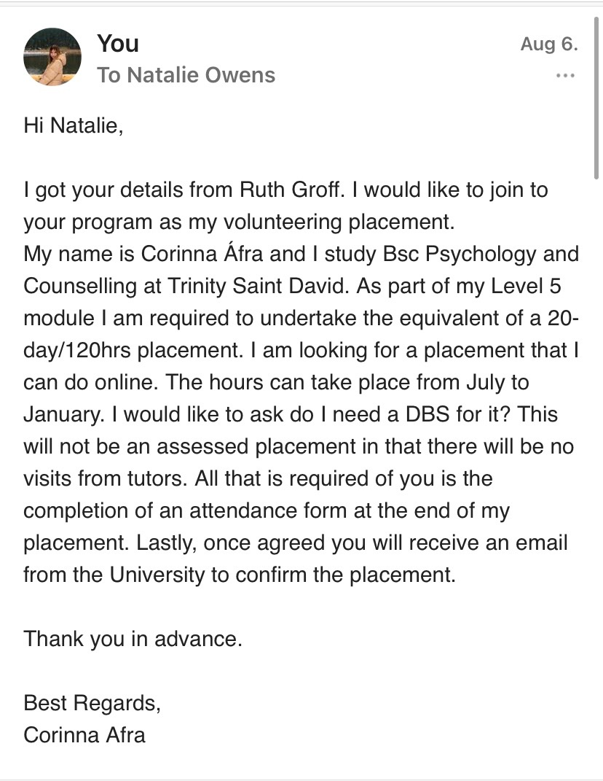
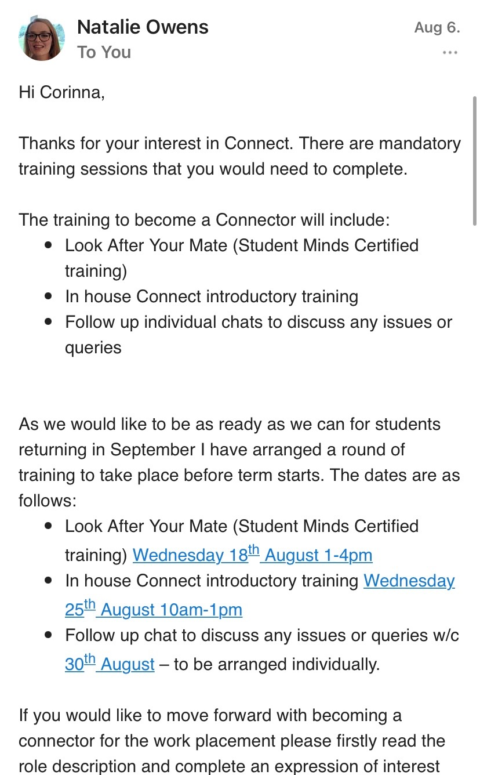
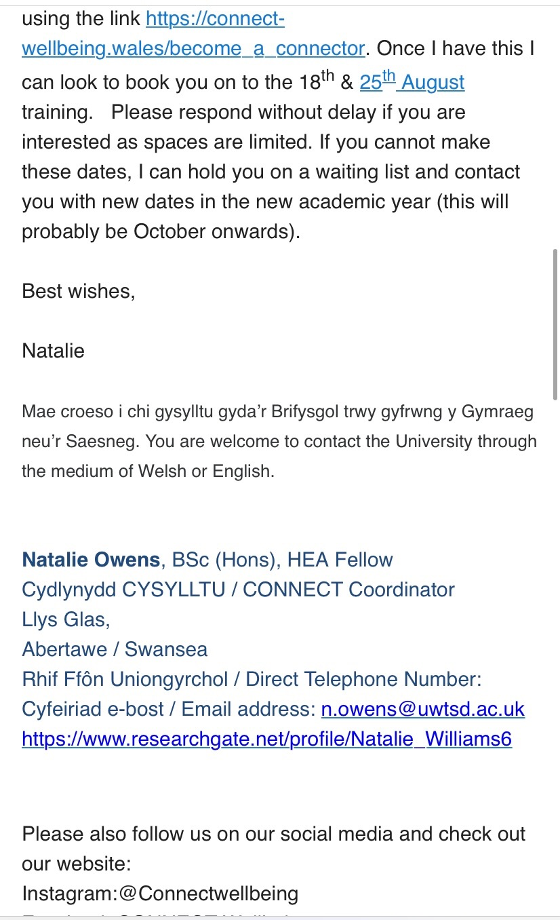
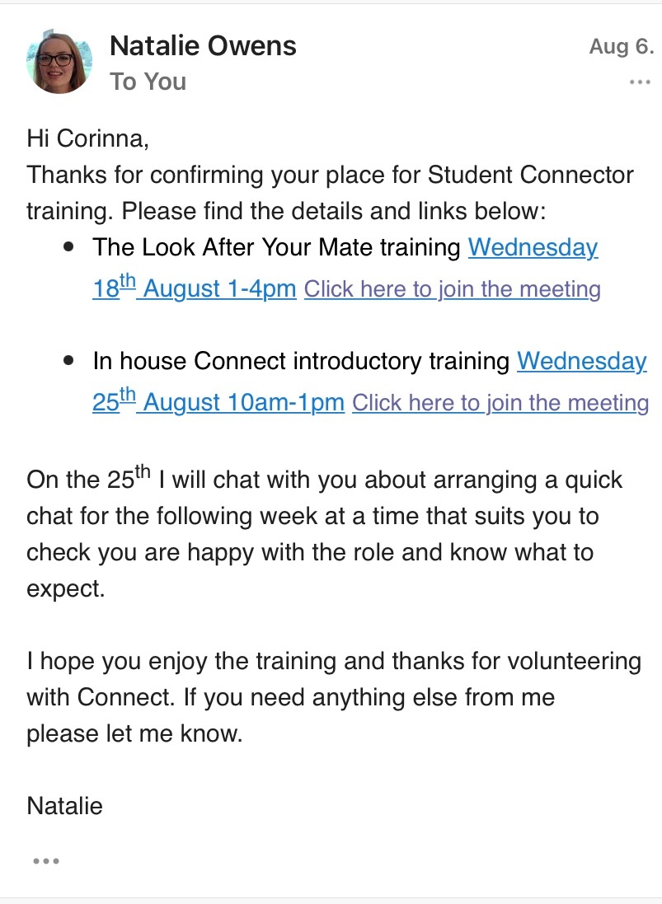

Appendix B

Email or document indicating approval from the module leader to confirm your placement.

I could not find a proper approval from the module leader.



