4b Selection in C (2) – if/else statements

1. Write a program to allow the user to enter their PIN on a bank ATM machine. Compare this PIN number with the actual correct PIN number (3456) and print a message on the screen to inform the user if the PIN they entered was correct.

Sample output:

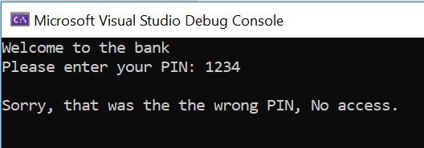

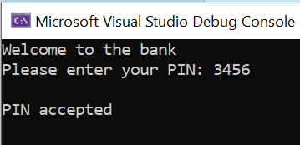

2. Enter a student's overall degree mark and tell them their classification as follows:

Mark of 70 or more – "First"
Mark between 60 and 70 – "2:1"
Mark between 50 and 60 – "2:2"
Mark between 40 and 50 – "3"
All other scores get "Resit"

Sample output:

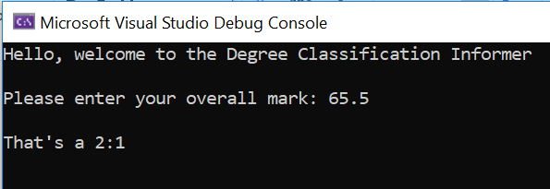

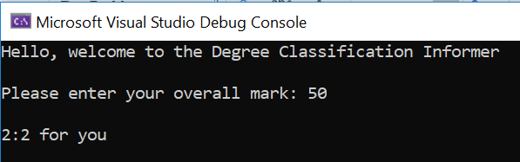

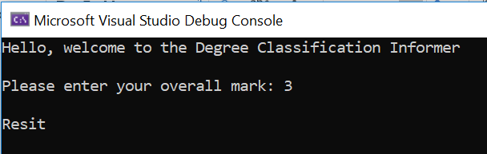

3. Write a program to check whether a number entered by the user is even or odd. (hint: % mod is helpful)

Sample output:

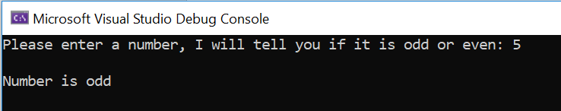

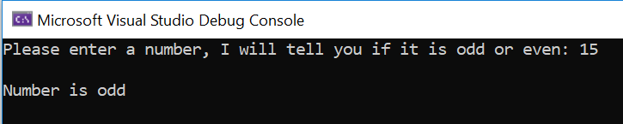

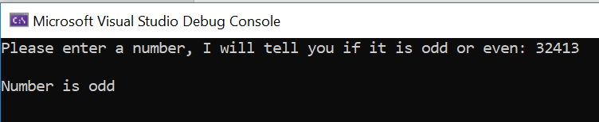

4. Write a C program to check whether a year is leap year or not. (hint: % mod is helpful)

Sample output:



