

LCMB7003- Strategic Management
Lecturer: Amare Desta
Student Name: Sufiyanhusen Najirhusen Patel
Student ID: 2309266
Task: 2
Topic:
Evaluation of emergence of Virtual Organisations

Executive Summary
This complete report provides detailed information on the emergence of virtual organizations. Where it has provided insight into various types of strategic management issues that are associated with the entities like designing, planning, and leading. The report also highlights the concept of virtual organizations and provides details on the advantages. This are associated with strategic management, challenges which are associated with strategic management, and implications for strategic management. In order to support the arguments, the report has also analyzed some research papers that highlight real-world examples and has provided a detailed understanding of the topic. Then it also discussed about the importance of corporate social responsibility (CSR) and business ethics in the context of virtual organizations.

Table of Contents
1. Introduction 4
2. Understanding Virtual Organizations 4
3. Advantages of Virtual Organizations 5
4. Challenges of Virtual Organizations 5
5. Strategic Management Issues 6
6. Corporate Social Responsibility (CSR) in Virtual Organizations 7
7. Business Ethics in Virtual Organizations 8
8. Conclusion 9
9. References 10

1. Introduction
This report aims to explore how the virtual organization has been a paradigm shift in light of changing technology and globalization. The following shall address the benefits, challenges, strategic management issues, and corporate social responsibility (CSR) together with the ethics associated with virtual settings. The report aims to demonstrate several aspects and information available in the context of virtual organizations. It finally zeroes down and gives insights and recommendations that guide organizations in making their way through how to handle the complexities that accrue from the virtual environment, therefore ensuring efficiency, sustainability, and ethical conduct. (Ipsen et al., 2021). Employees are not required to regularly visit any specific office. This type of virtual organization provides the highest level of flexibility to its employees, and this report is going to discuss the various aspects of virtual organizations.

2. Understanding Virtual Organizations
As Information technology is evolving at a very rapid pace and globalization has become a key aspect for accepting and demanding more new revolutionary solutions, it has also created a big impact on how organizations used to operate and this has introduced the concept of virtual organizations. Which is also known as distributed or network organizations. It represents a ship of working concept which has come up in organizations, especially in the organizations which are operating in the field of IS (Babapour Chafi, Hultberg and Bozic Yams, 2021). The entire foundation of a virtual organization is digital communication tools, technology, and platforms which can help to maintain the communication between the remote teams and will allow the teams to enhance their collaboration between the teams that are operating for an organization from remote locations. Where digital communication tools, technology, and platforms play a very important role for virtual organizations and allow them to overcome geographical boundaries and hire talent for them all around the world.
It has been also highlighted in the research article provided by Ferreira et al., (2021), that one of the main positives of virtual organizations is that they provide complete agility and flexibility to people who work there. The team operates from different locations so it helps them to stay aware of new market trends. Which allows the organization to quickly adapt according to the changing market conditions and demands of customers. It has been also identified that there can be some issues occur in virtual organizations on the parameters of data and network security. Which is important for organizations to address.

3. Advantages of Virtual Organizations
There are different types of advantages of Virtual organization have been identified, and some of them have been discussed below.
- Flexibility to employees: As it has been discussed one of the main advantages that virtual organization provides to its employees, is in the form of immense flexibility in their working pattern (Ipsen et al. 2021). It helps the employees to live their lives in a different lifestyle and helps to create a perfect balance between work and personal life.
- Reduce expenses of organizations: Another key benefit that organizations leverage in virtual operation is that, it allows them to reduce their unnecessary expenses which they have to pay in a physical office (Koohang et al., 2023). Like the investments in furniture, electricity bills of the number of devices, and it also cut out the expenses of physical maintenance and management of offices.
- Promotes diversification in the workforce: Another key advantage that has been identified by adopting the method of virtual organization is that it allows organizations to hire talent from different regions of the world (Green, Tappin and Bentley, 2020). Which helps the teams to work and understand the culture, knowledge, and practices of different people all around the world. It also helps to increase innovation in the table and allows the incorporation of new ideas into a project.
The research paper provided by Ipsen et al. (2021), has also highlighted about some key advantages that virtual organizations have provided to their employees while they were working from their homes during the time of COVID-19. Which includes advantages like work-life balance, improved work efficiency, and enhanced work control.

4. Challenges of Virtual Organizations
It is not like the virtual organization has only positive aspects, there are some major challenges are also present which the virtual organization has to deal with. These challenges have been discussed below.
- Communication problems: It is possible that teams who are working on the project may face issues in efficiently communicating with each other (Khan and Charan, 2023). It can occur due to different types of problems like language barriers, network issues, and other types of collaboration issues.
- Loneliness in working: Another challenge is that remote employees might not feel connected to their work or the company. This shows that working remotely, for example, from home or any other remote place, remote workers may not feel attached to the place that they are working from and the company's values (Raišienė et al., 2020). To counteract this, virtual companies should ensure that the employees are part of the process by keeping the employee connected and engaged.
- Data and network integrity issues: Keeping company information safe can be hard when everyone is working online. Furthermore, it introduces another risk because people use various devices to work from different places (Garro-Abarca, Palos-Sanchez and Aguayo-Camacho, 2021). Thereby, virtual companies are advised to secure their information with things like codes, extra security checks, and checking for issues on a regular basis.
The research provided by Khan and Charan (2023), has highlighted that data integrity and privacy issues are the key reasons that are limiting the operation and capabilities of virtual organizations. In the research, the authors have also highlighted that insider threats and malware attacks are the most common attacks that affect the integrity of organizations.

5. Strategic Management Issues
Considering that virtual organization planning generally involves developing strategic initiatives that comprehensively align with both the organization's goals and objectives (Ipsen et al., 2021). The leaders should carefully consider factors such as remote team dynamics, technological advancements, and market trends when formulating strategic plans.
All those sets of organizations need such as maintain productivity and deliver quality projects to the clients of the virtual organization with the motive to implement collaborative culture-building for breaking geographical barriers and enhance teamwork amongst the employees located remotely. That is, leaders should work on building a sense of trust, transparency, and accountability that has the capacity to reinforce the feeling of belongingness and a common purpose toward virtual teams. On the other hand, another crucial aspect of nurturing a culture of collaboration within virtual organizations includes recognition of individual contributions, apart from encouraging open communication and sharing of knowledge (Garro-Abarca, Palos-Sanchez and Aguayo-Camacho, 2021). Effective Leadership is also required to lead a team which is working in a virtual environment. Some of the ideas are required to be implemented. Which can help to dealing with challenges that arise in communication barriers, issues of team cohesion, and performance management within the virtual environment.
The organizational leaders and stakeholders have to set a clear goal and expectations and have to give constant feedback and support. They must also be technically ready to hold frequent interactions and meetings with the virtual team. Examples of leadership include ensuring trust and rapport with team members who are remote to the organization, instilling accountability, and motivating all individuals to attain the collective goals. In other words, strategic management within virtual organizations means planning, designing, and leading initiatives about how to further improve, develop, and expand the use of technology and innovation in order to allow organizational success. The paper provided by Maurer, Bach and Oertel, (2022), has outlines that organizations can enjoy the benefits of having a virtual workforce through the development of strategic plans. This aligns structures with organizational goals and designs flexible organizational structures and culture that allow for cooperation, and effective leadership, whereby the administration person does this from a distance, in the case of virtual teams. Leadership is the ticket to guiding the complexities of the virtual environment and inspiring teams for peak performance in this day and age of the digital era.

6. Corporate Social Responsibility (CSR) in Virtual Organizations
Corporate social responsibility (CSR) is equally important in virtual organizations as in traditional ones albeit with unique considerations. In virtual settings, CSR extends beyond the physical workplace to encompass environmental sustainability along with ethical businesses and social impact initiatives in the digital space.
- Environmental Sustainability: In a virtual office setup employees do not go to the office daily which helps to reduce the carbon emissions that would be produced by their vehicles. It has been highlighted by authors Van Ewijk and Hoekman, (2021), that it also helps to reduce the consumption of huge amounts of electricity which generally being consumed in a physical office. Both of these factors will help to promote or maintain environmental sustainability.
- Ethical Business Practices: The research paper provided by Chenneville and Schwartz-Mette, (2020), has shown that adherence to the highest respect for ethical standards in the virtual organization takes into consideration the assurance of data privacy, cyber protection, and securing fair labor practices. It should focus on the security level and measures of data, regulatory needs, and transparencies of digital transactions that shall further lead to building more confidence among the stakeholders and the reputation of the organization.
- Social Impact Initiatives: These include the ways that the virtual organizations can participate in the social impact initiative by promoting remote communities, diversification, and inclusion of other segments into its framework, and by encouraging digital literacy programs. The research conducted by Ferreira et al., (2021), provides information on virtual organizations can also assist in the delivery of social good through improved welfare to empower marginalized communities and bridge the digital divide by making positive contributions to society.
- Employee Engagement: The research conducted by Lee, (2021), has provided information on how CSR initiatives in virtual organizations also focus on promoting employee well-being, a sense of community, and support for opportunities regarding their professional development. This can also include virtual wellness programs, virtual volunteer activities, and the provision of resources for continued learning so that the workers attached to the organization are kept engaged and satisfied.

7. Business Ethics in Virtual Organizations
- Ethical Consideration: In virtual organizations, maintaining high ethical standards is to build trust and credibility amongst all stakeholders. The research paper provided by Chenneville and Schwartz-Mette, (2020), has shown that to be high on the list of business ethics in a virtual environment because principle areas are based on integrity, transparency, and accountability in all business transactions.
- Promoting Transparency: The research provided Chamakiotis, Panteli and Davison, (2021), has highlighted that for prevailing in a virtual organization, transparency is very key. This should be openness and transparency of the leaders to make the information flow and decision-making with integrity. Building up such high trust via transparency helps in gaining a commitment from stakeholders not to be unethical.
- Ethical dilemmas: This deals with the readiness of the virtual organizations to come up and deal with ethical issues such as privacy breaches, intellectual property rights conflicts, or even questions on what constitutes fair practice of competition. For such times, it has been highlighted in the paper provided by Maurer, Bach and Oertel, (2022), that there should be in place protocols to guide through the actions of leaders, clear channels on how to report cases of unethical behavior, and mechanisms for conflict resolution.
- Training and Education: This proves that permanent training and education in business ethics are supposed to be given for the organization’s employees in the case of virtual organizations. It has been also highlited by the researchers Abarca, Palos-Sanchez and Rus-Arias, (2020), that training programs or modules should imbibe the understanding of those areas that involve making ethical decisions, conflict resolution, and the code of conduct of the organization so that the person is made aware of the ethical responsibility that is subjected to him or her regarding the organization.

8. Conclusion
In conclusion, the emergence of virtual organizations presents both opportunities and challenges for modern businesses because virtual organizations do offer flexibility and reduce overall expenses and diversification in the workplace. The research has highlighted that the employees who work for virtual organizations have also experienced communication problems and potential loneliness among the remote workers and data security-associated issues. Strategic management in a virtual organization involves careful planning along with designing of a flexible structure and effective leadership to overcome these challenges comprehensively. Moving forward, integrating corporate social responsibility and business ethics into virtual operations is essential for sustaining comprehensive trust, credibility, and ethical conduct. Successfully navigating the virtual organization requires a balanced approach that leverages technology while prioritizing ethical principles and social responsibilities.

9. References
Abarca, V.M.G., Palos-Sanchez, P.R. and Rus-Arias, E., 2020. Working in virtual teams: a systematic literature review and a bibliometric analysis. IEEE access, 8, pp.168923-168940. https://ieeexplore.ieee.org/iel7/6287639/8948470/09195455.pdf
Babapour Chafi, M., Hultberg, A. and Bozic Yams, N., 2021. Post-pandemic office work: Perceived challenges and opportunities for a sustainable work environment. Sustainability, 14(1), p.294. https://www.mdpi.com/2071-1050/14/1/294
Chamakiotis, P., Panteli, N. and Davison, R.M., 2021. Reimagining e-leadership for reconfigured virtual teams due to Covid-19. International Journal of Information Management, 60, p.102381.https://www.ncbi.nlm.nih.gov/pmc/articles/PMC8682734/
Chenneville, T., and Schwartz-Mette, R. (2020). Ethical considerations for psychologists in the time of COVID-19. American Psychologist, 75(5), 644. https://psycnet.apa.org/manuscript/2020-35285-001.pdf
Ferreira, R., Pereira, R., Bianchi, I.S. and da Silva, M.M., 2021. Decision factors for remote work adoption: advantages, disadvantages, driving forces and challenges. Journal of Open Innovation: Technology, Market, and Complexity, 7(1), p.70. https://www.sciencedirect.com/science/article/pii/S2199853122008393
Garro-Abarca, V., Palos-Sanchez, P. and Aguayo-Camacho, M., 2021. Virtual teams in times of pandemic: Factors that influence performance. Frontiers in psychology, 12, p.624637. https://www.frontiersin.org/journals/psychology/articles/10.3389/fpsyg.2021.624637/full
Green, N., Tappin, D. and Bentley, T., 2020. Working from home before, during and after the Covid-19 pandemic: implications for workers and organisations. New Zealand Journal of Employment Relations, 45(2), pp.5-16. https://ojs.aut.ac.nz/nzjer/article/download/19/30
Hindarto, D., 2023. The Management of Projects is Improved Through Enterprise Architecture on Project Management Application Systems. International Journal Software Engineering and Computer Science (IJSECS), 3(2), pp.151-161. http://journal.lembagakita.org/index.php/ijsecs/article/download/1512/1029
Ipsen, C., van Veldhoven, M., Kirchner, K. and Hansen, J.P., 2021. Six key advantages and disadvantages of working from home in Europe during COVID-19. International journal of environmental research and public health, 18(4), p.1826. https://www.mdpi.com/1660-4601/18/4/1826
Khan, Z.H. and Charan, P., 2023. Work-from-home Security Issues and Risks over Internet. Sustainable Environment, Manifestation and Augmentation, 1, pp.468-472. https://www.researchgate.net/profile/Piyush-Charan/publication/370324808_Work-from-home_Security_Issues_and_Risk_over_Internet/links/644ac1ef4af788735241d99f/Work-from-home-Security-Issues-and-Risk-over-Internet.pdf
Koohang, A., Nord, J.H., Ooi, K.B., Tan, G.W.H., Al-Emran, M., Aw, E.C.X., Baabdullah, A.M., Buhalis, D., Cham, T.H., Dennis, C. and Dutot, V., 2023. Shaping the metaverse into reality: a holistic multidisciplinary understanding of opportunities, challenges, and avenues for future investigation. Journal of Computer Information Systems, 63(3), pp.735-765. http://gala.gre.ac.uk/id/eprint/38382/3/38382_MOGAJI_Shaping_the_metaverse_into_reality_multidisciplinary_perspectives.pdf
Lee, M.R., 2021. Leading virtual project teams: Adapting leadership theories and communications techniques to 21st century organizations. Auerbach Publications. http://students.aiu.edu/submissions/profiles/resources/onlineBook/B2t4W4_leadership%20virtual%20projects%20teams.pdf
Maurer, M., Bach, N. and Oertel, S., 2022. Forced to go virtual. Working-from-home arrangements and their effect on team communication during COVID-19 lockdown. German Journal of Human Resource Management, 36(3), pp.238-269. https://journals.sagepub.com/doi/pdf/10.1177/23970022221083698
Noto, G., Marisca, C. and Barresi, G., 2023. Adapting management control to virtual teams: evidence from a natural experiment. Qualitative Research in Accounting & Management, 20(5), pp.621-646. https://www.emerald.com/insight/content/doi/10.1108/QRAM-04-2022-0066/full/html
Raisiene, A.G., Rapuano, V., Varkuleviciute, K. and Stachova, K., 2020. Working from home-Who is happy? A survey of Lithuania's employees during the COVID-19 quarantine period. Sustainability, 12(13). https://www.mdpi.com/2071-1050/12/13/5332
Van Ewijk, S. and Hoekman, P., 2021. Emission reduction potentials for academic conference travel. Journal of Industrial Ecology, 25(3), pp.778-788. https://onlinelibrary.wiley.com/doi/pdf/10.1111/jiec.13079


LCMB7003- Strategic Management
Lecturer: Amare Desta
Student Name: Sufiyanhusen Najirhusen Patel
Student ID: 2309266

TASK 1: GROUP TASK
PRÉCIS on OUTSOUCING

THE ROLE OF OUTSOURCING MANAGEMENT PROECSS IN IMPROVING THE EFFECTIVENESS OF LOGISTICS OUTSOURCING
Precis
The Role of Outsourcing Management Process in Improving the effectiveness of logistics outsourcing:
Changing customer expectations, stiff global competition and the continuous expansion of the supply chain due to globalisation have motivated organisations to outsource their logistics-related activities to a third-party Vendor Company so that they can ensure competitive advantage. Outsourcing logistics activity not only increases flexibility in the organisation but also reduces the costs associated with the logistics. However, despite the advantages associated with logistics outsourcing, it has also been identified that logistics outsourcing does not necessarily offer a satisfactory level of performance. As an example, JD.com can have stalled outsourcing in logistics due to the uncontrollable behaviour of third parties (Zhu et al. 2017). Therefore, to ensure effective outsourcing, the outsourcing management process is important so that it can enhance the efficiencies of logistic outsourcing. A lack of effective outsourcing practices increases the possibility of outsourcing failure. Outsource management is effective in managing the interface activities among the suppliers as well as customers. It is effective in implementing logistic outsourcing and ensuring operational efficiencies by providing a structured work sequence in managing the timing and content of work.
Logistic outsourcing is of two types Advanced Logistics Outsourcing (ALO) and Basic Logistics Outsourcing (BLO). BLO is associated with outsourcing the traditional and basic logistics-related activities, whereas, ALO contracts out both the strategic as well as functional activities to the third-party logistics (Zhu et al. 2017). For effective management, the Outsourcing Management Process (OMP) is important in both the outsourcing process. Actually, the outsourcing management process is working as the governance of the logistic outsourcing. Therefore, an effective management system always improves the efficiencies of outsourcing in logistics.
In this paper, two sets of hypotheses were thus developed, one to check on the interrelationships between ALO and cost and delivery performance and the other to check on the interdependencies between BLO and cost and delivery performance. Another set of hypotheses was also developed based on the relationships of OMP to ALO and BLO (Zhu et al. 2017). A set of 250 subsidiaries of publicly listed manufacturing firms in China were selected with at least five years of experience in the logistic outsourcing processes and managers from either logistics or sales departments. The results identified presented more significant implications of BLO than ALO on the cost and delivery performances in the absence of proper OMP. The results further implied that BLO is independent of OMP whereas the results implied that ALO can be more effective than BLO only in the presence of right OMP measures. Thus, the paper emphasised that OMP may not be effective and efficient for every logistics outsourcing type. Firms can benefit from utilising ALO through OMP in case of dual logistics outsourcing which might increase complexities in management processes. Risks can thus arise for businesses due to the awareness of the conditions that are investing in management while involved in BLO or while utilising ALO ignoring them completely. Thus, firms can benefit from logistics outsourcing approaches by employing the right 3PL provider or OMP approaches to reduce such risks and enhance operational efficiency.

Reference: Zhu, W., Ng, S.C., Wang, Z. and Zhao, X., 2017. The role of outsourcing management process in improving the effectiveness of logistics outsourcing. International Journal of Production Economics, 188, pp.29-40.



LCMB7003- Strategic Management
Lecturer: Amare Desta
Student Name: Sufiyanhusen Najirhusen Patel
Student ID: 2309266

TASK 1: GROUP TASK
CRITICAL EVALUATION OF THE PAPER (summary)

B) Identification of what problem &/or issue your chosen paper trying to solve or explain in the field. Focus on why this research is being done by looking closely for evidence of agenda or motivation of the research

Critical Evaluation 2
With the increase in market competition and changing consumer preferences, businesses tend to employ logistics outsourcing from 3PLs as a corporate strategic approach to attain sustainable competitive advantage. However, businesses need to integrate various OMP processes to attain the benefits of logistics outsourcing successfully. The particular chosen study has focused on finding the interrelationships between the processes of logistics outsourcing and OMP to identify the levels of impact of OMP on logistics outsourcing measures. The study also focused on the popular dual outsourcing trends and identified two broader categories of logistics outsourcing BLO and ALO and employed its methodological approach to find implications of OMP on both separately. The paper was also supported by the theories of Social Exchange Theory (SET), Transaction Cost Economics (TCE) and Resource-based View (RBV) to showcase the significance of OMP as a critical factor to be implemented by businesses to organise outsourced resources efficiently (Zhu et al., 2017).
Hypotheses were developed for the paper to check on the relationships among the research variables which are OMP, BLO, ALO and cost and delivery performance. The study took a sample of 250 Chinese manufacturing subsidiaries to test the relationships by employing a survey with the managers (Zhu et al., 2017). Table 1 showcased the sample demographic whereas, Tables 2 and 3 showcased measurement items of logistics outsourcing from other literature. Before conducting the result analysis, H1a and H1b were to find BLO positively impacting cost and delivery performance respectively. Whereas, H2a and H2b were developed to find ALO positively impacting cost and delivery performance. Based on the other focus of the paper on OMP, a set of hypotheses was also developed to test the impact of OMP on BLO and ALO and on their impact on cost and delivery performance separately as H3a, H3b and H4a, H4b (Zhu et al., 2017). The results found in Table 4 depicted a greater mean value for BLO than ALO which were 9.104 and 7.464 respectively (Zhu et al., 2017). This indicated that businesses generally apply BLO more than ALO as they are generally more experienced in management-focused tasks and have less experience in IT-intensive, customer-focused and strategic tasks conducted through ALO. Whereas, the results found in Table 5 were developed through hierarchical regression analysis along with that ordinary least square estimation process which was based on the mean-centred data aiming at reducing the multicollinearity effect on the results of regression.
In Table 1, Models 1 to 3 focused on cost performance where Model 1 showed results without considering interactions and OMP whereas, in Model 2, only OMP was included and in Model 3, OMP and interactions with the two types of logistics were considered and in Models 4 to 6 similar approach were taken for delivery performance (Zhu et al., 2017). The results depicted that BLO significantly has an impact on cost and delivery performance on its own, however, ALO showcases a significant impact on the interactions only when a proper OMP is incorporated. Thus, the study rejected H2a and H2b and accepted H1a and H1b. Moreover, when interaction variables were included it was identified that OMP does not have such implications on BLO and the two performance variables. Whereas, in the case of ALO, the results showcased opposite patterns which indicated that the integration of the combination of ALO and OMP can generate a stronger interaction effect than that of the main effect produced by BLO alone and the results were summarised in Table 6. Thus, based on the results, H3a and H3b were rejected, whereas, H4a and H4b were accepted in the study (Zhu et al., 2017).
The study further evaluated the interrelationships of ALO, OMP and cost and delivery performance factors. The results in Table 7 and Figures 2a and 2b collaboratively indicated that integration of more ALOs in combination with moderate or lower level OMP can degrade both the cost and delivery performance levels (Zhu et al., 2017). Thus, the study could imply that BLO has a stronger and more direct implication on outsourcing performance than ALO and thus it might be a better approach for businesses that are aiming to adopt a short-term bottom-line performance. However, the result may indicate BLO as an independent factor but it did not devalue OMP measures as it also showcased through its results that OMP can also independently contribute to cost and delivery performances. However, with ALO it is necessary to employ OMP measures which can then allow businesses to have greater interaction with cost and delivery performance.
In conclusion, the study thus sheds light on the necessity of OMP measures and their roles in dual outsourcing trends. Theoretically, the study contributed to the knowledge of the role of OMP as an operational and governance mechanism for businesses in logistics outsourcing. The theories of SET, TCE and RBV collaboratively helped in identifying OMP as an organisational capacity to organise resources attained through 3PL providers and the role of governance mechanisms in improving outsourcing performance and reducing 3PL supplier opportunism (Zhu et al., 2017). Whereas, the managerial implications of the study were to assist businesses in identifying the right ways to employ BLO or ALO.
Limitations of the study were also identified as being chosen as a limited sample based on a single culture and economic conduction of China and its manufacturing industry. For this, the study mentioned the scope for future research to be conducted on other industries from different cultures considering this study as a milestone to reduce the limitation of biasedness (Zhu et al., 2017). Another limitation mentioned in the study was the integration of perceptual data from other studies making them secondary which can also be mitigated in future works by taking quantitative performance data (Zhu et al., 2017). The study also mentioned the limitation of taking into consideration only OMP measures which can be further expanded by taking into account the governance mechanisms other than OMP (Zhu et al., 2017). Based on the limitations identified in the study along with the mitigative options and the scope mentioned for future research it can be said that the gap can certainly be bridged.

Reference: Zhu, W., Ng, S.C., Wang, Z. and Zhao, X., 2017. The role of outsourcing management process in improving the effectiveness of logistics outsourcing. International Journal of Production Economics, 188, pp.29-40.

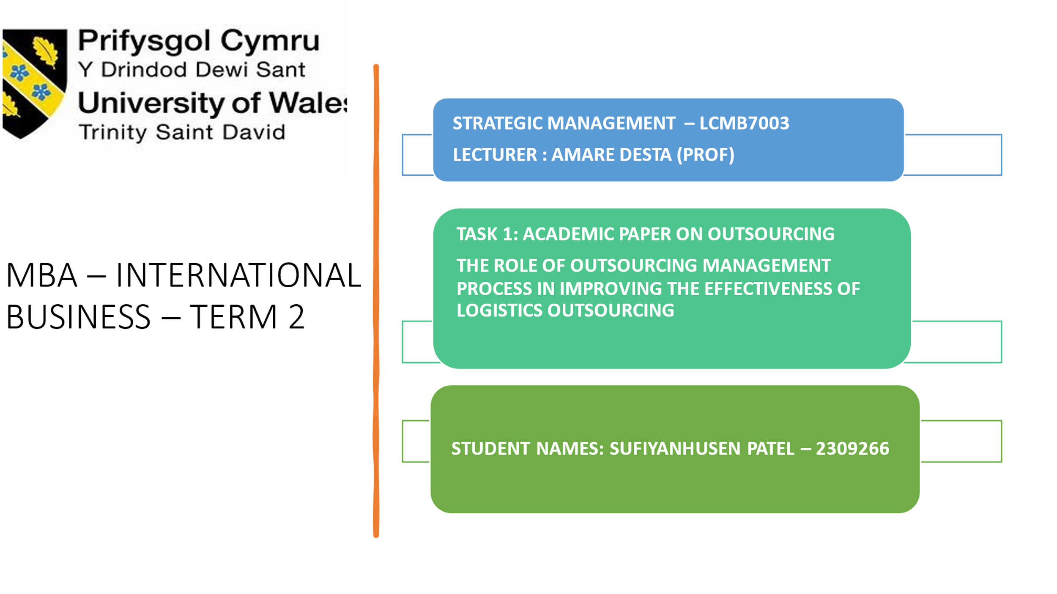

Group presentation: Outsourcing
Group members: : ATIK VAHORA – 2315701
SUFIYANHUSEN PATEl – 2309266
DEVYANI LUHAR – 2311508

PARTH MAKWANA – 2309490

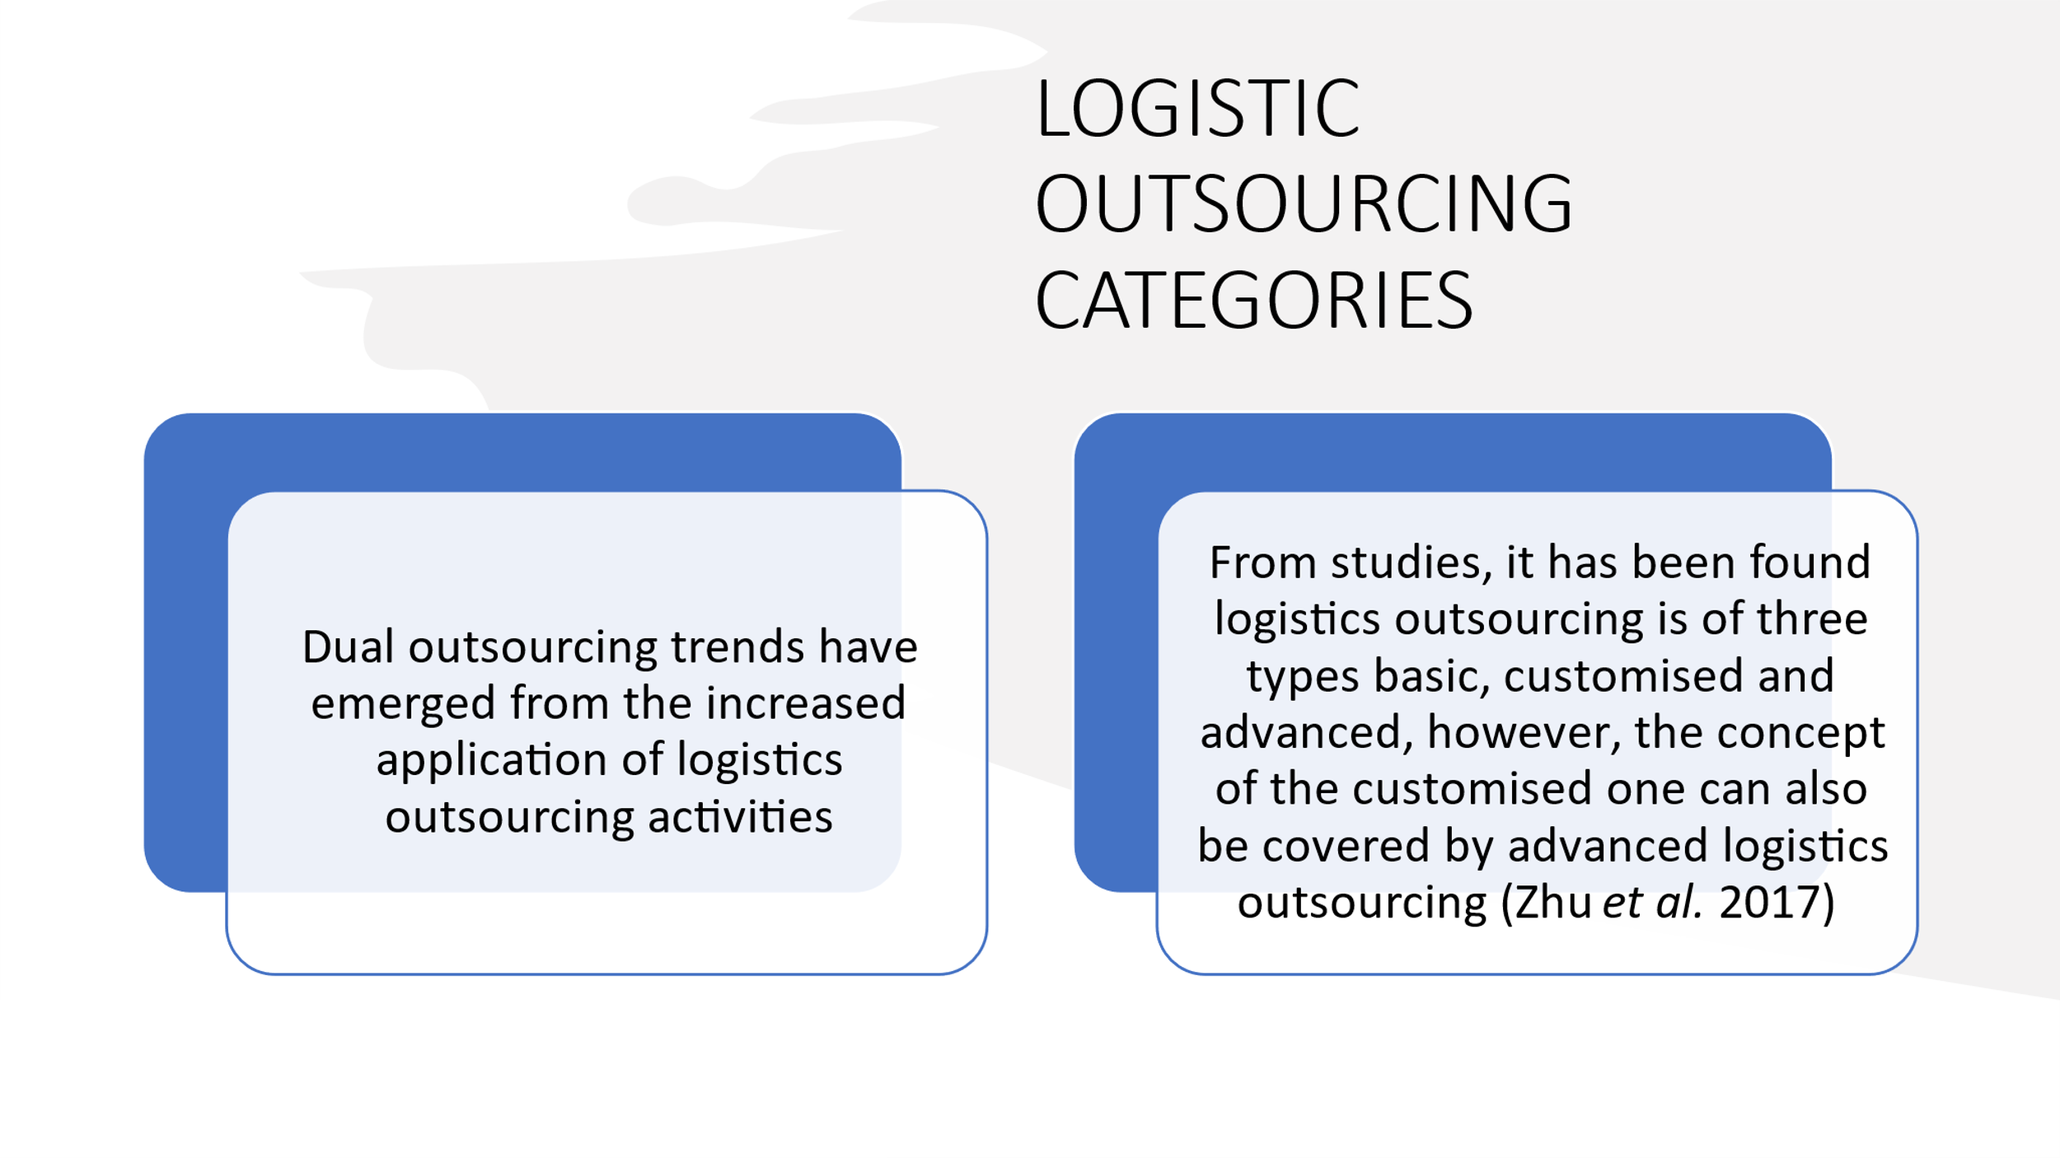

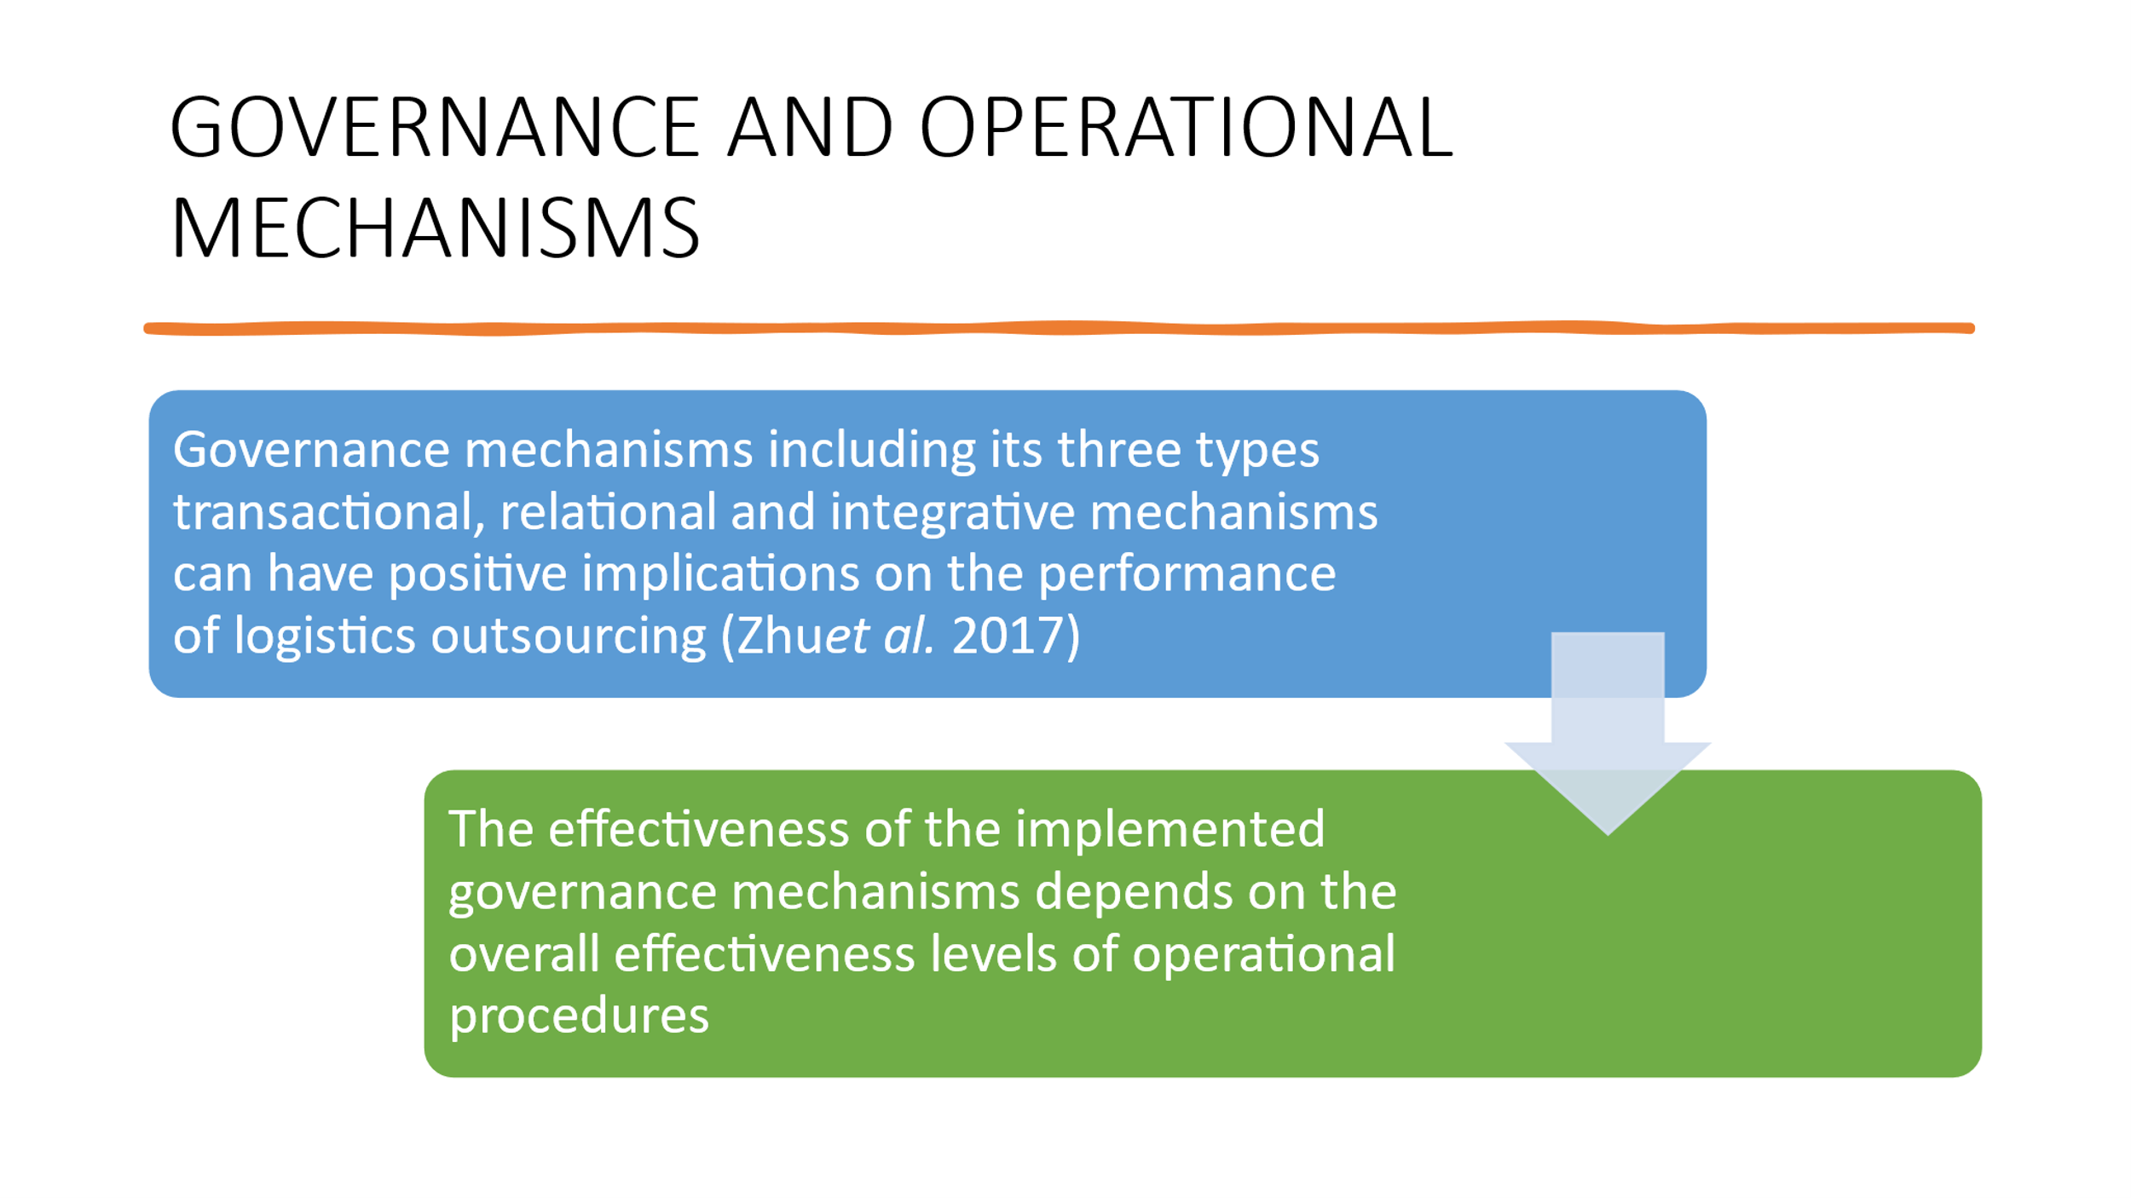

Reference: Zhu, W., Ng, S.C., Wang, Z. and Zhao, X., 2017. The role of outsourcing management process in improving the effectiveness of logistics outsourcing. International Journal of Production Economics, 188, pp.29-40.

