Component 2 - Research Report
Student Name: Anamaria Sdrabau
Student Number: 2214813
Lecturer Name: Chuen Leung
LCHS4002_BIRM
Digital Skills and Research Methods.

Contents
1. Introduction 3
2. Research design 4
2.1. Research Question 4
2.2. Method 4
2.3. Ethical Considerations 4
3. Results 5
4. Discussion 7
5. Conclusion 8
6. Reference List 9
7. Appendix A – A blank copy questionnaire. 10

Introduction

Technology and digital sources are an everyday essential practice in all levels of learning institutions (Romein et al.,2020). People are using technology in every domain to make them job efficient end easy. ​
Due to recent events – Covid 19 Pandemic in 2020 massive changes have degenerated in all institution and implicit in education, all students being `forced` to use online learning instead of face-to-face classes(Volkov et al.,2022).​
Teachers and students must adapt to the new criteria of learning, and they also implement a type of `hybrid` education avoiding face-to-face classes to minimize the spreading of covid19 virus(Villegas-Ch et al.,2021).​ Some institution try a combination of online with face to face classes to bring together only half of student in the class and others to be at home getting online version.
Universities seams to adapt to the situation and they adopt different digital tools to collaborate and students to have continuity with their studies.​
There are a number of digital tools that university and student adopt for collaborate​ like MS Teams, Zoom, WhatsApp, Messenger groups, etc.
In this research we will try to identify the most popular and most used digital tool by students in UWTSD to collaborate.

Research design

Research Question

Research represents the social science who can take many forms and is guided bay different objects. Some research aims for prediction and explanation while others search for understanding (Alvesson 2013).
One of the most important step in research is research question. It can develop knowledge of all research and sometimes can be as valuable as answers.
During the Digital Skills and Research Methods Module it was advertise a number of question that student have to chose and base on that to elaborate a mini research project that will examine how we use technology to collaborate at UWTSD.
`Which digital tool is most used by students at UWTSD to collaborate together?` was the chosen question by Group F. Base on this question Group F consider that they can evidence the knowledge obtain during this module and implicit to find out the answer of the question.

Method

During this research was elaborated a quantitative research method headed by Anamaria Sdrabau and Adrian Alex Jeleriu on students at University of Wales Trinity Saint Davies based on online survey.
Quantitative research is the numerical representation and manipulation of observations for the purpose of describing and explaining the phenomena that those observations reflect. (Sukamolson 2007) Moreover, Creswell (1994) has given a very concise definition of quantitative research as a type of research that is `explaining phenomena by collecting numerical data that are analysed using mathematically based methods (in particular statistics).'
Like was mention above the recent event with Pandemic, people and students to avoid getting sick are using technology to communicate and collaborate. This is one of the reason why is was ethical to elaborate an online survey to protect students health. Considering recent events people no longer trust each other and we consider that a face to face survey or on paper will be more difficult to obtain in time or in e considerable quantity needed for this research.
Survey questions was carefully created online on MS Forms and redirected via e-mail to the students at UWTSD. All survey question was base on the main research question and they reflect the answers needed to the research.

Ethical Considerations

`Ethics is a system of moral principles or standards governing conduct` (Rani 2012). To obtain trust and solve the problem in the research you have to use ethics methods. The most significant and vital content of a study is ethics. Every researcher must maintain ethics on the whole study project. Ethics in research defines guidelines for conducting professional research. It also teaches and regulates researchers to ensure that they follow a strict code of ethics when conducting research (Hasan 2021).
During this research the participants was not harmed in any way whatsoever​. It was respect them dignity especially because was an online survey and all participants have the opportunity to answer the question ​whenever they like.
Protection of the privacy of research participants was maintain and also mention at the beginning of survey questionary and also the most important aspect was confidentiality of research data. All resources and data collected was carefully stored ​in secure places.

- Results
According with Dictionary `Research Result means any tangible or intangible result developed, acquired or reduced to practice in the course of the Research Project, including, without limitation, any invention, technical information, data, know-how and materials that relate to the purpose of the Research Project.`
According to the questionnaire survey, responses to each of the questions are shown:
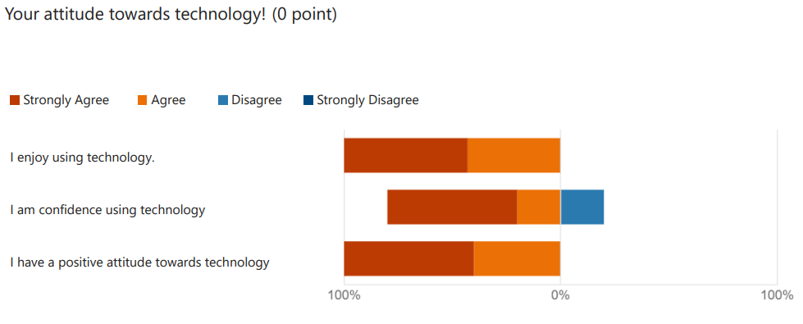
- One of the first question after the consent question, was related to the attitude of the student towards technology and seems that majority of the individuals have a positive attitude and enjoy using technology.
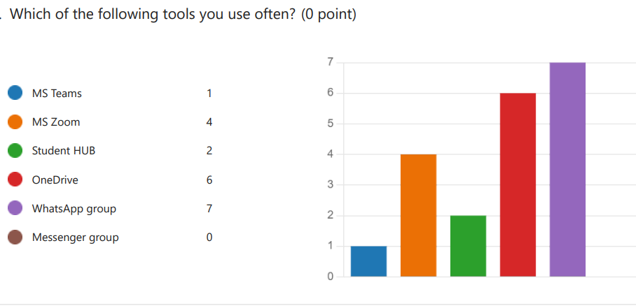
- According to the following question one of the most digital tool used bay student to collaborate on the every day aspects is WhatsApp group follow bay one drive.
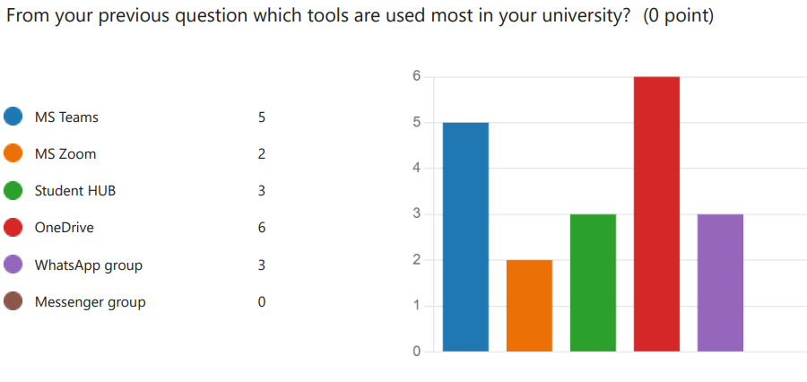
- One Drive sems to be one of the most used digital tool by student in UWTSD to collaborate according to the survey question however MS Teams is the digital tools used by university to transmit and record classes.
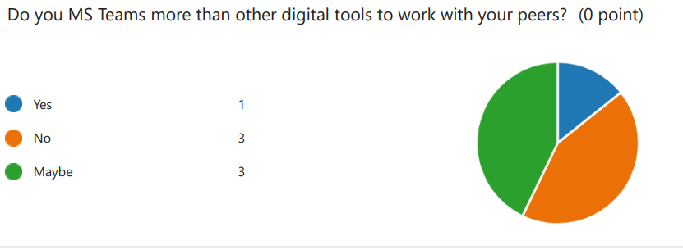
- When is about MS Teams an equal number of students are not using MS teams or are undecided for just in one student in favour of this tool.
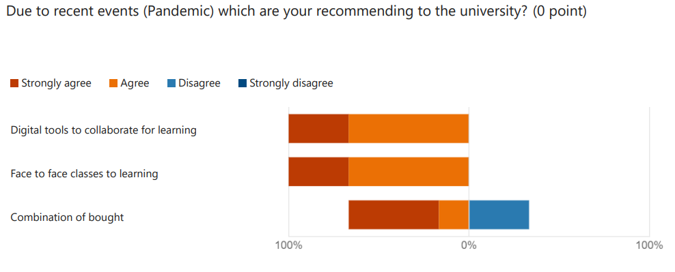
- Last question was mor in favour of the last events – Pandemic and students seems to be open to use digital tools for learning or face to face classes. A minor number of student sems to disagree with combination of bought digital and face to face classes for collaboration with peers.

Discussion

Group F was form around week three of Digital Skills and Research Methods class. After forming the group, the next step was chosen the right question that the members think was most suitable for them to start a research.
In week four participants to the research was concentrated on bibliography and literature review in obtaining the most relevant information that conduct for a good and relevant research. In relation with literature review we discover that technology `invaded` peoples life in a good way and is an every day essential in all domains especially in education institution. In 2020 the Pandemic force institution to adapt with critical situation and use the benefits of technology in favour for student to continue them studies without being in face to face classes an minimise the spread of the lethal virus.
During week five a group presentation was form when the main ideas was shared with lectured on the follow week. All group members share them work and ideas equally. Although some digital tools are more popular than the others, each individual will choose a digital tool suitable for his/her own needs. This was the hypothesis that our group research was think that they may obtain on the end of research.
According to the question chose the method purpose was a quantitative one base on the online survey. The question survey was carefully selected in order to obtain the best results and also to not harm the participants in any ways. It was considered that an online survey will be more efficient due to the recent Pandemic events.
In week eight after data was collected the results was start to be analyse bay the member of group research.
A number of seven student at the UWTSD took part of this research. They were question about the digital tools in favour for them. Firs the participants were assured that the survey is strictly confidential and used just for this research only.
Fist question shoed that majority of the student are very confident in using technology and was one of the results that we are expecting because technology is an every day essential and use everywhere.
On the second questions the results may be predictable. According with some online data more of the 2 billion people int the world is using WhatsApp group to communicate.
Data on third question and the most important are showing that student on this university are using one drive to collaborate and that is surprising because university is advertising and also using MS Teams for recording and transmitted classes online.
It was consider that the hypothesis that was consider in the beginning of the research is confirm. Every individual will find a suitable digital tools to collaborate.

- Conclusion
Base on this research is reflected the acknowledgment accumulated in the past 10 weeks of learning and also the most important is the results of the research that appear prove the hypothesis.
Researches sows that technology is used by most of the people in the world and also there are a number and variation of tools and methods. Depending on the domain that individuals are activated or working the digital tools are adapted to them work, job, industry.
Regarding Universities or other type of learning institutions they also semes to adapt and adopt defernite type of tools to communicate with students.
The current research was focus to obtain the information about the most used digital tool in the UWTSD University and the results confirm that One Drive is on the top list.
In conclusion the hypnotises was confirm and the answer to the main question was obtain.

- Reference List

Alvesson, M. and Sandberg, J., 2013. Constructing research questions: Doing interesting research. Sage.
Creswell, J.W., Research Design: Qualitative & Quantitative Approaches, London: SAGE Publications,1994
Hasan, N., Rana, R.U., Chowdhury, S., Dola, A.J. and Rony, M.K.K., 2021. Ethical considerations in research. Journal of Nursing Research, Patient Safety and Practise (JNRPSP) 2799-1210, 1(01), pp.1-4.
Rani, R. and Sharma, R.K., 2012. Ethical Consideration in Research. International Journal of Nursing Education, 4(1).
Romein, C.A., Kemman, M., Birkholz, J.M., Baker, J., De Gruijter, M., Meroño‐Peñuela, A., Ries, T., Ros, R. and Scagliola, S., 2020. State of the field: digital history. History, 105(365), pp.291-312.​
Sukamolson, S., 2007. Fundamentals of quantitative research. Language Institute Chulalongkorn University, 1(3), pp.1-20.
Volkov, A., Rishko, Y., Kostyukhin, Y., Sidorova, E., Boboshko, D., Savinova, D. and Ershova, V., 2022. Using Digital Tools to Teach Soft Skill-Oriented Subjects to University Students during the COVID-19 Pandemic. Education Sciences, 12(5), p.335.​
Villegas-Ch, W., Palacios-Pacheco, X., Roman-Cañizares, M. and Luján-Mora, S., 2021. Analysis of educational data in the current state of university learning for the transition to a hybrid education model. Applied Sciences, 11(5), p.2068.​
<a href="https://www.lawinsider.com/dictionary/research-result">Research Result Definition | Law Insider</a>

- Appendix A – A blank copy questionnaire.



