

The benefits and challenges of digital transformation of logistics systems

Natalia Schwenk

2514150

Degree Apprenticeship in Logistics and Supply Chain Management
1st of December 2025
Study and Research Skills (ACMA4021)
Word count: 1516 Words

Abstract:
Digital transformation in logistics integrates technologies such as automation, IoT, and advanced analytics to improve efficiency, visibility, and decision-making. Key benefits include process optimisation, enhanced transparency, stakeholder coordination, sustainability, and financial efficiency. However, challenges such as high costs, cybersecurity risks, digital skills shortages, and complex supply chains can hinder adoption. The DHL case study illustrates practical applications, showing how digital tools enhance operational performance while highlighting investment, integration, and workforce challenges. Successful transformation requires balancing technology with organisational, financial, and human considerations.


APPENDIX GA36a

LEVEL 4 ASSESSMENT SPECIFICATION

Student name: | Natalia Schwenk | Student ID number: | 2514150
Programme: | DA Program in Logistics and Supply Chain Management
Module: | Study and Research Skills
Module code: | ACMA 4021 | Contribution to Overall Module Assessment (%): | 100%
Lecturer: | Dr Irina Neaga | Internal Verifier: | Dr Moutushi Tanha
Assignment Title: | Contemporary challenges of logistics, supply chains and transport | Word count (or equivalent): | 1500 words (+/- 10%)
Submission deadline: |  | Return date of provisional marks & written feedback:
Submission method: | All written assessments, where practical and possible, must be submitted via Turnitin unless otherwise instructed by the Lecturer. (Please DO NOT put this assessment specification into Turnitin or it will match many similarities with other students’ submissions.)  Alternative submission method (if applicable):  Late submission of the assessment will result in a late penalty mark. Penalties for late submission: Up to one week late, maximum mark of 40%. Over one week late, 0%. Only the Extenuating Circumstances Panel may approve a change to submission dates.
Academic honesty / referencing: | Academic honesty is required. In the main body of your submission, you must give credit to authors on whose research and ideas your work is based. Append to your submission a reference list that indicates the books, articles, etc. that you have used, cited or quoted in order to complete this assessment.

TASK DESCRIPTION
Use of Generative AI in Assessment
(Lecturer to indicate Yes or Not against each element)
RESEARCH | For this assessment, you can use Generative AI to support you in research, including searching for bibliography, using tools to summarise, compare and interrogate materials. | Yes ​☒​  No ​☐​
STRUCTURE | For this assessment, you can use Generative AI to support you in structuring your submission, including creating a draft argument structure, identifying parts and headings, etc. | Yes ​☒​  No ​☐​
PROOFREADING | For this assessment, you can use Generative AI to check your own text/creation for grammatical and syntactical mistakes, including rephrasing of your own work within specific standards. | Yes ​☒​  No ​☐​
WRITING | For this assessment, you can use Generative AI to create text for submission. | Yes ​☐​  No ​☒​
CREATIVE | For this assessment, you can use Generative AI to create creative materials, such as images. | Yes ​☐​  No ​☒​
PROGRAMING | For this assessment, you can use Generative AI to create and check code. | Yes ​☐​  No ​☒​
NONE | For this assessment, you are not allowed to use any type of Generative AI support. This includes research support, structure support, writing/proofreading support and creative support. | Yes ​☐​  No ​☒​

I declare that I have not used artificial intelligence tools to generate or complete any part of this assignment.

Natalia Schwenk

Table of Contents:
Abstract
- Introduction
- Benefits of Digital Transformation in logistics Systems
  - Process optimisation
  - Enhanced organisational transparency
  - Sustainability benefits
  - Enhanced stakeholder coordination
  - Financial efficiency improvements
3.0 Challenges of Digital Transformation in Logistics Systems
3.1 High implementation costs
3.2 Cyber security
3.3 Lack of Digital skills
3.4 Complexity of Supply Chain Networks
4.0 DHL case study
4.1 Company Overview
4.2 Digital transformation DHL
4.3 Challenges and Benefits
5.0 Conclusion
6.0 References

- Introduction

Digital transformation has become a critical catalyst for improving logistics systems, reshaping how organisations coordinate the movement, storage, and monitoring of goods. Academic authors argue that technologies such as automation, data analytics, real-time tracking, and smart devices enhance operational visibility and enable more accurate decision-making across supply chains (Rushton et al., 2022). The integration of digital tools is widely recognised for helping logistics providers reduce waste, minimise delays, and respond more effectively to fluctuating customer demands (Waller & Fawcett, 2013). Additionally, digitally connected operations can strengthen competitive advantage by supporting faster and more flexible service models (Porter & Heppelmann, 2015).

However, despite these opportunities, digital transformation introduces significant challenges. Many logistics firms still rely on outdated systems that are difficult to integrate with modern platforms (Rogers, 2016). High investment costs, data standardisation issues, and shortages of digital talent are consistently identified as barriers to adoption (Rushton et al., 2022). Furthermore, digitalisation increases exposure to cybersecurity threats and requires strong data governance frameworks (Christopher, 2016). Organisational resistance and the need to coordinate multiple external partners can also slow down transformation efforts (Rogers, 2016).

Overall, while digital transformation offers logistics systems considerable benefits, success depends on navigating technological, financial, and organisational constraints.

2.0 Benefits of digital transformation in Logistics Systems

2.1 Process optimisation
Process optimisation is a key benefit of digital transformation in logistics systems, enabling organisations to streamline operations and improve overall efficiency. Through technologies such as automation, warehouse management systems, and advanced planning software, logistics providers can reduce manual errors, accelerate order processing, and improve resource allocation (Christopher, 2016; Rushton et al., 2022). Big data analytics and real-time monitoring further support continuous improvement by identifying bottlenecks and inefficiencies in transport and inventory management (Waller & Fawcett, 2013). Consequently, process optimisation not only lowers operational costs but also enhances service quality and responsiveness, providing firms with a more agile and competitive supply chain (Porter & Heppelmann, 2015).

2.2 Enhanced Organisational Transparency in Logistics systems
Enhanced organisational transparency is a critical advantage of digital transformation in logistics, as it allows firms to monitor supply chain activities in real time and make informed decisions. Technologies such as Internet of Things (IoT) sensors, GPS tracking, and cloud-based management systems provide end-to-end visibility of inventory, shipments, and delivery performance (Christopher, 2016; Rushton et al., 2022). This transparency not only improves accountability and risk management but also facilitates better coordination among suppliers, carriers, and customers (Waller & Fawcett, 2013). By enabling timely detection

2.3 Sustainability benefits
Digital transformation in logistics contributes significantly to sustainability by reducing environmental impact and optimising resource usage. Advanced route planning software, IoT-enabled fleet monitoring, and predictive analytics allow firms to minimise fuel consumption, lower emissions, and reduce unnecessary trips (Christopher, 2016; Waller & Fawcett, 2013). Additionally, digital inventory management helps prevent overstocking and waste, while automated warehouse systems optimise energy usage (Rushton et al., 2022). By integrating sustainable practices into operational processes, logistics companies can achieve both environmental and economic benefits, enhancing corporate social responsibility and meeting the growing expectations of environmentally conscious customers (Porter & Heppelmann, 2015).

  - Enhanced stakeholder coordination
Enhanced stakeholder coordination is a key benefit of digital transformation in logistics, enabling seamless interaction between suppliers, carriers, warehouses, and customers. Technologies such as cloud-based supply chain platforms, collaborative planning systems, and real-time communication tools facilitate better information sharing, reducing delays and miscommunications (Mentzer et al., 2001; Simchi-Levi et al., 2018). Digital collaboration improves transparency and trust across the supply chain, allowing partners to synchronise operations, anticipate disruptions, and optimise resource allocation (Christopher & Peck, 2004). Consequently, organisations can respond more quickly to market changes, improve service reliability, and foster stronger partnerships, ultimately enhancing overall supply chain performance (Chopra & Meindl, 2019).

  - Financial efficiency improvements
Financial efficiency improvements are a major benefit of digital transformation in logistics, enabling firms to optimise costs while maintaining service quality. Technologies such as predictive analytics, automated inventory management, and integrated transport management systems help organisations allocate resources more effectively, reduce waste, and lower operational expenditure (Melnyk et al., 2014; Stadtler, 2015). Real-time financial monitoring and reporting tools allow logistics managers to track costs, identify inefficiencies, and make data-driven decisions (Bowersox et al., 2013). These improvements not only enhance profitability but also support strategic investment planning, risk management, and sustainable financial performance across the supply chain (Ala-Risku & Hallikas, 2009).
Figure 1: Global Logistics Industry: Growth Trends and Forecasts to 2028 (https://www.rapidops.com/blog/digital-transformation-in-logistics/)
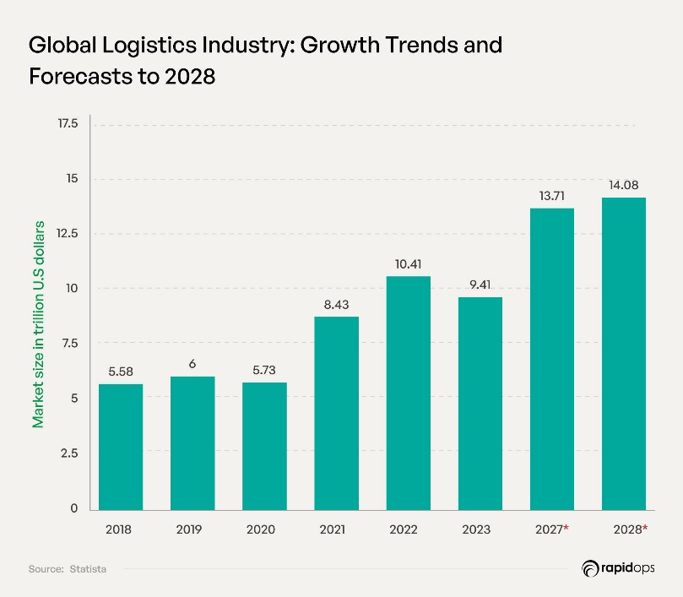

3.0 Challenges of Digital Transformation in Logistics Systems
3.1 High Implementation costs
High implementation costs are one of the main barriers to digital transformation in logistics because organisations must invest heavily in new technologies, system integration, and staff training. These expenses are particularly challenging for small and medium-sized enterprises, which often lack the financial flexibility to adopt advanced tools such as automation, IoT sensors or cloud-based logistics platforms (Wamba et al., 2018). In addition, the return on investment for digital initiatives can be slow or uncertain, making decision-makers cautious about committing large budgets (Rogerson & Parry, 2020). As a result, many firms delay or limit digital projects despite the long-term efficiency benefits.
3.2 Cyber security
Digitalisation significantly increases cyber-risk in logistics because connected devices, cloud platforms and third-party software expand the attack surface across fleets, warehouses and partner networks. Supply-chain attacks, ransomware and credential theft have targeted logistics operators and their smaller vendors, disrupting operations and causing costly outages (ENISA, 2024; NCSC, 2024). Recent industry reviews show a noticeable rise in incidents affecting transport and logistics and warn that vulnerability in suppliers often enables “island-hopping” attacks against larger firms (Maersk, 2025; TechRadar Pro, 2025). Mitigating these threats requires ongoing investment in cybersecurity, vendor oversight, and incident-response capability — costs and organisational complexity that slow digital transformation. (IT Governance, 2024).
3.3 Lack of Digital skills
A major obstacle to successful digital transformation in logistics is the shortage of digital skills among staff. Many companies struggle because their workforce lacks proficiency in new technologies and digital tools, which undermines implementation efforts (Supply Chain Xchange, 2024; GEP, 2025). For example, a 2024 UK-sector survey found that 63% of logistics firms reported insufficient digital talent, with fewer than 40% stating their teams were “well placed for digital growth.” Without adequate skills for tasks such as data management, system integration, and use of automation tools, organizations risk under-utilising new systems or encountering delays and errors (Cichosz et al. 2021 in Suganda & Judijanto, 2025). Thus, skills gaps — both technical and digital literacy — represent a significant barrier and can stall or even reverse digital initiatives
Figure 2: Digital skillset requirements in UK organisations (adapted from Neos Networks, 2023)
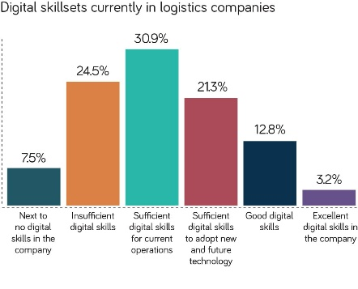
3.4 Complexity of Supply Chain Networks
The growing complexity of modern supply chain networks presents a significant challenge for digital transformation in logistics. Globalisation, outsourcing, and increasing numbers of partners have shifted supply chains from linear chains to intricate networks, which complicates coordination, data integration, and risk management (Kluth et al., 2020; Braziotis et al., 2013 in Paul & Choi, 2018). Digital initiatives often struggle to keep up because different nodes in the network use varied legacy systems, technologies, and data formats, making interoperability and end-to-end monitoring difficult (Hu et al., 2023; Nozari et al., 2022). Moreover, while digital tools can reduce some uncertainties, they may also increase the “complicatedness” of operations — with more dynamic flows, variable demand, and interdependent decisions — which demands greater planning, expertise, and robust governance (Paul & Choi, 2018). As a result, the complex network structure can slow down or even derail transformation efforts.
Figure 3: Supply chain network structure (adapted from Hu er al., 2021. Available at Designing a Resilient and Sustainable Logistics Network under Epidemic Disruptions and Demand Uncertainty (Accessed: (01.12.2025))
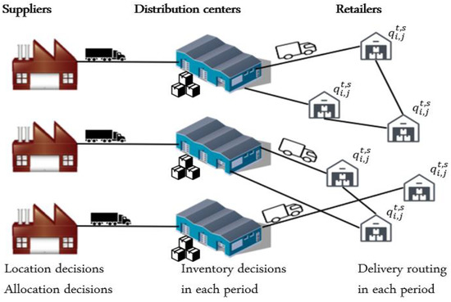

4.0 DHL case study
4.1 Company Overview
DHL is a leading global logistics company operating in over 220 countries, specialising in express delivery, freight, and supply chain management. It focuses on innovation to improve operational efficiency and maintain competitive advantage (DHL, 2019).

4.2 Digital transformation DHL
DHL uses robotics, IoT sensors, augmented-reality smart glasses, and advanced analytics to automate warehouse operations, increase picking accuracy, and enhance real-time inventory visibility (DHL, 2019; Waller & Fawcett, 2013).
Figure 4: Industrial IoT-enabled warehouse and logistics management system (Ali et al., 2024).
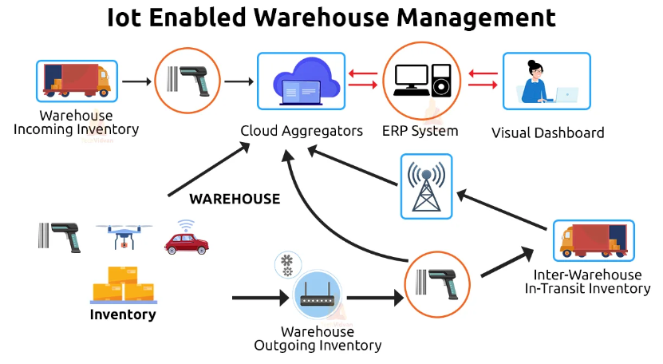

4.3 Challenges and Benefits
Benefits include faster processing, improved accuracy, and greater operational transparency. Challenges include high investment costs, integration with legacy systems, and workforce training requirements (DHL, 2019; Waller & Fawcett, 2013). Digital initiatives have strengthened DHL’s efficiency and competitiveness.

5.0 Conclusion
Digital transformation is a critical driver for modernising logistics systems, offering substantial benefits including process optimisation, enhanced transparency, stakeholder coordination, sustainability, and financial efficiency. These technologies enable firms to respond more quickly to market demands, reduce operational errors, and strengthen competitive advantage. However, adoption is not without challenges. High implementation costs, cybersecurity risks, digital skills shortages, and complex supply chain networks can hinder progress and require careful management. The DHL case study demonstrates that, despite these challenges, effective integration of robotics, IoT, and analytics can significantly enhance operational performance. Overall, successful digital transformation in logistics depends on balancing technological innovation with organisational readiness, workforce capability, and financial and strategic planning to achieve long-term efficiency and resilience.

6.0 References
Christopher, M. (2016) Logistics & Supply Chain Management. 5th ed. Harlow: Pearson.
Rushton, A., Croucher, P. & Baker, P. (2022) The Handbook of Logistics & Distribution Management. 7th ed. London: Kogan Page.
Waller, M.A. & Fawcett, S.E. (2013) ‘Data science, predictive analytics, and big data: A revolution in supply chain design and management’, Journal of Business Logistics, 34(2), pp. 77–84.
Porter, M.E. & Heppelmann, J. (2015) ‘How smart, connected products are transforming companies’, Harvard Business Review, October, pp. 1–20.
Chopra, S. & Meindl, P. (2019) Supply Chain Management: Strategy, Planning, and Operation. 7th ed. Harlow: Pearson.
Christopher, M. & Peck, H. (2004) Building the Resilient Supply Chain. The International Journal of Logistics Management, 15(2), pp. 1–13.
Mentzer, J.T., DeWitt, W., Keebler, J.S., Min, S., Nix, N.W., Smith, C.D. & Zacharia, Z.G. (2001) ‘Defining supply chain management’, Journal of Business Logistics, 22(2), pp. 1–25.
Simchi-Levi, D., Kaminsky, P. & Simchi-Levi, E. (2018) Designing and Managing the Supply Chain: Concepts, Strategies and Case Studies. 4th ed. New York: McGraw-Hill Education.
Ala-Risku, T. & Hallikas, J. (2009) ‘Financial performance implications of supply chain integration’, Supply Chain Management: An International Journal, 14(5), pp. 348–356.
Bowersox, D.J., Closs, D.J. & Cooper, M.B. (2013) Supply Chain Logistics Management. 4th ed. New York: McGraw-Hill Education.
Melnyk, S.A., Davis, E.W., Spekman, R.E. & Sandor, J. (2014) ‘Outcome-driven supply chains’, MIT Sloan Management Review, 55(1), pp. 33–38.
Stadtler, H. (2015) Supply Chain Management and Advanced Planning. 5th ed. Berlin: Springer.
Rogerson, M. & Parry, G. (2020) ‘Digital transformation in supply chains: Barriers and drivers’, International Journal of Operations & Production Management, 40(6), pp. 629–658.
Wamba, S.F., Gunasekaran, A., Akter, S., Ren, S.J., Dubey, R. & Childe, S.J. (2018) ‘Big data analytics and firm performance: Effects of dynamic capabilities’, Journal of Business Research, 70, pp. 356–365.
ENISA (2024) ENISA Threat Landscape 2024. European Union Agency for Cybersecurity. Available at: https://www.enisa.europa.eu/publications/enisa-threat-landscape-2024 (Accessed: [27.11.2025]).
National Cyber Security Centre (NCSC) (no date) Understanding the threat to the supply chain. GOV.UK / NCSC. Available at: https://www.ncsc.gov.uk/collection/assess-supply-chain-cyber-security/understanding-the-threat (Accessed: [27.11.2025]).

Maersk (2025) ‘Securing the supply chain: Cyber security’s importance in logistics’, Maersk Insights, 1 April 2025. Available at: https://www.maersk.com/insights/resilience/2025/04/01/securing-the-supply-chain (Accessed: [27.11.2025]).
IT Governance (2024) ‘Data breaches and cyber attacks – Europe 2024 report’, IT Governance blog, 19 June 2024. Available at: https://www.itgovernance.eu/blog/en/data-breaches-and-cyber-attacks-in-2024-in-europe (Accessed: [27.11.2025]).
TechRadar Pro (2025) ‘Supply chain cyberattacks are becoming unmanageable — and UK businesses are paying the price’, TechRadar Pro, (published 3 days ago). Available at: https://www.techradar.com/pro/supply-chain-cyberattacks-are-becoming-unmanageable-and-uk-businesses-are-paying-the-price (Accessed: [1.12.2025])
GEP (2025) 9 Barriers That Impede Digital Supply Chain Transformation. GEP. Available at: https://www.gep.com/blog/technology/9-barriers-that-impede-digital-supply-chain-transformation (Accessed: [1.12.2025]).
Suganda, U. & Judijanto, D. (2025) ‘The role of digital technologies in transforming global supply chain operations’, International Journal of Logistics, 14(3), pp. 50–68. (Discussing digital skills gap and workforce readiness).
Kluth, A., Schiffer, M., Fries, C. & König, J. (2020) ‘Influencing factors of the digital transformation on the supply chain complexity dimensions’, Journal of Production Systems and Logistics
Paul, K.K. & Choi, S.Y. (2018) Digital Transformation and Its Effect on Supply Chain Complexity: A Systematic Literature Review. Copenhagen Business School.
Nozari, H., Sadeghi, M.E., Ghahremaninahr, J. & Najafi, S.E. (2022) ‘Quantitative Analysis of Implementation Challenges of IoT-Based Digital Supply Chain’, arXiv preprint.
DHL (2019) Logistics Trend Radar 2019/20. DHL. Available at: https://www.dhl.com/global-en/home/insights-and-innovation/insights/logistics-trend-radar.html (Accessed: 2 December 2025).
Waller, M.A. & Fawcett, S.E. (2013) ‘Data science, predictive analytics, and big data: a revolution that will transform supply chain design and management’, Journal of Business Logistics, 34(2), pp. 77–84.
Ali, S.S., Kaur, R., Gupta, H., Ahmad, Z. & Jebahi, K. (2024) ‘Industrial IoT-enabled warehouse and logistic management system’, Prod Plan Control. Available at: https://www.researchgate.net/figure/Industrial-IoT-enabled-warehouse-and-logistic-management-system_source_fig1_311549913 (Accessed: 2 December 2025).

