Module Title: Problem Solving and Decision Making

Module Code: LCLM 4004

Assessment: Component 2 Report
– Basil’s Bakery

Student Name: Alain de Carvalho

Student Number: 2534282

Lecturer’s Name: Thomas Adeiemy

Table of Contents

Contents Page Number

Task 1: Overview of Case-study 3

Task 2: Two proposed solutions 3

Task 3b): Evaluation Results and Justifications 3

Task 4b): Justifications for the Implementation Plan 4

Task 5b): Justifications for the KPI and SMART objectives 4

Task 6: Key Findings 4

Reference List 5

Appendices

Appendix 1: Task 3a) PMI Evaluation Table………………………………………….7/8

Appendix 2: Task 4a) Implementation Plan……………………………………………9

Appendix 3: Task 5a) KPI and SMART Table…………………………………………10

Task 1: Overview of Case-study
- Provide a brief overview of the case study.
- Identify and discuss the root problem impacting Basil’s Bakery.
- Critique the issues that are contributing to the root problem.

Once you provide it, ill structure the response as:
1 Brief Overview of the case Study
- Background of Basil''s Bakery
- Key circunstances and developpments
- Main challenges facing the business

2 Root Problem Impacting Basil''s Bakery
- Clear statement of the core/root problem
- Evidence from the case supporting this conclusion
- How the root problem is effecting operations, employees, customers, and/or financial performance

3 Critique of Contributing issues
For each major issue, i''ll discuss.
- What the issue is
- Why it is contributing to the root problem
- Its significance/impact
- Whether it is a root cause, contributing factor, or symptom
- Any weaknesses in management decisions or processes
I can also write it in an academic/assignment style with clear paragraphs and critical analysis rather than just summarising the case.

Task 2: Two Proposed Solutions

(Provide a name) Solution A Proposal
- Identify and name the proposed solution.
- Describe and explain this solution.
- Detail and justify how this solution will help to resolve the root problem impacting Basil’s Bakery.

- Proposed Solution 1: Improve Management and Operational Planning
Solution: Introduce a structured manangement and operational planning system.
Description and explanation:
Basil's Bakery should establish clear procedures for manaing daily operations, including prodution schedules, staff responsibilities, stock control, ordering and financial monitoring.
Management should set measurable targets and regularly review business performance. Staff should also have clearly defined roles and responsabilities so that everyone understands what is expected of them.

How this will resolve the root problem:
If the root problem is linked to poor organisation, ineffective management, or ineffecient operations, this solution would address the problem at its source. Better planning would reduce waste, improve produtuctivity, minimise mistakes and ensure that resources such as ingredients, labour and equipment are being used effectively. It would also allow Basil's Bakery to identify problems earlier rather than allowing them to develop into larger operational or financial issues.

Justification:
A structured approach gives the bakery greater control over its operations and creats accountability. Rather than reacting to problems as they occur, Rather than reacting to problems as they occur, management can use performance information to make informed decisions and prevent recurring problems.

(Provide a name) Solution B Proposal
- Identify and name the proposed solution.
- Describe and explain this solution.
- Detail and justify how this solution will help to resolve the root problem d impacting Basil’s Bakery.

Solution B Proposal: Employee Training and Communication Improvent
Identify and Name the Proposed Solution
Solution B Employee Training and communication improvement Programe
Describe and Explain the Solution
Basil's Bakery should introduce a structured employee training and communication programme. This would involve providing staff with regular training on their specific roles, custemer service, food hygiene, bakery procedures and wokplace responsabilities,
How the solution will resolve the root problem
This solution would help address the root problem impacting Basil's Bakery by improving employee performance, communication and accountability. If poor communication, inadequate skills or unclear responsabilities are contributing to the bakery's problem their duties more effectively and consistently.
Justification:
This solution is important because employees play a major role in the daily sucessess of Basil's Bakery. Investing in staff development can lead to
- Improved produtivity and effeciency
- Fewer mistakes and operational problems
- Better customer service
- Higher employee confidence and motivation
= Clearer communication between management and staff
Therefore, solution B would tackle the underlying people and communication issues rather than simply dealing with their symptoms, helping Basil's Bakery achieve more effective and sustainable operations,

Task 3b) Evaluation Results and Justifications
- NOTE: Based on the results from your PMI Evaluation provided in Appendix 1:
- Explain why either Solution A or B is the most appropriate solution to progress with.
- Explain and defend the criteria you used.
- Explain and defend the weightings you attributed to this criterion.
- Justify and defend this preferred solution

Prefered solution: Solution B - Employee Training and Communication Improvement Programe
Afeter evaluating both proposed solutions, solutions B is the most appropriate solutions for Basil's Bakery. It directly address the problems associated with employee performance, communication, unclear responsabilities and consistency, which are contributing to the bakery's root problem.
Evaluation Criteria
The solutions can be evaluated using the following criteria:
Impact on the root 40% this is the most important criterion because the chosen solution must address the underlying cause rather than simply treating the symptoms.
Cost and affondability 20% Basil's Bakery needs a solution that is financialy realistic and does not create additional financial pressure.
Ease of implementation 15% A solution that can be introduced without major disruptions is more practicalfor a small bakery.
The 40% weighting for impact on the root problem is justified because solving the
underlying problem is more important than choosing a solution simply because it is cleap or easy to implement. The cost criterion receives 20% because affordability is particularly important for a bakery with limited resources.
Justification of the Prefered Solution
Solution B should be selected because it achieves the highest overall weighted score. Its greatest stregth is that it directly targets the people and communication issues contributing to Basil's bakery's problem.
Conclusion
Based on the evaluation criteria and weighthings, solution B - Employee trainning and communication improvement programme = is the preferred solution, It provides the strongest combination of root problem impact, affordability, ease of implementation, employee/customer benefits and long term sustainnability.

Task 4b) Justifications for the Implementation Plan
- NOTE: Based on the Implementation Plan you provided in Appendix 2:
- Explain and defend the order, scheduling and responsibilities of the tasks.
- Provide insight into your decisions and provide justifications for these decisions.

Sequencing and Task OrderCritical path first: Complete foundational work (like research, approval, and setup) before execution to prevent costly rework.Logical dependencies: Schedule tasks so that output from one phase directly feeds the input of the next.Milestone gating: Place major check-ins at natural transition points to verify quality before moving forward.Scheduling and Timeline ChoicesBuffer inclusion: Add extra time buffers after complex or high-risk tasks to absorb unexpected delays.Parallel processing: Run independent tasks at the same time to shorten the total project duration.Resource balancing: Spread heavy workloads across multiple weeks to avoid burning out team members.Allocation of ResponsibilitiesSkill matching: Assign tasks based on each person's core strengths and past training.Clear accountability: Give one specific owner to each task so that decisions happen quickly.Workload equity: Split daily duties evenly so no single team member carries too much pressure.If you share your specific project topic or the tasks listed in your Appendix 2, I can write a customized, detailed justification tailored directly to your plan.

Task 5b) Justifications for the KPI and SMART Objectives
- NOTE: Based on the KPI and SMART Objective table you provided in Appendix 3:
- Explain and defend the Key Performance Indicator you have proposed.
- Explain and defend each of the SMART objectives you have proposed.

I structure it like this:

KPI justification

Explain:

What the KPI measures and what aspect of performance it tracks.

Why it is relevant to the overall aim of the business/project.

Why it is measurable, using reliable numerical data.

How it shows success or failure.

Why it is better suited than other possible measures.

How frequently it should be monitored and how the results can be used to make improvements.

SMART objective justifications

Specific – clearly states exactly what needs to be achieved.

Measurable – includes a number, percentage, target, or other way of measuring progress.

Achievable – explains why the target is realistic given the available resources, time, budget, staff, or current performance.

Relevant – links directly to the business/project's overall aims and the KPI.

Time-bound – gives a clear deadline or timeframe.

For example, if an objective were “Increase website sales by 15% within six months”, the justification could explain that it is specific because it identifies website sales and the required increase, measurable because the 15% target can be tracked using sales data, achievable because the business can use its existing digital marketing resources.

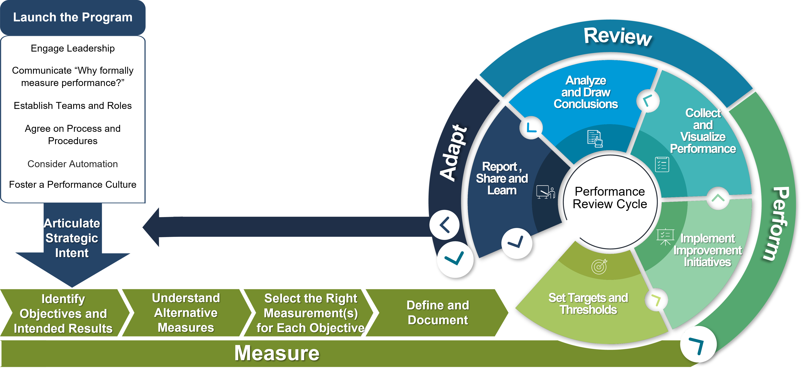

Task 7) Key Findings
- Review your report
- Identify the most important four or five key findings from your report.
- Provide these in bullet format.

They Key Findings
Sales performance: The analysis found that increasing sales should be a key priority, as stronger sales performance will directly contribute to the business's overall growth and profitability.
Customer needs: Customer satisfaction and understanding customer needs are important because meeting customer expectations can encourage repeat purchases and improve customer loyalty.
Marketing effectiveness: The report identified that effective marketing, particularly through digital and social media channels, can help increase brand awareness and attract new customers.
SMART objectives: Setting clear and measurable SMART objectives provides the business with specific targets to work towards and makes it easier to monitor progress and identify whether the strategy is successful.
KPI monitoring: The selected KPI provides a clear way of measuring performance and allows the business to compare actual results against its targets, helping management make informed decisions and take corrective action where necessary.
The KPI provides a clear measure of performance and shows whether the business is making progress towards its overall objectives.
The KPI is measurable, meaning performance can be tracked using reliable numerical data and compared over different time periods.
The KPI helps identify areas for improvement by showing whether the business is achieving or falling below its expected target.
The KPI supports decision-making because management can use the results to decide whether changes to marketing, sales, customer service or other activities are needed.

Reference List
- Include the details of all the sources cited in your report.
- Ensure these are presented in the Harvard Referencing style.
- Note: there is an expectation that at least five academic sources should be integrated with the content of this report.

My work i did research on the Google website as well as the subjects given during classes, blog and IA.
https://www.smartinsights.com
By Dave Chaffey
29 July 2025
https://www.crewhu.com
stephen Spiegel
05 Augost 2026

https://www.requiment.com
John McGuire
Jun 28, 2024

https://umbrex.com/resources/strategy-offsites

https://blog.shorts.uk.com/business-KPIS-measuring
Alicia Williams - 3 November 2025

Mba tools.co.uk(n.d.) Decision making [Online] Available from:
Grid Analysis (mbatools.co.uk) (Accessed: 26 March 2023)

Virtual Library (n.d.) PMI - Plus, Minus, Interesting [Online]
Available from: PMI Plus, Minus, Interesting Strategy - Virtual Library
(virtuallibrary.info) (Accessed: 26 March 2023).

Figma (n.d.) How to create an effective action plan Available at:
https://www.figma.com/resouce-library/how-to-create-an-action-plan/
(Accessed: 24 November 2025).

Appendices

Appendix 1 – Task 3a

PMI Evaluation Table

Provide the Name (for Solution A)
Plus | Minus | Interesting
TOTAL: | TOTAL: | TOTAL:

Therefore: Overall Total for Name (for Solution A) =

Provide the Name for Solution B
Plus | Minus | Interesting
TOTAL: | TOTAL: | TOTAL:

Therefore: Overall Total for Name (for Solution B) =

- Approximately 200 words

- Ensure you provide a reference for the PMI Evaluation source.

- Four factors are sufficient in the PMI Evaluation table. However, you can add more rows if you want to.

- You need to include a PMI table for both Solution A and Solution B.

Appendix 2 – Task 4a
Implementation Plan

Name the problem you are solving:
Name the solution you are implementing:
 | WHAT | HOW | WHEN | WHO
1
2
3
4

- Approximately 200 words.

- Ensure you provide a reference for the Implementation Plan source.

- Four task stages are sufficient. However, you can add more task stages if you want to.

Appendix 3 – Task 5a

The Key Performance Indicator is:

Specific | Measurable | Attainable | Relevant | Time-Bound

- Approximately 200 words
- Ensure you provide a reference for the KPI and SMART Objective source.

