Unit code: BMSK4002

Unit Title: Effective Team Work and Communication
Student Name: YUSSUF ALI ABDALLA
Student ID:1706806

Table of Contents

Introduction: 3
Effective Communication in Management 3
Communication Theory: 4
Importance of tone, language and level of formality in management communications 5
The effectiveness of verbal and written communications 6
Conclusion……………………………………………………………………………………….. 8
References……………………………………………………………………………….…….10

Introduction:
Communication is an important aspect of several managerial tools where effective communication is always first priority all over the world. Communication is the way providing information and making a person understood something by someone else. Effective communication is a matter of practice which results from different skills like personal skills, interpersonal skills, leadership skills, learning skills, presentation skills, writing skills, numeracy skills, parenting skills (Levin,2013). Without strong communication skills employees won’t understand what the manager or leader wants them to achieve.
At the very beginning of this report we will understand the effective communication in management by demonstrating the relevance of communication cycle in effective management with understanding the process, by understanding tone, language and level of formality in management communication and by scrutinizing the effectiveness of verbal and written communication methods within management of organization (Collins, 2013). Along the process of understanding effective communication, we will also understand theories relevant to theworkplace with examples to clear our concept on this topic from different real-life scenarios.

Effective Communication in Management
Teamwork and communication are getting more important in this modern era of business where we are socially connected and working with our common group of people. In management, communication is defined as systematic way of planning, directing, implementing, monitoring, motivating and designing the code of conduct among employees within the organization and between organizations as well (Hunt, 2015). With effective communication system, any organization can improve their quality with a number of outputs at a workplace where effective communication works as a building block of the organization. It accelerates the growth of an organization within its industry as well as among the other industries. An effective communication system facilitates the organizational works by balancing among different departments like HRM and executive decisions about recruiting qualified employees.

Communication cycle in effective management
Modern business world greatly depends on effective communication where managers required to achieve strong communication skills to conduct with fellow members of theorganization and different stakeholders as well. Communication is the process of management where leaders transmit information within the cycle for attending employees and employers’ concerns through exchanging ideas, plans, decisions, proposals to keep individuals involve with the organization and motivate to perform better with commitment and courage (Littlejohn and Foss, 2009). It also increases the understanding and relationships among the managers, staffs, colleagues and stakeholders.

Communication Theory:

The Shannon-Weaver Model is referred to as transmission model of communication which is composed of six steps. It facilitates to break down an information system into sub-system to remember all essential points so that an individual doesn’t miss any important point. The effectiveness of communication cycle depends on time by which feedback is received by the source or initial sender(Zelizer,2015). The main purpose of the communication cycle is to interact with parties with a high frequency.
Figure-1: Shannon-Weaver’s Model
Source: (Rosendal, 2011)
Source: It starts with a source where individual plans message by knowing what the message is, how to convey and who will receive as well.Encode: The source or sender encodes the message that the recipient can understand easily as selecting the right option or word or tone of voice or picture.Channel: Sender transmit the message through a channel that suitsthe best way to verbal including meeting, phone or telephone, videoconferencing or written including notice, email, memos or reports. Transmitting normal task directly by directing face to face an important task in emails with detail instructions. Decode:Then the receiver decodes the message by reading or knowing the code of conduct. It’s important to listen or read the message by understanding the predetermined instruction or knowing thestandard format of decoding message from the source. Receiver: Receiver is the destination of a message where message meets the ultimate target of the information cycle.Feedback:Theessential part of the information cycle is feedback which indicates the result of understanding the message by thereceiver. The efficiency of communication cycle depends on the feedback where thereceivergets a chance to send the message if the receiver doesn’t understand the message.
For example, CeX (company) limited is a second-hand chain shop where retailersends a query by email on inventories to an employee name “John” where theretailer is the source or sender of themessage and Johnis the receiver. Here, the channel of communication is anon-verbal written message and the message was decoded by John who knows the process of decoding the mail and the message was encoded by theretailer. By giving ananswerto the query that is called feedback in communication cycle results the effectiveness of the communication process.

Importance of tone, language and level of formality in management communications
As a manager of an organization, theindividual has to communicate with employees several times and themanager has to make employees understand the work what he or she wants to be done. Effective communication procedure is obtained by a manager through different approaches such as providing structure, solving problems together, practising strong visual interactions, practising conflict management, considering cultural issues, instructing by strongly written documentation (Tench,2013). In this process of effective management procedure manager required to maintain some standard styles through which he or she can get a task done by employees like when managers have to go under pressure of works. The manager needs to select anappropriate tone, language and level of formalities so that employees are more likely to follow the instructions or accept the messages. The manager should be courteous and professional in atone that sounds favourable to work and to workplace environment even employees make mistakes. Management should not be so harsh and rude to deliver the message that is more likely to disagree with the employees. The manager also required focussing on word choices when communicating with the employees which reflect manager’s professional knowledge and confidence.
In anorganization, themanager should be formal all the time to achieve anorganizational goal and maintaining corporate governance as well. The manager also should not use slang, poor grammarand discriminatory words as well as he or she needs to be self-controlledto refrain from those things. The manager also needs to be anassertive communicator to state thoughts and plans so that employees can understand them easily (UniversalClass, 2017). By practisingclear and quality manner a manager can influence staff or employees to get more output at their professional level. Flexible body language or gesture with listening practice and delivering aspeech a manager can get more attention from the employees to flourish the workplace culture.
To communicate through thewritten process, themanager needs to choose appropriate words and languageso that the message reaches the targeted audience or employees smoothly.This is how the message can be transmitted effectively. The manager also has to conscious of the organizational code of conduct so that employees can comply with the changes of instruction and orders.

The effectiveness of verbal and written communications
Organizational growth greatly depends on effective communication which is performed by the managers along with the employees. Manager required to be awell-skilled person so that he or she can improve the communication skills of employees by practising different skills through aneffective channel which transmit the message from the beginning of communication cycle to the end of the process (Rosendal, 2011). By enhancing the quality of employee’s communication skills a manager can get more satisfaction at internal and external functions like instant response in need of emergency, satisfying customers and dealing with stakeholders etc.The communication channel is the way to which messages are transmitted. In an efficient management system, the important component of effective communication is to select the right communication channel. There are two kinds of effective communication channels, the verbal and the written communication.
Verbal Communication is the way by which manager sends messages by speaking to employees including meeting, phone call, and video conferencing etc. Manager sometimes like to visit employees to instruct directly by face to face or call over the telephone or call for a meeting such activities are included in vocal communication where the manager needs to use his or her tone, language courteously and required to be more professional in practice(Ujene and Edike,2015). For example, CeX ltd. A retail second-hand chain shop who conduct its employees by verbal communication to increase sale by demonstrating the business policy. To promote business profile management called for a meeting it is also a verbal communication. To facilitate the sale all over the country, the company took an initiative to contact every shop by telephone which is also a verbal communication. In this process of the communication manager should refrain his/her from slang or poor grammar etc. In case of the verbal communication, themanager has a chance to interpret the mind of the employee to motivate or consult for getting the best performance.
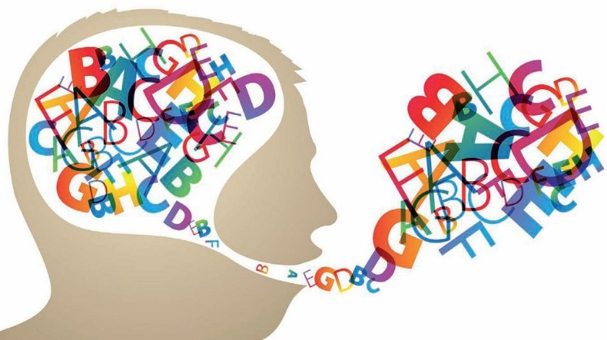
Figure-2: Verbal Communication
Source: (Tench, 2013)
Written communication is sharing information without using words which are called non-verbal communication. In this way of the communication manager doesn’t speak to encode the message. The expression through facial expression, body languages and gesture are essential for a successful non-verbal communication. Non-verbal communication includes eye contact, posture as well. According to Stella Ting-Toomey, nonverbal communication can be used in conjunction with verbal communication or alone (Shannon,2014). Nonverbal signals can help you relate to someone on a deeper level than verbal communication is able to do on its own.
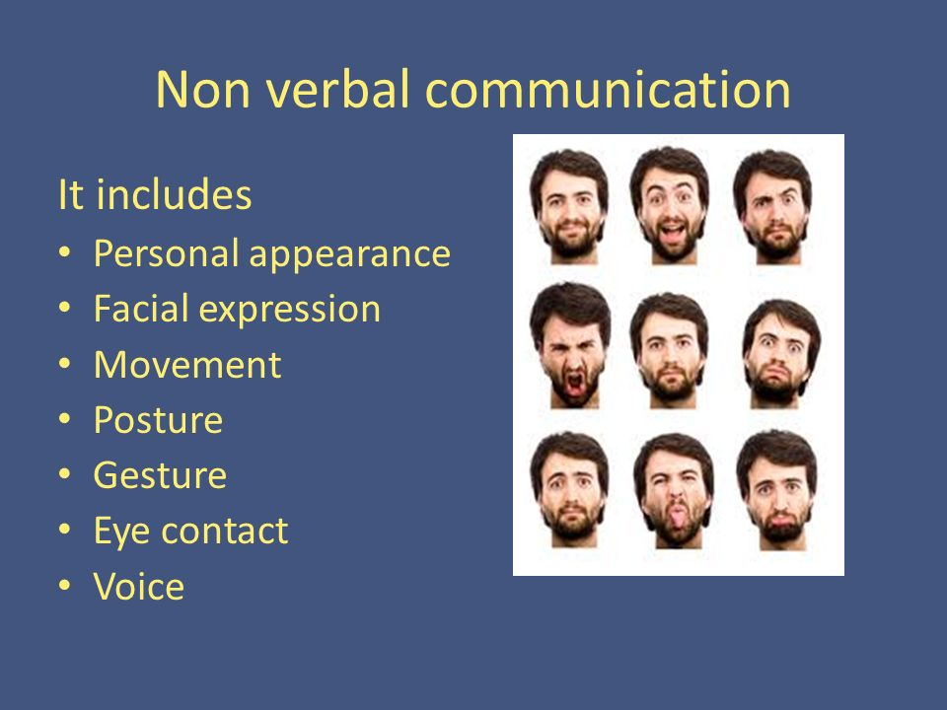
Figure-3: Nonverbal Communication
Source: (Ujene and Edike, 2015)
Using nonverbal communication allows you to complement, emphasize, substitute and contradict the meaning of verbal communication. Written communication is the form of non-verbal communication in which manager deploy his employees by sending e-mail, memos, notice, letter etc. According to Help Guide, effective nonverbal communication will allow you to read the emotions and feelings others are not expressing verbally. It will help enhance others' trust and demonstrates an interest in the topic and makes others know you care.

Conclusion
The effective communication system of any organization accelerates the growth of organizational performance. The manager should be skilled in interpersonal skills to be agood communicator to build an effective management where communication cycle is followed by the strong managerial team. Professionalism and level of confidence with awareness of communication cycle help management to achieve team goals. Effective communication in management like CeX Limited will keep employees and team members involved with the organization that would result in effective management. An effective manager understands the effectiveness of communication channel and facilitate to run the organization effectively through the best channel. Among the channels of communication, verbal and written communication have more impact on employees because of its wide range of uses in management where it discovers barriers and takes preventive steps to avoid them. Communication cycle results in feedback that is used to improve the communication process along with individual and team performance.

References:
Cardon, P. (2014). Business communication. New York: McGraw-Hill Irwin.
Collins, S. (2013). Effective communication. London: Jessica Kingsley.
Hunt, G. (2015). Effective communication. Englewood Cliffs, N.J.: Prentice-Hall.
Levin, G. (2013). Program management. Boca Raton, FL: CRC Press.
Littlejohn, S. and Foss, K. (2009). Encyclopedia of communication theory. Thousand Oaks, Calif.: Sage.
Rosendal, T. (2011). Linguistic Landshapes. Köln: Köppe.
Shannon, C. (2014). The mathematical theory of communication. Urbana: University of Illinois Press.
Tench, P. (2013). The fall and rise of the level tone in English. Functions of Language, 4(1), pp.1-22.
Tools4Management. (2017). the Communication Cycle and Its Applications - Tools4Management. [Online] Available at: https://www.tools4management.com/article/the-communication-cycle-and-its-applications/ [Accessed 19 Dec. 2017].
Ujene, A. and Edike, U. (2015). Effectiveness of Written, Verbal and Nonverbal Communications: Perceptive X-Ray of Construction Internal Stakeholders in Developing Countries. International Journal of Architecture, Engineering and Construction, 4(1).
UniversalClass.com. (2017). How to Create the Appropriate Tone in Business Communications. [Online] Available at: https://www.universalclass.com/articles/writing/business-writing/appropriate-tone-in-business-communications.htm [Accessed 19 Dec. 2017].
Zelizer, B. (2015). Making Communication Theory Matter. Communication Theory, 25(4), pp.410-415.

