
ACCA4019
Analysing & Solving Problems

Component 2
Written assessment: Problem Analysis and Solution Development

Student ID: 2512868
Contents
1. Introduction 1
2. Problem Deconstruction 1
2.1 MoSCoW Technique Requirement 1
2.2 Variables Identification 1
3. Proposed Solution and Explanation 2
3.1 Flowchart 3
3.2 Flowchart Explanation 4
4. Reflection and Justification 6
4.1 Abstract Thinking 6
4.2 Sub-dividing 6
4.3 Justification of the Solution 6
4.4 Limitations 7
4.5 Assumptions 7
5. Conclusion 7
References 8

1. Introduction
The purpose of this report is to provide an explicit approach to organising weekly meetings of a group project. It considers scheduling as a time and resource management problem. This is a method where each student enters their available time. It eliminates times that are not appropriate. It then prioritises the remaining options and chooses the optimal meeting time. The method also ensures that meetings take place ahead of project deadlines. It documents key issues and accountability for tasks. This will promote fairness, accountability, and timely project delivery.

2. Problem Deconstruction
The primary issues were not just in agreeing on a time. A mixed scheduling, communication and load-balancing problem. All students have set time for college, time for work, time for travelling, and time for personal. The group also has a lockdown for projects every week. So it needs to compare multiple calendars, take account of fixed appointments, and pick a meeting early enough to enable helpful project work to be performed. This type of problem is known in constraint-satisfaction research as finding values that satisfy specified constraints and minimise conflicts [1][2].

2.1 MoSCoW Technique Requirement
MoSCoW prioritisation is a technique that divides necessary requirements from desirable ones [3]. The Must Have requirements encompass a meeting prior to D minus B, complete availability from all members, no overlaps with classes or declared work, one to confirm and notice to all members. Should Have requirements are a high combined preference score, a regular weekly pattern, fair rotation of inconvenient times, and at least twenty-four hours’ notice. Auto calendar invites, room bookings, reminders, and online attendance are all aspects of Could Have requirements. Artificial-intelligence prediction, Private calendar details, and links to Employer systems are among the Won't Have requirements in the first version.

2.2 Variables Identification
Inputs, Rules, Processing, and Outputs can all be separated from the problem. Inputs are the group-member list, the weekly deadline, meeting duration, possible days, available time slots, preferred slots, meeting mode, and minimum preparation time. The important variables are n, the number of members; s, a candidate time-slot; A(i,s), which is 1 if the candidate member i is available; P(i,s), the preference score that member i gives to the candidate time slot s; D, the deadline of the project; L, the length of the meeting; and B, a safety buffer between the meeting and the deadline. The final product is a time, attendance sheet, agenda, and list of tasks that have been confirmed.
Hard constraints are constraints that must be followed at all costs. These include obligatory classes, working shifts, meeting times and the weekly deadline. Not all soft constraints can be compared. These include Preferred Time, Travel Convi, Meeting Mode and Fairness. The calendar system shall be written to cope with failures of availability, incorrect availability and late changes to it, and with weeks in which there is no shared availability slot. Privacy is relevant because if students are not free and available, they should not give details of their future. These demarcations maintain the problem's clarity and avoid making the first solution too complicated.
The key stakeholders include students, the group leader, the module tutor and the college. The student should have workable arrangements, and there should be good participation, obviously measurable progress, and timely submission without undue monitoring/collection of private information by the tutor and the college.
Table 1: MoSCoW Analysis of the Meeting Scheduling System.
Priority | Requirements
Must Have | Collect all members’ availability; avoid class and work conflicts; schedule meetings before the weekly deadline; confirm one final meeting time.
Should Have | Consider preferred times; provide at least 24 hours’ notice; ensure fair scheduling; include a meeting agenda.
Could Have | Send automatic reminders; create calendar invitations; support online meetings; store attendance and task records.
Won’t Have | Access private calendar details; connect with employer systems; use AI-based schedule prediction in the first version.

3. Proposed Solution and Explanation
The solution proposed is a very clear weekly scheduling process, which uses constraint filtering and a method to rank the constraints through scoring. It can be implemented in a spreadsheet, simple web form, or small application. The design is based on computational thinking. Separates data collection, validation, selection, confirmation and review using decomposition. It uses abstraction in terms of either an unavailable, available or preferred commitment [4].

3.1 Flowchart
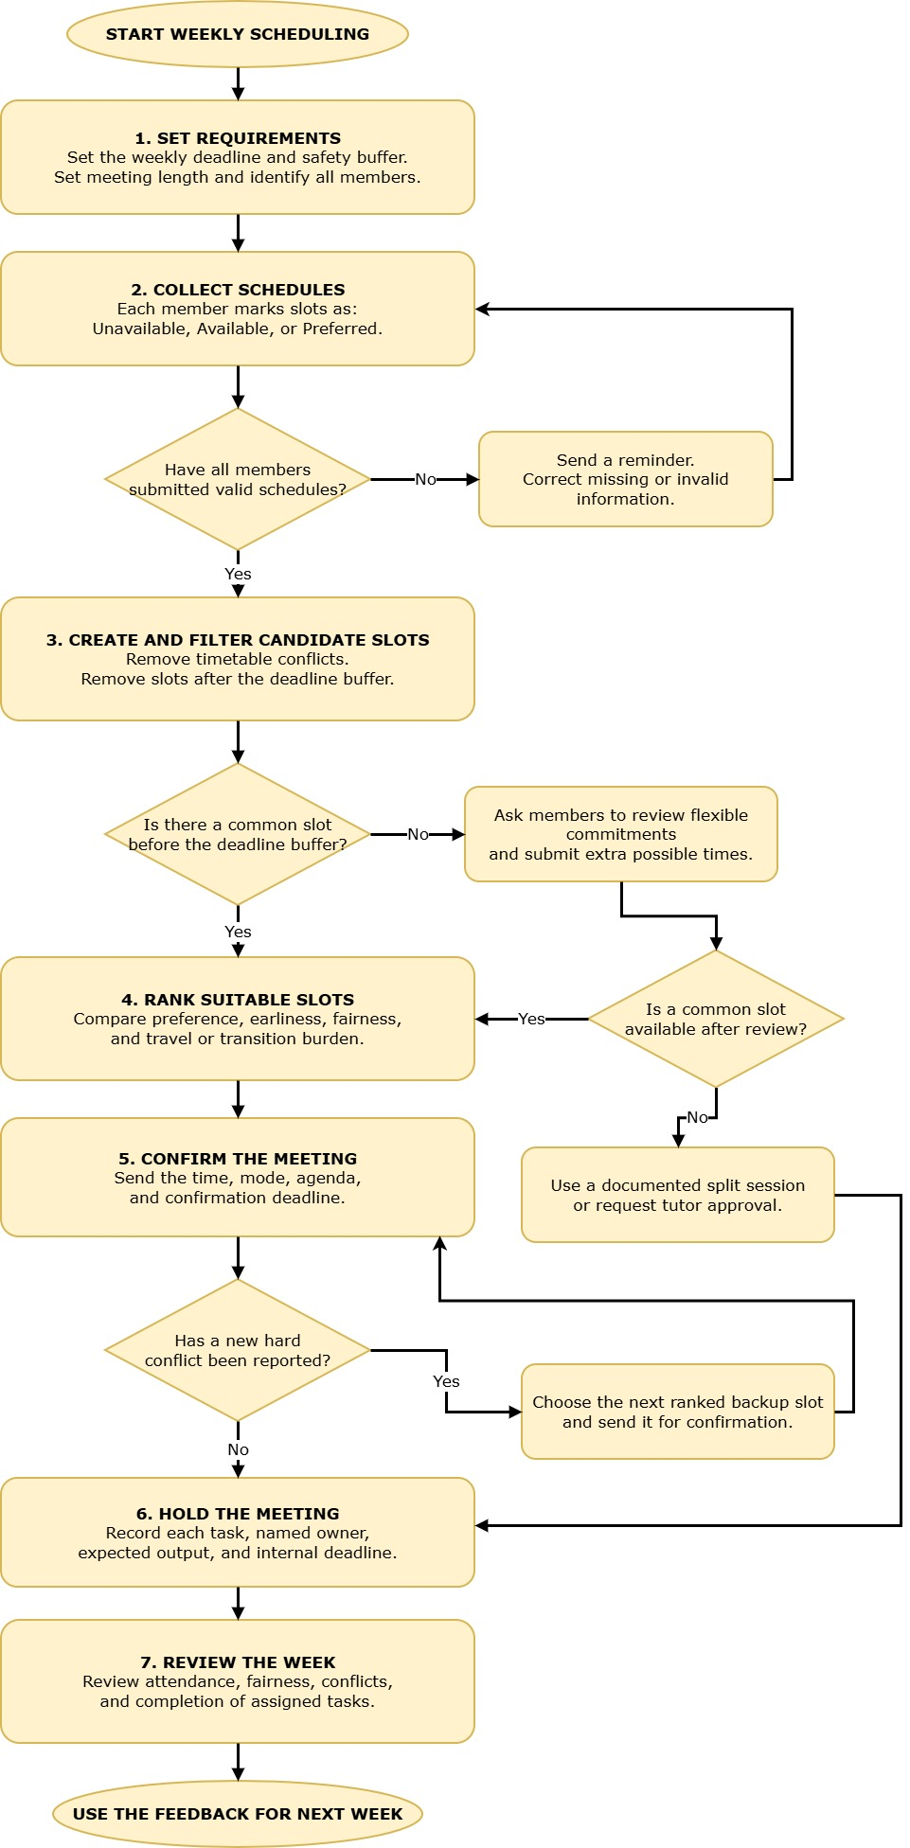
Figure 1: Group Meeting Scheduling Flowchart (draw.io).

3.2 Flowchart Explanation
The group leader sets up a planning window for the following week. The “Window” runs from before the last deadline until D minus B. A minimum of 24 hours of buffering is suggested. This implies that the meeting can't be the one that's already submitted. There is still time for the group to do things, take care of files, bring things together, resolve unexpected problems, etc. According to the project scheduling guidance, deadlines also do not rely only on dates, but also on task order and availability of resources [5].
Second, the availabilities of each member are posted prior to a hard deadline. The form organises the week into equal segments, e.g., 30-minute blocks. One person uses a slot to signify that it is not available, is available, or is preferred. This is a hard restriction as a response to availability. Attendable if available. Preferred attendance is that which can be undertaken with minimal inconvenience. Additional online-only time or time necessary for travel may also be identified. Every person must respond, and each entry must meet the minimum meeting length requirement to be checked by the system. Incomplete records are sent back for correction.
Thirdly, candidate meeting periods are generated in the system. The candidate should contain as many blocks as are required for L. It must be within the planning window. The system computes total availability for each candidate s and adds up A(i,s). If the total is less than n, then that candidate is eliminated. This intersecting method properly prevents the case of a normal meeting when a member has expressed a real conflict. In constraint-based meeting research, "hard" availability constraints are also distinguished from “soft” ones that can be optimised [2, 6].
Fourth, there is a rank among the remaining candidates. A simple score can be used:
$$Score(s) = 4P(s) + 3E(s) + 2R(s) - 3T(s)$$
P(s) denotes the total preference score from the members. E(s) encourages early meetings as they provide more time to the deadline. R(s) provides for the fairness of all members when the chosen time does not unfairly re-common only the same member again. T(s) is the total travel or transition burden. Weights must be disclosed in an openly displayed and proportionate manner. The maximum score is the first choice. The following two are backup options. After basic constraints are met, automated meeting studies can be useful for supporting the usage of its participant preferences [6].
Fifth, system deadlines risk checks. It considers the likelihood of the first choice slot happening before D minus B and whether it is possible to follow up with planned activities during the meeting. The meeting agenda should provide decision items, outstanding action items, action owners and internal deadlines for tasks. If the project has dependent tasks, the group should first discuss the tasks that will influence the project's completion date. This refers to critical-path thinking, and delays in critical dependent activities can impact the desired date [6]. The meeting is not useful unless it affords some time for action to be taken.
Sixthly, the proposed time is notified to all the members for confirmation. Members will be informed of the time, mode, location or online link, agenda and response time. If there is an error, or a new hard conflict is discovered, the confirmation is not a new vote. This is needed in case the meeting is delayed with repeated discussion. The slot is then confirmed, placed in the shared calendar and backed up by reminders. The obvious confirmation will also remove confusion regarding who attended.
Last, there is a record of actions resulting from the meeting itself. The output of each task is known, each task is assigned to someone named, and there is an internal due date. Splitting up of work may be by abilities and capacity but must be transparent to everyone. A covert lack of responsibility combined with the perception of unequal effort can affect participation, as shown in students' collaborative work [7]. Studies of software-engineering teams also relate task visibility as well as perceived fairness to reduced social loafing [8]. Consequently, the scheduling activity does not isolate the meeting, but rather helps to coordinate attendance as well as allocate tasks.
The process contains an exception route. If there is no common slot by default, the system does not break hard constraints secretly. It will ask members to take a closer look at flexible commitments and send in one additional potential time. When it is still not possible to identify a common time, a short split-session procedure is publicised. The largest, common hour is the place for core decisions, which is recorded or documented, and if a member is not present, gives written input before the meeting. A short follow-up is then organised with all members, or the tutor is asked to approve an alternative. This path is less preferable, and it does not compromise the deadline.
The group conducts a quick review every week. It logs attendance, adds late changes, attendance at the usefulness of meetings, tasks completed, and whether the selected slot was a repeated inconvenience. These scoring weights or buffers can then be modified. Systems thinking here works well as the time of the appointment, workload, motivation, mode of communication, and deadlines have an effect on each other [9]. The review establishes a feedback process. It optimises future decision-making rather than making an assumption that the one timetable will keep working throughout the project.
The entire logic is displayed below in a flowchart. It starts with data that is verified and concludes with review. The key decision points are whether all members responded, whether there is a common slot, whether the preferred option would not compromise the deadline, and whether all members confirm.

4. Reflection and Justification

4.1 Abstract Thinking
Abstract thinking transforms various personal commitments into straightforward scheduling data. Each commitment is indicated as unavailable, available, or preferred. The system doesn't have to identify why a student is "busy". It only has to be aware of how that commitment works into the timetable. According to Wing, abstraction is a way users can take into account the necessary parts of problems while neglecting the rest [4]. This way, it is simple to schedule and clear.

4.2 Sub-dividing
The problem is broken down into smaller sections. These are: availability collection, constraint check, search for reasonable time, confirm meeting, task assignment. This is what's known as decomposition. It makes the problem "bite-sized" and will help the group spot incorrectities early on. The purpose of each step is well-defined and can be verified individually. So the scheduling problem is not as daunting.

4.3 Justification of the Solution
It's a solution that utilises MoSCoW prioritisation, constraint checking, scoring, and systems thinking. Alternative features are focused upon first by the MoSCoW approach before they are essential [3]. Classes, Work Shifts and Deadlines are protected by Hard Constraints. Help is provided by soft constraints to compare acceptable times. The scoring system takes into account preference, travel, fairness and timeliness of before submission. Thus, the system doesn't always choose the first available open slot.
It's also a solution that enhances accountability. Every task is to be executed by the member by the deadline. This minimises the confusion and disagreements over contributions. In student group work, many students make inconsistent efforts [7]. Task visibility may also indirectly decrease social loafing through a chain of events [8]. Review on a weekly basis helps improvement, as the scheduling, load, communication and deadlines can interact.

4.4 Limitations
Information is the key to the solution. Students might not specify work shifts or report flexible work as fixed. If the weights of the preferences are equal, this does not indicate that there is no direction toward caring, disability, transport or religious aspects. The method of scoring personal circumstances is simplified and is not enough to remove all problems. Some discussions may require a longer meeting. Meetings split may result in a decrease of common ground. Poor Internet connections or poor equipment can also affect online meetings.

4.5 Assumptions
The solution makes the same assumptions as people will cooperate, availability is honest, and responses are timely. It assumes that there will be one meeting per week, a known deadline, and a fixed meeting period. Formal optimisation software may be needed for larger groups. Future features could be calendar integration as well as better privacy permissions.

5. Conclusion
This solution offers a straightforward and equitable method of arranging small group gatherings. It helps to reduce conflict, create shared responsibility and allow students to effectively and reliably complete projects tasks in a timely fashion on a weekly basis.

References
[1] R. Barták, M. A. Salido, and F. Rossi, “New trends in constraint satisfaction, planning, and scheduling: A survey,” Knowl. Eng. Rev., vol. 25, no. 3, pp. 249–279, Sep. 2010, doi: 10.1017/S0269888910000202.
[2] M. Bofill, J. Coll, M. Garcia, J. Giráldez-Cru, G. Pesant, J. Suy, and M. Villaret, “Constraint solving approaches to the business-to-business meeting scheduling problem,” J. Artif. Intell. Res., vol. 74, pp. 263–301, 2022, doi: 10.1613/JAIR.1.12670.
[3] Agile Business Consortium, “What is MoSCoW prioritization?” May 28, 2026. [Online]. Available: [Insert complete webpage URL]. Accessed: Aug. 1, 2026.
[4] J. M. Wing, “Computational thinking,” Commun. ACM, vol. 49, no. 3, pp. 33–35, Mar. 2006, doi: 10.1145/1118178.1118215.
[5] Project Management Institute, A Guide to the Project Management Body of Knowledge (PMBOK Guide), 7th ed. Newtown Square, PA, USA: Project Management Institute, 2021.
[6] T. Haynes, S. Sen, N. Arora, and R. Nadella, “An automated meeting scheduling system that utilizes user preferences,” in Proc. 1st Int. Conf. Autonomous Agents, Marina del Rey, CA, USA, 1997, pp. 308–315, doi: 10.1145/267658.267733.
[7] Y. Chang and P. Brickman, “When group work doesn’t work: Insights from students,” CBE Life Sci. Educ., vol. 17, no. 3, Art. no. ar42, Sep. 2018, doi: 10.1187/cbe.17-09-0199.
[8] J. P. Pabico, J. A. C. Hermocilla, J. P. C. Galang, and C. C. De Sagun, “Perceived social loafing in undergraduate software engineering teams,” Philipp. Inf. Technol. J., vol. 1, no. 2, pp. 22–28, Oct. 2008.
[9] P. Checkland, Systems Thinking, Systems Practice. Chichester, U.K.: John Wiley & Sons, 1981.

