University of Wales Trinity Saint David
BA(HONS) Business and Management

AstraZeneca Plc

Management Economics Assessment 2, Resit, Weekend

Lecturer: Emad Elkhashen
Submitted By: Raveca Cernea

Student ID: 1917346

Executive Summary

The report covers managerial economics to evaluate the company and the previous and existing market structures in which it operated and is currently operating. An overview of the company has been presented with the view of informing about the history of the evolution of the company and the products or services it provides. Also, the report covered the discussion about the monopolistic competition it faces its performance in the previous oligopolistic structure and the role and significance of government intervention in the economy.
Table of Contents

Executive Summary 2
Introduction 4
Company’s Description 5
Market Analysis 6
Market Structure 9
Venturing or not in a different market structure 12
Conclusion 15
References 16

Introduction

The report will aim to present an overall evaluation of AstraZeneca Plc, a U.K. based multinational company engaged in providing biotechnological and pharmaceutical products. The report will aim to present an understanding of the history and evolution of the company along with the product or service range of the firm. In addition, the report will attempt to provide information about the existing market structure in which the company operates and the initial market structure, and its performance during that period. Moreover, an attempt will be made to discuss the importance and need for government intervention in an economy.

Company’s Description

AstraZeneca is a company that operates in the biotechnology and pharmaceutical company having its operations in different parts of the world, i.e. it is a multinational corporation. The company was established due to the amalgamation of two companies - one Swedish (Astra AB) and one British company (Zeneca Group). The amalgamation of the two companies took place in 1999. The head office of the company is situated in Cambridge (England) under the name Cambridge Biomedical Campus (Cantwell et al. 2019). The interesting thing about Zeneca Group (One of the combined firms in AstraZeneca is that the company itself was formed due to the demerger that took place in Imperial chemical industries in 1993.
Today, AstraZeneca is one of the major Pharmaceutical and Biotechnology firms in the world. The company is engaged in producing a wide variety of products for major diseases (Freimanis and Senfelde 2020). The company's product range extends to areas that include infection, inflammation, respiratory diseases, neuroscience, etc. One of the major highlights of the company is that it was involved in the formulation and development of a Vaccine for the coronavirus under the name of "Oxford- AstraZeneca COVID-19 Vaccine."
The main operations and activities of the company include the research, development, production, and sales of biotechnology and pharma products such as medicines to treat diseases and disorders mentioned above. In addition to the manufacturing of the various medicines, the company is also engaged in the production of various drugs that help treat gastrointestinal problems and disorders (Haldar and Sethi 2020). Moreover, the production of these drugs also assists in treating other disorders like cardiovascular and oncology. In a short period, the company has emerged as a leading company worldwide and competes solidly with the other firms in the U.K. in the same industry.

Market Analysis

As per the discipline of economics, the type of market structure in which different firms operate is a major determinant of the allocation of scarce resources to these firms forming part of different types of market structures and also the measures by the government of the country towards the promotion of economic welfare in the country (Kian et al. 2020). Therefore, the market structure analysis in which the pharmaceutical firms operate needs to be done based on the structure in which the firms find themselves, and an understanding of the various major features of the related market structure is needed for that purpose.
The applicable Market Structure
As far as the applicability of market structure to the various firms in the Pharmaceutical Industry is concerned, it can be said that these firms are operating in a monopolistic competition structure.
Monopolistic competitive structure
In the last decade or so, there has been significant growth, year by year, in the number of pharmaceutical and biotechnology firms in the industry. Currently, there are many firms in the structure, which is a clear indication that the firms in this industry identify themselves with the monopolistic competitive structure (Kian et al. 2020). A monopolistic market structure involves many firms producing products that are similar but can perfectly replace the products of other firms. Firms establish themselves and survive based on product differentiation. The market share and the profitability of the other firms are not necessarily impacted by a particular firm's operation, decisions, and actions.
Number of Firms
At present, many entities are operating in the pharmaceutical industry. The number of active firms in this structure is well above 670 firms.

Major Competitors of AstraZeneca
The major competitors of AstraZeneca in the pharmaceutical and biotechnology industry include Boehringer, Ingelheim, Novartis, Glaxo Smith Kline (G.S.K.), Bayer, Teva Pharmaceuticals, etc.
Revenue of AstraZeneca
An evaluation of the revenue levels of AstraZeneca in the last five years presents strong evidence of the profitability and the high share of the company's revenue in the total revenue generated by the company. The revenue figures of the firm during the 2017-2021 period were20,152. 21,049. 23,565. 25,890 and 36,541 million dollars, respectively (Haldar and Sethi 2020). Therefore, there is an increasing trend in revenue earned by the company in the said period.
Market Share
In the previous few years, the company's market share has also improved significantly. As per the company's annual reports, the company's market share was 1.8% in the year 2019, which rose to 2.0% in the year 2020 and a 2.6% market share in the year 2020. Thus, there has been an increase of about 0.8% in the last three years in the company's market share (Pan and Yoshida 2018). The year-by-year increase in the company's market share was 0.2% and 2.6% in 2020 and 2021 respectively.
If the above market share figures are to be analysed, the company has been able to improve it with each passing year. While in 2020, the rise in the market share according to sales value was normal (Kian et al. 2020). There has been a significant rise in 2021 in the company's market share, which is three times the growth achieved in the prior period. The high growth in the company's market share in the year 2021 can be attributed to the outbreak of the COVID-19 pandemic due to which there has been an unprecedented rise in the revenue and thus, the company's market share.
Revenue-based on therapy area of AstraZeneca
- Oncology: The 2019-2021 revenue figures are 8,667, 10,850 and 13,048 million dollars respectively.
- Cardiovascular and Metabolic disease: The 2019-2021 revenue figures are 6,906, 7,906, and 8,020 million dollars, respectively.
- Respiratory: The last three figures are 5,391, 5,357 and 6,034 million dollars.
- Other diseases: The revenue earned from other disease areas by the firm in the last three years is 2,601, 2,587, and 2,367, respectively.
- COVID-19 and other rare diseases: The contribution of therapy and vaccines toward COVID-19 and other rare diseases are 4002 and 3070 million dollars, respectively.
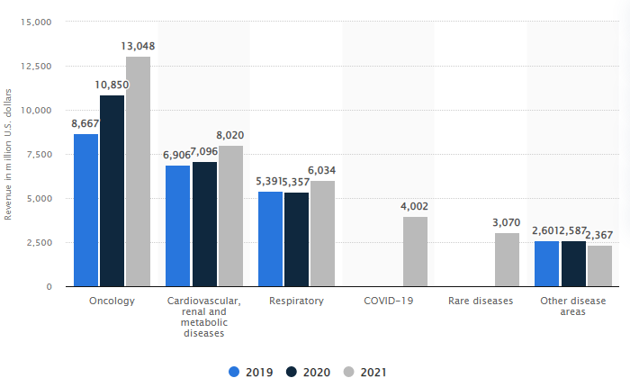
(Source: Statista.com)

Market Structure

The market structure of the company in the past
In the Past, AstraZeneca and the other pharmaceutical and Biotechnology firms belonged to an oligopolistic structure. A limited number of large firms in the industry controlled and dominated the entire market (Pan and Yoshida 2018). The analysis of the previous market structure of the company necessitates the understanding of the major features of the structure to which this and the other companies belonged.
Oligopolistic Market Structure
As per the discipline of economics, the oligopolistic market structure is one where there is a limited number of firms. All these firms are large in size and operation, and all the firms in the industry dominate the market and the industry (Lordkipanidze 2019). In this structure, a major highlight is that all the firms operating in the structure are highly interrelated and interdependent. In other words, the operations, actions, and decisions of any one of such large firms in the structure can affect the levels of profits that the other firms (rivals) in the industry achieve and the share in the market the rivals occupy.
Features of an Oligopolistic market structure
The following are the major characteristics of an Oligopolistic market structure-
- Limited Number of Firms: The number of firms in an oligopolistic market structure is limited. In other words, there are a few firms in the structure, and these firms have control over the entire market.
- Barriers to Entry: Another distinct feature of an Oligopolistic market structure is high restrictions on the entry of the new firms into the structure and the exit of existing firms (Lordkipanidze 2019). The barrier is due to the high setup costs and brand and loyalty expenditure, making it difficult for new firms to establish themselves in the market.
- Higher prices: In an oligopolistic structure, there are a few firms. Only a few firms in the whole market enable them to discuss and decide prices that are mostly higher than many other market structures. The firms can manipulate and charge higher prices to their customers, which is a privilege not available to the companies in the other structures, say perfect competition.
- Interrelation: The firms in an oligopolistic market firm are hugely interrelated. The decisions made and activities and operations performed by any one of such large firms directly impact the revenue, profitability, and market share of the other firms that exist in the structure (Macedoni and Tyazhelnikov 2019). Thus, any major action or decision made by any firm in this sector is supported by a consideration of the results and decisions of the other firms.
- Little power: One of the major features of the Oligopolistic market structure is that all the firms in the industry have access to limited (and very little) control over the market power (Kian et al. 2020). This is because the other firms in the industry can take advantage of the firm's decision to raise prices, and it will lose its customers.
Number of Firms
The number of pharmaceutical companies in the past was quite less (due to which the market structure was oligopoly). Researchers suggest that the number of pharmaceutical firms in the industry was just 180 in 1998 (A year before the incorporation of AstraZeneca).
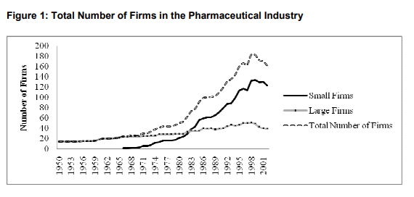

Revenue by Companies
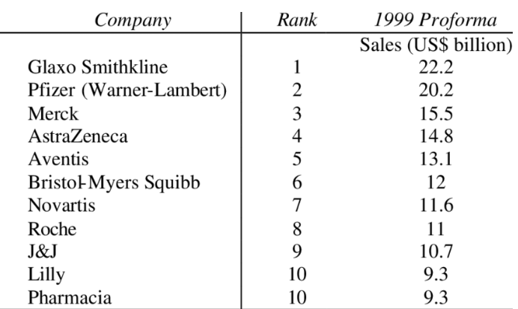
Observation and evaluation of the various pharmaceutical companies in 1999 revealed that majorly 10-12 companies occupied a greater share of the companies during that time. The table suggests that G.S.K. was the market leader with sales of 22.2 billion dollars, followed by companies such as Pfizer and Merck with revenues of 20.2 billion dollars and 15.5 billion dollars, respectively (Phuong 2021). It is important to note here that AstraZeneca secured the fourth position with annual revenue of 14.8 billion dollars. In addition, Aventis was also a part of the top five firms of that time, with annual revenue of 13.1 billion dollars. Moreover, the top names in the pharma industry included Bristol-Myers Squibb, Novartis, Roche, J&J, Lilly, and Pharmacia. These firms majorly dominated the market in the past.

Venturing or not in a different market structure

AstraZeneca Plc is presently a part of the monopolistic competition structure. The firms have been focusing on differentiating their products from the rival firms' products in the market (Phuong 2021). The present market structure of the company allows it to compete with a large number of firms in the industry, with few restrictions on the entry or exit of the firms. It is safe to say that the existing structure in which the firm finds itself is optimal for the firm, and it is not needed to venture into any other structure. The following reasons support this argument:
Demerits to operate in any other structure
- Monopoly: For AstraZeneca to become a part of a monopolistic structure, there needs to be no other firm in the industry other than AstraZeneca itself. The possibility of this happening is quite less (Said 2021). Understandably, a monopoly has the whole of the market in its control, and the profits and revenues in that structure are also very high. However, it will not be practically possible for a single firm to handle the whole industry, which has become huge over the years.
- Perfect Competition: First, the concept of a perfect competition exists only in books. It is more of a theoretical structure where all the firms in the industry provide the same products, and there are normal profits received by all the firms in the industry (Wankhede 2018). Moreover, all the other firms in the industry would exert massive competitive pressures on the firm. They would limit its ability to make price changes as it would most likely result in the loss of customers and loss of profitability of the firm that wants to raise prices.
- Oligopoly: Before becoming part of the existing monopolistic competitive structure, the firm was a part of the Oligopolistic structure itself. Operating in that structure would mean a massive reduction in the number of firms in the industry, which is likely to create a massive imbalance of activity and revenue levels in the industry (Said 2021). Though it will enhance the level of profits for the firm, it would also mean the firm will have to incur high setup costs and branding and licensing expenses. Moreover, the firm will have to spend time in the market to establish itself before gaining any access or control over the market share, which is assumed to be preoccupied with the existing firms in the market sector.
Government Intervention: Good or Bad?
There are various arguments about whether the government's exercise of control and intervention in the economy and its activities are good or bad. Some argue that it should be restricted to the provision of public goods to the individuals and households of the economy. In contrast, others think that it promotes equitable distribution and efficient use of the resources in the economy (Wankhede 2018). The significance of efficient resource utilization in an economy is paramount, and thus, it is concluded that government intervention is good for society. The following points are in support of the said conclusion:
- Promotes Equality: The absence of government intervention in society may result in an increase in poverty and inequality in the economy. It may result in the rich becoming richer and the poor are getting poorer. The increase in government intervention increases economic welfare in the economies, which helps unemployed individuals and financially struggling households (Said 2021). In this way, government intervention helps in reducing poverty and inequality in the economy. It also ensures that all the sections of the society have equal access to the resources available in the society.
- Provision of Public facilities: In an economy where there is no or less government intervention, the firms in the economy would not be motivated to provide any public goods as the cost of providing such facilities would have to be incurred by the firms with no real benefit to these firms (Phuong 2021). All the benefits of the public goods would be enjoyed by the individuals and households of the economy. Thus, it is clear that government intervention is hugely necessary to ensure that individuals and society can access various public goods and facilities.
- Influences consumer behaviour: One of the most significant reasons government intervention is hugely necessary for any economy is that it assists in bringing a shift in the behaviour of the consumers in the economy. This is done by identifying the goods that are likely to cause damage to the society and restricting their usage by imposing higher taxes on them or prohibiting their usage altogether (Lordkipanidze 2019). It would not be possible in the case of a free economy, where the firms are normally only interested in their profits and not the potential damage to society.

Conclusion

The report has presented an insight into the history and the presence of the AstraZeneca Plc. Since its evolution, it has been observed that the company has emerged as a major provider of pharmaceutical products and holds a significant market share at the current time. Moreover, the company presently operates in a monopolistic competitive market and is engaged in various product differentiation activities. In the past, the company operated in an oligopolistic structure and was one of the top five firms. Moreover, it is concluded that the need for government intervention is paramount to regulating economic activities and ensuring social welfare.

References

- Cantwell, J., Marra, M., Edris, S. and Athreye, S. (2019), June. The evolution of the international knowledge networks of innovative M.N.E.s in the pharmaceutical industry. In Druid Conference, jun (Vol. 20).
- Freimanis, K. and Šenfelde, M. (2020), June. Approach of scaling the level of government intervention in the financial market. In 11th International Scientific Conference "Business and Management 2020 ".
- Haldar, A. and Sethi, N. (2020). The effect of country-level factors and government intervention on the incidence of COVID-19. Asian Economics Letters, 1(2), p.17804.
- Kian, M.J., Hadian, M. and Ghaffari, S. (2020). Factors affecting pharmaceutical industry enforcements in Iran and selected countries. Arch Pharm Pract, 11(S4), pp.95-102.
- Lordkipanidze, R. (2019). For Real World Market of Well-being, which will Overcome Monopolistic Dictatorships. International Charity Scientific-Research Partnership of Physical Persons, 14.
- Macedoni, L. and Tyazhelnikov, V. (2019). Oligopoly and oligopsony in international trade.
- Pan, C. and Yoshida, S. (2018). Multichannel distribution under international oligopoly. Mimeo.
- Phuong, L.C.M. (2021). How Covid-19 affects the share price of Vietnam's pharmaceutical industry: event study method. Entrepreneurship and Sustainability Issues, 8(4), p.250.
- Said, L.R., (2021). Market Structure of Sago Starch in Southeast Sulawesi, Indonesia.
- Wankhede, A.B.H.A. (2018). Evaluating the effect of digitalization on the sales force of pharmaceutical industry. Economics and Applied Informatics, (2), pp.21-29.

