Horror
According to Dr Walters (2004) [1] horror is alluring to viewers and players due to three elements. These are unrealism, tension and relevance. Unrealism plays an important role in horror as a form of entertainment as it separates and disconnect the events from reality for the audience. Suspense, shock and gore will generate tension, keeping the audience focused and anticipating what happens next. Relevance can include personal relevance or meaningfulness culturally. The director of Resident Evil 7, Koushi Nakanishi believes that “Overcoming fear is an addictive experience.” One of the main reasons why people watch and enjoy horror media is due to the fact that the chemicals that the brain releases when it experiences authentic or simulated fear and horror are very addictive. In horror games the character a player can control is usually the protagonist. Attempting to survive through the games and controlling the actions of the character can give the player a sense of bravery. In order to reproduce these emotions and feelings with an animation instead of a fame it is essential to have an understanding of why people enjoy certain elements of horror and how these elements are incorporated in both films and games.
The most common and frequent type of monsters seen in horror media are supernatural creatures. Although these types of creatures can all be dissimilar to one another and distinct in their own way they all share one factor. This is the concept of the unknown. Supernatural characters are a popular choice of monster for a horror movie as an audience will likely be scared of the supernatural as they won’t understand it.

Lighting

Pan’s Labyrinth
To set the tone and atmosphere of a scene, lighting is an important technique employed by directors and one that must be studied in order to produce an animation/film that is believable and visually interesting. In the film Pan’s Labyrinth (2006) two forms of lighting are used. One assists in accentuating the story line where as the other is used to add drama to scenes throughout the film. These types of lighting and the way in which they are applied to the film consistently aids the viewer in interpreting and understanding the themes and story correctly. To place greater emphasis on the fantasy elements of the film a high-key lighting is utilised. As defined by Goodykoontz and Jacobs (2014) [2] high key lighting is a design that “has very bright light over everything, with few shadows and relatively low contrast between the lightest and darkest parts of the scene”. When Ofelia enters the mythical world in any scene in the film then high key lighting is implemented into that scene. In order to assist the audience in understanding and discerning the difference between reality and fantasy, golds and reds are used. The use of the high-key lighting design also helps to highlight and accentuate the elements of innocence and goodness in the film’s theme.

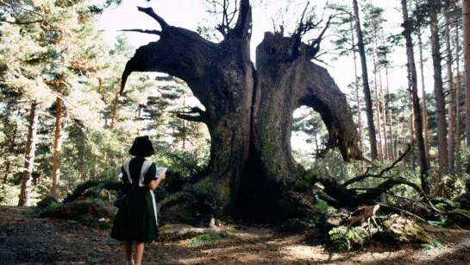
Figure 1
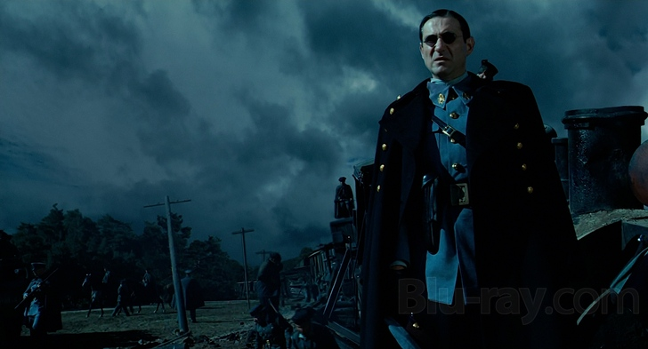
Figure 2

However, throughout the majority of this film low-key lighting is used. This gives reality a much more darker tone. Goodykoontz and Jacobs (2014) also defined lowkey lighting, stating that it “looks dark overall by comparison, marked by extreme use of deep shadows, with very high contrast between the brightest parts of the scene and the darkest parts, which are obscured in shadows”. The low-key lighting design creates a dark tone and places even more emphasis on this through the use of hues and blues. As with the high-key lighting it is used to accentuate elements to the film’s theme, in particular the evilness in the theme. It also provides the audience with the feeling of drama and emotion. In this film the low-key lighting adds an atmosphere of despair, being overwhelmed and entrapment whilst an atmosphere of happiness, escape and freedom is created through the high-key lighting. The contrast when used in different scenes supports the film’s themes of good vs evil vs innocence.
Most scenes in films use lighting designs that fall between high-key and low-key lighting. However low-key lighting is regularly utilised for horror films or scenes which are intense and dramatic. Using this type of lighting design can create a very dark and dramatic tone whilst also establishing an unsettling and eerie atmosphere. If it is executed effectively then it can provide a film or animation with a sense of realism even if the audience is aware that what is happening in the scene is impossible and does not exist. Incorporating this technique into our own animation for the Major Project could help to make it seem more believable whilst also adding tension and drama, particularly in scenes which are slower-paced. As a result of high-key lighting being used to flood a sequence or scene with light, the characters or environment will generally seem happy, safe and peaceful. Contrastingly, low-key lighting will emphasise a sense of danger.

Tim Burton
Tim Burton and his style will have a large influence on our work in the Major Project due to his style of blending gothic and eccentric horror with fantasy. To better understand his techniques and why they are effective, I watched and studied some of his films.
During his time at Disney Burton produced a stop-motion animation, lasting six minutes, called Vincent (1982). For his film Vincent, Burton drew imagery from German Expressionist horror. A stark and simple black and white palette was used, reproducing the stylised lighting and shadow techniques that are often identified with the films of F. W. Murnau and Robert Wiene. However, he also payed homage to horror films of the 1950s and 60s as well as Vincent Price and Edgar Allan Poe. One of the key themes of this film is the conflict between the world of reason and the world of imagination which is a theme used in Gothic literature. Although pressured by Disney to conclude the film with a happier ending Burton challenged the fear of death when in the world of imagination, following the Gothic tradition.
Again, Tim Burton combined a very stylised gothic style, particularly influenced and affected by German Expressionism, with the mid-twentieth century approach to horror inn order to create the style for his film Sleepy Hollow (1999). The film was filmed in colour but had a monochromatic, filtered effect. Sleepy Hollow employed Gothic horror excessively throughout this film, using horrifying confrontation instead of using dread and apprehension in order to alarm audiences.
In his film the Corpse Bride (2005) Burton used colour to accentuate the storyline. Vibrant colours and muted tones are used to create contrast between the land of the living and the land of the dead in the film. The world of the living is dull and monochromatic in order to make it seem dead. In this world everyone is ruled and controlled by routine, which is only ended through death. In contrast the land of the dead contains vibrant greens and golds, showing their release and freedom from these rules. This colour scheme helps to support the narrative and provide the audience with a deeper context. Additionally, the muted tones of the world of the living are tinted with pinks, blues and violets in later scenes. These reflect the romantic themes that become more apparent in the story. The colour schemes are often used throughout this film to demonstrate the progression of the character and the narrative as well as the overall themes of the story. Similarly, in Charlie and the Chocolate Factory (2005), the main character, Charlie’s world and the world of the factory are set in contrast through the continuous use of muted tones and then vibrant colours.
This technique was also used in Beetlejuice (1988). The interior of the house of the Maitlan uses a high-key lighting design in order to create a comfortable and cosy atmosphere that reflects the personality and temperament of the family. Yet, when the family dies and the Deetzes enter and move in, renovating the hose, low-key lighting is used making it seem much more darker. This ensures that the house seems much colder and unsettling in comparison to its appearance in earlier scenes. This is then emphasized in the scene the Deetzes host a dinner party. The Mailtans are in a brightly it environment where as the dining room is cold and gloomy. This then heightens and intensifies the audience’s ill will towards the Deetzes. Burton’s effective use of lighting successfully tugging at the heartstrings of the audience and ensures that they connect emotionally and sympathise with the characters. This technique could be useful in the major project to separate the world which the main character first starts off in from the are that he encounters the monster.

Lighting - Shadows
The producer of Silent Hill 2 Akhiro Imamura defined the players’ fear invoked by the game as paranoia, that “what you don’t see makes you feel afraid”. Adopting the techniques of dark lighting and utilising unlit areas to produce shadows, ensuring that environments make the player fear the possibilities of what could be hiding in the darkness, is very popular in horror games and can be seen in many of them such as Amnesia: The Dark Descent. The different layers of perception in the game can then be dabble with through using different light sources. Often in games this is when the player’s character interacts with torches of lighters.
In the horror genre, particularly movies, it is popular to expose the story’s threat slowly and gradually. In order to execute this effectively, contrast and affinity can be applied. For example, when revealing a monster silhouettes are often used. An additional technique that is popular in horror movies, in terms of lighting and compositions, is to surround a brightly illuminated and small figure by itself with darkness. The increased use of focused and directional lighting and the absence of balanced lighting provides a small area of light the means to create an atmospheric environment. Through revealing the monster of character gradually the tensions can build, making the scene or sequence more intense and frightening for the viewer. However, it can also be used to demonstrate the emotional state of a character. Throughout the story, in the movie Repulsion (1965), the range of the lighting and tone progresses to parallel the main character’s emotional breakdown.
Dead Space 2’s lead artist, Ian Milham, presented a scene from Dead Space 2 in different stages of lighting. In the initial stages of lighting the scenes are very bright, where all of the environment is visible and contrasted. As a result, the environments seemed friendly and safe, unlike that which is typical of a horror atmosphere. However, in later stages of the lighting process, the scenes are much more like what one would consider to be horror-like. Low-key lighting in implemented emphasising the shadows and preventing the players from viewing the entire environment at once. By specifically placing enemies in these darker areas it heightens tensions and the fear the player feels as they encounter them. This demonstrates the different effects lighting techniques can have on an environment and a scene. Integrating this style of lighting could benefit our work in the Major Project and help us to make some scenes seem more horror-like and alarming. By preventing the audience from having a clear view of the monster we could build up the drama and place more emphasis on it.
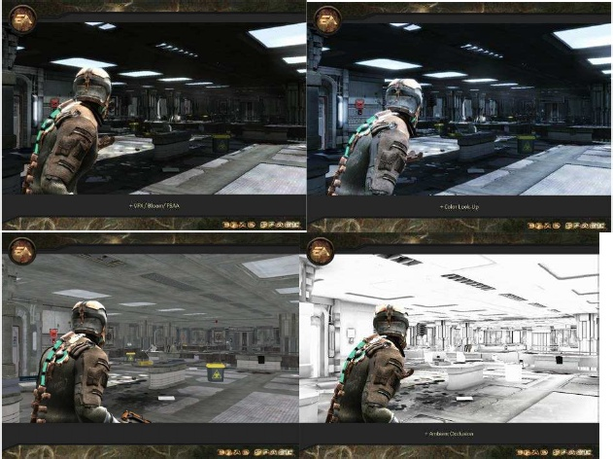
Figure 3
NetherRealm Studios’ Mike Birkhead [3] also emphasised the importance of this style of lighting. He stated that “sometimes, it is less about what you can see, and more about what you can't see. Light is a crucial factor in drawing the player's eye, in making them feel uneasy, or, when placed in complete darkness, terrified. Shadows are also great for unsettling the player. The disappearing doctor in Bioshock is a great example of using lights and shadows to scare the player.”
Filmakers often use the technique of designing a very clear and defined shadow but with a shape that is non-human or unrecognisable to confuse the audience. With the absence of enough information the audience will try to fill in the details themselves, often imaging something far scarier then what is actually there and will try to think of all of the possibilities. The shadow’s form is distinct enough that it cannot be mistaken however as it is unrecognisable it will scare the viewer. As the viewer continues thinking of all the different possibilities, fear making them think irrationally. The use of shadows is highly effective as the audience’s imagination will conjure up what each person finds to be the most terrifying. According to film producer Bruce Block (2008) [4] shape characteristics can also play a role in influencing the audience’s emotions. Typically, triangular shapes are linked with words such as aggressive, scary or disorientating and squared shapes are considered unnatural. Softer and rounder shapes are often considered to be friendly and more approachable. This can be used to trick the audience into believing that it is unthreatening initially. This could be used in the environments and shadows in the Major Project to give the audience a false sense of security
The research carried out here will help me to develop a style appropriate for the tone and themes of the animation in the Major Project. As lighting and colour plays a significant role in the atmosphere of a film or sequence and I chose to focus the research primarily on the different techniques incorporated by notable film and game makers. Carrying out more in-depth research on horror and why people enjoy it will also help us in create scenes and characters that will elicit fear in the audience, ensuring that our animation has effective horror and fantasy elements.

Bibliography

References

[1] Walters, Glenn D. (2004). Understanding the Popular Appeal of Horror Cinema: An Integrated-Interactive Model. Journal of Media Psychology, Vol 9, No. 2. 2004. [online] Available at: https://www.scribd.com/document/285716133/Understanding-thePopular-Appeal-of-Horror-Cinema
[2] Goodykoontz, B. & Jacobs, C. P. (2014). Film: From Watching To Seeing (2nd. ed.). San Diego, CA. Bridgepoint Education Inc.
[3] Birkhead, Mike. (2011). Opinion: How to make a game scary. NetherRealm Studios. [online] Available at: http://www.gamasutra.com/view/news/126963/Opinion_How_To_Make_A_Scary_Game.php
[4] Block, Bruce A. (2008). The Visual Story: Creating the Visual Structure of Film, TV and Digital Media. Abingdon: Taylor & Francis.
Sipos, Thomas M. (2010). Horror Film Aesthetics: Creating the Visual Language of Fear. Jefferson, NC: McFarland.
Harris, R. (2018). Elements of the Gothic Novel. [online] Virtualsalt.com. Available at: https://www.virtualsalt.com/gothic.htm

Images
Figure 1- Proctor, B. (2013, April 15). Pan’s Labyrinth (2006). Available at: https://bproc.wordpress.com/2013/04/15/pans-labyrinth-2006/
Figure 2- Pan’s Labyrinth Blu-ray. (n.d.), Available at: http://www.blu-ray.com/movies/Pans-Labyrinth-Blu-ray/611/
Figure 3 - Milham, Ian (2009). Creating Horror and Immersion with the Art of Dead Space. GDC 09 Conference, Moscone centre, San Francisco. Available at: https://www.gdcvault.com/play/1384/Art-Directing-Horror-and-Immersion

