

Student Name: Shamila Altaf
Student id: 2108744
Module Code: BMSW 4005
Subject: Professional and Career development
Assignment title: Task 3 – Reflective portfolio
Table of Contents
Personal Development Plan 3
Skills Needed as a Childcare Provider 4
Self-awareness Tools 6
Johari Window 7
REFERENCES 9

Personal Development Plan
The world is moving so fast with each passing day. New technologies, new inventions, and growing numbers of industries result in fierce competition. Not only the nations, but also industries and companies are competing to become number one. The survival of companies is becoming more and more difficult these days. As new companies are emerging, we also see that many companies are going through downsizing or some even completely shutting down which causes difficulty for mankind.
Earning money is becoming more difficult these days, and jobs become scary. Only people with a good education, knowledge, experience, and skill set consider being valuable. The criterion for hiring is becoming more and more fierce these days. One must be top-notch to get hired.
People are working hard, but sometimes working hard doesn’t pay that much. Now people are opting for working smartly. The need to develop certain skill sets within yourself is necessary. But the question is how to evaluate yourself. Which skill set needs to be developed to be recognized by the companies?
For these queries, we need to do a Personal Development Plan (PDP). A Personal Development plan is a tool used to enhance your skill set and the ability to think beyond the box for the future so that you can stand out among different people.
As a Child Care Provider, I am using the SMART tool for my PDP which is:
- S for Specific: which means you need to answer what, where, why, when, who, and how. My specific aim is to design classroom activities in a way that every student should learn and participate in it. Children should be able to speak the alphabets, and numbers and sing poems without any charts.

- M for Measurable: your aim should be measurable and for this measurement, we usually look for an assessment or exams. My measurable aim is that by the end of the period, children should learn to eat by themselves, and they need to have a little sense of responsibility in them like keeping the classroom neat and clean.

- A for Attainable: your aim needs to be achievable and for this, you need to plan your way accordingly. This includes that 95% of my students should be able to recite the alphabets and poems without looking at any chart or screen.

- R for Realistic: Aim should be clear and concise. It is something that children need for their future education. This includes children’s need to learn the basic manners for attending school.

- T for Timely: Aim should be achievable in the given time frame. For this, I am designing the activities in which children complete the task in the given time frame.

Skills Needed as a Childcare Provider
Providing care for the child is a very difficult task. You need to connect with them to understand them fully and handle them with care. You need to have those qualities which they see in their own mother. Handling a child is the most important and yet most dangerous task as your slightest mistake can ruin their self-confidence and self-esteem and your support and love make them happy, both can shape them physically and mentally. For example, if you scold a child more as compared to other children, 75% chances are that the nature of that child will become aggressive.
The following are the skill sets required for the childcare provider:
- Planning: Childcare goes beyond looking at the children. One must have the ability to plan and design the activities so that they can learn and enjoy at the same time and promote physical and mental wellness. The activities should include pre-schooling education like how to read, learn and write. They need to design in advance so that they can complete all their daily activities.

- Patience: Dealing with children requires a huge amount of patience as each child is different and so does their capabilities and abilities. They learn and develop differently so having patience is necessary. Sometimes children ask so many mind-juggling questions that may cause them to lose their temper. Listening to them patiently and answering them softly without looking irritated helps them to boost their confidence. Patience is also needed to interact with the parents and family members. Listening patiently to them helps to better understand the child.

- Having Empathy: Children come from different backgrounds. Each child has a different story about their parents and family members. Some come from broken families, while others come from career-oriented families. Understanding the story of each child and putting yourself in their place is what empathy is. It is also very important because a childcare provider is responsible for both, physical and mental health. You need to show your compassion for the children.

- Communication: it is necessary as a child care provider to have strong communication skills, verbal and non-verbal to communicate with children and their parents. Children mostly learn through an example and stories so communicating in a way that they are related to helps them in teaching the lessons. They also need to communicate with the parents about the child’s development and progress.

- Observation Skills: Childcare providers need to observe the children closely. They need to keep a close eye on the children, their behavior with other children, their development, and their ability to learn throughout the day so that they can give detailed insight about the child to their parents.

- Child Psychology: This is one of the most important skills a childcare provider must have. They need to understand child psychology. You need to know how to soothe a child or engage him in an activity when he is crying or causing any trouble with or without any reason.

- Decision Making: Childcare providers make various decisions throughout the day such as how to resolve the conflict among children or which lesson to teach them. Sometimes they need to face emergencies and make decisions on time.

- Creativity: Designing the daily tasks, and activities and decorating classrooms requires creativity. Teaching the children in a creative way helps them to pick up the lesson quickly.

- Managing Stress level: Being a childcare provider is not a simple job as you can only look after the children. It involves different tasks and processes. From managing their documentation, planning, and designing their preschool activities and curriculum, dealing with their parents and family members, keeping the classroom neat and clean, and even picking their gross dirty things. This job sometimes becomes so difficult and stressful, especially when you feel exhausted or tired or not feeling well. Managing your stress level and keeping a smile on your face is a very important yet difficult task.

Self-awareness Tools
Self-awareness tools give insight into your own self. They basically give the idea of what your core strengths are and how you need to overcome your weakness so that you can become an effective and efficient person.
I am using SWOT analysis and Johari Window as my self-awareness tools.
SWOT Analysis:
Strengths:  - Degree in Early Childcare Education.  - Having experience in working reputable daycare.  - Patience  - Strong nursing abilities.  - Good communication skills  - Self-stamina  - Knows how to handle children  - Creativity. Think out of the box.  - Passionate about my work  - Observant.  - Knows what to do when the child gets ill. | Weakness:  - Get emotional sometimes.  - Get carried away easily.  - Mis-managed data.  - Loses focus.
Opportunities:  - Networking. Having connections with parents, family members, child specialists, and other childcare workers.  - Get to learn about the behavior of the child.  - Get to learn lessons from children as well.  - Learn insight into this business so that I can open my own child care center someday.  - Can pursue my degree further in this area. | Threats:  - Takes loads of hard work which cause exhaustion by the end of the day.  - Dealing with difficult parents and children can be stressful.  - Easily get ill because children get ill more frequently.  - Low salary.

Johari Window
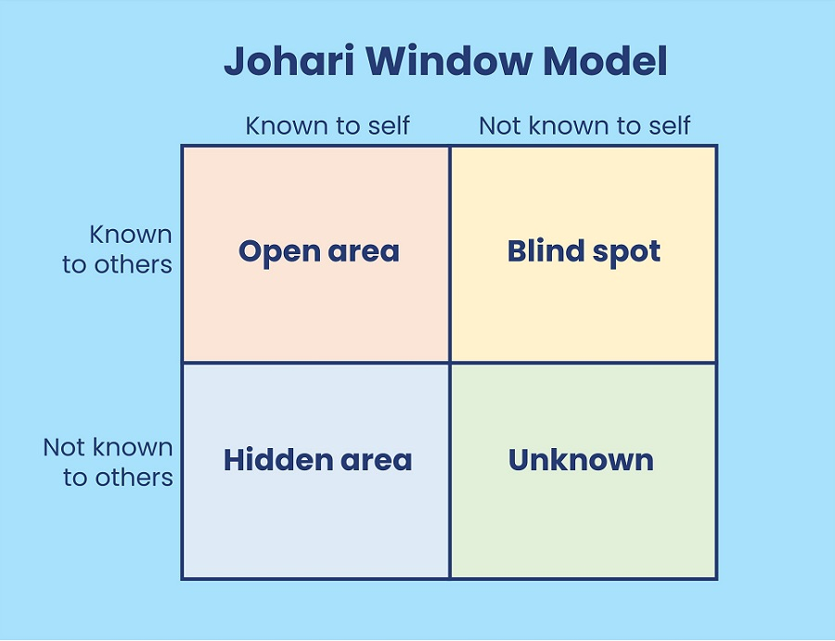
The Johari window is used to track down yourself. It gives you insight into your skills, knowledge, experience, your views, expectations, and intentions in relation to yourself and also within the group. It covers basically four areas:
- Open area
- Blind Spot
- Hidden area
- Unknown
My Johari Window is below:
Open Area: It is something that is known to me and known to others. My open areas are that:
- I am very passionate about my work and follow my work ethic very seriously.
- I am a positive thinker and tend to see the glass as half full, not half empty.
- I have strong communication skills and can communicate with people easily.
- I am open to feedback.
- I always have a smile on myself.
Blind Spot: This is the area, which is known to others, but known to me.
- Recently, one of my colleagues pointed out that I have the habit of not touching anything for a good 5 minutes after applying lotion to my hands. He said I was developing OCD within myself. I am trying to overcome this problem.
Hidden areas: These are those areas that are only known to yourself, not to others. Like:
- I am an introvert. I don’t want to mingle a lot with people.
- I am not open to people about my feelings. I hide my emotions very easily.
- I observe other people a lot, looking in detail, and trying to read them.
- Sometimes I may be talking, but behind my mind, I will be thinking about something else.
- I have a very good memory and I remember each detail.
- I have empathy for others, and I can easily understand what other people are going through and put myself in these shoes.
- I have a strong sense of giving back to society. I have a future to work for the betterment of the community and society.
- As mentioned above, I am open to feedback, but I find it difficult to accept feedback and it builds anxiety within me.
- I may look calm, but deep down I am fighting with myself.
Unknown: Unknown areas are those which are not known to yourself and to others. And this is the area which I am currently discovering.

REFERENCES
Beausaert, S., Segers, M., Fouarge, D. and Gijselaers, W., (2013), Effect of using a personal development plan on learning and development, Journal of Workplace Learning.

Business Balls, (2022), What is the Johari Window Model?, [Picture] Available:
https://www.businessballs.com/self-awareness/johari-window-model-and-free-diagrams/ (Accessed on 20-Nov-2022)

Chlebikova, D., Misankova, M., and Kramarova, K., (2015), Planning of Personal Development and Succession, Procedia Economics and Finance, Volume 26, 2015, Pages 249-253.

Eisele, L., Grohnert, T., Beausaert, S. and Segers, M. (2013), Employee motivation for personal development plan effectiveness, European Journal of Training and Development, Vol. 37 No. 6, pp. 527-543.

Emiliano, I., (2015), Heuristic Reasoning: Studies in Applied Philosophy, Epistemology and Rational Ethics. Switzerland: Springer International Publishing. pp. 1–2.

Frymier, A.B. and Houser, M.L., (2000), The teacher‐student relationship as an interpersonal relationship, Communication education, 49(3), pp.207-219.

