Reflective Report on Employability Skills

Student Name: USMAN UDDIN

Student ID: 2116921

Module code: BMSW 4001_BIRM

Assignment section: TASK 2

Lecturer’s name:: EFUA ADAMS

Table of contents

Introduction 3
Gibbs Model of Reflection 3
Describtion 3.4
Feelings 4.5
Evaluation 5
Analysis 5.6
Conclusion 6
Personal Action Plan 6.7
Experience of Working as a Group 7
Personal Development Plan 7.8
References 9

Introduction
National speeches have been enhanced around the approaches that have been applied to make students and the graduates ready for career and university life. The indications of this readiness cannot be overlooked. If you are a career ready then you must have three primary skills such as central academic skills and the quantity to apply these skills into our real life situations and function in a work setting and day to day activities that occurs; employability skills such as taking responsibility and critical thinking plays a huge role in the career; and job particular technological skills to progress a distinct career path. Many studies look at the skills such vital in permissive students join a reliable career path, which gives career development opportunities and family-alimentary allowance. Academic skills contain that kind of concept that makes students to hone career-ready skills. Plus, academic skills make the students to follow high standard of learning without the remediation. However, employability skills allow students to make use of their academic within the work context and career development. The aim of this report is twofold. First of all, this report will apply the Gibbs cycle to identify how the academic writing, research methods and academic referencing techniques I learned in the task 1 and the things that I had learnt throughout the whole module which will be beneficial for both academic and employability skills. Afterwards, I will apply the Gibbs cycle to explain any skills gaps and approved how I will improve gaps through an action plan.

Gibbs Model of Reflection
I will apply the Gibbs life cycle in my reflective report to write about my academic and employability skills course. The Gibbs model consists of six stage process which includes describing the situation, examining the feelings, assessing the experience, analysis and conclusion.
Description:
Throughout this course the lecturer taught us about various concepts about academic skills or report. In academic skills I learn about different approaches to time management. I learn how to develop and apply my development plan, and also how to maximize my time as a student, and how to become time efficient. I also learned during the course that how to gather relevant information to use in writing reports and projects.
So some of the key aspects identified are taking notes during lectures and from readings, note taking, source analysis and how to discover authentic sources and assessing information from online websites.. During this academic I also learned more about how to use grammar and language, like how to borrow and use vocabulary, and also how to develop sentence and paragraphs structure. So the academic provided the guidelines to academic writing styles, and the paragraphs structure which help develop my skills by understanding many language instructions to improve my academic writing.
Another important aspect which I learned during this course was the role of referencing in academic writing. The lecturer taught us about how to use Harvard referencing techniques using the Harvard referencing guide and several other referencing exercises.
At the end of the academic I also learned about how to make and deliver PowerPoint presentations and how to develop my speaking skills in public events. So I learned the most effective ways to apply PowerPoint, and the role of body language, the role of communication skills which will contribute to the well presented presentation.
Feelings:
My feeling towards academic writing is both stressful and important. During academic class I felt that one needs an advanced understanding of grammar, vocabulary, and academic style skills to develop a well- refined academic writing. I learned during this academic that academic writing is way different from other types of writing, and its demands are unique like one must develop grammar, sentences, body paragraphs and clauses. So, writing formats for academic writing is very important, and every student must apply several steps and approaches to academic writing. So, for this I have done an in-depth study of different academic writing techniques and aspects which will in developing an academic report. But sometimes I do realize that for some of the student it was easy to be confused about writing an academic report when they lack several writing skills and language discourse functions.
The use of other authors work in your academic writing without their acknowledgement is a serious mistake or offence which may lead you to termination. But also their use offers proof that supports your arguments in academic writing. The use of credible citation and online sources suggest that the student has conducted enough research and is also offering credit to the authors by recognizing their views. Thus the use of references in the academic writing will help to maintain track and identify the sources used in the academic report writing like in the form of reference list, citation.
Evaluation:
One of the most accomplishment from my academic and employability skills course that I enhanced my knowledge about grammar, use of vocabulary and sentence structure. In the previous, I frequently find it hard to achieve a research topic, limit it and concentrate on a particular question. Nonetheless, thanks to this course that I easily accomplished a research question, analyse the most relevant sources, and apply them to establish my paper. Already I have learnt how to establish body paragraphs and sentence clauses; it is now tempting to be passionate about academic writing. Regardless of these achievements I am afraid to say that I still struggle with the references. As we know that the course is mainly focusing on the Harvard referencing style. However, there are many referencing styles available like APA, Vancouver etc. Therefore, I get confused sometimes to what kind of writing structure I should apply for a particular paper.
Analysis:
Once the course ended, I accomplished that I have achieved and made it better my academic employability skills. The writing aim probably seems opposing needing the author to brainstorm, identify the sources and relevant information, producing outlines, drafts, and edit. As a result of this course, I can now say that I have a better understating of the process and I can write a project in record time. Moreover, I have accomplished an effective method of analysing and determining the assignment and researching the sources and appropriate information with efficiency. The ambition was to make sure that the report links to the selected sources and give wide validation and causes for the conclusions. It has led me to a point now that I can chose to work in a appropriate writing setting and ignore delay. The lecture on academic writing like improving grammar, vocabulary, and styles has advised me to hone my skills in adhesive to the standard formats when writing an academic paper. However, I have mentioned some gaps that need to be improved like referencing.
Conclusion:
The discussion that I did above, I have identified that my module on academic writing, research methods and academic referencing methods. I have developed my skills in time management, and I can develop and amplify those on my devolvement plan to assassinate my daily activities. These skills will not just only help me as a student at this university but can be beneficial for the future workplace setting. Moreover, I have also developed into time efficient, observant and appeared balanced since I have learned not to delay activities. There is other another skill that I have developed such as critical, reflective, and analytical thinking will assist me to maintain to problems, make a solution to the issues that raise and communicate efficiently and creatively using research-based evidence. After finishing this course, I can proudly say that this module has assisted me to develop academic and employment skills. My grammar, vocabulary, sentence structure, producing of clauses, body paragraphs and referencing has also been improved. I am confident to say that I can write an excellent academic paper, research project, report, or CV.
Personal Action plan:
If you look at academic and employability life, they both need a particular skill set. Let’s look at academic writing where I use time has a huge impact on not only on the quality of the work that has been provided but can impact on my future deliverables. Effective time management is very crucial as it will conclude my future productivity. This module has made me improve my time management and academic writing. I am now able to progress a report or essay from exclusive ideas with the use of correct grammar and vocabulary. However, I have done have some weaknesses such as not knowing the correct way of referencing. Therefore, I need to learn how to reference other sources of information in my assignment which I will take help from my universities.
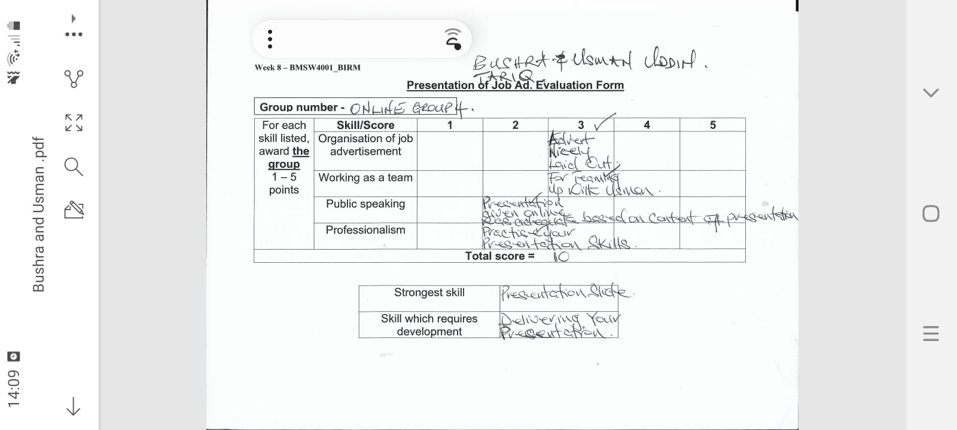

EXPERIENCE OF WORKING AS A GROUP

Group work is the collaborative effort of a team to achieve a target or to complete the task in the most efficient and effective way. As far my experience is concerned I always enjoy working as a group. In a group we all work as a single cohesive unit where everyone has their Owen say and sharing their information and ideas which lead to success of completing your task. As a team member in a group every other member tries to support each other with different skills and unique ideas. So Good communication skills and flow of information is also the experience I get during the group work.
I also experience a very friendly environment and everyone was very patience and tolerance to listen and also try to understand and value my ideas. So attitude of each and every individual of the team was also a great experience to observe. So in my experience group work makes things a lot easier than working on their own self. A task was easily being divided among the group’s
members and everyone was involved to achieve the task.
Furthermore, my concern was to finish the task before due time, so meeting the deadline in the group was the experience where everyone was so committed and sharing their contributions. If one of team member was lacking behind the other group members come to rescue him and it makes the task to be completed on time.
So working in a group I experienced that brainstorming is key in group discussion, brainstorming in a group always create new and creative ideas from every member and their always something new to learn from every one.
Overall it was good experience and I thoroughly enjoyed my time in group, like from sharing information, negotiations, and brainstorming, to time management.

Personal development plan:
I tried to pay attention to every details of what they are saying so they can know that I was l listening to their views and ideas. By paying attention I meant I had a good eye contact, nodding, asking question to show interest. I also tried not interrupt until my peers finished. I was given a task to do my research on specific topic and present that topic in front of the whole class professionally. I tried to prepare my content before the meeting as if I had rushed it, i would not have enough knowledge of the topic. This way my group members would figured it out that I do knowledge of the topic and that way I was able to make my ideas known to the group. We were 4 in a group so we decided to divide each task between ourselves. Every individual did its own part in their own time and then one person has to lay out the whole presentation. Nobody was left out of the discussion however if there was anybody then I would have made them involve in the discussion by making them comfortable enough to present their views. Plus, I would have reflected and responded carefully to their conversation so they don’t feel left out. It would have been frustrating, if any of our peers didn’t do the work that they were supposed to do it. As it would not just affect our mark but our whole group would be getting affected by that. First of all, I would have been spoken to my peer directly to ask the genuine reason of why haven’t they done the work. Afterwards, getting that information then I would help and encourage so they can contribute to the task that was given. I was a bit nervous at the beginning. However, in my opinion I presented quite well. For example, I prepared myself good enough to not be nervous by making good preparation, knowing my topic, and knowing what I was saying and how I was saying , it boosted my confidence and help reduce my nerves.

References:
- Ajay Singh (2021). Develop Critical Thinking Skills In Students | Most Effective Ways. Available at: https://www.theasianschool.net/blog/develop-critical-thinking-skills-in-students/(Accessed 28th August 2021).

- Indeed.com (2021) Available at: https://www.indeed.com/career-advice/finding-a-job/employability-skills (Accessed 27thAugust 2021.

- Herzing University (2021) 7 Important Teamwork Skills You Need in School and Your Career. Available at: https://www.herzing.edu/blog/7-important-teamwork-skills-you-need-school-and-your-career (Accessed 28thAugust 2021).

- The Balance Careers. 2022. Types of Listening Skills With Examples. [online] Available at: <https://www.thebalancecareers.com/types-of-listening-skills-with-examples-2063759> [Accessed 5 April 2022].

- 2011-2022, (., 2022. Coping With Presentation Nerves - Presentation Skills | SkillsYouNeed. [online] Skillsyouneed.com. Available at: <https://www.skillsyouneed.com/present/presentation-nerves.html> [Accessed 5 April 2022].

- Businesstrainingcollege.com. 2022. Presenting Your Ideas to a Group or Audience. [online] Available at: <https://www.businesstrainingcollege.com/business/presenting-ideas.htm> [Accessed 5 April 2022].
Indeed Career Guide. 2022. 12 Examples of Academic Skills (And How To Improve Them). [online] Available at: <https://www.indeed.com/career-advice/career-development/academic-skills> [Accessed 5 April 2022].

