Kyle Fisher Bibliographical piece:

Book Chosen - PHI 01221: Missale Salisburiens.

Desc. Missale Salisburiens in Anglia. This is a roman catholic Sarum Missal, that is, for use in the Salisbury tradition. It was printed in 1511, in latin. This copy lacks the entire first quire (including the title-page). Signature A1 begins: Missale ad usum Sarum incipit feliciter.

As said previously, the entire title page is missing. I did not notice a colophon from when I was documenting the book. I also did not document the pagination.

Statement of Signing:

a-t⁸, b⁶, x⁶, y⁸, A-H⁸, I⁸, H⁸(-H.i), B-H⁸, ნ⁸, Ћ⁸

The book is an irregularly signed Octavo, with a few sections that are different to the rest of the book. I will list these differences, as well as any other notable details below.

The gatherings b⁶ and x⁶ are interesting, as not only do they contain 6 leaves each, but they are also of a noticeably different material to the rest of the book. It is, however, in the binding connected to the rest of the pages, suggesting to me that they were added to the book at its creation, and not added in later.

The I gathering is interesting for multiple reasons. Firstly, It marks a change in the font for the rest of the book, for I⁸-Ћ⁸, which suggests to me that the latter half may be from another source, and in a similar way to b⁶ and x⁶, it was added to the book at its creation as it sits in the same binding. The second reason the I gathering is interesting is the page signatures. Unlike anywhere else in the book, which signs the first five leaves of a gathering and leaving the last three blank, (e.g. a.i,a.ii,a.iii,a.iiii,a.b,*,*,*), I signs the first six, and leaves the last two blank. The last interesting thing is that after I⁸ but before H, there are three unsigned pages. I believe that since the font changes here, and I’s unique signing, that the purpose of I has been modified to better connect the latter portion of the book, which was added to the original print from a difference source. It would explain the strange signing as the original print was removed and replaced with something that did not follow the exact rules previously, and the three extra unsigned pages may act as a sort of bridge from the original book to the new contents, as the new content starts with H, as opposed to following after I or starting from a again, and so assuming that the new text starts in the middle of what would have been the other book, the three extra pages were needed to explain this difference to the reader at the time.

Throughout the book, there are various woodcut pieces of art depicting various religious events deemed important enough to have a drawing of. Two of these woodcut pieces are described below.
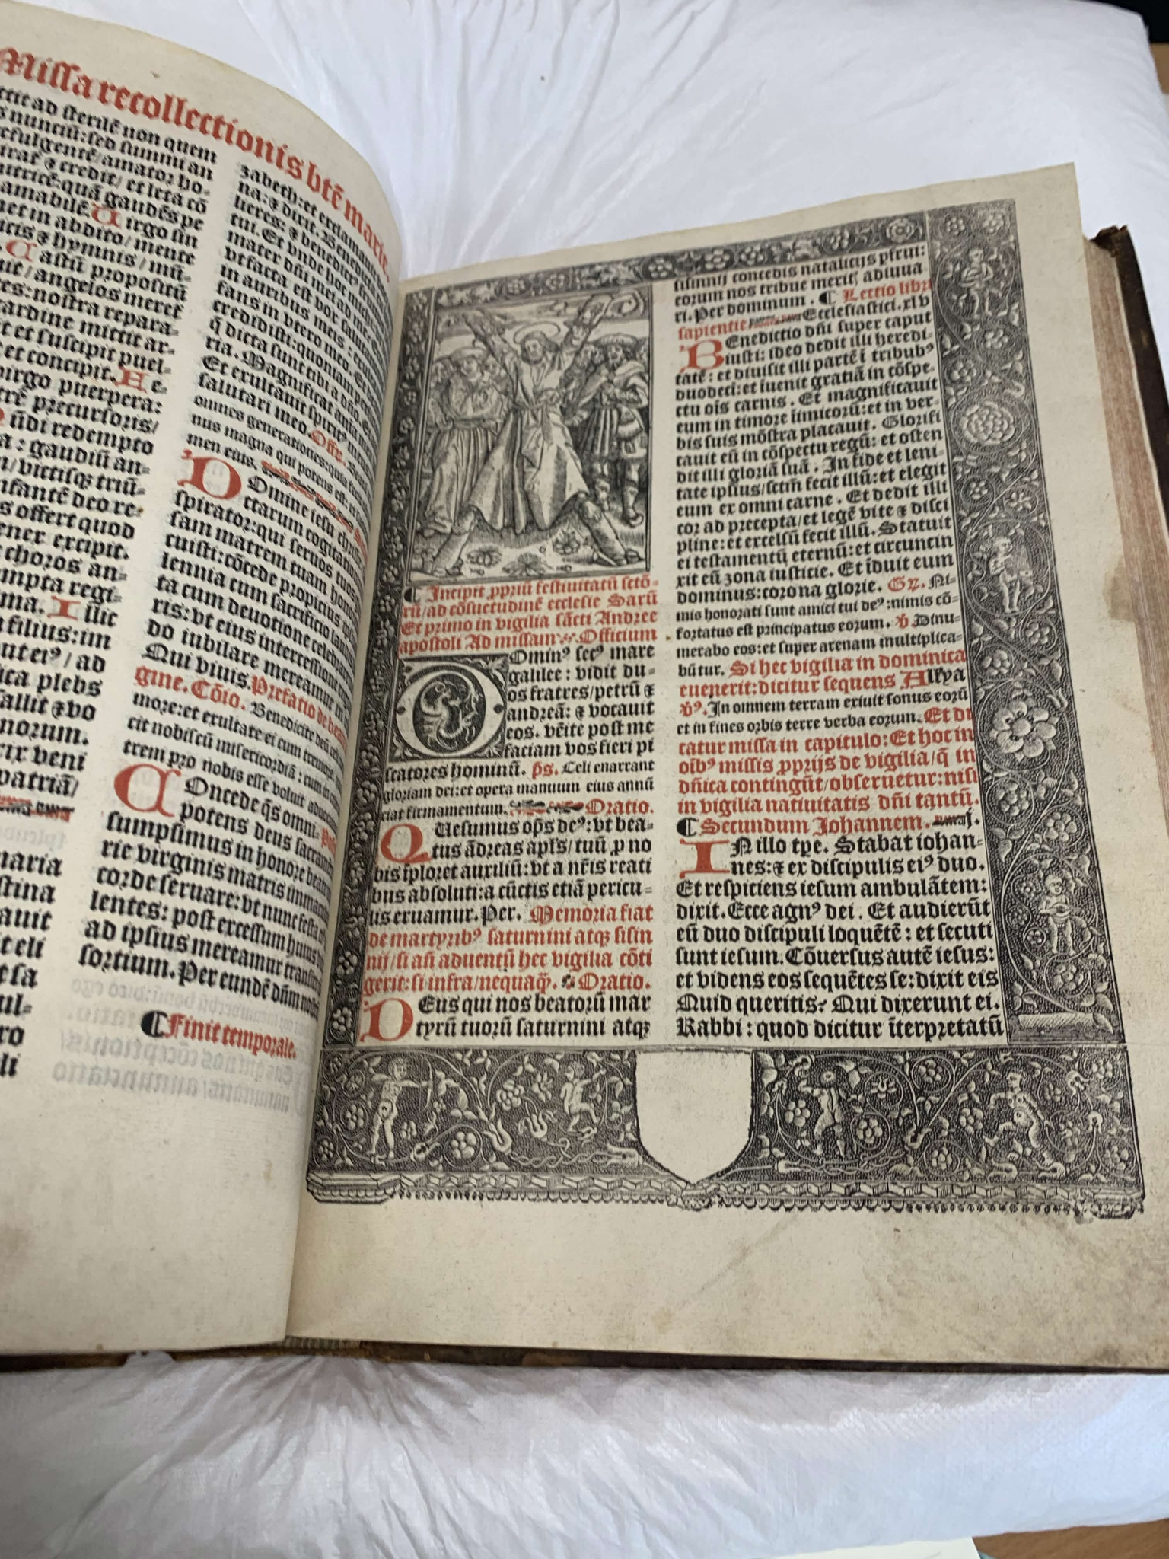
On the left is an image taken of the book, with a woodcut on the top left of the page depicting the crucifixion of Saint Andrew. I could not find credit to the creator of the piece, however I was able to find another imagine of a page from a separate book, using the same print dated to 1520, 9 years after the publishing of my book (4). This would suggest the one online was produced in close proximity to mine as the same woodcut was used, something which would have been kept with the printer.

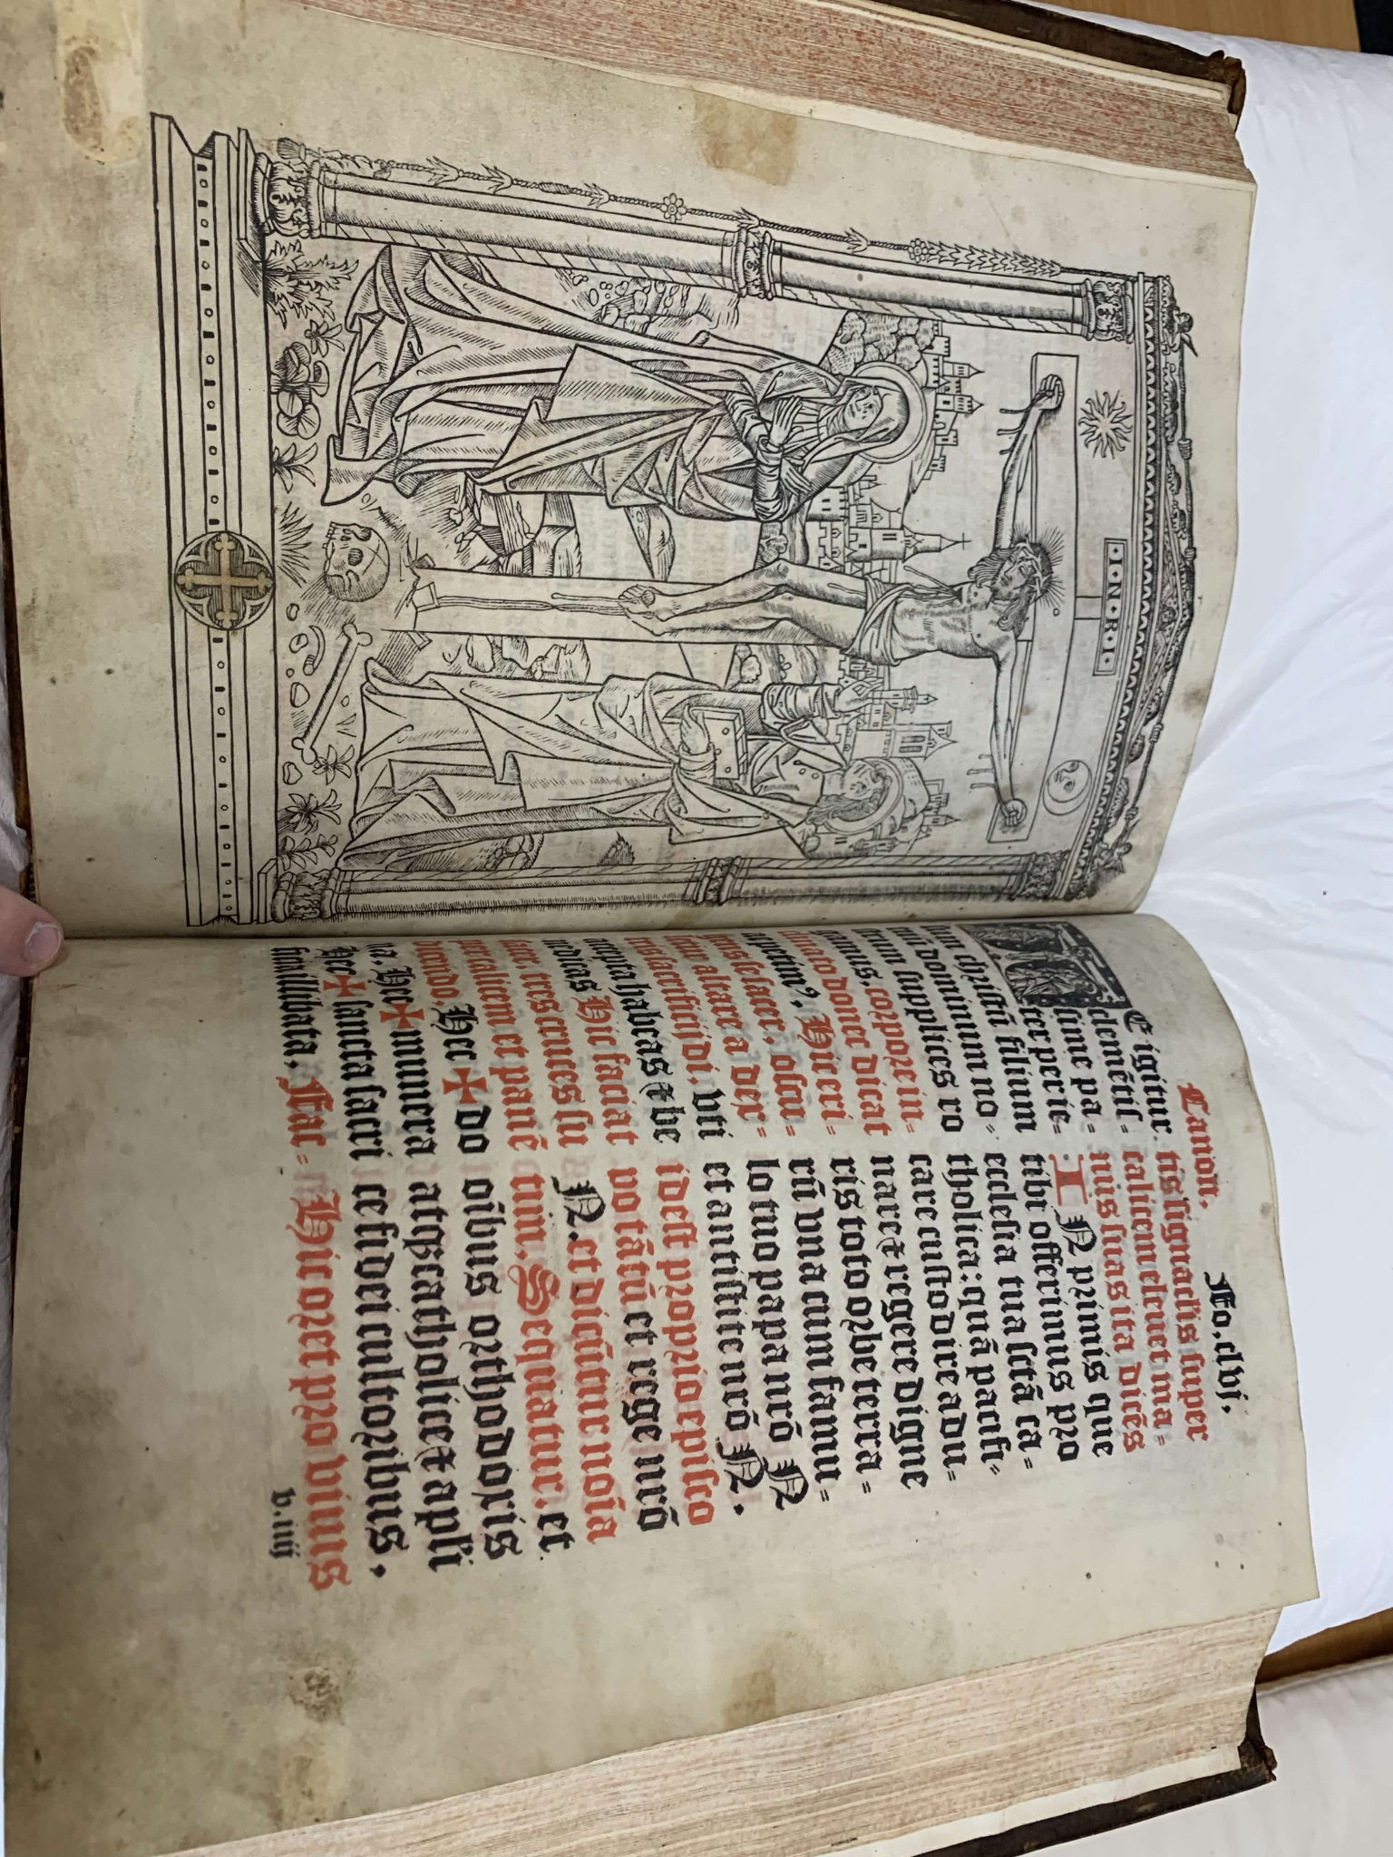

This is another image of the book, with a large, whole page of art depicting Jesus on the cross. Again, I looked for any creator of the piece but none were found. I was, however, able to find another woodcutting print from an earlier date that is incredibly similar to showing in my book, with a few minor differences.

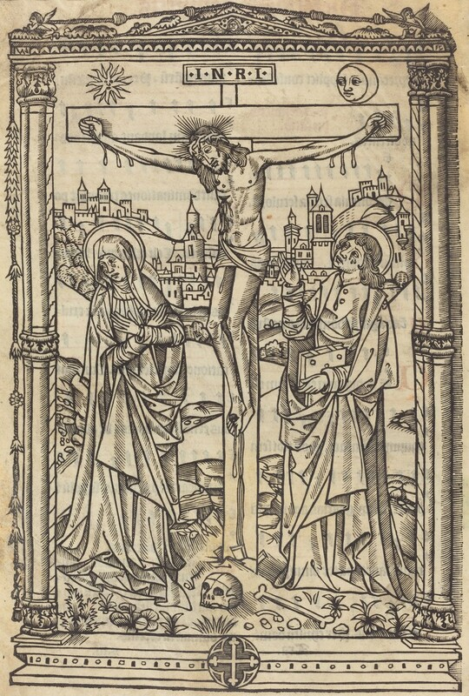

To the left is the one I found online (5), dated to 1490, sadly with not much information, as all the knowledge about the piece comes from the page that was linked - everywhere else I can find online uses the art gallery linked as the source. There are a few small differences between the one online and my book, which will be listed below.
- The steeple under Jesus’s right arm is a cross in my book, but appears to be a flag in the online version.
- The sun depiction in the top left has a face in the online version, but not in my book.
- The skull sitting on the floor at the base of the cross, the horizontal line touches the drawn curve in the skull in the online version, but not in my book.

It suggests that the woodcut of this image was used for multiple different books, and may suggest that the online book and my book may have been made in a similar area to each other as they both use the same woodcut. The differences to me are so minor that I do not think the woodcut itself would have been changed in the time between the two prints, instead the differences being drawn on later.

In the modern day, Missal can generally refer to three different things in the Roman Liturgy. The first is the Roman Missal, the official liturgical book which contains the texts prayed by priests and people at every celebration of mass. Secondly is a Sunday or Weekday Missal, which is a compilation of text from the Missal ( the prayers ) and the lectionary ( the readings) which are grouped together to allow for more participation in the people attending mass, and the third, which is the overall volume or section of the liturgical rites (1). My book was printed in 1511, a Roman Catholic Missale for the Sarum rite. The Sarum rite, alternatively named the Use of Sarum, or the Salisbury Tradition, was a variant of the Roman Rite, which ‘governs the manner in which ecclesiastical services, sacraments, and blessings are performed ‘(2). It originates from the Cathedrals of Salisbury, in England ( Hence Salisburiens) and was also used across England, and was the foundation for the First book of Common Prayer in 1549, which was largely based on the Sarum rite (3). My book would have been written with the knowledge from the second cathedral of Salisbury, which was built in the thirteenth century. This does not mean my book is directly from the cathedral, as the Sarum rite was popular throughout England at the time.

Something else that makes my book interesting is that it was printed 59 years before the Tridentine Mass was put in place, a mass decided upon by many catholic priests at the Council of Trent, that was made in reaction to the spreading of many local versions of the Roman Missal, and was an attempt to control this and make all Catholic churches use the same Missal. My book gives an insight into some of the variations made before this event, and gives a look into what the Catholic church was like at the time.

To sum up the information, my book would have been printed at a time when many local churches and cathedrals would have their own, localised version of the holy texts that the Pope would have put out. Mine is specifically the Roman Catholic Sarum Missale, which means it was an official liturgical book for the Sarum rite, containing the prayers and the directions for worship, acting as a guide for the priest.

Bibliography
- Liturgy Office | Roman Missal - Accessed 6/7/2026
- What is the Roman Rite? - World History Edu - Accessed 6/7/2026
- Sarum Rite - Accessed 6/7/2026

- Crucifixion of Saint Andrew from Missale Monasteriense, plate 65 from Woodcuts from Books of the XVI Century by Unknown Artist, 1520, depicting the martyrdom of the apostle Andrew bound to an X-shaped cross with onlookers and soldiers below Stock Photo - Alamy - Accessed 7/72026
- Christ on the Cross by French 15th Century - Accessed 7/72026

